Table S1. The OHIP-14 questionnaire.
Domain Item | Fourteen questions
Domain 1: Functional limitation | 1. Had trouble pronouncing any words  2. Felt sense of taste has worsened
Domain 2: Physical pain | 3. Had painful aching  4. Found it uncomfortable to eat any foods
Domain 3: Psychological discomfort | 5. Been self-conscious  6. Felt tense
Domain 4: Physical disability | 7. Felt diet has been unsatisfactory  8. Had to interrupt meals
Domain 5: Psychological disability | 9. Found it difficult to relax  10. Been a bit embarrassed
Domain 6: Social disability | 11. Been a bit irritable  12. Had difficulty doing usual jobs
Domain 7: Handicap | 13. Felt life less satisfying  14. Been totally unable to function

The descriptive statistics and significances of the 7 domains of the OHIP-14 questionnaire and patients' perceived aesthetics through the VAS scale are given below.

Functional limitation
Descriptive data of this OHRQoL domain at the 3 study times are represented in Table S2. The results showed that there was statistically significant data from T0 to T2 (p<0.01) and from T1 to T2 (p<0.01). In contrast, from T0 to T1 there was no statistical evidence as shown in Figure S1.

Table S2. Descriptive statistics of the functional limitation domain in the 3 study times.
Time | Patients | Minimum | Maximum | Median | Mean | Standard deviation
T0 | 100 | 2 | 10 | 3 | 3.67 | 2.108
T1 | 100 | 2 | 10 | 3 | 3.25 | 1.527
T2 | 100 | 2 | 8 | 2 | 2.69 | 1.187

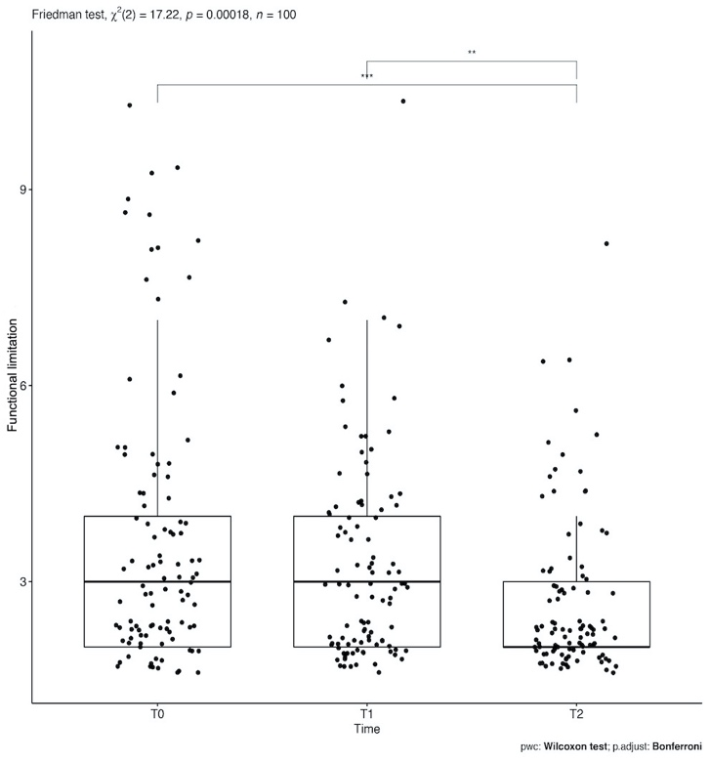
Figure S1. Functional limitation domain statistical significance in the 3-time intervals (T0, T1, T2). Legend: *=p<0.05; **= p<0.01; ***= p<0.001; ****=p<0.0001.

Physical pain
Descriptive data for this OHRQoL domain at the 3 study times are represented in Table S3. It was shown that there is statistically significant data from T0 to T2 (p<0.01) and from T0 to T1 (p<0.01) In contrast, no statistically significant data emerged from T1 to T2 as shown in the figure below (Fig. S2).

Table S3. Descriptive statistics of the physical pain domain in the 3 study times.
Time | Patients | Minimum | Maximum | Median | Mean | Standard deviation
T1 | 100 | 2 | 10 | 3 | 4.04 | 2.247
T2 | 100 | 2 | 10 | 3 | 3.22 | 1.773
T3 | 100 | 2 | 9 | 2 | 2.85 | 1.431

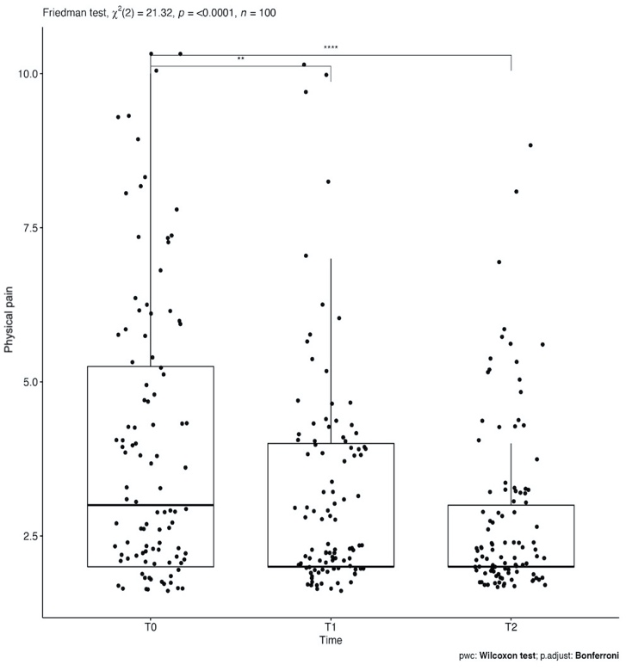
Figure S2. Physical pain domain statistical significance in the 3-time intervals (T0, T1, T2). Legend: *=p<0.05; **= p<0.01; ***= p<0.001; ****=p<0.0001.

Psychological discomfort
Descriptive data for this OHRQoL domain at the 3 study times are represented in Table S4. It was shown that there are statistically significant data at all 3 times thus from T0 to T2 (p<0.01), from T0 to T1 (p<0.01), and from T1 to T2 (p= 0.01) as shown in Figure S3.

Table S4. Descriptive statistics of the psychological discomfort domain in the 3 study times.
Time | Patients | Minimum | Maximum | Median | Mean | Standard deviation
T1 | 100 | 2 | 10 | 3 | 4.17 | 2.28
T2 | 100 | 2 | 10 | 3 | 3.1 | 1.446
T3 | 100 | 2 | 7 | 2 | 2.66 | 1.13

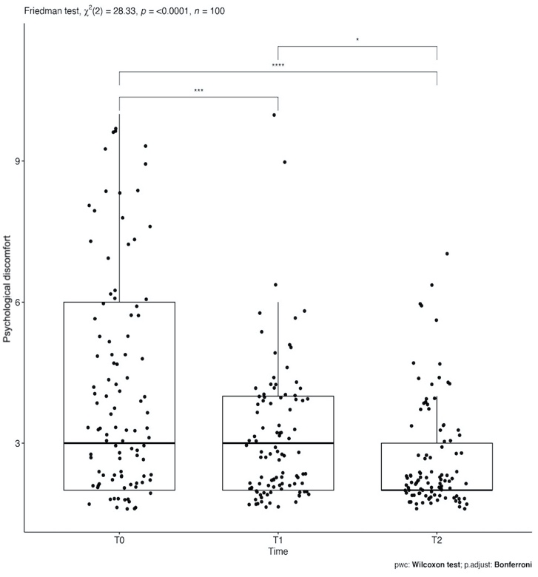
Figure S3 Psychological discomfort domain statistical significance in the 3-time intervals (T0, T1, T2). Legend: *=p<0.05; **= p<0.01; ***= p<0.001; ****=p<0.0001.

Physical disability
Descriptive data for this OHRQoL domain at the 3 study times are represented in Table S5. It was shown that there is statistically significant data at all 3 times thus from T0 to T2 (p<0.01), from T0 to T1 (p= 0.01), and T1 to T2 (p<0.01) as shown in the figure below (Fig. S4).

Table S5. Descriptive statistics of the physical disability domain in the 3 study times.
Time | Patients | Minimum | Maximum | Median | Mean | Standard deviation
T1 | 100 | 2 | 10 | 3 | 4.1 | 2.158
T2 | 100 | 2 | 9 | 3 | 3.43 | 1.865
T3 | 100 | 2 | 10 | 2 | 2.76 | 1.45

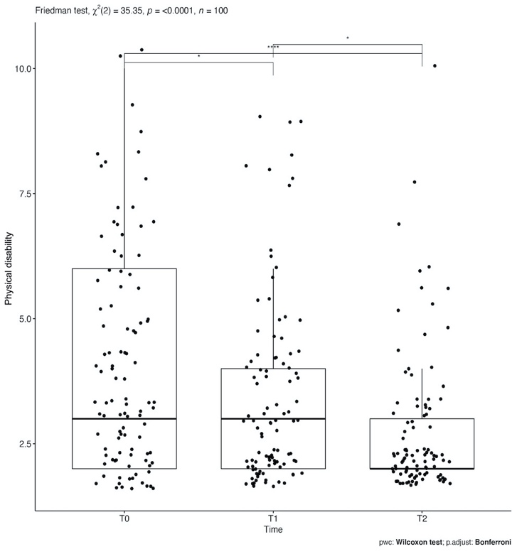
Figure S4. Physical disability domain statistical significance in the 3-time intervals (T0, T1, T2). Legend: *=p<0.05; **= p<0.01; ***= p<0.001; ****=p<0.0001.

Psychological disability
Descriptive data for this OHRQoL domain at the 3 study times are represented in Table S6. The results showed that there are statistically significant data at the 3 times, thus from T0 to T1 (p<0.01), from T0 to T2 (p<0.01), and from T1 to T2 (p<0.01) as shown in Figure S5.

Table S6. Descriptive statistics of the psychological disability domain in the 3 study times.
Time | Patients | Minimum | Maximum | Median | Mean | Standard deviation
T1 | 100 | 2 | 10 | 4 | 3.96 | 2.084
T2 | 100 | 2 | 10 | 3 | 3.22 | 1.655
T3 | 100 | 2 | 8 | 2 | 2.69 | 1.212

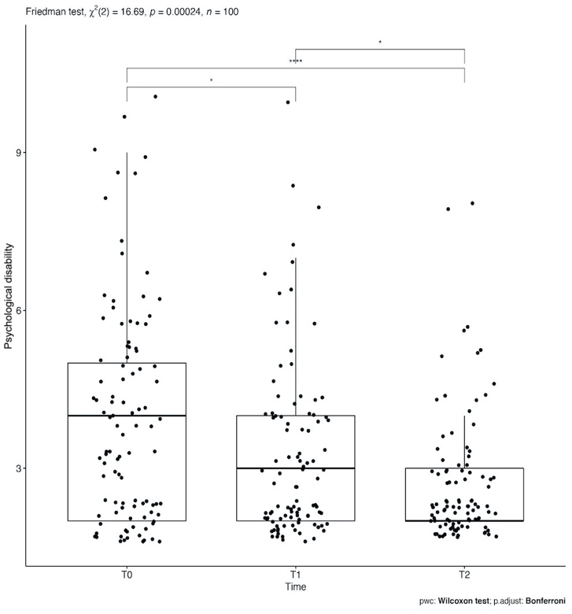
Figure S5. Psychological disability domain statistical significance in the 3-time intervals (T0, T1, T2). Legend: *=p<0.05; **= p<0.01; ***= p<0.001; ****=p<0.0001.

Social disability
Descriptive data of this OHRQoL domain in the 3 study times are represented in Table S7. It was found that there are statistically significant data in 2-time intervals from T0 to T2 (p<0.01), and T1 to T2 (p<0.01) as shown in the figure below (Fig. S6).

Table S7. Descriptive statistics of the social disability domain in the 3 study times.
Time | Patients | Minimum | Maximum | Median | Mean | Standard deviation
T1 | 100 | 2 | 10 | 3 | 3.83 | 2.161
T2 | 100 | 2 | 10 | 3 | 3.33 | 2.015
T3 | 100 | 2 | 8 | 2 | 2.59 | 1.102

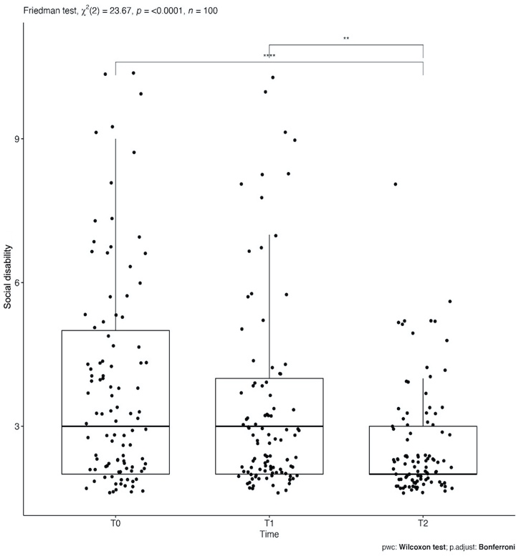
Figure S6. Social disability domain statistical significance in the 3-time intervals (T0, T1, T2). Legend: *=p<0.05; **= p<0.01; ***= p<0.001; ****=p<0.0001.

Handicap
Descriptive data for this OHRQoL domain at the 3 study times are represented in Table S8. It was found that there are statistically significant data in 2-time intervals from T0 to T1 (p<0.01), and T0 to T2 (p<0.01) as shown in Figure S7.

Table S8. Descriptive statistics of the social disability domain in the 3 study times.
Time | Patients | Minimum | Maximum | Median | Mean | Standard deviation
T1 | 100 | 2 | 10 | 3 | 4.11 | 2.352
T2 | 100 | 2 | 10 | 3 | 3.08 | 1.824
T3 | 100 | 2 | 7 | 2 | 2.65 | 1.167

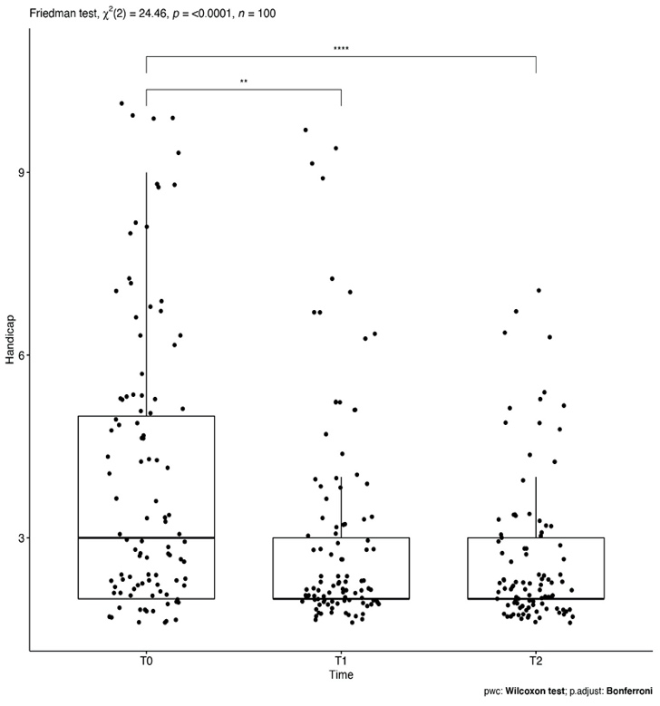
Figure S7. Handicap domain statistical significance in the 3-time intervals (T0, T1, T2). Legend: *=p<0.05; **= p<0.01; ***= p<0.001; ****=p<0.0001.

Visual Analogue Scale (VAS)
The patients' perceived aesthetics was analyzed through a VAS scale from 0 to 100. It was found that there are statistically significant data in all 3-time intervals, thus from T0 to T1 (p<0.01), from T0 to T2 (p<0.01), and from T1 to T2 (p<0.01) as shown in the figure below (Fig. S8).

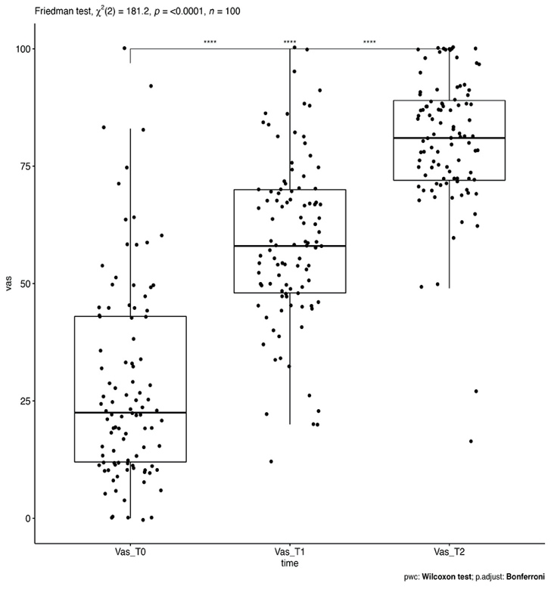
Figure S8. VAS scale of patients' perceived aesthetics statistical significance in the 3-time intervals (T0, T1, T2). Legend: *=p<0.05; **= p<0.01; ***= p<0.001; ****=p<0.0001.

