Supplementary information

Fig S1. Brown precipitation deposited during the bioleaching process, proposed to be the oxidation of Fe (II) from the leaching media as indicator for the suggested mechanism of bioleaching according to previous study.
Fig S2. Plate growth of individual strains, SE, SE2, S1A, and SC.

Fig S3. Physical changes (colour) of each leaching media after the bioleaching media was completed.

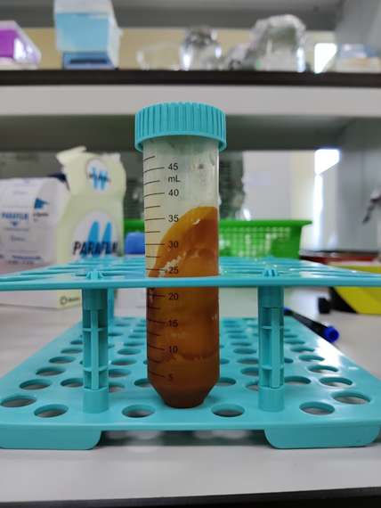
Fig. S1 Muhammad Syafiq Razali et al

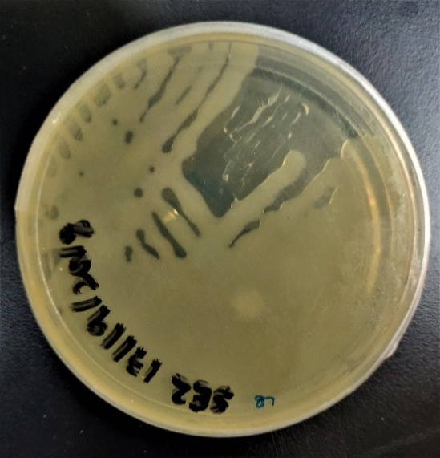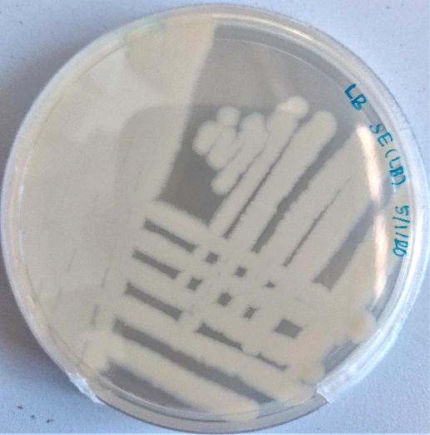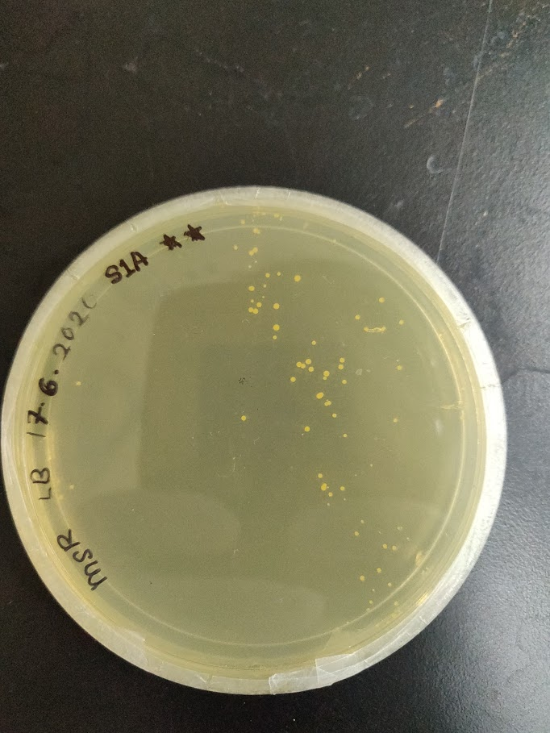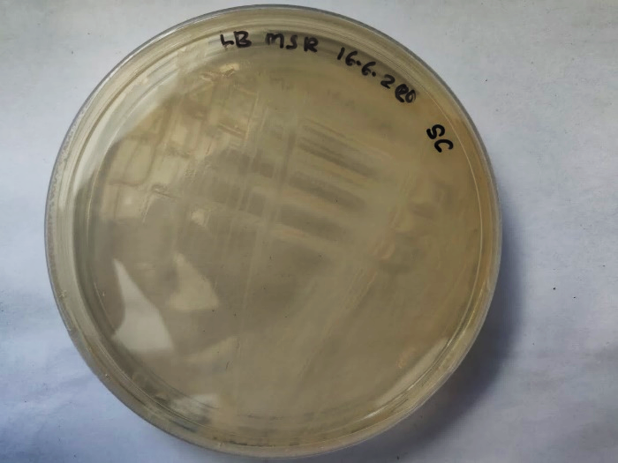
Fig. S2 Muhammad Syafiq Razali et al

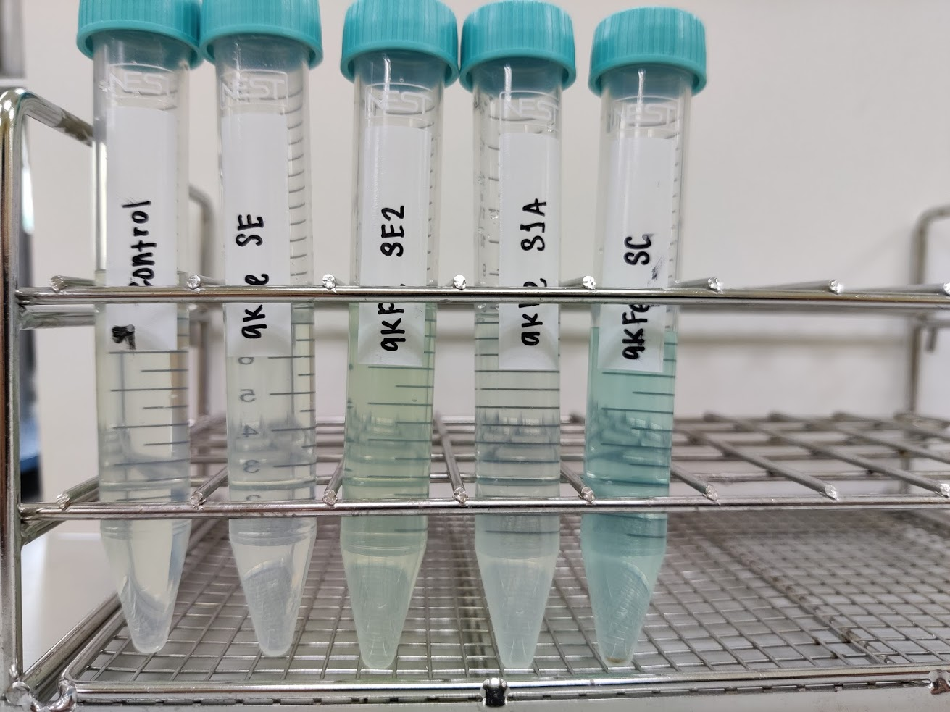
Fig. S3 Muhammad Syafiq Razali et al

