Supplementary Materials for

Atomically-precise engineering of spin-orbit polarons
in a kagome magnetic Weyl semimetal

Hui Chen^{1,2,3}†, Yuqing Xing^{1,2}†, Hengxin Tan⁴, Li Huang^{1,2}, Qi Zheng^{1,2}, Zihao Huang^{1,2}, Xianghe Han^{1,2}, Bin Hu^{1,2}, Yuhan Ye^{1,2}, Yan Li^{1,2}, Yao Xiao^{1,2}, Hechang Lei⁵, Xianggang Qiu¹, Enke Liu¹, Haitao Yang^{1,2,3}, Ziqiang Wang⁶, Binghai Yan⁴ and Hong-Jun Gao^{1,2,3*}

Corresponding author: hjgao@iphy.ac.cn,

Fig. S1.

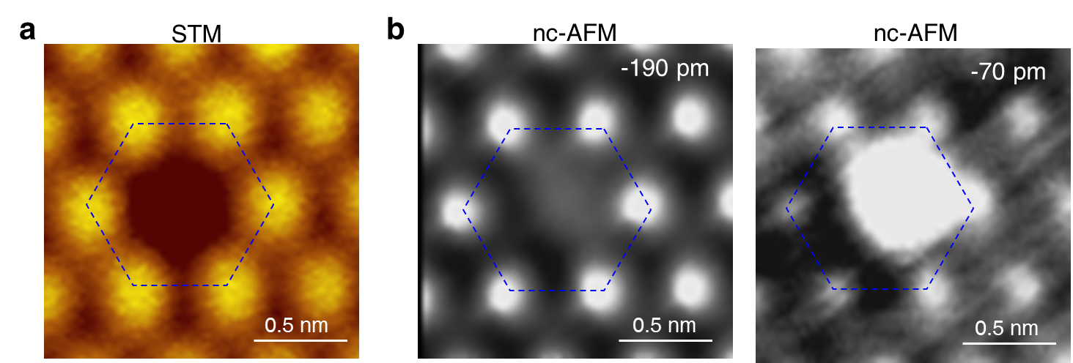

Fig. S1. Demonstration of the single vacancy with nc-AFM. a, STM image of the single S vacancy, showing a hole-like feature (V_{s}= -4 mV, I_{t}=10 pA). b, Constant-height AFM images by using a CO tip in the same region of (a) with the scanning height of -190 pm (left) and -70 pm (right), respectively, showing the missing S atom at the vacancy site. Scanning height: -190 pm, V_{s}= -4 mV, I_{t}=10 pA. Scanning amplitude = 50 pm.

Fig. S2.

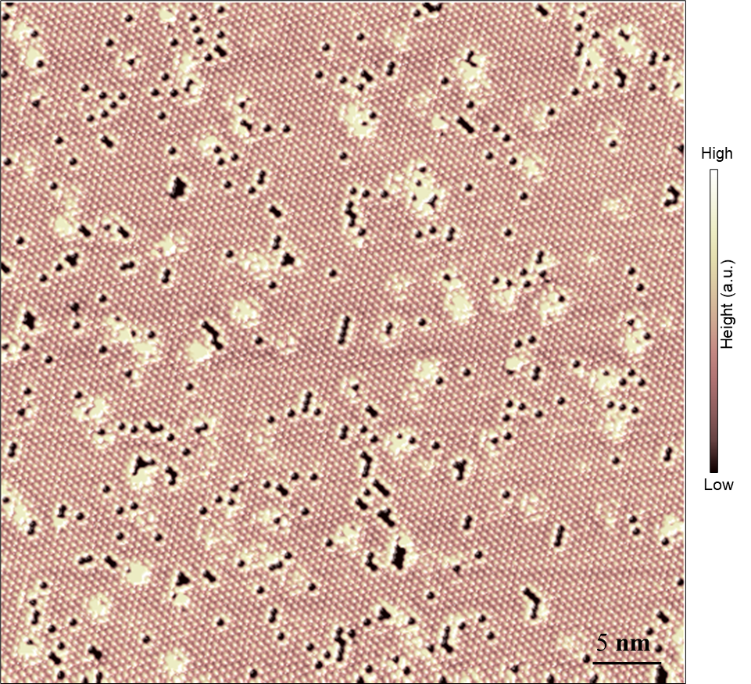

Fig. S2. Typical large-scale STM image of S-terminated surface, showing randomly-distributed S vacancies with different size and shape.

Fig. S3.

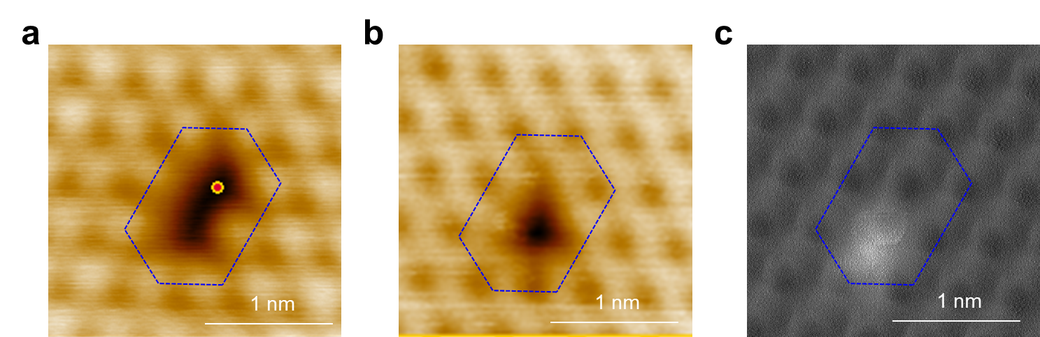

Fig. S3. Demonstration of the single vacancy repairing with nc-AFM. a,b STM images showing the topography before (a) and after (b) vacancy repairing (V_{s}= -4 mV, I_{t}=10 pA). c, Constant-height AFM images at the same region of (b), showing the filling of an additional S atom at the vacancy site as marked by the red spot in (a). Scanning height: -190 pm, V_{s}= -4 mV, I_{t}=10 pA. Scanning amplitude = 50 pm.

Fig. S4.

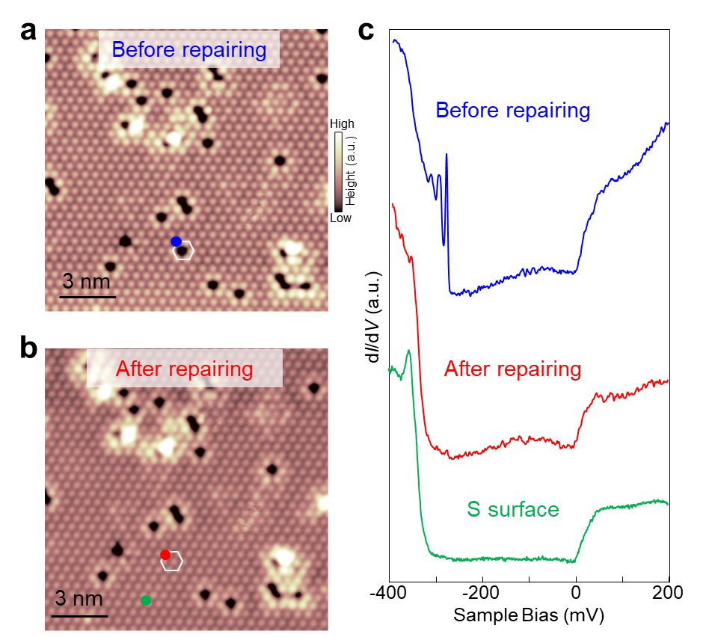
Fig. S4. Topography and dI/dV spectra of S vacancies before and after vacancy repairing. a,b STM images before (a) and after (b) STM manipulations, showing that a single S vacancy is repaired (V_{s} = −400 mV, I_{t} = 500 pA). c, Typical dI/dV spectra obtained at the blue, red and green spots, respectively, showing the similar density of state at the as-repaired vacancy with vacancy-free S surface region (V_{s} = −400 mV, I_{t} = 500 pA, V_{mod} = 0.5 mV).

Fig. S5.

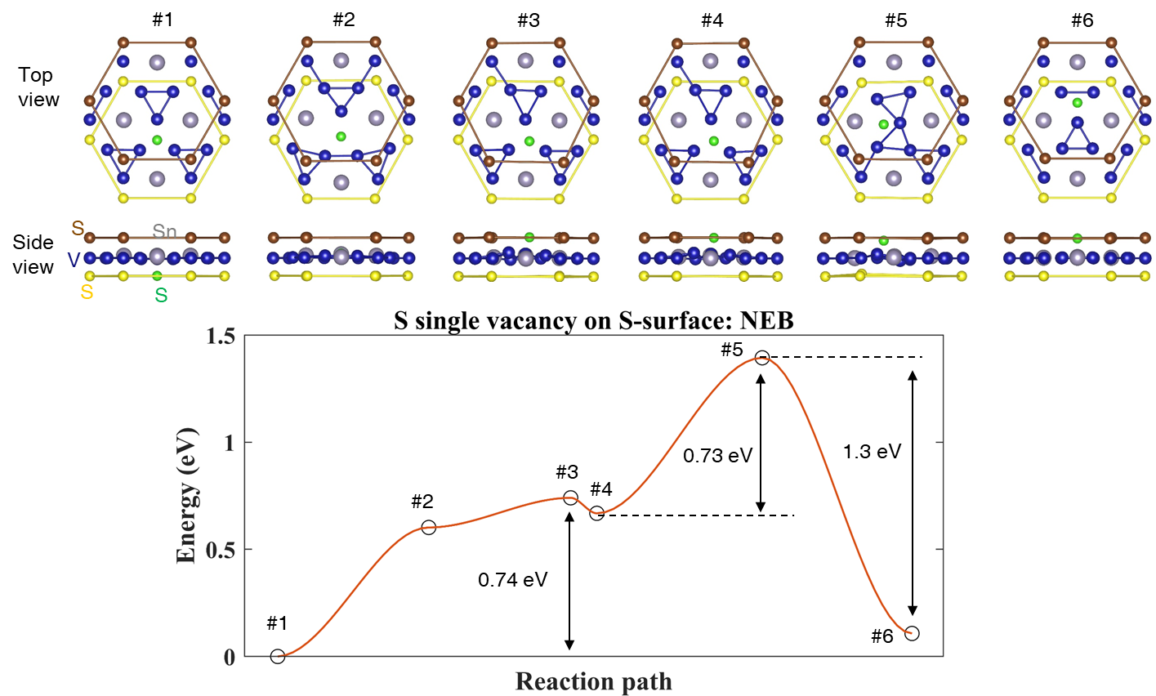

Fig. S5. Transition barrier of a S atom from the bulk to the single vacancy site on the S-surface. Four intermediate structures in the Nudged Elastic Band (NEB) calculations are considered as #2 ~#5, where #1 and #6 show the surface S vacancy and bulk S vacancy respectively (only the three top-most layers are shown for simplicity). The S (green) moves in out-of-plane direction from #1 to #3 (barrier ~ 0.74 eV), and moves in the surface plane from #3 to #6 (barrier ~ 0.73 eV). Notice that structures #3 and #4 are very close but not the same. The medium energy barrier indicates that pulling one S from the bulk to occupy the surface vacancy site is possible. Spin-orbit coupling is not included.

Fig. S6.

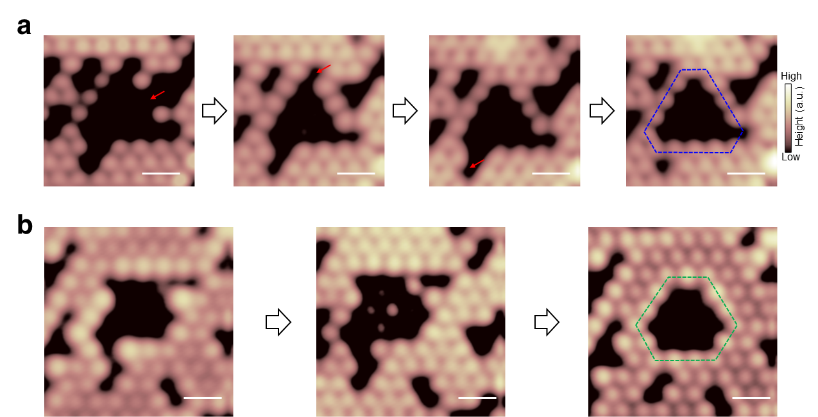
Fig. S6. Step-by-step atomic manipulation of S vacancy aggregates: from irregular to regular vacancy shape. a, Consecutive STM images of a large vacancy being repaired and transformed into a quasi-triangular vacancy highlighted by the dotted blue triangle (V_{s} = −100 mV, I_{t} = 500 pA). b, Consecutive STM images of another large vacancy being repaired and transformed into a quasi-hexagonal vacancy highlighted by the dotted green hexagon (V_{s} = −100 mV, I_{t} = 500 pA). The scale bars in all figures correspond to 1 nm.

Fig. S7.
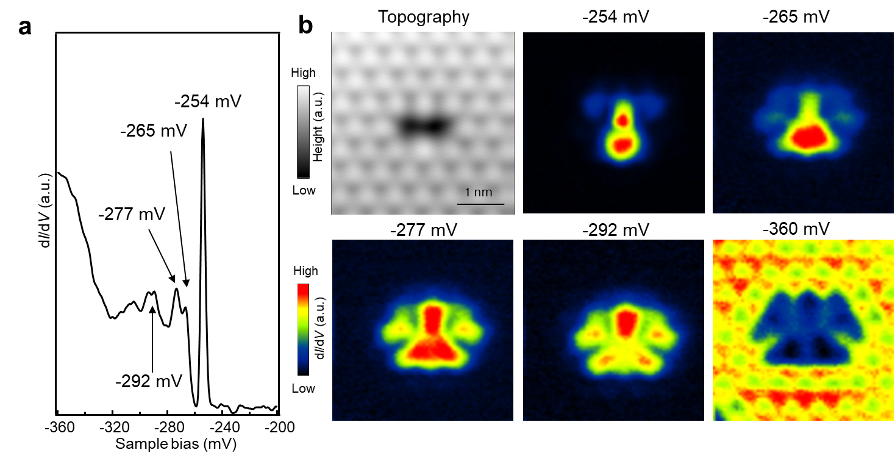

Fig. S7. Localized quantum states around a dimer S-vacancy at the S-terminated surface. a, dI/dV spectra at a dimer S-vacancy, showing several peaks corresponding to the bound states induced by the vacancy. b, STM image of a dimer-vacancy and dI/dV maps at different energies: -254 meV, -265 meV, -277 meV, -292 meV, and -360 meV, respectively.

Fig. S8.

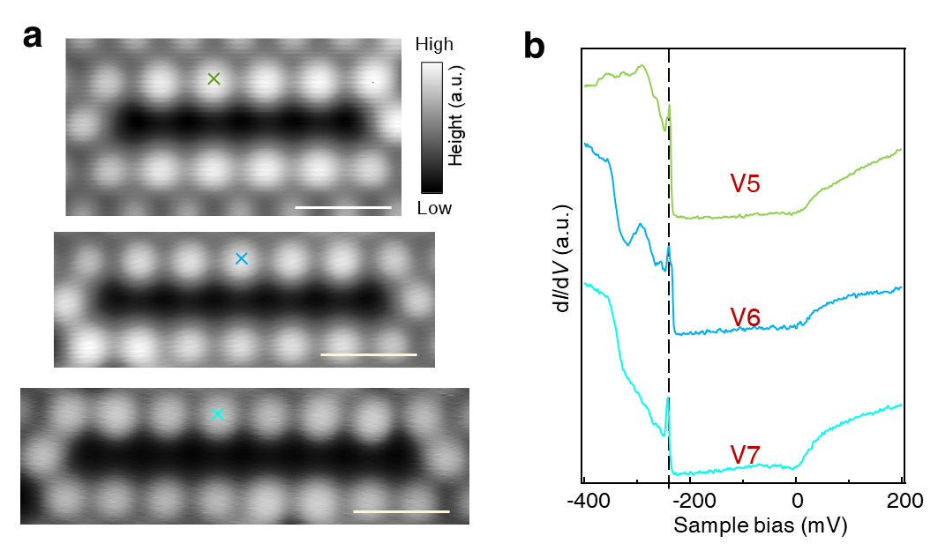

Fig. S8. STM images and spectra of five-, six-, and seven- atomic vacancies on S terminated surfaces. a, STM images showing five-, six-, and seven- atomic vacancies on S-terminated surfaces. b, dI/dV spectra on the positions (marked by light blue, blue and green cross in (a), respectively) of the five-, six-, and seven- atomic vacancies, respectively, showing the sharp peak around -240 mV. The scale bar is 1 nm in (a) and (b).

Fig. S9.
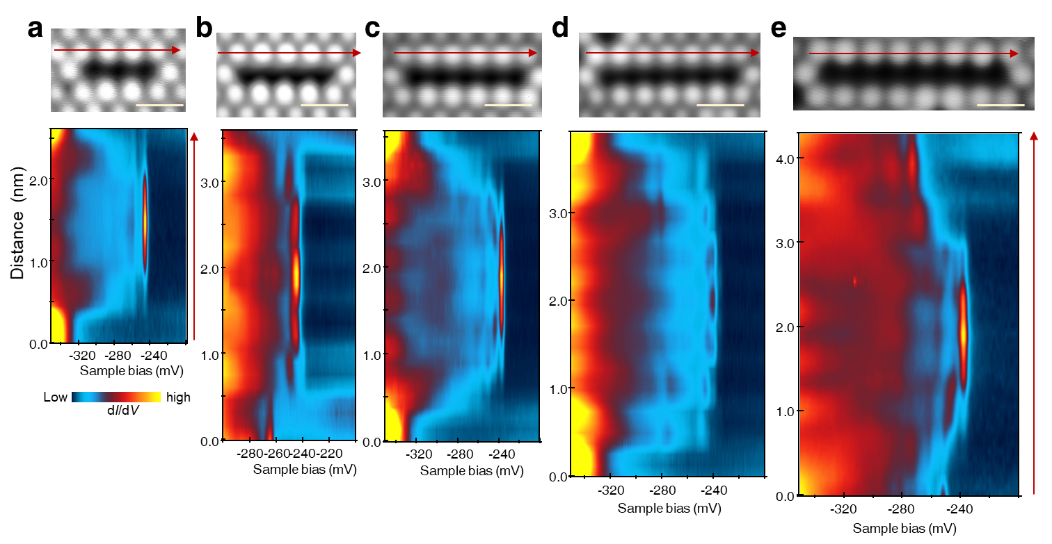
Fig. S9. The dI/dV linecut along the edge of linear atomic S vacancies. a-e STM topography of linear atomic vacancies and dI/dV linecut along the red arrow, showing the spatial decay of the bound states with the atomic shift. The scale bar is 1 nm.

Fig. S10.
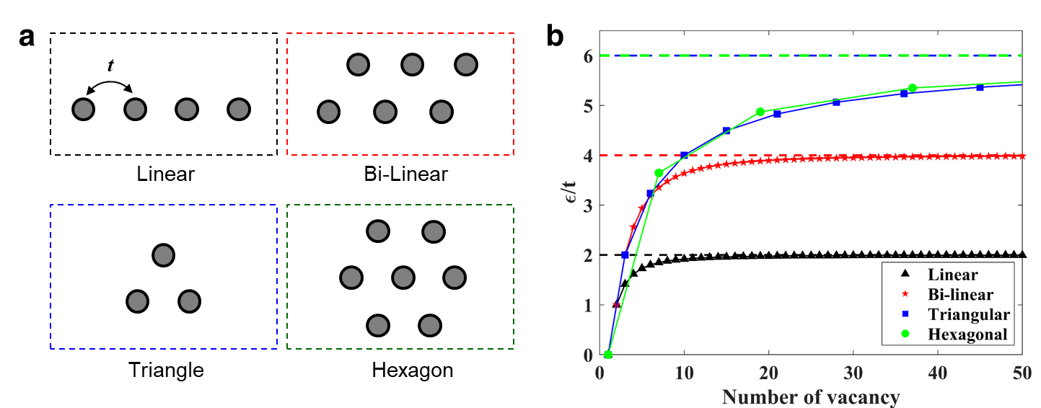
Fig. S10. Energy evolution of anti-bonding states for different vacancies. a, The model with a single hopping parameter, t, is considered in for simulation of the inter-vacancy interaction. by a In the vacancy number, energy levels saturate to corresponding infinite size cases, 2t, 4t and 6t for linear, bilayer and triangular (also hexagonal) configurations. b, Energy evolution of the anti-bonding states for different vacancies based on the model in (a).

Fig. S11.
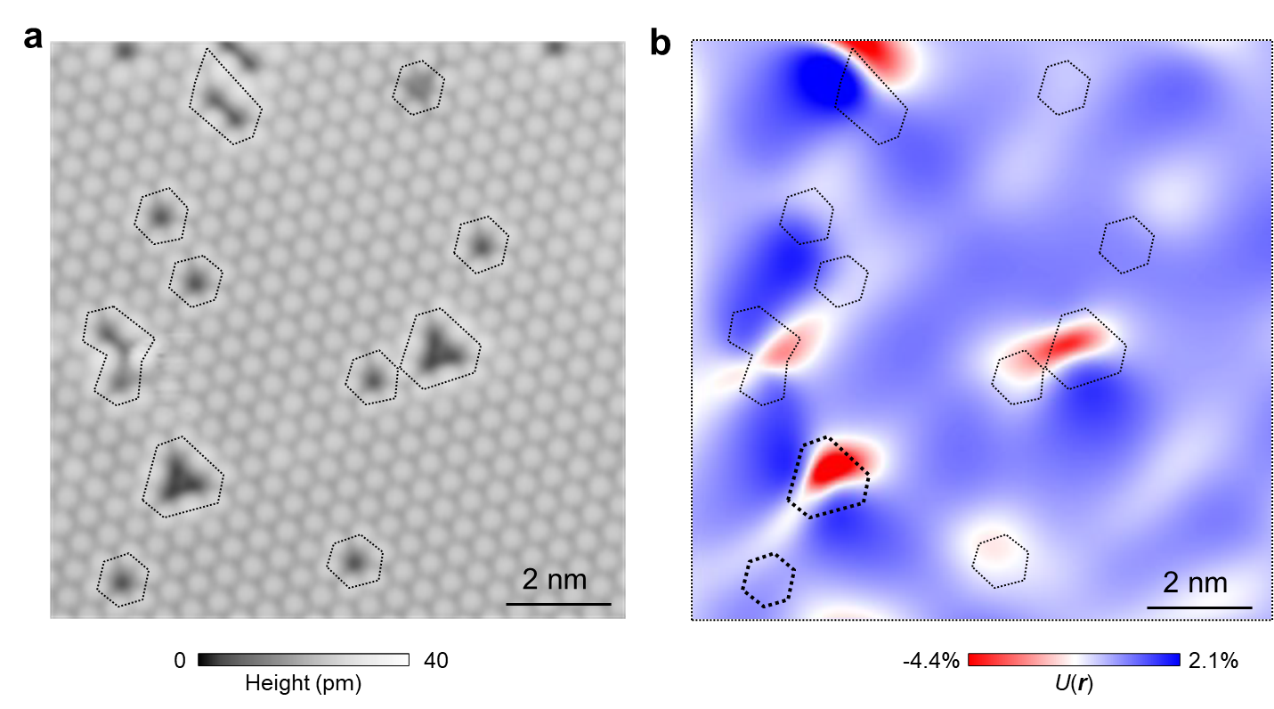
Fig. S11. Analysis of the lattice distortion around S vacancies. The antisymmetric strain map U(r)≡u_{aa}(r)-u_{bb}(r)(a) are derived from STM topography (b), showing that the relatively-larger lattice distortion is localized at the triangular vacancies.

