Supplementary material

Table S1 – Geodetic velocity field in Eurasia-fixed reference frame (units: cm/yr)
SITES | LONG | LAT | vE | vN | vUp | σVe | σVn | σVup | Duration  (years)
003A | 22.1345 | 37.4017 | -2.1 | -2.8 | 0.2 | 0.02 | 0.03 | 0.08 | 2
004A | 22.8539 | 37.2444 | -1.9 | -2.6 | 0.1 | 0.02 | 0.08 | 0.09 | 2
005A | 21.0211 | 39.166 | -0.7 | -0.6 | -0.6 | 0.02 | 0.02 | 0.03 | 2
009A | 22.9642 | 36.2984 | -1.8 | -2.5 | -0.2 | 0.01 | 0.01 | 0.03 | 2
010A | 23.4524 | 37.5004 | -1.8 | -2.7 | -0.7 | 0.01 | 0.13 | 0.08 | 2
011A | 22.3166 | 38.1527 | -1.4 | -2.4 | -0.2 | 0.02 | 0.02 | 0.03 | 2
012A | 21.7898 | 38.2952 | -1.7 | -2.0 | -0.5 | 0.02 | 0.02 | 0.04 | 2
013A | 22.1248 | 37.8988 | -1.6 | -2.8 | -0.1 | 0.00 | 0.01 | 0.01 | 2
015A | 22.7322 | 38.5165 | -1.1 | -1.9 | -0.5 | 0.04 | 0.05 | 0.18 | 2
016A | 21.4819 | 40.1526 | -0.1 | -0.6 | 0.1 | 0.01 | 0.02 | 0.10 | 2
018B | 25.5238 | 40.4741 | -0.3 | -0.3 | 0.7 | 0.00 | 0.03 | 0.09 | 2
020A | 26.3888 | 41.2699 | -0.2 | -0.2 | -0.2 | 0.00 | 0.03 | 0.04 | 2
023A | 24.3224 | 38.0466 | -1.7 | -2.5 | 0.1 | 0.03 | 0.01 | 0.01 | 2
025A | 24.1132 | 38.574 | -1.5 | -2.5 | -0.1 | 0.04 | 0.04 | 0.13 | 2
026A | 22.9766 | 38.8632 | -0.9 | -1.4 | -0.3 | 0.04 | 0.05 | 0.12 | 2
027A | 21.7325 | 38.8428 | -0.7 | -0.7 | -0.5 | 0.01 | 0.01 | 0.07 | 2
028A | 20.8447 | 37.7295 | -1.3 | -1.3 | 0.0 | 0.02 | 0.05 | 0.05 | 2
029A | 21.6487 | 37.4848 | -2.1 | -2.8 | -0.2 | 0.04 | 0.02 | 0.07 | 2
037A | 23.9049 | 40.8718 | 0.0 | -0.5 | -0.3 | 0.04 | 0.05 | 0.08 | 2
040A | 20.5229 | 38.115 | -0.7 | -1.0 | 0.0 | 0.03 | 0.03 | 0.08 | 2
041A | 22.8024 | 41.1652 | 0.1 | -0.8 | -0.4 | 0.03 | 0.02 | 0.04 | 2
043A | 22.7609 | 37.9764 | -1.6 | -2.8 | 0.0 | 0.03 | 0.05 | 0.04 | 2
047A | 25.9021 | 36.8322 | -1.9 | -2.7 | 0.7 | 0.01 | 0.02 | 0.04 | 2
048A | 25.4635 | 36.3877 | -1.8 | -3.4 | 0.1 | 0.02 | 0.08 | 0.17 | 2
052A | 24.8775 | 37.3997 | -1.8 | -2.8 | 0.2 | 0.03 | 0.02 | 0.07 | 2
054A | 22.3836 | 36.6661 | -2.4 | -2.7 | 0.0 | 0.03 | 0.01 | 0.07 | 2
056A | 22.9411 | 36.7657 | -1.9 | -2.7 | -0.4 | 0.04 | 0.06 | 0.04 | 2
057A | 22.2285 | 39.8791 | -0.3 | -1.0 | -0.5 | 0.04 | 0.05 | 0.15 | 2
058A | 22.7576 | 39.7192 | -0.2 | -0.9 | 0.0 | 0.01 | 0.03 | 0.07 | 2
059A | 22.4204 | 39.3345 | -0.6 | -0.8 | 0.3 | 0.02 | 0.03 | 0.03 | 2
062A | 23.1026 | 39.4387 | 0.1 | -1.4 | -0.8 | 0.05 | 0.09 | 0.24 | 2
068A | 20.2776 | 39.4536 | -0.4 | 0.0 | 0.1 | 0.01 | 0.06 | 0.07 | 2
069A | 25.2886 | 41.0904 | -0.1 | -0.5 | 0.1 | 0.01 | 0.04 | 0.01 | 2
072A | 22.3715 | 38.9037 | -0.9 | -1.1 | 0.1 | 0.04 | 0.06 | 0.06 | 2
073A | 21.3967 | 40.8512 | 0.1 | -0.5 | -0.2 | 0.01 | 0.05 | 0.03 | 2
076A | 23.9443 | 40.039 | 0.1 | -0.7 | 0.2 | 0.01 | 0.06 | 0.10 | 2
079A | 25.6718 | 35.0139 | -1.7 | -3.1 | 0.3 | 0.03 | 0.07 | 0.03 | 2
085A | 23.6855 | 35.2339 | -1.6 | -2.6 | 0.1 | 0.04 | 0.00 | 0.06 | 2
088A | 27.9211 | 36.0245 | -0.9 | -2.7 | 0.1 | 0.01 | 0.04 | 0.08 | 2
089A | 25.2009 | 39.9078 | -1.5 | -1.2 | -0.1 | 0.01 | 0.01 | 0.00 | 2
091A | 26.1055 | 39.2485 | -2.1 | -1.4 | 0.0 | 0.03 | 0.01 | 0.04 | 2
092A | 24.566 | 38.9047 | -1.6 | -2.5 | 0.1 | 0.03 | 0.06 | 0.10 | 2
093A | 26.8334 | 37.6716 | -1.2 | -2.1 | -0.3 | 0.03 | 0.03 | 0.07 | 2
094A | 26.0828 | 37.6003 | -1.8 | -2.7 | -0.5 | 0.03 | 0.07 | 0.10 | 2
095A | 26.1265 | 38.3169 | -2.1 | -1.9 | 0.7 | 0.02 | 0.07 | 0.02 | 2
096A | 27.1819 | 35.4862 | -1.4 | -3.2 | 0.5 | 0.02 | 0.01 | 0.07 | 2
AFYT | 23.4353 | 40.0971 | 0.1 | -0.9 | -0.1 | 0.02 | 0.02 | 0.05 | 3.4
AGNA | 21.847 | 39.4837 | -0.4 | -0.7 | -1.0 | 0.02 | 0.04 | 0.06 | 2.2
AGRI | 21.409 | 38.624 | -1.2 | -0.7 | 0.0 | 0.02 | 0.03 | 0.05 | 6.2
AKYR | 24.9126 | 34.9808 | -1.6 | -2.9 | -0.2 | 0.02 | 0.02 | 0.04 | 6.8
ALEX | 25.8535 | 40.8492 | 0.0 | -0.4 | 0.0 | 0.02 | 0.02 | 0.06 | 4.3
ANAV | 23.9041 | 37.7334 | -1.7 | -2.6 | 0.0 | 0.02 | 0.02 | 0.05 | 8.7
ANDR | 24.7371 | 37.8864 | -1.8 | -2.6 | -0.1 | 0.03 | 0.04 | 0.09 | 5.7
ANKR | 32.7585 | 39.8874 | -2.4 | -0.1 | -0.2 | 0.02 | 0.03 | 0.04 | 16
ANOP | 24.096 | 35.218 | -1.7 | -2.6 | 0.0 | 0.02 | 0.01 | 0.05 | 5.7
ARK2 | 23.0336 | 38.7551 | -1.0 | -1.9 | 0.0 | 0.02 | 0.02 | 0.04 | 3.9
ARKL | 25.269 | 35.134 | -1.7 | -3.0 | 0.2 | 0.02 | 0.02 | 0.06 | 2
ART1 | 20.9333 | 39.1529 | -0.6 | -0.6 | -0.2 | 0.01 | 0.02 | 0.08 | 1.6
ART2 | 20.9917 | 39.1588 | -0.7 | -0.5 | -0.1 | 0.03 | 0.03 | 0.05 | 3.7
ASTY | 26.3533 | 36.5451 | -1.6 | -2.9 | 0.1 | 0.03 | 0.04 | 0.06 | 4.3
ATAL | 22.9994 | 38.6531 | -1.2 | -2.0 | -0.1 | 0.02 | 0.03 | 0.04 | 7.3
ATRS | 22.8349 | 37.2444 | -1.9 | -2.9 | -0.1 | 0.02 | 0.02 | 0.04 | 6.5
AUT1 | 23.0037 | 40.5668 | 0.1 | -0.8 | -0.2 | 0.02 | 0.02 | 0.04 | 11.8
BOR1 | 17.0735 | 52.277 | 0.0 | 0.0 | -0.1 | 0.02 | 0.02 | 0.03 | 15.8
BUCU | 26.1257 | 44.464 | -0.1 | -0.1 | 0.2 | 0.01 | 0.01 | 0.03 | 10.7
CALI | 28.1363 | 45.178 | 0.0 | -0.3 | -0.2 | 0.01 | 0.01 | 0.04 | 1.8
CHIO | 26.1272 | 38.3679 | -2.0 | -2.3 | 0.0 | 0.02 | 0.02 | 0.06 | 4.3
COTI | 24.6733 | 44.6256 | -0.3 | -0.4 | 0.3 | 0.02 | 0.03 | 0.04 | 2.7
DION | 23.9327 | 38.0785 | -1.7 | -2.6 | 0.0 | 0.02 | 0.02 | 0.04 | 7
DIOP | 23.9325 | 38.0787 | -1.7 | -2.6 | -0.1 | 0.02 | 0.03 | 0.07 | 3.6
DRAG | 22.9335 | 42.9318 | -0.1 | -0.3 | 0.1 | 0.02 | 0.02 | 0.03 | 3
DRAM | 24.0689 | 41.1657 | -0.1 | 0.1 | -0.1 | 0.01 | 0.02 | 0.03 | 2
DUTH | 24.9168 | 41.1402 | 0.0 | -0.3 | 0.0 | 0.02 | 0.02 | 0.03 | 8.3
DYNG | 23.9324 | 38.0786 | -1.8 | -2.6 | 0.1 | 0.04 | 0.03 | 0.05 | 3.9
EDES | 22.0513 | 40.8043 | 0.2 | -0.8 | -0.6 | 0.02 | 0.02 | 0.07 | 5.7
EYPA | 21.9284 | 38.4268 | -1.3 | -1.3 | -0.2 | 0.02 | 0.03 | 0.06 | 14.4
FLOR | 21.4017 | 40.7799 | 0.0 | -0.6 | -0.2 | 0.02 | 0.01 | 0.05 | 2
GODE | 23.7293 | 41.5759 | 0.4 | 0.0 | 0.5 | 0.03 | 0.02 | 0.07 | 1.9
GOUM | 22.4474 | 40.9468 | -0.2 | -0.7 | 0.0 | 0.01 | 0.02 | 0.04 | 1.6
GRAZ | 15.4935 | 47.0671 | 0.1 | 0.1 | -0.1 | 0.01 | 0.01 | 0.03 | 16
GREV | 21.4381 | 40.0847 | 0.0 | -0.5 | -0.1 | 0.02 | 0.02 | 0.03 | 3.4
GVDS | 24.0812 | 34.8315 | -1.8 | -2.7 | -0.1 | 0.02 | 0.02 | 0.06 | 5.3
HALK | 23.6025 | 38.4655 | -1.4 | -2.4 | 0.0 | 0.03 | 0.03 | 0.05 | 6.3
HERA | 25.1415 | 35.3241 | -1.8 | -2.8 | -0.1 | 0.02 | 0.04 | 0.06 | 6.3
IERA | 25.7972 | 35.0531 | -1.7 | -2.8 | 0.0 | 0.05 | 0.04 | 0.09 | 6.5
IGOU | 20.2627 | 39.51 | -0.4 | -0.1 | -0.2 | 0.02 | 0.01 | 0.05 | 2
IOAN | 20.8505 | 39.6641 | -0.2 | -0.3 | -0.1 | 0.03 | 0.04 | 0.05 | 6
ISTA | 29.0193 | 41.1045 | -0.1 | -0.2 | -0.1 | 0.01 | 0.01 | 0.04 | 10.3
ISTI | 23.1519 | 38.956 | -1.0 | -1.8 | -0.1 | 0.02 | 0.03 | 0.05 | 3.8
ITEA | 22.4302 | 38.431 | -1.4 | -1.7 | -0.1 | 0.03 | 0.02 | 0.07 | 5.2
KAL1 | 22.8569 | 40.6419 | 0.1 | -1.1 | 0.2 | 0.01 | 0.01 | 0.03 | 2
KAL2 | 22.8485 | 40.6428 | -0.2 | -1.0 | -0.2 | 0.01 | 0.01 | 0.03 | 2
KALA | 21.6369 | 39.6861 | -0.2 | -0.9 | 0.0 | 0.02 | 0.02 | 0.05 | 1.5
KALM | 22.1114 | 37.0337 | -2.1 | -2.8 | 0.0 | 0.02 | 0.03 | 0.05 | 5
KALY | 26.9762 | 36.9558 | -1.8 | -2.7 | 0.1 | 0.03 | 0.04 | 0.08 | 3.9
KARP | 21.8029 | 38.9119 | -0.9 | -1.0 | 0.0 | 0.03 | 0.03 | 0.07 | 5.5
KASI | 19.9355 | 39.7464 | -0.4 | 0.0 | -0.1 | 0.02 | 0.02 | 0.04 | 9.7
KAST | 21.2632 | 40.5231 | 0.1 | -0.4 | -0.1 | 0.02 | 0.02 | 0.05 | 5.4
KATC | 27.7808 | 35.9515 | -0.9 | -3.0 | -0.3 | 0.02 | 0.02 | 0.11 | 8.2
KATE | 22.5213 | 40.2701 | 0.1 | -0.9 | -0.2 | 0.02 | 0.02 | 0.05 | 7
KAVA | 24.3873 | 40.9338 | 0.0 | -0.5 | 0.1 | 0.02 | 0.02 | 0.04 | 6.3
KERA | 25.3481 | 36.4178 | -1.6 | -3.0 | 0.9 | 0.04 | 0.02 | 0.10 | 6.8
KERY | 22.3835 | 36.4933 | -2.4 | -3.0 | -0.2 | 0.04 | 0.03 | 0.06 | 6.9
KIPO | 20.3484 | 38.2032 | -0.6 | -0.5 | -0.1 | 0.02 | 0.02 | 0.05 | 3
KITH | 23.0152 | 36.2745 | -1.9 | -2.7 | 0.1 | 0.02 | 0.01 | 0.06 | 5.8
KLOK | 22.0144 | 39.5647 | -0.3 | -0.9 | -0.1 | 0.02 | 0.02 | 0.04 | 8.5
KOMO | 25.4059 | 41.1199 | 0.5 | 0.1 | -0.1 | 0.03 | 0.03 | 0.04 | 2.7
KOPA | 21.8182 | 37.2895 | -2.2 | -3.0 | 0.0 | 0.02 | 0.02 | 0.05 | 2
KORI | 22.9309 | 37.9416 | -1.7 | -2.7 | 0.0 | 0.02 | 0.02 | 0.05 | 8.4
KOUN | 22.0458 | 38.2095 | -1.5 | -2.6 | -0.1 | 0.03 | 0.02 | 0.06 | 13.7
KRDI | 21.9226 | 39.3665 | -0.5 | -0.8 | 0.0 | 0.01 | 0.02 | 0.03 | 4.6
KRPS | 27.1611 | 35.5471 | -1.3 | -3.1 | 0.0 | 0.03 | 0.03 | 0.07 | 3.3
KRUM | 25.6519 | 41.4735 | 0.0 | -0.1 | 0.0 | 0.02 | 0.02 | 0.04 | 5
KRYO | 22.6179 | 37.9723 | -1.7 | -2.8 | 0.0 | 0.02 | 0.02 | 0.04 | 6.6
KTCH | 21.2469 | 38.4116 | -1.2 | -1.7 | -0.1 | 0.02 | 0.03 | 0.05 | 2.5
KTIM | 22.12 | 39.1345 | -0.7 | -1.0 | -0.3 | 0.02 | 0.02 | 0.05 | 2.1
KUST | 22.7131 | 42.2837 | 0.0 | -0.2 | 0.0 | 0.01 | 0.01 | 0.03 | 3
KYMI | 24.1052 | 38.6349 | -1.7 | -2.6 | 0.0 | 0.02 | 0.02 | 0.09 | 2
LAMA | 22.4322 | 38.8982 | -0.9 | -1.2 | 0.2 | 0.01 | 0.02 | 0.04 | 5
LARM | 22.3879 | 39.6141 | -0.3 | -1.0 | 0.0 | 0.02 | 0.02 | 0.06 | 5.9
LEMN | 25.1806 | 39.8972 | -1.6 | -1.4 | 0.0 | 0.03 | 0.03 | 0.04 | 9.5
LEPE | 21.29 | 38.7098 | -2.2 | -1.1 | -0.2 | 0.02 | 0.02 | 0.05 | 2
LESV | 26.5538 | 39.1001 | -2.2 | -1.6 | 0.0 | 0.02 | 0.02 | 0.04 | 2
LIDO | 22.201 | 38.529 | -1.2 | -1.4 | 0.0 | 0.03 | 0.02 | 0.07 | 14.3
LYGO | 23.0377 | 37.6125 | -1.9 | -3.0 | 0.0 | 0.01 | 0.02 | 0.04 | 2
MALI | 28.5876 | 43.8162 | 0.5 | 0.0 | -0.7 | 0.02 | 0.01 | 0.04 | 1.8
MATE | 16.7045 | 40.6491 | 0.0 | 0.4 | 0.0 | 0.02 | 0.02 | 0.03 | 16
MDVJ | 37.2145 | 56.0215 | 0.0 | 0.1 | 0.0 | 0.04 | 0.05 | 0.06 | 14.6
MEDI | 11.6468 | 44.52 | 0.1 | 0.2 | -0.2 | 0.02 | 0.02 | 0.03 | 15.9
MEGI | 29.5929 | 36.1514 | -1.6 | -1.2 | 0.3 | 0.02 | 0.02 | 0.05 | 1.7
MENA | 23.3861 | 37.561 | -1.8 | -2.8 | -0.2 | 0.01 | 0.02 | 0.03 | 6.9
MET0 | 23.7623 | 38.0653 | -1.7 | -2.6 | 0.0 | 0.02 | 0.02 | 0.05 | 9
METH | 21.7046 | 36.8255 | -2.3 | -3.1 | -0.4 | 0.02 | 0.05 | 0.04 | 6.8
MILO | 24.4313 | 36.7422 | -1.8 | -2.8 | -0.1 | 0.02 | 0.03 | 0.05 | 5.4
MLOS | 24.5191 | 36.7468 | -1.8 | -2.7 | -0.2 | 0.01 | 0.01 | 0.03 | 5.9
MOIR | 24.8778 | 35.054 | -1.8 | -2.8 | -0.1 | 0.02 | 0.04 | 0.06 | 4.2
MOLA | 22.8508 | 36.8056 | -1.9 | -2.8 | -0.1 | 0.02 | 0.03 | 0.07 | 6.1
NAXO | 25.3812 | 37.0982 | -1.9 | -2.7 | -0.1 | 0.02 | 0.02 | 0.06 | 5.5
NEAB | 23.0603 | 36.5092 | -1.9 | -2.8 | 0.1 | 0.03 | 0.04 | 0.07 | 4.5
NEAP | 25.6104 | 35.2614 | -1.8 | -2.9 | -0.1 | 0.02 | 0.02 | 0.05 | 5.8
NICO | 33.3965 | 35.141 | -0.7 | 0.3 | 0.0 | 0.02 | 0.02 | 0.04 | 15.3
NOA1 | 23.864 | 38.0471 | -1.7 | -2.6 | 0.0 | 0.02 | 0.03 | 0.06 | 10.8
NOMI | 25.4286 | 36.4217 | -1.9 | -3.0 | 0.8 | 0.03 | 0.02 | 0.11 | 6.8
NOT1 | 14.9898 | 36.8759 | -0.2 | 0.4 | -0.1 | 0.03 | 0.03 | 0.04 | 16
NVRK | 23.8697 | 41.3357 | -0.4 | -0.2 | 0.1 | 0.10 | 0.06 | 0.10 | 5.3
ONSA | 11.9255 | 57.3953 | 0.0 | 0.0 | 0.2 | 0.03 | 0.03 | 0.05 | 16
ORES | 26.5458 | 41.4142 | 0.0 | -0.2 | 0.0 | 0.02 | 0.02 | 0.04 | 5
ORID | 20.7941 | 41.1273 | 0.0 | -0.3 | 0.0 | 0.02 | 0.02 | 0.04 | 16
PALC | 23.6407 | 35.2394 | -1.8 | -2.7 | 0.1 | 0.02 | 0.02 | 0.05 | 4.2
PAT0 | 21.7868 | 38.2837 | -1.7 | -2.2 | 0.0 | 0.02 | 0.02 | 0.04 | 7.9
PATR | 21.733 | 38.2409 | -1.6 | -2.2 | -0.1 | 0.02 | 0.02 | 0.05 | 5.9
PAX2 | 20.1639 | 39.2108 | 0.1 | 0.5 | -0.6 | 0.02 | 0.01 | 0.10 | 3.9
PAZA | 24.34 | 42.231 | 0.0 | -0.1 | 0.1 | 0.01 | 0.02 | 0.04 | 3
POLV | 34.5429 | 49.6026 | -0.1 | 0.1 | -0.1 | 0.03 | 0.04 | 0.04 | 15.4
PONT | 20.5852 | 38.619 | -0.4 | -0.7 | -0.1 | 0.03 | 0.02 | 0.07 | 9.9
POTS | 13.0661 | 52.3793 | 0.0 | 0.0 | 0.0 | 0.02 | 0.02 | 0.03 | 16
PRKV | 26.265 | 39.2457 | -2.0 | -1.4 | 0.0 | 0.02 | 0.02 | 0.04 | 8.5
PROV | 23.387 | 41.0684 | 0.1 | -0.6 | -0.2 | 0.02 | 0.01 | 0.04 | 3.9
PSAR | 22.1843 | 38.3218 | -1.6 | -1.6 | 0.0 | 0.02 | 0.02 | 0.05 | 14.5
PTOL | 21.6781 | 40.5114 | 0.0 | -0.6 | 0.0 | 0.02 | 0.02 | 0.04 | 5.5
PVOG | 21.5234 | 38.614 | -1.5 | -1.0 | 0.0 | 0.02 | 0.02 | 0.05 | 2.5
PYLO | 21.6953 | 36.9142 | -2.3 | -2.8 | -0.1 | 0.02 | 0.03 | 0.05 | 5.4
PYRG | 21.4622 | 37.6788 | -2.0 | -2.7 | 0.0 | 0.02 | 0.03 | 0.04 | 5.7
RAMO | 34.7631 | 30.5976 | -0.3 | 0.7 | 0.0 | 0.03 | 0.03 | 0.05 | 16
RETH | 24.6131 | 35.3878 | -1.8 | -2.8 | -0.1 | 0.03 | 0.04 | 0.06 | 6.3
RETS | 21.4293 | 38.4289 | -1.6 | -1.4 | -0.2 | 0.02 | 0.01 | 0.05 | 1.4
RLSO | 21.4647 | 38.0558 | -1.4 | -2.3 | 0.0 | 0.02 | 0.02 | 0.04 | 7.8
RLS_ | 21.4647 | 38.0558 | -1.6 | -1.9 | 0.4 | 0.03 | 0.05 | 0.10 | 2.6
RODO | 28.1617 | 36.2926 | -1.2 | -2.6 | 0.2 | 0.02 | 0.03 | 0.06 | 5.7
ROSU | 25.9439 | 45.4905 | 0.0 | -0.2 | 0.0 | 0.02 | 0.02 | 0.05 | 2.7
SAMO | 26.7053 | 37.7928 | -2.0 | -2.4 | 0.1 | 0.02 | 0.03 | 0.06 | 5.2
SAND | 23.2678 | 41.5506 | 0.0 | -0.4 | 0.0 | 0.01 | 0.01 | 0.03 | 6.4
SANT | 25.4226 | 36.4336 | -2.0 | -3.1 | 0.4 | 0.04 | 0.04 | 0.05 | 5.3
SERR | 23.0375 | 41.2859 | 0.1 | -0.6 | 0.1 | 0.02 | 0.02 | 0.07 | 4.9
SFER | 353.7944 | 36.4644 | -0.4 | 0.0 | -0.1 | 0.05 | 0.05 | 0.07 | 13
SITI | 26.1061 | 35.2048 | -1.8 | -3.0 | -0.7 | 0.02 | 0.02 | 0.06 | 2
SKOP | 23.7278 | 39.1218 | -0.7 | -2.2 | -0.1 | 0.03 | 0.03 | 0.06 | 5.4
SKYR | 24.5646 | 38.9045 | -1.5 | -2.6 | 0.0 | 0.02 | 0.03 | 0.05 | 4.1
SMOL | 24.7059 | 41.5775 | 0.1 | -0.3 | 0.0 | 0.02 | 0.01 | 0.03 | 4.3
SNTR | 25.3571 | 36.3577 | -1.8 | -2.8 | 0.0 | 0.01 | 0.01 | 0.04 | 7
SOFA | 23.2685 | 42.6678 | 0.3 | -0.4 | 0.1 | 0.04 | 0.03 | 0.05 | 3
SOFI | 23.3947 | 42.5561 | 0.0 | -0.3 | -0.1 | 0.01 | 0.01 | 0.04 | 10.7
SPAN | 20.6736 | 38.7813 | -0.3 | -1.0 | -0.1 | 0.02 | 0.03 | 0.04 | 9.6
SPET | 23.1554 | 37.2674 | -1.8 | -2.7 | -0.1 | 0.02 | 0.03 | 0.05 | 8
SPRT | 22.3721 | 37.046 | -2.1 | -3.0 | -0.2 | 0.03 | 0.04 | 0.10 | 5.4
STRA | 23.7908 | 40.5202 | 0.1 | -0.8 | 0.1 | 0.02 | 0.02 | 0.04 | 6.3
SVIL | 26.1962 | 41.7609 | 0.0 | -0.1 | 0.0 | 0.02 | 0.02 | 0.06 | 5
SVTL | 29.7809 | 60.5329 | 0.1 | -0.1 | 0.2 | 0.04 | 0.05 | 0.07 | 12.1
SYRO | 24.885 | 37.3931 | -1.8 | -2.7 | -0.1 | 0.02 | 0.02 | 0.05 | 3.7
THIR | 25.4525 | 36.3849 | -2.4 | -2.8 | 0.7 | 0.01 | 0.01 | 0.02 | 3
THIV | 23.317 | 38.3162 | -1.5 | -2.1 | 0.6 | 0.02 | 0.02 | 0.04 | 2.2
THS1 | 22.9594 | 40.6275 | 0.1 | -0.8 | 0.0 | 0.02 | 0.02 | 0.04 | 4.9
THV_ | 23.3184 | 38.3166 | -1.6 | -2.3 | 0.2 | 0.02 | 0.02 | 0.06 | 5.6
TILO | 27.3937 | 36.3804 | -1.3 | -3.1 | -0.2 | 0.02 | 0.02 | 0.04 | 3.6
TRIP | 22.3694 | 37.5081 | -1.8 | -2.7 | -0.1 | 0.03 | 0.03 | 0.11 | 5.5
TRIZ | 22.0727 | 38.3654 | -1.6 | -1.5 | -0.2 | 0.03 | 0.03 | 0.05 | 13.8
TUBI | 29.4507 | 40.7867 | -0.5 | -0.2 | -0.1 | 0.02 | 0.01 | 0.03 | 16
TUC2 | 24.0706 | 35.5332 | -1.7 | -2.7 | 0.0 | 0.03 | 0.03 | 0.05 | 12.3
TUDO | 27.6687 | 45.5939 | -0.1 | -0.1 | 0.1 | 0.01 | 0.02 | 0.05 | 2.7
VALY | 21.9835 | 37.1641 | -2.1 | -2.7 | -0.1 | 0.01 | 0.02 | 0.04 | 4.1
VASS | 21.8993 | 37.4304 | -1.9 | -2.8 | 0.0 | 0.02 | 0.02 | 0.04 | 6.7
VER1 | 22.2395 | 40.4964 | 0.1 | -0.6 | -0.1 | 0.02 | 0.02 | 0.07 | 1.8
VER2 | 22.2044 | 40.5228 | -0.1 | -0.9 | 0.0 | 0.02 | 0.02 | 0.05 | 1.8
VLSM | 20.5887 | 38.1768 | -0.7 | -1.0 | -0.2 | 0.03 | 0.03 | 0.06 | 9.7
VOLO | 22.8872 | 39.353 | -0.5 | -1.3 | 0.1 | 0.02 | 0.02 | 0.06 | 6.3
WSRT | 6.6045 | 52.9146 | 0.0 | 0.1 | -0.2 | 0.02 | 0.02 | 0.04 | 16
WTZR | 12.8789 | 49.1442 | 0.0 | 0.0 | -0.1 | 0.01 | 0.01 | 0.04 | 16
XIRO | 21.4889 | 39.8015 | -0.2 | -0.7 | -0.1 | 0.02 | 0.03 | 0.07 | 2.2
XRSO | 23.5327 | 35.3105 | -1.7 | -2.6 | 0.0 | 0.02 | 0.02 | 0.04 | 6.7
YEBE | 356.9114 | 40.5249 | -0.1 | -0.1 | -0.1 | 0.04 | 0.03 | 0.05 | 16
YUND | 23.8538 | 42.0644 | 0.1 | -0.2 | 0.1 | 0.01 | 0.01 | 0.03 | 2.9
ZAK_ | 20.8851 | 37.7792 | -1.1 | -1.8 | 0.1 | 0.03 | 0.06 | 0.05 | 3.4
ZAKY | 20.8778 | 37.7812 | -1.3 | -1.6 | -0.1 | 0.02 | 0.02 | 0.05 | 2.3
ZECK | 41.5651 | 43.7884 | 0.0 | 0.1 | 0.1 | 0.03 | 0.04 | 0.04 | 16
ZIMM | 7.4653 | 46.8771 | 0.0 | 0.0 | 0.0 | 0.02 | 0.01 | 0.03 | 15.9

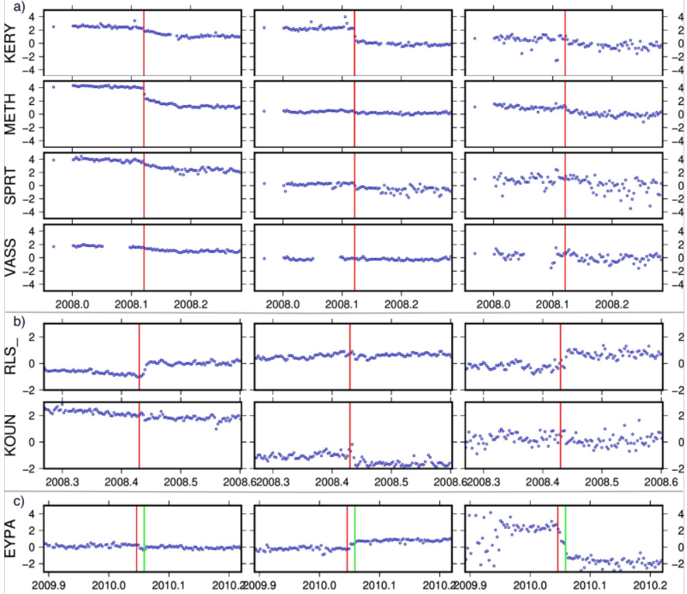
Figure F1 - Timeseries of daily position coordinates (E, N, Up) for a) Methoni b) Movri, and c) Efpalion earthquake events (2010/01/18, and 2010/01/22). The time of the main shock indicated with the red and green lines.

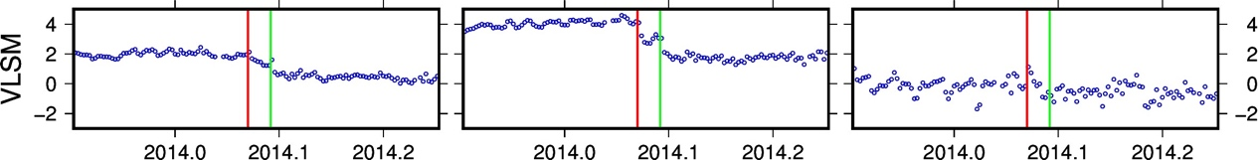
Figure F2 - Timeseries of daily position coordinates (E, N, Up) for Cephalonia earthquake events (2014-01-26 and 2014-02-03). The time of the main shock indicated with the red and green lines.
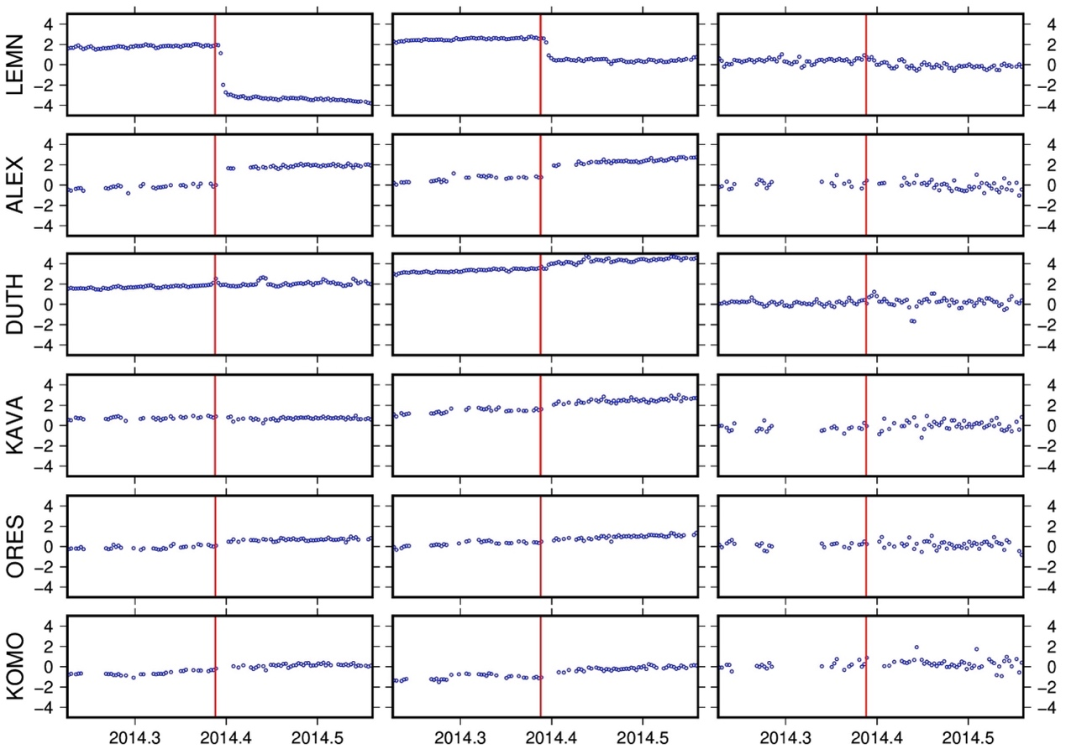
Figure F3 - Timeseries of daily position coordinates (E, N, Up) for Samothraki earthquake event. The time of the main shock indicated with the red lines.

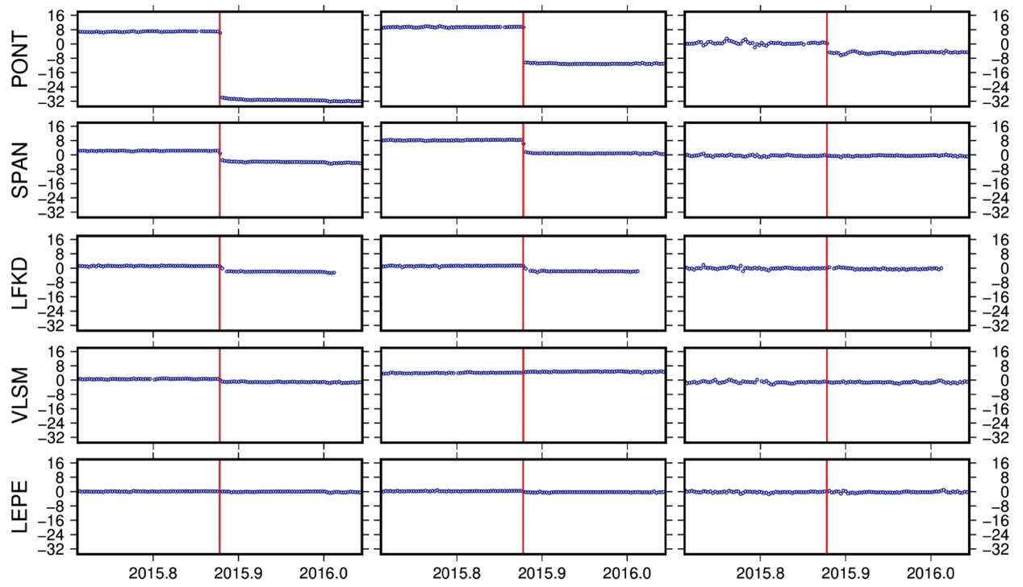
Figure F4 - Timeseries of daily position coordinates (E, N, Up) for Lefkada earthquake event. The time of the main shock indicated with the red lines.

