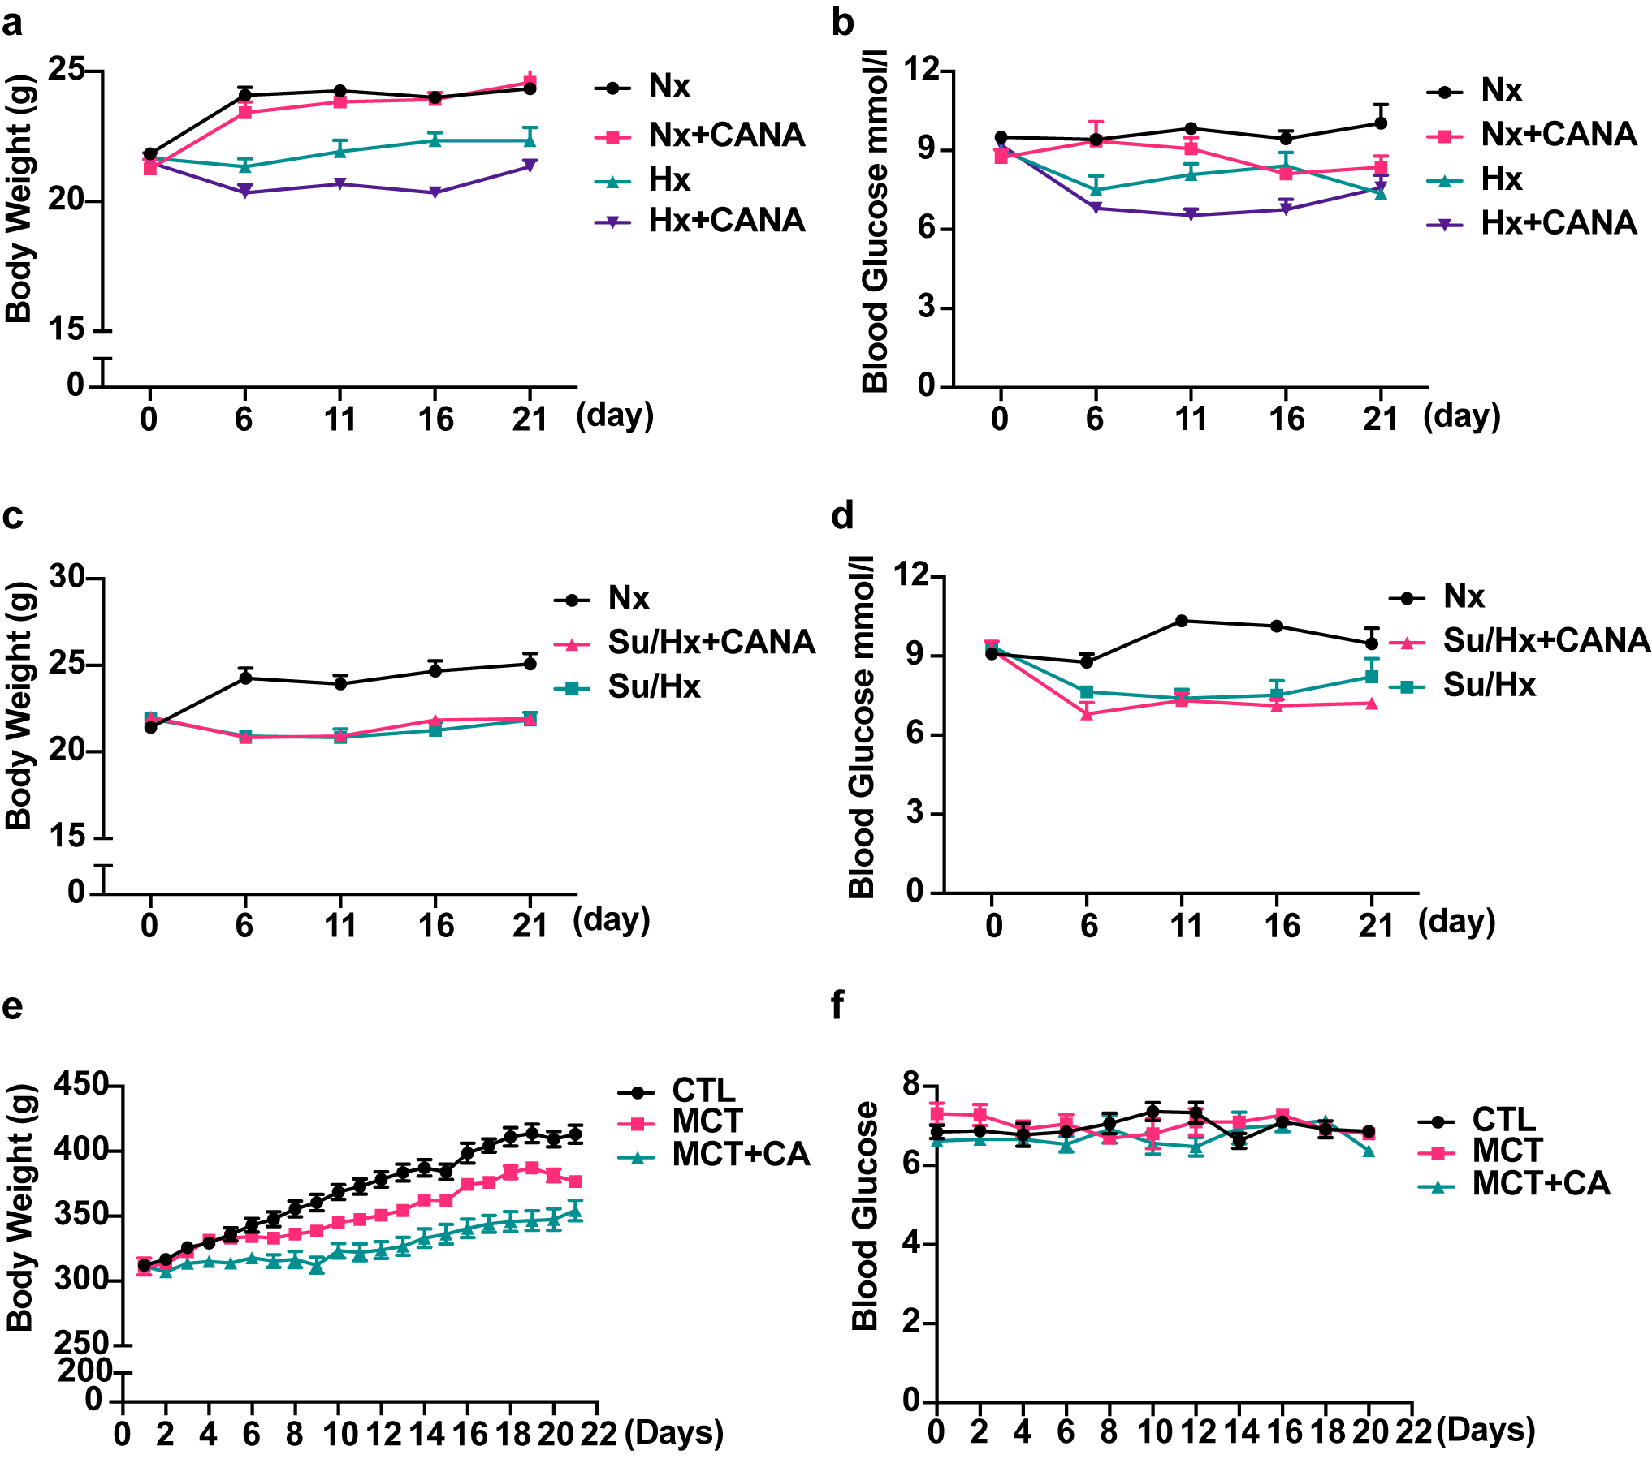
Figure S1 The body weight and blood glucose level in PH models. (a) The change of body weight of Nx, Nx+CANA, Hx, and Hx+CANA group mice. (b) The change of blood glucose of Nx, Nx+CANA, Hx, and Hx+CANA group mice. (c) The change of body weight of Nx, Su/Hx, and Su/Hx+CANA group mice. (d) The change of blood glucose of Nx, Su/Hx, and Su/Hx+CANA group mice. (e) The change of body weight of CTL, MCT, and MCT+CANA group rats. (f) The change of blood glucose of CTL, MCT, and MCT+CANA group rats.

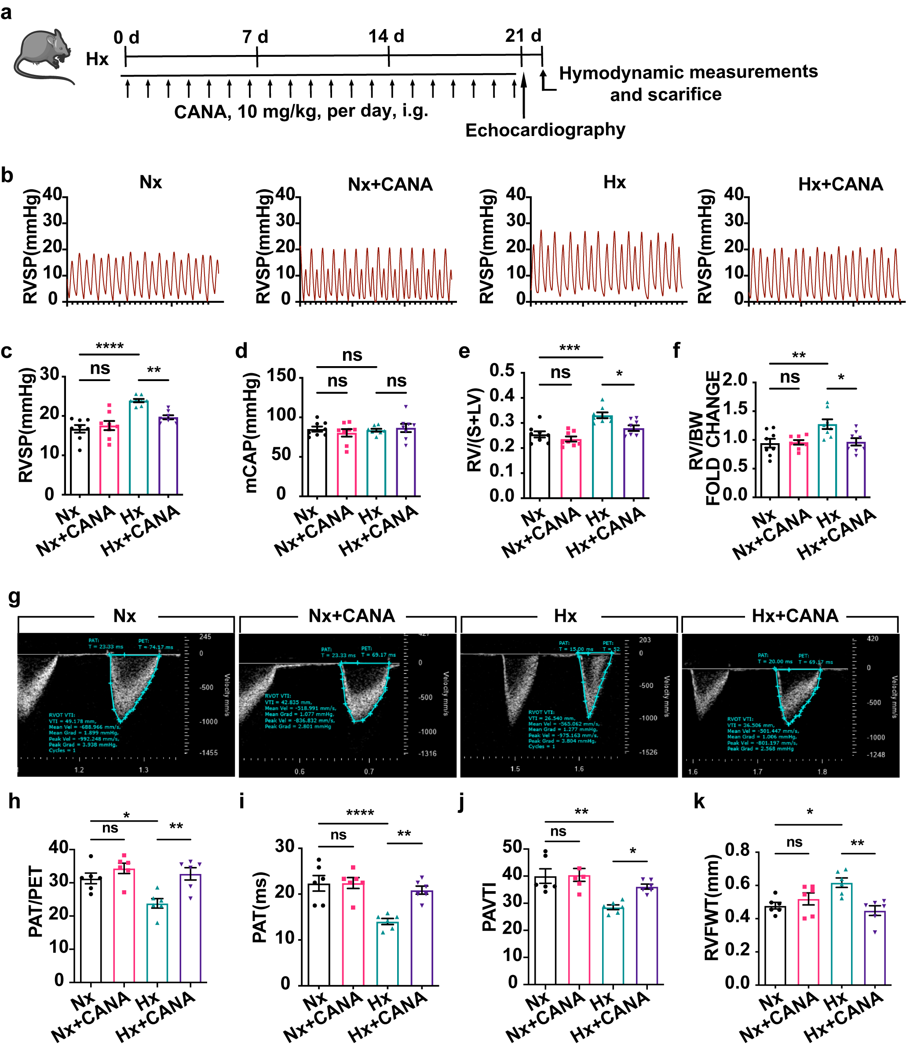
Figure S2 CANA alleviates hemodynamic and right ventricular hypertrophy in Hx-induced mouse PH. (a) Flowchart for Hx-induced PH model establishment. (b) Representative images of RVSP waves in Nx, Nx+CANA, Hx, and Hx+CANA groups. (c) Quantitative analysis of the RVSP of each group as shown in (b) (n = 8 per group). (d) Quantitative analysis of the mCAP in these groups (n = 8 per group). (e-f) Quantitative analysis of RV/(S+LV) (e) and RV/WT (f) in these groups (n = 8 per group). (g) Echocardiographic images illustrating PAT, PET and PAVTI in Nx, Nx+CANA, Hx, and Hx+CANA groups. (h-k) Echocardiographic measurements illustrating PAT/PET (h), PAT (i), PAVTI (j) and RVFWT (k) of each group as shown in (g) (n = 6 per group). ^{ns}P > 0.05, *P < 0.05, **P < 0.01, ***P < 0.001, ****P < 0.0001.
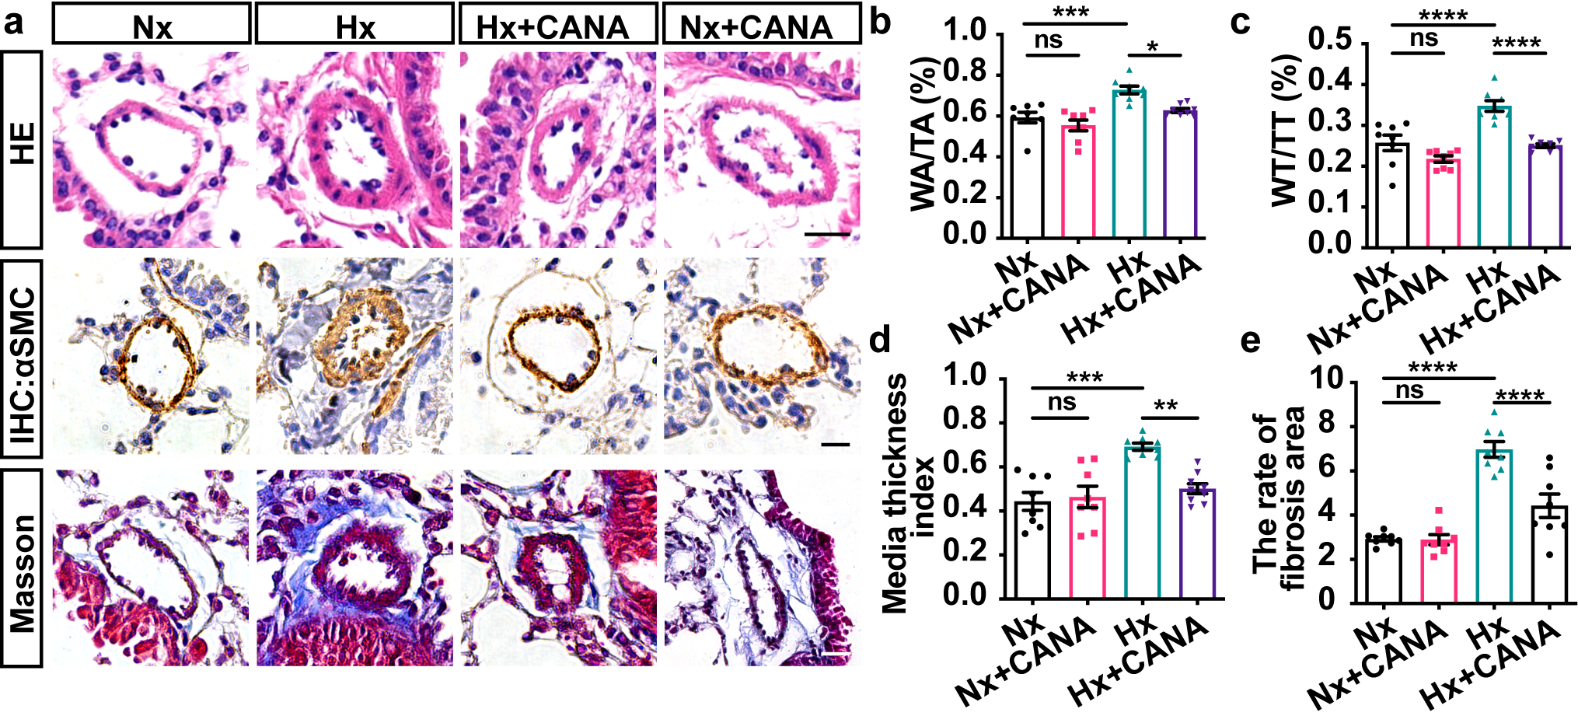
Figure S3 CANA alleviates pulmonary vascular remodeling in Hx-induced mouse PH. (a) Representative images of H&E staining, immunofluorescence and Masson staining in Nx, Nx+CANA, Hx, and Hx+CANA groups. (b-e) Quantitative analysis of WA/TA (%) (b), WT/TT (%) (c), media thickness index (d), and the rate of fibrosis are (e) of each group as shown in (a). n=8 mice per group, the results of each dot were quantified as means in randomly selected at least 5 fields per mouse. ^{ns}P > 0.05, *P < 0.05, **P < 0.01, ***P < 0.001, ****P < 0.0001. Scale bars = 20 µm.

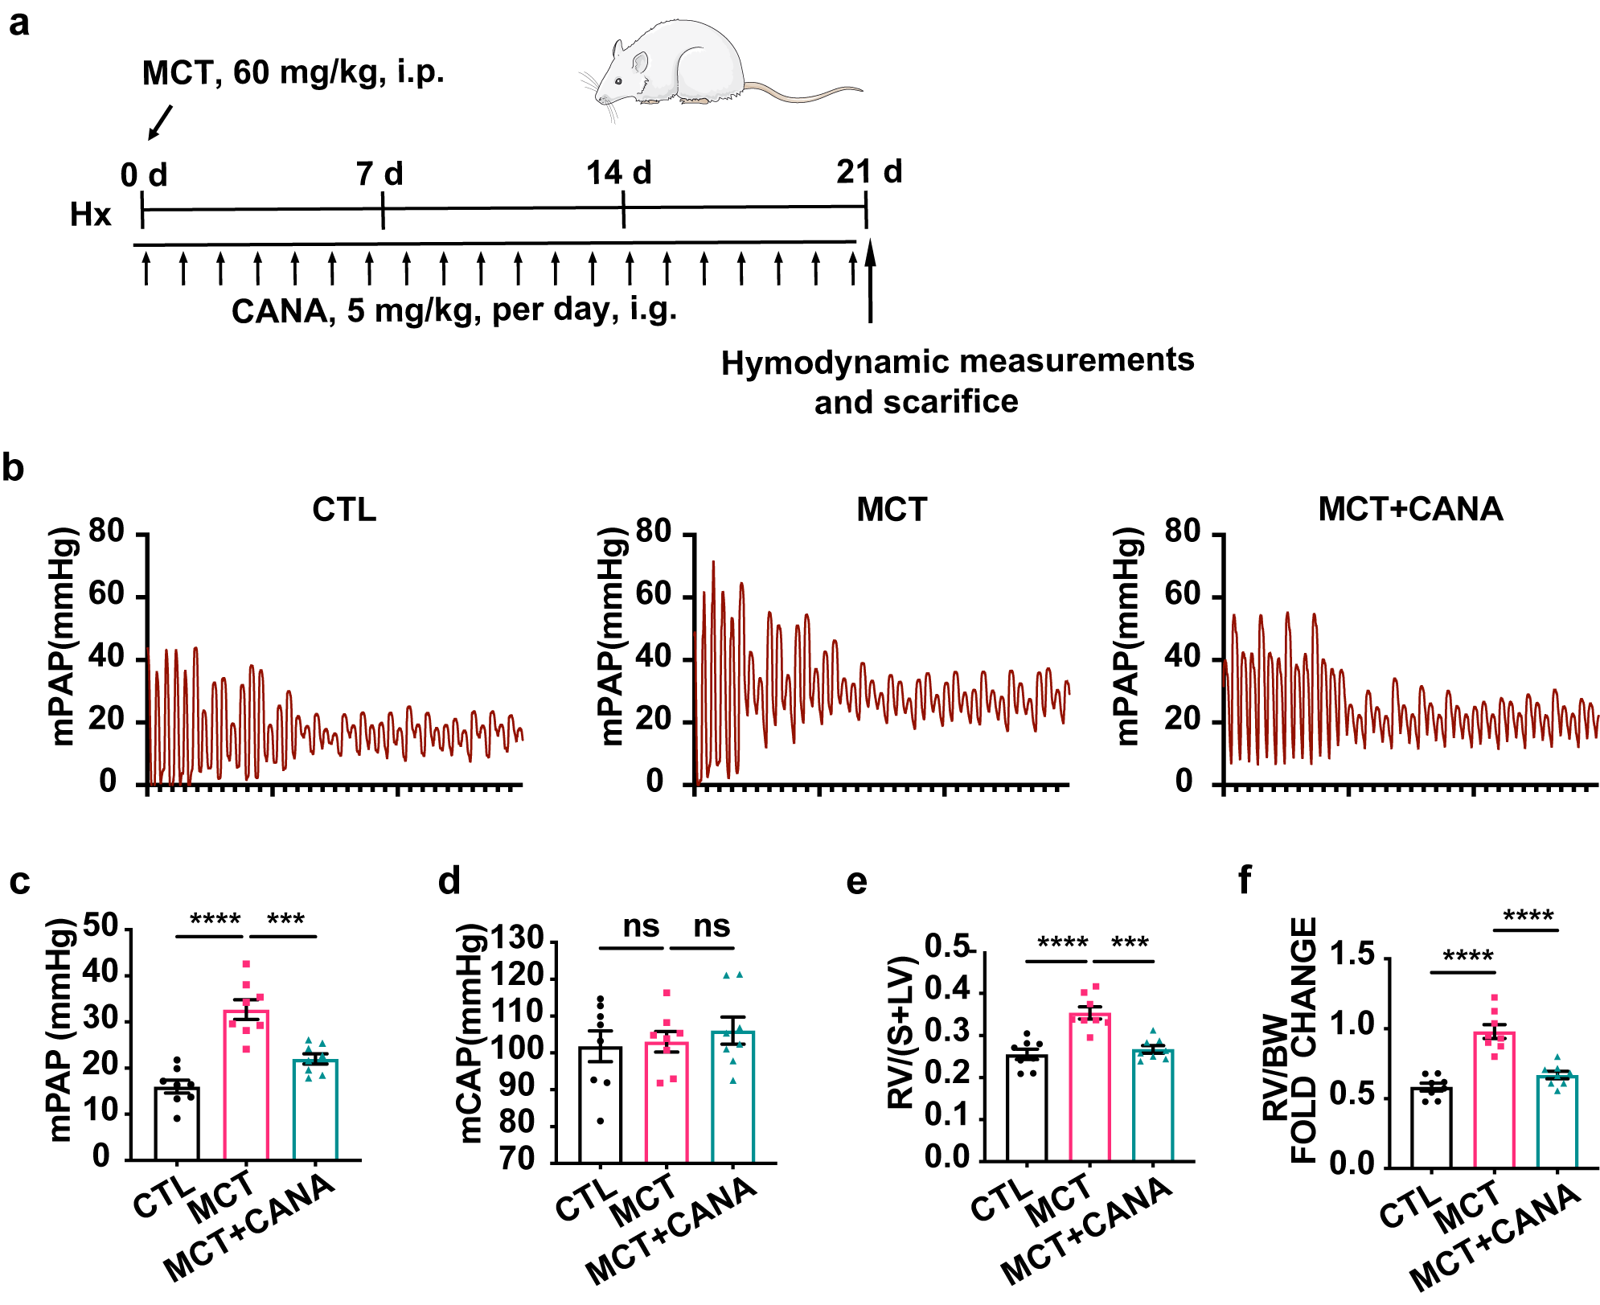
Figure S4 CANA alleviates hemodynamic and right ventricular hypertrophy in MCT-induced rat PH. (a) Flowchart for MCT-induced PH model establishment. (b) Representative images of mPAP waves in CTL, MCT, and MCT+CANA groups. (c) Quantitative analysis of the RVSP of each group as shown in (b) (n = 8 per group). (d) Quantitative analysis of the mCAP in these groups (n = 8 per group). (e-f) Quantitative analysis of RV/(S+LV) (e) and RV/WT (f) in these groups (n = 8 per group). ^{ns}P > 0.05, ***P < 0.001, ****P < 0.0001.

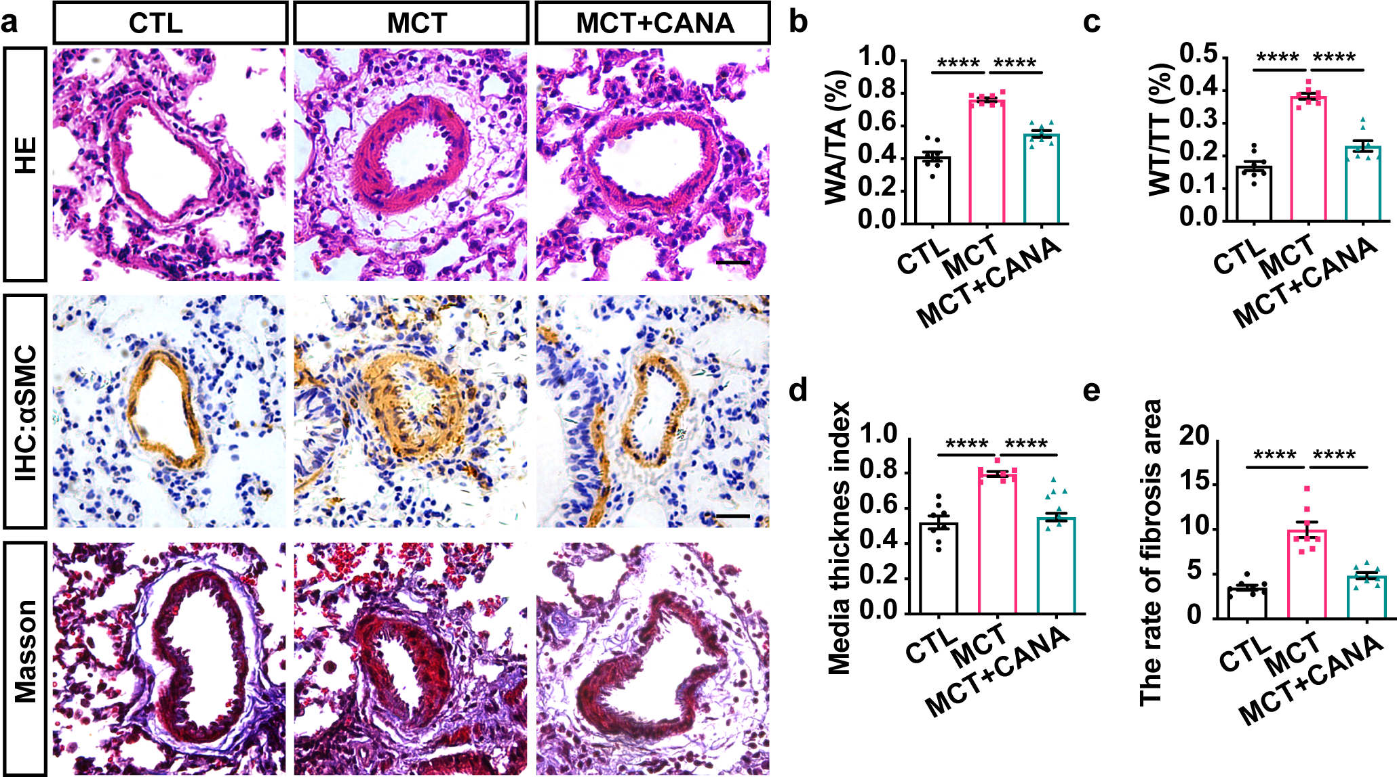
Figure S5 CANA alleviates pulmonary vascular remodeling in MCT-induced rat PH. (a) Representative images of H&E staining, immunofluorescence and Masson staining in CTL, MCT, and MCT+CANA groups. (b-e) Quantitative analysis of WA/TA (%) (b), WT/TT (%) (c), media thickness index (d), and the rate of fibrosis are (e) of each group as shown in (a). n=8 mice per group, the results of each dot were quantified as means in randomly selected at least 5 fields per mouse. ****P < 0.0001. Scale bars = 20 µm.

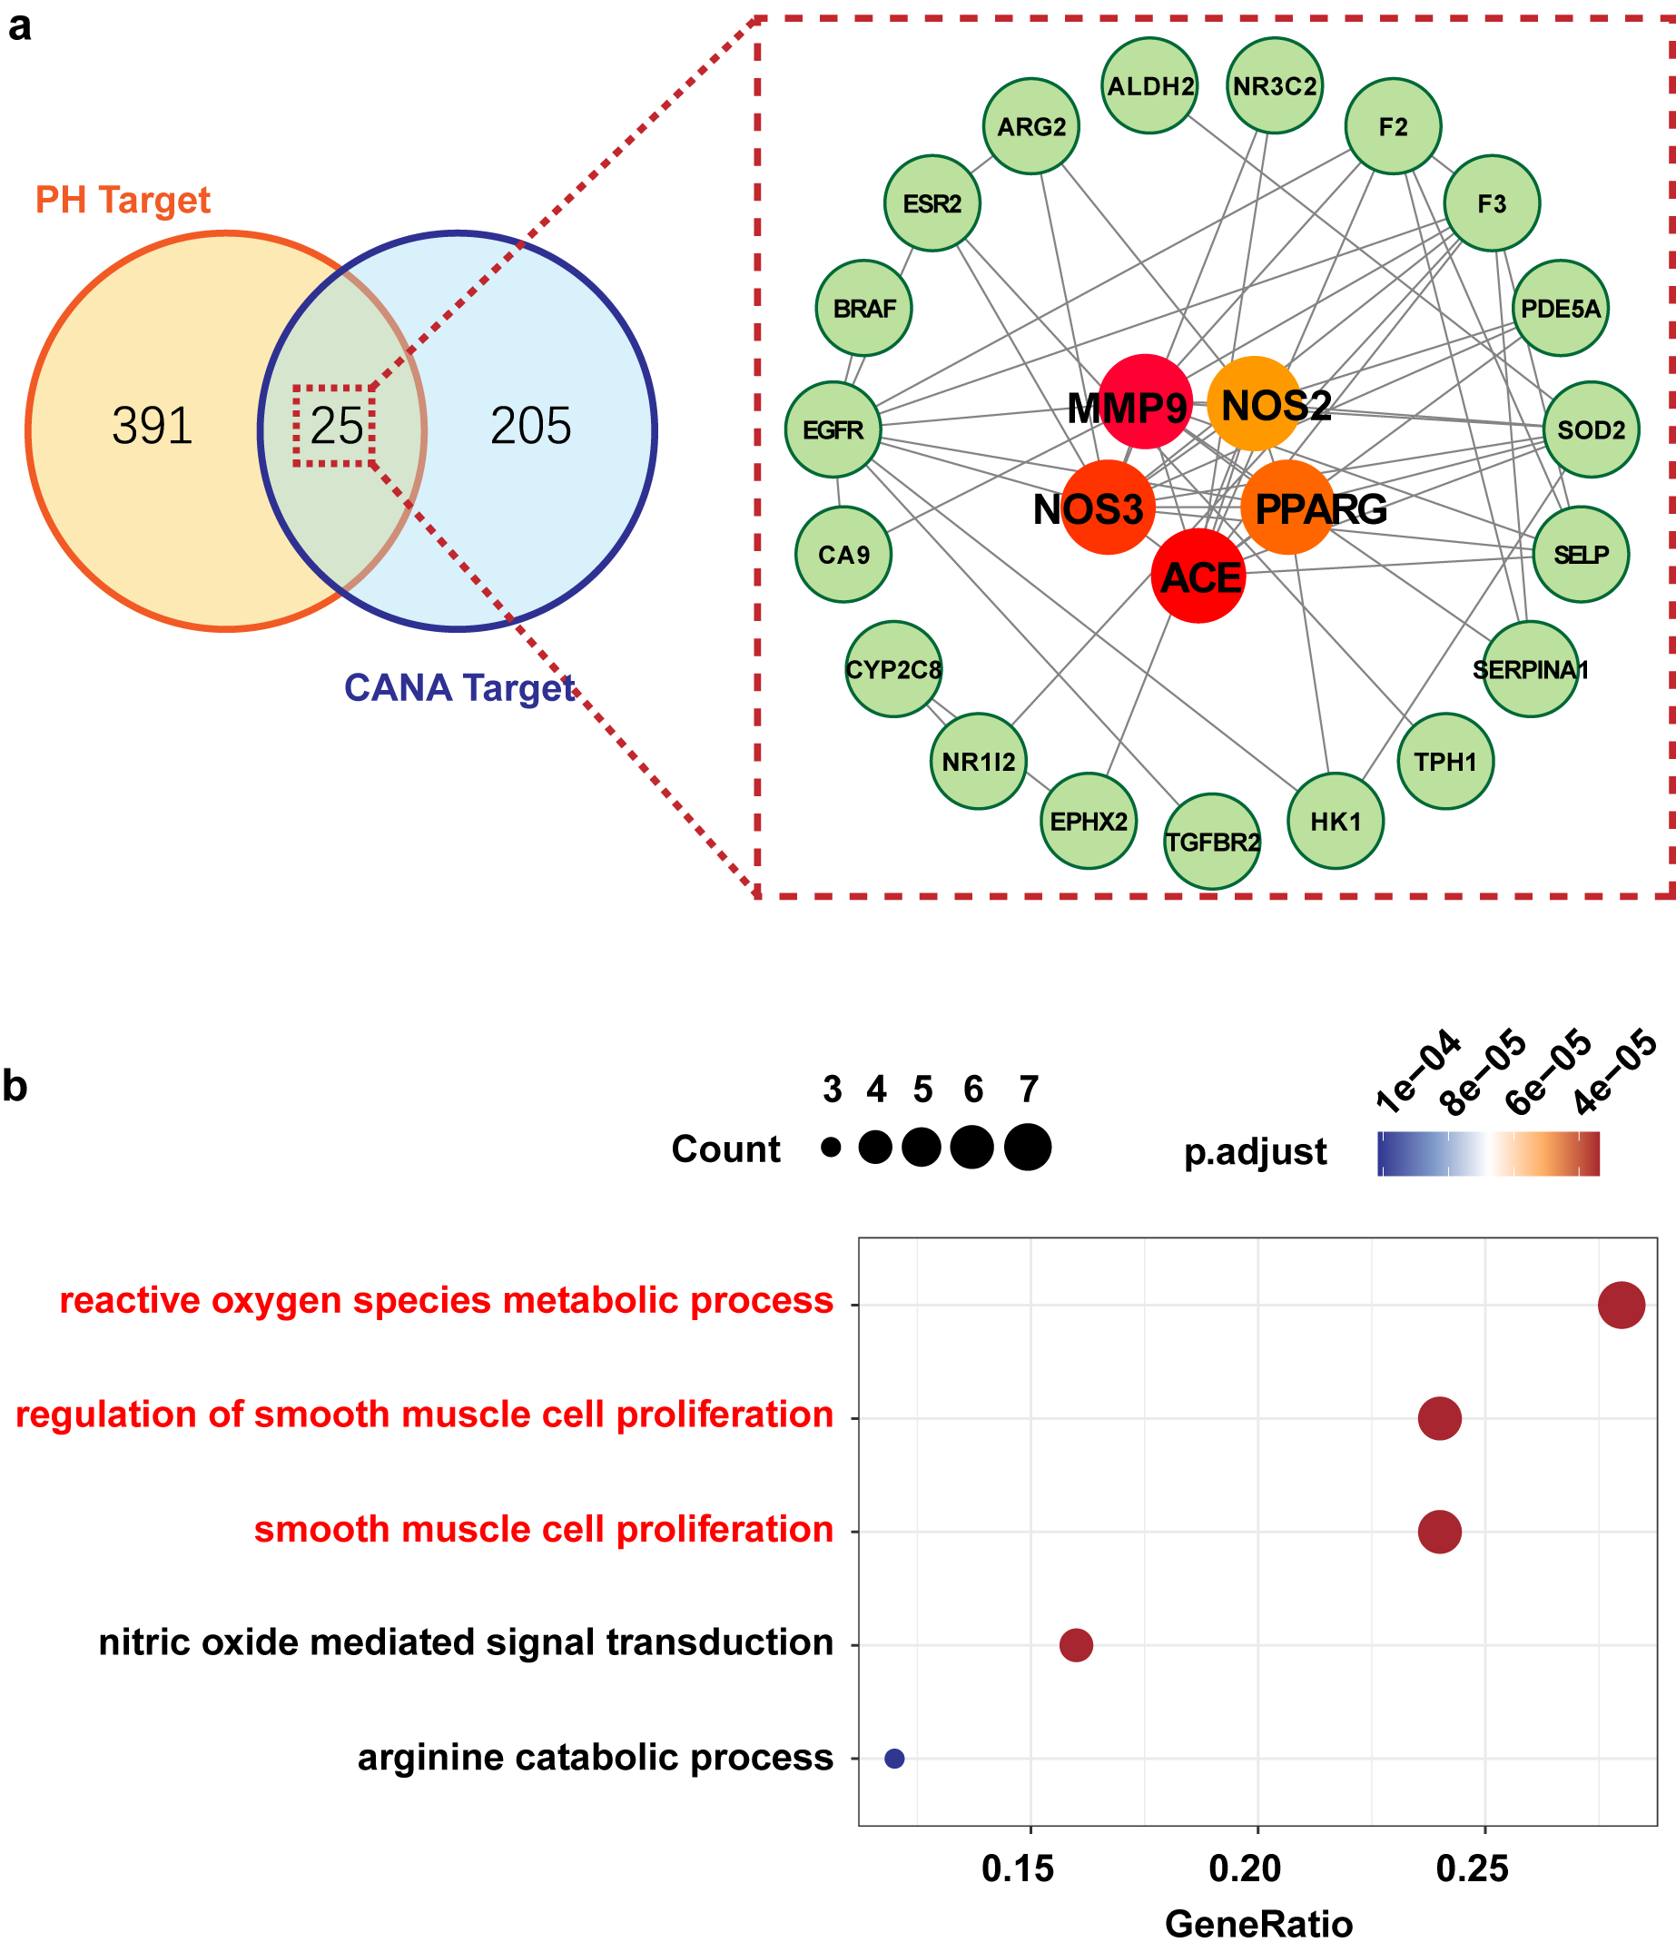
Figure S6 Network pharmacology reveals the mechanism of CANA on PH. (a) Left panel: Venn diagram showed the intersection (25) of PH targets (416) and CANA targets (230). Right panel: PPI network of 25 intersecting genes, and the 5 core genes are located in the center. (b) GO analysis of these 25 intersecting genes.

Supplementary. Table 1. The antibodies used in this study.
Antibody | Source | Identifier | ratio | application
αSMC | Santa | sc-32251 | 1:400 | IHC
PPARγ | Abcam | ab272718 | 1:1000 | WB
PCNA | CST | #13110 | 1:1000 | WB
β-ACTIN | CST | #4970 | 1:1000 | WB
p-S253-PPARγ | HuaAn bio | / | 1:1000 | WB
Ki67 | Abcam | ab16667 | 1:250 | IF
Flag | Abcam | ab205606 | 1:250 | IF
goat anti-rabbit IgG | Abcam | ab205718 | 1:10000 | WB
Donkey anti-Rabbit IgG (H+L) Highly Cross-Adsorbed Secondary Antibody, Alexa Fluor™ 488 | Invitrogen | A21206 | 1:1000 | IF

Supplementary. Table 2. The primers used for qPCR and cell transfection.
Gene | Species | Primers | Sequence (5’→3’)
NRF2 | Mouse | Forward primer | TCTTGGAGTAAGTCGAGAAGTGT
NRF2 | Mouse | Reverse primer | GTTGAAACTGAGCGAAAAAGGC
CAT | Mouse | Forward primer | AGCGACCAGATGAAGCAGTG
CAT | Mouse | Reverse primer | TCCGCTCTCTGTCAAAGTGTG
HO-1 | Mouse | Forward primer | AAGCCGAGAATGCTGAGTTCA
HO-1 | Mouse | Reverse primer | GCCGTGTAGATATGGTACAAGGA
PPARγ | Mouse | Forward primer | TCGCTGATGCACTGCCTATG
PPARγ | Mouse | Reverse primer | GAGAGGTCCACAGAGCTGATT
NOX4 | Mouse | Forward primer | GAAGGGGTTAAACACCTCTGC
NOX4 | Mouse | Reverse primer | ATGCTCTGCTTAAACACAATCCT
PGC1α | Mouse | Forward primer | TATGGAGTGACATAGAGTGTGCT
PGC1α | Mouse | Reverse primer | CCACTTCAATCCACCCAGAAAG
SOD2 | Mouse | Forward primer | CAGACCTGCCTTACGACTATGG
SOD2 | Mouse | Reverse primer | CTCGGTGGCGTTGAGATTGTT
β-ACTIN | Mouse | Forward primer | ACTGCCGCATCCTCTTCCTC
β-ACTIN | Mouse | Reverse primer | AACCGCTCGTTGCCAATAGTG
si-PPARγ-1 | Rat | AGGAAAGACAACAGACAAATT
si-PPARγ-2 | Rat | GCAAGAGAUCACAGAGUAUTT
si-PPARγ-3 | Rat | GGACAAGGAUUCAUGACCATT
PPARγ WT | Rat | GACGGATCGGGAGATCTCCCGATCCCCTATGGTGCACTCTCAGTACAATCTGCTCTGATGCCGCATAGTTAAGCCAGTAT  CTGCTCCCTGCTTGTGTGTTGGAGGTCGCTGAGTAGTGCGCGAGCAAAATTTAAGCTACAACAAGGCAAGGCTTGACCGA  CAATTGCATGAAGAATCTGCTTAGGGTTAGGCGTTTTGCGCTGCTTCGCGATGTACGGGCCAGATATACGCGTTGACATT  GATTATTGACTAGTTATTAATAGTAATCAATTACGGGGTCATTAGTTCATAGCCCATATATGGAGTTCCGCGTTACATAA  CTTACGGTAAATGGCCCGCCTGGCTGACCGCCCAACGACCCCCGCCCATTGACGTCAATAATGACGTATGTTCCCATAGT  AACGCCAATAGGGACTTTCCATTGACGTCAATGGGTGGAGTATTTACGGTAAACTGCCCACTTGGCAGTACATCAAGTGT  ATCATATGCCAAGTACGCCCCCTATTGACGTCAATGACGGTAAATGGCCCGCCTGGCATTATGCCCAGTACATGACCTTA  TGGGACTTTCCTACTTGGCAGTACATCTACGTATTAGTCATCGCTATTACCATGGTGATGCGGTTTTGGCAGTACATCAA  TGGGCGTGGATAGCGGTTTGACTCACGGGGATTTCCAAGTCTCCACCCCATTGACGTCAATGGGAGTTTGTTTTGGCACC  AAAATCAACGGGACTTTCCAAAATGTCGTAACAACTCCGCCCCATTGACGCAAATGGGCGGTAGGCGTGTACGGTGGGAG  GTCTATATAAGCAGAGCTCTCTGGCTAACTAGAGAACCCACTGCTTACTGGCTTATCGAAATTAATACGACTCACTATAG  GGAGACCCAAGCTGGCTAGTTAAGCTTGGTACCGAGCTCGGATCCGCCACCatggttgacacagagatgccattctggcc  caccaacttcggaatcagctctgtggacctctctgtgatggatgaccactcccattcctttgacatcaaaccctttacca  cggttgatttctccagcatttctgctccacactatgaagacatcccgttcacaagagctgacccaatggttgctgattac  aaatatgacctgaagctccaagaataccaaagtgcgatcaaagtagagcctgcgtccccgccttattattctgaaaaaac  ccaactctacaacaggccacatgaagagccttcaaactccctcatggccatcgagtgccgagtctgtggggataaagcat  caggcttccactatggagtccatgcttgtgaaggatgcaagggttttttccgaagaaccatccgattgaagcttatttat  gataggtgtgatcttaactgtcggatccacaaaaagagtagaaataaatgtcagtactgtcggtttcagaagtgccttgc  tgtggggatgtctcacaatgccatcaggtttgggcgaatgccacaggccgagaaggagaagctgttggcggagatctcca  gtgatatcgaccagctgaacccagagtctgctgatctgcgagccctggcaaagcatttgtatgactcatacataaagtcc  ttcccgctgaccaaagccaaggcgagggcgatcttgacaggaaagacaacagacaaatcaccatttgtcatctacgacat  gaattccttaatgatgggagaagacaaaatcaagttcaaacatatcacccccctgcaggagcagagcaaagaggtggcca  tccgcatttttcaagggtgccagtttcgatccgtggaagctgtgcaagagatcacagagtatgccaaaaatatccctggt  ttcattaaccttgacttgaatgaccaagtgactctgctcaagtatggtgtccatgagatcatctacaccatgctggcctc  cctgatgaataaagatggagtcctcatatcagagggacaaggattcatgaccagggagttcctcaaaagcctgcggaagc  cctttggtgactttatggagcctaagtttgagtttgctgtgaagttcaatgcactggaattagatgacagtgacttggcc  atatttatagctgtcattattctcagtggagaccgcccaggcttgctgaacgtgaagcccatcgaggacatccaagacaa  cctgctgcaggccctggaactccagctgaagctgaaccacccggagtcctcccagctgttcgccaaggtgctccagaaga  tgacagacctcaggcagattgtcacagagcacgtgcagctactgcatgtgatcaagaagacggagacagatatgagcctt  caccctctgctccaggagatctacaaggacttgtatCTCGAGTCTAGAGGGCCCTTCGACTACAAAGACCATGACGGTGA  TTATAAAGATCATGACATCGACTACAAGGATGACGATGACAAGTGAGTTTAAACCCGCTGATCAGCCTCGACTGTGCCTT  CTAGTTGCCAGCCATCTGTTGTTTGCCCCTCCCCCGTGCCTTCCTTGACCCTGGAAGGTGCCACTCCCACTGTCCTTTCC  TAATAAAATGAGGAAATTGCATCGCATTGTCTGAGTAGGTGTCATTCTATTCTGGGGGGTGGGGTGGGGCAGGACAGCAA  GGGGGAGGATTGGGAAGACAATAGCAGGCATGCTGGGGATGCGGTGGGCTCTATGGCTTCTGAGGCGGAAAGAACCAGCT  GGGGCTCTAGGGGGTATCCCCACGCGCCCTGTAGCGGCGCATTAAGCGCGGCGGGTGTGGTGGTTACGCGCAGCGTGACC  GCTACACTTGCCAGCGCCCTAGCGCCCGCTCCTTTCGCTTTCTTCCCTTCCTTTCTCGCCACGTTCGCCGGCTTTCCCCG  TCAAGCTCTAAATCGGGGGCTCCCTTTAGGGTTCCGATTTAGTGCTTTACGGCACCTCGACCCCAAAAAACTTGATTAGG  GTGATGGTTCACGTAGTGGGCCATCGCCCTGATAGACGGTTTTTCGCCCTTTGACGTTGGAGTCCACGTTCTTTAATAGT  GGACTCTTGTTCCAAACTGGAACAACACTCAACCCTATCTCGGTCTATTCTTTTGATTTATAAGGGATTTTGCCGATTTC  GGCCTATTGGTTAAAAAATGAGCTGATTTAACAAAAATTTAACGCGAATTAATTCTGTGGAATGTGTGTCAGTTAGGGTG  TGGAAAGTCCCCAGGCTCCCCAGCAGGCAGAAGTATGCAAAGCATGCATCTCAATTAGTCAGCAACCAGGTGTGGAAAGT  CCCCAGGCTCCCCAGCAGGCAGAAGTATGCAAAGCATGCATCTCAATTAGTCAGCAACCATAGTCCCGCCCCTAACTCCG  CCCATCCCGCCCCTAACTCCGCCCAGTTCCGCCCATTCTCCGCCCCATGGCTGACTAATTTTTTTTATTTATGCAGAGGC  CGAGGCCGCCTCTGCCTCTGAGCTATTCCAGAAGTAGTGAGGAGGCTTTTTTGGAGGCCTAGGCTTTTGCAAAAAGCTCC  CGGGAGCTTGTATATCCATTTTCGGATCTGATCAAGAGACAGGATGAGGATCGTTTCGCATGATTGAACAAGATGGATTG  CACGCAGGTTCTCCGGCCGCTTGGGTGGAGAGGCTATTCGGCTATGACTGGGCACAACAGACAATCGGCTGCTCTGATGC  CGCCGTGTTCCGGCTGTCAGCGCAGGGGCGCCCGGTTCTTTTTGTCAAGACCGACCTGTCCGGTGCCCTGAATGAACTGC  AGGACGAGGCAGCGCGGCTATCGTGGCTGGCCACGACGGGCGTTCCTTGCGCAGCTGTGCTCGACGTTGTCACTGAAGCG  GGAAGGGACTGGCTGCTATTGGGCGAAGTGCCGGGGCAGGATCTCCTGTCATCTCACCTTGCTCCTGCCGAGAAAGTATC  CATCATGGCTGATGCAATGCGGCGGCTGCATACGCTTGATCCGGCTACCTGCCCATTCGACCACCAAGCGAAACATCGCA  TCGAGCGAGCACGTACTCGGATGGAAGCCGGTCTTGTCGATCAGGATGATCTGGACGAAGAGCATCAGGGGCTCGCGCCA  GCCGAACTGTTCGCCAGGCTCAAGGCGCGCATGCCCGACGGCGAGGATCTCGTCGTGACCCATGGCGATGCCTGCTTGCC  GAATATCATGGTGGAAAATGGCCGCTTTTCTGGATTCATCGACTGTGGCCGGCTGGGTGTGGCGGACCGCTATCAGGACA  TAGCGTTGGCTACCCGTGATATTGCTGAAGAGCTTGGCGGCGAATGGGCTGACCGCTTCCTCGTGCTTTACGGTATCGCC  GCTCCCGATTCGCAGCGCATCGCCTTCTATCGCCTTCTTGACGAGTTCTTCTGAGCGGGACTCTGGGGTTCGCGAAATGA  CCGACCAAGCGACGCCCAACCTGCCATCACGAGATTTCGATTCCACCGCCGCCTTCTATGAAAGGTTGGGCTTCGGAATC  GTTTTCCGGGACGCCGGCTGGATGATCCTCCAGCGCGGGGATCTCATGCTGGAGTTCTTCGCCCACCCCAACTTGTTTAT  TGCAGCTTATAATGGTTACAAATAAAGCAATAGCATCACAAATTTCACAAATAAAGCATTTTTTTCACTGCATTCTAGTT  GTGGTTTGTCCAAACTCATCAATGTATCTTATCATGTCTGTATACCGTCGACCTCTAGCTAGAGCTTGGCGTAATCATGG  TCATAGCTGTTTCCTGTGTGAAATTGTTATCCGCTCACAATTCCACACAACATACGAGCCGGAAGCATAAAGTGTAAAGC  CTGGGGTGCCTAATGAGTGAGCTAACTCACATTAATTGCGTTGCGCTCACTGCCCGCTTTCCAGTCGGGAAACCTGTCGT  GCCAGCTGCATTAATGAATCGGCCAACGCGCGGGGAGAGGCGGTTTGCGTATTGGGCGCTCTTCCGCTTCCTCGCTCACT  GACTCGCTGCGCTCGGTCGTTCGGCTGCGGCGAGCGGTATCAGCTCACTCAAAGGCGGTAATACGGTTATCCACAGAATC  AGGGGATAACGCAGGAAAGAACATGTGAGCAAAAGGCCAGCAAAAGGCCAGGAACCGTAAAAAGGCCGCGTTGCTGGCGT  TTTTCCATAGGCTCCGCCCCCCTGACGAGCATCACAAAAATCGACGCTCAAGTCAGAGGTGGCGAAACCCGACAGGACTA  TAAAGATACCAGGCGTTTCCCCCTGGAAGCTCCCTCGTGCGCTCTCCTGTTCCGACCCTGCCGCTTACCGGATACCTGTC  CGCCTTTCTCCCTTCGGGAAGCGTGGCGCTTTCTCATAGCTCACGCTGTAGGTATCTCAGTTCGGTGTAGGTCGTTCGCT  CCAAGCTGGGCTGTGTGCACGAACCCCCCGTTCAGCCCGACCGCTGCGCCTTATCCGGTAACTATCGTCTTGAGTCCAAC  CCGGTAAGACACGACTTATCGCCACTGGCAGCAGCCACTGGTAACAGGATTAGCAGAGCGAGGTATGTAGGCGGTGCTAC  AGAGTTCTTGAAGTGGTGGCCTAACTACGGCTACACTAGAAGAACAGTATTTGGTATCTGCGCTCTGCTGAAGCCAGTTA  CCTTCGGAAAAAGAGTTGGTAGCTCTTGATCCGGCAAACAAACCACCGCTGGTAGCGGTGGTTTTTTTGTTTGCAAGCAG  CAGATTACGCGCAGAAAAAAAGGATCTCAAGAAGATCCTTTGATCTTTTCTACGGGGTCTGACGCTCAGTGGAACGAAAA  CTCACGTTAAGGGATTTTGGTCATGAGATTATCAAAAAGGATCTTCACCTAGATCCTTTTAAATTAAAAATGAAGTTTTA  AATCAATCTAAAGTATATATGAGTAAACTTGGTCTGACAGTTACCAATGCTTAATCAGTGAGGCACCTATCTCAGCGATC  TGTCTATTTCGTTCATCCATAGTTGCCTGACTCCCCGTCGTGTAGATAACTACGATACGGGAGGGCTTACCATCTGGCCC  CAGTGCTGCAATGATACCGCGAGACCCACGCTCACCGGCTCCAGATTTATCAGCAATAAACCAGCCAGCCGGAAGGGCCG  AGCGCAGAAGTGGTCCTGCAACTTTATCCGCCTCCATCCAGTCTATTAATTGTTGCCGGGAAGCTAGAGTAAGTAGTTCG  CCAGTTAATAGTTTGCGCAACGTTGTTGCCATTGCTACAGGCATCGTGGTGTCACGCTCGTCGTTTGGTATGGCTTCATT  CAGCTCCGGTTCCCAACGATCAAGGCGAGTTACATGATCCCCCATGTTGTGCAAAAAAGCGGTTAGCTCCTTCGGTCCTC  CGATCGTTGTCAGAAGTAAGTTGGCCGCAGTGTTATCACTCATGGTTATGGCAGCACTGCATAATTCTCTTACTGTCATG  CCATCCGTAAGATGCTTTTCTGTGACTGGTGAGTACTCAACCAAGTCATTCTGAGAATAGTGTATGCGGCGACCGAGTTG  CTCTTGCCCGGCGTCAATACGGGATAATACCGCGCCACATAGCAGAACTTTAAAAGTGCTCATCATTGGAAAACGTTCTT  CGGGGCGAAAACTCTCAAGGATCTTACCGCTGTTGAGATCCAGTTCGATGTAACCCACTCGTGCACCCAACTGATCTTCA  GCATCTTTTACTTTCACCAGCGTTTCTGGGTGAGCAAAAACAGGAAGGCAAAATGCCGCAAAAAAGGGAATAAGGGCGAC  ACGGAAATGTTGAATACTCATACTCTTCCTTTTTCAATATTATTGAAGCATTTATCAGGGTTATTGTCTCATGAGCGGAT  ACATATTTGAATGTATTTAGAAAAATAAACAAATAGGGGTTCCGCGCACATTTCCCCGAAAAGTGCCACCTGACGTC
PPARγ S225A | Rat | GACGGATCGGGAGATCTCCCGATCCCCTATGGTGCACTCTCAGTACAATCTGCTCTGATGCCGCATAGTTAAGCCAGTAT  CTGCTCCCTGCTTGTGTGTTGGAGGTCGCTGAGTAGTGCGCGAGCAAAATTTAAGCTACAACAAGGCAAGGCTTGACCGA  CAATTGCATGAAGAATCTGCTTAGGGTTAGGCGTTTTGCGCTGCTTCGCGATGTACGGGCCAGATATACGCGTTGACATT  GATTATTGACTAGTTATTAATAGTAATCAATTACGGGGTCATTAGTTCATAGCCCATATATGGAGTTCCGCGTTACATAA  CTTACGGTAAATGGCCCGCCTGGCTGACCGCCCAACGACCCCCGCCCATTGACGTCAATAATGACGTATGTTCCCATAGT  AACGCCAATAGGGACTTTCCATTGACGTCAATGGGTGGAGTATTTACGGTAAACTGCCCACTTGGCAGTACATCAAGTGT  ATCATATGCCAAGTACGCCCCCTATTGACGTCAATGACGGTAAATGGCCCGCCTGGCATTATGCCCAGTACATGACCTTA  TGGGACTTTCCTACTTGGCAGTACATCTACGTATTAGTCATCGCTATTACCATGGTGATGCGGTTTTGGCAGTACATCAA  TGGGCGTGGATAGCGGTTTGACTCACGGGGATTTCCAAGTCTCCACCCCATTGACGTCAATGGGAGTTTGTTTTGGCACC  AAAATCAACGGGACTTTCCAAAATGTCGTAACAACTCCGCCCCATTGACGCAAATGGGCGGTAGGCGTGTACGGTGGGAG  GTCTATATAAGCAGAGCTCTCTGGCTAACTAGAGAACCCACTGCTTACTGGCTTATCGAAATTAATACGACTCACTATAG  GGAGACCCAAGCTGGCTAGTTAAGCTTGGTACCGAGCTCGGATCCGCCACCatggttgacacagagatgccattctggcc  caccaacttcggaatcagctctgtggacctctctgtgatggatgaccactcccattcctttgacatcaaaccctttacca  cggttgatttctccagcatttctgctccacactatgaagacatcccgttcacaagagctgacccaatggttgctgattac  aaatatgacctgaagctccaagaataccaaagtgcgatcaaagtagagcctgcgtccccgccttattattctgaaaaaac  ccaactctacaacaggccacatgaagagccttcaaactccctcatggccatcgagtgccgagtctgtggggataaagcat  caggcttccactatggagtccatgcttgtgaaggatgcaagggttttttccgaagaaccatccgattgaagcttatttat  gataggtgtgatcttaactgtcggatccacaaaaagagtagaaataaatgtcagtactgtcggtttcagaagtgccttgc  tgtggggatgtctcacaatgccatcaggtttgggcgaatgccacaggccgagaaggagaagctgttggcggagatctcca  gtgatatcgaccagctgaacccagagtctgctgatctgcgagccctggcaaagcatttgtatgactcatacataaaggCG  ttcccgctgaccaaagccaaggcgagggcgatcttgacaggaaagacaacagacaaatcaccatttgtcatctacgacat  gaattccttaatgatgggagaagacaaaatcaagttcaaacatatcacccccctgcaggagcagagcaaagaggtggcca  tccgcatttttcaagggtgccagtttcgatccgtggaagctgtgcaagagatcacagagtatgccaaaaatatccctggt  ttcattaaccttgacttgaatgaccaagtgactctgctcaagtatggtgtccatgagatcatctacaccatgctggcctc  cctgatgaataaagatggagtcctcatatcagagggacaaggattcatgaccagggagttcctcaaaagcctgcggaagc  cctttggtgactttatggagcctaagtttgagtttgctgtgaagttcaatgcactggaattagatgacagtgacttggcc  atatttatagctgtcattattctcagtggagaccgcccaggcttgctgaacgtgaagcccatcgaggacatccaagacaa  cctgctgcaggccctggaactccagctgaagctgaaccacccggagtcctcccagctgttcgccaaggtgctccagaaga  tgacagacctcaggcagattgtcacagagcacgtgcagctactgcatgtgatcaagaagacggagacagatatgagcctt  caccctctgctccaggagatctacaaggacttgtatCTCGAGTCTAGAGGGCCCTTCGACTACAAAGACCATGACGGTGA  TTATAAAGATCATGACATCGACTACAAGGATGACGATGACAAGTGAGTTTAAACCCGCTGATCAGCCTCGACTGTGCCTT  CTAGTTGCCAGCCATCTGTTGTTTGCCCCTCCCCCGTGCCTTCCTTGACCCTGGAAGGTGCCACTCCCACTGTCCTTTCC  TAATAAAATGAGGAAATTGCATCGCATTGTCTGAGTAGGTGTCATTCTATTCTGGGGGGTGGGGTGGGGCAGGACAGCAA  GGGGGAGGATTGGGAAGACAATAGCAGGCATGCTGGGGATGCGGTGGGCTCTATGGCTTCTGAGGCGGAAAGAACCAGCT  GGGGCTCTAGGGGGTATCCCCACGCGCCCTGTAGCGGCGCATTAAGCGCGGCGGGTGTGGTGGTTACGCGCAGCGTGACC  GCTACACTTGCCAGCGCCCTAGCGCCCGCTCCTTTCGCTTTCTTCCCTTCCTTTCTCGCCACGTTCGCCGGCTTTCCCCG  TCAAGCTCTAAATCGGGGGCTCCCTTTAGGGTTCCGATTTAGTGCTTTACGGCACCTCGACCCCAAAAAACTTGATTAGG  GTGATGGTTCACGTAGTGGGCCATCGCCCTGATAGACGGTTTTTCGCCCTTTGACGTTGGAGTCCACGTTCTTTAATAGT  GGACTCTTGTTCCAAACTGGAACAACACTCAACCCTATCTCGGTCTATTCTTTTGATTTATAAGGGATTTTGCCGATTTC  GGCCTATTGGTTAAAAAATGAGCTGATTTAACAAAAATTTAACGCGAATTAATTCTGTGGAATGTGTGTCAGTTAGGGTG  TGGAAAGTCCCCAGGCTCCCCAGCAGGCAGAAGTATGCAAAGCATGCATCTCAATTAGTCAGCAACCAGGTGTGGAAAGT  CCCCAGGCTCCCCAGCAGGCAGAAGTATGCAAAGCATGCATCTCAATTAGTCAGCAACCATAGTCCCGCCCCTAACTCCG  CCCATCCCGCCCCTAACTCCGCCCAGTTCCGCCCATTCTCCGCCCCATGGCTGACTAATTTTTTTTATTTATGCAGAGGC  CGAGGCCGCCTCTGCCTCTGAGCTATTCCAGAAGTAGTGAGGAGGCTTTTTTGGAGGCCTAGGCTTTTGCAAAAAGCTCC  CGGGAGCTTGTATATCCATTTTCGGATCTGATCAAGAGACAGGATGAGGATCGTTTCGCATGATTGAACAAGATGGATTG  CACGCAGGTTCTCCGGCCGCTTGGGTGGAGAGGCTATTCGGCTATGACTGGGCACAACAGACAATCGGCTGCTCTGATGC  CGCCGTGTTCCGGCTGTCAGCGCAGGGGCGCCCGGTTCTTTTTGTCAAGACCGACCTGTCCGGTGCCCTGAATGAACTGC  AGGACGAGGCAGCGCGGCTATCGTGGCTGGCCACGACGGGCGTTCCTTGCGCAGCTGTGCTCGACGTTGTCACTGAAGCG  GGAAGGGACTGGCTGCTATTGGGCGAAGTGCCGGGGCAGGATCTCCTGTCATCTCACCTTGCTCCTGCCGAGAAAGTATC  CATCATGGCTGATGCAATGCGGCGGCTGCATACGCTTGATCCGGCTACCTGCCCATTCGACCACCAAGCGAAACATCGCA  TCGAGCGAGCACGTACTCGGATGGAAGCCGGTCTTGTCGATCAGGATGATCTGGACGAAGAGCATCAGGGGCTCGCGCCA  GCCGAACTGTTCGCCAGGCTCAAGGCGCGCATGCCCGACGGCGAGGATCTCGTCGTGACCCATGGCGATGCCTGCTTGCC  GAATATCATGGTGGAAAATGGCCGCTTTTCTGGATTCATCGACTGTGGCCGGCTGGGTGTGGCGGACCGCTATCAGGACA  TAGCGTTGGCTACCCGTGATATTGCTGAAGAGCTTGGCGGCGAATGGGCTGACCGCTTCCTCGTGCTTTACGGTATCGCC  GCTCCCGATTCGCAGCGCATCGCCTTCTATCGCCTTCTTGACGAGTTCTTCTGAGCGGGACTCTGGGGTTCGCGAAATGA  CCGACCAAGCGACGCCCAACCTGCCATCACGAGATTTCGATTCCACCGCCGCCTTCTATGAAAGGTTGGGCTTCGGAATC  GTTTTCCGGGACGCCGGCTGGATGATCCTCCAGCGCGGGGATCTCATGCTGGAGTTCTTCGCCCACCCCAACTTGTTTAT  TGCAGCTTATAATGGTTACAAATAAAGCAATAGCATCACAAATTTCACAAATAAAGCATTTTTTTCACTGCATTCTAGTT  GTGGTTTGTCCAAACTCATCAATGTATCTTATCATGTCTGTATACCGTCGACCTCTAGCTAGAGCTTGGCGTAATCATGG  TCATAGCTGTTTCCTGTGTGAAATTGTTATCCGCTCACAATTCCACACAACATACGAGCCGGAAGCATAAAGTGTAAAGC  CTGGGGTGCCTAATGAGTGAGCTAACTCACATTAATTGCGTTGCGCTCACTGCCCGCTTTCCAGTCGGGAAACCTGTCGT  GCCAGCTGCATTAATGAATCGGCCAACGCGCGGGGAGAGGCGGTTTGCGTATTGGGCGCTCTTCCGCTTCCTCGCTCACT  GACTCGCTGCGCTCGGTCGTTCGGCTGCGGCGAGCGGTATCAGCTCACTCAAAGGCGGTAATACGGTTATCCACAGAATC  AGGGGATAACGCAGGAAAGAACATGTGAGCAAAAGGCCAGCAAAAGGCCAGGAACCGTAAAAAGGCCGCGTTGCTGGCGT  TTTTCCATAGGCTCCGCCCCCCTGACGAGCATCACAAAAATCGACGCTCAAGTCAGAGGTGGCGAAACCCGACAGGACTA  TAAAGATACCAGGCGTTTCCCCCTGGAAGCTCCCTCGTGCGCTCTCCTGTTCCGACCCTGCCGCTTACCGGATACCTGTC  CGCCTTTCTCCCTTCGGGAAGCGTGGCGCTTTCTCATAGCTCACGCTGTAGGTATCTCAGTTCGGTGTAGGTCGTTCGCT  CCAAGCTGGGCTGTGTGCACGAACCCCCCGTTCAGCCCGACCGCTGCGCCTTATCCGGTAACTATCGTCTTGAGTCCAAC  CCGGTAAGACACGACTTATCGCCACTGGCAGCAGCCACTGGTAACAGGATTAGCAGAGCGAGGTATGTAGGCGGTGCTAC  AGAGTTCTTGAAGTGGTGGCCTAACTACGGCTACACTAGAAGAACAGTATTTGGTATCTGCGCTCTGCTGAAGCCAGTTA  CCTTCGGAAAAAGAGTTGGTAGCTCTTGATCCGGCAAACAAACCACCGCTGGTAGCGGTGGTTTTTTTGTTTGCAAGCAG  CAGATTACGCGCAGAAAAAAAGGATCTCAAGAAGATCCTTTGATCTTTTCTACGGGGTCTGACGCTCAGTGGAACGAAAA  CTCACGTTAAGGGATTTTGGTCATGAGATTATCAAAAAGGATCTTCACCTAGATCCTTTTAAATTAAAAATGAAGTTTTA  AATCAATCTAAAGTATATATGAGTAAACTTGGTCTGACAGTTACCAATGCTTAATCAGTGAGGCACCTATCTCAGCGATC  TGTCTATTTCGTTCATCCATAGTTGCCTGACTCCCCGTCGTGTAGATAACTACGATACGGGAGGGCTTACCATCTGGCCC  CAGTGCTGCAATGATACCGCGAGACCCACGCTCACCGGCTCCAGATTTATCAGCAATAAACCAGCCAGCCGGAAGGGCCG  AGCGCAGAAGTGGTCCTGCAACTTTATCCGCCTCCATCCAGTCTATTAATTGTTGCCGGGAAGCTAGAGTAAGTAGTTCG  CCAGTTAATAGTTTGCGCAACGTTGTTGCCATTGCTACAGGCATCGTGGTGTCACGCTCGTCGTTTGGTATGGCTTCATT  CAGCTCCGGTTCCCAACGATCAAGGCGAGTTACATGATCCCCCATGTTGTGCAAAAAAGCGGTTAGCTCCTTCGGTCCTC  CGATCGTTGTCAGAAGTAAGTTGGCCGCAGTGTTATCACTCATGGTTATGGCAGCACTGCATAATTCTCTTACTGTCATG  CCATCCGTAAGATGCTTTTCTGTGACTGGTGAGTACTCAACCAAGTCATTCTGAGAATAGTGTATGCGGCGACCGAGTTG  CTCTTGCCCGGCGTCAATACGGGATAATACCGCGCCACATAGCAGAACTTTAAAAGTGCTCATCATTGGAAAACGTTCTT  CGGGGCGAAAACTCTCAAGGATCTTACCGCTGTTGAGATCCAGTTCGATGTAACCCACTCGTGCACCCAACTGATCTTCA  GCATCTTTTACTTTCACCAGCGTTTCTGGGTGAGCAAAAACAGGAAGGCAAAATGCCGCAAAAAAGGGAATAAGGGCGAC  ACGGAAATGTTGAATACTCATACTCTTCCTTTTTCAATATTATTGAAGCATTTATCAGGGTTATTGTCTCATGAGCGGAT  ACATATTTGAATGTATTTAGAAAAATAAACAAATAGGGGTTCCGCGCACATTTCCCCGAAAAGTGCCACCTGACGTC

