Figure S1. Laboratory methods comparison A) Comparison of Filter vs unfiltered grab samples showed no significant difference B) comparison of PEG and SMF showed modest improvement for detection by PEG for one sample. C) Samples concentrated with PEG and tested for SARS-CoV-2 using the CDC N1 RT-PCR assay over time (x-axis) and cycle threshold (y-axis) show the low viral loads of these samples. Phase 1 is in light blue and phase 2 is in dark blue

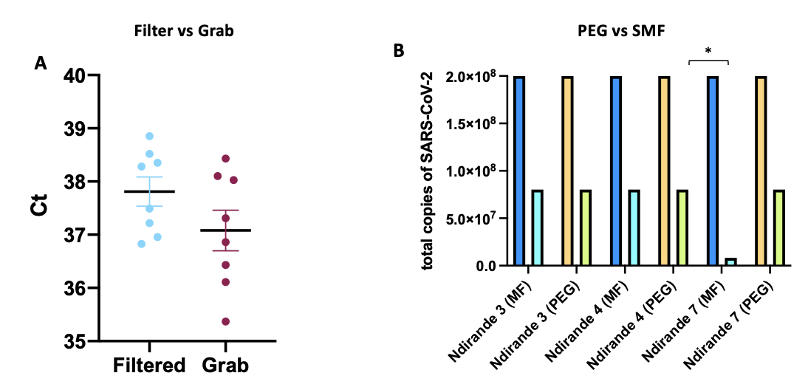
C

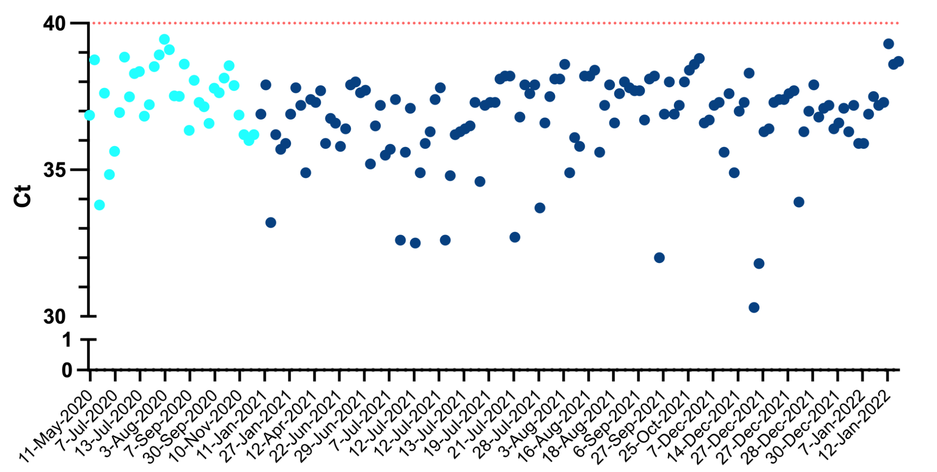

Figure S2. (left panel) ES detection rates at the estimated lag in red, with prevalence rates for each wave in black, (right panel) residual deviance by lag for each wave

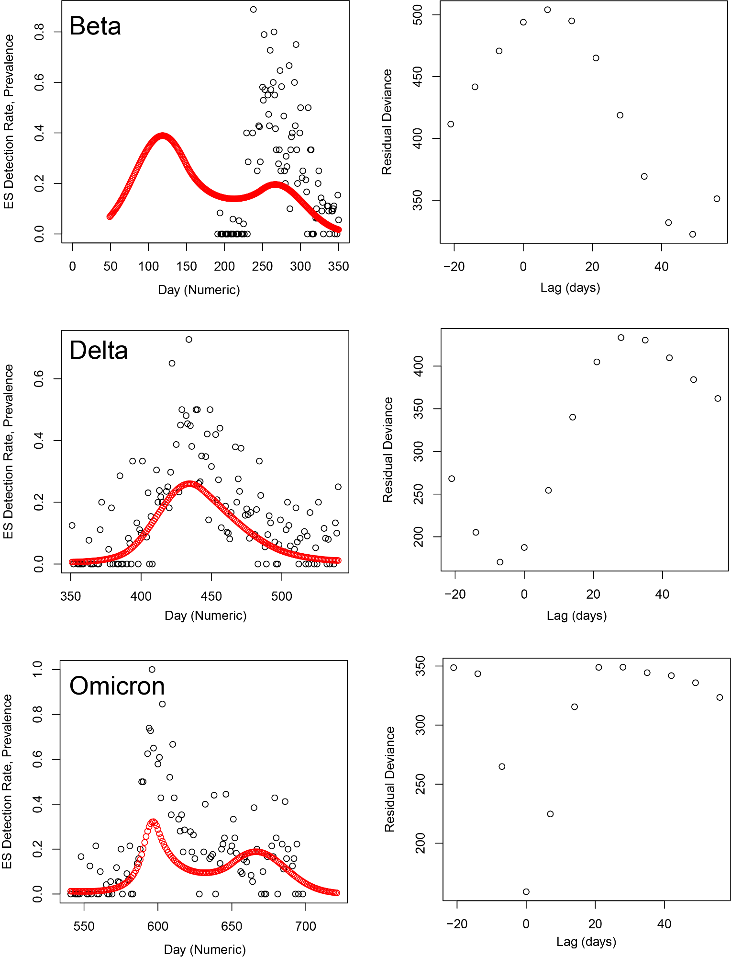

Figure S3. Predicted prevalence across ES detection rates for each modeled wave, where waves 1, 2, and 3 represent Beta, Delta, and Omicron, respectively.

Figure S4: 1,000 realizations from the multivariate normal distribution parameterized by the ES model, showing uncertainty in modeled ES detection rates.

Figure S5: Histogram of the p-values for ES waves 1-3, where waves 1, 2, and 3 represent Beta, Delta, and Omicron, respectively.

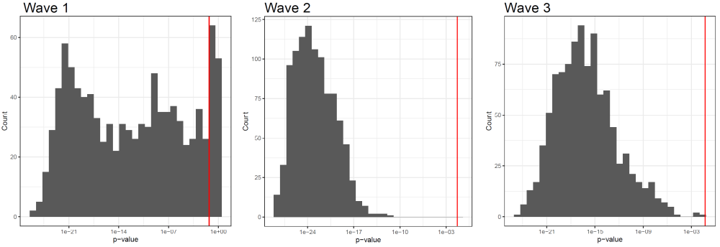

Figure S6. Estimates of lag time between ES and passive case (DHO) surveillance. Yellow represents the rolling average of ES positivity over time compared to passive case surveillance numbers (bar graph in gray) where the y-axis is total on number of positive cases per day. DHO data is over a fold higher in numbers than the active case data (Fig2) but low numbers of Delta compared to high numbers of Omicron could not be independently validated and may represent reporting issues. Spline analysis of both ES (red) and passive surveillance (black) show how closely linked peaks in both detection methods are over multiple waves.

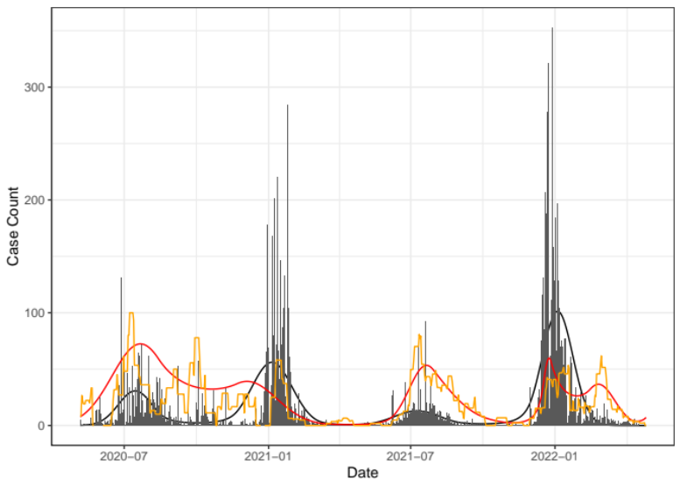

Figure S7. Sequencing Methods
A) Percentage genome coverage (y-axis) for ARTIC+Minion method vs EasySeq+Illumina method for all samples B) Percentage genome coverage (y-axis) for ARTIC+Minion (blue) method vs EasySeq+Illumina method (red) per matched sample
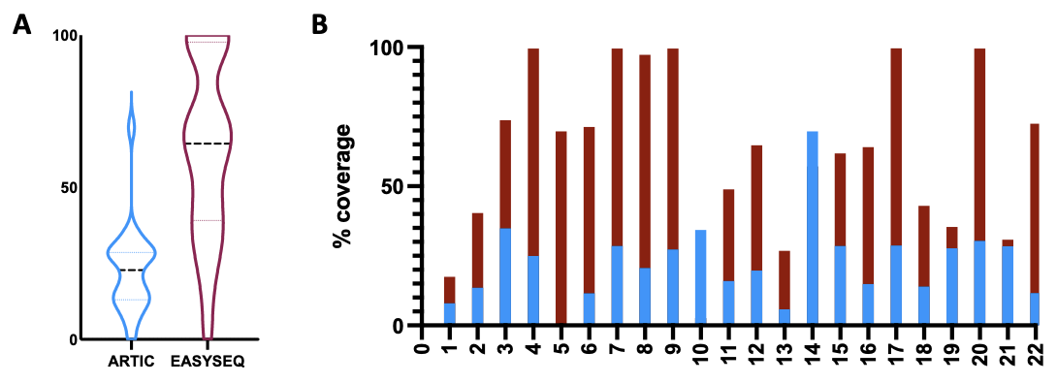

Figure S8. Deeper analysis of Sept 2021 genome with possible contamination A) Detailed analysis of Sept-2021 Omicron signatures in one sample with similar mutations to a patient (EPI_ISL) shown in green. The number of identical mutations is higher than by chance showing evidence for likely contamination of the wastewater sample. B) is the same sample sequenced from the original wastewater shows no contamination and the addition of the BA.2/BA.4 mutations.

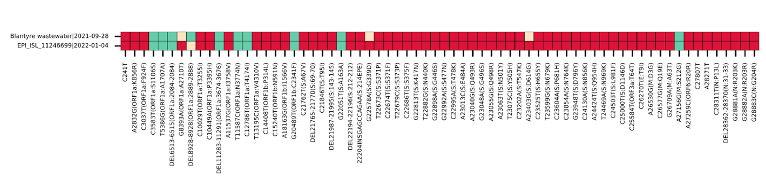
A∫
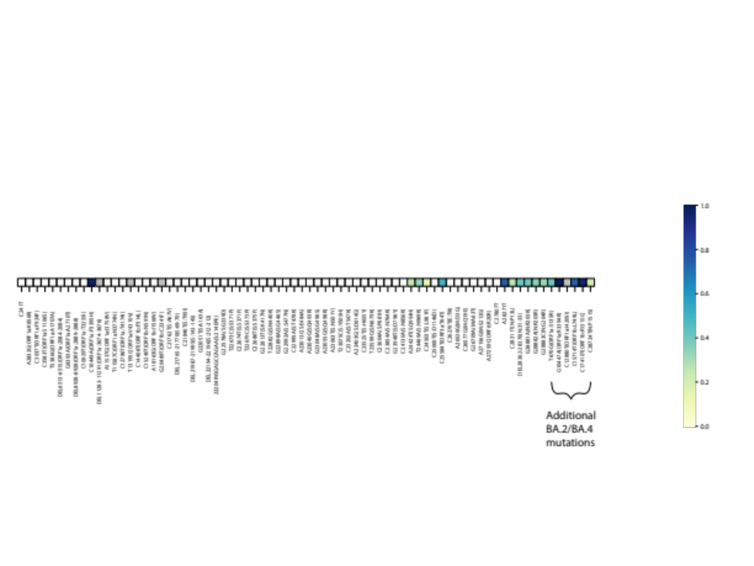
B

Figure S9. Maximum likelihood phylogenetic trees for Delta show ES samples from Malawi (in blue) cluster mainly with patient samples from Malawi South Africa and Kenya
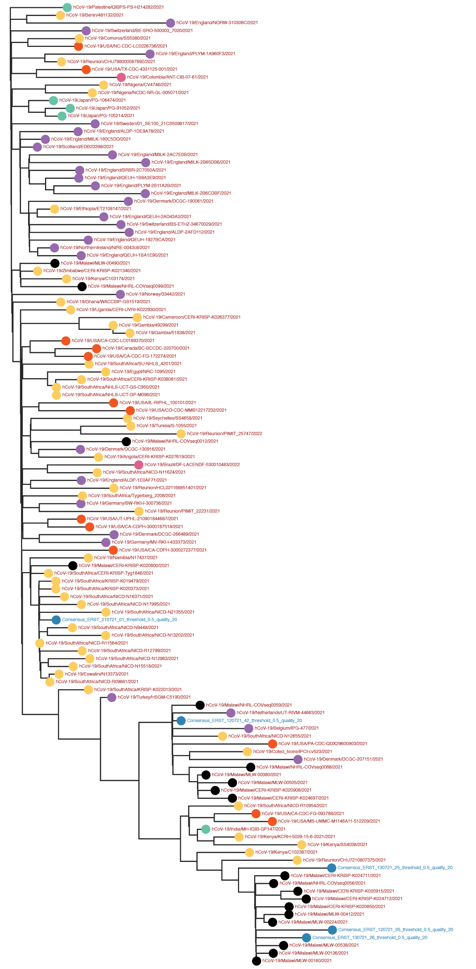
Table S1. All sample site information. All site names, areas, site type, location and collection numbers and positivity
Site Name | Area of Blantyre | Site type | GPS.Lat | GPS.Lon | Total samples | positive samples | % Positivity
Bangwe 1 | Bangwe | river | -15.82913 | 35.07536 | 2 | 0 | 0
Bangwe 2 | Bangwe | river | -15.83230 | 35.08310 | 4 | 0 | 0
Bangwe 3 | Bangwe | river | -15.82823 | 35.08589 | 3 | 0 | 0
Bangwe 4 | Bangwe | river | -15.82450 | 35.08550 | 4 | 0 | 0
Bangwe 6 | Bangwe | river | -15.81449 | 35.09437 | 2 | 0 | 0
Bangwe 7 | Bangwe | river | -15.81240 | 35.09630 | 2 | 0 | 0
Bangwe 8 | Bangwe | river | -15.80729 | 35.10067 | 3 | 0 | 0
Bangwe 5 | Bangwe | river | -15.81993 | 35.08767 | 5 | 1 | 20
Chilomoni 1 | Chilomoni | river | -15.75908 | 34.98742 | 22 | 0 | 0
Chilomoni 10 | Chilomoni | river | -15.77864 | 34.97572 | 13 | 0 | 0
Chilomoni 2 | Chilomoni | river | -15.76050 | 34.98650 | 21 | 0 | 0
Chilomoni 5 | Chilomoni | river | -15.75750 | 34.97960 | 19 | 0 | 0
Chilomoni 6 | Chilomoni | river | -15.75900 | 34.97820 | 20 | 0 | 0
Chilomoni 7 | Chilomoni | river | -15.76520 | 34.98400 | 20 | 0 | 0
Chilomoni 11 | Chilomoni | river | -15.77974 | 34.97757 | 22 | 1 | 4.5
Chilomoni 4 | Chilomoni | river | -15.75522 | 34.98094 | 25 | 4 | 16
Chirimba 9 | Chirimba | river | -15.74435 | 34.99927 | 28 | 1 | 3.6
Chirimba 3 | Chirimba | river | -15.73533 | 35.01666 | 26 | 1 | 3.8
Chirimba 6 | Chirimba | river | -15.74302 | 35.00324 | 23 | 1 | 4.3
Chirimba 2 | Chirimba | river | -15.73839 | 35.02107 | 19 | 2 | 10.5
Chirimba 4 | Chirimba | river | -15.72923 | 35.01555 | 15 | 2 | 13.3
Golf Course | Golf Course | river | -15.79220 | 34.99760 | 15 | 4 | 26.7
Kwacha/Chinyonga | Kwacha/Chinyonga | river | -15.80928 | 35.04114 | 23 | 4 | 17.4
Manase 2 | Manase | river | -15.80696 | 34.98903 | 41 | 1 | 2.4
Manase 1 | Manase | river | -15.80458 | 34.99352 | 32 | 2 | 6.3
Manase 5 | Manase | river | -15.80200 | 34.98760 | 14 | 2 | 14.3
Manase 4 | Manase | river | -15.81192 | 34.99090 | 31 | 5 | 16.1
Manase Sewage Plant | Manase Sewage Plant | sewage | -15.80856 | 34.98877 | 233 | 54 | 23.2
Mbayani 3 | Mbayani | river | -15.76900 | 35.00800 | 4 | 0 | 0
Mbayani 4 | Mbayani | river | -15.76089 | 35.01289 | 15 | 0 | 0
Mbayani 5 | Mbayani | river | -15.75960 | 35.01150 | 19 | 0 | 0
Mbayani 7 | Mbayani | river | -15.75593 | 35.00324 | 24 | 2 | 8.3
Mbayani 2 | Mbayani | river | -15.77117 | 35.00637 | 62 | 6 | 9.7
Mbayani 6 | Mbayani | river | -15.75688 | 35.00801 | 24 | 3 | 12.5
Mbayani 1 | Mbayani | river | -15.76979 | 35.00202 | 58 | 9 | 15.5
Naperi 3 | Naperi | river | -15.80790 | 35.00450 | 15 | 2 | 13.3
Naperi 2 | Naperi | river | -15.80840 | 35.01610 | 12 | 2 | 16.7
Naperi 1 | Naperi | river | -15.80577 | 35.02362 | 4 | 3 | 75
No ID 25 | Soche | river | -15.82300 | 35.02150 | 3 | 0 | 0
Soche 2 | Soche | river | -15.81250 | 35.01460 | 10 | 0 | 0
Soche 5 | Soche | river | -15.82180 | 35.00090 | 11 | 0 | 0
Soche 3 | Soche | river | -15.81550 | 35.00947 | 73 | 2 | 2.7
Soche 4 | Soche | river | -15.81972 | 35.00531 | 13 | 1 | 7.7
Soche 6 | Soche | river | -15.82788 | 34.99864 | 32 | 3 | 9.4
Soche 1 | Soche | river | -15.80698 | 35.01143 | 33 | 8 | 24.2
Victoria Bridge | Victoria Bridge | river | -15.79377 | 35.00417 | 33 | 8 | 24.2
Waterboard 2 | Waterboard 2 | river | -15.78928 | 35.01881 | 26 | 2 | 7.7
Zingwangwa 1 | Zingwangwa | river | -15.82617 | 35.00814 | 26 | 2 | 7.7
Chigumula 1 | Chigumula | river | -15.84490 | 35.07420 | 1 | 0 | 0
Chigumula 3 | Chigumula | river | -15.84640 | 35.08210 | 1 | 0 | 0
Chigumula 4 | Chigumula | river | -15.84910 | 35.08100 | 3 | 0 | 0
Chigumula 5 | Chigumula | river | -15.85050 | 35.08980 | 1 | 0 | 0
Chigumula 6 | Chigumula | river | -15.84629 | 35.09456 | 3 | 0 | 0
Chigumula 7 | Chigumula | river | -15.84630 | 35.09790 | 3 | 0 | 0
Manje | Chigumula | river | -15.84694 | 35.03965 | 3 | 0 | 0
Chigumula 9 | Chilomoni | river | -15.83570 | 35.09446 | 2 | 0 | 0
Chirimba 1 | Chirimba | river | -15.74187 | 35.02405 | 29 | 0 | 0
Chirimba 5 | Chirimba | river | -15.72890 | 35.01400 | 38 | 0 | 0
Chirimba 7 | Chirimba | river | -15.75325 | 35.00063 | 15 | 0 | 0
Chirimba 8 | Chirimba | river | -15.74930 | 34.99900 | 32 | 0 | 0
Chirimba Industrial 1 | Chirimba | river | -15.73049 | 35.06236 | 18 | 0 | 0
Chirimba Industrial 2 | Chirimba | river | -15.72815 | 35.05248 | 23 | 0 | 0
Chirimba Industrial 3 | Chirimba | river | -15.73030 | 35.05210 | 9 | 0 | 0
Chirimba Industrial 4 | Chirimba | river | -15.73006 | 35.05083 | 7 | 0 | 0
Machinjiri 2 | Machinjiri | river | -15.75302 | 35.08274 | 14 | 0 | 0
Machinjiri 3 | Machinjiri | river | -15.74835 | 35.08439 | 9 | 0 | 0
Machinjiri 4 | Machinjiri | river | -15.74707 | 35.08488 | 17 | 0 | 0
Machinjiri 5 | Machinjiri | river | -15.74210 | 35.08330 | 34 | 0 | 0
Machinjiri 6 | Machinjiri | river | -15.73200 | 35.04630 | 8 | 0 | 0
Machinjiri 1 | Machinjiri | river | -15.75524 | 35.08160 | 14 | 1 | 7.1
Manase 3 | Manase | river | -15.81021 | 34.99379 | 6 | 0 | 0
Manase 6 | Manase | river | -15.74350 | 35.02540 | 1 | 0 | 0
No ID 19 | Manase | river | -15.81370 | 34.98680 | 1 | 0 | 0
Michiru 1 | Michiru | river | -15.74129 | 34.99343 | 35 | 0 | 0
Michiru 2 | Michiru | river | -15.74552 | 34.99346 | 2 | 0 | 0
Michiru 3 | Michiru | river | -15.74785 | 34.99325 | 2 | 0 | 0
Michiru 5 | Michiru | river | -15.75177 | 34.99067 | 6 | 0 | 0
Michiru 6 | Michiru | river | -15.73150 | 34.99820 | 6 | 0 | 0
Michiru 4 | Michiru | river | -15.74900 | 34.98710 | 16 | 1 | 6.3
Mount Pleasant | Mount Pleasant | river | -15.79570 | 35.00930 | 8 | 2 | 25
Mudi dam | Mudi dam | river | -15.79490 | 35.03650 | 20 | 2 | 10
Nancholi 2 | Nancholi | river | -15.82426 | 34.97986 | 4 | 0 | 0
Nancholi 4 | Nancholi | river | -15.83571 | 34.98839 | 3 | 0 | 0
Nancholi 6 | Nancholi | river | -15.82731 | 34.99528 | 4 | 0 | 0
Southwest 1 | Nancholi | river | -15.82510 | 34.96800 | 11 | 0 | 0
Nancholi 5 | Nancholi | river | -15.83167 | 34.99195 | 19 | 1 | 5.3
Nancholi 1 | Nancholi | river | -15.82262 | 34.98408 | 24 | 4 | 16.7
Ndirande 4 | Ndirande | river | -15.77168 | 35.04473 | 17 | 0 | 0
Ndirande 6 | Ndirande | river | -15.78400 | 35.02510 | 28 | 0 | 0
Ndirande 8 | Ndirande | river | -15.77700 | 35.03100 | 15 | 0 | 0
Ndirande 1 | Ndirande | river | -15.77610 | 35.03490 | 63 | 5 | 7.9
Ndirande 5 | Ndirande | river | -15.75901 | 35.03319 | 19 | 2 | 10.5
Ndirande 2 | Ndirande | river | -15.77430 | 35.04069 | 43 | 5 | 11.6
Ndirande 7 | Ndirande | river | -15.76740 | 35.03050 | 13 | 3 | 23.1
Nkolokoti 10 | Nkolokoti | river | -15.76996 | 35.07786 | 22 | 0 | 0
Nkolokoti 11 | Nkolokoti | river | -15.73570 | 35.08160 | 12 | 0 | 0
Nkolokoti 3 | Nkolokoti | river | -15.78240 | 35.07390 | 15 | 0 | 0
Nkolokoti 4 | Nkolokoti | river | -15.77868 | 35.07410 | 6 | 0 | 0
Nkolokoti 5 | Nkolokoti | river | -15.77826 | 35.07775 | 1 | 0 | 0
Nkolokoti 7 | Nkolokoti | river | -15.77581 | 35.07933 | 19 | 0 | 0
Nkolokoti 8 | Nkolokoti | river | -15.77377 | 35.07584 | 20 | 0 | 0
Nkolokoti 9 | Nkolokoti | river | -15.77156 | 35.07147 | 1 | 0 | 0
Nkolokoti 6 | Nkolokoti | river | -15.77598 | 35.07537 | 16 | 1 | 6.3
Nkolokoti 1 | Nkolokoti | river | -15.78473 | 35.08695 | 14 | 1 | 7.1
Nkolokoti 2 | Nkolokoti | river | -15.77637 | 35.08663 | 1 | 1 | 100
North 1 | North | river | -15.69546 | 34.99164 | 13 | 0 | 0
North 2 | North | river | -15.70368 | 35.00473 | 13 | 0 | 0
North 3 | North | river | -15.69928 | 35.03733 | 5 | 0 | 0
North 4 | North | river | -15.70617 | 35.04277 | 13 | 0 | 0
North 5 | North | river | -15.69844 | 35.05979 | 8 | 0 | 0
No ID 26 | Zingwangwa | river | -15.82330 | 35.00870 | 1 | 0 | 0
Zingwangwa 3 | Zingwangwa | river | -15.81840 | 35.01220 | 1 | 0 | 0

