Supplementary Material

Hybrids of two destructive subterranean termites established in the field, revealing a potential for gene flow between species
Guan-Yu Chen, Shih-Ying Huang, Ming-Der Lin, Thomas Chouvenc, Yung-Hao Ching and Hou-Feng Li*

Supplementary Data

PCR conditions of the genetic markers used in the study
For microsatellite markers, a 10 µL PCR reaction contained 1 µL of template DNA, final reagent concentrations of 1X amaR OnePCRTM master mix. In the reaction, for the loci CopF6F, CpoF10F, and CopF10-4, 100 nM of forward primer, 200 nM of reverse primer, and 40 nM of M13 (-19, 5’-CAC GAC GTT GTA AAA CGA C-3’) fluorescent primer were added; for loci Clac1 and Cg33, 350 nM of forward primer, 200 nM of reverse primer, and 24 nM of M13 (-19, 5’-CAC GAC GTT GTA AAA CGA C-3’) fluorescent primer were added. Loci were amplified on SensoQuest Labcycler thermal cyclers (SensoQuest Biomedizinische Elektronik GmbH, Gottingen, Germany). The cycling program is as follows: initial denaturation step at 95 °C (5 mins), followed by 27 cycles of 95 °C (30 s), 55 °C (30 s) and 72 °C (30 s), and then 8 cycles of 95 °C (30 s), 50 °C (30 s) and 72 °C (30 s), with a final extension step at 72 °C (5 min).
To verify the atypical individuals’ maternal lineage. The forward primer Ft-Glu (5’-GCG GTT AAA ATC CGT TTA CA-3’) and the reverse primer Rt-Phe (5’-GAC GCT GAA GAT GTC GAT GA-3’) were used. PCR amplifications were performed with the DNA samples prepared as described above. A single PCR reaction, total volume 10 µL, contained 1 µL of template DNA, final reagent concentrations of 1X amaR OnePCRTM master mix, 200 nM of each forward and reverse primer. The cycling program is as follows: initial denaturation step at 95 °C (5 mins), followed by 35 cycles of 95 °C (30 s), 55 °C (30 s), and 72 °C (30 s), with a final extension step at 72 °C (20 mins).

Supplementary Figures and Tables

Supplementary Figures
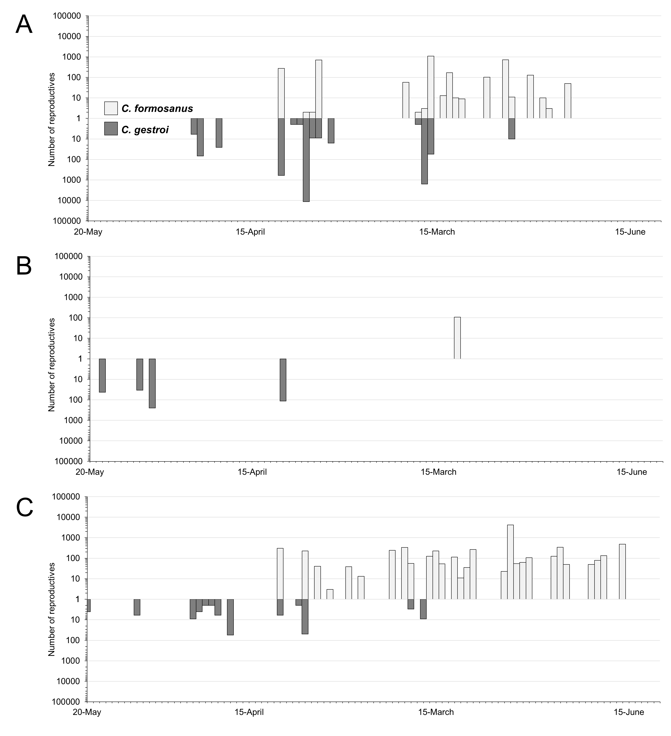
Fig. S1. The dispersal flights of Coptotermes. The pre-test of the dispersal flights survey was conducted in (A) Taichung, (B) Yunlin, and (C) Chiayi between March 20th and June 20th, 2019. A total 70 dispersal flight events were observed in Taichung (27), Yunlin (5), and Chiayi (38) with color represent their identity. Concurrent dispersal flights were observed 8 times in Taichung and 3 times in Chiayi, and Taichung stand out to be the area most possible to find the hybrids.
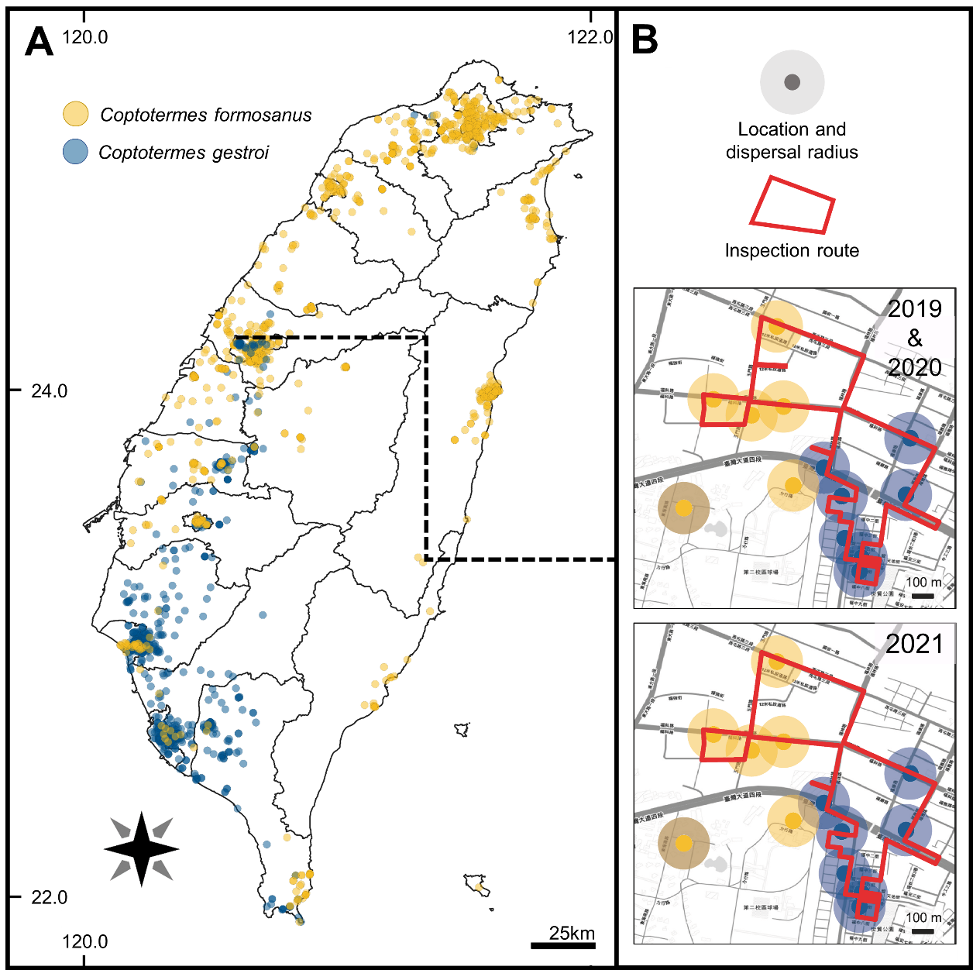
Fig. S2. Geographical distribution of C. formosanus and C. gestroi and the experimental design of the inspection on the dispersal flight events. (A) Distribution of C. formosanus and C. gestroi in Taiwan. (B) Coptotermes disperse radius and inspecting routes in the downtown area in Taichung. The routes for inspecting dispersal flights were design to pass through the overlapping dispersal radius of the two species. Each route was designed as a loop, which allows for continuous patrol. The dispersal radius of C. formosanus (color yellow) and C. gestroi (color blue) in was speculated from our termite collection records and the dispersal distance 125m on average reported in Mullins et al. (2015).
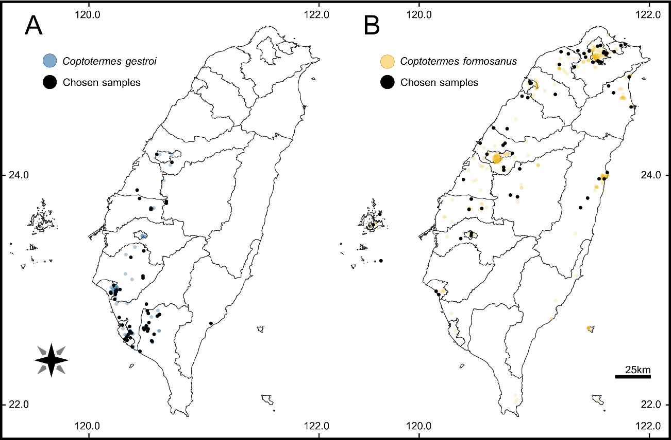
Figure S3. The distribution of the alate samples and the sampling method. Each dot represented a swarming event with alate samples collected, preserved in the NCHU Termite Collection. The dot with samples chosen for the morphological measurements and the genetic analysis were marked as black. A total of (A) 115 C. formosanus and (B) 108 C. gestroi were randomly selected from all over Taiwan. The map was divided into 5 by 5 km grids (process was not showed); 50 grids containing alate samples were randomly selected. For each grid at most four individuals were chosen, for each swarming event at most two individuals were chosen. Dried, rotten, and old samples preserved > 7 years were not used and replaced with alate samples geographically closest to it.
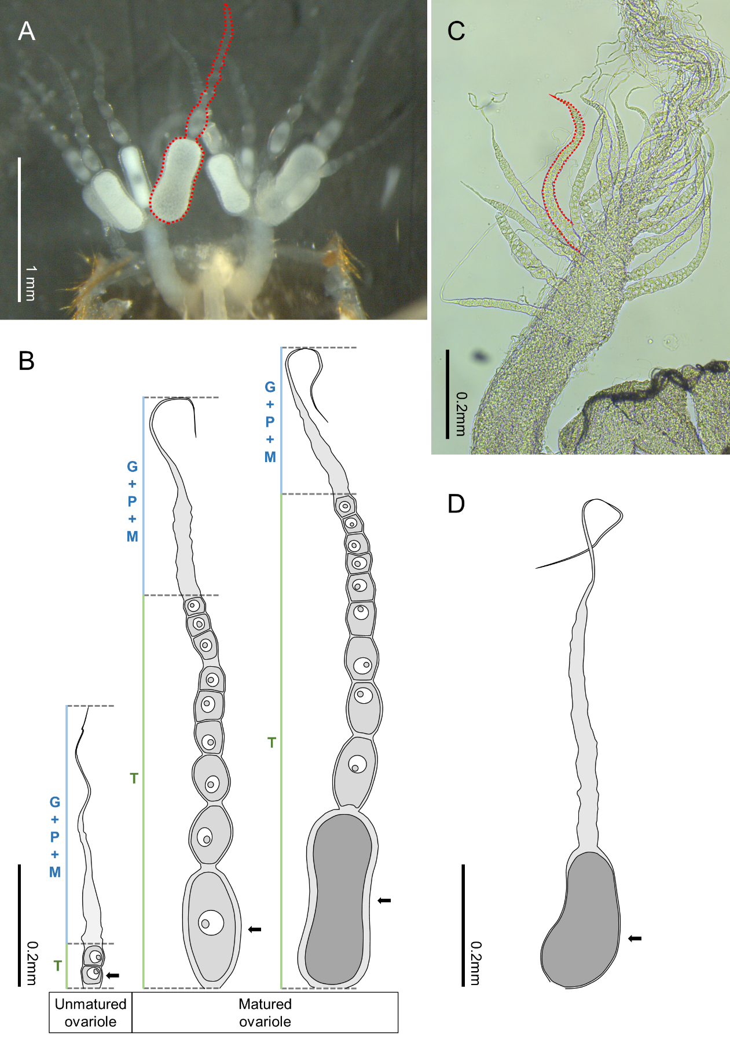
Figure S4. Ovary and ovariole developmental stages of Coptotermes. (A) A pair of ovaries of a C. gestroi one day after the flight. The ovarioles on an ovary were arranged in a “raceme” manner, i.e., matured ovarioles towards the base and unmatured ones towards the apex of an ovary. An ovariole was marked with a red dotted line. (B) In each ovariole is a series of oocytes. The oocytes were generated in the distal end, gradually enlarge, and move to the proximal end of the ovariole. The oocyte at the proximal end is called basal oocyte (arrow pointed). From left to right are unmatured ovariole, matured ovariole, and a matured ovariole with a larger basal oocyte (egg-producing ovariole). Unmatured ovariole contains several oocytes in the pre-vitellogenic stage. The mature ovariole contains many pre-vitellogenic oocytes and one basal oocyte in the vitellogenic stage (oocyte length > 0.13 mm). If under the right condition, large amounts of yolk granules and lipid droplets will then accumulate inside the basal oocyte, the accumulation causes the volume to increase and the germinal vesicles become invisible (the one ovariole on the right, egg-producing ovariole). (C) An ovary from a hybrid alate. The ovarioles are short at length, and usually contain oocytes not yet reached the pre-vitellogenic stage, (D) and even if it reached the pre-vitellogenic stage or further, the shape of the oocyte was abnormal and the follicular epithelium was incomplete from the appearance. In this kind of ovarioles, a series of pre-vitellogenic oocytes above basal oocyte are still absent. In the picture (B) and (D), only the oocytes in the pre-vitellogenic stage and the vitellogenic stage were shown. The divisions of ovariole were according to Weesner (1969) and Higa & Bess (1974). The developmental stages of oocyte were according to Costa-Leonardo et al. (2022). T (terminal region), G (germarium), P (prophase region), M (medium growth region).

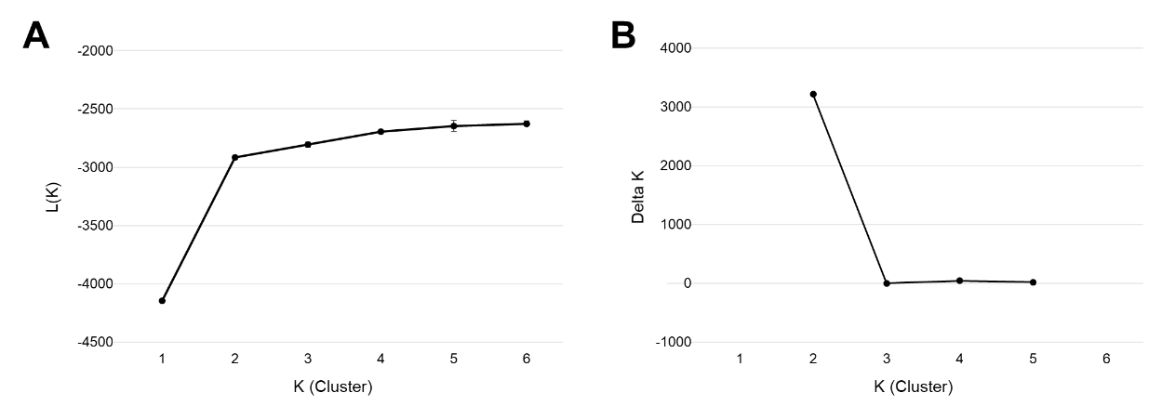
Figure S5. The optimum K was determined using the ∆K method. (A) The mean of likelihood L(K) becoming steady when K ≥2, and (B) the greatest ΔK value presented when K=2. Both show that K=2 was the best number of population clusters.

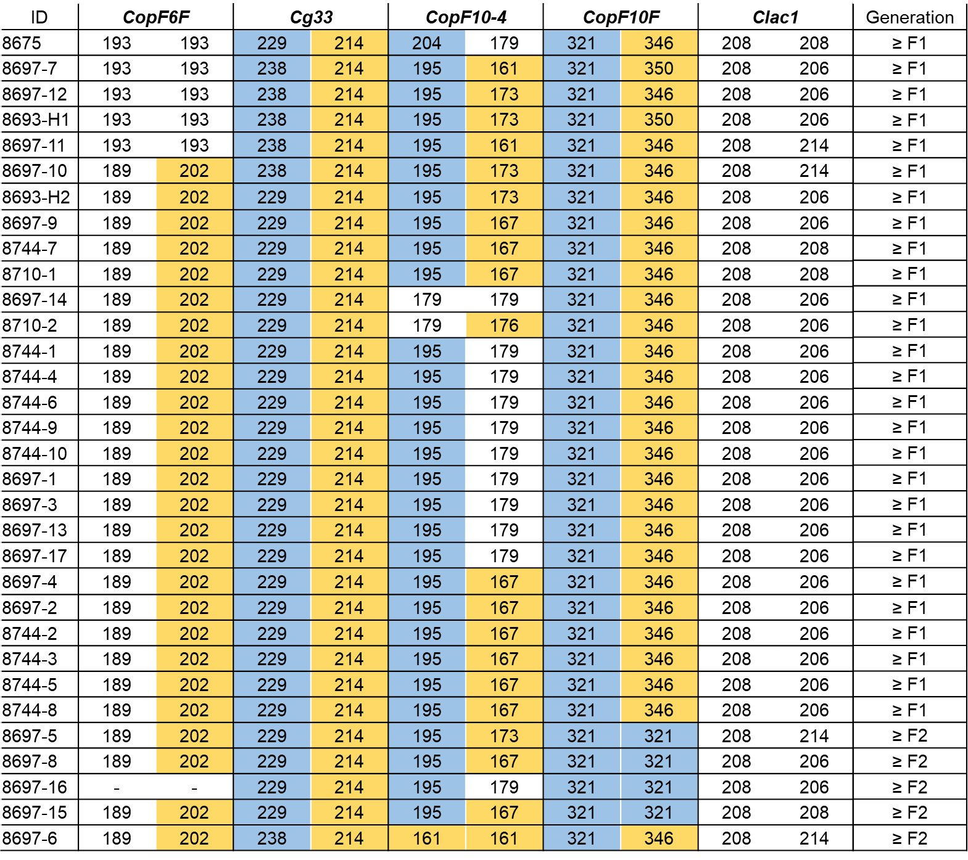
Figure S6. Individuals’ genetic profile and advanced hybrids. Alleles of the five markers inferred hybrid generation. The alleles of the two diagnostic makers on the 32 identified hybrids were shown, the species’ private alleles were marked with color. If a microsatellite locus of a hybrid individual carrying two alleles originated from one species, such individual was counted as “non-F1 hybrids”, else were counted as “F1 or higher”. Among 32 hybrids, five individuals were classified as “non-F1 hybrids”.

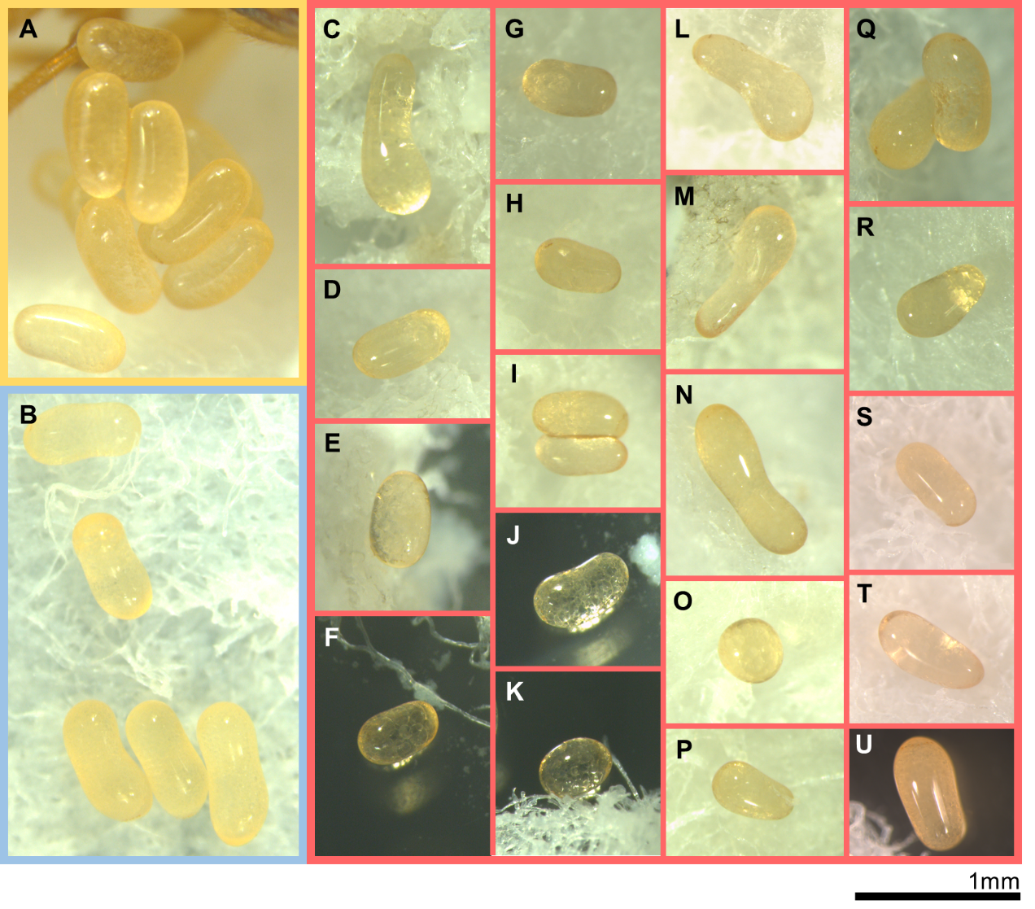
Figure S7. The abnormal egg produced by the hybrids. (A) The normal bean-like egg produced by C. formosanus and (B) C. gestroi. (C)-(K) The eggs produced by hybrid pairings, HY × HY. (L)-(R) The eggs produced by the backcross parings, HY × CF. (S)-(U) The eggs produced by the backcross parings, HY × CG. Most of the eggs produced by hybrid females had smaller volumes than the normal ones, and their shape was highly variable. The same scale was applied to the figures.

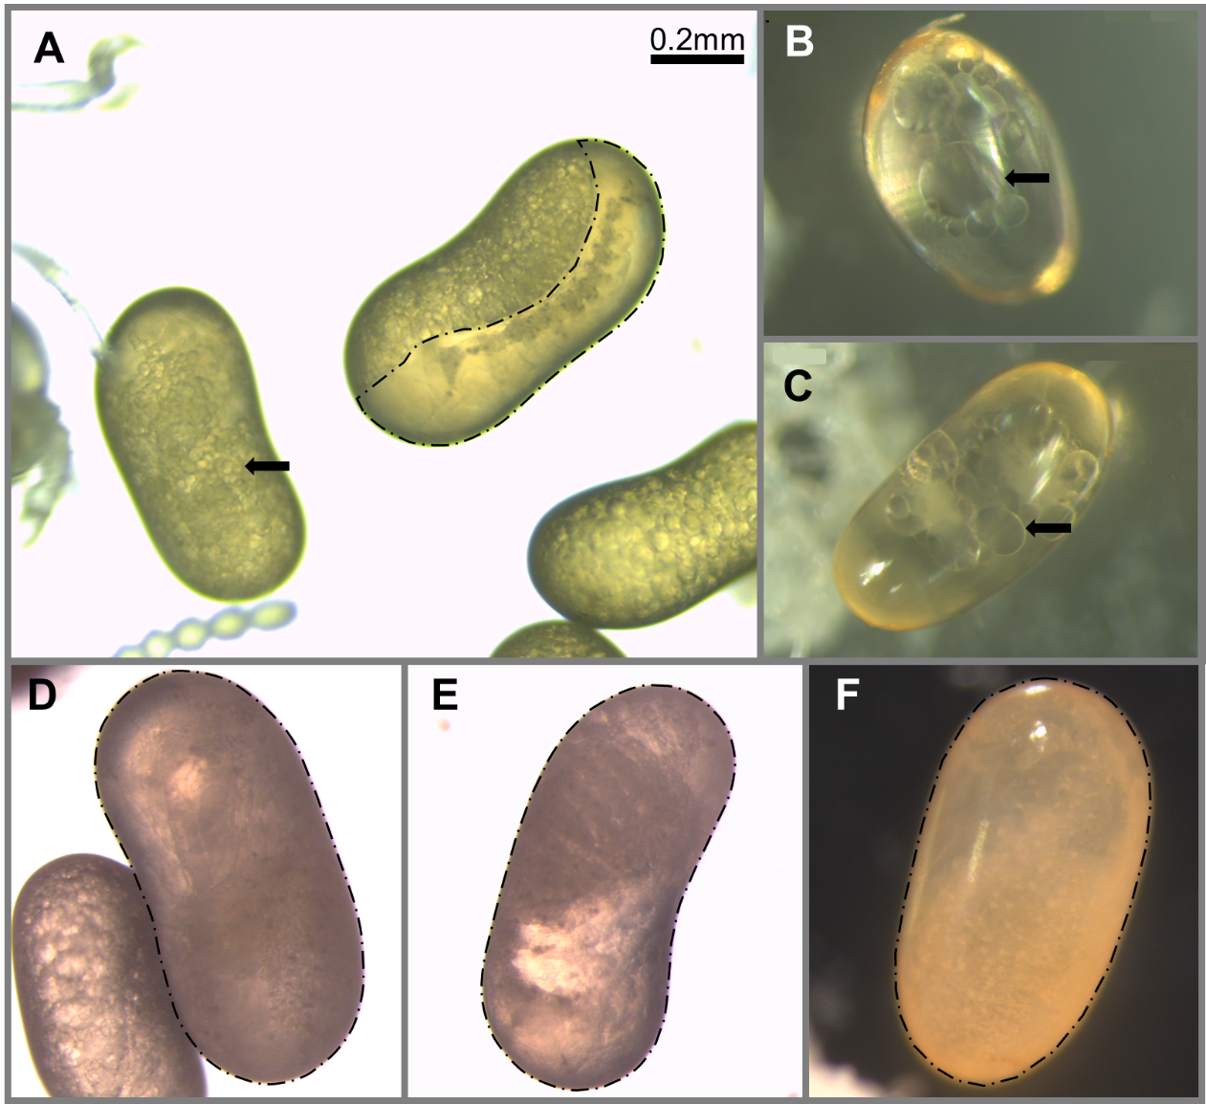
Figure S8. The internal structure and embryos of eggs. (A) Normal eggs produced by a C. gestroi colony. A newly produced egg regularly has numerous evenly distributed small yolk granules and lipid droplets (arrow pointed). Egg with developing embryo inside can easily be observed among the egg pile (border marked with dotted line). (B) and (C) Obviously larger and unevenly distributed yolk or lipid sphere observed in some of the eggs produced by the hybrid females. No developing embryo were found among the eggs produced by the hybrid females. (D) Egg produced by a C. formosanus colony, with a developing embryo inside. (E) Egg produced by a CF×HY colony, with a developing embryo inside. (F) Egg produced by a CG×HY colony, with a developing embryo inside. The same scale was applied to the plate.

Supplementary Tables

Table S1. Detailed information of the selected samples
Code¹ | Species | LATDD | LONDD | Col. Date | HAC | BH | SH | CopF6F² |  | CopF10F-1 |  | Cg33-1 |  | CopF10-4-1 |  | Clac1-1
 |  |  |  |  |  |  |  | -1 | -2 | -1 | -2 | -1 | -2 | -1 | -2 | -1 | -2
TW4931-1 | CF | 24.04429 | 120.735 | 2017/5/31 | 39.77 | 199.32 | - | 202 | 206 | 350 | 350 | 214 | 214 | 170 | 170 | 206 | 214
TW4931-2 | CF | 24.04429 | 120.735 | 2017/5/31 | 65.43 | 182.61 | - | 206 | 206 | 346 | 346 | 214 | 214 | 170 | 170 | 206 | 214
TW7567-1 | CF | 23.96943 | 121.5625 | 2017/5/17 | 55.43 | 189.78 | - | 189 | 189 | 363 | 363 | 214 | 214 | 135 | 176 | 197 | 206
TW7567-2 | CF | 23.96943 | 121.5625 | 2017/5/17 | 46.90 | 234.60 | - | 189 | 189 | 363 | 363 | 214 | 214 | 173 | 176 | 206 | 206
TW7612-1 | CF | 24.68979 | 120.8936 | 2018/5/24 | 38.97 | 190.08 | - | 202 | 202 | 350 | 350 | 214 | 214 | 170 | 176 | 206 | 214
TW7612-2 | CF | 24.68979 | 120.8936 | 2018/5/24 | 28.55 | 215.70 | - | 202 | 202 | 350 | 350 | 214 | 214 | 170 | 201 | 206 | 214
TW7660-1 | CF | 25.13157 | 121.7523 | 2018/6/2 | 39.49 | 194.45 | - | 193 | 202 | 350 | 350 | 214 | 214 | 173 | 188 | 216 | 216
TW7660-2 | CF | 25.13157 | 121.7523 | 2018/6/2 | 19.30 | 219.60 | - | 202 | 202 | 350 | 350 | 214 | 214 | 167 | 173 | 216 | 216
TW7661-1 | CF | 23.66096 | 119.6583 | 2018/5/31 | 50.03 | 224.14 | - | 191 | 198 | 346 | 350 | 214 | 214 | 170 | 170 | 206 | 206
TW7661-2 | CF | 23.66096 | 119.6583 | 2018/5/31 | 51.56 | 237.81 | - | 191 | 193 | 350 | 363 | 214 | 214 | 170 | 170 | 199 | 206
TW7817-1 | CF | 23.82812 | 120.7921 | 2018/7/3 | 42.68 | 164.46 | - | 193 | 202 | 346 | 350 | 214 | 214 | 158 | 191 | 210 | 210
TW7817-2 | CF | 23.82812 | 120.7921 | 2018/7/3 | 46.40 | 186.30 | - | 193 | 204 | 346 | 350 | 214 | 214 | 158 | 179 | 208 | 210
TW7831-1 | CF | 24.4128 | 120.6461 | 2018/5/23 | 49.82 | 203.28 | - | 198 | 202 | 350 | 350 | 214 | 214 | 167 | 170 | 206 | 206
TW7831-2 | CF | 24.4128 | 120.6461 | 2018/5/23 | 49.82 | 203.28 | - | 202 | 202 | 350 | 354 | 214 | 214 | 182 | 188 | 197 | 206
TW7838-1 | CF | 23.79364 | 120.4524 | 2018/6/24 | 26.48 | 230.12 | - | 191 | 191 | 346 | 346 | 214 | 214 | 173 | 173 | 206 | 216
TW7838-2 | CF | 23.79364 | 120.4524 | 2018/6/24 | 15.04 | 247.59 | - | 191 | 191 | 346 | 346 | 214 | 214 | 161 | 173 | 206 | 216
TW8069-1 | CF | 25.08316 | 121.4764 | 2018/5/22 | 67.89 | 199.14 | - | 202 | 202 | 350 | 350 | 214 | 214 | 158 | 167 | 206 | 214
TW8069-2 | CF | 25.08316 | 121.4764 | 2018/5/22 | 50.06 | 202.48 | - | 202 | 202 | 346 | 350 | 214 | 214 | 158 | 167 | 206 | 214
TW8092-1 | CF | 24.96615 | 121.217 | 2018/9/4 | 20.29 | 284.69 | - | 202 | 204 | 346 | 350 | 214 | 214 | 176 | 188 | 197 | 214
TW8092-2 | CF | 24.96615 | 121.217 | 2018/9/4 | 31.20 | 210.67 | - | 185 | 202 | 346 | 350 | 214 | 214 | 167 | 188 | 197 | 214
TW8159-1 | CF | 23.71809 | 121.4012 | 2019/4/6 | 55.52 | 162.71 | - | 189 | 202 | 346 | 363 | 214 | 214 | 173 | 176 | 206 | 206
TW8159-2 | CF | 23.71809 | 121.4012 | 2019/4/6 | 43.87 | 161.66 | - | 189 | 202 | 346 | 350 | 214 | 214 | 170 | 173 | 206 | 216
TW8167-1 | CF | 22.99016 | 120.1471 | 2019/4/20 | 29.16 | 181.41 | - | 202 | 202 | 350 | 350 | 214 | 214 | 170 | 188 | 208 | 216
TW8176-1 | CF | 24.26244 | 120.7289 | 2019/4/26 | 32.57 | 234.10 | - | 202 | 204 | 346 | 350 | 214 | 214 | 164 | 179 | 199 | 206
TW8176-2 | CF | 24.26244 | 120.7289 | 2019/4/26 | 32.57 | 234.10 | - | 195 | 202 | 346 | 346 | 214 | 214 | 164 | 164 | 206 | 206
TW8189-1 | CF | 24.98581 | 121.5817 | 2019/5/4 | 33.81 | 200.98 | - | 191 | 202 | 350 | 352 | 214 | 214 | 173 | 185 | 197 | 214
TW8189-2 | CF | 24.98581 | 121.5817 | 2019/5/4 | 28.07 | 166.58 | - | 202 | 206 | 350 | 352 | 214 | 214 | 158 | 173 | 197 | 214
TW8224-1 | CF | 25.0668 | 121.6011 | 2019/5/15 | 43.13 | 213.70 | - | 202 | 202 | 350 | 350 | 214 | 214 | 173 | 188 | 208 | 214
TW8224-2 | CF | 25.0668 | 121.6011 | 2019/5/15 | 56.14 | 194.50 | - | 202 | 206 | 350 | 352 | 214 | 214 | 173 | 173 | 214 | 214
TW8228 | CF | 24.98688 | 121.5077 | 2019/5/17 | 32.61 | 176.71 | - | 202 | 202 | 346 | 350 | 214 | 214 | 158 | 188 | 208 | 216
TW8240 | CF | 24.18455 | 120.5889 | 2019/5/16 | 25.19 | 200.68 | - | 191 | 206 | 346 | 350 | 214 | 214 | 179 | 182 | 206 | 206
TW8267-1 | CF | 22.9607 | 120.1702 | 2019/5/22 | 34.21 | 185.75 | - | 193 | 206 | 346 | 350 | 214 | 214 | 191 | 191 | 199 | 206
TW8267-2 | CF | 22.9607 | 120.1702 | 2019/5/22 | 37.52 | 165.60 | - | 206 | 206 | 346 | 363 | 214 | 214 | 170 | 191 | 199 | 206
TW8277-1 | CF | 25.13223 | 121.5751 | 2019/5/27 | 37.74 | 219.36 | - | 202 | 202 | 346 | 346 | 214 | 214 | 167 | 188 | 206 | 216
TW8277-2 | CF | 25.13223 | 121.5751 | 2019/5/27 | 63.32 | 208.64 | - | 202 | 202 | 350 | 350 | 214 | 214 | 176 | 176 | 216 | 216
TW8298 | CF | 24.80122 | 120.9646 | 2019/5/27 | 32.58 | 225.79 | - | 202 | 204 | 346 | 350 | 214 | 214 | 170 | 176 | 208 | 214
TW8312-1 | CF | 24.80392 | 120.972 | 2019/6/4 | 48.40 | 239.41 | - | 202 | 202 | 350 | 350 | 214 | 214 | 158 | 170 | 197 | 204
TW8312-2 | CF | 24.80392 | 120.972 | 2019/6/4 | 61.56 | 195.60 | - | 195 | 195 | 350 | 350 | 214 | 214 | 170 | 173 | 197 | 216
TW8345 | CF | 24.59591 | 121.8409 | 2019/6/25 | 34.08 | 232.71 | - | 202 | 202 | 350 | 361 | 214 | 214 | 173 | 173 | 197 | 197
TW9517-1 | CF | 23.96903 | 121.6072 | 2019/5/16 | 53.16 | 247.99 | - | 185 | 202 | 361 | 363 | 214 | 214 | 161 | 173 | 216 | 216
TW9517-2 | CF | 23.96903 | 121.6072 | 2019/5/16 | 42.87 | 220.76 | - | 185 | 206 | 350 | 361 | 214 | 214 | 173 | 173 | 197 | 208
TW9525 | CF | 23.70292 | 120.4327 | 2019/6/22 | 44.88 | 208.10 | - | 198 | 206 | 346 | 350 | 214 | 214 | 167 | 173 | 206 | 210
TW9534-1 | CF | 24.99764 | 121.5526 | 2019/7/4 | 74.66 | 201.68 | - | 200 | 202 | 350 | 350 | 214 | 214 | 167 | 170 | 206 | 214
TW9534-2 | CF | 24.99764 | 121.5526 | 2019/7/4 | 59.03 | 188.19 | - | 202 | 204 | 350 | 352 | 214 | 214 | 176 | 176 | 214 | 214
TW9542 | CF | 25.0621 | 121.432 | 2019/8/3 | 19.48 | 276.98 | - | 202 | 202 | 350 | 350 | 214 | 214 | 167 | 173 | 208 | 214
TW9556-1 | CF | 24.19226 | 120.8086 | 2019/5/26 | 46.56 | 249.37 | - | 202 | 204 | 350 | 350 | 214 | 214 | 173 | 182 | 197 | 206
TW9556-2 | CF | 24.19226 | 120.8086 | 2019/5/26 | 25.13 | 237.98 | - | 195 | 202 | 350 | 350 | 214 | 214 | 167 | 185 | 214 | 214
TW9569-1 | CF | 24.05644 | 120.8729 | 2019/5/26 | 71.09 | 180.17 | - | 198 | 202 | 350 | 350 | 214 | 214 | 173 | 173 | 206 | 206
TW9569-2 | CF | 24.05644 | 120.8729 | 2019/5/26 | 53.05 | 158.83 | - | 202 | 202 | 350 | 350 | 214 | 214 | 173 | 173 | 197 | 214
TW9578 | CF | 23.47366 | 120.451 | 2019/5/16 | 24.52 | 240.69 | - | 191 | 191 | 350 | 350 | 214 | 214 | 164 | 191 | 197 | 206
TW9580-1 | CF | 23.4979 | 120.4548 | 2019/5/18 | 81.58 | 177.42 | - | 191 | 198 | 346 | 350 | 214 | 214 | 161 | 161 | 206 | 206
TW9580-2 | CF | 23.4979 | 120.4548 | 2019/5/18 | 38.18 | 182.70 | - | 198 | 198 | 350 | 350 | 214 | 214 | 161 | 173 | 206 | 206
TW9581 | CF | 24.2811 | 120.5291 | 2019/5/29 | 63.85 | 208.52 | - | 195 | 202 | 346 | 346 | 214 | 214 | 170 | 173 | 206 | 216
TW7427 | CF | 24.81663 | 120.9599 | 2018/5/8 | 50.17 | 216.87 | - | 202 | 202 | 350 | 350 | 214 | 214 | 158 | 167 | 206 | 216
TW7428-1 | CF | 22.03722 | 121.5584 | 2018/5/2 | 21.38 | 201.75 | - | 189 | 202 | 346 | 352 | 214 | 214 | 135 | 155 | 206 | 206
TW7428-2 | CF | 22.03722 | 121.5584 | 2018/5/2 | 40.11 | 158.98 | - | 202 | 204 | 346 | 352 | 214 | 214 | 135 | 135 | 206 | 206
TW7437-1 | CF | 25.05153 | 121.6228 | 2018/5/15 | 59.46 | 183.82 | - | 202 | 202 | 350 | 352 | 214 | 214 | 167 | 173 | 206 | 210
TW7437-2 | CF | 25.05153 | 121.6228 | 2018/5/15 | 42.82 | 273.97 | - | 202 | 202 | 352 | 352 | 214 | 214 | 173 | 173 | 210 | 216
TW7442-1 | CF | 25.06424 | 121.6306 | 2018/5/16 | 50.01 | 176.24 | - | 202 | 206 | 346 | 350 | 214 | 214 | 135 | 188 | 206 | 216
TW7442-2 | CF | 25.06424 | 121.6306 | 2018/5/16 | 59.61 | 166.74 | - | 202 | 206 | 346 | 350 | 214 | 214 | 135 | 188 | 206 | 216
TW7630-1 | CF | 23.81322 | 120.8536 | 2018/5/23 | 40.99 | 179.57 | - | 198 | 206 | 350 | 350 | 214 | 214 | 185 | 185 | 216 | 216
TW7630-2 | CF | 23.81322 | 120.8536 | 2018/5/23 | 48.78 | 166.54 | - | 202 | 206 | 350 | 350 | 214 | 214 | 185 | 185 | 216 | 220
TW8245-1 | CF | 24.77926 | 121.6454 | 2019/5/13 | 56.71 | 157.11 | - | 185 | 202 | 346 | 350 | 214 | 214 | 167 | 173 | 212 | 214
TW8245-2 | CF | 24.77926 | 121.6454 | 2019/5/13 | 34.58 | 161.18 | - | 202 | 202 | 350 | 363 | 214 | 214 | 173 | 173 | 199 | 206
TW8261 | CF | 25.08629 | 121.3786 | 2019/4/30 | 34.22 | 172.03 | - | 202 | 202 | 350 | 350 | 214 | 214 | 164 | 164 | 206 | 206
TW8201-1 | CF | 25.07871 | 121.6063 | 2019/5/13 | 58.50 | 182.51 | - | 202 | 202 | 350 | 350 | 214 | 214 | 170 | 173 | 214 | 218
TW8201-2 | CF | 25.07871 | 121.6063 | 2019/5/13 | 55.23 | 149.72 | - | 202 | 202 | 346 | 350 | 214 | 214 | 173 | 179 | 206 | 214
TW7670 | CF | 25.07725 | 121.2322 | 2018/5/27 | 29.71 | 199.61 | - | 185 | 200 | 350 | 350 | 214 | 214 | 170 | 173 | 197 | 204
TW7707 | CF | 25.05911 | 121.2962 | 2018/5/24 | 42.07 | 201.30 | - | 193 | 206 | 350 | 350 | 214 | 214 | 161 | 170 | 206 | 206
TW7682-1 | CF | 23.44935 | 120.3611 | 2018/5/19 | 41.21 | 226.66 | - | 202 | 202 | 350 | 354 | 214 | 214 | 182 | 182 | 197 | 204
TW7682-2 | CF | 23.44935 | 120.3611 | 2018/5/19 | 51.54 | 214.42 | - | 191 | 202 | 350 | 350 | 214 | 214 | 176 | 176 | 197 | 197
TW7655-1 | CF | 25.07792 | 121.6936 | 2018/5/29 | 36.38 | 224.83 | - | 202 | 202 | 346 | 350 | 214 | 214 | 170 | 182 | 206 | 208
TW7655-2 | CF | 25.07792 | 121.6936 | 2018/5/29 | 30.56 | 182.80 | - | 185 | 202 | 346 | 346 | 214 | 214 | 173 | 182 | 214 | 216
TW7636 | CF | 24.98917 | 121.5671 | 2018/5/19 | 48.01 | 186.80 | - | 189 | 189 | 350 | 352 | 214 | 214 | 135 | 170 | 197 | 214
TW7593 | CF | 24.99041 | 121.5592 | 2018/5/15 | 43.02 | 107.11 | - | 202 | 202 | 350 | 350 | 214 | 214 | 170 | 173 | 206 | 214
TW7656 | CF | 25.03 | 121.4454 | 2018/6/1 | 69.33 | 195.30 | - | 202 | 202 | 350 | 350 | 214 | 214 | 170 | 173 | 214 | 218
TW7581 | CF | 24.70543 | 121.1825 | 2018/5/18 | 48.67 | 202.25 | - | 193 | 202 | 350 | 350 | 214 | 214 | 167 | 173 | 214 | 214
TW7640-1 | CF | 25.12523 | 121.5495 | 2018/5/24 | 48.61 | 182.71 | - | 191 | 202 | 350 | 350 | 214 | 214 | 167 | 173 | 206 | 206
TW7640-2 | CF | 25.12523 | 121.5495 | 2018/5/24 | 44.02 | 188.38 | - | 202 | 202 | 346 | 350 | 214 | 214 | 176 | 182 | 206 | 206
TW7674-1 | CF | 23.12615 | 121.3656 | 2018/5/21 | 52.49 | 172.40 | - | 189 | 202 | 361 | 361 | 214 | 214 | 135 | 135 | 197 | 214
TW7674-2 | CF | 23.12615 | 121.3656 | 2018/5/21 | 51.84 | 156.67 | - | 189 | 202 | 361 | 369 | 214 | 214 | 135 | 173 | 197 | 214
TW8318-1 | CF | 24.67764 | 120.9436 | 2019/5/17 | 64.83 | 158.78 | - | 202 | 204 | 350 | 350 | 214 | 214 | 158 | 173 | 214 | 216
TW8318-2 | CF | 24.67764 | 120.9436 | 2019/5/17 | 54.04 | 158.26 | - | 202 | 202 | 350 | 350 | 214 | 214 | 167 | 173 | 197 | 214
TW8213-1 | CF | 23.25588 | 119.6681 | 2019/5/13 | 25.70 | 205.21 | - | 193 | 202 | 350 | 350 | 214 | 214 | 173 | 191 | 206 | 216
TW8213-2 | CF | 23.25588 | 119.6681 | 2019/5/13 | 39.89 | 189.41 | - | 193 | 202 | 350 | 363 | 214 | 214 | 191 | 191 | 206 | 216
TW8271-1 | CF | 23.56922 | 119.6013 | 2019/5/21 | 45.69 | 210.17 | - | 185 | 198 | 346 | 363 | 214 | 214 | 164 | 170 | 206 | 208
TW8271-2 | CF | 23.56922 | 119.6013 | 2019/5/21 | 48.71 | 209.62 | - | 191 | 193 | 346 | 363 | 214 | 214 | 170 | 170 | 206 | 208
TW8185 | CF | 24.71963 | 121.6882 | 2019/4/27 | 45.51 | 150.02 | - | 189 | 202 | 350 | 361 | 214 | 214 | 173 | 179 | 206 | 214
TW8169 | CF | 24.28022 | 120.7458 | 2019/4/19 | 63.53 | 178.49 | - | 191 | 202 | 350 | 363 | 214 | 214 | 161 | 182 | 208 | 214
TW8194-1 | CF | 24.0704 | 120.7335 | 2019/4/26 | 65.63 | 158.09 | - | 202 | 202 | 350 | 350 | 214 | 214 | 170 | 170 | 199 | 199
TW8194-2 | CF | 24.0704 | 120.7335 | 2019/4/26 | 43.18 | 159.87 | - | 202 | 206 | 350 | 363 | 214 | 214 | 170 | 179 | 204 | 210
TW8070-1 | CF | 25.08316 | 121.4764 | 2018/5/30 | 63.19 | 230.59 | - | 202 | 202 | 350 | 350 | 214 | 214 | 176 | 188 | 206 | 208
TW8070-2 | CF | 25.08316 | 121.4764 | 2018/5/30 | 43.68 | 298.87 | - | 202 | 202 | 346 | 350 | 214 | 214 | 173 | 176 | 206 | 214
TW9523-1 | CF | 24.94487 | 121.3485 | 2019/6/19 | 69.13 | 267.05 | - | 202 | 202 | 350 | 350 | 214 | 214 | 158 | 167 | 206 | 216
TW9523-2 | CF | 24.94487 | 121.3485 | 2019/6/19 | 49.24 | 178.66 | - | 202 | 202 | 350 | 350 | 214 | 214 | 158 | 158 | 214 | 214
TW9585-1 | CF | 24.85761 | 121.8235 | 2019/5/14 | 45.14 | 142.69 | - | 202 | 204 | 346 | 350 | 214 | 214 | 167 | 173 | 218 | 218
TW9585-2 | CF | 24.85761 | 121.8235 | 2019/5/14 | 60.18 | 152.36 | - | 206 | 206 | 352 | 352 | 214 | 214 | 170 | 173 | 206 | 206
TW4861-1 | CF | 24.02517 | 121.633 | 2017/6/3 | 42.63 | 182.39 | - | 185 | 204 | 350 | 361 | 214 | 214 | 170 | 176 | 206 | 206
TW4861-2 | CF | 24.02517 | 121.633 | 2017/6/3 | 48.93 | 200.33 | - | 202 | 202 | 350 | 361 | 214 | 214 | 170 | 173 | 206 | 206
TW4881 | CF | 24.9852 | 121.5111 | 2017/6/3 | 58.28 | 173.24 | - | 202 | 202 | 346 | 350 | 214 | 214 | 170 | 176 | 206 | 210
TW7549-1 | CF | 23.802 | 121.463 | 2018/5/4 | 42.82 | 168.72 | - | 202 | 202 | 363 | 363 | 214 | 214 | 170 | 173 | 206 | 206
TW7549-2 | CF | 23.802 | 121.463 | 2018/5/4 | 41.76 | 139.41 | - | 189 | 189 | 361 | 363 | 214 | 214 | 161 | 173 | 206 | 206
TW7434-1 | CF | 25.14302 | 121.7889 | 2018/5/13 | 52.02 | 209.45 | - | 193 | 202 | 350 | 350 | 214 | 214 | 161 | 161 | 210 | 216
TW7434-2 | CF | 25.14302 | 121.7889 | 2018/5/13 | 59.13 | 192.54 | - | 193 | 202 | 350 | 350 | 214 | 214 | 161 | 161 | 216 | 216
TW7036 | CF | 23.71159 | 120.5434 | 2017/6/3 | 42.70 | 173.25 | - | 191 | 202 | 346 | 350 | 214 | 214 | 170 | 185 | 197 | 206
TW4536-1 | CF | 24.499277 | 118.40341 | 2016/5/26 | 40.26 | 182.42 | - | 193 | 202 | 346 | 346 | 214 | 214 | 170 | 173 | 206 | 206
TW4536-2 | CF | 24.499277 | 118.40341 | 2016/5/26 | 50.99 | 212.18 | - | 195 | 202 | 346 | 346 | 214 | 214 | 173 | 173 | 206 | 206
TW7704-1 | CF | 23.81289 | 120.8536 | 2018/6/5 | 62.89 | 163.98 | - | 198 | 206 | 350 | 350 | 214 | 214 | 185 | 185 | 216 | 220
TW7704-2 | CF | 23.81289 | 120.8536 | 2018/6/5 | 57.12 | 209.40 | - | 202 | 202 | 350 | 350 | 214 | 214 | 185 | 185 | 216 | 220
TW7846-1 | CF | 23.96379 | 120.384 | 2018/5/28 | 34.08 | 266.92 | - | 193 | 198 | 346 | 350 | 214 | 214 | 164 | 164 | 206 | 210
TW7846-2 | CF | 23.96379 | 120.384 | 2018/5/28 | 37.14 | 228.57 | - | 193 | 198 | 350 | 350 | 214 | 214 | 161 | 185 | 199 | 206
TW7036-1 | CF | 23.71159 | 120.5434 | 2017/6/3 | 48.31 | 190.32 | - | 202 | 202 | 346 | 350 | 214 | 214 | 161 | 185 | 206 | 206
TW7036-2 | CF | 23.71159 | 120.5434 | 2017/6/3 | 55.00 | 191.29 | - | 202 | 202 | 346 | 350 | 214 | 214 | 161 | 161 | 197 | 206
TW7575-1 | CF | 24.40615 | 120.7637 | 2018/5/19 | 35.99 | 187.46 | - | 197 | 202 | 346 | 350 | 214 | 214 | 170 | 170 | 206 | 216
TW7575-2 | CF | 24.40615 | 120.7637 | 2018/5/19 | 36.68 | 208.47 | - | 195 | 198 | 350 | 350 | 214 | 214 | 173 | 179 | 210 | 214
TW4655-1 | CG | 22.642635 | 120.50906 | 2017/4/17 | 58.08 | 143.99 | 0.072 | 189 | 189 | 321 | 321 | 229 | 229 | 204 | 204 | 206 | 208
TW4655-2 | CG | 22.642635 | 120.50906 | 2017/4/17 | 83.79 | 165.66 | 0.076 | 189 | 189 | 321 | 321 | 229 | 229 | - | - | - | -
TW4731-1 | CG | 22.55352 | 120.55 | 2017/4/8 | 68.01 | 92.32 | 0.066 | 189 | 189 | 321 | 321 | 229 | 229 | 195 | 195 | 206 | 208
TW4731-2 | CG | 22.55352 | 120.55 | 2017/4/8 | 92.37 | 121.98 | 0.073 | 189 | 189 | 321 | 321 | 229 | 238 | 195 | 204 | 206 | 208
TW4735-1 | CG | 22.78797 | 120.614 | 2017/4/8 | 85.57 | 92.88 | 0.077 | 189 | 212 | 321 | 321 | 229 | 229 | 195 | 195 | 206 | 208
TW4735-2 | CG | 22.78797 | 120.614 | 2017/4/8 | 92.36 | 98.22 | 0.072 | 189 | 212 | 321 | 321 | 229 | 229 | 182 | 195 | 206 | 208
TW4739-1 | CG | 23.34264 | 120.4771 | 2017/4/9 | 84.06 | 108.67 | 0.072 | 189 | 212 | 321 | 321 | 229 | 244 | 204 | 204 | 206 | 208
TW4739-2 | CG | 23.34264 | 120.4771 | 2017/4/9 | 79.49 | 100.40 | 0.073 | 189 | 189 | 321 | 321 | 238 | 238 | 204 | 204 | 206 | 208
TW4736-1 | CG | 22.78551 | 120.6096 | 2017/4/8 | 71.08 | 97.57 | 0.075 | 189 | 212 | 321 | 321 | 229 | 229 | 195 | 204 | 206 | 208
TW4736-2 | CG | 22.78551 | 120.6096 | 2017/4/8 | 61.24 | 84.46 | 0.076 | 189 | 189 | 321 | 321 | 229 | 229 | 195 | 210 | 206 | 208
TW4747-1 | CG | 22.7612 | 120.264 | 2017/4/8 | 81.16 | 98.55 | 0.082 | 189 | 208 | 321 | 321 | 229 | 235 | 179 | 195 | 208 | 208
TW4747-2 | CG | 22.7612 | 120.264 | 2017/4/8 | 104.6 | 113.62 | 0.069 | 189 | 189 | 321 | 321 | 229 | 247 | 195 | 195 | 206 | 206
TW4751-1 | CG | 22.68935 | 120.4982 | 2017/4/17 | 76.14 | 83.39 | 0.07 | 189 | 189 | 321 | 321 | 238 | 244 | 204 | 204 | 208 | 208
TW4751-2 | CG | 22.68935 | 120.4982 | 2017/4/17 | 76.05 | 92.25 | 0.068 | 189 | 189 | 321 | 321 | 238 | 244 | 195 | 204 | 208 | 208
TW4753-1 | CG | 23.34179 | 120.4766 | 2017/4/17 | 91.53 | 100.16 | 0.074 | 189 | 212 | 321 | 321 | 238 | 244 | 204 | 210 | 206 | 206
TW4753-2 | CG | 23.34179 | 120.4766 | 2017/4/17 | 82.95 | 93.50 | 0.063 | 189 | 212 | 321 | 321 | 229 | 244 | 204 | 204 | 208 | 208
TW4756-1 | CG | 22.81923 | 120.5075 | 2017/4/20 | 75.92 | 98.31 | 0.074 | 189 | 189 | 321 | 321 | 244 | 244 | 204 | 204 | 206 | 208
TW4756-2 | CG | 22.81923 | 120.5075 | 2017/4/20 | 66.06 | 84.15 | 0.073 | 189 | 189 | 321 | 321 | 244 | 244 | 198 | 204 | 206 | 208
TW8684-1 | CG | 24.18669 | 120.6146 | 2019/4/24 | 56.37 | 80.75 | 0.072 | 189 | 212 | 321 | 321 | 229 | 244 | 195 | 198 | 206 | 208
TW8684-2 | CG | 24.18669 | 120.6146 | 2019/4/24 | 67.08 | 92.58 | 0.071 | 189 | 189 | 321 | 321 | 229 | 229 | 204 | 204 | 208 | 208
TW4764-1 | CG | 23.87178 | 120.4192 | 2017/4/21 | 67.43 | 107.85 | 0.07 | 189 | 189 | 321 | 321 | 229 | 229 | 204 | 204 | 208 | 208
TW4796 | CG | 22.58366 | 120.3603 | 2017/4/28 | 64.96 | 97.51 | 0.065 | 189 | 189 | 321 | 321 | 229 | 229 | 195 | 204 | 208 | 208
TW4802-1 | CG | 22.87831 | 120.4999 | 2017/5/15 | 68.39 | 104.89 | 0.073 | 189 | 189 | 321 | 321 | 229 | 238 | 195 | 204 | 208 | 208
TW4802-2 | CG | 22.87831 | 120.4999 | 2017/5/15 | 74.40 | 101.28 | 0.072 | 189 | 189 | 321 | 321 | 229 | 238 | 195 | 204 | 208 | 208
TW4804-1 | CG | 22.55841 | 120.5454 | 2017/5/16 | 92.65 | 104.72 | 0.072 | 189 | 193 | 321 | 321 | 229 | 229 | 195 | 204 | 206 | 208
TW4948-1 | CG | 22.79624 | 120.5164 | 2017/6/17 | 83.63 | 109.35 | 0.078 | 189 | 189 | 321 | 321 | 229 | 229 | 195 | 195 | 208 | 208
TW7462-1 | CG | 22.78771 | 120.6139 | 2018/4/4 | 61.21 | 108.02 | 0.081 | 189 | 189 | 321 | 321 | 229 | 229 | 204 | 204 | 206 | 208
TW7462-2 | CG | 22.78771 | 120.6139 | 2018/4/4 | 75.62 | 117.36 | 0.077 | 189 | 189 | 321 | 321 | 229 | 229 | 204 | 210 | 208 | 208
TW7468-1 | CG | 22.467 | 120.4439 | 2018/4/13 | 82.09 | 94.74 | 0.072 | 189 | 189 | 321 | 321 | 229 | 238 | 195 | 204 | 206 | 208
TW7468-2 | CG | 22.467 | 120.4439 | 2018/4/13 | 112.84 | 112.81 | 0.078 | 189 | 189 | 321 | 321 | 229 | 238 | 204 | 204 | 208 | 212
TW7469-1 | CG | 22.66161 | 120.5153 | 2018/4/13 | 70.51 | 93.72 | 0.071 | 189 | 189 | 321 | 321 | 229 | 229 | 204 | 204 | 206 | 208
TW7469-2 | CG | 22.66161 | 120.5153 | 2018/4/13 | 101.5 | 114.56 | 0.069 | 189 | 189 | 321 | 321 | 238 | 238 | 195 | 204 | 208 | 208
TW7474-1 | CG | 23.10608 | 120.4703 | 2018/4/13 | 70.65 | 99.43 | 0.069 | 189 | 189 | 321 | 321 | 229 | 238 | 195 | 204 | 208 | 208
TW7474-2 | CG | 23.10608 | 120.4703 | 2018/4/13 | 80.77 | 131.90 | 0.068 | 189 | 212 | 321 | 321 | 229 | 238 | 195 | 204 | 208 | 208
TW7489 | CG | 22.785381 | 120.60943 | 2018/4/22 | 87.36 | 115.95 | 0.063 | 189 | 189 | 321 | 321 | 229 | 229 | 195 | 204 | 208 | 208
TW7490-1 | CG | 23.75684 | 120.6725 | 2018/4/13 | 73.70 | 95.94 | 0.071 | 189 | 212 | 321 | 321 | 229 | 229 | 195 | 204 | 208 | 208
TW7490-2 | CG | 23.75684 | 120.6725 | 2018/4/13 | 77.07 | 102.89 | 0.077 | 189 | 212 | 321 | 321 | 229 | 229 | 195 | 204 | 206 | 208
TW7499-1 | CG | 22.66854 | 120.4728 | 2018/5/1 | 82.89 | 118.52 | 0.07 | 189 | 189 | 321 | 321 | 229 | 238 | 195 | 204 | 206 | 208
TW7499-2 | CG | 22.66854 | 120.4728 | 2018/5/1 | 78.99 | 100.17 | 0.069 | 189 | 189 | 321 | 321 | 229 | 238 | 195 | 204 | 206 | 208
TW7740-1 | CG | 22.50433 | 120.379 | 2018/4/13 | 88.60 | 132.24 | 0.079 | 189 | 189 | 321 | 321 | 235 | 238 | 191 | 195 | 206 | 208
TW7740-2 | CG | 22.50433 | 120.379 | 2018/4/13 | 75.38 | 115.48 | 0.066 | 189 | 189 | 321 | 321 | 229 | 235 | 195 | 195 | 208 | 208
TW7748-1 | CG | 22.921 | 120.2253 | 2018/5/15 | 87.53 | 111.01 | 0.071 | 189 | 189 | 321 | 321 | 229 | 244 | 195 | 195 | 208 | 208
TW7748-2 | CG | 22.921 | 120.2253 | 2018/5/15 | 79.98 | 107.82 | 0.067 | 189 | 189 | 321 | 321 | 238 | 244 | 195 | 195 | 208 | 208
TW7751-1 | CG | 22.98094 | 120.1893 | 2018/5/19 | 81.44 | 128.64 | 0.067 | 189 | 189 | 321 | 321 | 229 | 238 | 195 | 204 | 208 | 208
TW7751-2 | CG | 22.98094 | 120.1893 | 2018/5/19 | 61.62 | 117.68 | 0.074 | 189 | 189 | 321 | 321 | 229 | 229 | 195 | 195 | 206 | 206
TW7936-1 | CG | 22.710262 | 121.06077 | 2019/4/6 | 94.53 | 115.47 | 0.081 | 189 | 189 | - | - | 229 | 232 | 204 | 204 | 206 | 208
TW7936-2 | CG | 22.710262 | 121.06077 | 2019/4/6 | 93.41 | 111.00 | 0.077 | 189 | 189 | - | - | 229 | 229 | - | - | 206 | 208
TW8485 | CG | 23.28587 | 120.3646 | 2019/3/14 | 79.02 | 97.45 | 0.065 | 189 | 189 | 321 | 321 | 229 | 238 | 195 | 204 | 206 | 208
TW8497-1 | CG | 23.12315 | 120.4699 | 2019/3/28 | 63.30 | 100.36 | 0.065 | 189 | 189 | 321 | 321 | 229 | 238 | 204 | 204 | 208 | 208
TW8497-2 | CG | 23.12315 | 120.4699 | 2019/3/28 | 75.25 | 106.56 | 0.064 | 189 | 189 | 321 | 321 | 229 | 238 | 204 | 204 | 208 | 208
TW8503 | CG | 22.56478 | 120.3316 | 2019/4/6 | 74.57 | 99.24 | 0.075 | 216 | 216 | 321 | 321 | 229 | 229 | 195 | 204 | 208 | 208
TW8505-1 | CG | 22.97155 | 120.192 | 2019/4/8 | 76.55 | 133.83 | 0.068 | 189 | 189 | 321 | 321 | 229 | 229 | 195 | 204 | 206 | 208
TW8505-2 | CG | 22.97155 | 120.192 | 2019/4/8 | 57.90 | 106.11 | 0.071 | 189 | 189 | 321 | 321 | 229 | 229 | 195 | 195 | 206 | 206
TW8511-1 | CG | 22.77301 | 120.594 | 2019/3/28 | 69.32 | 99.91 | 0.076 | 212 | 212 | 321 | 321 | 238 | 244 | 195 | 195 | 206 | 206
TW8511-2 | CG | 22.77301 | 120.594 | 2019/3/28 | 69.58 | 93.18 | 0.072 | 189 | 189 | 321 | 321 | 229 | 229 | 195 | 204 | 208 | 208
TW8521-1 | CG | 22.68347 | 120.3536 | 2019/4/23 | 82.60 | 108.22 | 0.078 | 189 | 197 | 321 | 321 | 235 | 238 | 195 | 204 | 206 | 208
TW8521-2 | CG | 22.68347 | 120.3536 | 2019/4/23 | 75.55 | 93.41 | 0.074 | 189 | 197 | 321 | 321 | 229 | 238 | 195 | 204 | 206 | 208
TW8530-1 | CG | 22.69473 | 120.2913 | 2019/4/25 | 71.59 | 88.38 | 0.077 | 189 | 210 | 321 | 321 | 232 | 238 | 182 | 204 | 208 | 208
TW8530-2 | CG | 22.69473 | 120.2913 | 2019/4/25 | 71.64 | 93.10 | 0.072 | 189 | 189 | 321 | 321 | 229 | 229 | 204 | 204 | 208 | 208
TW8532-1 | CG | 24.11383 | 120.7212 | 2019/4/21 | 93.62 | 119.20 | 0.077 | 189 | 189 | 321 | 321 | 235 | 238 | 204 | 204 | 208 | 212
TW8532-2 | CG | 24.11383 | 120.7212 | 2019/4/21 | 75.87 | 112.21 | 0.076 | 189 | 189 | 321 | 321 | 235 | 247 | 191 | 195 | 208 | 212
TW8534-1 | CG | 23.71063 | 120.5415 | 2019/4/18 | 60.10 | 114.10 | 0.064 | 189 | 212 | 321 | 321 | 229 | 229 | 204 | 204 | 208 | 208
TW8534-2 | CG | 23.71063 | 120.5415 | 2019/4/18 | 73.83 | 140.00 | 0.073 | 189 | 212 | 321 | 321 | 229 | 229 | 204 | 204 | 208 | 208
TW8547-1 | CG | 22.7166 | 120.5214 | 2019/4/20 | 67.34 | 117.99 | 0.066 | 189 | 189 | 321 | 321 | 229 | 238 | 195 | 204 | 206 | 208
TW8547-2 | CG | 22.7166 | 120.5214 | 2019/4/20 | 80.25 | 133.57 | 0.071 | 189 | 189 | 321 | 321 | 229 | 238 | 195 | 195 | 206 | 208
TW8555 | CG | 22.6689 | 120.4861 | 2019/4/10 | 74.14 | 95.17 | 0.066 | 189 | 189 | 321 | 321 | 238 | 238 | 195 | 204 | 208 | 208
TW8575-1 | CG | 22.59339 | 120.3311 | 2019/5/14 | 83.43 | 157.38 | 0.077 | 189 | 230 | 321 | 321 | 229 | 232 | 195 | 195 | 206 | 208
TW8575-2 | CG | 22.59339 | 120.3311 | 2019/5/14 | 73.75 | 130.77 | 0.078 | 189 | 189 | 321 | 321 | 229 | 232 | 195 | 204 | 208 | 208
TW8660-1 | CG | 22.97309 | 120.2294 | 2019/5/17 | 68.41 | 114.05 | 0.07 | 189 | 189 | 321 | 321 | 229 | 229 | 195 | 195 | 208 | 208
TW8660-2 | CG | 22.97309 | 120.2294 | 2019/5/17 | 60.48 | 109.33 | 0.071 | 189 | 189 | 321 | 321 | 229 | 238 | 195 | 195 | 208 | 208
TW4229-1 | CG | 23.7738 | 120.67273 | 2014/3/29 | 53.55 | 130.15 | 0.07 | 189 | 189 | 321 | 321 | 238 | 238 | 195 | 198 | 208 | 208
TW4155 | CG | 23.773679 | 120.67292 | 2013/4/29 | 87.16 | 240.82 | 0.078 | 189 | 189 | 321 | 321 | 229 | 229 | 204 | 204 | 208 | 208
TW4318 | CG | 23.7738 | 120.67273 | 2015/4/7 | 82.05 | 193.45 | 0.072 | 189 | 212 | 321 | 321 | 229 | 229 | 204 | 204 | 208 | 208
TW4354 | CG | 22.5628 | 120.3324 | 2014/4/20 | 67.70 | 187.75 | 0.085 | 189 | 193 | 321 | 321 | 229 | 235 | 195 | 204 | 206 | 208
TW7494-1 | CG | 23.71508 | 120.5388 | 2018/4/13 | 89.98 | 143.55 | 0.073 | 189 | 189 | 321 | 321 | 229 | 229 | 195 | 195 | 206 | 206
TW7494-2 | CG | 23.71508 | 120.5388 | 2018/4/13 | 92.94 | 135.91 | 0.076 | 189 | 189 | 321 | 321 | 229 | 229 | 195 | 195 | 206 | 206
TW7485 | CG | 22.96316 | 120.2298 | 2018/4/13 | 61.52 | 103.22 | 0.073 | 212 | 212 | 321 | 321 | 229 | 229 | 198 | 201 | 208 | 208
TW8564 | CG | 23.79807 | 120.4404 | 2019/5/16 | 62.08 | 108.43 | 0.077 | 189 | 189 | 321 | 321 | 229 | 229 | 195 | 195 | 208 | 208
TW4387-2-1 | CG | 23.70229 | 120.5384 | 2015/6/26 | 59.05 | 119.50 | 0.066 | 189 | 212 | 321 | 321 | 229 | 229 | 195 | 204 | 206 | 208
TW4387-2-2 | CG | 23.70229 | 120.5384 | 2015/6/26 | 71.95 | 117.13 | 0.069 | 189 | 189 | 321 | 321 | 229 | 229 | 195 | 204 | 206 | 208
TW7470-1 | CG | 22.62671 | 120.3705 | 2018/4/13 | 78.97 | 109.70 | 0.082 | 189 | 189 | 321 | 321 | 229 | 229 | 195 | 204 | 206 | 208
TW7470-2 | CG | 22.62671 | 120.3705 | 2018/4/13 | 81.78 | 126.89 | 0.062 | 189 | 216 | 321 | 321 | 226 | 238 | 195 | 195 | 208 | 208
TW7482-1 | CG | 23.00071 | 120.243 | 2018/4/14 | 73.75 | 144.36 | 0.076 | 189 | 212 | 321 | 321 | 229 | 229 | 195 | 204 | 206 | 208
TW7482-2 | CG | 23.00071 | 120.243 | 2018/4/14 | 64.51 | 167.51 | 0.062 | 189 | 189 | 321 | 321 | 229 | 229 | 195 | 195 | 208 | 208
TW7484-1 | CG | 23.04296 | 120.2161 | 2018/4/13 | 69.79 | 105.24 | 0.073 | 189 | 212 | 321 | 321 | 229 | 238 | 195 | 198 | 208 | 208
TW7484-2 | CG | 23.04296 | 120.2161 | 2018/4/13 | 58.84 | 105.51 | 0.075 | 189 | 212 | 321 | 321 | 229 | 238 | 195 | 195 | 208 | 208
TW7463 | CG | 22.61306 | 120.3431 | 2018/4/10 | 84.57 | 145.98 | 0.081 | 189 | 218 | 321 | 321 | 229 | 238 | 195 | 195 | 208 | 208
TW4739 | CG | 23.34264 | 120.4771 | 2017/4/9 | 73.83 | 103.19 | 0.073 | 189 | 212 | 321 | 321 | 229 | 229 | 195 | 204 | 206 | 208
TW4876-1 | CG | 22.6411 | 120.3587 | 2017/5/9 | 70.72 | 116.96 | 0.078 | 189 | 218 | 321 | 321 | 229 | 247 | 195 | 204 | 206 | 208
TW4876-2 | CG | 22.6411 | 120.3587 | 2017/5/9 | 95.41 | 117.66 | 0.072 | 189 | 189 | 321 | 321 | 229 | 247 | 195 | 204 | 206 | 208
TW4904 | CG | 22.66822 | 120.4978 | 2017/6/10 | 71.15 | 108.73 | 0.067 | 189 | 218 | 321 | 321 | 229 | 229 | 195 | 195 | 206 | 208
TW7756-1 | CG | 22.6558 | 120.4806 | 2018/5/24 | 100.8 | 162.54 | 0.066 | 189 | 189 | 321 | 321 | 229 | 229 | 195 | 204 | 206 | 208
TW7756-2 | CG | 22.6558 | 120.4806 | 2018/5/24 | 83.84 | 154.78 | 0.075 | 189 | 189 | 321 | 321 | 229 | 229 | 195 | 204 | 206 | 208
TW4734 | CG | 22.57298 | 120.3125 | 2017/4/8 | 91.29 | 104.25 | 0.082 | 189 | 189 | 321 | 321 | 238 | 238 | 195 | 204 | 206 | 208
TW4226 | CG | 22.615126 | 120.5663 | 2014/3/28 | 67.58 | 178.06 | 0.076 | 189 | 189 | 321 | 321 | 232 | 238 | 195 | 195 | 208 | 208
TW4229-2 | CG | 23.7738 | 120.67273 | 2014/3/29 | 45.59 | 255.98 | 0.069 | 189 | 189 | 321 | 321 | 238 | 238 | 198 | 198 | 208 | 208
TW4872 | CG | 22.64069 | 120.3553 | 2017/6/3 | 68.97 | 112.72 | 0.073 | 189 | 210 | 321 | 321 | 229 | 229 | 204 | 204 | 208 | 208
TW8366-1 | CG | 22.99418 | 120.2329 | 2018/8/1 | 69.85 | 109.81 | 0.071 | 212 | 212 | 321 | 321 | 229 | 229 | 195 | 204 | 208 | 208
TW8366-2 | CG | 22.99418 | 120.2329 | 2018/8/1 | 77.10 | 136.33 | 0.076 | 189 | 212 | 321 | 321 | 229 | 229 | 195 | 204 | 208 | 208
TW8501 | CG | 23.00549 | 120.2702 | 2019/4/2 | 90.12 | 117.24 | 0.069 | 189 | 189 | 321 | 321 | 238 | 244 | 195 | 195 | 208 | 208
TW8546-1 | CG | 22.467 | 120.4439 | 2019/4/12 | 88.42 | 104.30 | 0.07 | 189 | 189 | 321 | 321 | 229 | 238 | 195 | 204 | 208 | 212
TW8546-2 | CG | 22.467 | 120.4439 | 2019/4/12 | 76.18 | 102.15 | 0.072 | 189 | 189 | 321 | 321 | 229 | 229 | 195 | 204 | - | -
TW8680-1 | CG | 23.707459 | 120.53984 | 2019/4/20 | 79.14 | 119.56 | 0.069 | 210 | 212 | 321 | 321 | 229 | 229 | 195 | 204 | 206 | 208
TW8680-2 | CG | 23.707459 | 120.53985 | 2019/4/20 | 65.92 | 119.30 | 0.069 | 189 | 212 | 321 | 321 | 229 | 229 | 195 | 204 | 206 | 208
TW8665-1 | CG | 23.707596 | 120.54617 | 2019/3/30 | 63.19 | 96.75 | 0.069 | 189 | 212 | 321 | 321 | 229 | 229 | 198 | 204 | 208 | 208
TW8665-2 | CG | 23.707596 | 120.54617 | 2019/3/30 | 64.06 | 97.58 | 0.064 | 189 | 212 | 321 | 321 | 229 | 229 | 204 | 204 | 208 | 208
TW8676-1 | CG | 24.187065 | 120.61013 | 2019/4/20 | 69.41 | 97.92 | 0.072 | 189 | 189 | 321 | 321 | 229 | 238 | 195 | 204 | 206 | 208
TW8676-2 | CG | 24.187065 | 120.61013 | 2019/4/20 | 75.09 | 129.96 | 0.073 | - | - | - | - | 229 | 238 | - | - | 208 | 208
TW8744_1 | HY | 24.187099 | 120.61135 | 2019/5/30 | 77.22 | 205.36 | 0.097 | 189 | 202 | 321 | 346 | 229 | 214 | 195 | 179 | 208 | 206
TW8744_2 | HY | 24.187099 | 120.61135 | 2019/5/30 | 75.26 | 200.92 | 0.103 | 189 | 202 | 321 | 346 | 229 | 214 | 195 | 167 | 208 | 206
TW8744_3 | HY | 24.187099 | 120.61135 | 2019/5/30 | 88.83 | 180.13 | 0.1 | 189 | 202 | 321 | 346 | 229 | 214 | 195 | 167 | 208 | 206
TW8744_4 | HY | 24.187099 | 120.61135 | 2019/5/30 | 73.73 | 188.33 | 0.112 | 189 | 202 | 321 | 346 | 229 | 214 | 195 | 179 | 208 | 206
TW8744_5 | HY | 24.187099 | 120.61135 | 2019/5/30 | 96.41 | 194.82 | 0.105 | 189 | 202 | 321 | 346 | 229 | 214 | 195 | 167 | 208 | 206
TW8744_6 | HY | 24.187099 | 120.61135 | 2019/5/30 | 88.09 | 172.95 | 0.099 | 189 | 202 | 321 | 346 | 229 | 214 | 195 | 179 | 208 | 206
TW8744_7 | HY | 24.187099 | 120.61135 | 2019/5/30 | 87.35 | 181.65 | 0.101 | 189 | 202 | 321 | 346 | 229 | 214 | 195 | 167 | 208 | 208
TW8744_8 | HY | 24.187099 | 120.61135 | 2019/5/30 | 85.09 | 203.67 | 0.094 | 189 | 202 | 321 | 346 | 229 | 214 | 195 | 167 | 208 | 206
TW8744_9 | HY | 24.187099 | 120.61135 | 2019/5/30 | 94.75 | 179.17 | 0.091 | 189 | 202 | 321 | 346 | 229 | 214 | 195 | 179 | 208 | 206
TW8744_10 | HY | 24.187099 | 120.61135 | 2019/5/30 | 76.58 | 179.05 | 0.099 | 189 | 202 | 321 | 346 | 229 | 214 | 195 | 179 | 208 | 206
TW8697_1 | HY | 24.187099 | 120.61135 | 2019/5/4 | 76.55 | 156.96 | 0.093 | 189 | 202 | 321 | 346 | 229 | 214 | 195 | 179 | 208 | 206
TW8697_2 | HY | 24.187099 | 120.61135 | 2019/5/4 | 84.02 | 172.06 | 0.108 | 189 | 202 | 321 | 346 | 229 | 214 | 195 | 167 | 208 | 206
TW8697_3 | HY | 24.187099 | 120.61135 | 2019/5/4 | 74.64 | 164.39 | 0.104 | 189 | 202 | 321 | 346 | 229 | 214 | 195 | 179 | 208 | 206
TW8697_4 | HY | 24.187099 | 120.61135 | 2019/5/4 | 73.10 | 196.61 | 0.105 | 189 | 202 | 321 | 346 | 229 | 214 | 195 | 167 | 208 | 206
TW8697_8* | HY | 24.187099 | 120.61135 | 2019/5/4 | 89.50 | 183.34 | 0.106 | 189 | 202 | 321 | 321 | 229 | 214 | 195 | 167 | 208 | 206
TW8697_9 | HY | 24.187099 | 120.61135 | 2019/5/4 | 89.62 | 189.79 | 0.108 | 189 | 202 | 321 | 346 | 229 | 214 | 195 | 167 | 208 | 206
TW8697_13 | HY | 24.187099 | 120.61135 | 2019/5/4 | 81.63 | 160.18 | 0.105 | 189 | 202 | 321 | 346 | 229 | 214 | 195 | 179 | 208 | 206
TW8697_14 | HY | 24.187099 | 120.61135 | 2019/5/4 | 88.75 | 160.78 | 0.099 | 189 | 202 | 321 | 346 | 229 | 214 | 179 | 179 | 208 | 206
TW8697_15* | HY | 24.187099 | 120.61135 | 2019/5/4 | 69.92 | 180.86 | 0.1 | 189 | 202 | 321 | 321 | 229 | 214 | 195 | 167 | 208 | 208
TW8697-16* | HY | 24.187099 | 120.61135 | 2019/5/4 | 89.68 | 189.60 | 0.097 | - | - | 321 | 321 | 229 | 214 | 195 | 179 | 208 | 206
TW8697_17 | HY | 24.187099 | 120.61135 | 2019/5/4 | 78.68 | 187.77 | 0.101 | 189 | 202 | 321 | 346 | 229 | 214 | 195 | 179 | 208 | 206
TW8710_1 | HY | 24.187099 | 120.61135 | 2019/5/16 | 90.49 | 179.05 | 0.1 | 189 | 202 | 321 | 346 | 229 | 214 | 195 | 167 | 208 | 208
TW8710_2 | HY | 24.187099 | 120.61135 | 2019/5/16 | 91.67 | 168.19 | 0.105 | 189 | 202 | 321 | 346 | 229 | 214 | 179 | 176 | 208 | 206
TW8675 | HY | 24.187099 | 120.61135 | 2019/4/17 | 75.82 | 181.81 | 0.106 | 193 | 193 | 321 | 346 | 229 | 214 | 204 | 179 | 208 | 208
TW8693_H1 | HY | 24.187099 | 120.61135 | 2019/4/28 | 85.18 | 197.80 | 0.109 | 193 | 193 | 321 | 350 | 238 | 214 | 195 | 173 | 208 | 206
TW8693_H2 | HY | 24.187099 | 120.61135 | 2019/4/28 | 89.12 | 209.27 | 0.102 | 189 | 202 | 321 | 346 | 229 | 214 | 195 | 173 | 208 | 206
TW8697_5* | HY | 24.187099 | 120.61135 | 2019/4/24 | 86.12 | 166.70 | 0.111 | 189 | 202 | 321 | 321 | 229 | 214 | 195 | 173 | 208 | 214
TW8697_6* | HY | 24.187099 | 120.61135 | 2019/4/24 | 72.14 | 202.02 | 0.098 | 189 | 202 | 321 | 346 | 238 | 214 | 161 | 161 | 208 | 214
TW8697_7 | HY | 24.187099 | 120.61135 | 2019/4/24 | 71.81 | 217.13 | 0.103 | 193 | 193 | 321 | 350 | 238 | 214 | 195 | 161 | 208 | 206
TW8697_10 | HY | 24.187099 | 120.61135 | 2019/4/24 | 73.55 | 186.74 | 0.106 | 189 | 202 | 321 | 346 | 238 | 214 | 195 | 173 | 208 | 214
TW8697_11 | HY | 24.187099 | 120.61135 | 2019/4/24 | 66.12 | 179.46 | 0.106 | 193 | 193 | 321 | 346 | 238 | 214 | 195 | 161 | 208 | 214
TW8697_12 | HY | 24.187099 | 120.61135 | 2019/4/24 | 65.00 | 180.68 | 0.105 | 193 | 193 | 321 | 346 | 238 | 214 | 195 | 173 | 208 | 206
¹Individuals classified as advanced hybrid which hybrid generation more than one (>F1) were marked with an asterisk.
²Private alleles were marked in different colors according to which species it belonged.
HAC, contract between antennal spots color and head color.
BH, brightness of head.
SH, height of antennal spots

Table S2. Detailed information of the 5 markers used in this study.
Locus | Primer sequences¹ | Motif | Ta² | Allele size (bp)  C. formosanus³ | Allele size (bp)  C. gestroi^{c}
CopF6F | F: CAGTGGCAGCGACGTATA  R: ATCCTGGAGTCCTAAGAAGC | (AC)₈GC(AC)₁₄ | 56.9 | 185*, 189, 191*, 193, 195*, 197,  198*, 200*, 202*, 204*, 206* | 189, 193, 197, 208*, 210*, 212*,  216*, 218*, 230*
CopF10F | F: AGGTGTTGAATGGGCTGTT  R: CCAAGCCTGCCAGAAAGT | (AC)₁₇ | 61.4 | 346*, 350*, 352*, 354*, 361*, 363*,  369* | 321*
Cg33 | F: TTTCATCGAAAGTGCAGGTG  R: TGTCGCATGAGGAAGATGTC | (CAA)₁₆ | 56.0 | 214* | 226*, 229*, 232*, 235*, 238*, 244*,  247*
CopF10-4 | F: CGCATGTGGACTGTAAAAA  R: TCCAAGTATGCTGATCGGGT | (AGT)₁₂ | 61.4 | 135*, 155*, 158*, 161*, 164*, 167*,  170*, 173*, 176*, 179, 182, 185*,  188*, 191, 201 | 179, 182, 191, 195*, 198*, 201, 204*, 210*
Clac1 | F: CAGAGGTGACATCAGAAATTG  R: GCACATAACAGTAAACCTGCTG | (AG)₉AA(AG)₄ | 53.0 | 197*, 199*, 204*, 206, 208, 210*,  212, 214*, 216*, 218*, 220* | 206, 208, 212
Allele sizes displayed the observed values in this study.
¹ F = forward primer, R = reverse primer
² Ta = annealing temperature
³ Alleles marked with asterisk are “private alleles”, which are specific to the species.

Table S3. The paring combinations for testing the reproductive performance
Combination | Date | Sample code | Replications
CF×CF | 2021.05.04 | TW11422, TW11423, TW11429, TW11432, TW11435, TW11436 | 24
CF×CF | 2021.05.06 | TW11437, TW11438, TW11443 | 24
CF×CF | 2021.05.12 | TW11446, TW11447, TW11448, TW11449, TW11450, TW11451 | 24
CF×CF | 2021.05.15 | TW11452, TW11455, TW11465 | 24
CF×CG | 2021.05.02 | TW11419, TW11420, TW11421 | 4
CF×CG | 2021.05.04 | TW11420, TW11421, TW11422, TW11423, TW11424, TW11425, TW11429, TW11432, TW11435, TW11436 | 24
CF×CG | 2021.05.15 | TW11452, TW11454, TW11455, TW11465 | 7
CF×HY | 2022.04.28 | TW12557, TW12558 | 2
CF×HY | 2022.05.11 | TW12647, TW12648 | 8
CF×HY | 2022.05.13 | TW12851, TW12852 | 12
CG×CG | 2021.04.02 | TW11415, TW11416 | 11
CG×CG | 2021.04.23 | TW11418 | 2
CG×CG | 2021.05.02 | TW11419, TW11420, TW11421 | 24
CG×CG | 2021.05.04 | TW11424 | 24
CG×CG | 2021.05.04 | TW11425, TW11426 | 24
CG×CF | 2021.05.02 | TW11419, TW11420, TW11421 | 2
CG×CF | 2021.05.04 | TW11420, TW11421, TW11422, TW11423, TW11424, TW11425, TW11429, TW11432, TW11435, TW11436 | 23
CG×CF | 2021.05.06 | TW11443 | 7
CG×CF | 2021.05.15 | TW11452, TW11454, TW11455, TW11465 | 13
CG×HY | 2022.04.23 | TW12550, TW12551, TW12552 | 5
HY×HY | 2021.05.06 | TW11424, TW11441, TW11445 | 24
HY×CF | 2021.05.06 | TW11441, TW11443, TW11445 | 24
HY×CG | 2021.05.04 | TW11425, TW11426, TW11428, TW11434 | 5
HY×CG | 2021.05.06 | TW11439, TW11440, TW11441, TW11445 | 7
HY×CG | 2022.04.23 | TW12550, TW12551, TW12552 | 10

Table S4. The genetic diversity and tests for HWE of five microsatellite loci measured for the three morphotypes in this study.
Populationª | Locus | N | Na^{b} | Ho^{c} | He^{d} | ChiSq | P value
CF | CopF6F | 115 | 11 | 0.557 | 0.682 | 99.666 | P<0.001
CF | CopF10F | 115 | 7 | 0.478 | 0.589 | 55.562 | P<0.001
CF | Cg33 | 115 | Monomorphic | - | - | - | -
CF | CopF10-4 | 115 | 15 | 0.687 | 0.875 | 255.614 | P<0.001
CF | Clac1 | 115 | 11 | 0.661 | 0.780 | 116.034 | P<0.001
CG | CopF6F | 107 | 9 | 0.327 | 0.350 | 50.512 | 0.055
CG | CopF10F | 105 | Monomorphic | - | - | - | -
CG | Cg33 | 108 | 7 | 0.454 | 0.538 | 28.329 | 0.131
CG | CopF10-4 | 105 | 8 | 0.552 | 0.575 | 34.905 | 0.173
CG | Clac1 | 106 | 3 | 0.453 | 0.424 | 2.020 | 0.568
HY | CopF6F | 31 | 3 | 0.839 | 0.622 | 62.000 | P<0.001
HY | CopF10F | 32 | 3 | 0.875 | 0.518 | 19.358 | P<0.001
HY | Cg33 | 32 | 3 | 1.000 | 0.576 | 32.000 | P<0.001
HY | CopF10-4 | 32 | 7 | 0.938 | 0.721 | 40.980 | P<0.01
HY | Clac1 | 32 | 3 | 0.875 | 0.539 | 19.358 | P<0.001
ª CF = C. formosanus, CG = C. gestroi, HY = hybrids
^{b} Na, No. of Different Alleles
^{c} Ho, Observed Heterozygosity
^{d} He, Expected Heterozygosity
Chi-Square tests were performed for Hardy-Weinberg Equilibrium; the degrees of freedom (DF) were determined as DF = [Na(Na-1)]/2, and the p value were shown.

