Appendix 1: List of stations used in hierarchical cluster analysis.
Sub-Region | Station ID | Station Name | Latitude | Longitude | Source
Maritime Region | USC00173897 | ME-Houlton | 46.13 | -67.83 | NOAA*
Maritime Region | USC00179891 | ME-Woodland | 45.15 | -67.40 | NOAA
Maritime Region | 8100300 | NB-Aroostook | 46.71 | -67.72 | ECCC**
Maritime Region | 8101200 | NB-Doaktown | 46.55 | -66.14 | ECCC
Maritime Region | 8101800 | NB-Gagetown | 45.78 | -66.15 | ECCC
Maritime Region | 8102200 | NB-Harvey | 45.73 | -67.02 | ECCC
Maritime Region | 8103100 | NB-Moncton | 46.09 | -64.78 | ECCC
Maritime Region | 8103500 | NB-Nepisiguit Falls | 47.42 | -65.81 | ECCC
Maritime Region | 8104400 | NB-Rexton | 46.65 | -64.88 | ECCC
Maritime Region | 8104500 | NB-Sackville | 45.90 | -64.37 | ECCC
Maritime Region | 8105200 | NB-Sussex | 45.72 | -65.51 | ECCC
Maritime Region | 8105600 | NB-Woodstock | 46.15 | -67.60 | ECCC
Maritime Region | 8200100 | NS-Annapolis Royal | 44.74 | -65.52 | ECCC
Maritime Region | 8200300 | NS-Baddeck | 46.10 | -60.75 | ECCC
Maritime Region | 8201000 | NS-Collegeville | 45.48 | -62.02 | ECCC
Maritime Region | 8203700 | NS-Nappan | 45.77 | -64.24 | ECCC
Maritime Region | 8204400 | NS-Parrsboro | 45.41 | -64.33 | ECCC
Maritime Region | 8205200 | NS-Springfield | 44.63 | -64.87 | ECCC
Maritime Region | 8204800 | NS-St Margaret's Bay | 44.49 | -63.97 | ECCC
Maritime Region | 8204193 | NS-Upper Stewiacke | 45.21 | -62.97 | ECCC
Maritime Region | 8300100 | PE-Alliston | 46.06 | -62.61 | ECCC
Maritime Region | 7051200 | QC-Causapscal | 48.37 | -67.24 | ECCC
Maritime Region | 7056120 | QC-Port Daniel | 48.12 | -64.96 | ECCC
Central Region | USC00068138 | CT-Storrs | 41.80 | -72.23 | NOAA
Central Region | USC00190120 | MA-Amherst | 42.39 | -72.54 | NOAA
Central Region | USC00192451 | MA-East Wareham | 41.77 | -70.67 | NOAA
Central Region | USC00193505 | MA-Haverhill | 42.76 | -71.06 | NOAA
Central Region | USC00193821 | MA-Hyannis | 41.66 | -70.30 | NOAA
Central Region | USC00194105 | MA-Lawrence | 42.70 | -71.17 | NOAA
Central Region | USC00194313 | MA-Lowell | 42.64 | -71.36 | NOAA
Central Region | USC00194744 | MA-Middleton | 42.59 | -71.02 | NOAA
Central Region | USC00196486 | MA-Plymouth Kingston | 41.98 | -70.70 | NOAA
Central Region | USC00197627 | MA-Southbridge | 41.90 | -71.07 | NOAA
Central Region | USC00198367 | MA-Taunton | 44.45 | -71.19 | NOAA
Central Region | USC00174566 | ME-Lewiston | 44.10 | -70.22 | NOAA
Central Region | USC00176430 | ME-Orono | 44.90 | -68.67 | NOAA
Central Region | USC00270690 | NH-Berlin | 43.14 | -70.95 | NOAA
Central Region | USC00272174 | NH-Durham | 45.09 | -71.29 | NOAA
Central Region | USC00272999 | NH-First Connecticut Lake | 43.71 | -72.29 | NOAA
Central Region | USC00274399 | NH-Keene | 42.94 | -72.32 | NOAA
Central Region | USC00274566 | NH-Lancaster | 44.50 | -71.58 | NOAA
Central Region | USC00300379 | NY-Baldwinsville | 43.15 | -76.33 | NOAA
Central Region | USC00301401 | NY-Chazy | 44.88 | -73.40 | NOAA
Central Region | USC00301752 | NY-Cooperstown | 42.72 | -74.93 | NOAA
Central Region | USC00304102 | NY-Indian Lake | 43.75 | -74.28 | NOAA
Central Region | USC00304174 | NY-Ithaca Cornell University | 42.45 | -76.45 | NOAA
Central Region | USC00304731 | NY-Liberty | 41.80 | -74.74 | NOAA
Central Region | USC00304912 | NY-Lowville | 43.79 | -75.48 | NOAA
Central Region | USC00305426 | NY-Mohonk Lake | 41.77 | -74.16 | NOAA
Central Region | USC00306085 | NY-Norwich | 42.51 | -75.52 | NOAA
Central Region | USW00094728 | NY-NYC Central Park | 40.78 | -73.97 | NOAA
Central Region | USC00306164 | NY-Ogdensburg | 44.73 | -75.44 | NOAA
Central Region | USC00306774 | NY-Port Jervis | 41.39 | -74.69 | NOAA
Central Region | USC00308944 | NY-Wanakena Ranger School | 44.15 | -74.90 | NOAA
Central Region | 6105460 | ON-Morrisburg | 44.90 | -75.18 | ECCC
Central Region | 6105976 | ON-Ottawa CDA | 45.42 | -75.70 | ECCC
Central Region | 7020840 | QC-Brome | 45.19 | -72.57 | ECCC
Central Region | 7031360 | QC-Chelsea | 45.54 | -75.87 | ECCC
Central Region | 7021954 | QC-Danville | 45.78 | -72.01 | ECCC
Central Region | 7012070 | QC-Donnacona | 46.68 | -71.73 | ECCC
Central Region | 7022160 | QC-Drummondville | 45.88 | -72.48 | ECCC
Central Region | 7022320 | QC-Farnham | 45.28 | -72.97 | ECCC
Central Region | 7023240 | QC-Huntingdon | 45.09 | -74.17 | ECCC
Central Region | 7083480 | QC-Kipawa Laniel | 47.05 | -79.27 | ECCC
Central Region | 7043960 | QC-La Malbaie | 47.66 | -70.15 | ECCC
Central Region | 7074240 | QC-La Tuque | 47.44 | -72.78 | ECCC
Central Region | 7025440 | QC-Nicolet | 46.23 | -72.62 | ECCC
Central Region | 7035520 | QC-Nominingue | 46.39 | -75.03 | ECCC
Central Region | 7026465 | QC-Richmond | 45.67 | -72.15 | ECCC
Central Region | 7018000 | QC-Shawinigan | 46.56 | -72.74 | ECCC
Central Region | 7027200 | QC-St Ephrem | 46.06 | -70.94 | ECCC
Central Region | 7048320 | QC-Tadoussac | 48.15 | -69.71 | ECCC
Central Region | 7088760 | QC-Ville Marie | 45.51 | -73.56 | ECCC
Central Region | USC00374266 | RI-Kingston | 41.49 | -71.54 | NOAA
Central Region | USC00435733 | VT-Northfield | 44.16 | -72.66 | NOAA
Central Region | USC00436995 | VT-Rutland | 43.63 | -72.98 | NOAA
Central Region | USC00437054 | VT-Saint Johnsbury | 44.42 | -72.02 | NOAA
Continental Region | USC00300085 | NY-Alfred | 42.25 | -77.76 | NOAA
Continental Region | USC00301974 | NY-Dansville | 42.56 | -77.72 | NOAA
Continental Region | USC00303033 | NY-Fredonia | 42.45 | -79.31 | NOAA
Continental Region | 6150689 | ON-Belleville | 44.16 | -77.38 | ECCC
Continental Region | 6060773 | ON-Biscotasing | 47.30 | -82.10 | ECCC
Continental Region | 6150815 | ON-Bloomfield | 43.98 | -77.22 | ECCC
Continental Region | 6112171 | ON-Durham | 44.18 | -80.82 | ECCC
Continental Region | 6073960 | ON-Kapuskasing CDA | 49.38 | -82.40 | ECCC
Continental Region | 6084770 | ON-Madawaska | 45.50 | -77.99 | ECCC
Continental Region | 6088144 | ON-Sturgeon Falls | 46.37 | -79.93 | ECCC
Continental Region | 6139445 | ON-Welland | 42.99 | -79.25 | ECCC
Continental Region | 6149625 | ON-Woodstock | 43.13 | -80.75 | ECCC
Continental Region | 7090120 | QC-Amos | 48.57 | -78.11 | ECCC
*National Oceanic and Atmospheric Administration
**Environment and Climate Change Canada

Supplementary Material
Sup. Table 1 Linear trends of extreme weather records for each weather variable, station, and season. There were no occurrences of summer snow, thus the values are depicted as N/A
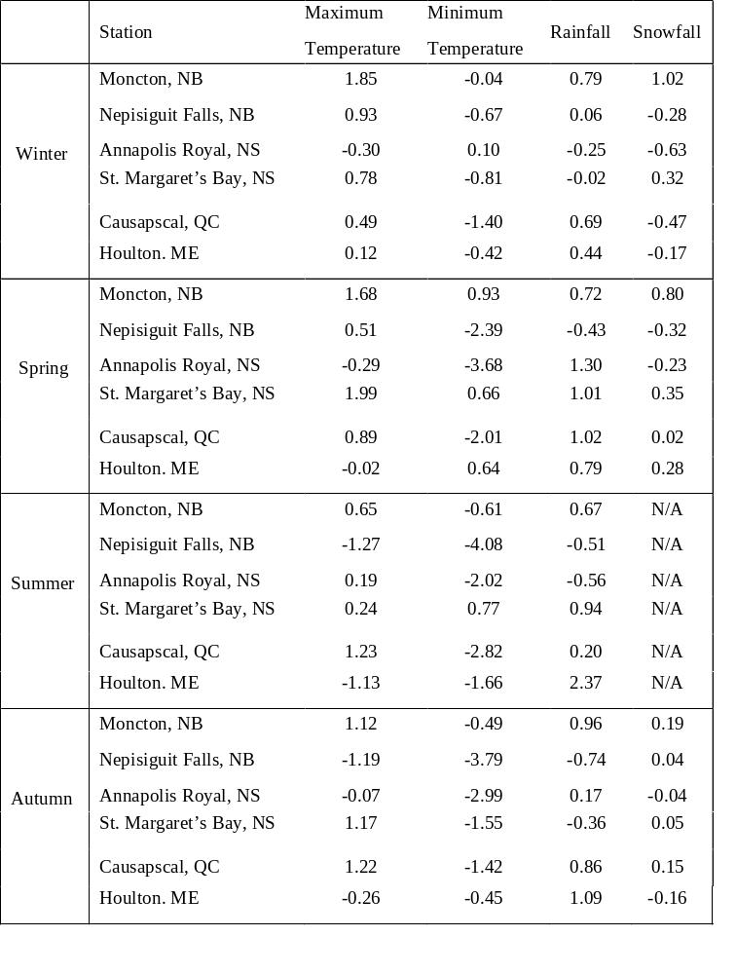

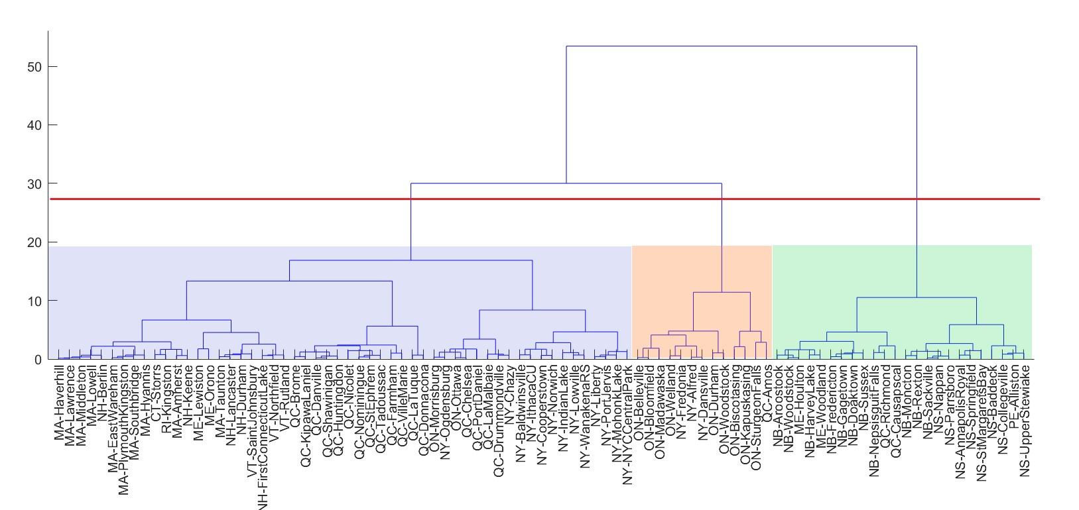
Sup. Fig. 1 Ward linkage cluster analysis showing three clusters, nodes labelled with weather station names. Colours correspond to those shown in map view in Fig. 1

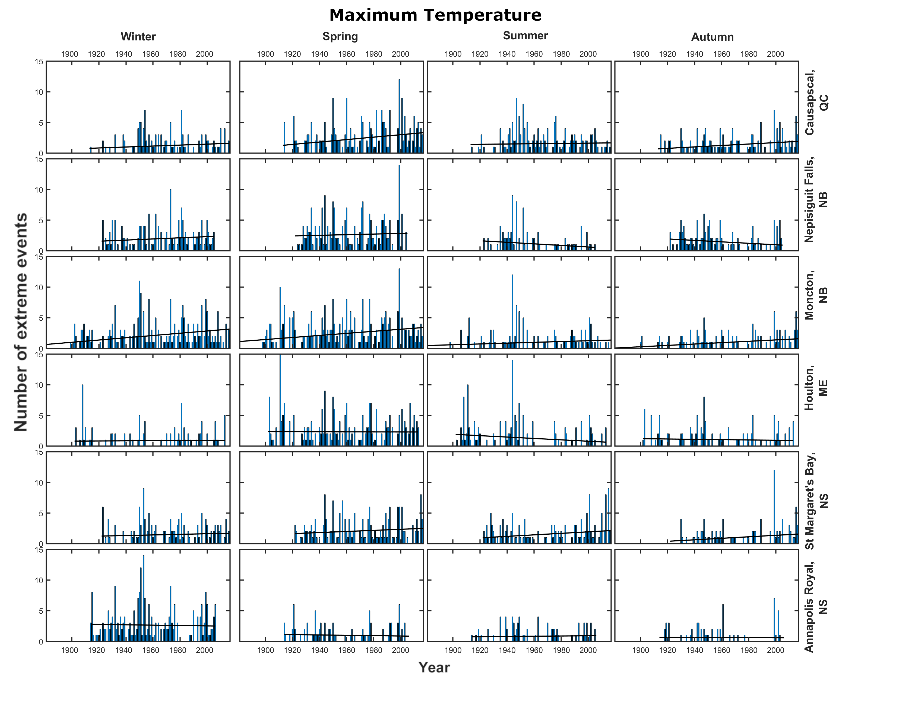
Sup. Fig. 2 Bar graphs for extreme maximum temperature events at the six stations used in this study. Linear trends that correspond to the best fit lines can be found in Sup. Table 1
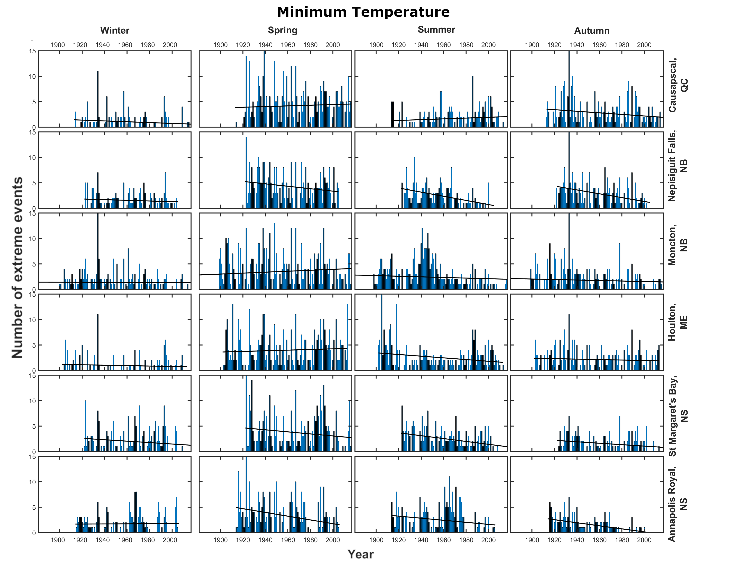
Sup. Fig. 3 Bar graphs for extreme minimum temperature events at the six stations used in this study. Linear trends that correspond to the best fit lines can be found in Sup. Table 1
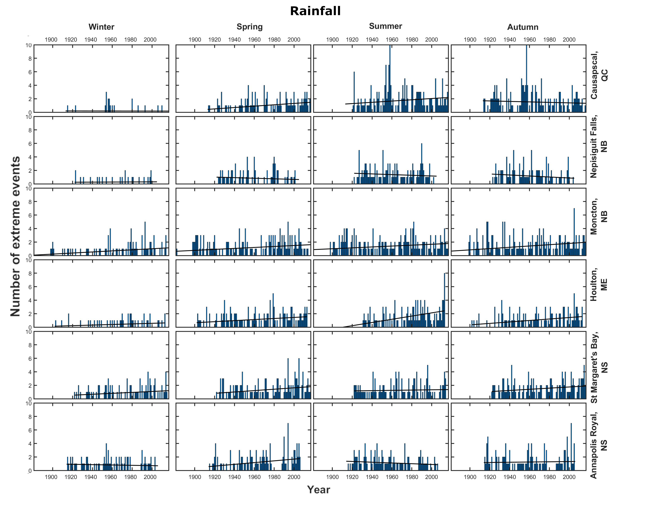
Sup. Fig. 4 Bar graphs for extreme rainfall events at the six stations used in this study. Linear trends that correspond to the best fit lines can be found in Sup. Table 1
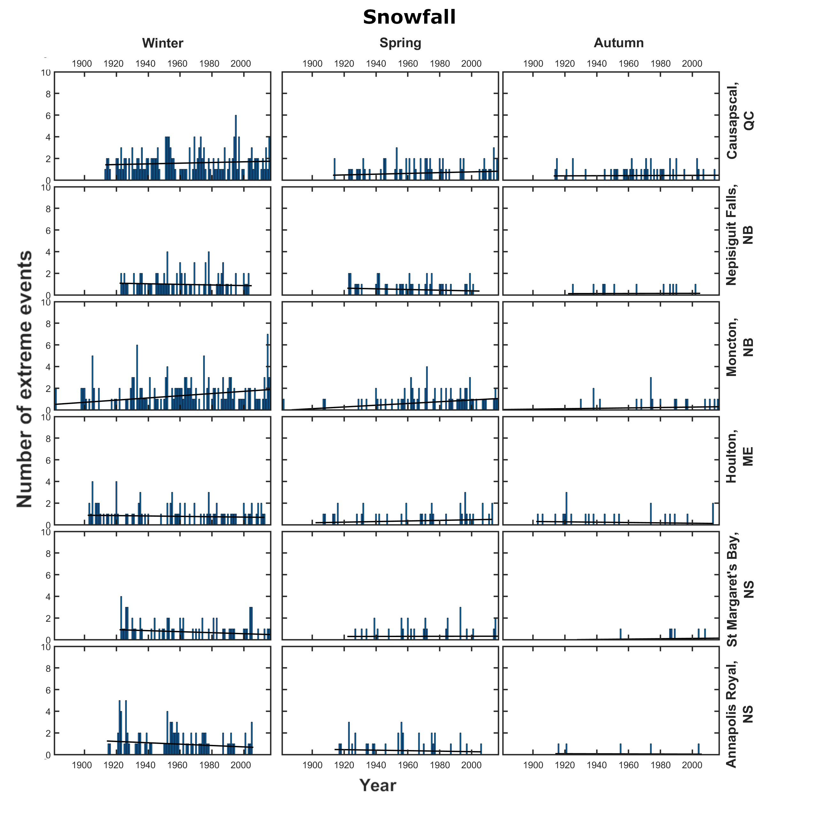
Sup. Fig. 5 Bar graphs for extreme snowfall events at the six stations used in this study.
Linear trends that correspond to the best fit lines can be found in Sup. Table 1
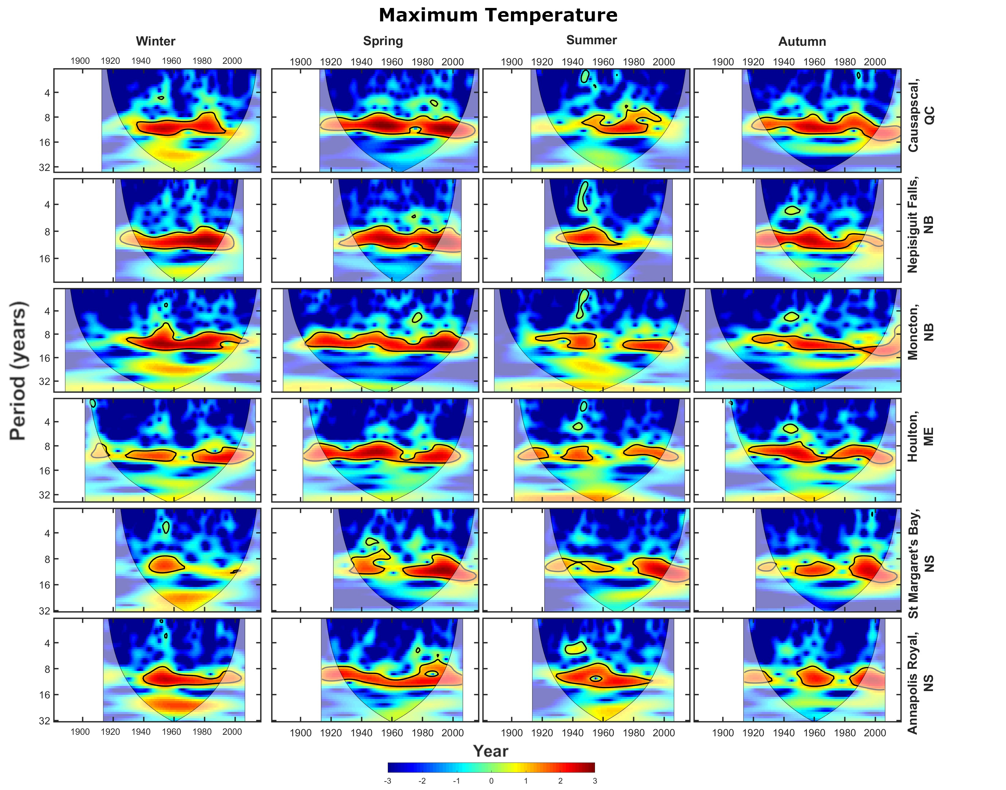
Sup. Fig. 6 Cross wavelet transforms (XWTs) between extreme maximum temperature and the SSC at the six stations used in this study at the six stations used in this study. Areas of high common spectral density that are above the 95% confidence interval are outlined in black
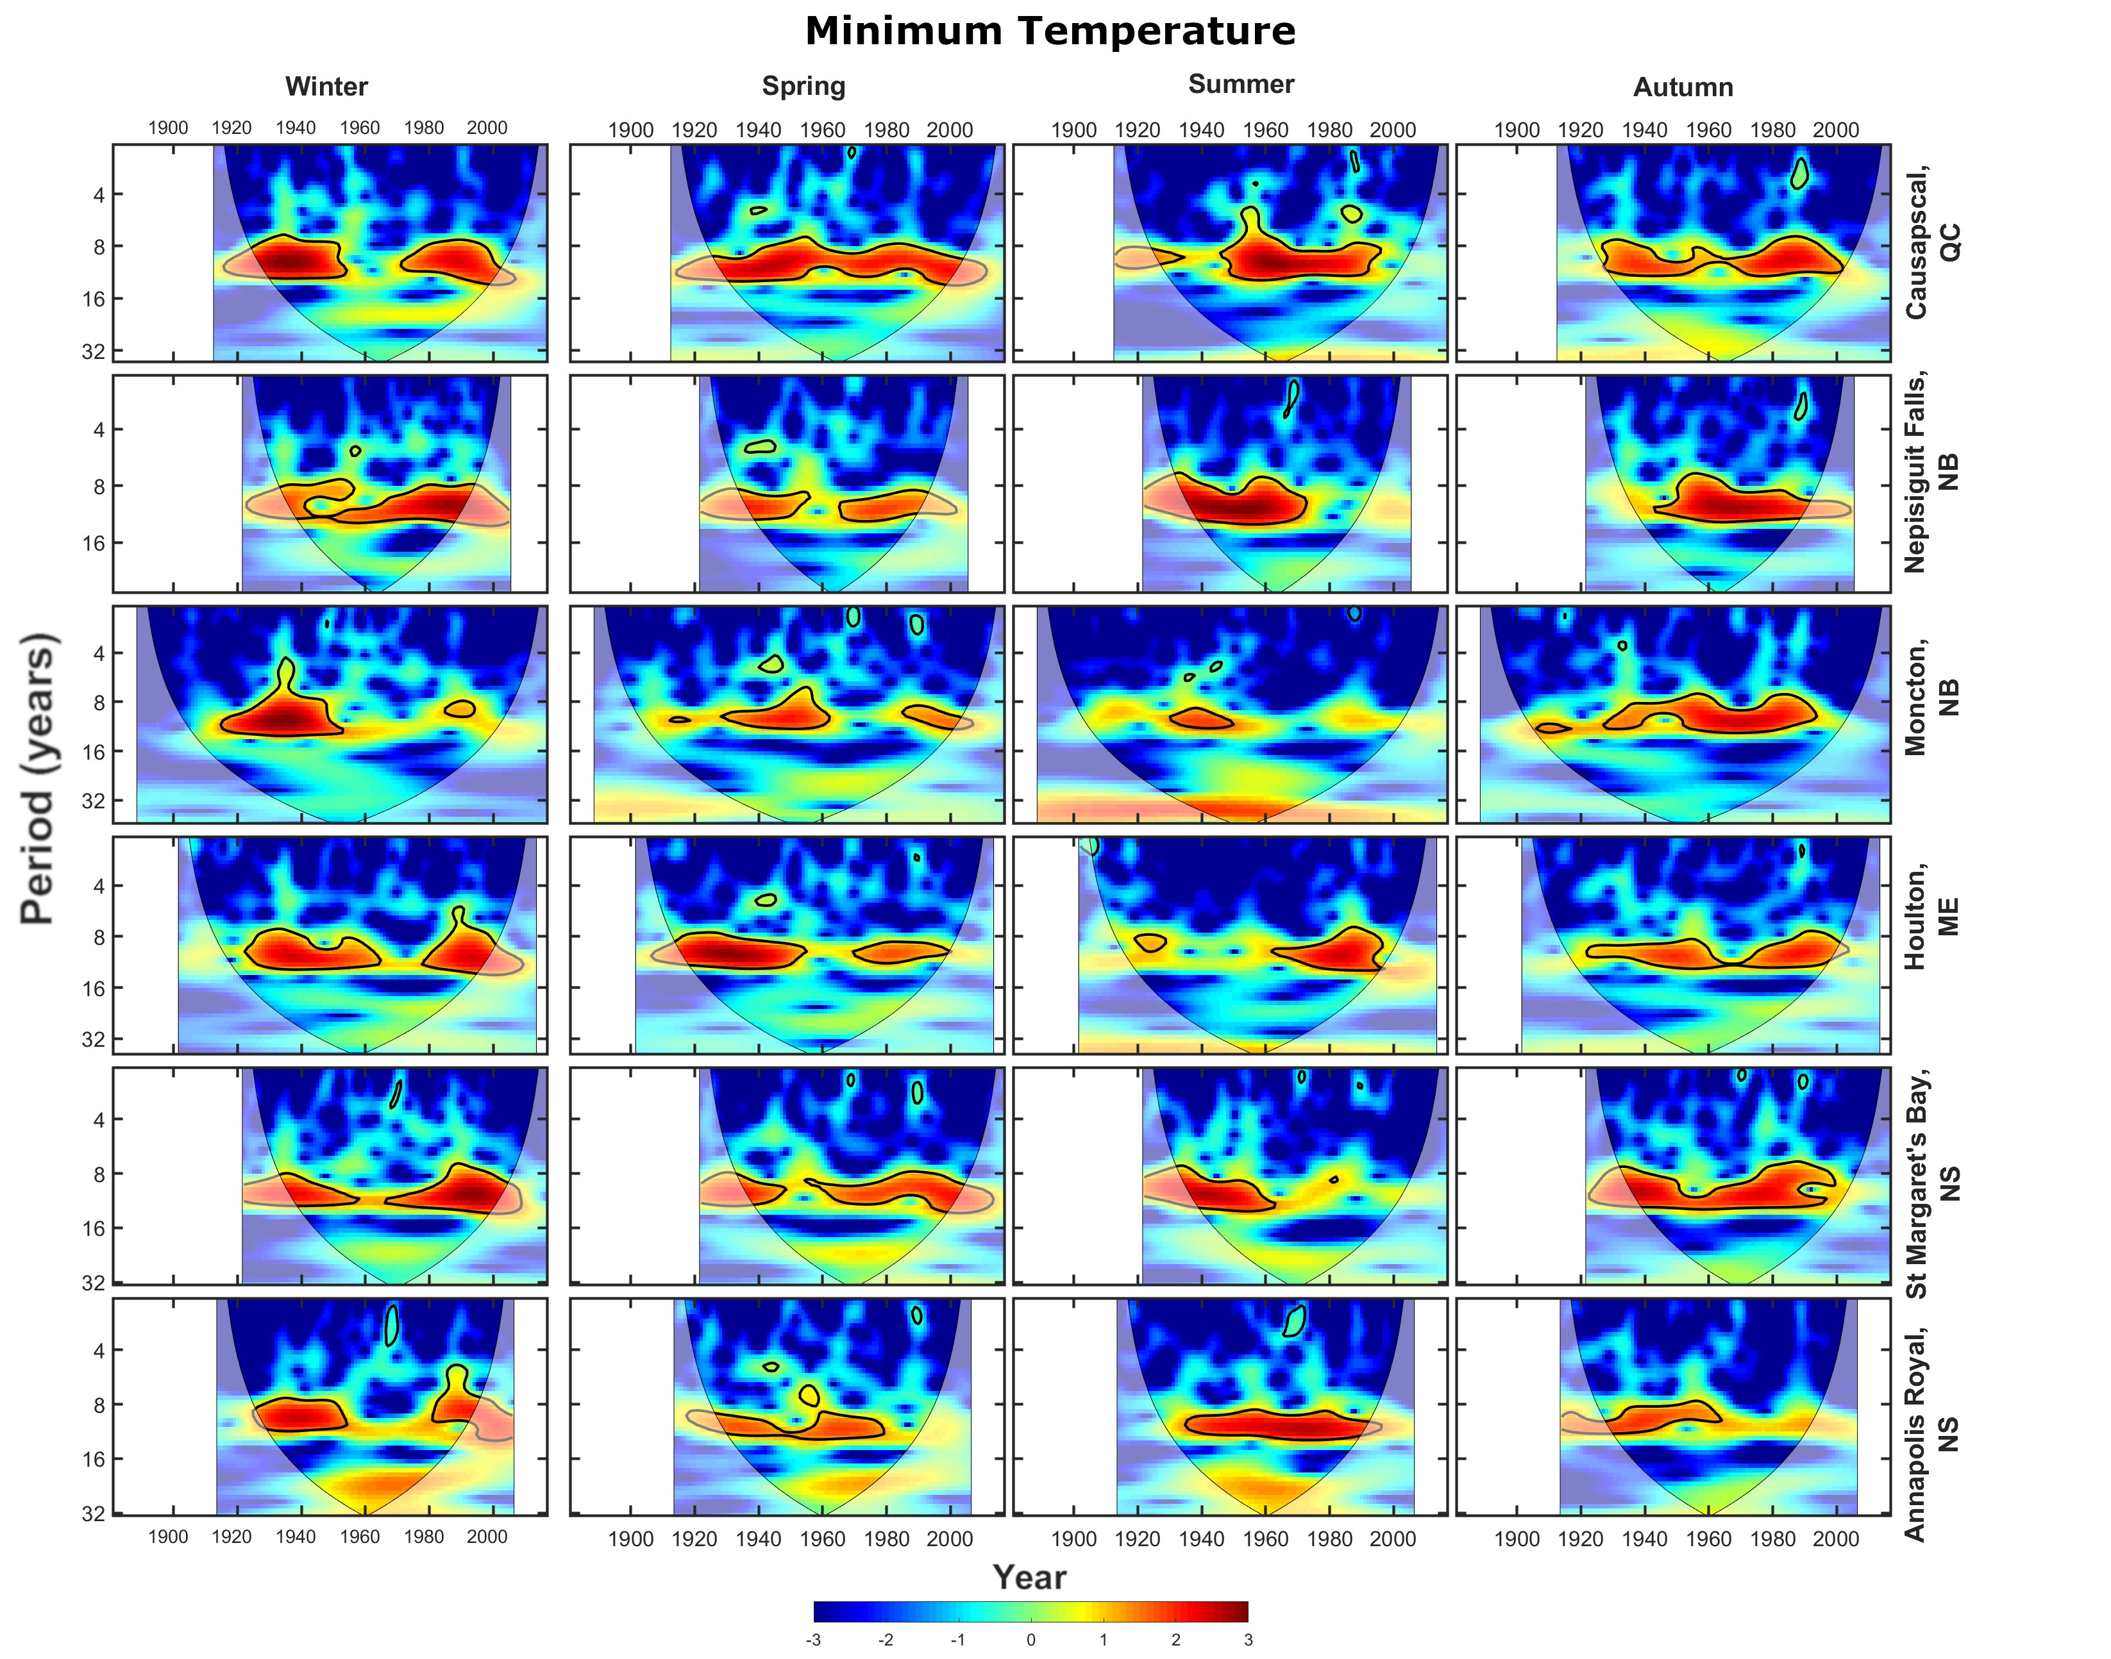
Sup. Fig. 7 Cross wavelet transforms (XWTs) between extreme minimum temperature and the SSC at the six stations used in this study at the six stations used in this study. Areas of high common spectral density that are above the 95% confidence interval are outlined in black
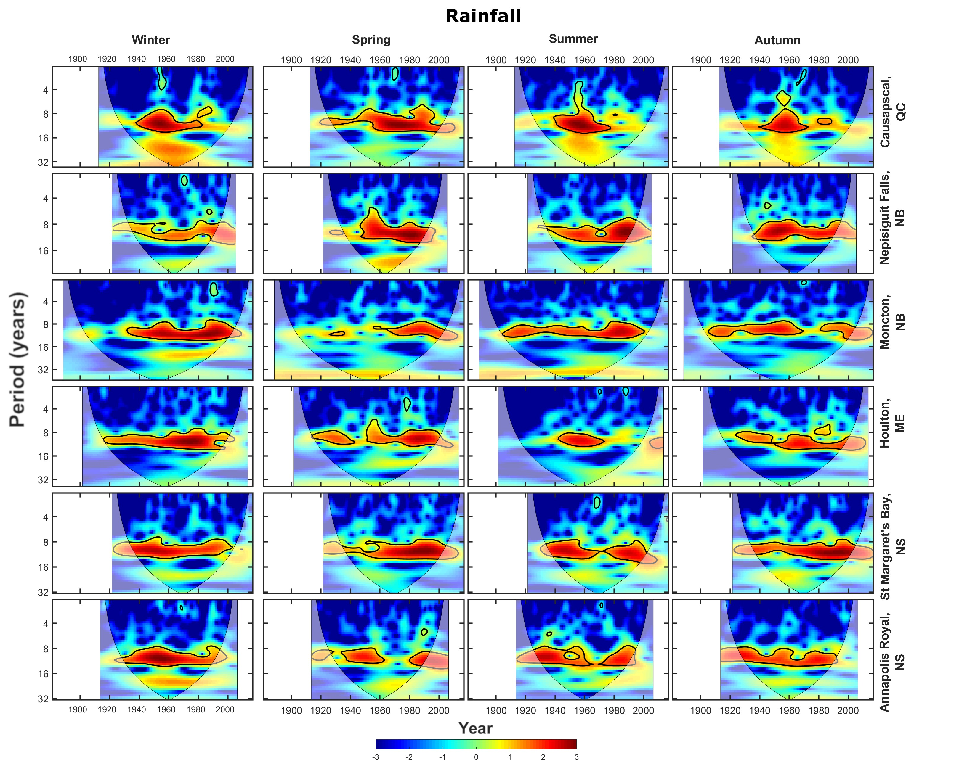
Sup. Fig. 8 Cross wavelet transforms (XWTs) between extreme rainfall and the SSC at the six stations used in this study at the six stations used in this study. Areas of high common spectral density that are above the 95% confidence interval are outlined in black

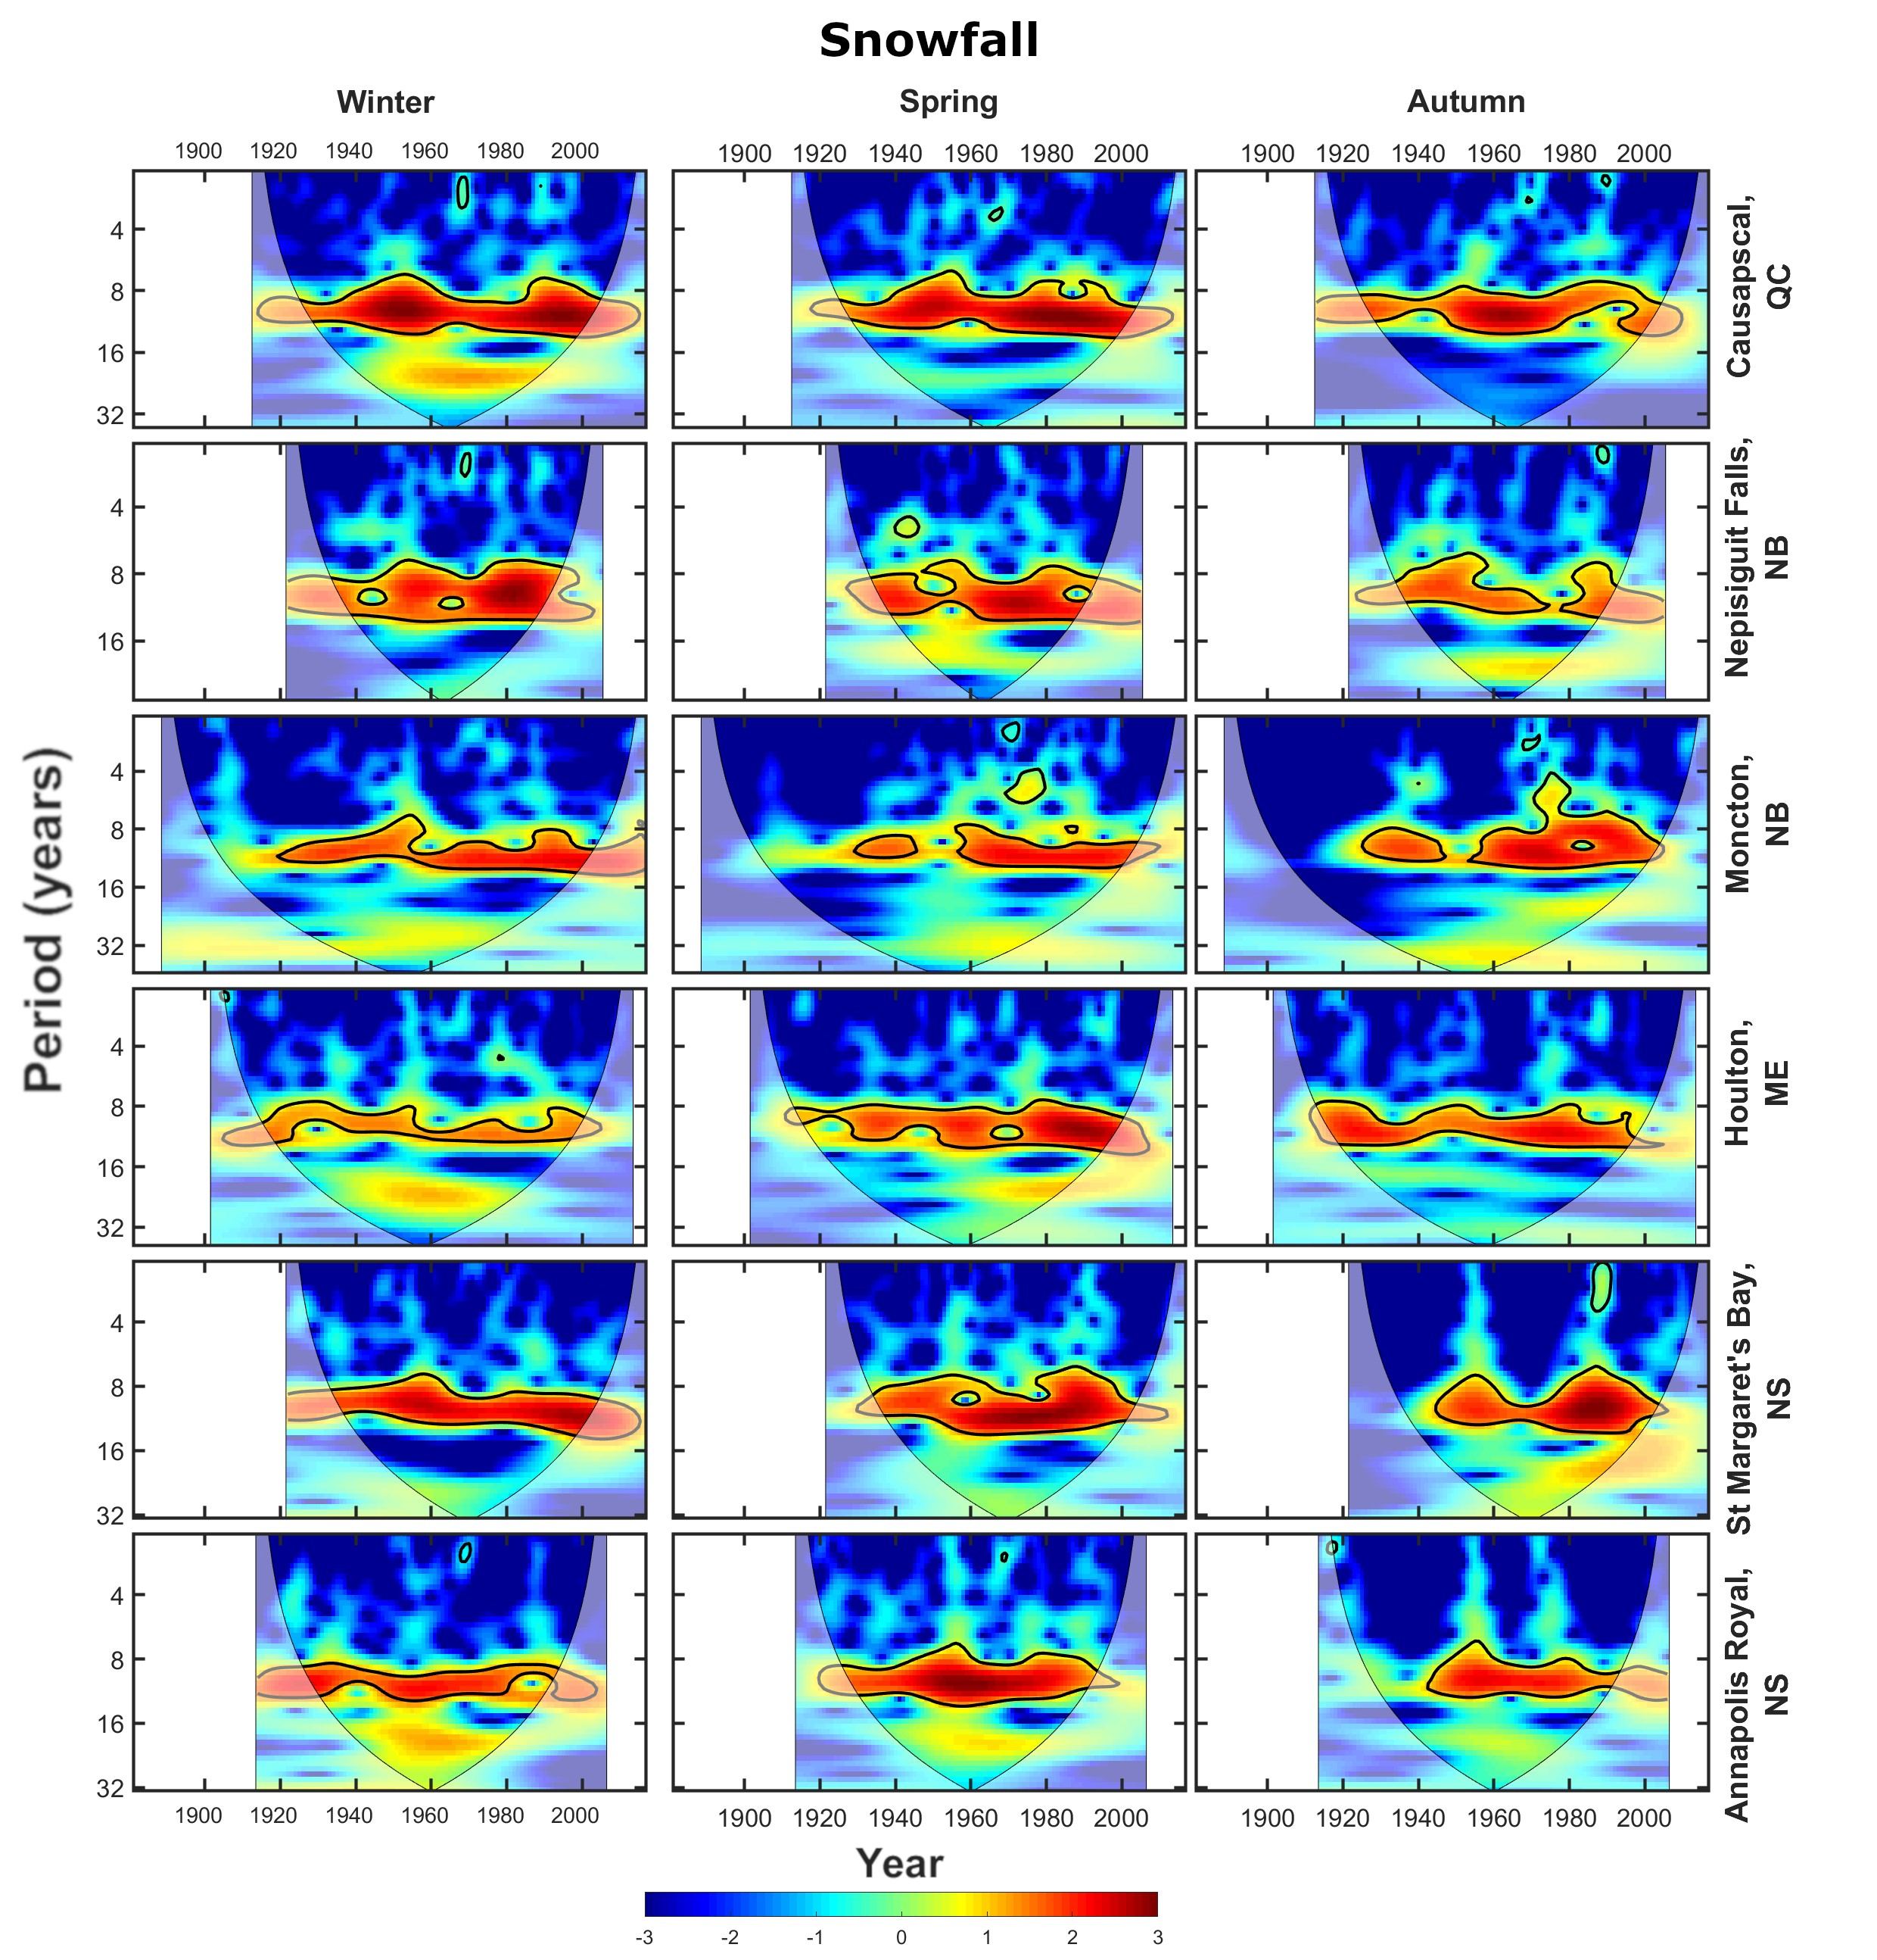
Sup. Fig. 9 Cross wavelet transforms (XWTs) between extreme snowfall and the SSC at the six stations used in this study at the six stations used in this study. Areas of high common spectral density that are above the 95% confidence interval are outlined in black
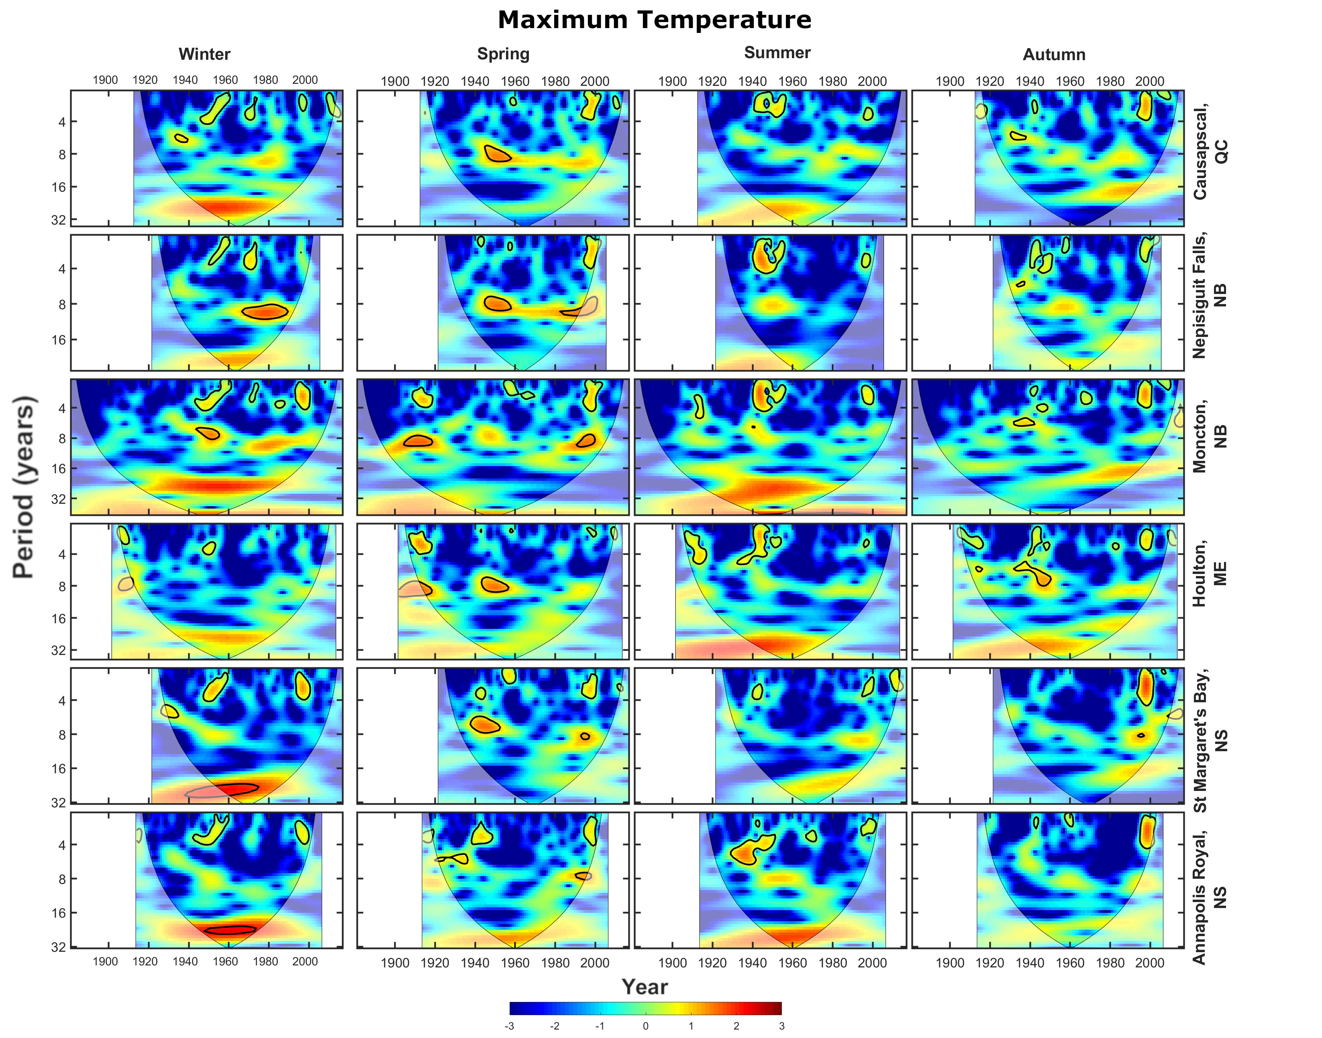
Sup. Fig. 10 Cross wavelet transforms (XWTs) between extreme maximum temperature and the AMO at the six stations used in this study at the six stations used in this study. Areas of high common spectral density that are above the 95% confidence interval are outlined in black
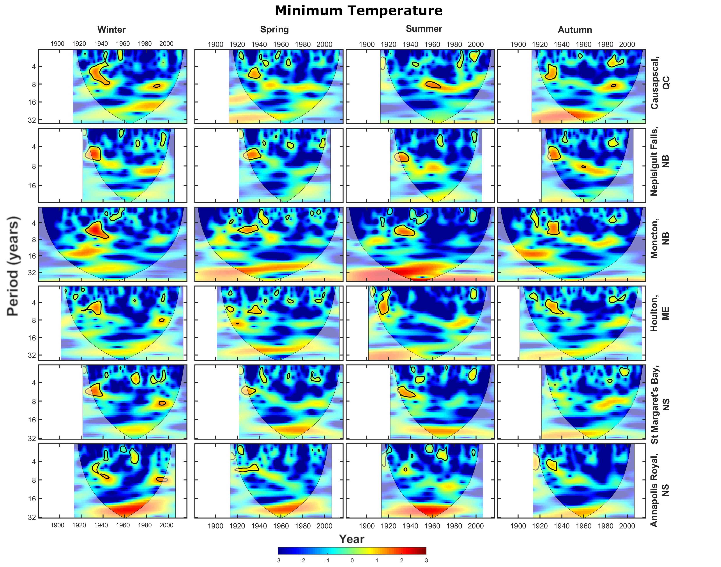
Sup. Fig. 11 Cross wavelet transforms (XWTs) between extreme minimum temperature and the AMO at the six stations used in this study at the six stations used in this study. Areas of high common spectral density that are above the 95% confidence interval are outlined in black
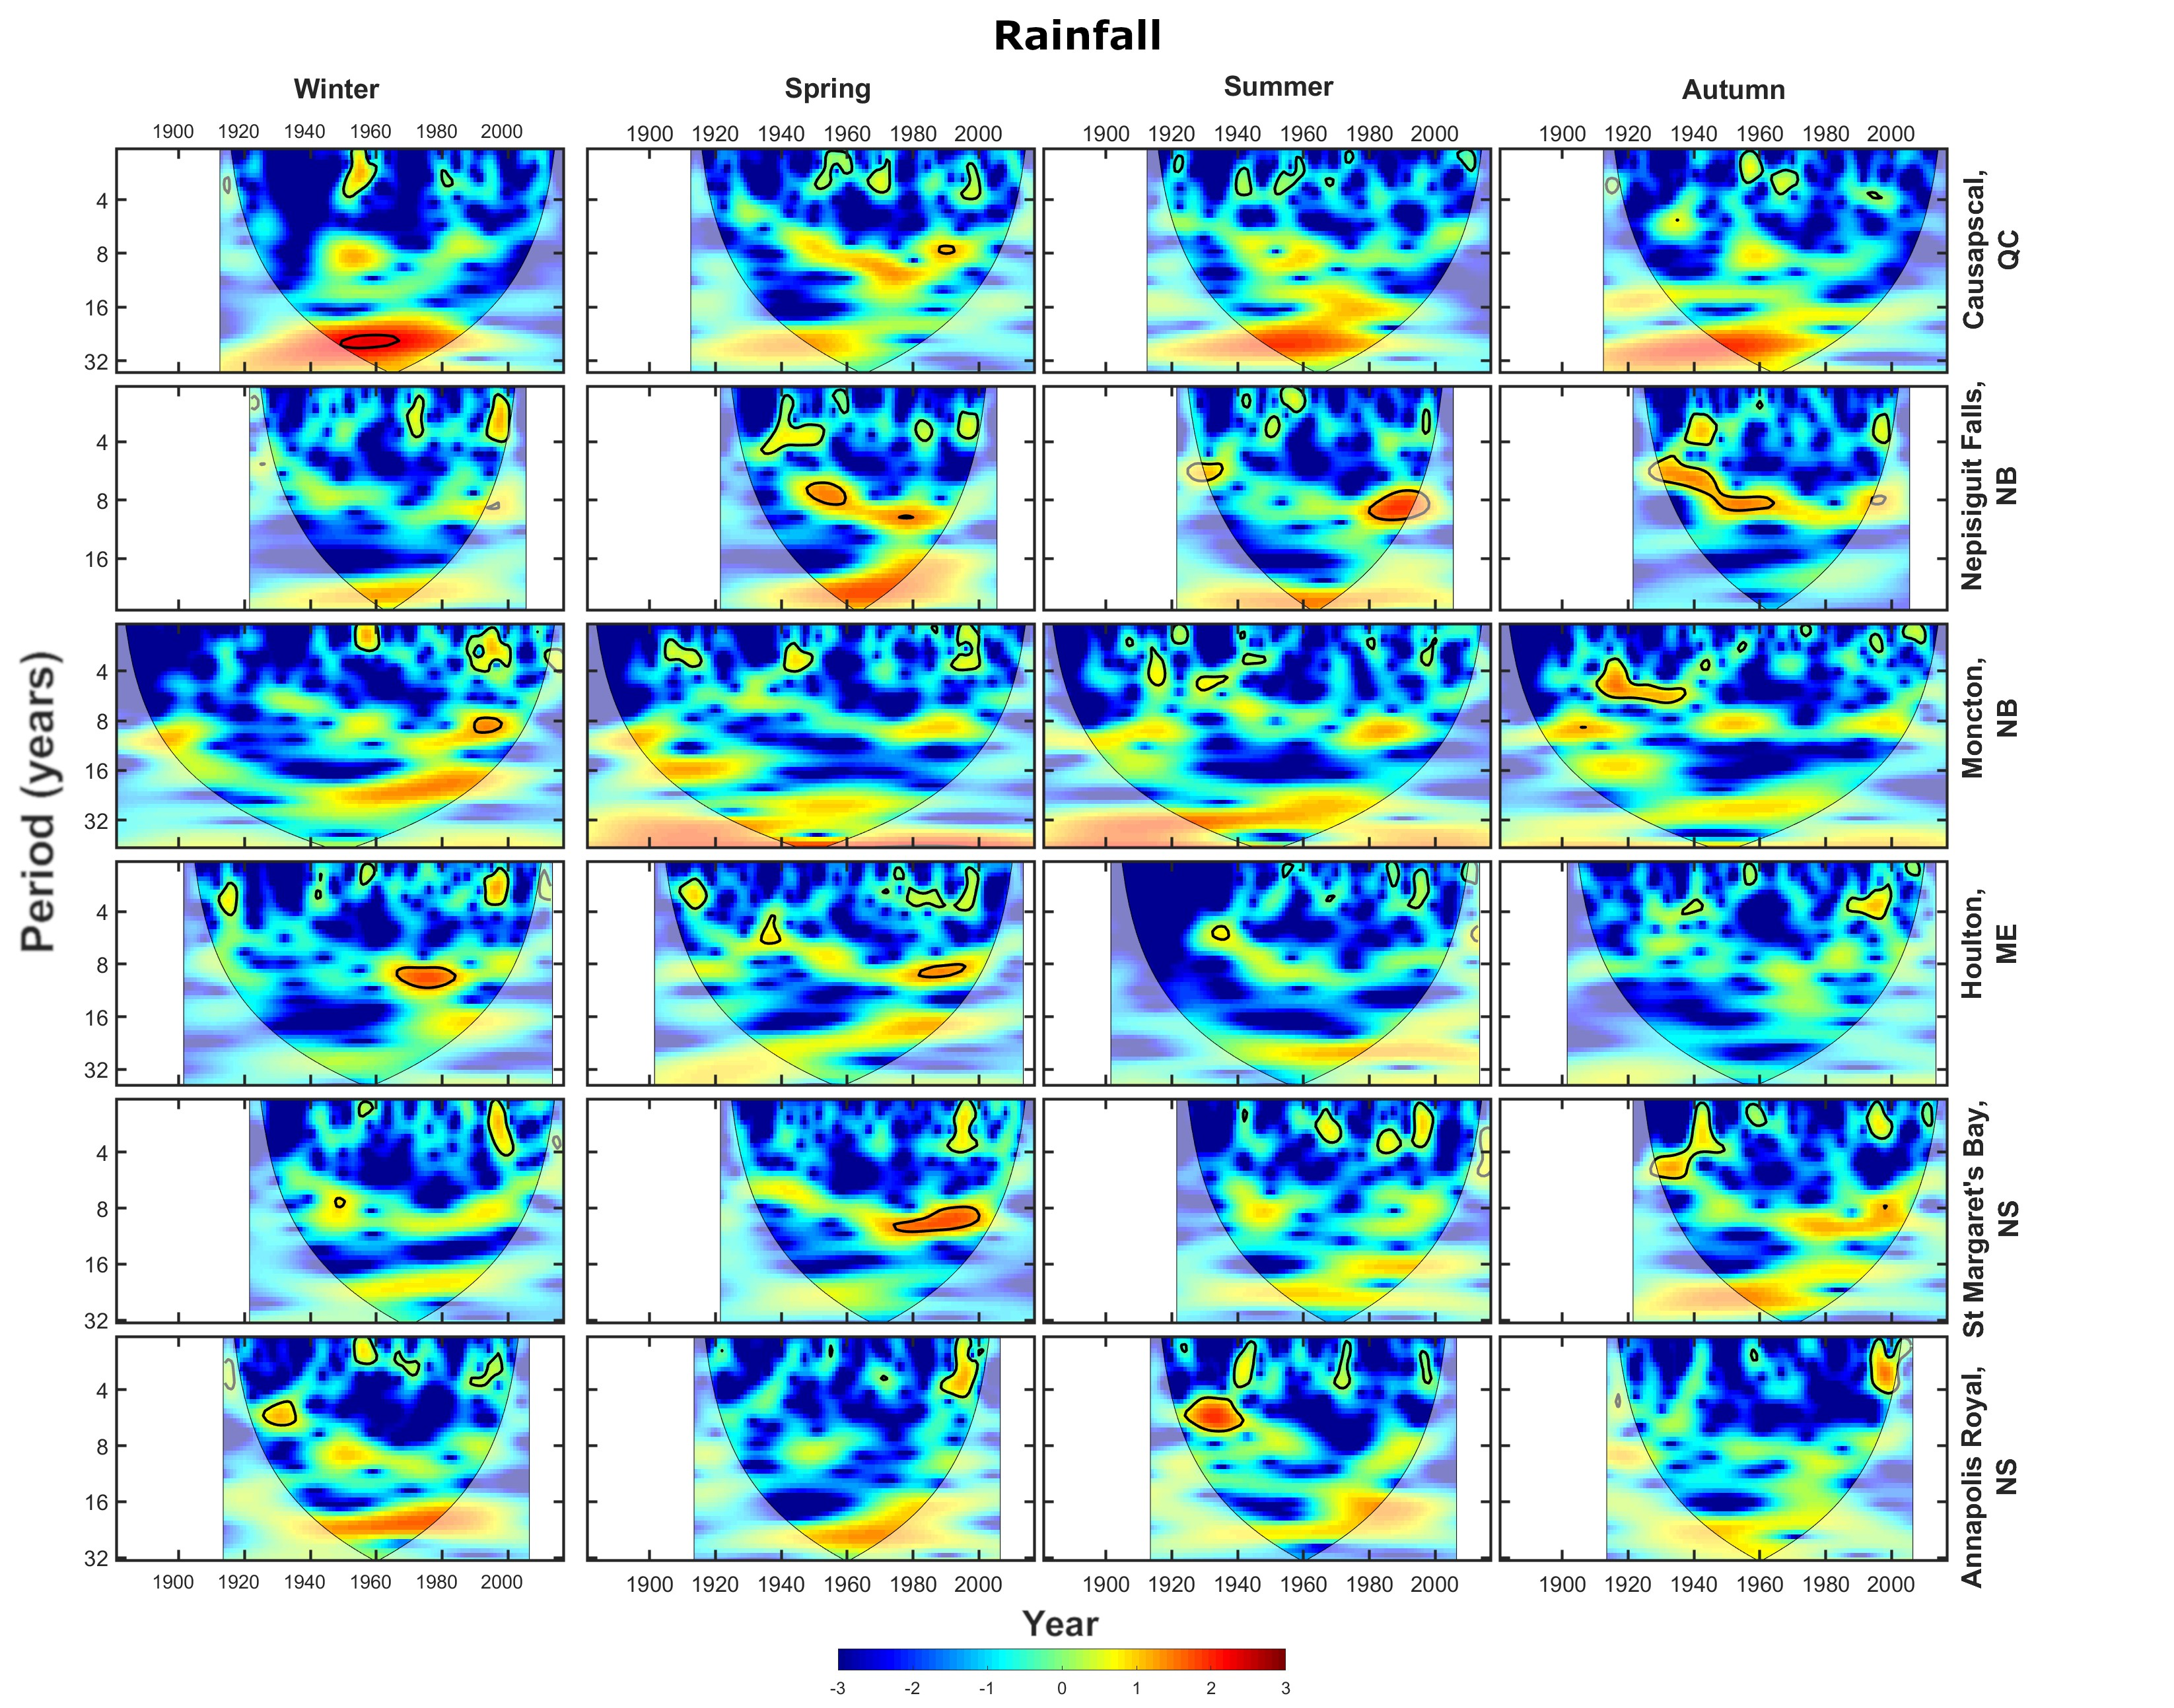
Sup. Fig. 12 Cross wavelet transforms (XWTs) between extreme rainfall and the AMO at the six stations used in this study at the six stations used in this study. Areas of high common spectral density that are above the 95% confidence interval are outlined in black

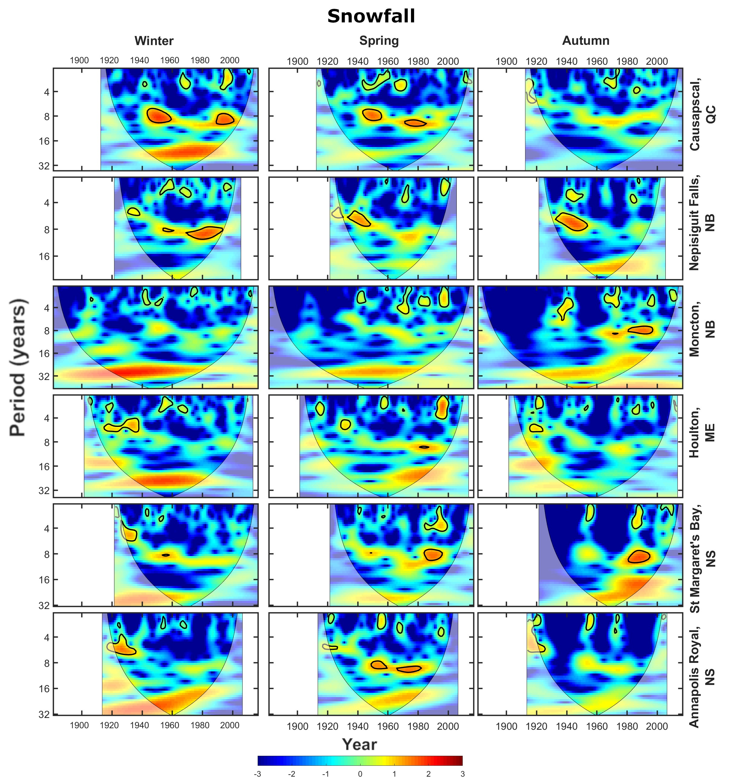
Sup. Fig. 13 Cross wavelet transforms (XWTs) between extreme snowfall and the AMO at the six stations used in this study at the six stations used in this study. Areas of high common spectral density that are above the 95% confidence interval are outlined in black
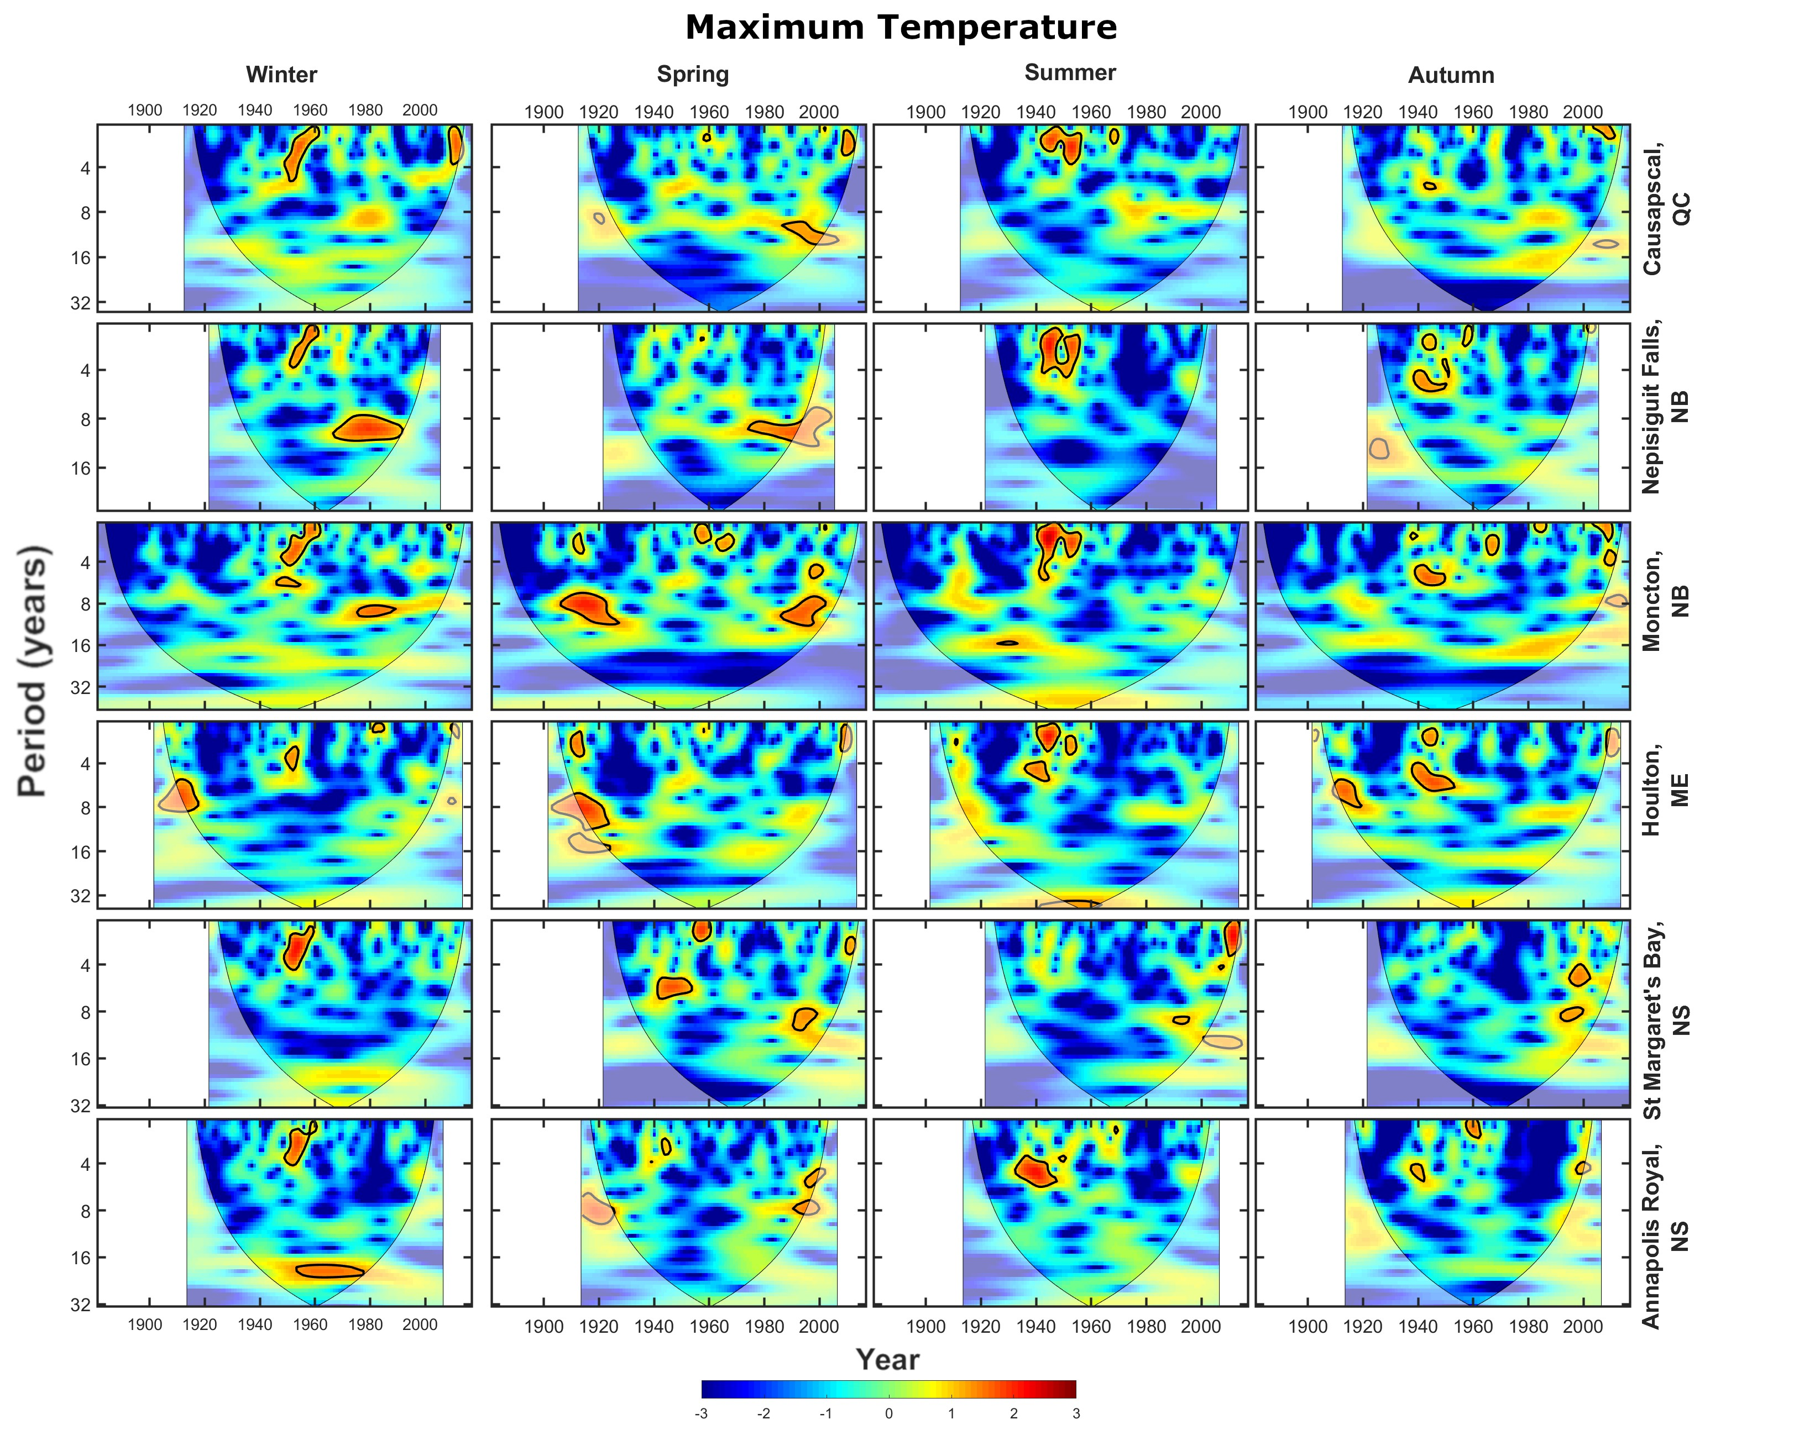
Sup. Fig. 14 Cross wavelet transforms (XWTs) between extreme maximum temperature and the NAO at the six stations used in this study. Areas of high common spectral density that are above the 95% confidence interval are outlined in black
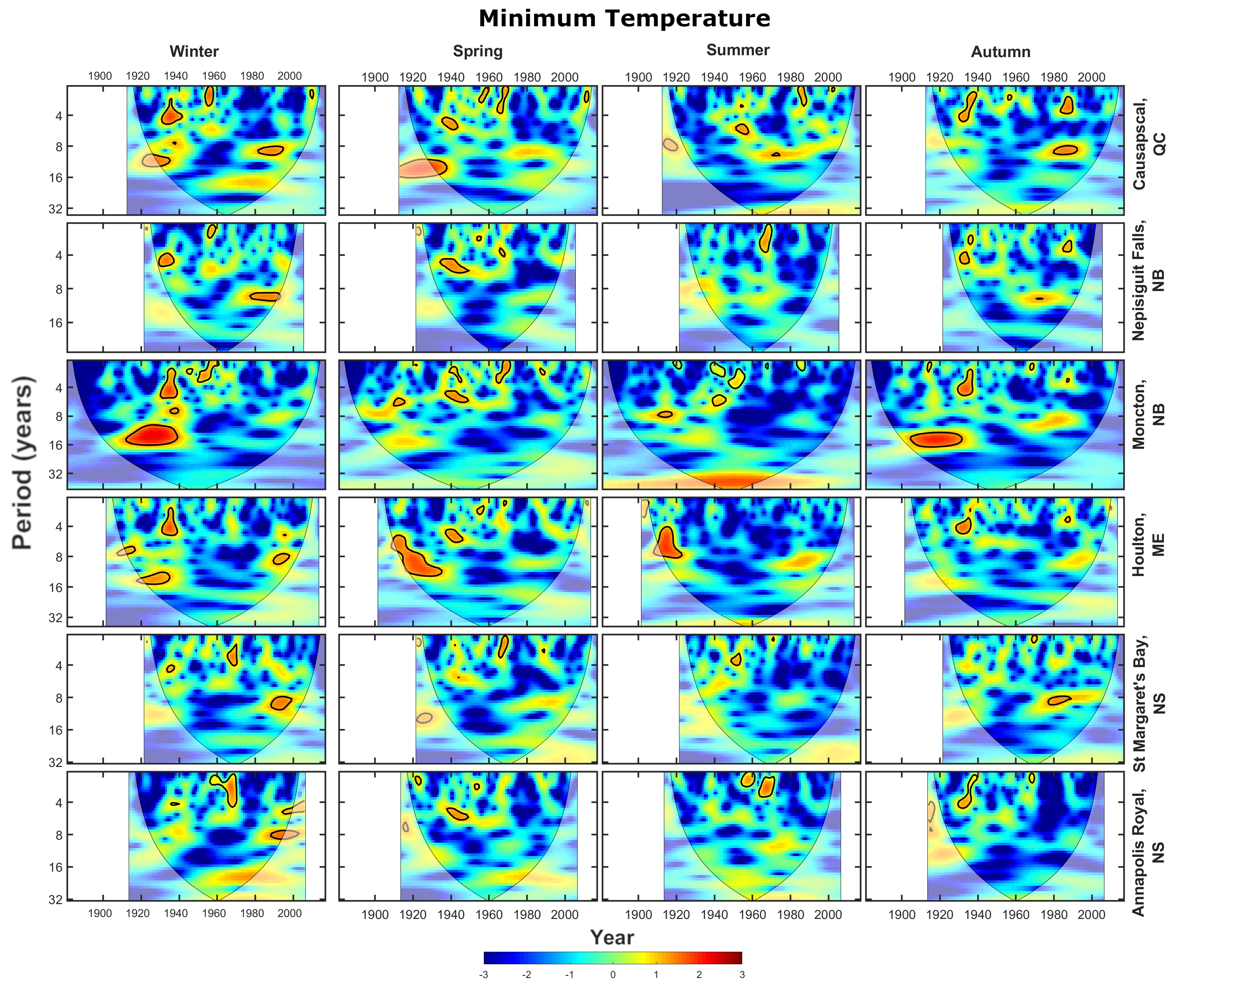
Sup. Fig. 15 Cross wavelet transforms (XWTs) between extreme minimum temperature and the NAO at the six stations used in this study. Areas of high common spectral density that are above the 95% confidence interval are outlined in black
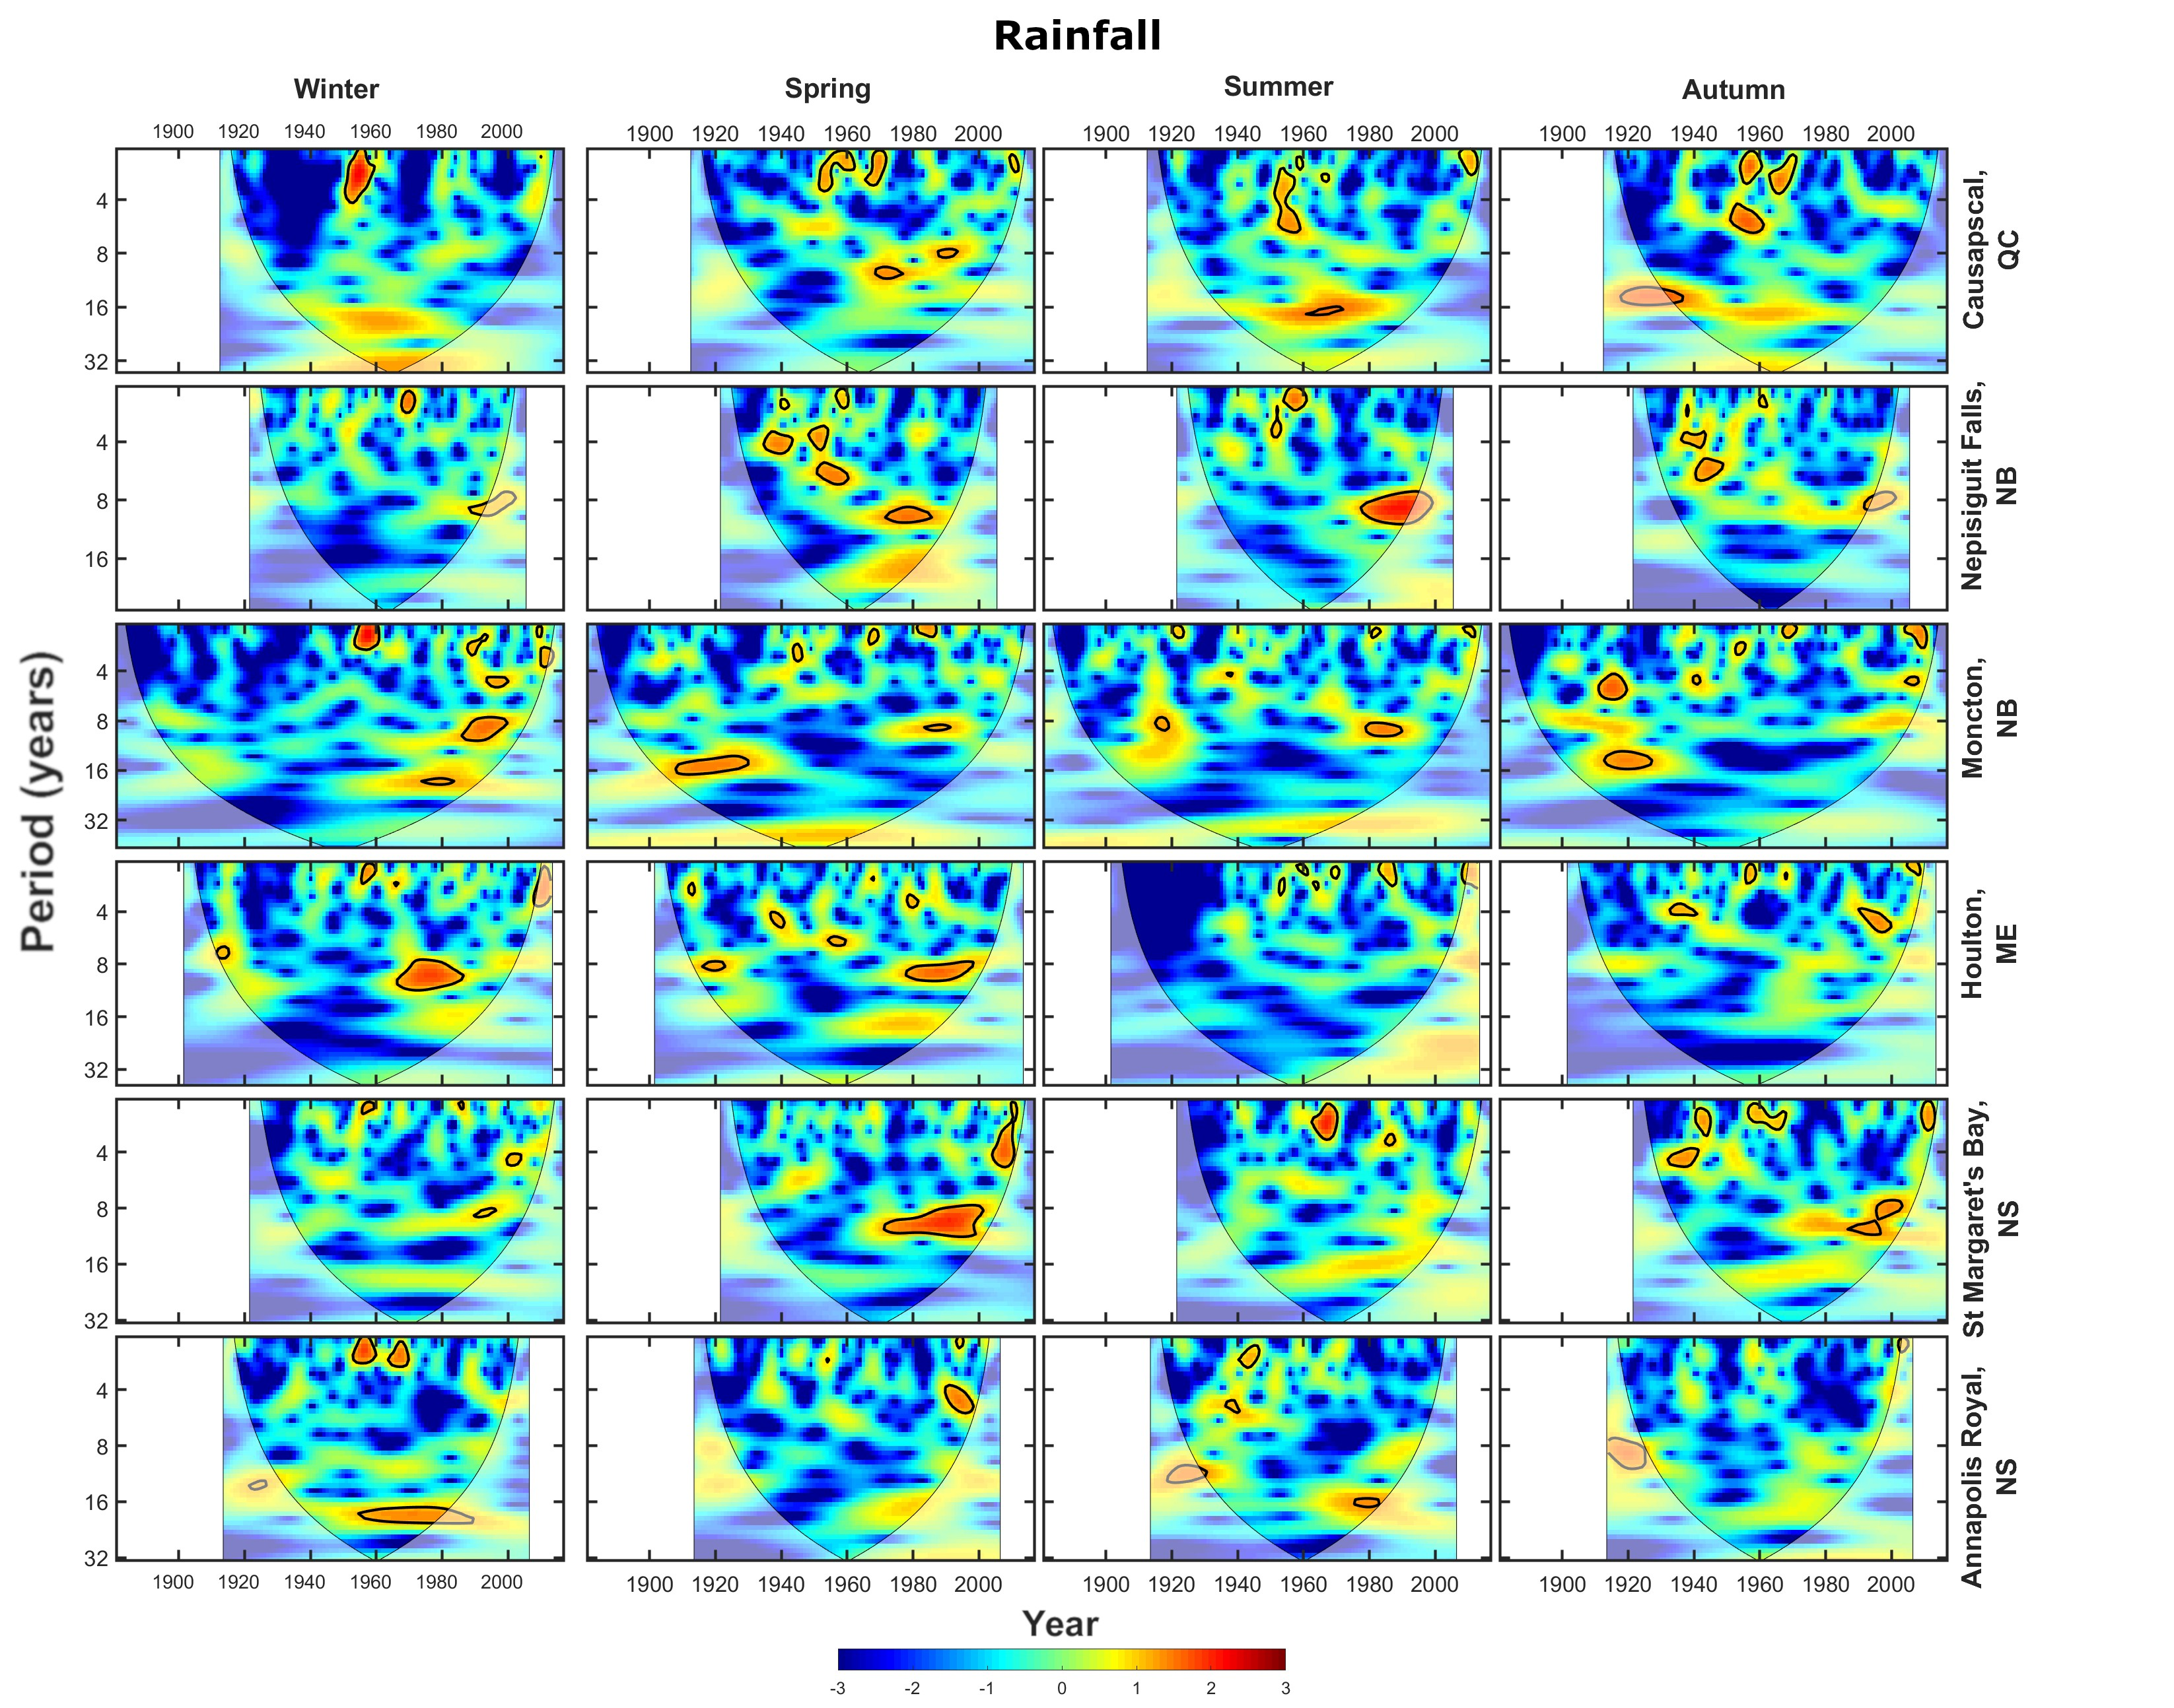
Sup. Fig. 16 Cross wavelet transforms (XWTs) between extreme rainfall and the NAO at the six stations used in this study. Areas of high common spectral density that are above the 95% confidence interval are outlined in black

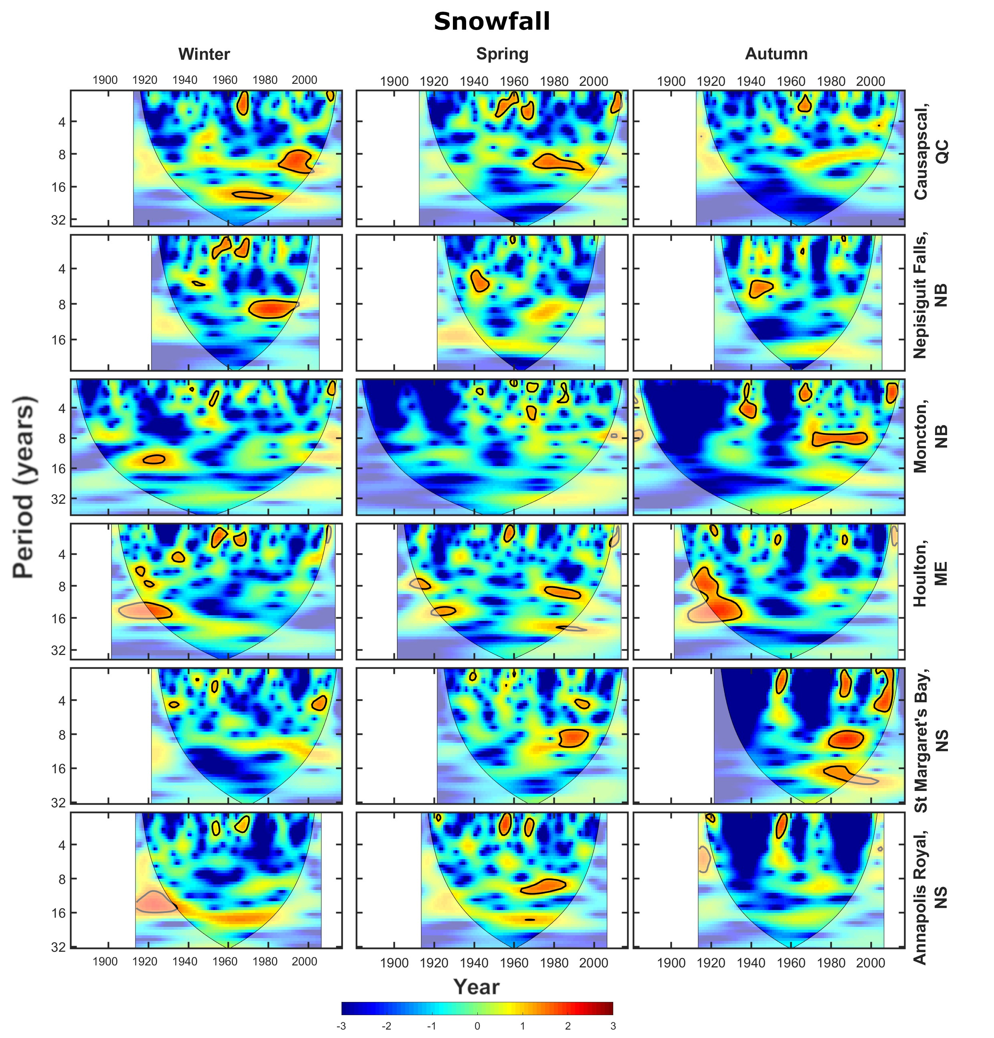
Sup. Fig. 17 Cross wavelet transforms (XWTs) between extreme snowfall and the NAO at the six stations used in this study. Areas of high common spectral density that are above the 95% confidence interval are outlined in black
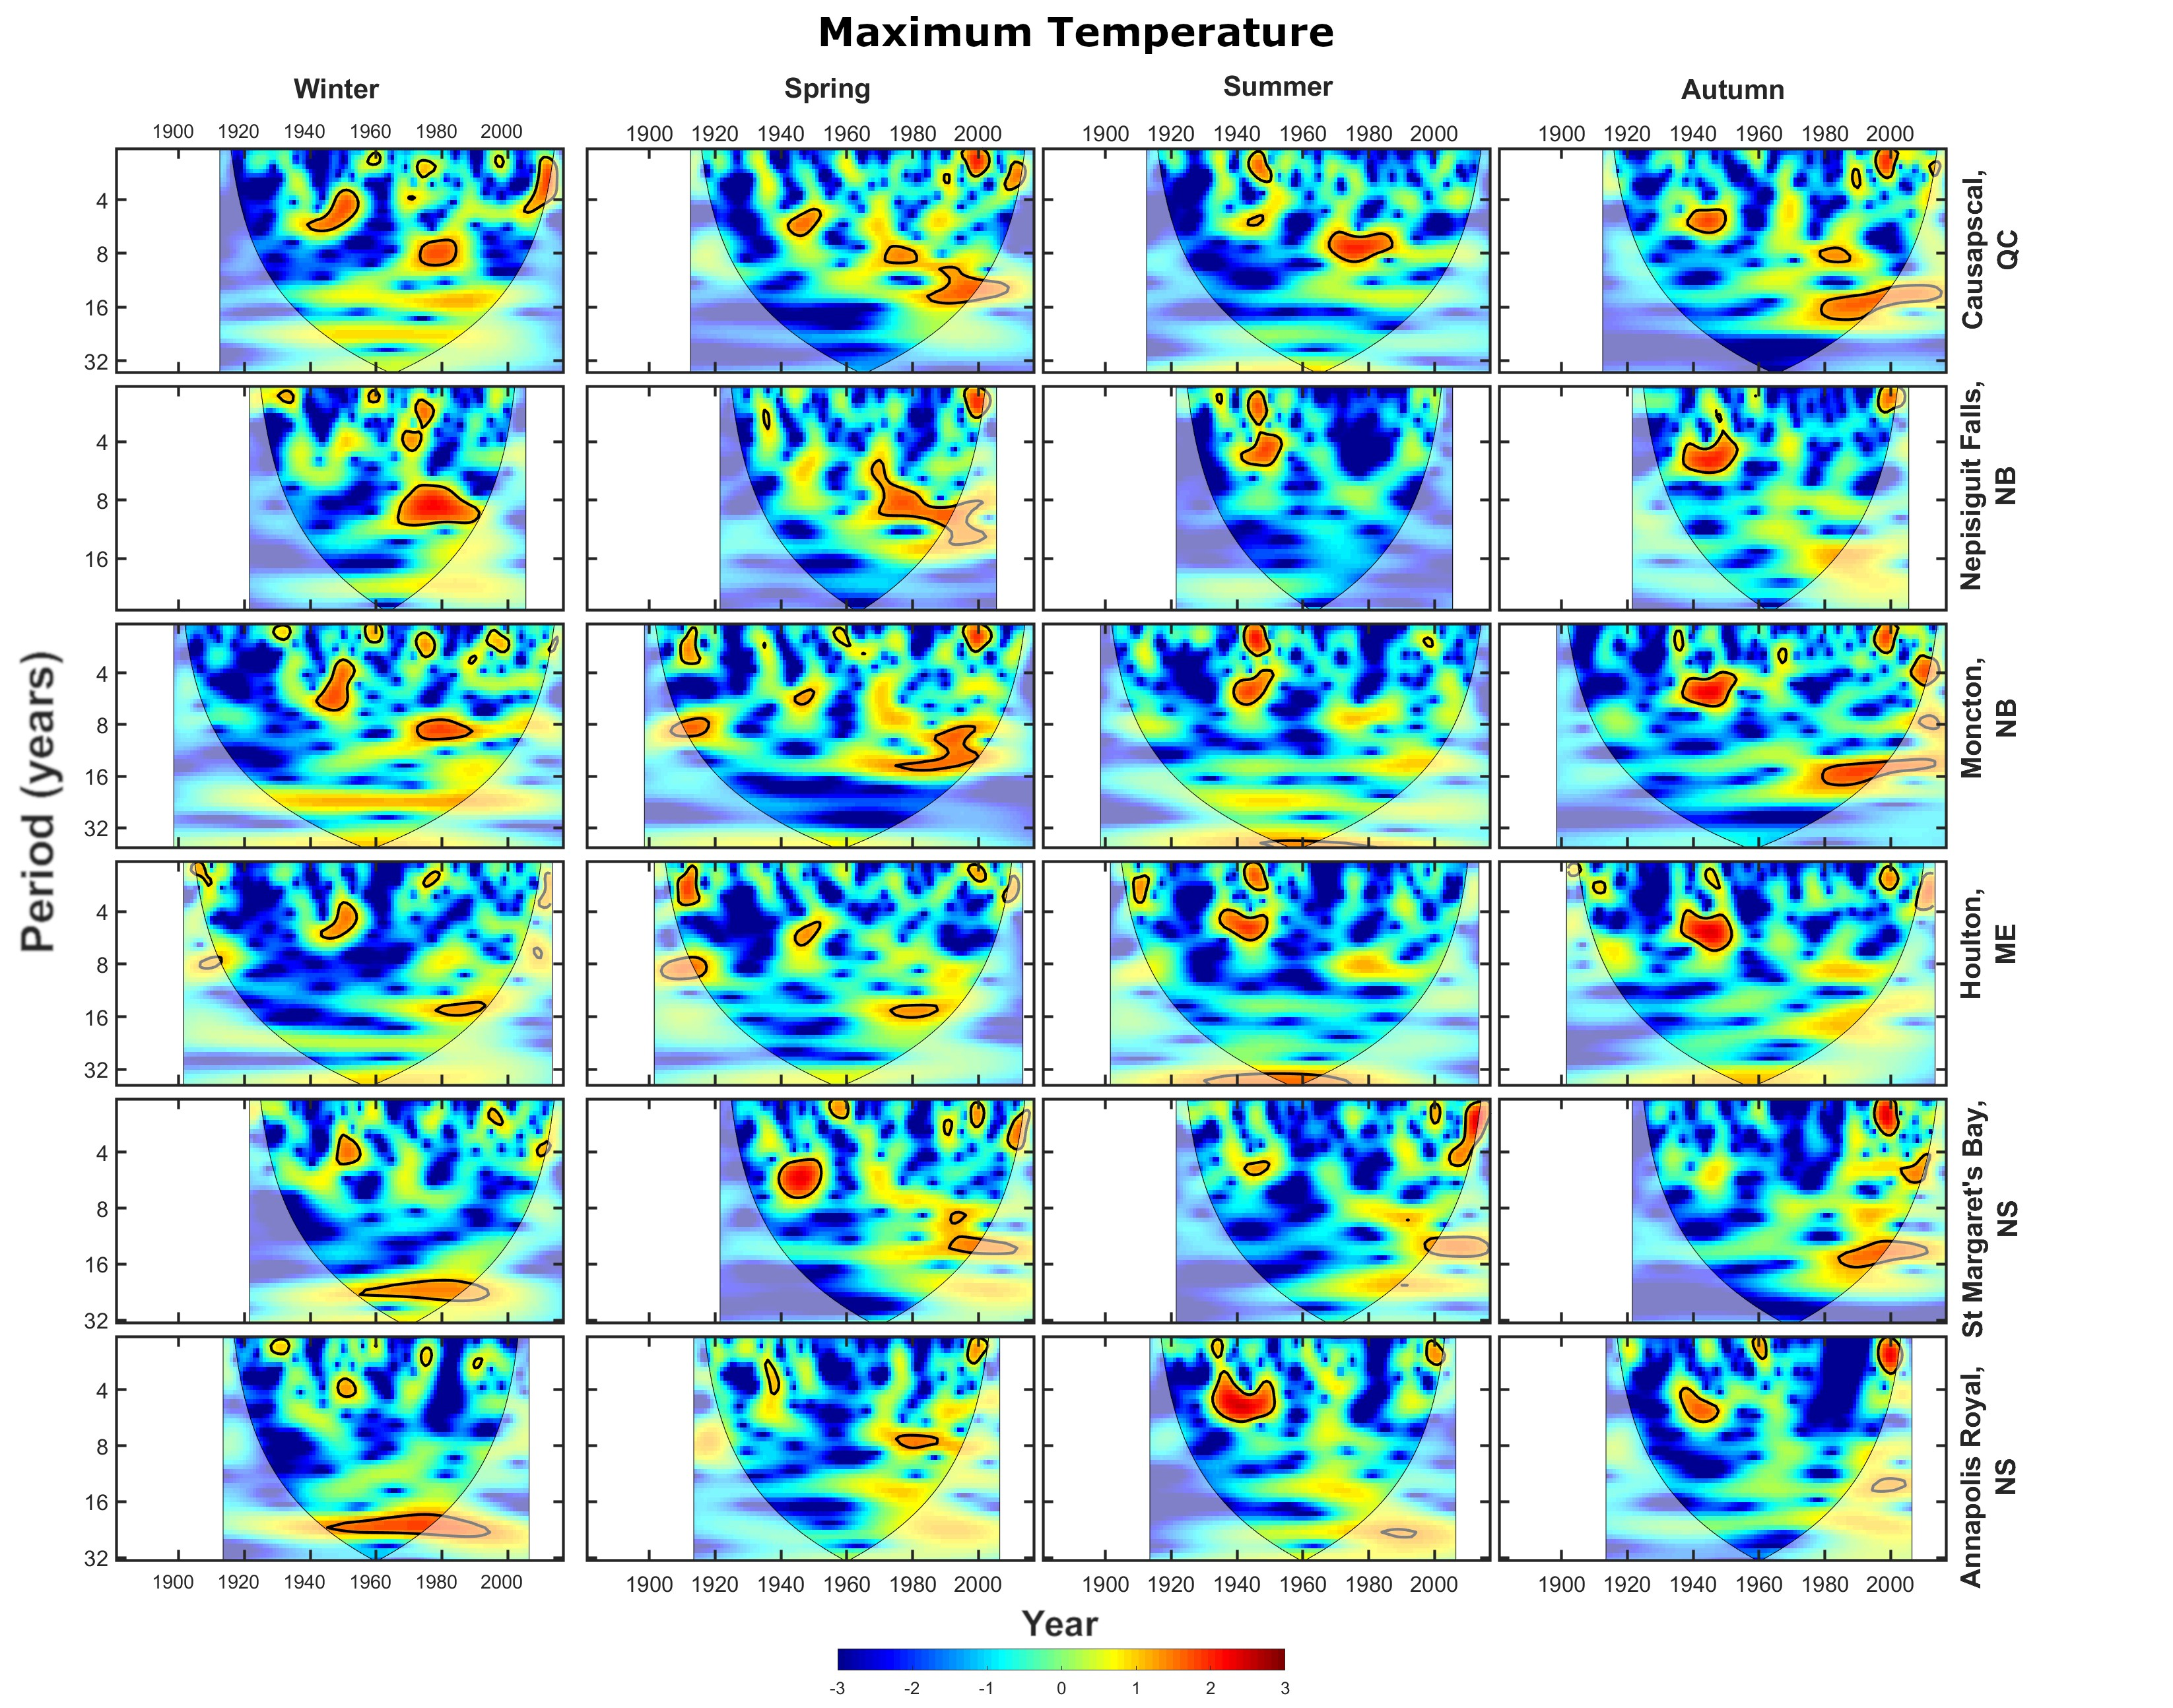
Sup. Fig. 18 Cross wavelet transforms (XWTs) between extreme maximum temperature and the AO at the six stations used in this study. Areas of high common spectral density that are above the 95% confidence interval are outlined in black
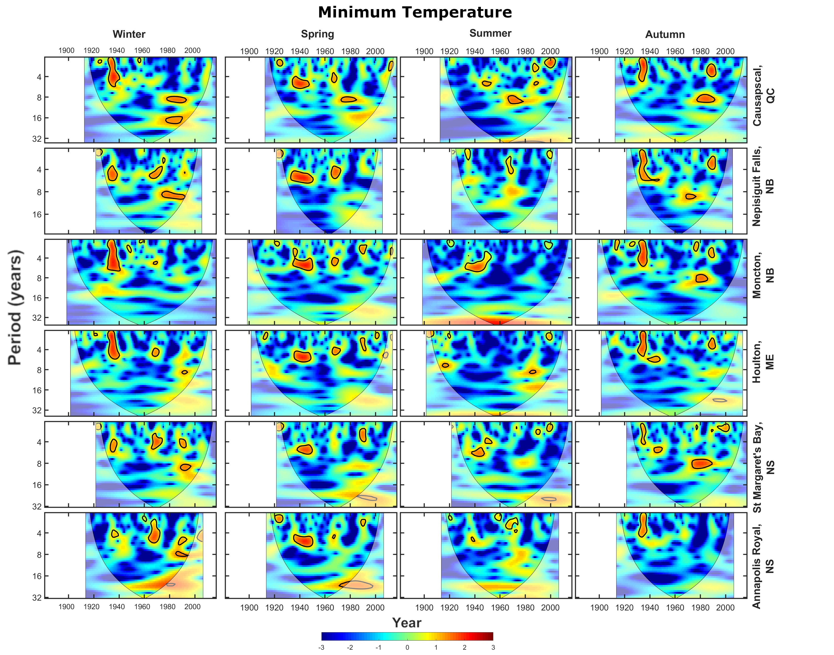
Sup. Fig. 19 Cross wavelet transforms (XWTs) between extreme minimum temperature and the AO at the six stations used in this study. Areas of high common spectral density that are above the 95% confidence interval are outlined in black
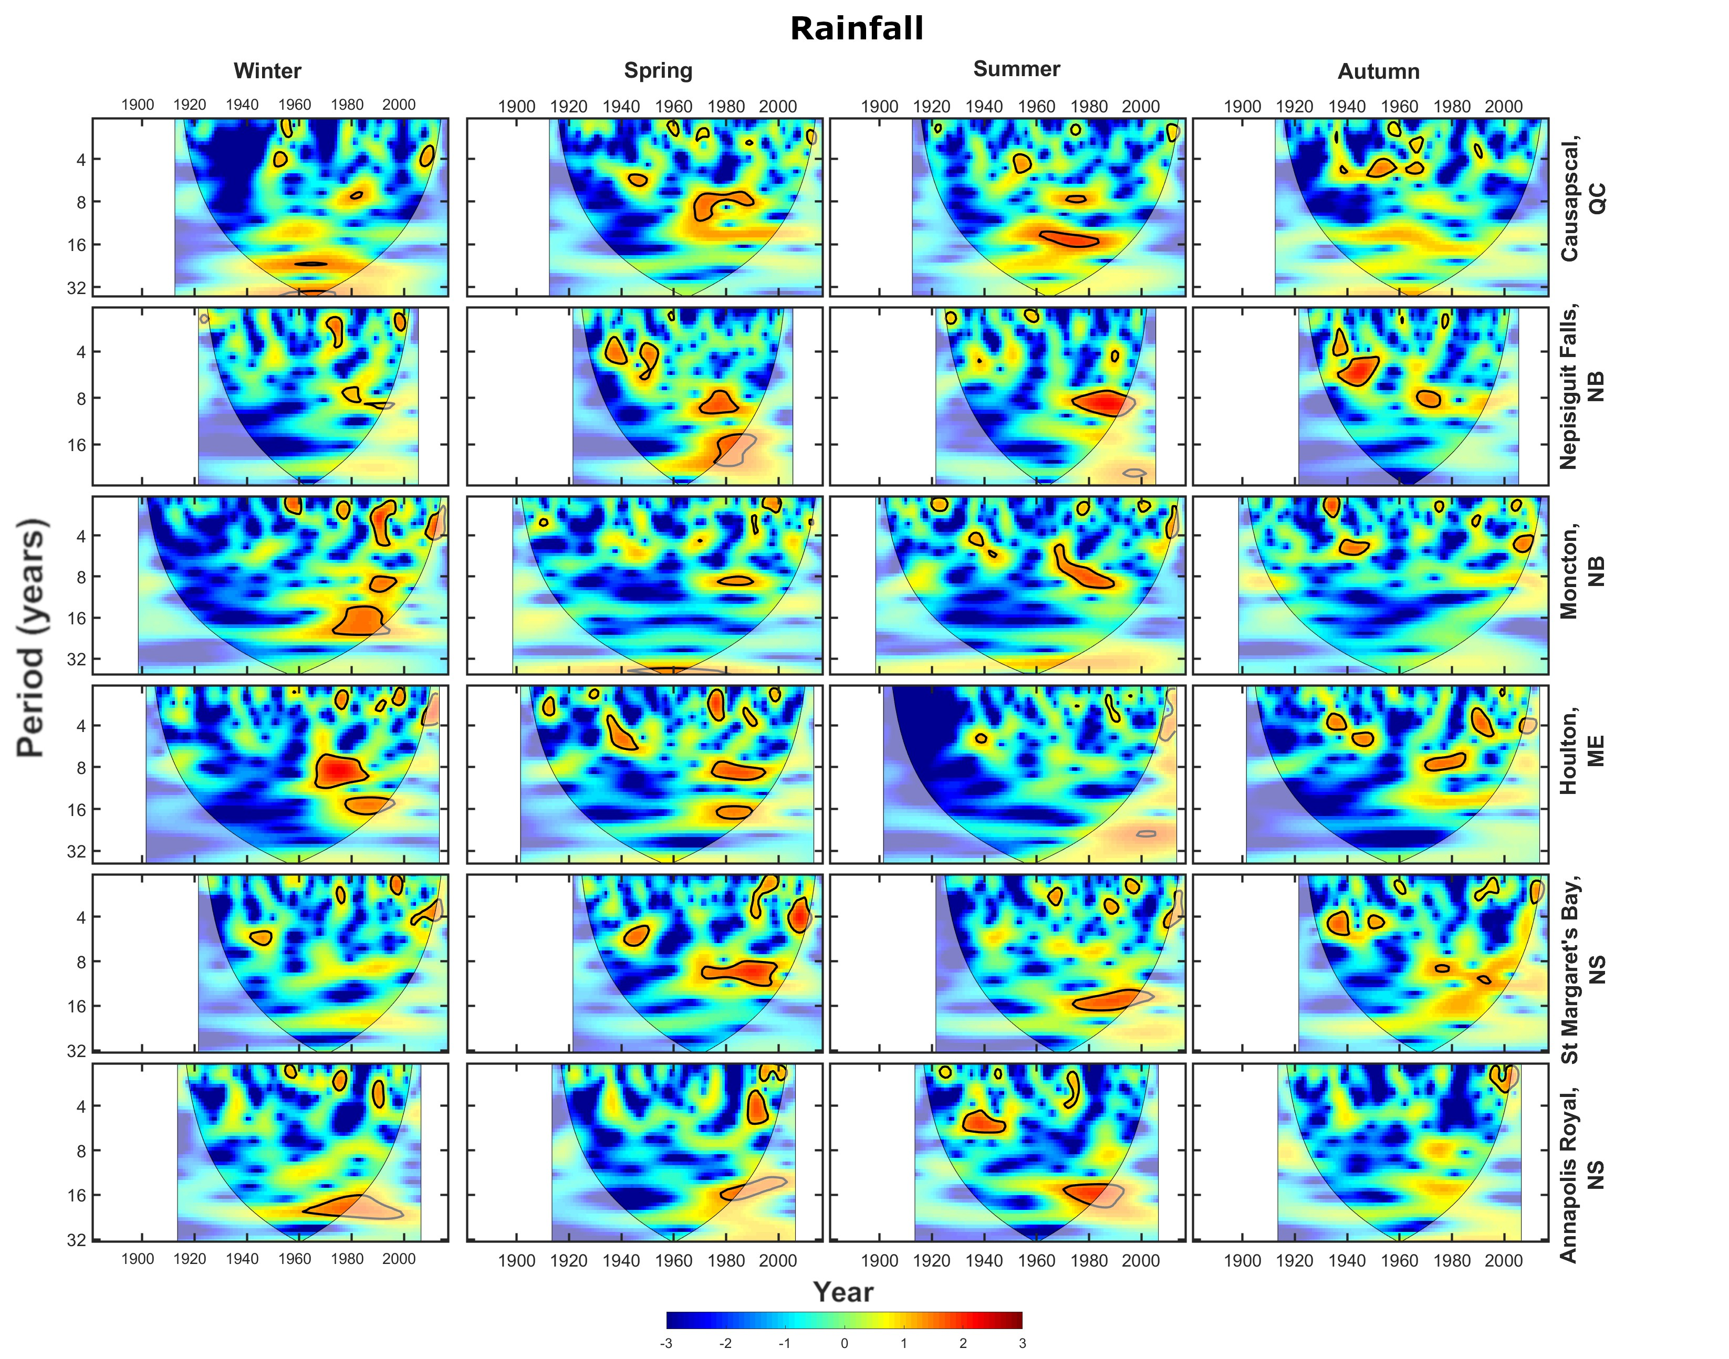
Sup. Fig. 20 Cross wavelet transforms (XWTs) between extreme rainfall and the AO at the six stations used in this study. Areas of high common spectral density that are above the 95% confidence interval are outlined in black

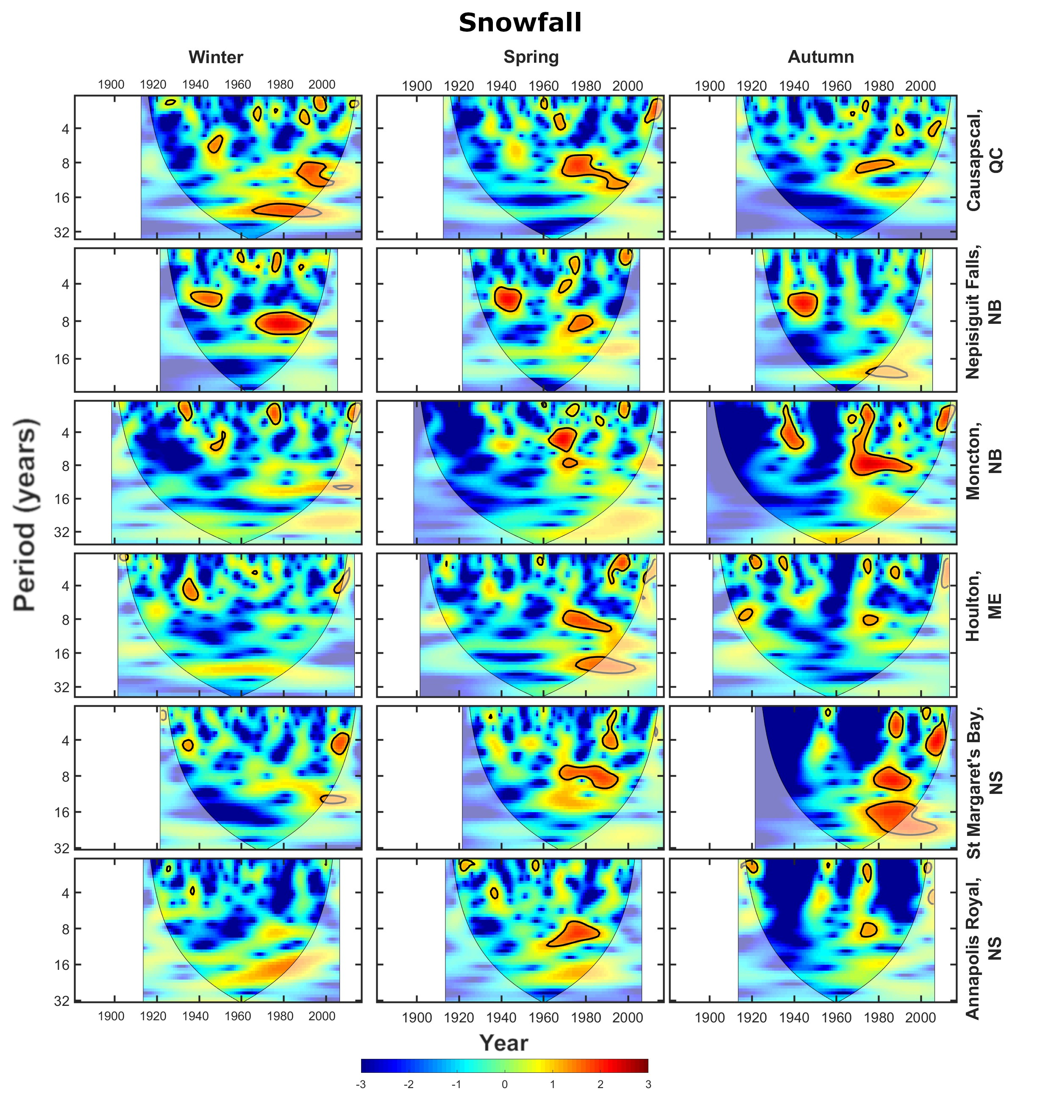
Sup. Fig. 21 Cross wavelet transforms (XWTs) between extreme snowfall and the AO at the six stations used in this study. Areas of high common spectral density that are above the 95% confidence interval are outlined in black
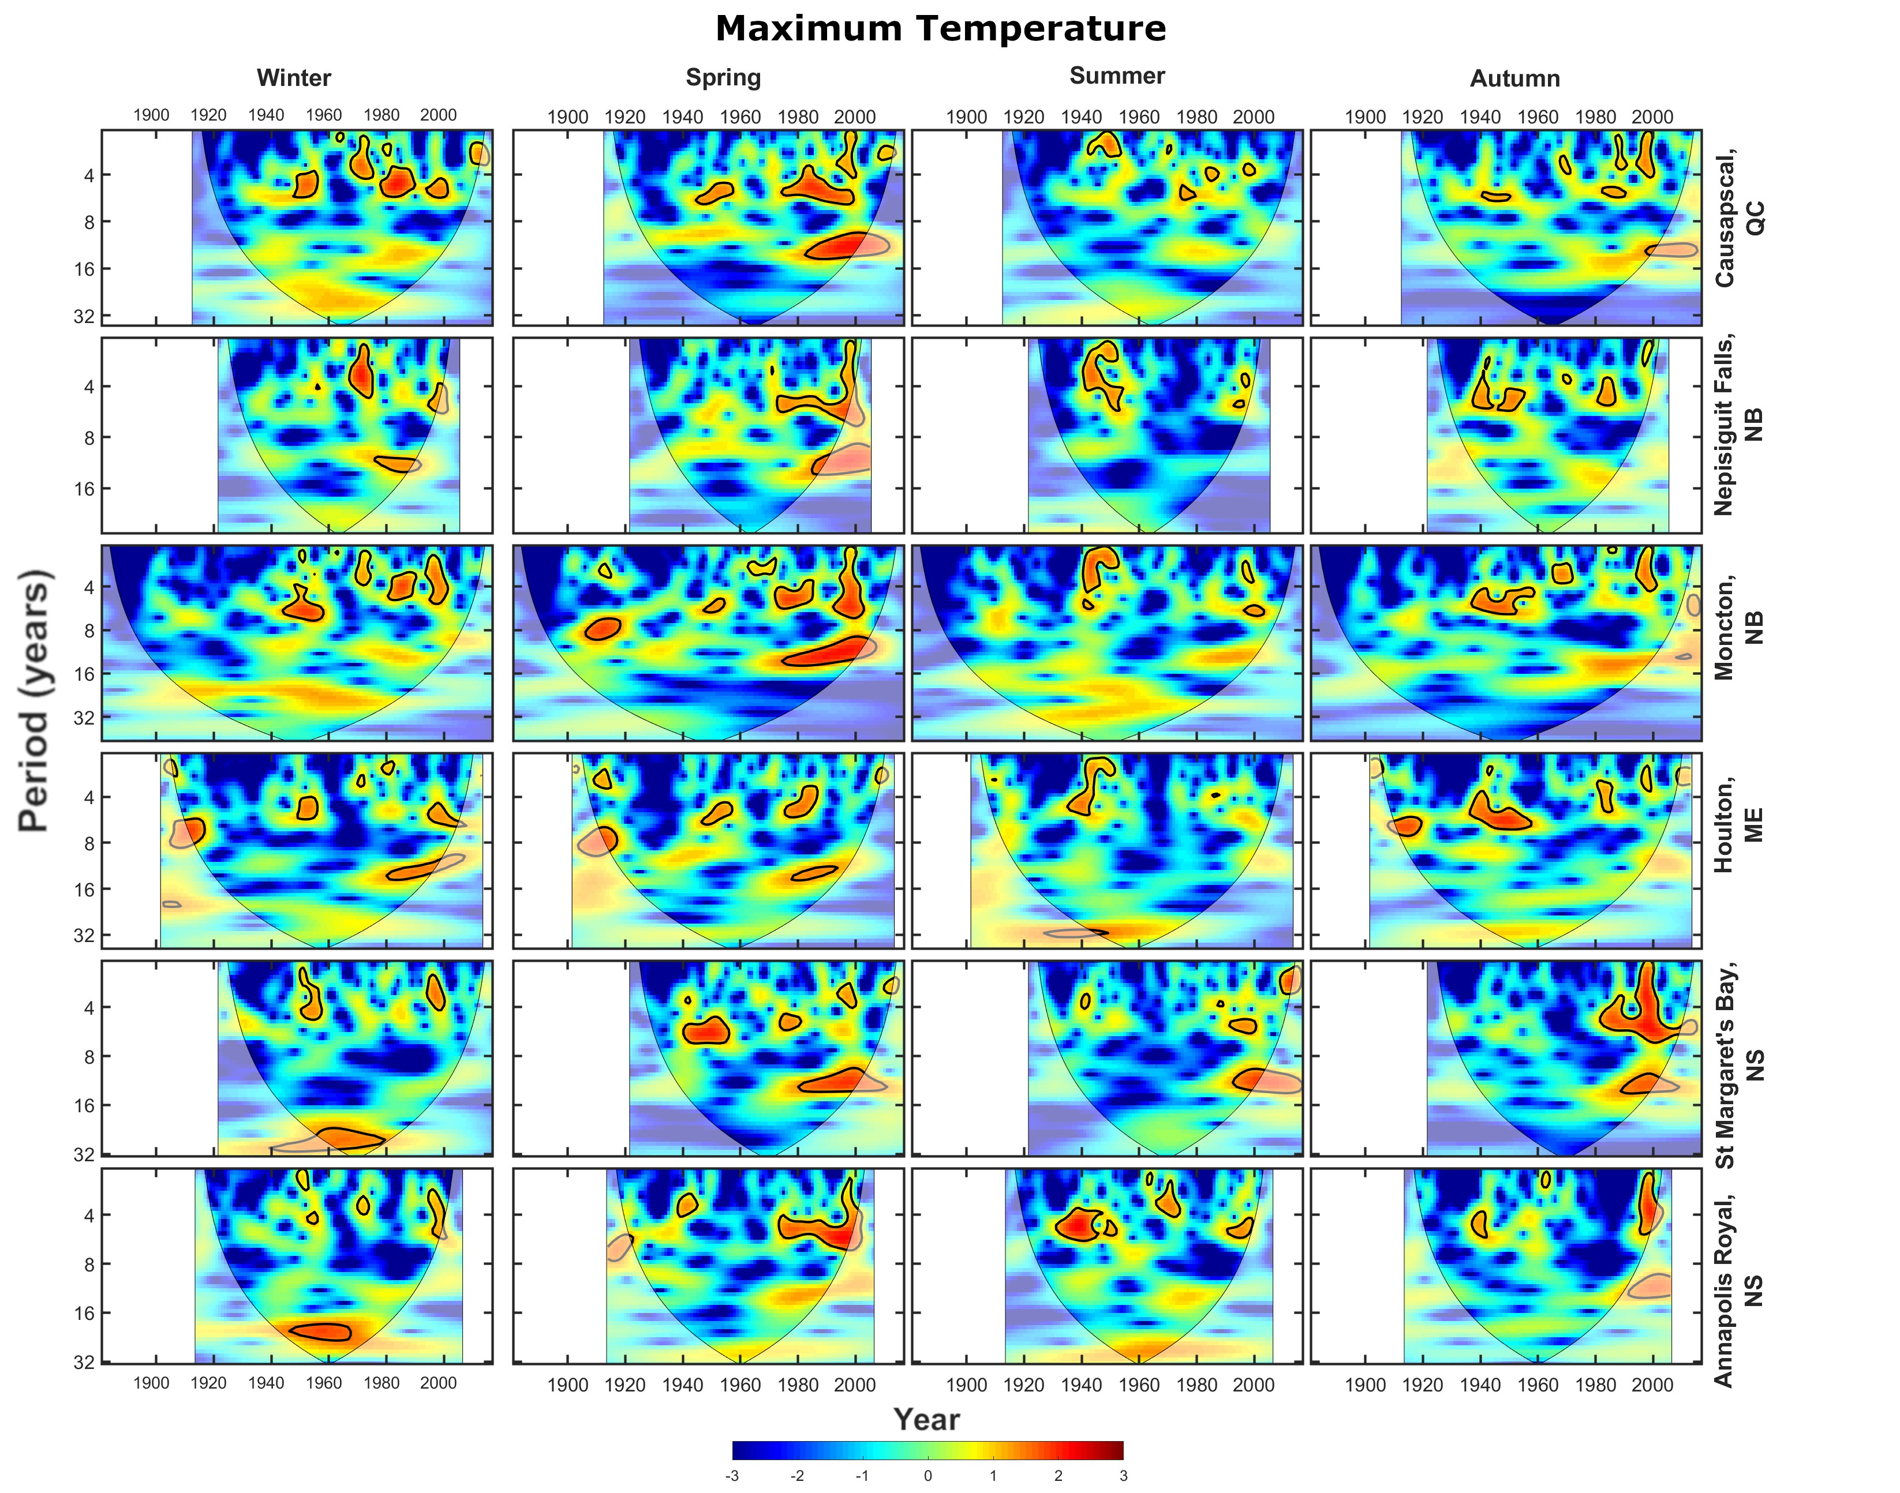
Sup. Fig. 22 Cross wavelet transforms (XWTs) between extreme maximum temperature and the ENSO at the six stations used in this study. Areas of high common spectral density that are above the 95% confidence interval are outlined in black
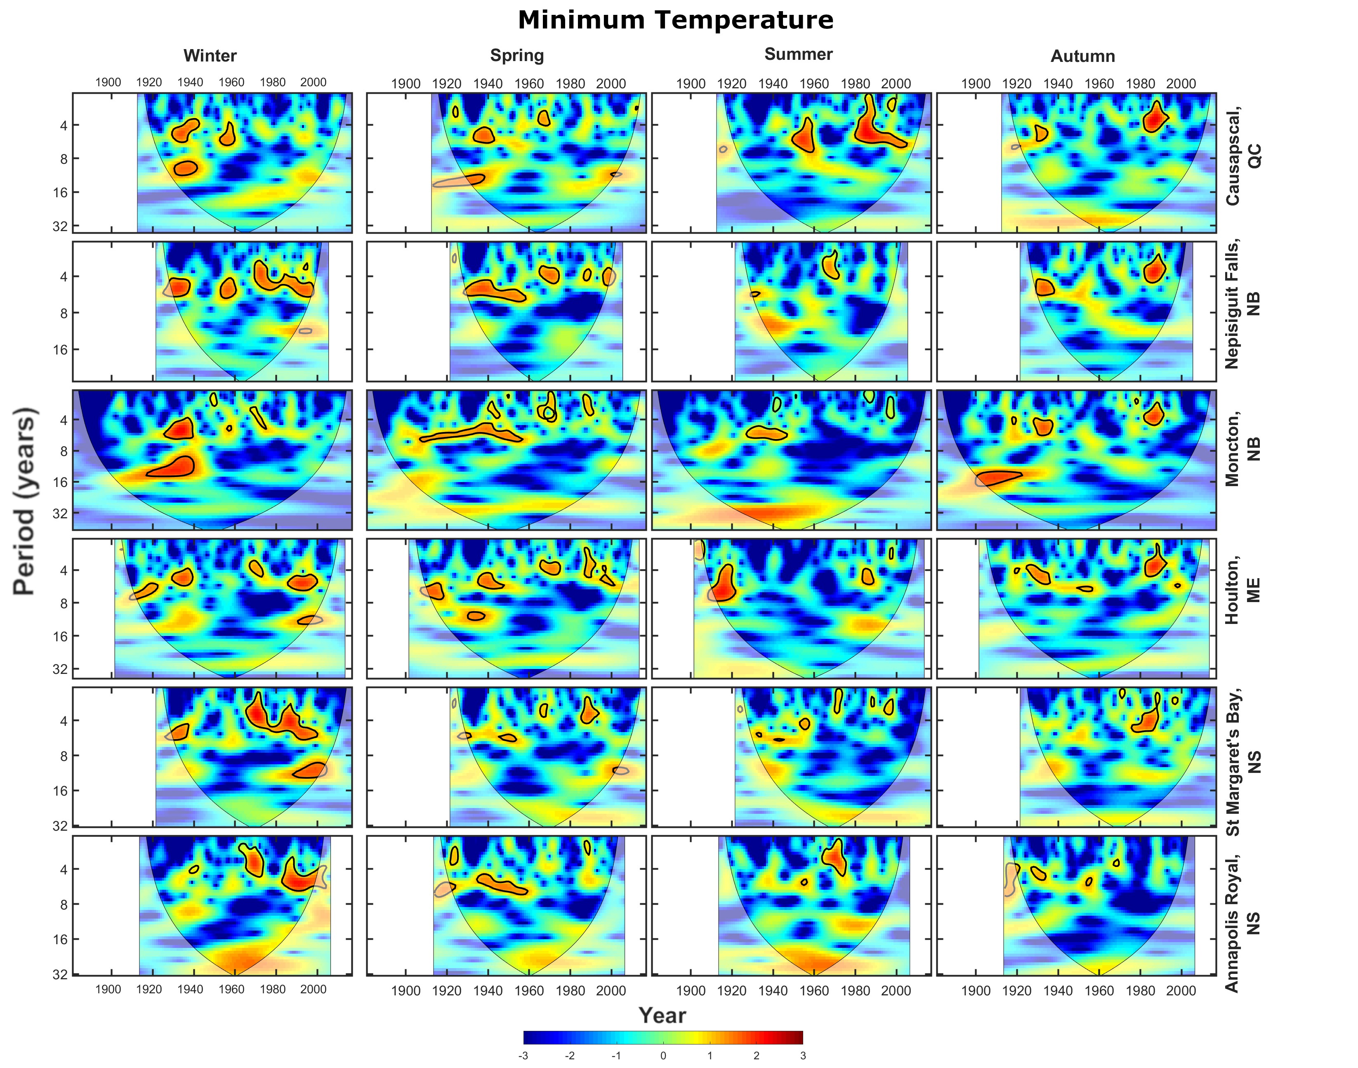
Sup. Fig. 23 Cross wavelet transforms (XWTs) between extreme minimum temperature and the ENSO at the six stations used in this study. Areas of high common spectral density that are above the 95% confidence interval are outlined in black
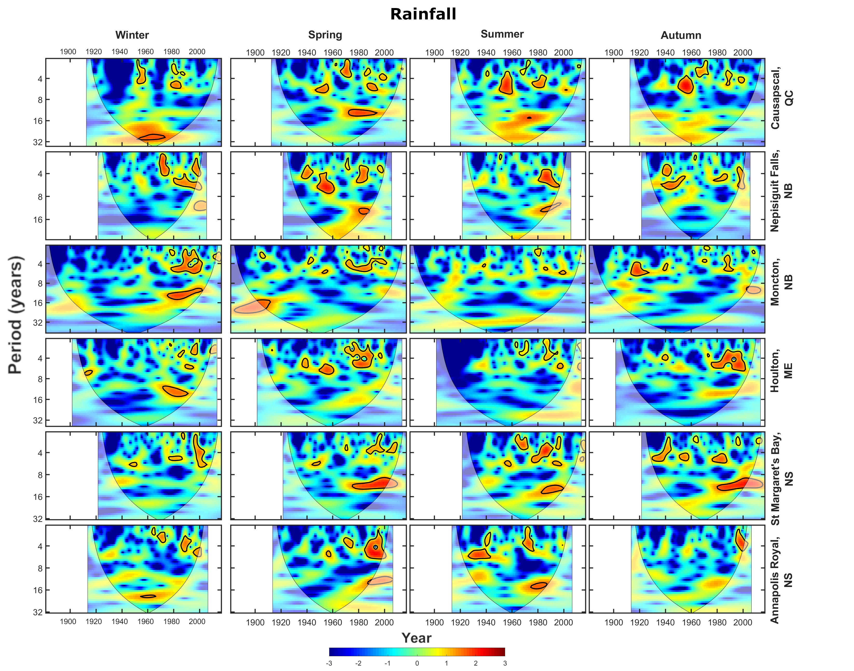
Sup. Fig. 24 Cross wavelet transforms (XWTs) between extreme rainfall and the ENSO at the six stations used in this study. Areas of high common spectral density that are above the 95% confidence interval are outlined in black

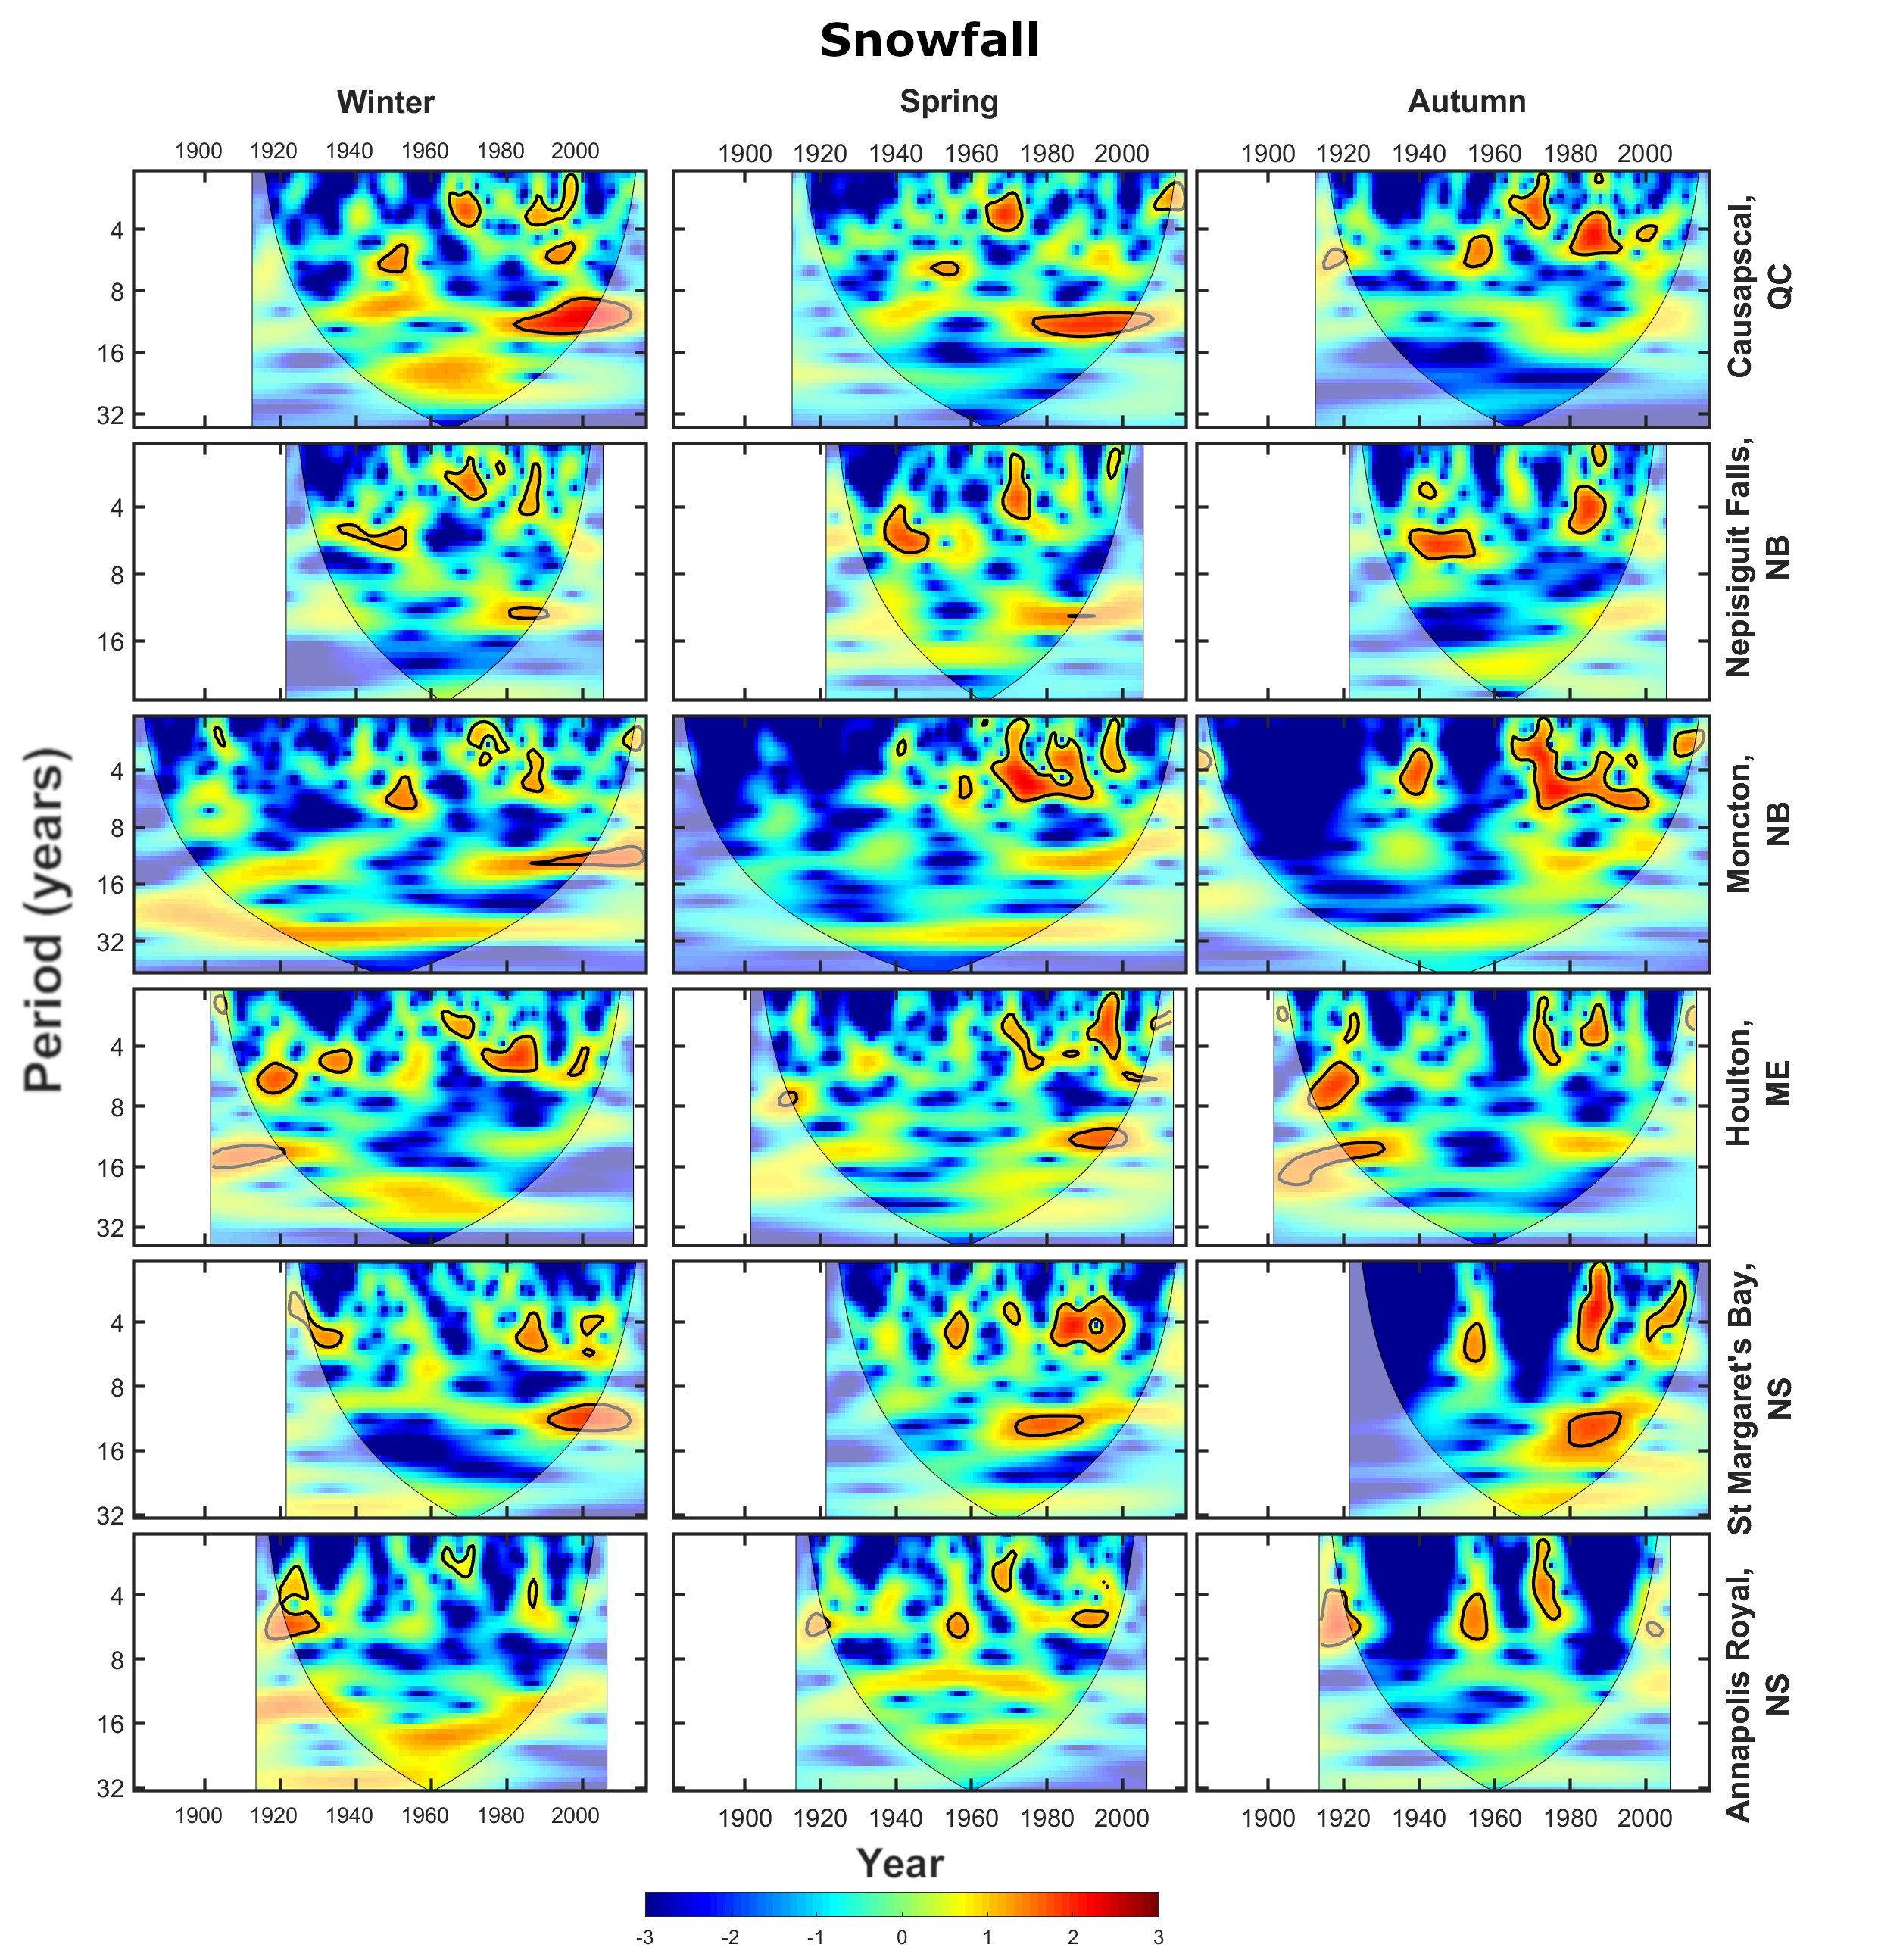
Sup. Fig. 25 Cross wavelet transforms (XWTs) between extreme snowfall and the ENSO at the six stations used in this study. Areas of high common spectral density that are above the 95% confidence interval are outlined in black
Sup. Fig. 26 Cross wavelet transforms (XWTs) between extreme maximum temperature and the QBO at the six stations used in this study. Areas of high common spectral density that are above the 95% confidence interval are outlined in black
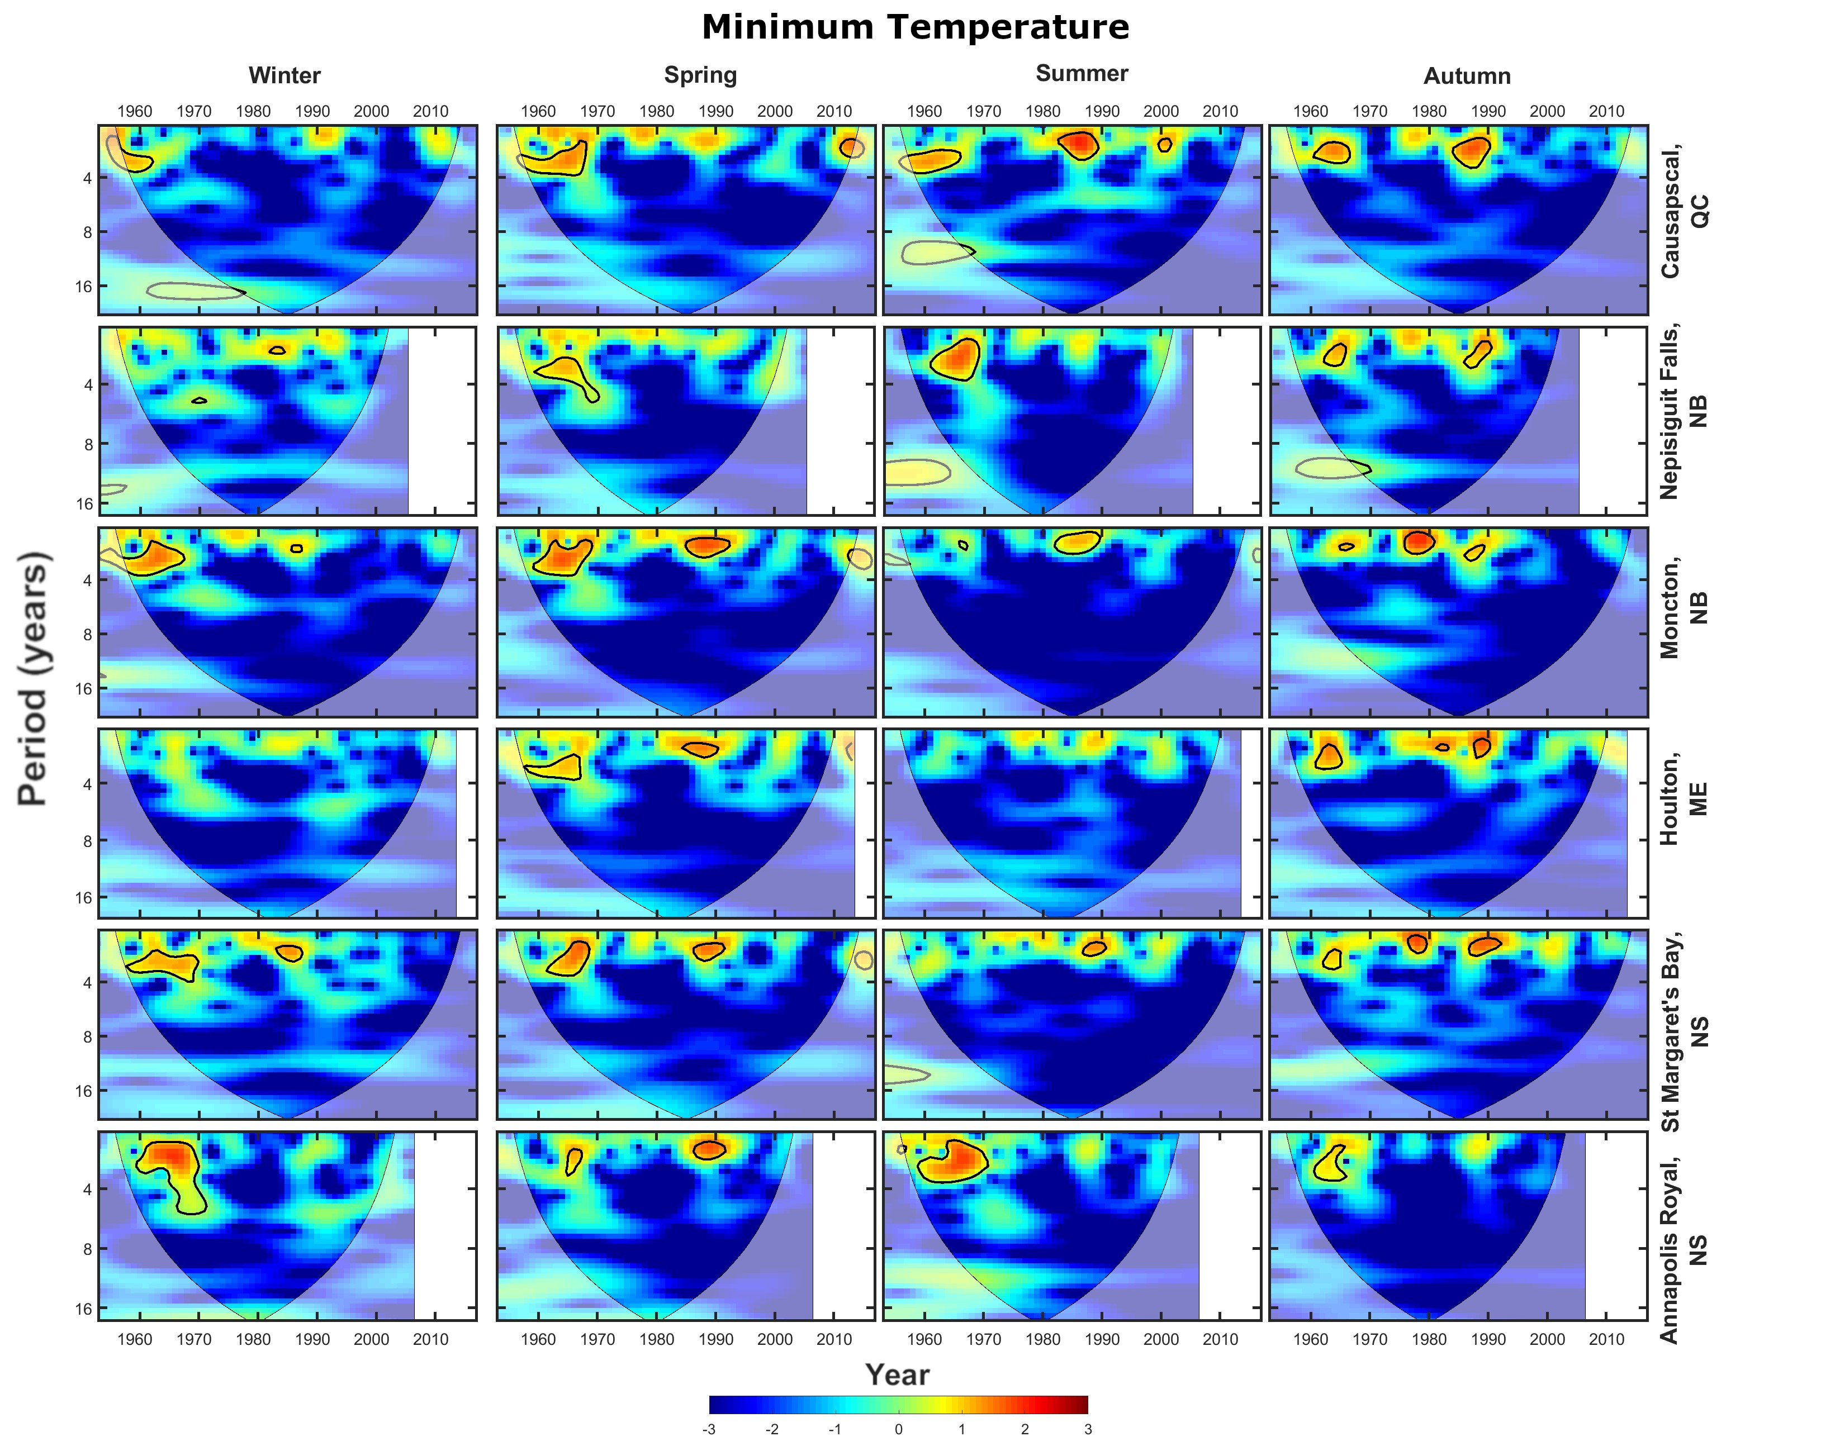
Sup. Fig. 27 Cross wavelet transforms (XWTs) between extreme minimum temperature and the QBO at the six stations used in this study. Areas of high common spectral density that are above the 95% confidence interval are outlined in black
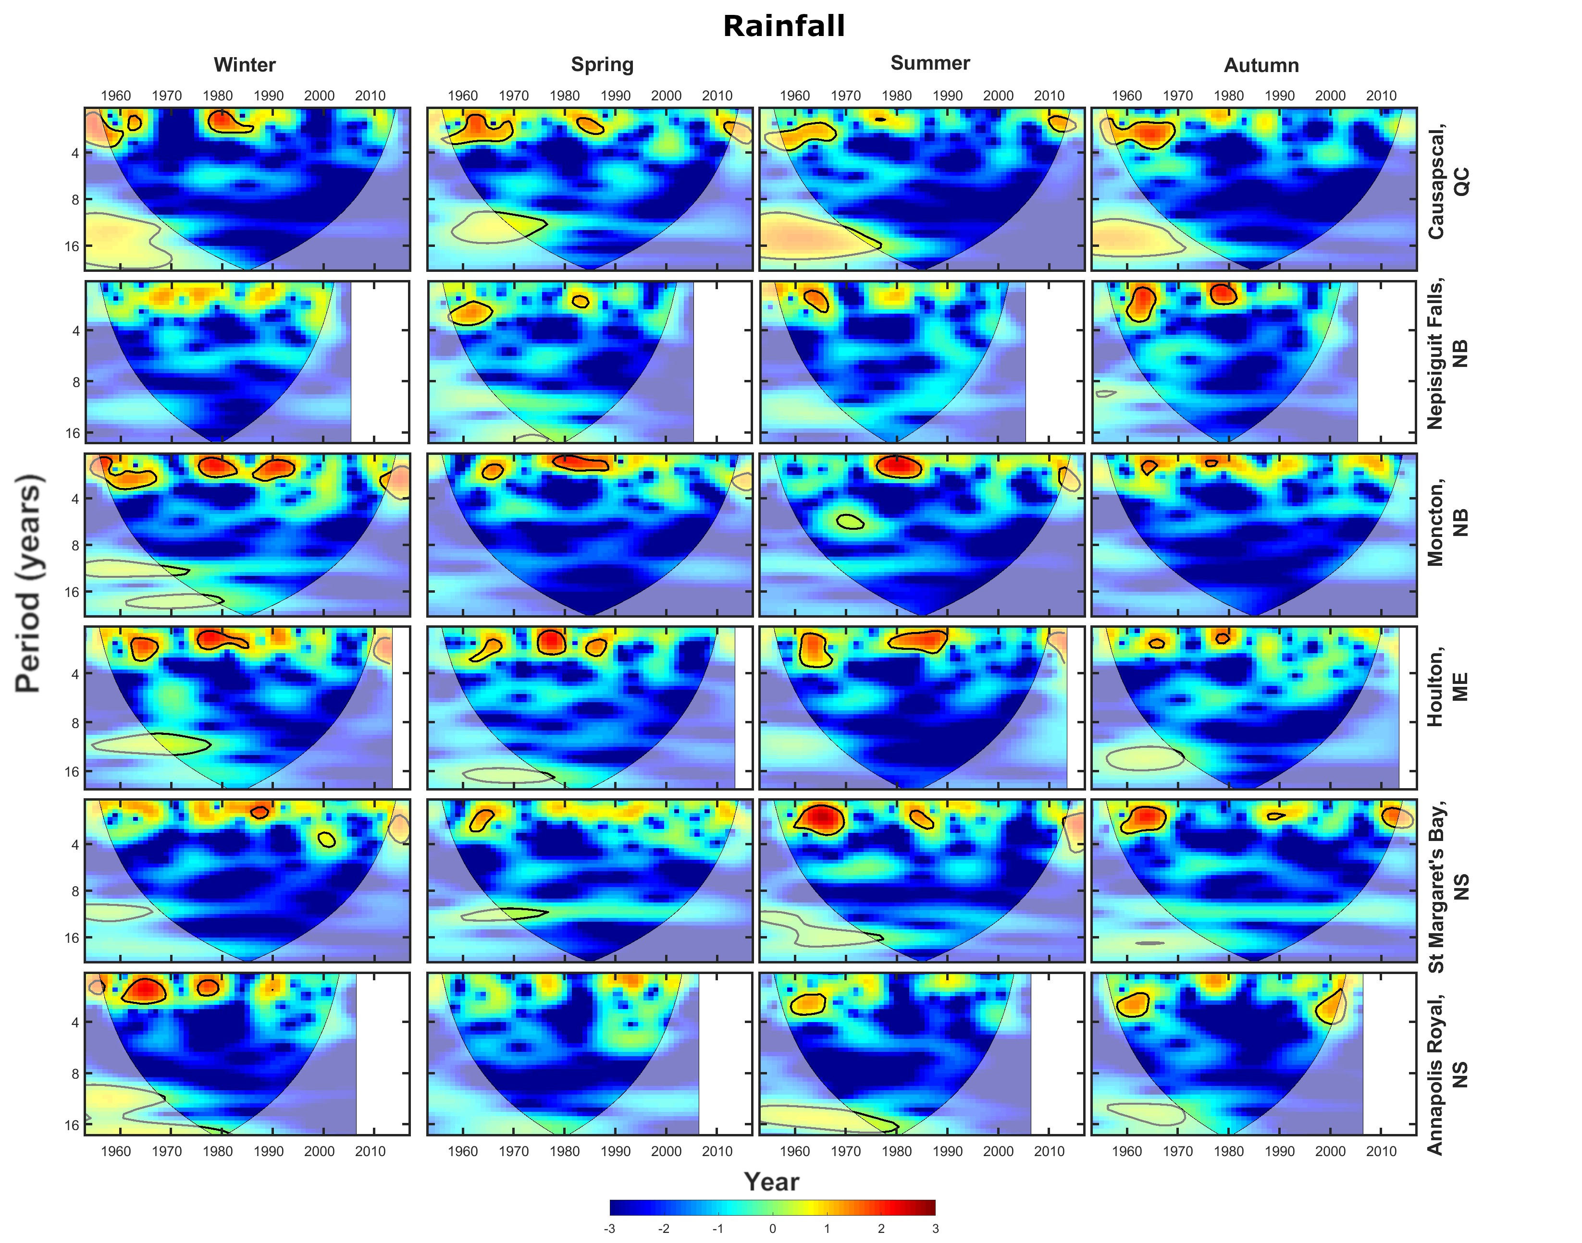
Sup. Fig. 28 Cross wavelet transforms (XWTs) between extreme rainfall and the QBO at the six stations used in this study. Areas of high common spectral density that are above the 95% confidence interval are outlined in black
Sup. Fig. 29 Cross wavelet transforms (XWTs) between extreme snowfall and the QBO at the six stations used in this study. Areas of high common spectral density that are above the 95% confidence interval are outlined in black

