Supporting Information for

Unveiling the molecular recognition process between USP7 N-terminal TRAF-like domain and β-catenin for small molecule discovery

Mitul Srivastava^{a, b}, Rajani Mathur^{b,c}, Shailendra Asthana^{a,}*
ª Translational Health Science and Technology Institute (THSTI), Haryana, India
^{b}Delhi Pharmaceutical Sciences and Research University (DPSRU), New Delhi, India
^{c}Delhi Institute of Pharmaceutical Sciences and Research (DIPSAR), New Delhi, India

*To whom the correspondence should be addressed.
Dr. Shailendra Asthana
Principal Scientist
Translational Health Science and Technology Institute,
NCR Biotech Science Cluster, 3rd Milestone, Faridabad-Gurugram Expressway, Faridabad, Haryana, India-121001
Email: sasthana@thsti.res.in

This file includes:
- Supporting Tables S1 to S8
- Supporting Figures S1 to S4

1. Supporting Tables

Table S1. Details of PDB structures used in this study
Index | PDB-ID | Resolution (Å) | System | Peptide length
1 | 2FOJ | 1.6 | USP7-N-terminal + p53 | G361-S367
2 | 2FOP | 2.1 | USP7-N-terminal + mdm2 | E142-S147
3 | 2XXN | 1.6 | USP7-N-terminal + Viral Interferon Regulatory Factor protein | S209-M216
4 | 3MQS | 2.4 | USP7-N-terminal + HDM2 | S395-S401
5 | 4KG9 | 1.7 | USP7-N-terminal + MCM-BP | V153-Y159
6 | 4YSI | 1.0 | USP7-N-terminal + Viral protein | S44-G51

Table S2. Details of MD simulation of peptide-bound crystals
ID | Systems | Time (ns) | Total no. of atoms | Water molecules | Ions
1 | USP7_{2FOJ} | 300 | 25795 | 7901 | 2 Na⁺
2 | USP7_{2FOP} | 300 | 25931 | 7846 | 2 Na⁺
3 | USP7_{2XXN} | 300 | 26590 | 8066 | 4 Na⁺
4 | USP7_{3MQS} | 300 | 25829 | 7815 | 3 Na⁺
5 | USP7_{4KG9} | 300 | 26737 | 8110 | 3 Na⁺
6 | USP7_{4YSI} | 300 | 25967 | 7857 | 4 Na⁺
7 | USP7_{β-catenin} | 300 | 25792 | 7786 | 4 Na⁺

Table S3. Details of MD simulation of identified hits molecule
ID | Systems | Time (ns) | Total no. of atoms | Water molecules | Ions
1 | H1 | 200 | 25793 | 7812 | 3 Na⁺
2 | H2 | 200 | 25765 | 7891 | 3 Na⁺
3 | H3 | 200 | 25801 | 7993 | 4 Na⁺
4 | H4 | 200 | 25778 | 7806 | 3 Na⁺
5 | H5 | 200 | 25786 | 7806 | 3 Na⁺
6 | H6 | 200 | 25792 | 7857 | 4 Na⁺
7 | H7 | 200 | 25811 | 7786 | 4 Na⁺
8 | H8 | 200 | 25805 | 7815 | 3 Na⁺
9 | H9 | 200 | 25783 | 7799 | 3 Na⁺
10 | H10 | 200 | 25793 | 7812 | 3 Na⁺

Table S4. The hydrogen bonds (HBs) formed between USP7 N-terminal interface site and endogenous peptides.
Hydrogen-bonds (cut-off < 3.5Å) (Protein@peptide: Distance)
USP7_{2FOJ}  (Å) | USP7_{2FOP}  (Å) | USP7_{3MQS}  (Å) | USP7_{4KG9}  (Å) | USP7_{4YSI}  (Å) | USP7_{2XXN}  (Å)
M102@S367: 3.5 | M102@S367: 3.5 | - | - | - | -
R104@S367: 2.9 | R104@S147: 2.8 | R104@S400: 3.0 | R104@S158: 3.3 | R104@S50: 3.0 | R104@S214: 2.8
F118@H365: 3.5 | F118@S145: 3.4 | F118@S398: 3.4 | F118@S156: 3.5 | F118@G48: 3.5 | F118@S212: 3.5
- | - | - | - | - | R152@E209: 2.9
D164@S367: 2.9 | D164@S146: 3.5 | D164@T399: 3.5 | D164@T157: 3.5 | D164@P49: 3.5 | D164@S214: 2.9
- | D164@S147: 2.8 | D164@S400: 2.8 | D164@S158: 2.8 | D164@S50: 2.8 | D164@T213: 3.5
W165@H365: 3.5 | W165@S145: 3.5 | W165@S398: 3.5 | W165@S156: 3.5 | W165@E47: 3.0 | W165@A211: 3.5
G166@A364: 3.3 | G166@P144: 3.1 | G166@P397: 3.2 | G166@P155: 3.3 | G166@E47: 3.3 | G166@S212: 2.9
G166@H365: 2.8 | G166@S145: 2.9 | G166@S398: 2.9 | G166@S156: 2.9 | G166@G48: 3.0 | G166@A211: 3.2
S168@H365: 3.1 | - | - | - | S168@G46: 3.1 | -
- | - | - | - | N169@S44: 2.9 | -

Table S5. Hydrogen bond analysis on the simulated system of USP7-ꞵ-catenin complex
Hydrogen-bonds (cut-off < 3.5Å) (USP7@β-catenin: Distance)
S84@K216:3.2
M100@S214:3.4
M102@S367: 3.5
R104@S214: 2.8
F118@S214: 3.5
R152@T209:2.9
D164@S214: 2.9
W165@L213: 2.9
G166@P211: 3.2
G166@S212: 2.9
F167@T209: 3.5
S168@S212: 3.5

Table S6. Poisson Boltzmann (PB) Binding Free Energy (ΔGbind_{calc}) of all peptide COMs systems. Results were represented as standard deviation (SD) and mean standard error (SE). All values are in kcal/mol.
Contribution | USP7_{2FOJ} | USP7_{2FOP} | USP7_{3MQS} | USP7_{4KG9} | USP7_{4YSI} | USP7_{2XXN} | USP7-ꞵ-catenin
∆E_{int} | 0 | 0 | 0 | 0 | 0 | 0 | 0
∆E_{vdW} | -32.01  (4.37 ± 0.13) | -35.76  (3.39 ± 0.21) | -37.39  (3.90 ± 0.12) | -39.12  (3.96 ± 0.12) | -44.16  (3.76 ± 0.11) | -32.58  (4.73 ± 0.23) | -42.97  (5.04 ± 0.15)
∆E_{ele} | 13.78  (22.56 ± 0.93) | -55.69  (11.04 ± 2.39) | -70.98  (21.56 ± 0.98) | -71.76  (22.83 ± 0.89) | -77.82  (21.34 ± 0.88) | -76.46  (19.59 ± 0.63) | -163.56  (18.71 ± 0.92)
∆E_{pb_solv} | 3.93  (20.29 ± 0.78) | 75.62  (13.54 ± 2.12) | 83.04  (19.98 ± 0.86) | 85.54  (21.47 ± 0.79) | 92.72  (24.13 ± 0.84) | 88.93  (22.19 ± 0.74) | 179.61  (13.57 ± 0.64)
∆E_{np-solv} | -3.89  (0.35 ± 0.01) | -4.24  (0.61 ± 0.00) | -4.37  (0.20 ± 0.00) | -4.54  (0.28 ± 0.00) | -4.89  (0.19 ± 0.00) | -4.25  (0.51 ± 0.02) | -5.2  (0.47 ± 0.01)
∆G_{gas} | -18.22  (19.04 ± 0.91) | -91.45  (6.18 ± 0.23) | -108.38  (17.38 ± 0.98) | -110.88  (15.91 ± 0.73) | -121.99  (12.86 ± 0.87) | -109.04  (15.12 ± 0.91) | -206.53  (14.69 ± 0.67)
∆G_{solv} | 0.03  (21.03 ± 0.78) | 71.38  (7.65 ± 1.17) | 78.66  (23.91 ± 0.85) | 81.00  (21.82 ± 0.89) | 87.83  (19.63 ± 0.84) | 84.67  (16.43 ± 0.82) | 174.33  (16.18 ± 0.79)
∆G_{bind} | -18.19  (8.01 ± 0.25) | -20.07  (5.65 ± 0.48) | -29.71  (7.71 ± 0.24) | -29.88  (7.57 ± 0.23) | -34.15  (6.12 ± 0.29) | -24.36  (8.12 ± 0.34) | -32.20  (5.18 ± 0.23)

Table S7. Quantitative analysis of hits
Compound code | Docking score (kcal/mol) | MM-GBSA (kcal/mol)
H1 | -5.21 | -61.23
H2 | -5.43 | -61.01
H3 | -5.39 | -60.02
H4 | -5.76 | -59.76
H5 | -5.49 | -59.71
H6 | -5.27 | -58.69
H7 | -5.84 | -58.66
H8 | -5.52 | -55.42
H9 | -6.23 | -54.12
H10 | -6.12 | -53.36

Table S8. Poisson Boltzmann (PB) Binding Free Energy (ΔGbind_{calc}) of all hits systems. Results were represented as standard deviation (SD) and mean standard error (SE). All values are in kcal/mol.
Contribution | H1 | H2 | H3 | H4 | H6 | H7 | H8
∆E_{int} | 0 | 0 | 0 | 0 | 0 | 0 | 0
∆E_{vdW} | -33.80  (2.91 ± 0.13) | -24.32  (3.08 ± 0.42) | -31.34  (2.42 ± 0.34) | -27.19  (2.68 ± 0.23) | -41.87  (2.85 ± 0.36) | -32.98  (2.29 ± 0.32) | -26.85  (2.69 ± 0.37)
∆E_{ele} | -35.48  (5.56 ± 0.24) | -537.70  (4.10 ± 0.57) | -35.73  (4.85 ± 0.68) | -21.67  (4.20 ± 0.37) | -110.12  (11.41 ± 0.97) | -61.72  (7.02 ± 0.98) | -138.74  (15.29 ± 2.14)
∆E_{pb_solv} | 40.78  (4.69 ± 0.21) | 40.52  (4.35 ± 0.60) | 38.37  (3.61 ± 0.50) | 32.32  (4.49 ± 0.40) | 123.12  (10.58 ± 1.35) | 70.87  (6.35 ± 0.89) | 150.73  (15.31 ± 2.14)
∆E_{np-solv} | -3.14  (0.20 ± 0.00) | -2.80  (0.11 ± 0.01) | -3.29  (0.10 ± 0.01) | -3.21  (0.20 ± 0.01) | -3.40  (0.19 ± 0.00) | -3.77  (0.11 ± 0.01) | -3.04  (0.13 ± 0.01)
∆G_{gas} | -69.28  (6.38 ± 0.28) | -62.02  (4.49 ± 0.63) | -67.07  (4.99 ± 0.69) | -48.87  (4.70 ± 0.41) | -151.99  (10.23 ± 0.91) | -94.70  (7.21 ± 1.01) | -165.60  (15.62 ± 0.69)
∆G_{solv} | 37.64  (4.59 ± 0.20) | 37.71  (4.29 ± 0.60) | 35.08  (3.62 ± 0.50) | 29.10  (4.46 ± 0.39) | 119.72  (10.62 ± 0.84) | 67.09  (6.32 ± 0.88) | 147.69  (15.25 ± 0.93)
∆G_{bind} | -31.64  (3.91 ± 0.17) | -24.31  (5.65 ± 0.48) | -31.99  (3.42 ± 0.47) | -19.76  (3.97 ± 0.35) | -32.27  (3.25 ± 0.41) | -27.61  (3.66 ± 0.51) | -17.90  (4.77 ± 0.66)

- Supporting Figures

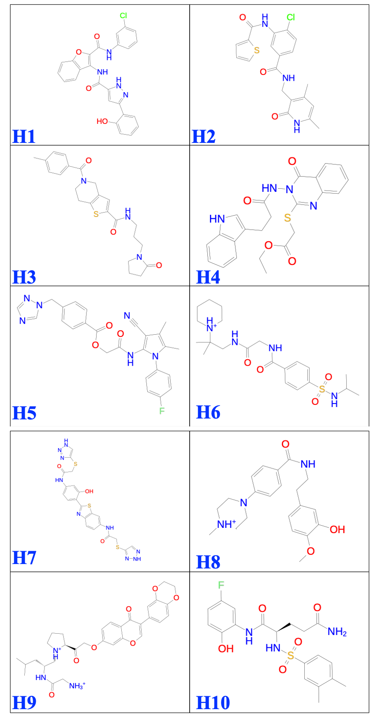
Figure S1. 2D structures of identified hits

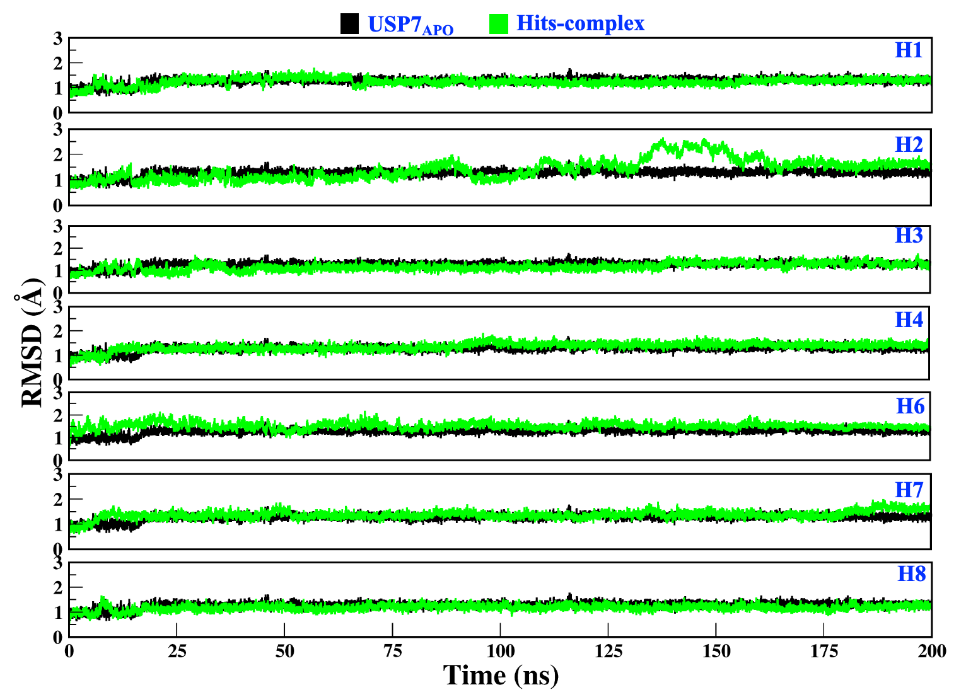
Figure S2. Comparison of RMSD values of USP7_{APO} and hits-complex systems. In graph black and green color denotes USP7_{APO} and hits-complex, respectively.

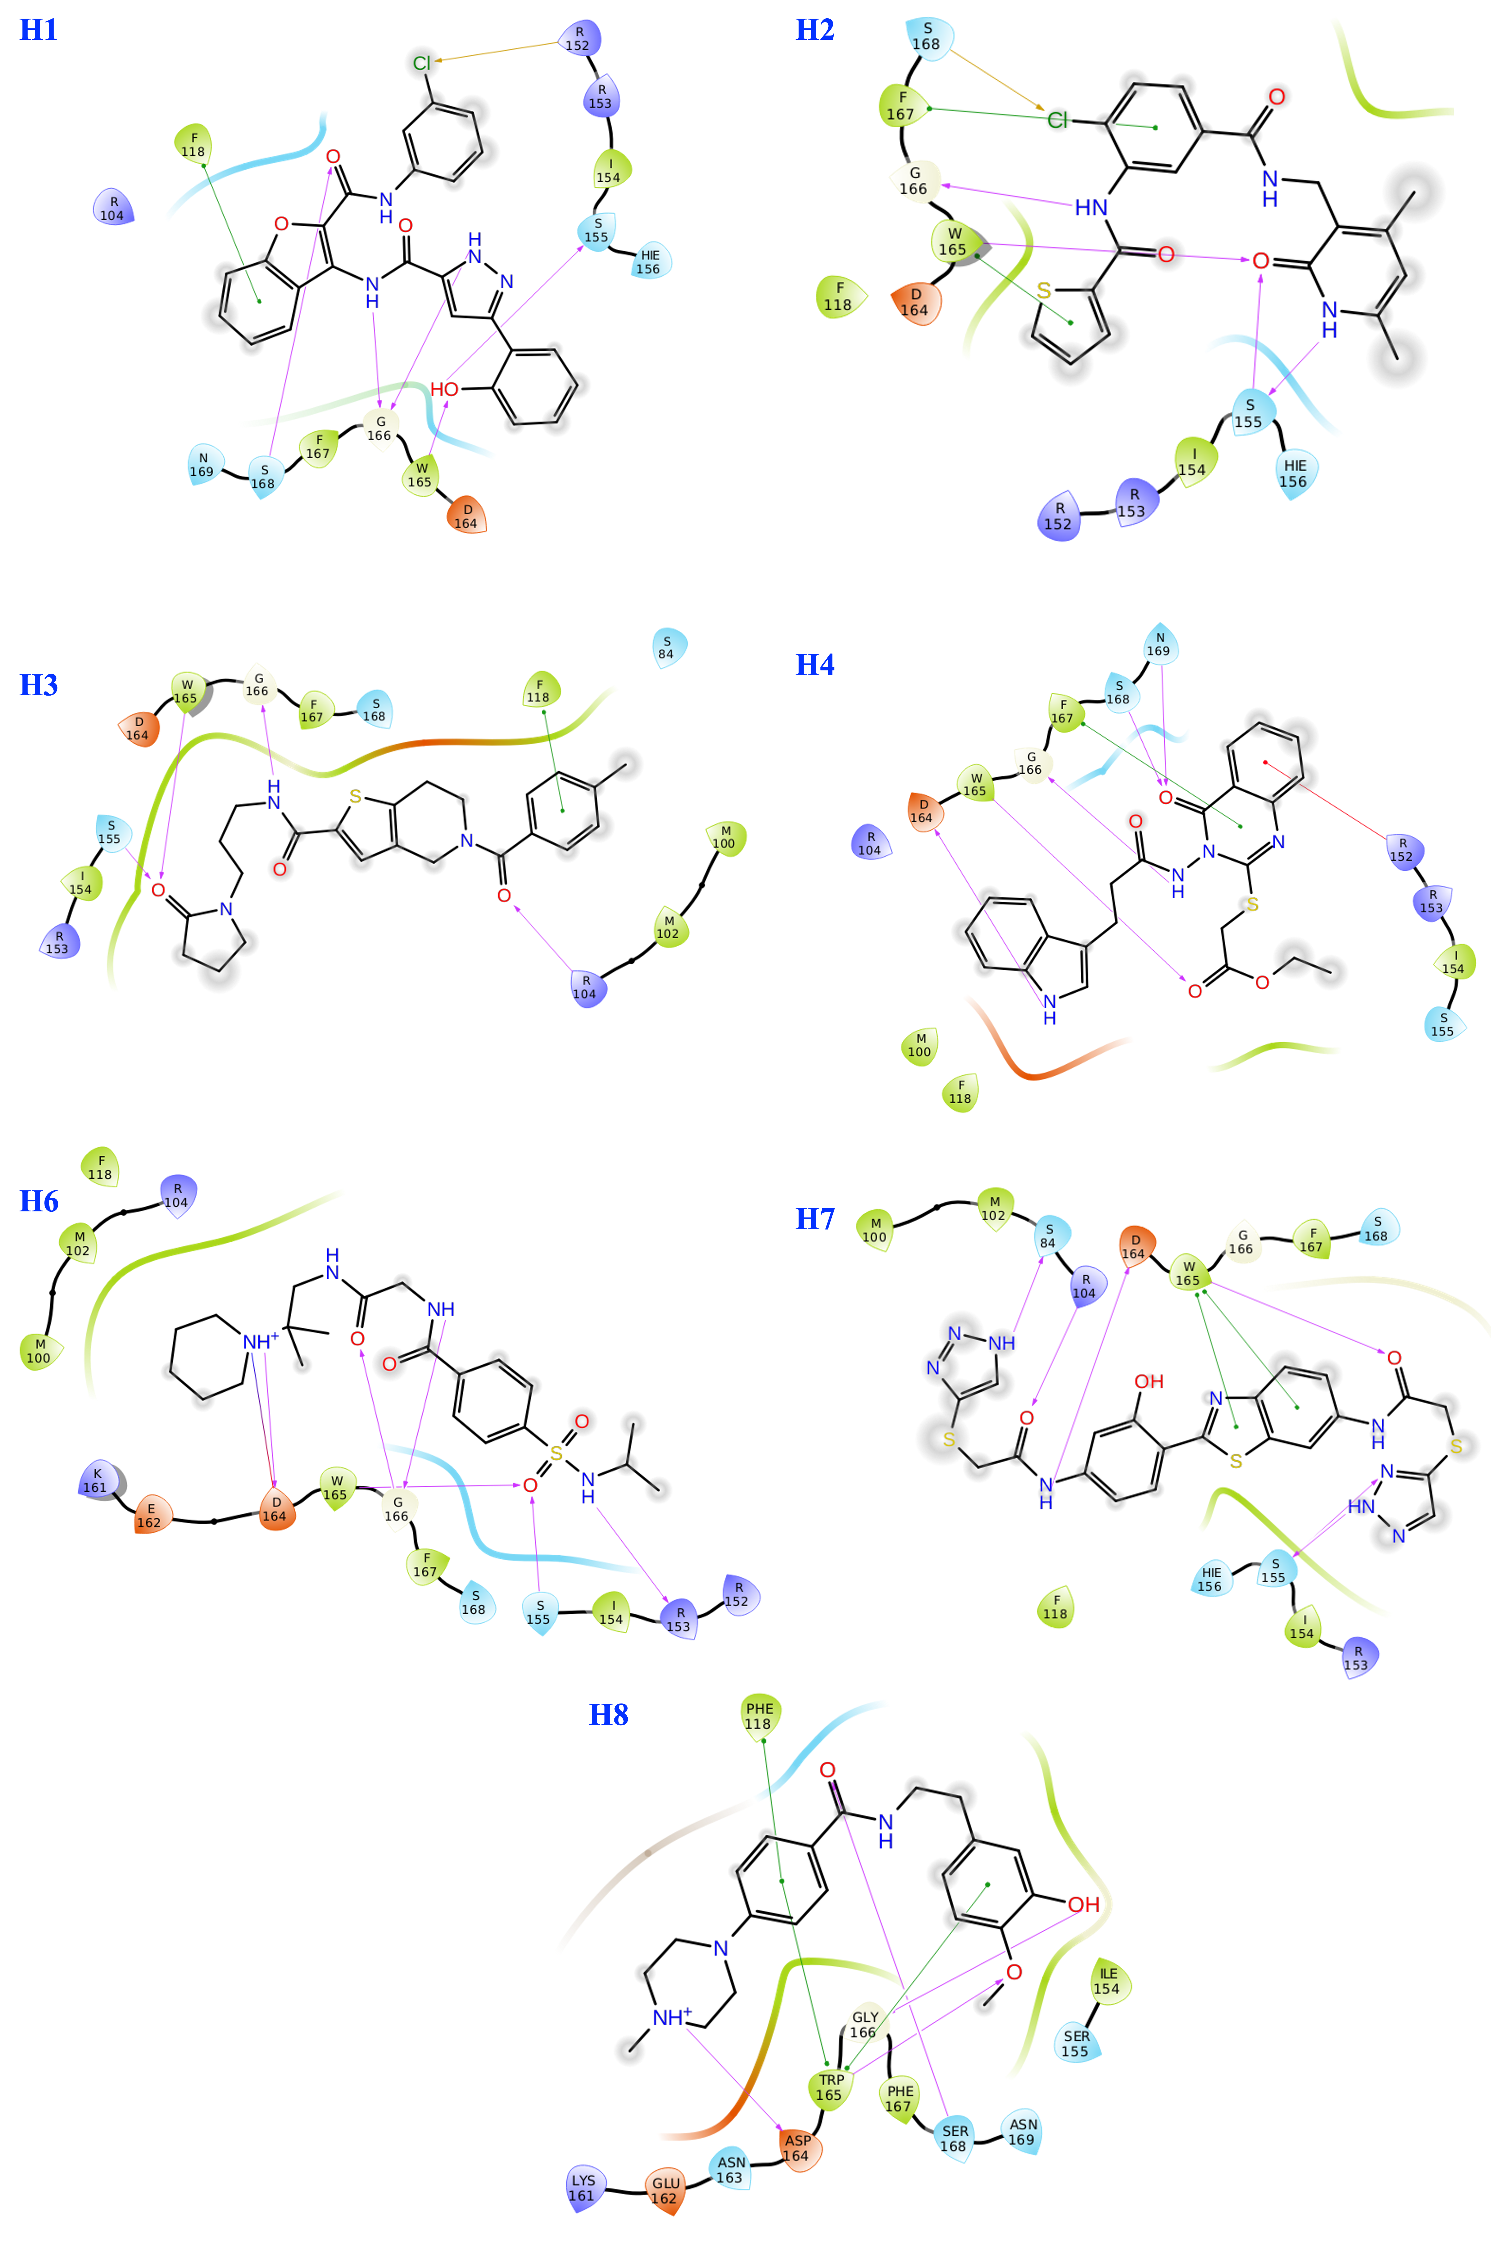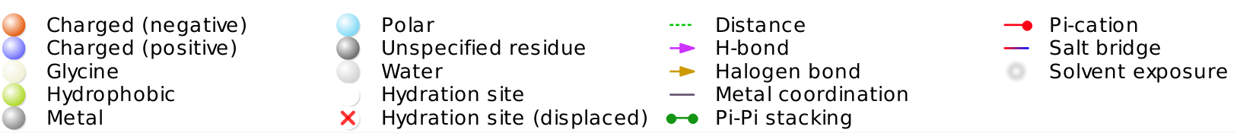

Figure S3. The 2D structural interaction mapping of hits, H1, H2, H3, H4, H6, H7, and H8.

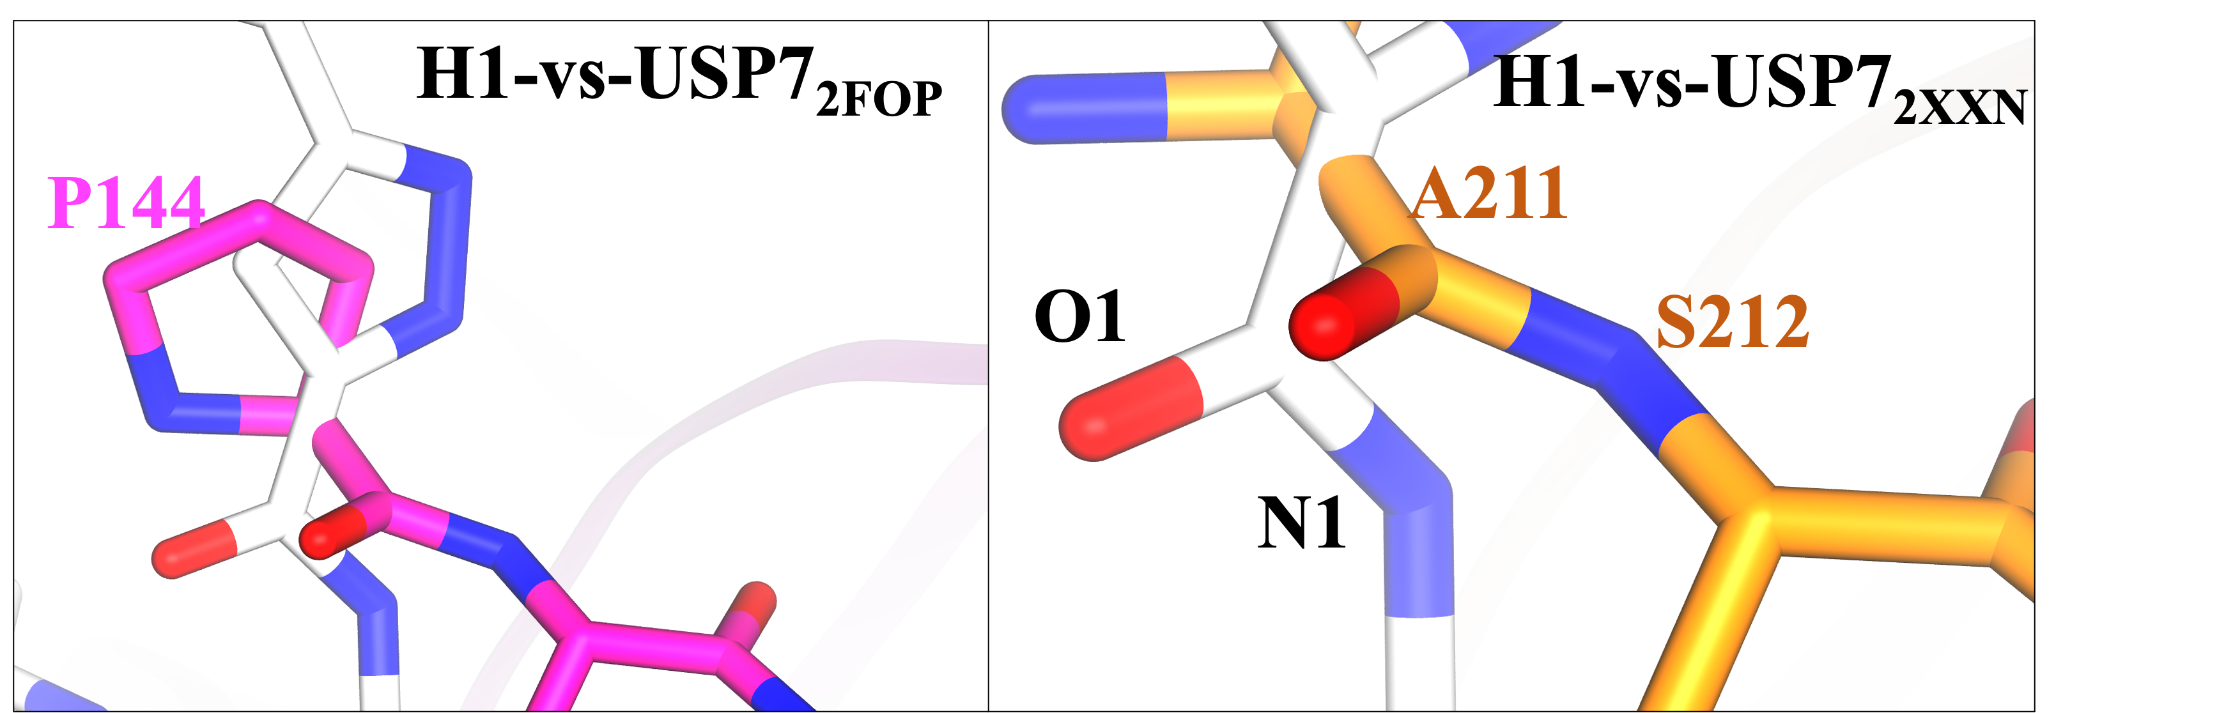
Figure S4. Structural characterization of H1 at the interface site. (A, B) the comparison of H1 with peptide of USP7_{2FOP} and USP7_{2XXN}. The peptides of USP7_{2FOP} and USP7_{2XXN} are shown in licorice: magenta and licorice: orange, respectively, and H1 is shown in licorice: white

