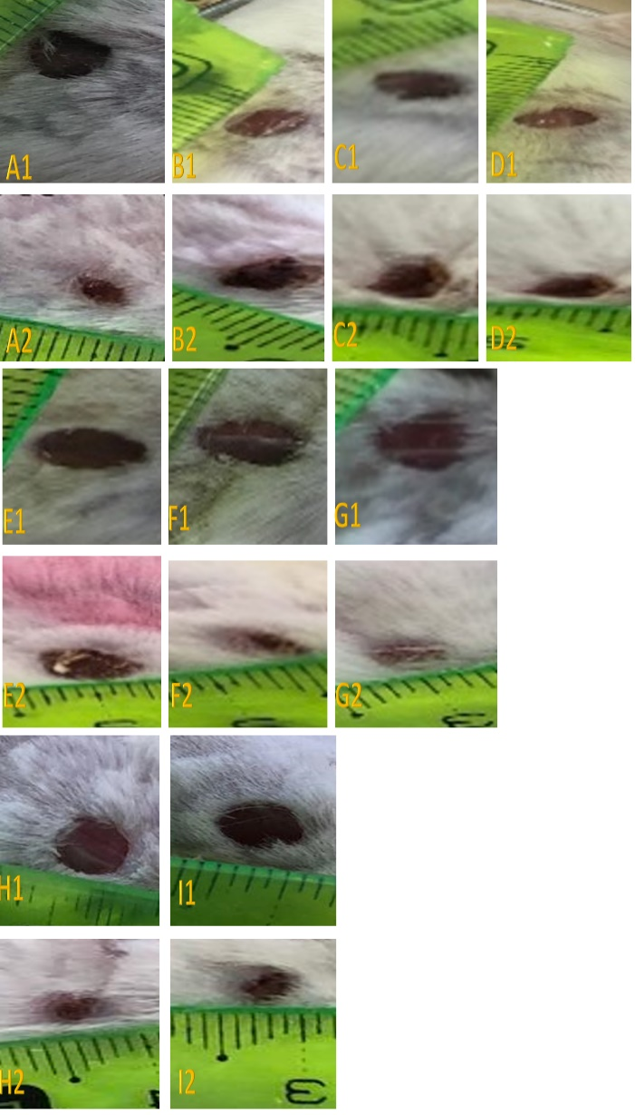
Picture 1: The first and ninth day of oral treatment, A1-control group day 1, A2-after 9 days, B1-RJ treatment group (50 mg/kg) day 1, B2-after 9 days, C1- RJ treatment group (100 mg/kg) day 1,C2-after 9 days, D1- RJ treatment group (200 mg/kg) day 1, D2-after 9 days, E1-Melittin treatment group (9*10⁻⁶ mg/kg) day 1, E2-after 9 days, F1- Melittin treatment group (3x10⁻⁵ mg/kg) day 1,F2-after 9 days, G1- Melittin treatment group (15x10⁻⁵ mg/kg) day 1, G2-after 9 days, H1-The combined treatment (RJ-50+M-9x10⁻⁶ ) day 1, H2-after 9 days, I1-The combined treatment (RJ-50+M-3x10⁻⁵) day 1, I2-after 9 days.

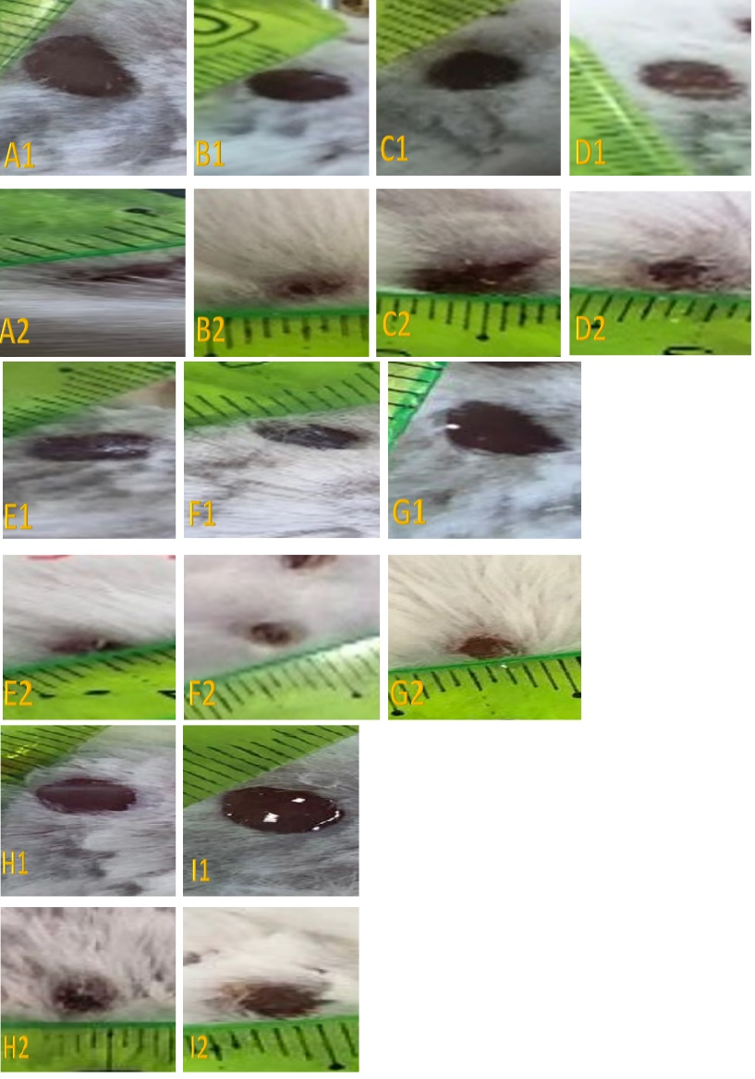
Picture 2: The first and ninth day of topical treatment, A1-control group day1,A2-after 9 days, B1-RJ treatment group (2.5%) day 1 B2-after 9 days, C1- RJ treatment group (5%) day 1,C2-after 9 days, D1- RJ treatment group (10%) day 1, D2-after 9 days, E1-Melittin treatment group (0.5x10⁻⁴ %) day 1, E2-after 9 days, F1- Melittin treatment group (1x10⁻⁴%) day 1, F2-after 9 days, G- Melittin treatment group (2x10⁻⁴%) day 1,G2-after 9 days, H1-The combined treatment (RJ-2.5%+M-0.5x10⁻⁴% ) day 1,H2-after 9 days, I1-The combined treatment (RJ-2.5+M-1x10⁻⁴%) day 1, I2-after 9 days.

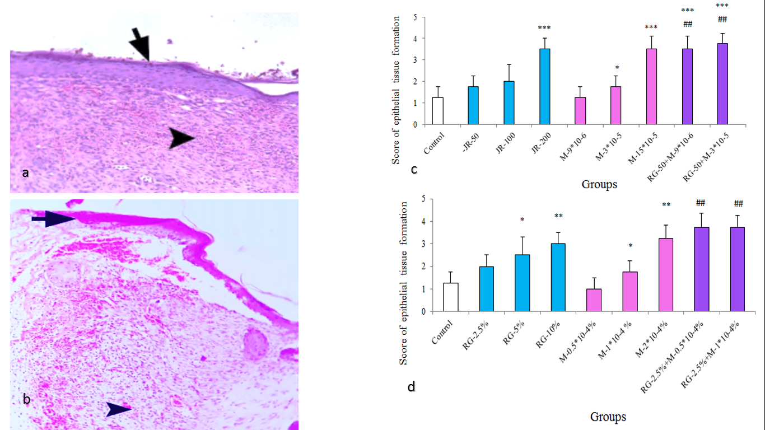
Picture 3: Epidermal renewal (arrow) and formation of new blood vessels (arrowhead) after oral treatment (H & E, x10) (a). Significant regeneration of the epidermis (arrow) and formation of new blood vessels (arrow head) after topical treatment (H & E, x10) (b). The effect of combined oral treatment of RJ and melittin on epithelial tissue repair in small mice Laboratory for 9 days(c). The effect of combined topical treatment of skin wound with RJ and melittin on epithelial tissue repair for 9 days (d). *p<0.05, ***p<0.001 shows a significant difference between the treatment group and control group. ##p<0.01 shows a significant difference of Synergistic treatment from single dose of RJ and melittin.

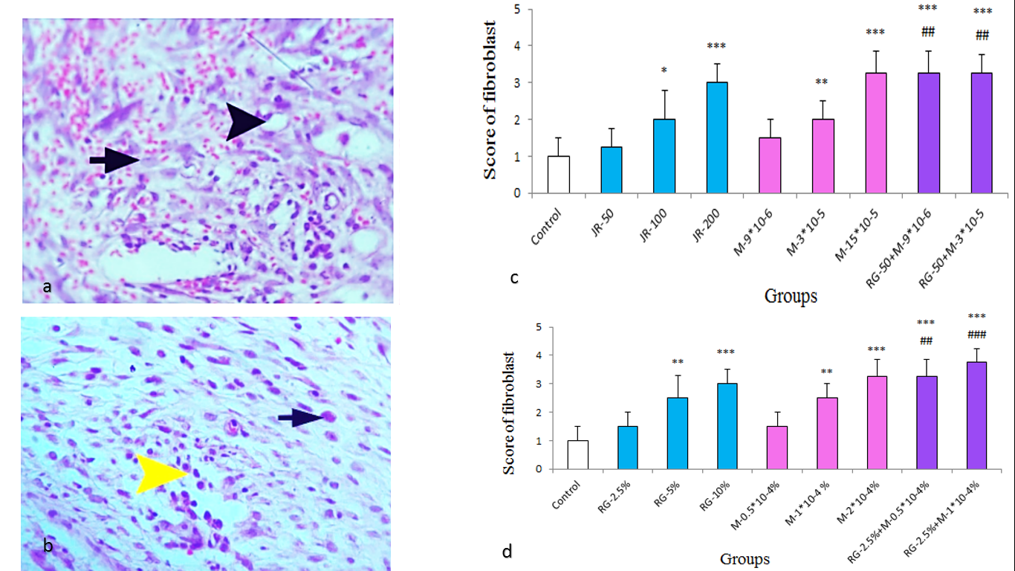
Picture 4: Skin section with newly formed blood vessels (arrowhead), prominent presence of fibroblasts (arrow), after oral treatment. (H&E x40) (a). Inflammatory cells (yellow arrowhead), fibroblasts (arrow) after topical treatment (H&E, x40) (b). The effect of oral treatment of RJ and melittin on the presence of fibroblasts at the site of skin wound in small laboratory mice for 9 days(c). The effect of combined skin wound treatment with RJ and melittin on the presence of fibroblasts in the skin wound site of mice small laboratory tests for 9 days (d). **p<0.01, ***p<0.001 indicates a difference from the control group. ##p<0.01, ###p<0.001 shows a significant difference of Synergistic treatment from single dose of RJ and melittin.

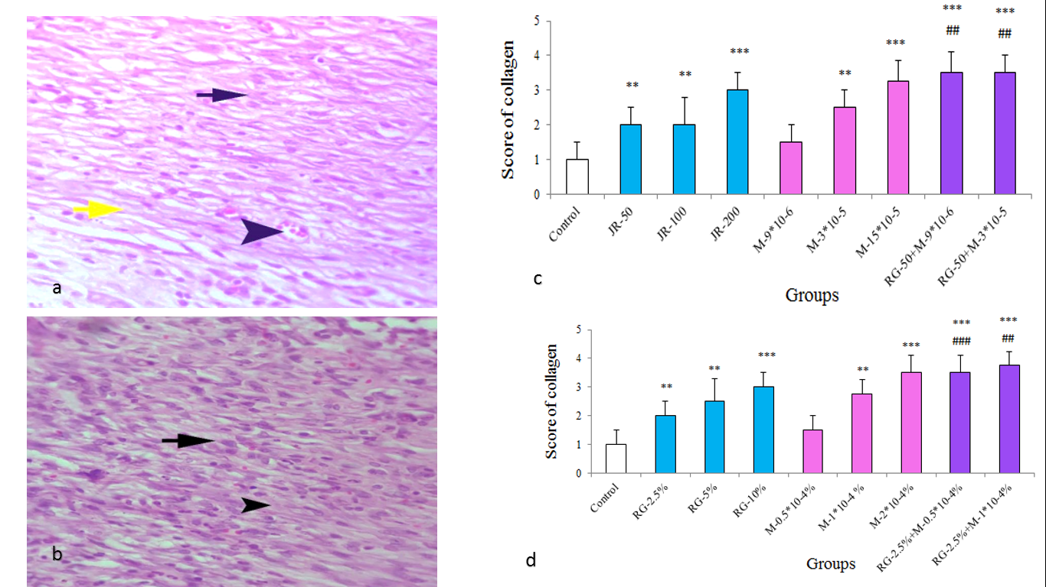
Picture 5: Skin section with newly formed blood vessels (arrowhead), prominent presence of fibroblasts (arrow), collagen fibers (yellow arrow) after oral treatments (H&E, x40) (a). Skin section relatively thick collagen fibers (arrowhead) and significant presence of fibroblasts (arrow) after topical treatment (H&E, x40) (b). The effect of oral treatment of RJ and melittin on collagen synthesis in situ Skin ulceration in small laboratory mice for 9 days(c). The effect of combined treatment of skin wound with RJ and melittin solution on the amount of collagen in the skin wound Small laboratory mice for 9 days (d). *p<0.05, **p<0.01, ***p<0.001 shows the difference from the control group. ##p<0.01, ###p<0.001 shows a significant difference of Synergistic treatment from single dose of RJ and melittin.

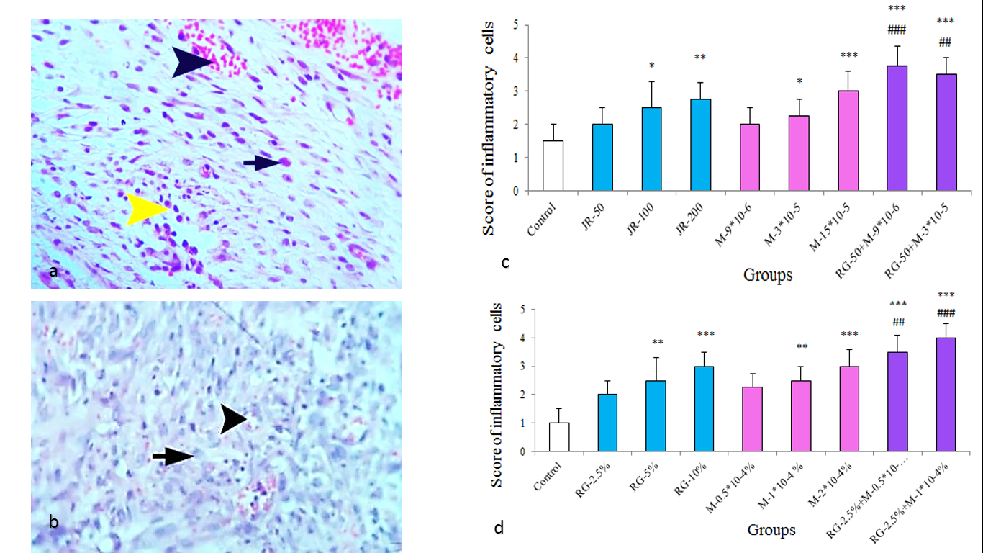
Picture 6: New blood vessels (arrowhead), inflammatory cells (yellow arrowhead), fibroblasts (arrow) after oral treatment (H&E, x40) (a). Significant presence of inflammatory cells and fibroblasts (arrowhead) new blood vessels (arrowhead) (H&E, x40)(b). The effect of combined oral treatment of RJ and melittin on the presence of cells Inflammation at the site of skin wound in small laboratory mice for 9 days(c). The effect of combined treatment of skin wound with RJ solution and melittin on the presence of inflammatory cells in the site Skin wound of small laboratory mice for 9 days (d). **p<0.01, ***p<0.001 shows the difference from the control group. ##p<0.01, ###p<0.001 shows the difference from the single dose of RJ and melittin.

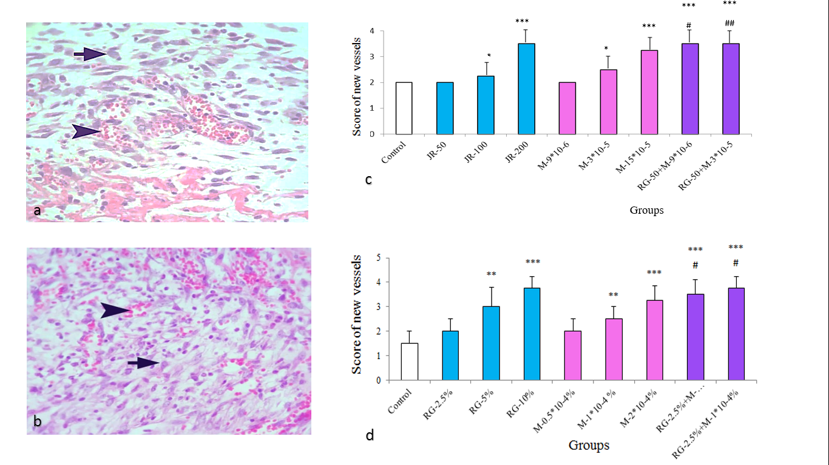
Picture 7: skin section, Formation of new blood vessels (arrowhead), fibroblasts (arrow) (H&E, x40) (a). New blood vessels (arrowhead) and the presence of fibroblasts (arrow) in topical treatment (H&E, x40) (b). The effect of combined oral treatment of RJ (50, 100 and 200 mg/kg) and melittin (9x10⁻⁶, 3x10⁻⁵ and 15x10⁻⁵ mg/kg) On the number of new blood vessels at the site of skin wound in small laboratory mice for 9 days(c). The effect of combined skin wound topical treatment with RJ (2.5, 5 and 10%) and melittin (0.5x10⁻⁴, 1x10⁻⁴ and 2x10⁻⁴%) on the presence of new blood vessels in the wound The skin of small laboratory mice for 9 days.(d) **p<0.01, ***p<0.001 shows the difference from the control group. #p<0.05 shows the difference from the single dose of RJ and melittin.

