Supplementary information
Time-resolved Observation of Surface-Bound Carbon Dioxide Radical Anions on Metallic Nanocatalyst
Zhiwen Jiang^{1,2}, Carine Clavaguéra², Changjiang Hu³, Jun Ma^{1,3}*, and Mehran Mostafavi²*
¹ School of Nuclear Science and Technology, University of Science and Technology of China, Hefei, Anhui 230026, China.
² Université Paris-Saclay, CNRS, Institute de Chimie Physique, UMR8000, 91405, Orsay, France.
³ Department of Materials Science and Technology, Nanjing University of Aeronautics and Astronautics, Nanjing, 211106, P. R. China.

Supplementary information Contents
Methods 3
Synthesis of metal nanoparticles 3
Characterization 3
Pulse radiolysis 4
Computational methods. 4
Supplementary Table and Figures 6
Reference 18

Methods

Synthesis of metal nanoparticles
All metal nanoparticles were synthesized by radiolytic methods.
In a typical synthesis for Cu nanoparticles, 20 mmol sodium formate and 0.5 mmol cetyltrimethylammonium chloride (CTAC) were added to 10 mL H₂O. Then, 10 mL copper(II) sulfate (1 mmol/L) solution was added to form homogeneous solutions. The solutions were saturated with Ar and sealed in a home-made cuvette. The cuvette was irradiated at a ⁶⁰Co gamma source (5.35 × 10¹³ Bq, located in the Université Paris-Saclay) at a dose rate of 2.2 kGy/h at ambient conditions. The dose rate was calibrated using the Fricke dosimeter, and the total absorbed dose reached 6.6 kGy. The resulting Cu nanoparticle solution was directly used for pulse radiolysis experiments and absorption spectroscopy characterization.
For Ni or Au nanoparticles, the precursor was replaced with nickel(II) chloride or sodium tetrachloroaurate. For size modification, it was controlled by varying the concentration of surfactant (cetrimonium bromide, CTAB), with higher concentrations resulting in larger particles. The synthesied 1.7, 5.3, and 6.2 nm Au nanoparticles correspond to 1 mM, 2.5 mM, and 10 mM CTAB concentration systems, respectively. The supernatant solution was centrifuged with the speed of 164700 RCF for 24 h at an Ultracentrifuge (Optima XE-90, BECKMAN COULTER) to remove nanoparticles from prepared solutions.

Characterization
Particle morphology and size distribution were examined by high-resolution transmission electron microscopy (HR-TEM, JEOL 2100 PLUS, 150 kV). UV-vis spectra were recorded on a UV-spectrophotometer (HEWLETT PACKARD 8453, HP) in the range from 190 to 800 nm.

Pulse radiolysis
Pulse radiolysis experiments were carried out employing the picosecond laser-triggered electron accelerator, ELYSE, coupled with a time-resolved absorption spectrophotometric detection system. Laser (260 nm) driven Cs₂Te photocathode allows the production of short electron pulses with a typical half width of 7 ps, a charge of ~ 6 nC, and energy of ~ 7.8 MeV at a repetition rate of 10 Hz. During irradiation, metal nanoparticle solutions were contained in a home-made cell with a path length of 1 cm. The diameter of the electron beam was 3 mm, and the irradiated volume was less than 0.1 mL.
Absorption spectral measurements were performed using the white light from a homemade Xenon flash lamp. The light was focused on the sample parallel to the electron beam with a smaller diameter and then directed onto a flat field spectrograph (250IS, Chromex), which disperses the light on the entrance optics of a high dynamic range streak-camera (C-7700-01, HAMAMATSU) to obtain an image resolved in wavelength and time. The kinetic data and absorption spectra were extracted from three series of 250 resulting images. In this work, the transient spectra were measured from 290 to 720 nm at 1 µs, 10 µs, 20 µs, 100 µs, and 1 ms.

Computational methods.
DFT calculations were done using the ORCA 5.0.3 software¹.
The geometry optimization calculations were performed using the PBE functional, the SDD pseudopotential (with 19 valence-electrons treated explicitly) for the metal atoms, and the def2-TZVP basis set for carbon and oxygen atoms. Dispersion corrections were added to the functional used in the D3 framework proposed by Grimme with the addition of the Becke–Johnson damping (D3BJ) in all cases². ${{{\text{[CO}}_{\text{2}}}^{\text{•–}}\text{]}}_{{\text{M}}_{\text{m}}}^{\text{ad}}$ (M for Au and Cu) has been designed as a model of a metallic NP in interaction with one CO₂•‒ radical with solvent effects represented by a dielectric continuum model. The orientation and nature of the interaction between the radical and NP have been probed by several quantum chemical analyses. Numerical frequencies were calculated to ensure the structures corresponded to energy minima. For Au and Cu, the 38-atom nanoparticle is considered in the singlet spin state, and the complex with the radical results in a doublet spin state. The CPCM implicit solvent model was used to represent the water environment. The electronic spectra were computed in the TD-DFT framework using the CAM-B3LYP functional and the implicit solvent. Between 600 and 800 excited states were included in the calculations to obtain the spectra of the different metal systems. The TD-DFT spectrum of the isolated CO₂•‒ radical was obtained at the CAM-B3LYP/aug-cc-pVTZ level by calculating 200 excited states.
The structure of the 92-atom Au NP with 5 CO₂•‒ radicals was optimized at PBE-D3BJ level (with the SVP basis set for C and O atoms) using an implicit solvent. A simplified calculation of the electronic spectrum was computed in vacuum using the simplified sTDA³ approach and the wB97X functional.
The quantum chemical topological and electronic transition analyses were performed with the Multiwfn code by analyzing the electron density generated from ORCA⁴. The analyses of both covalent and non-covalent interactions were calculated based on the Density Overlap Regions Indicator (DORI)⁵. The electron localization function (ELF) was calculated to determine the valence basins⁶.

Supplementary Table and Figures:
Supplementary 1: Structural and electronic properties of ${{{\text{[CO}}_{\text{2}}}^{\text{•–}}\text{]}}_{{\text{Au}}_{\text{m}}}^{\text{ad}}$ and ${{{\text{[CO}}_{\text{2}}}^{\text{•–}}\text{]}}_{{\text{Cu}}_{\text{m}}}^{\text{ad}}$, and comparison with CO₂^{•−} ADCH for atomic dipole corrected Hirshfeld atomic charges.
 | $${{{\text{[CO}}_{\text{2}}}^{\text{•–}}\text{]}}_{{\text{Au}}_{\text{m}}}^{\text{ad}}$$ | $${{{\text{[CO}}_{\text{2}}}^{\text{•–}}\text{]}}_{{\text{Cu}}_{\text{m}}}^{\text{ad}}$$ | CO₂^{•−}
C-O (Å) | 1.231  1.230 | 1.305  1.248 | 1.233
COC (deg) | 138 | 124 | 134
M-C (Å) | 2.172 | 2.011
M-O (Å) |  | 2.080
CO₂^{•−} ADCH charge (e) | -0.5 | -0.6 | -1.0
M---C Mayer bond order | 0.45 | 0.85
M---O Mayer bond order | - | 0.54
M-C ELF basin | 1.2 e | 2.2 e + 2.5 e

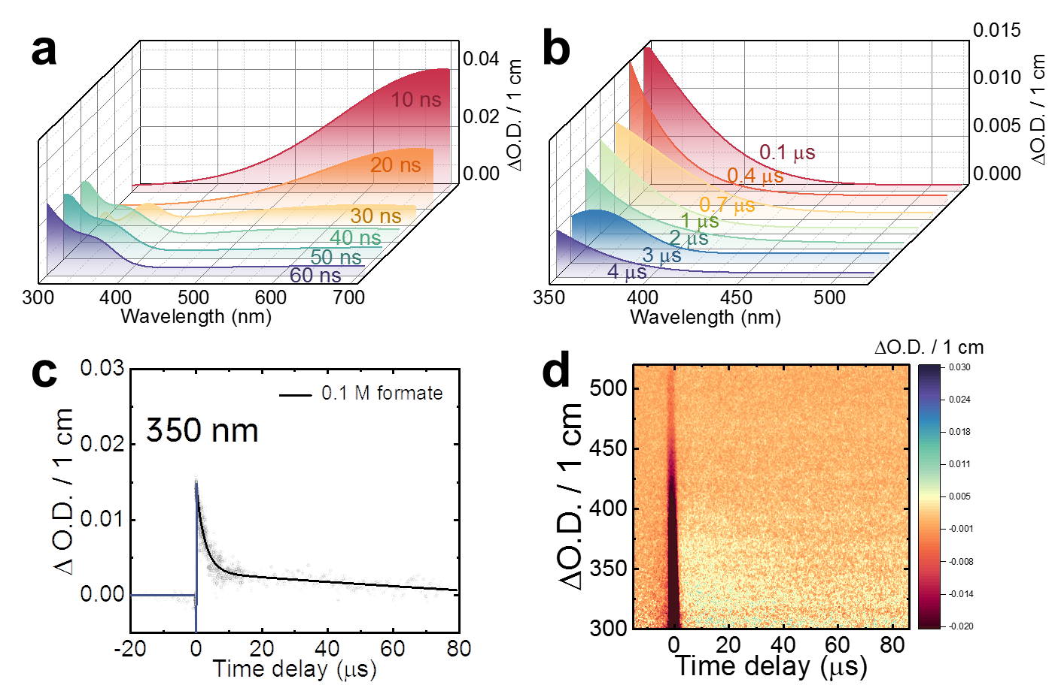
Supplementary Fig. 1 │ Time-resolved absorption of CO₂•‒ radical in free nanocatalyst solution containing 0.1 M formate. a-b, 3D stereograph of transient absorption spectra within 60 ns (a) and 4 µs (b). c, Transient kinetics at 350 nm within 80 µs. d, Transient absorption matrix, showing the evolution of the absorbance at every wavelength versus time after one electron pulse.

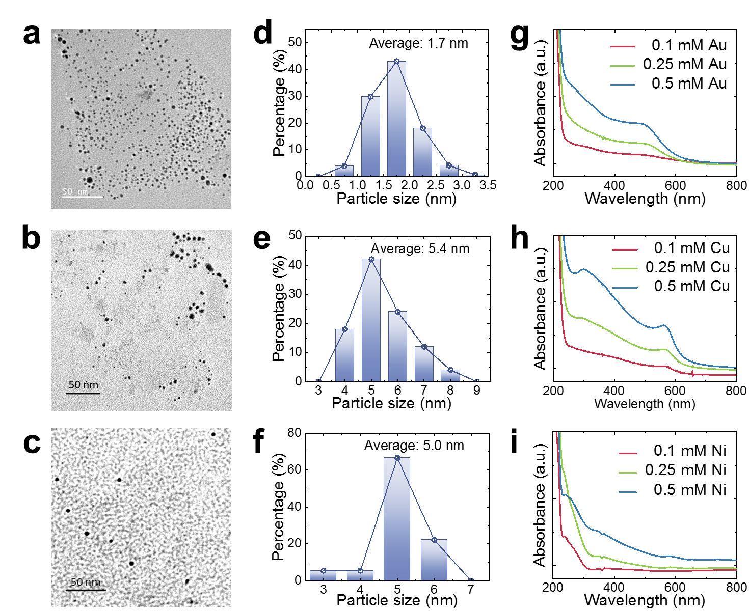
Supplementary Fig. 2 │ Morphology and size distribution of Au, Cu, and Ni nanoparticles. a-c, TEM image of Au (a), Cu (b), and Ni (c) nanoparticles. d-f, Size distribution derived from TEM images of Au (d), Cu (e), and Ni (f) nanoparticles. g-i, UV-vis spectra of Au (g), Cu (h), and Ni (i) dispersion.

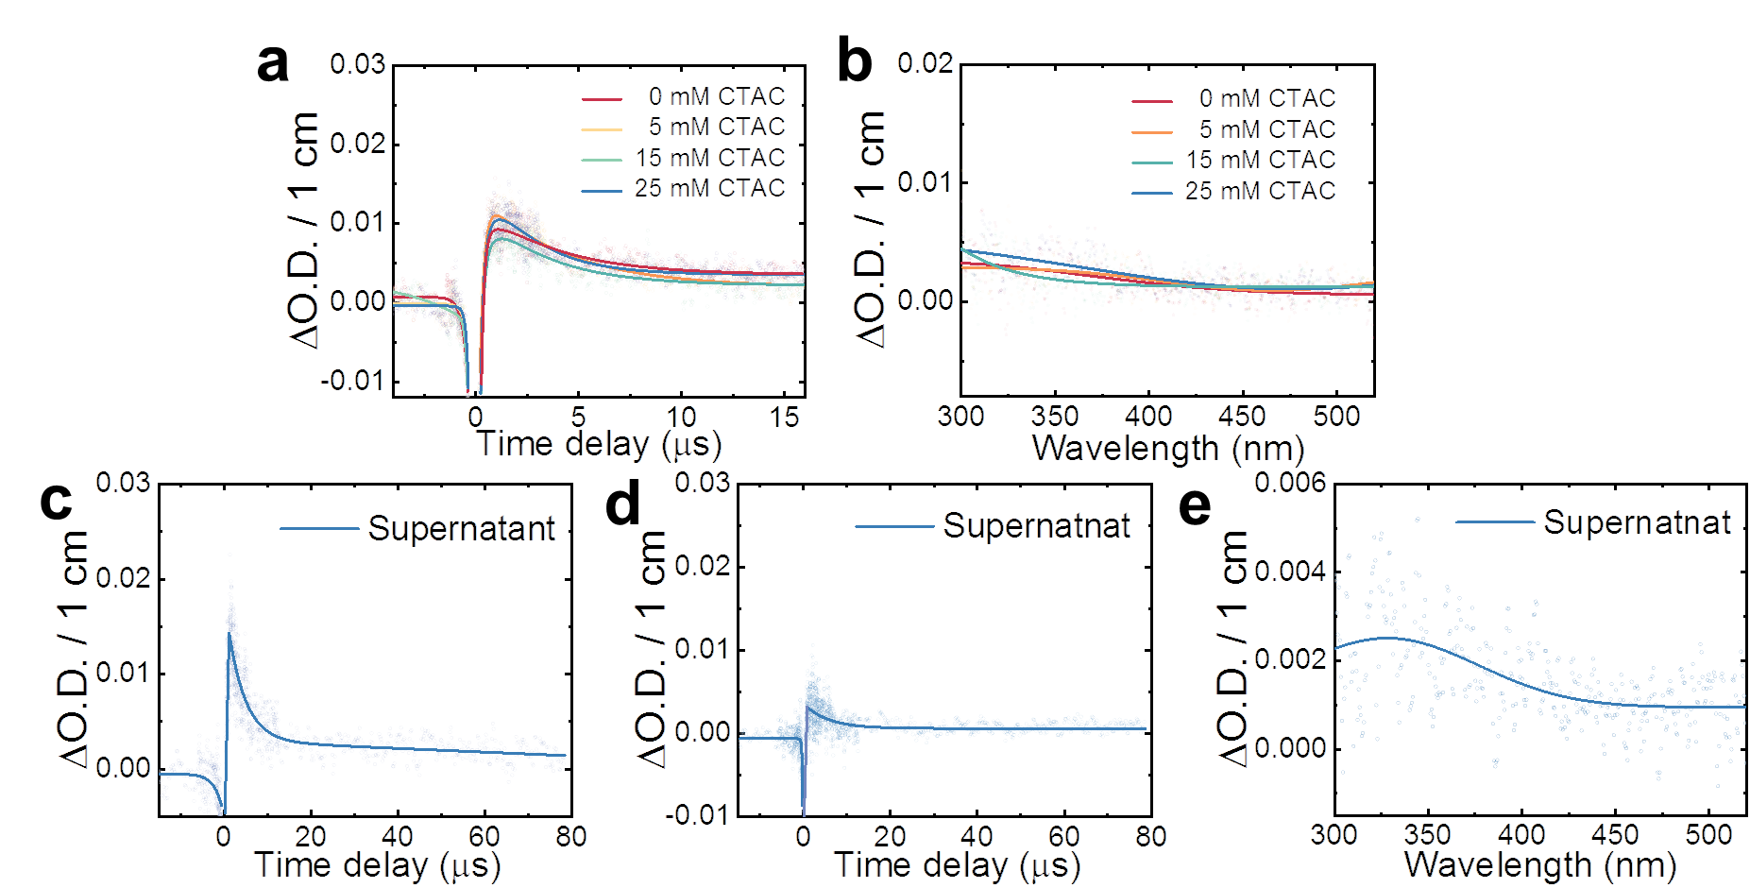
Supplementary Fig. 3 │ Transient kinetics and absorption spectra of CO₂•─ radical in reference solutions. a-b, Transient kinetics at 350 nm within 20 µs (a) and transient absorption spectra at 15 µs (b) in different concentration CTAC solutions. c-e, Transient kinetics at 350 nm (c) and 450 nm (d) within 20 µs and transient absorption spectra at 80 µs (e) in the Au supernatant.

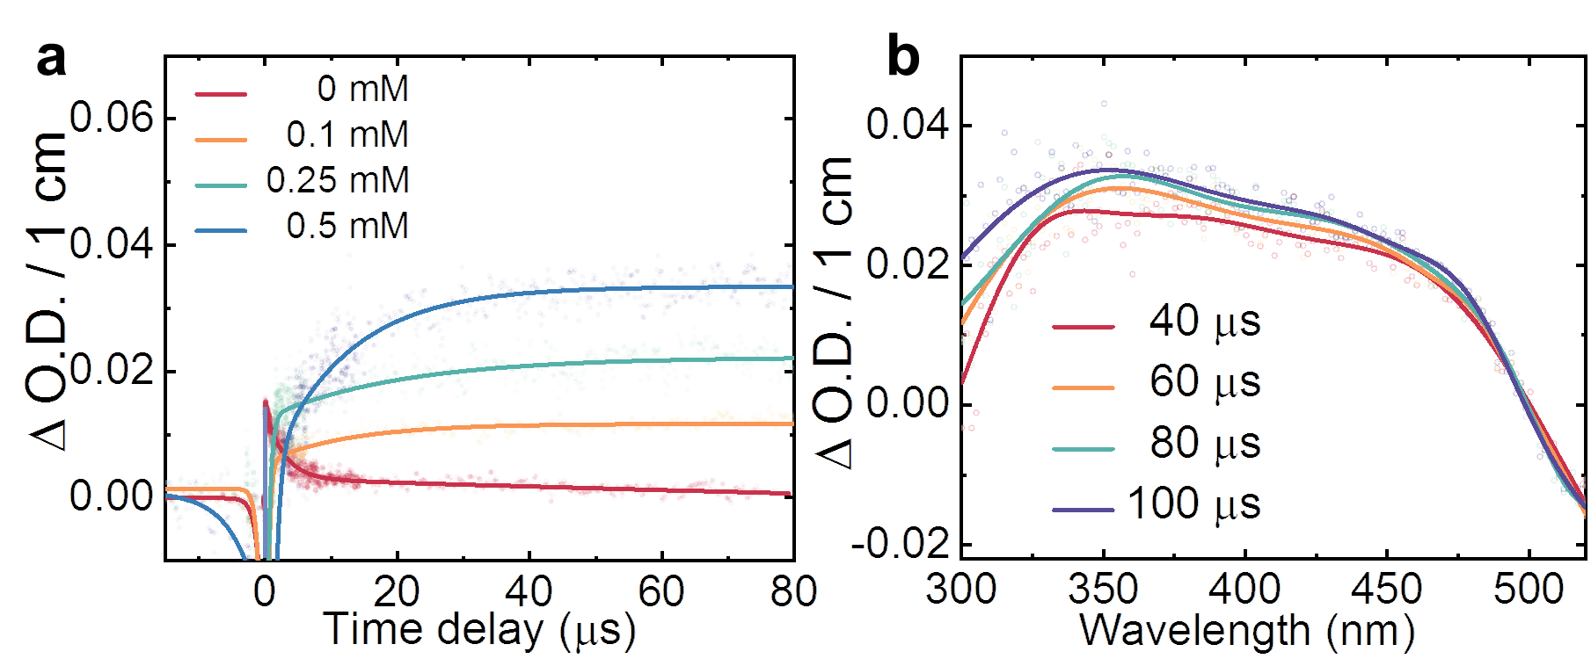
Supplementary Fig. 4 │ Transient kinetics of CO₂•─ radical stabilization process with Au at 350 nm within 100 µs.

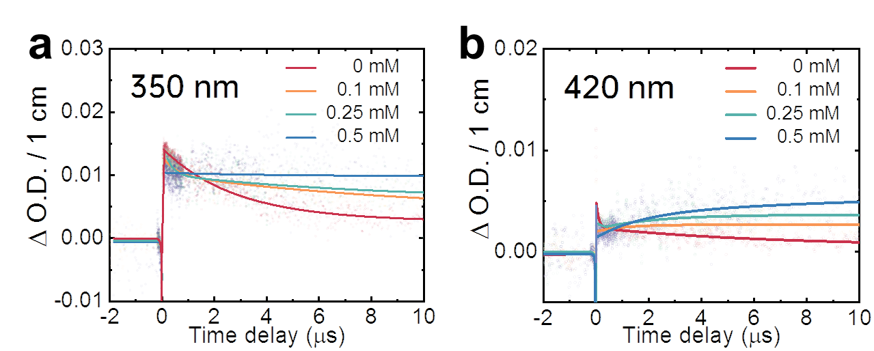
Supplementary Fig. 5 │ Transient kinetics of CO₂•─ radical stabilization process with Cu. a, Transient kinetics at 350 nm within 10 µs. b, Transient kinetics at 420 nm within 10 µs.

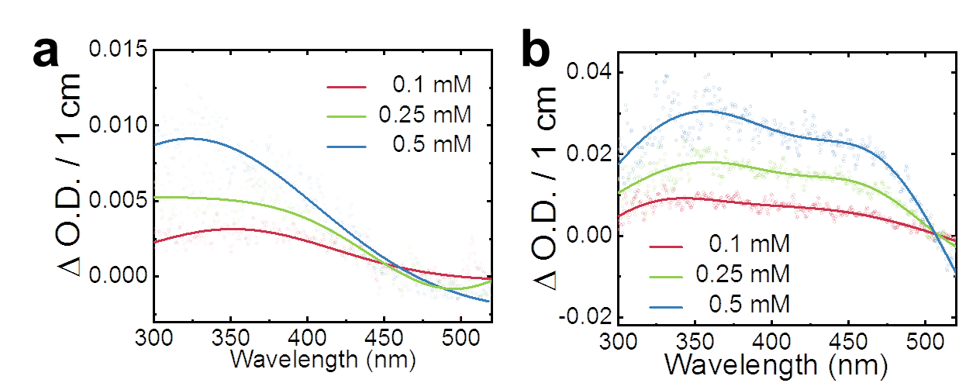
Supplementary Fig. 6 │ Transient absorption spectra of ${{{\text{[CO}}_{\text{2}}}^{\text{•–}}\text{]}}_{{\text{M}}_{\text{m}}}^{\text{ad}}$ radicals at 750 µs in the presence of Cu (a) and Au (b) nanoparticles.

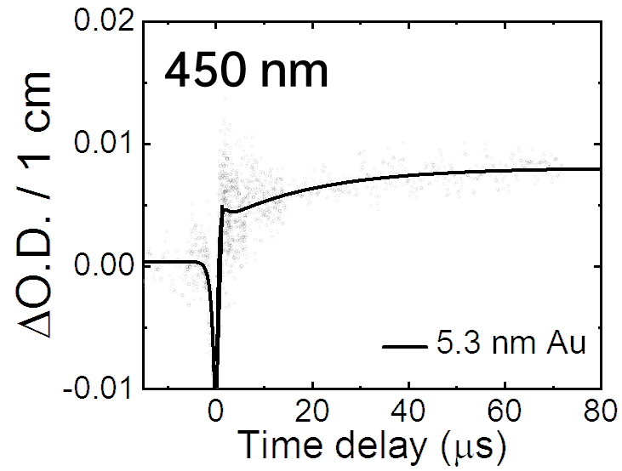
Supplementary Fig. 7 │ Transient kinetics of ${{{\text{[CO}}_{\text{2}}}^{\text{•–}}\text{]}}_{{\text{Au}}_{\text{m}}}^{\text{ad}}$ radicals at 450 nm in the presence of 5.3 nm Au.

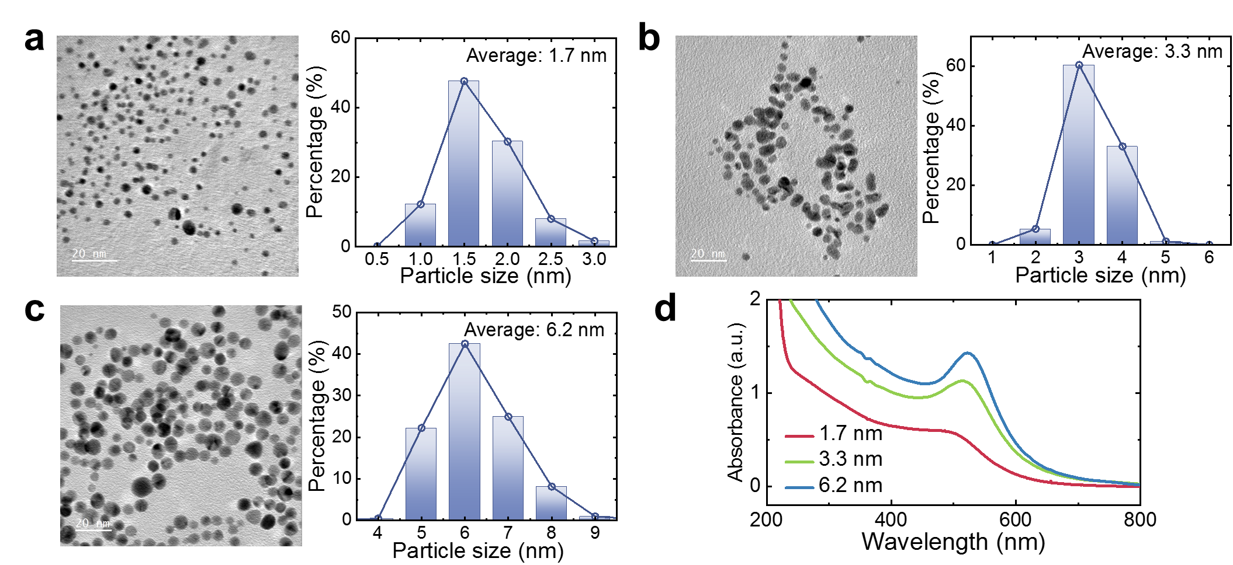
Supplementary Fig. 8 │ Morphology and size distribution of size-controlled Au nanoparticles. a-c, TEM image and corresponding size distribution of Au nanoparticles with the size of 3.3 nm (a), 5.3 nm (b), 6.2 nm (c). d, UV-vis spectra of Au dispersions.

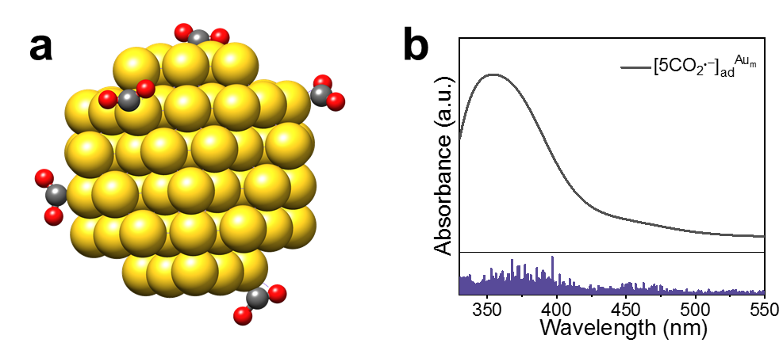
Supplementary Fig. 9 │ The simulation of 5 CO₂•‒ radical stabilized on a 92-atom Au NP. a, DFT optimized structure. b, sTDA electronic spectrum of ${{{\text{[5CO}}_{\text{2}}}^{\text{•–}}\text{]}}_{{\text{Au}}_{\text{m}}}^{\text{ad}}$(a shift of +80 nm has been applied to correct the sTDA approximation).
.

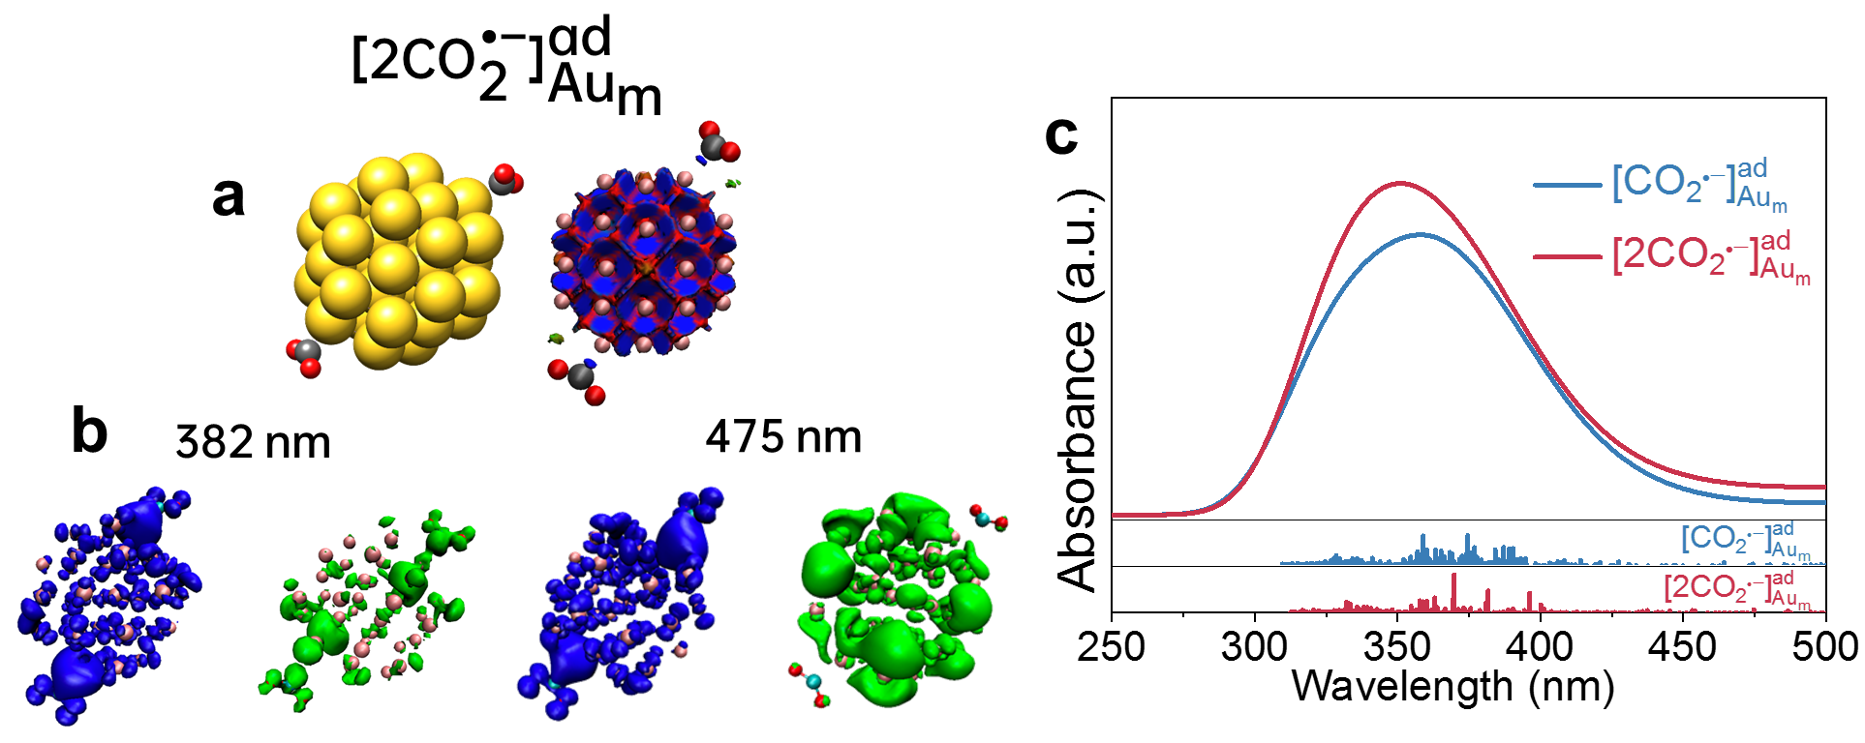
Supplementary Fig. 10 │ The simulation of 2CO₂•‒ radical stabilized on Au. a-b, DFT optimized structures, DORI plots (repulsive forces in red and covalent interaction in blue) (a), and electronic transition analysis (hole in blue and electron in green) (b) of ${{{\text{[2CO}}_{\text{2}}}^{\text{•–}}\text{]}}_{{\text{Au}}_{\text{m}}}^{\text{ad}}$. c, TD-DFT electronic spectra of ${{{\text{[CO}}_{\text{2}}}^{\text{•–}}\text{]}}_{{\text{Au}}_{\text{m}}}^{\text{ad}}$ and ${{{\text{[2CO}}_{\text{2}}}^{\text{•–}}\text{]}}_{{\text{Au}}_{\text{m}}}^{\text{ad}}$.

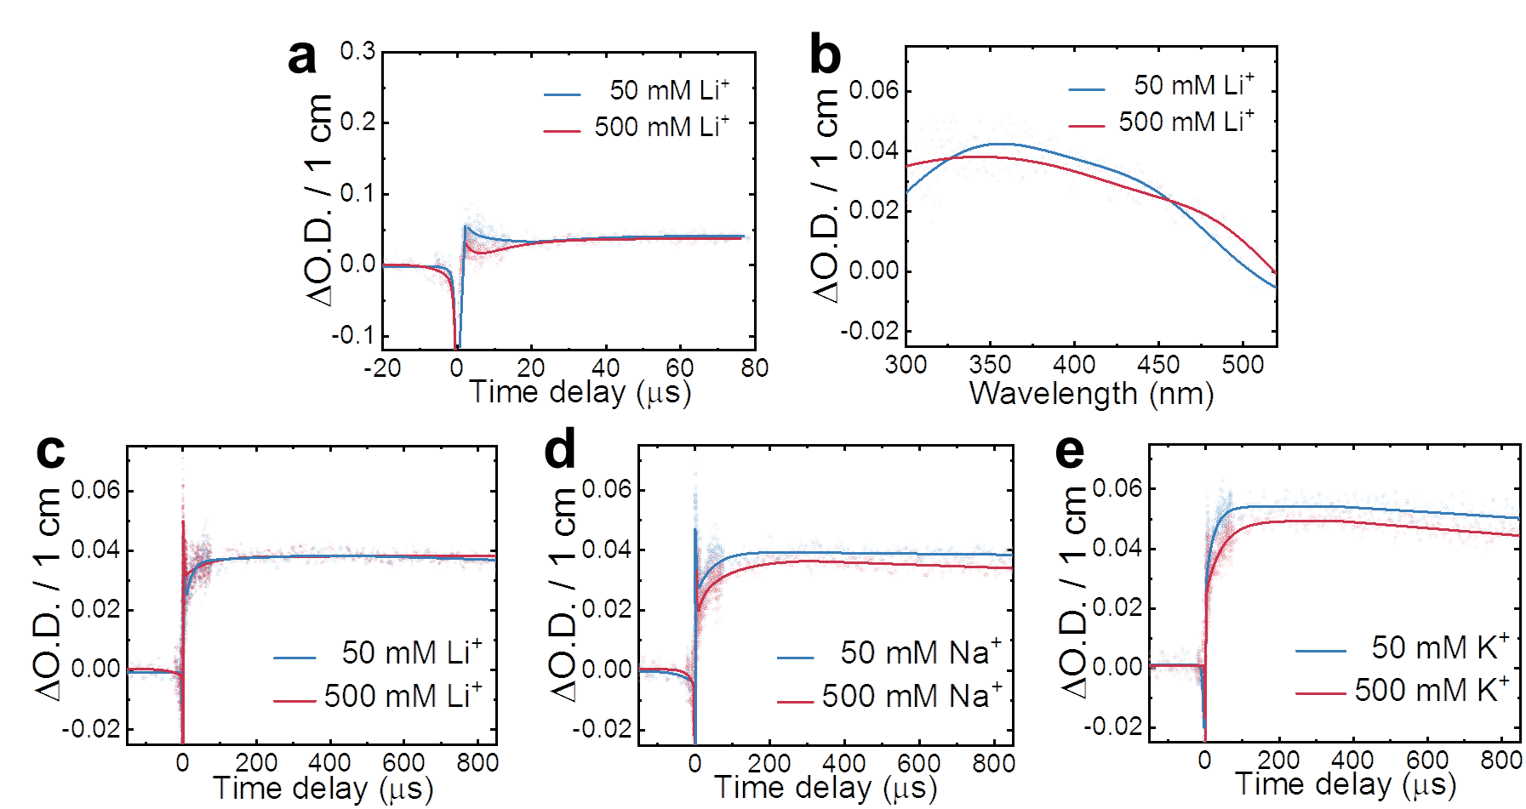
Supplementary Fig. 11 │ Cation effect on CO₂•‒ radical stabilization process within 850 µs. a-b, Transient kinetics at 350 nm (a) and absorption spectra at 75 µs (b) of *CO₂•‒ in different Li⁺ concentration solutions (radiolytic preparation with lithium formate). c-e, Transient kinetics at 350 nm (a) of *CO₂•‒ in different cation solutions within 850 µs.

Reference
1. Neese, F. The ORCA program system. Wiley Interdiscip. Rev. Comput. Mol. Sci. 2, 73–78 (2012).
2. Grimme, S., Ehrlich, S. & Goerigk, L. Effect of the damping function in dispersion corrected density functional theory. J. Comput. Chem. 32,1456-1465 (2011).
3. De Wergifosse, M. & Grimme, S. Nonlinear-response properties in a simplified time-dependent density functional theory (sTD-DFT) framework: evaluation of excited-state absorption spectra. J. Chem. Phys. 150, 094112 (2019).
4. Lu, T. & Chen, F. Multiwfn: a multifunctional wavefunction analyzer. J. Comput. Chem. 33, 580–592 (2012).
5. Silva, P. De. Simultaneous visualization of covalent and noncovalent interactions using regions of density overlap. J. Chem. Theory Comput. 10, 3745-3756 (2014).
6. Becke, A. D. & Edgecombe, K. E. A simple measure of electron localization in atomic and molecular systems. J. Chem. Phys. 92, 5397–5403 (1990).

