Microbial communities on UV cabins in the dermatology service of a Spanish hospital: ecology and resistance to UV light and antibiotics

Esther Molina-Menor ¹, Nicolás Carlotto ¹, Àngela Vidal-Verdú ¹, Amparo Pérez-Ferriols ², Gemma Pérez-Pastor ², and Manuel Porcar ^{1,3,}*
¹ Institute for Integrative Systems Biology (I2SysBio, University of Valencia-CSIC), Spain
²Servicio de Dermatología, Consorcio Hospital General de Valencia, Spain
³ Darwin Bioprospecting Excellence SL (Parc Científic Universitat de València, C/ CAtedràtic Agustín Escardino Benlloch 9, Paterna, Spain
*Correspondence: manuel.porcar@uv.es

ABSTRACT
Abstract: Microorganisms colonize all possible ecological habitats, including those subjected to harsh stressors such as UV radiation. Hospitals, in particular the UV cabins used in phototherapy units, constitute an environment in which microbes are intermittently subjected to UV irradiation. This selective pressure, in addition to the frequent use of antibiotics by patients, may represent a threat in the context of the increasing problem of antimicrobial resistance. In this work, a collection of microorganisms has been established in order to study the microbiota associated to the inner and outer surfaces of UV cabins and to assess their resistance to UV light and the antibiotics frequently used in the Dermatology Service of a Spanish hospital. Our results show that UV cabins harbor a relatively diverse biocenosis dominated by typically UV-resistant microorganisms commonly found in sun-irradiated environments, such as Kocuria, Micrococcus or Deinococcus spp., but also clinically relevant taxa, such as Staphylococcus or Pseudomonas spp. The UV-radiation assays revealed that, although some isolates displayed some resistance, UV is not a major factor shaping the biocenosis living on the cabins, since a similar pool of resistant microorganisms was identified on the external surface of the cabins. Interestingly, some Staphylococcus spp. displayed resistance to one or more antibiotics, although the hospital reported no cases of antibiotic-resistance infections of the patients using the cabins. Finally, no association between UV and antibiotic resistances was found.

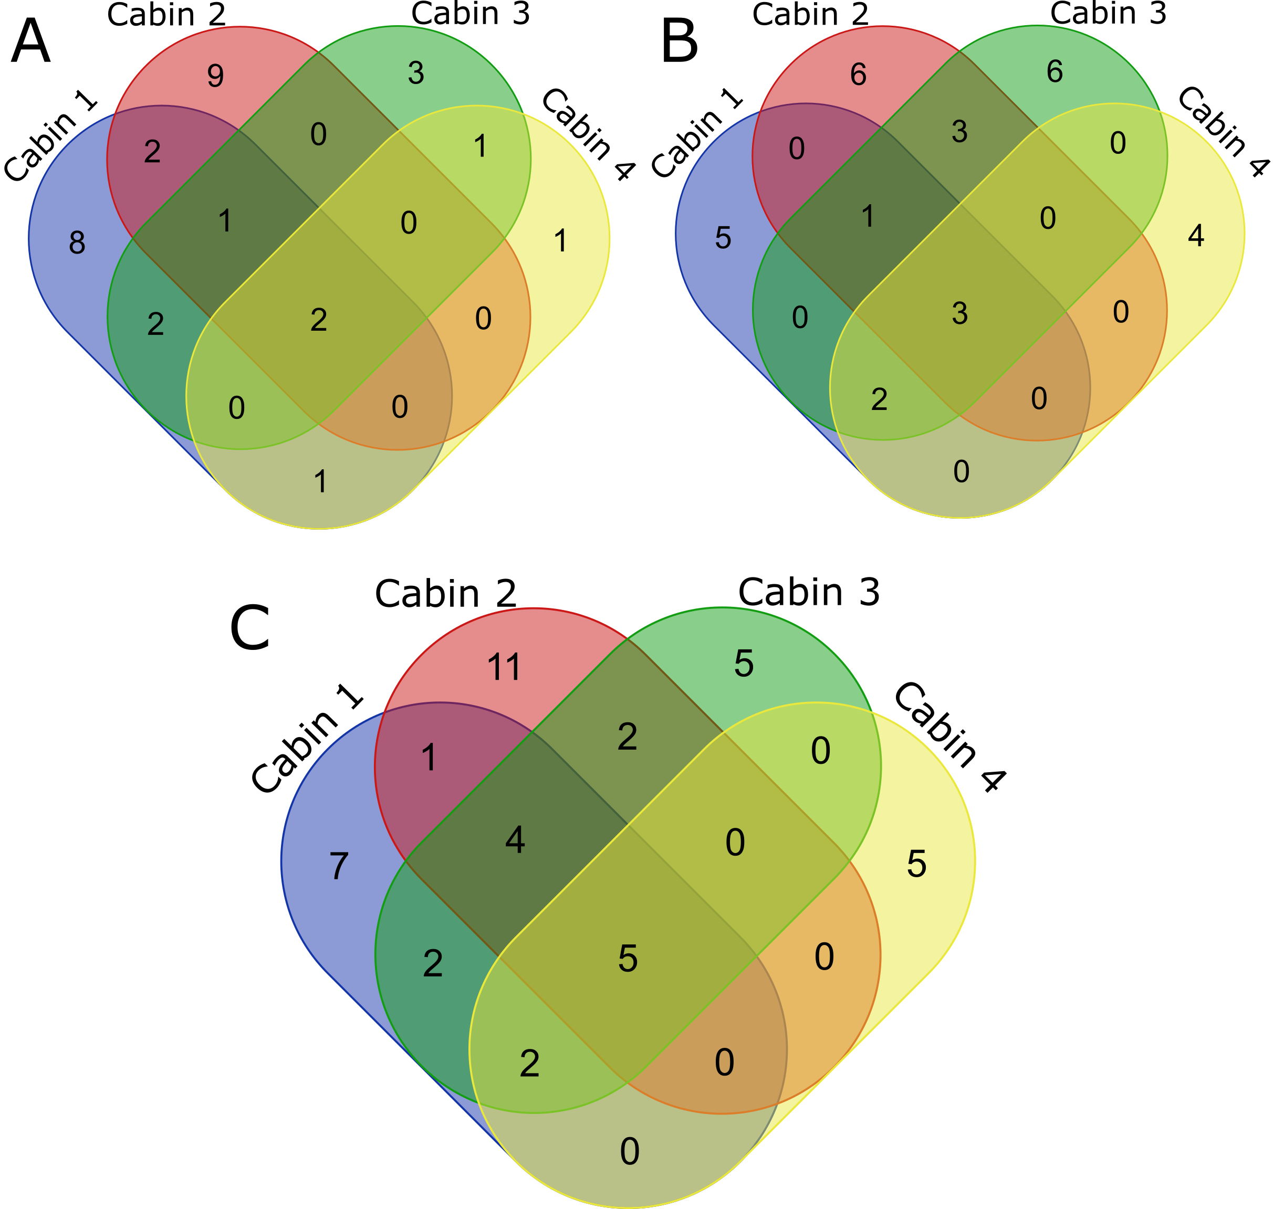
Figure S1. Venn diagrams showing the shared and exclusive taxa, at the genus level, in the different cabins. A) Genera isolated from inside the cabins. B) Genera isolated from outside the cabins. C) Genera regardless of the sampling site.
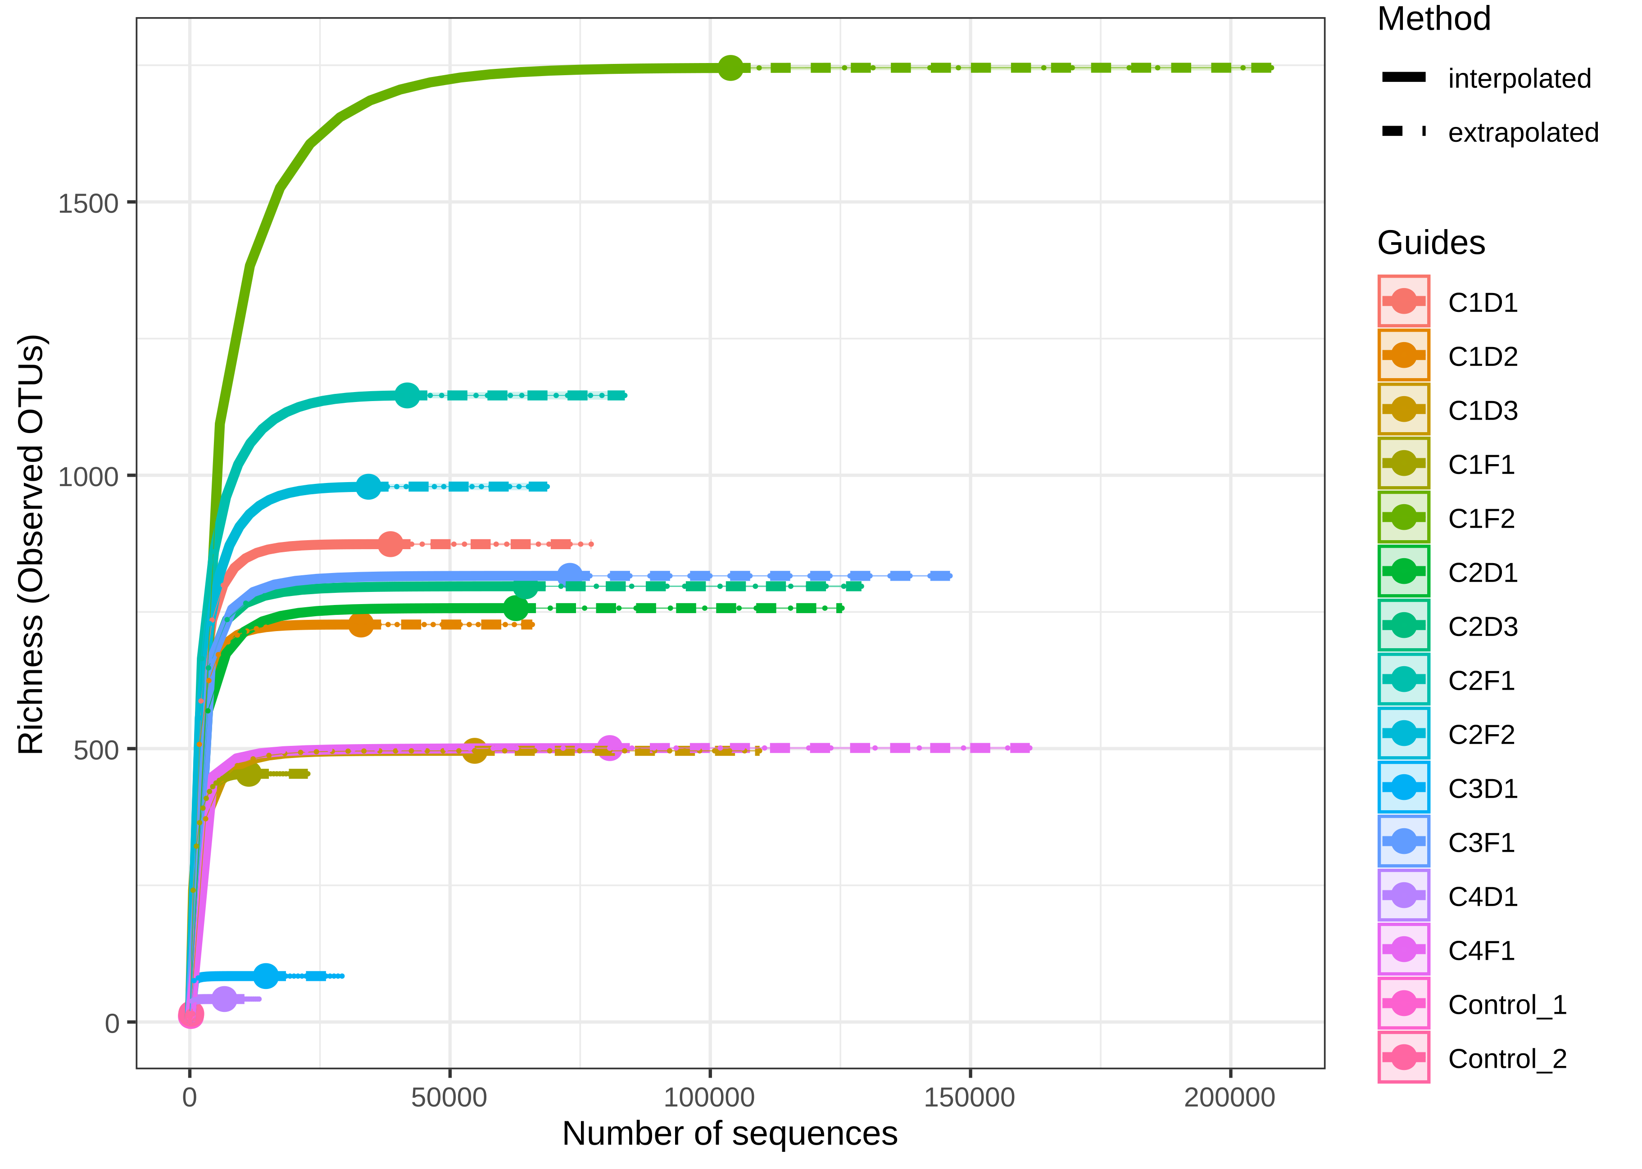
Figure S2. Rarefaction curve at OTU level.
A
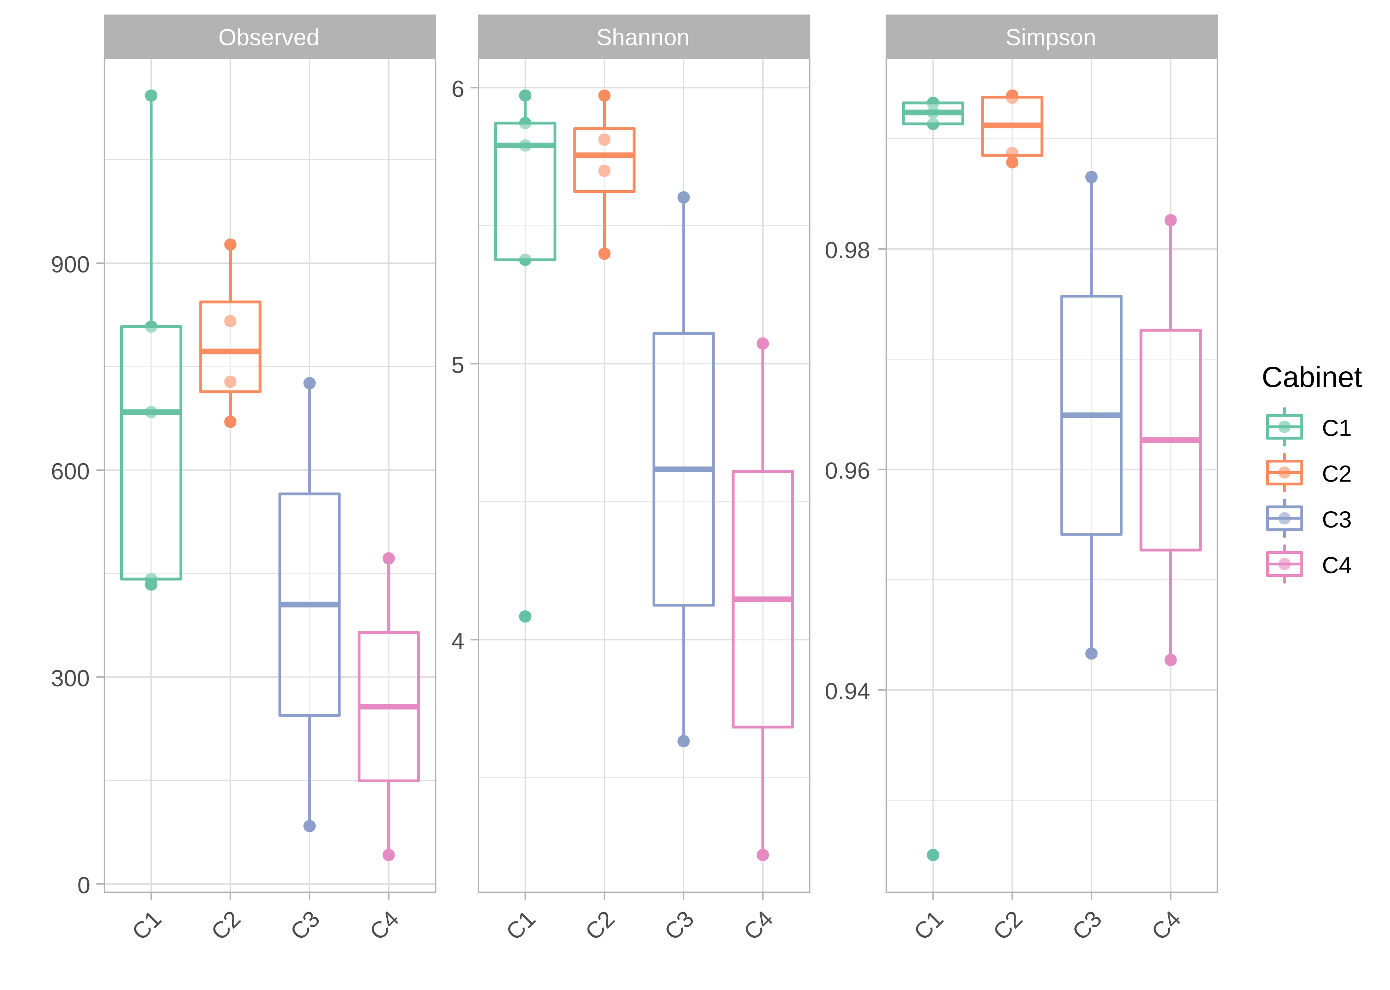
B
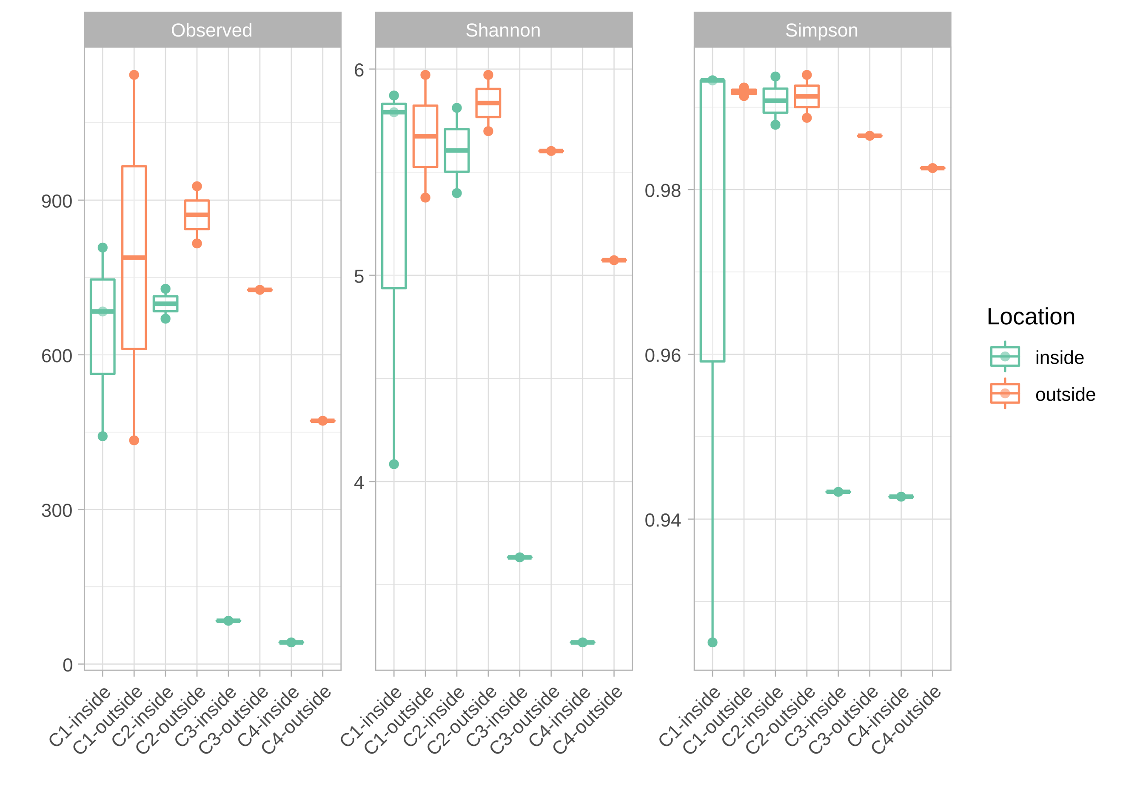

Figure S3. Microbial α-diversity at the ASV level (clones) observed through Wilcoxon test and measured by Shannon and Simpson indexes. A) Diversity among cabins. B) Diversity among cabins and sampling sites.

A
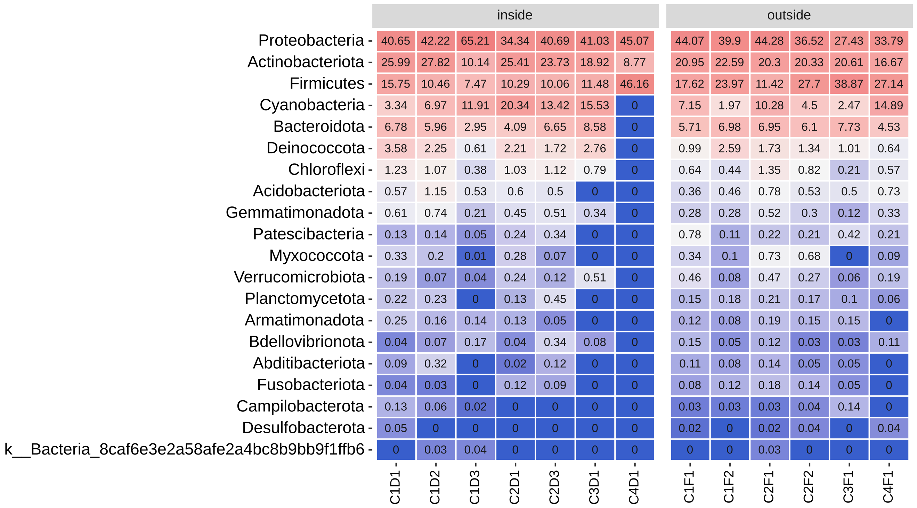
B
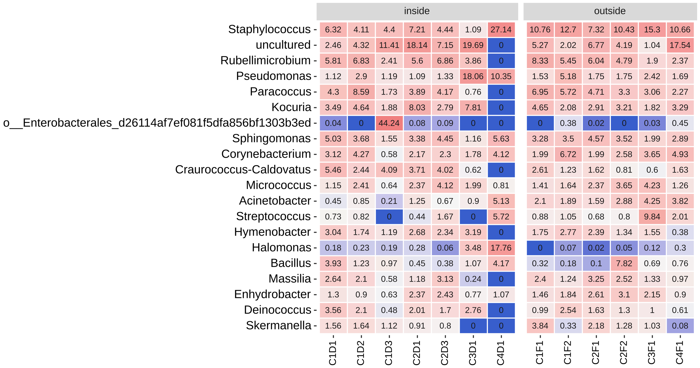
Figure S4. Heatmap showing the relative abundances (%) of bacteria in the sampled cabins as deduced by high-throughput 16S rRNA gene sequencing. A) Relative abundances at the phylum level. B) Relative abundances at the genus level.
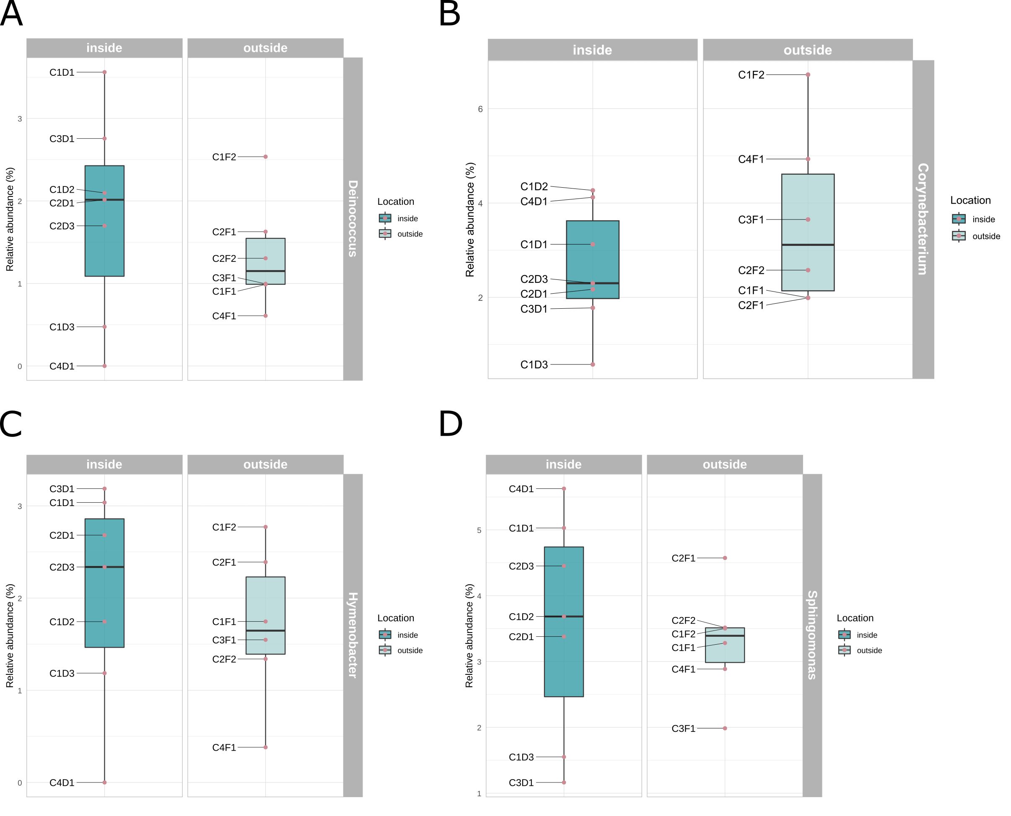
Figure S5. Relative abundances (%) at the genus level of specific taxa based on their abundance and relevance for the study. A) Abundance of Deinococcus. B) Abundance of Corynebacterium. C) Abundance of Hymenobacter. D) Abundance of Sphingomonas.

Table S1. Microbial collection identification and isolation data.
CODE COLLECTION | CABIN | SOURCE | GENUS | TOP HIT TYPE STRAIN
886 | 1 | INSIDE | Peribacillus | Peribacillus simplex
887 | 1 | INSIDE | Priestia | Priestia megaterium
888 | 1 | OUTSIDE | Pseudomonas | Pseudomonas stutzeri
889 | 1 | OUTSIDE | Staphylococcus | Staphylococcus haemolyticus
890 | 1 | OUTSIDE | Staphylococcus | Staphylococcus cohnii
891 | 2 | INSIDE | Kocuria | Kocuria rosea
892 | 2 | INSIDE | Staphylococcus | Staphylococcus borealis
893 | 2 | INSIDE | Pseudoxanthomonas | Pseudoxanthomonas suwonensis
894 | 2 | OUTSIDE | Bacillus | Bacillus zhangzhouensis
895 | 3 | INSIDE | Staphylococcus | Staphylococcus hominis subsp. hominis
896 | 3 | OUTSIDE | Kocuria | Kocuria palustris
897 | 3 | OUTSIDE | Staphylococcus | Staphylococcus caprae
898 | 3 | OUTSIDE | Micrococcus | Micrococcus luteus
899 | 3 | OUTSIDE | Pseudomonas | Pseudomonas fulva
900 | 4 | INSIDE | Paenibacillus | Paenibacillus illinoisensis
901 | 4 | INSIDE | Staphylococcus | Staphylococcus cohnii
902 | 4 | OUTSIDE | Kocuria | Kocuria arsenatis
903 | 1 | INSIDE | Frigoribacterium | Frigoribacterium endophyticum
904 | 1 | INSIDE | Micrococcus | Micrococcus luteus
905 | 1 | OUTSIDE | Bacillus | Bacillus altitudinis
906 | 2 | INSIDE | Micrococcus | Micrococcus luteus
907 | 2 | INSIDE | Micrococcus | Micrococcus luteus
908 | 2 | OUTSIDE | Micrococcus | Micrococcus luteus
909 | 2 | OUTSIDE | Staphylococcus | Staphylococcus haemolyticus
910 | 2 | OUTSIDE | Micrococcus | Micrococcus luteus
911 | 3 | INSIDE | Staphylococcus | Staphylococcus hominis subsp. hominis
912 | 4 | INSIDE | Staphylococcus | Staphylococcus hominis subsp. novobiosepticus
913 | 4 | OUTSIDE | Micrococcus | Micrococcus luteus
914 | 1 | INSIDE | Staphylococcus | Staphylococcus epidermidis
915 | 1 | OUTSIDE | Priestia | Priestia aryabhattai
916 | 2 | INSIDE | Staphylococcus | Staphylococcus hominis subsp. hominis
917 | 2 | INSIDE | Kocuria | Kocuria arsenatis
918 | 2 | OUTSIDE | NID | NID
919 | 2 | OUTSIDE | Microbacterium | Microbacterium algeriense
920 | 3 | INSIDE | Staphylococcus | Staphylococcus hominis subsp. hominis
921 | 3 | OUTSIDE | Pseudomonas | Pseudomonas oryzihabitans
922 | 4 | OUTSIDE | Roseomonas | Roseomonas mucosa
923 | 2 | INSIDE | Acinetobacter | Acinetobacter variabilis
924 | 1 | INSIDE | Micrococcus | Micrococcus luteus
925 | 1 | INSIDE | Curtobacterium | Curtobacterium flaccumfaciens
926 | 1 | INSIDE | Deinococcus | Deinococcus terrestris
927 | 2 | INSIDE | Staphylococcus | Staphylococcus epidermidis
928 | 2 | OUTSIDE | Metabacillus | Metabacillus idriensis
929 | 4 | OUTSIDE | Staphylococcus | Staphylococcus hominis subsp. novobiosepticus
930 | 2 | OUTSIDE | Pseudomonas | Pseudomonas kuykendallii
931 | 3 | INSIDE | Bacillus | Bacillus licheniformis
932 | 3 | INSIDE | Lysinibacillus | Lysinibacillus halotolerans
933 | 3 | INSIDE | Micrococcus | Micrococcus luteus
934 | 3 | OUTSIDE | Deinococcus | Deinococcus ficus
935 | 3 | INSIDE | Kocuria | Kocuria arsenatis
936 | 3 | OUTSIDE | Paracoccus | Paracoccus chinensis
937 | 3 | OUTSIDE | Pantoea | Pantoea conspicua
938 | 3 | OUTSIDE | Bacillus | Bacillus manliponensis
939 | 3 | OUTSIDE | Paracoccus | Paracoccus niistensis
940 | 4 | INSIDE | Kocuria | Kocuria turfanensis
941 | 4 | OUTSIDE | Kocuria | Kocuria arsenatis
942 | 1 | INSIDE | Metabacillus | Metabacillus idriensis
943 | 1 | OUTSIDE | Bacillus | Bacillus aerius
944 | 1 | OUTSIDE | Pseudomonas | Pseudomonas oryzihabitans
945 | 2 | INSIDE | Planococcus | Planococcus glaciei
946 | 2 | INSIDE | Kocuria | Kocuria rosea
947 | 2 | OUTSIDE | Micrococcus | Micrococcus luteus
948 | 2 | OUTSIDE | Staphylococcus | Staphylococcus edaphicus
949 | 3 | INSIDE | Robertmurraya | Robertmurraya siralis
950 | 3 | INSIDE | Bacillus | Bacillus altitudinis
951 | 3 | OUTSIDE | Micrococcus | Micrococcus luteus
952 | 3 | OUTSIDE | Metabacillus | Metabacillus halosaccharovorans
953 | 3 | OUTSIDE | Staphylococcus | Staphylococcus equorum subsp. equorum
954 | 4 | INSIDE | Bacillus | Bacillus pseudomycoides
955 | 4 | INSIDE | Staphylococcus | Staphylococcus saprophyticus subsp. saprophyticus
956 | 4 | OUTSIDE | Staphylococcus | Staphylococcus edaphicus
957 | 4 | OUTSIDE | Cytobacillus | Cytobacillus firmus
958 | 1 | INSIDE | Kocuria | Kocuria rosea
959 | 1 | INSIDE | Micrococcus | Micrococcus luteus
960 | 1 | INSIDE | Arthrobacter | Arthrobacter bussei
961 | 1 | INSIDE | Micrococcus | Micrococcus luteus
962 | 2 | INSIDE | Arthrobacter | Arthrobacter bussei
963 | 1 | OUTSIDE | Aureobasidium | Aureobasidium namibiae
964 | 2 | INSIDE | Acinetobacter | Acinetobacter variabilis
965 | 2 | OUTSIDE | Psychrobacillus | Psychrobacillus psychrodurans
966 | 3 | INSIDE | Micrococcus | Micrococcus luteus
967 | 3 | OUTSIDE | Pseudomonas | Pseudomonas oryzihabitans
968 | 3 | OUTSIDE | NID | NID
969 | 3 | OUTSIDE | Planococcus | Planococcus okeanokoites
970 | 4 | OUTSIDE | Kocuria | Kocuria arsenatis
971 | 4 | OUTSIDE | Staphylococcus | Staphylococcus borealis
972 | 4 | OUTSIDE | Ustilago | Ustilago shanxiensis
973 | 4 | INSIDE | Staphylococcus | Staphylococcus hominis subsp. novobiosepticus
974 | 4 | OUTSIDE | Micrococcus | Micrococcus luteus
975 | 1 | INSIDE | Domibacillus | Domibacillus indicus
976 | 1 | INSIDE | Streptomyces | Streptomyces flavovirens
977 | 1 | INSIDE | Frigoribacterium | Frigoribacterium faeni
978 | 1 | OUTSIDE | Streptomyces | Streptomyces ambofaciens
979 | 1 | OUTSIDE | Priestia | Priestia aryabhattai
980 | 1 | OUTSIDE | Bacillus | Bacillus altitudinis
981 | 2 | INSIDE | Sphingomonas | Sphingomonas aerolata
982 | 2 | INSIDE | Massilia | Massilia dura
983 | 2 | OUTSIDE | Pseudomonas | Pseudomonas oryzihabitans
984 | 2 | OUTSIDE | Staphylococcus | Staphylococcus argenteus
985 | 2 | OUTSIDE | Arthrobacter | Arthrobacter agilis
986 | 2 | OUTSIDE | Neobacillus | Neobacillus niacini
987 | 3 | OUTSIDE | NID | NID
988 | 4 | INSIDE | Staphylococcus | Staphylococcus cohnii
989 | 4 | OUTSIDE | Kocuria | Kocuria arsenatis
990 | 4 | OUTSIDE | Pseudomonas | Pseudomonas kuykendallii
991 | 1 | INSIDE | Cryptococcus | [Cryptococcus] albidus var. kuetzingii
992 | 2 | INSIDE | Cystobasidium | Cystobasidium slooffiae
993 | 2 | INSIDE | Massilia | Massilia arvi
994 | 2 | INSIDE | Rhodotorula | Rhodotorula mucilaginosa
995 | 2 | INSIDE | Saccharibacillus | Saccharibacillus qingshengii
996 | 2 | OUTSIDE | Erwinia | Erwinia endophytica
997 | 3 | INSIDE | Staphylococcus | Staphylococcus hominis subsp. hominis
998 | 4 | INSIDE | Paenibacillus | Paenibacillus illinoisensis
999 | 3 | OUTSIDE | Aureobasidium | Aureobasidium namibiae
1000 | 4 | OUTSIDE | Kocuria | Kocuria arsenatis
1001 | 4 | OUTSIDE | Novosphingobium | Novosphingobium silvae
1002 | 1 | INSIDE | Aureobasidium | Aureobasidium namibiae
1003 | 1 | OUTSIDE | Moraxella | Moraxella osloensis
1004 | 2 | INSIDE | Massilia | Massilia arvi
1005 | 2 | INSIDE | Saccharibacillus | Saccharibacillus qingshengii
1006 | 2 | INSIDE | Acinetobacter | Acinetobacter variabilis
1007 | 2 | OUTSIDE | Massilia | Massilia agri
1008 | 2 | OUTSIDE | Stenotrophomonas | Stenotrophomonas rhizophila
1009 | 3 | OUTSIDE | Kosakonia | Kosakonia cowanii
1010 | 3 | OUTSIDE | Staphylococcus | Staphylococcus hominis subsp. novobiosepticus
1011 | 3 | OUTSIDE | Arthrobacter | Arthrobacter agilis
1012 | 4 | INSIDE | Curtobacterium | Curtobacterium citreum
1013 | 4 | INSIDE | Curtobacterium | Curtobacterium oceanosedimentum
1014 | 4 | OUTSIDE | Kocuria | Kocuria arsenatis
1015 | 4 | OUTSIDE | Novosphingobium | Novosphingobium silvae
1016 | 1 | INSIDE | Microbacterium | Microbacterium esteraromaticum
1017 | 1 | INSIDE | Arthrobacter | Arthrobacter bussei
1018 | 1 | INSIDE | Frigoribacterium | Frigoribacterium faeni
1019 | 1 | OUTSIDE | Micrococcus | Micrococcus luteus
1020 | 1 | OUTSIDE | Kocuria | Kocuria arsenatis
1021 | 1 | OUTSIDE | Cellulomonas | Cellulomonas pakistanensis
1022 | 1 | OUTSIDE | Bacillus | Bacillus toyonensis
1023 | 1 | OUTSIDE | NID | NID
1024 | 2 | INSIDE | Staphylococcus | Staphylococcus epidermidis
1025 | 2 | INSIDE | Paracoccus | Paracoccus halotolerans
1026 | 2 | INSIDE | Staphylococcus | Staphylococcus cohnii
1027 | 2 | INSIDE | Arthrobacter | Arthrobacter bussei
1028 | 2 | INSIDE | Kocuria | Kocuria polaris
1029 | 2 | OUTSIDE | Fredinandcohnia | Fredinandcohnia onubensis
1030 | 2 | OUTSIDE | NID | NID
1031 | 2 | OUTSIDE | Pseudomonas | Pseudomonas stutzeri
1032 | 3 | INSIDE | Microbacterium | Microbacterium esteraromaticum
1033 | 3 | INSIDE | Frigoribacterium | Frigoribacterium faeni
1034 | 3 | INSIDE | Rhodococcus | Rhodococcus corynebacterioides
1035 | 3 | OUTSIDE | Pseudomonas | Pseudomonas oryzihabitans
1036 | 3 | OUTSIDE | Aureobasidium | Aureobasidium namibiae
1037 | 4 | INSIDE | Staphylococcus | Staphylococcus cohnii
1038 | 4 | OUTSIDE | Kocuria | Kocuria palustris
1039 | 4 | OUTSIDE | Aureobasidium | Aureobasidium namibiae
1040 | 3 | OUTSIDE | Arthrobacter | Arthrobacter bussei
1041 | 3 | INSIDE | Micrococcus | Micrococcus luteus
1042 | 4 | OUTSIDE | Cytobacillus | Cytobacillus horneckiae
1043 | 4 | OUTSIDE | Kocuria | Kocuria arsenatis
1044 | 2 | INSIDE | Cellulomonas | Cellulomonas cellasea
1045 | 1 | INSIDE | Paracoccus | Paracoccus panacisoli
1046 | 1 | INSIDE | Priestia | Priestia endophytica
1047 | 2 | INSIDE | Staphylococcus | Staphylococcus hominis subsp. hominis
1048 | 1 | OUTSIDE | Mixta | Mixta calida
1049 | 3 | INSIDE | Frigoribacterium | Frigoribacterium faeni
1050 | 3 | INSIDE | Frigoribacterium | Frigoribacterium faeni
1051 | 2 | OUTSIDE | Staphylococcus | Staphylococcus edaphicus
1052 | 3 | OUTSIDE | Curtobacterium | Curtobacterium flaccumfaciens
1053 | 1 | OUTSIDE | Pseudomonas | Pseudomonas stutzeri
1054 | 3 | OUTSIDE | Neobacillus | Neobacillus niacini

Table S2. Selected strains for biological activity assays.
CODE COLLECTION | ID | SOURCE
889 | Staphylococcus haemolyticus | Outside
890 | Staphylococcus cohnii | Outside
896 | Kocuria palustris | Outside
901 | Staphylococcus cohnii | Inside
906 | Micrococcus luteus | Inside
912 | Staphylococcus hominis | Inside
925 | Curtobacterium flaccumfaciens | Inside
927 | Staphylococcus epidermidis | Inside
929 | Staphylococcus hominis | Outside
932 | Lysinibacillus halotolerans | Inside
934 | Deinococcus ficus | Outside
935 | Kocuria arsenatis | Inside
950 | Bacillus altitudinis | Inside
964 | Acinetobacter variabilis | Inside
977 | Frigoribacterium faeni | Inside
979 | Priestia aryabhattai | Outside
980 | Bacillus altitudinis | Outside
1008 | Stenotrophomonas rhizophila | Outside
1011 | Arthrobacter agilis | Outside
1016 | Microbacterium esteraromaticum | Inside
1019 | Micrococcus luteus | Outside
1020 | Kocuria arsenatis | Outside
1027 | Arthrobacter bussei | Inside
1028 | Kocuria polaris | Inside
1040 | Arthrobacter bussei | Outside
1045 | Paracoccus panacisoli | Inside
1052 | Curtobacterium flaccumfaciens | Outside
1053 | Pseudomonas stutzeri | Outside

