Appendix
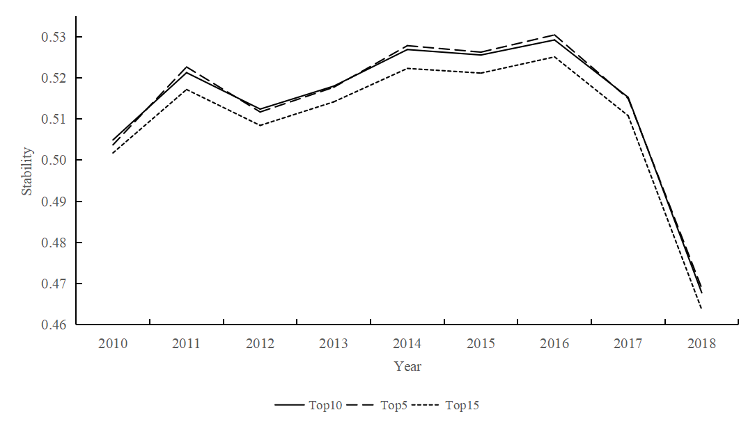
Figure A1 Export stability (for alternative cutoffs)
Note: the difference between the values of the export stability index calculated under different cut-off criteria is less than 0.1 and is consistent in terms of time trends. These results suggest that the choice of export destination ranking class may cause some differences in the values of the export stability index, but the relevant differences should not be sufficient to influence the results of subsequent empirical studies.

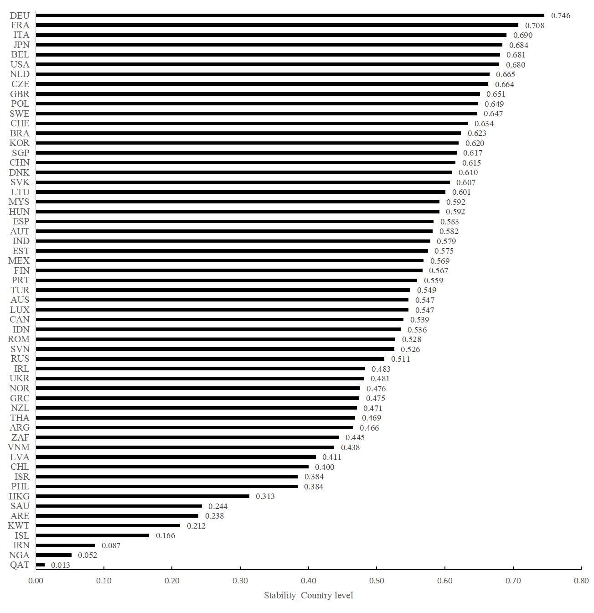
Figure A2 Cross-country heterogeneity in export stability
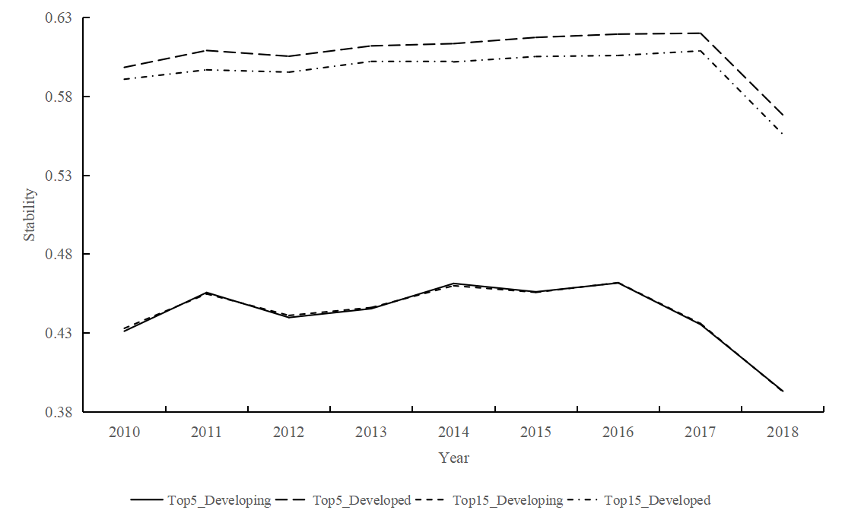
Figure A3 Cross-country heterogeneity in export stability (alternative cutoffs)

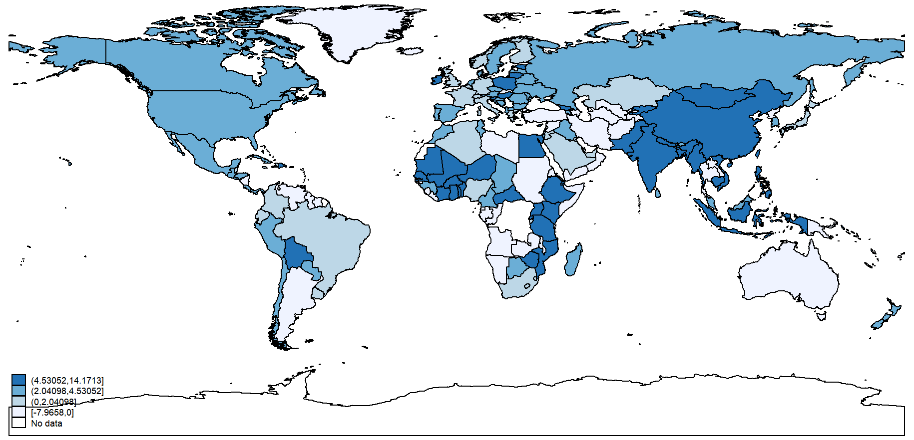
Figure A4 Global GNI growth rate, 2018
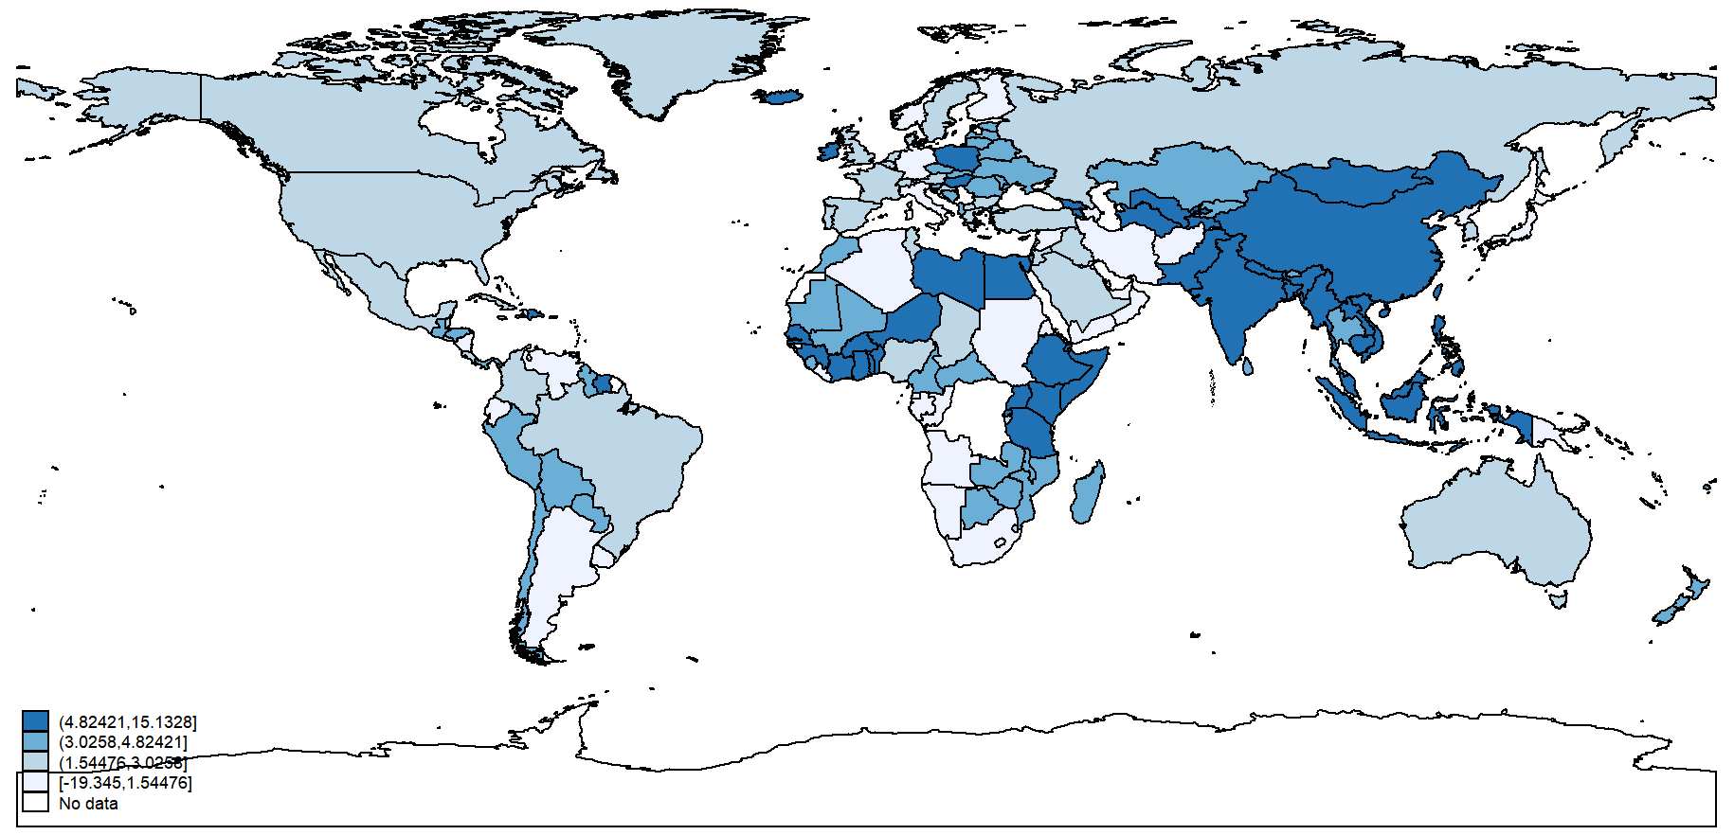
Figure A5 Global growth rate of GDP per capita, 2018

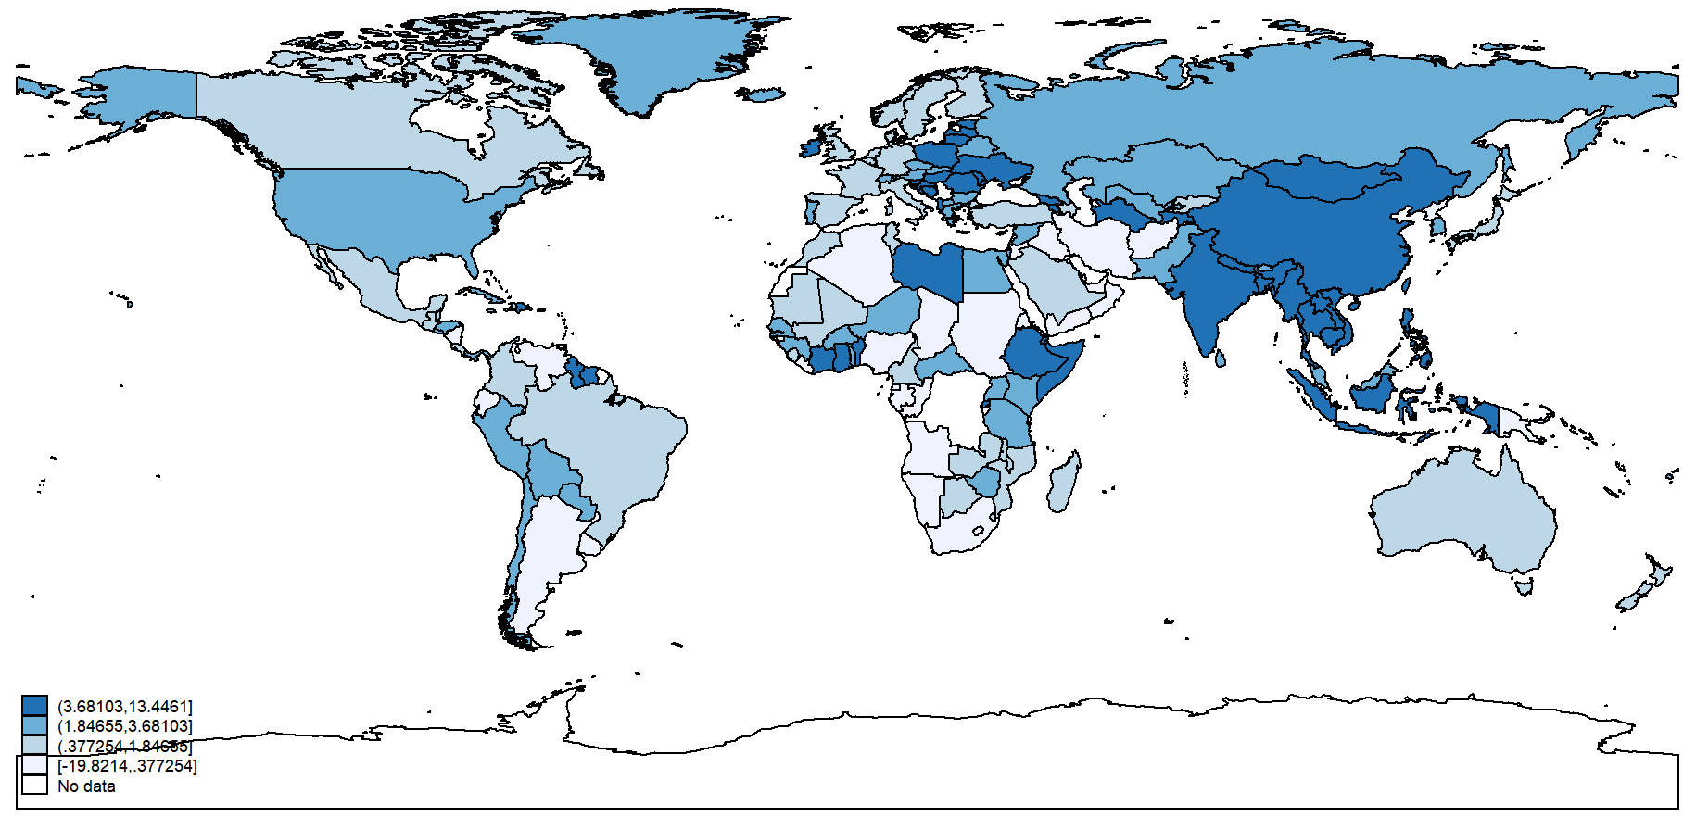
Figure A6 Global GDP growth rate, 2018

Table A1 Variable description and statistic
Variable | Description | Mean | min | Max | Source
Sta_Top10 | Export stability(TOP10) | 0.508 | 0.000 | 1.000 | Calculate manually
Sta_Top5 | Export stability(TOP5) | 0.508 | 0.000 | 1.000 | Calculate manually
Sta_Top15 | Export stability(TOP15) | 0.503 | 0.000 | 1.000 | Calculate manually
Sta_Top10_{USA,} | Export stability of the US | 0.679 | 0.000 | 1.000 | Calculate manually
Sta10_Top_{CHN} | Export stability of China | 0.615 | 0.000 | 1.000 | Calculate manually
Sta10_Top_{JPN,} | Export stability of Japan | 0.684 | 0.000 | 1.000 | Calculate manually
Sta10_Top_{DEU,} | Export stability of Germany | 0.745 | 0.000 | 1.000 | Calculate manually
G_PGNI_{it} | GNI per capita growth rate | 1.017 | -4.089 | 2.780 | World Bank
G_PGDP | GDP per capita growth rate | 1.053 | -2.573 | 3.218 | World Bank
G_GNI | GNI growth rate | 1.214 | -3.104 | 2.850 | World Bank
G_GDP | GDP growth rate | 1.293 | -2.559 | 3.264 | World Bank
Trade_value | Export size | 15.318 | 0.000 | 26.444 | UN-Comtrade
Life | Life expectancy per capita | 4.394 | 3.954 | 4.484 | World Bank
Farm | Agricultural land area | 2.465 | 0.001 | 6.272 | World Bank
Inter | Level of internal conflict | 2.341 | 1.945 | 2.564 | ICRG
Exter | Level of external conflict | 2.390 | 1.871 | 2.564 | ICRG
Mili | Level of government militarization | 1.749 | 0.982 | 1.945 | ICRG
Reli | Level of religious conflict | 1.715 | 0.693 | 1.945 | ICRG
Law | Level of legal system | 1.672 | 0.916 | 1.945 | ICRG
Trade_con | Net terms-of-trade index | 4.678 | 3.925 | 5.432 | World Bank
pop | Pupolation size | 16.863 | 12.669 | 21.049 | World Bank
lab | Labor productivity | 10.691 | 7.700 | 12.370 | The Conference Board Total Economy Database
Adv | Comparative advantage of product exports | 5.242 | 0.000 | 16.644 | Calculate manually
Price | Product export price | 1.457 | 0.000 | 19.308 | UN-Comtrade
Exp | Export Value Index (Country) | 5.721 | 4.634 | 7.304 | World Bank
Job | Unemployment rate | 2.121 | 0.760 | 3.383 | World Bank

Table A2 Include extensive control variables and change sample classification criteria
 | (1) | (2) | (3) | (4) | (5) | (6)
 | Developing countries | Developed countries | Developing countries | Developed countries | Non-OECD countries | Non-OECD countries
 | G_PGNI | G_PGNI | G_PGNI | G_PGNI | G_PGNI | G_PGNI
Sta_Top10 | 0.201***  (0.055) | -0.040  (0.041) | 0.196***  (0.054) | -0.001  (0.037) | 0.146***  (0.043) | 0.039  (0.059)
Trade_value | 0.046  (0.380) | 0.084  (0.227) | 0.342  (0.357) | 0.042  (0.220) | 0.337  (0.326) | -0.395  (0.320)
Life |  |  | 0.120  (0.108) | -0.363  (0.334) | 0.086  (0.087) | -0.786  (0.469)
Farm |  |  | 0.045  (0.048) | -0.177  (0.146) | 0.101***  (0.036) | -0.468***  (0.151)
Institutional characteristics |  |  | Y | Y | Y | Y
Control variables | Y | Y | Y | Y | Y | Y
Fixed Effect | Y | Y | Y | Y | Y | Y
Sample size | 227,494 | 182,622 | 227,494 | 182,622 | 283,976 | 126,140
R² | 0.490 | 0.335 | 0.515 | 0.366 | 0.462 | 0.465
Note: See note of Table 1 for model specification. ***p < 0.01, **p < 0.05, *p < 0.10. Column (1)-(4) shows that positive effect of export stability on the growth rate of GNI per capita in the developing country sample persists after controlling for exporting value and the institutional characteristics of the exporting country, while export stability does not have a significant effect on export stability in developed countries. Columns (5)-(6) shows a positive effect of export stability on growth for non-OECD countries.
Table A3 Changes to dependent variable
 | (1) | (2) | (3) | (4) | (5) | (6)
 | Developing countries | Developed countries | Developing countries | Developed countries | Developing countries | Developed countries
 | G_PGDP | G_PGDP | G_GNI | G_GNI | G_GDP | G_GDP
Sta_Top10 | 0.102**  (0.042) | -0.076  (0.051) | 0.501**  (0.214) | -0.236  (0.162) | 0.051*  (0.028) | -0.069  (0.043)
Trade_value | 0.014  (0.295) | 0.088  (0.192) | -2.531  (2.010) | -0.049  (0.862) | -0.055  (0.172) | 0.232  (0.264)
Life | -0.027  (0.094) | 0.236  (0.217) | 0.019  (0.336) | 0.775  (1.035) | 0.011  (0.066) | -0.038  (0.194)
Farm | -0.101  (0.078) | -0.001  (0.006) | -0.400  (0.427) | -0.371*  (0.195) | -0.014  (0.048) | 0.000  (0.005)
Instituional characteristics | Y | Y | Y | Y | Y | Y
Control variables | Y | Y | Y | Y | Y | Y
Fixed Effect | Y | Y | Y | Y | Y | Y
Sample size | 252,691 | 204,718 | 277,026 | 219,640 | 264,967 | 211,595
R² | 0.534 | 0.443 | 0.661 | 0.602 | 0.600 | 0.466
Note: See note of Table 1 for model specification. ***p < 0.01, **p < 0.05, *p < 0.10. The results across all columns are consistent with previous baseline results.
Table A4 Changes to independent variables (alternative cut-off)
 | (1) | (2) | (3) | (4)
 | Developing countries | Developed countries | Developing countries | Developed countries
 | G_PGNI | G_PGNI | G_PGNI | G_PGNI
Sta_Top5 | 0.164***  (0.050) | -0.007  (0.031)
Sta_Top15 |  |  | 0.198***  (0.054) | 0.001  (0.039)
Trade_value | 0.305  (0.344) | 0.031  (0.221) | 0.326  (0.349) | 0.046  (0.217)
Life | 0.120  (0.109) | -0.363  (0.334) | 0.119  (0.108) | -0.364  (0.334)
Farm | 0.046  (0.048) | -0.177  (0.145) | 0.046  (0.048) | -0.177  (0.145)
Institutional characteristics | Y | Y | Y | Y
Control variables | Y | Y | Y | Y
Fixed Effect | Y | Y | Y | Y
Sample size | 227,494 | 182,622 | 227,494 | 182,622
R² | 0.515 | 0.366 | 0.515 | 0.366
Note: See note of Table 1 for model specification. ***p < 0.01, **p < 0.05, *p < 0.10. In all models, export stability is positive and significant at 1% level for developing countries, and not statistically significant for developed countries.

