Nanocellulose/natural latex composite film with high barrier and preservation properties
Liucheng Meng¹, Jianfeng Xi¹, Yuqing Deng¹, Wenjie Ye¹, Huiyang Bian¹, Huining Xiao², Weibing Wu^{1*}
¹Jiangsu Co-Innovation Center of Efficient Processing and Utilization of Forest Resources, International Innovation Center for Forest Chemicals and Materials, Nanjing Forestry University, Nanjing 210037, China
²Department of Chemical Engineering, University of New Brunswick, Fredericton, NB E3B 5A3, Canada
* Corresponding author’s e-mail address: wbwu@njfu.edu.cn

- Zeta potential analysis
In polymer blending technology, interfacial compatibility greatly affects the mechanical and barrier properties of the material. Zeta potential is one of the means to evaluate the dispersion stability of the blended solution. When the absolute value of the zeta potential is greater than or equal to 30 mV, the suspension is in a state of dispersion stability (Dukhin and Goetz 1998). Both TOCNF (-33.8 ± 1 mV) and NRL (-30.6 ± 4 mV) have a negative charge due to the presence of carboxyl groups on the surface of TOCNF (Isogai and Zhou 2019) (carboxyl content of 1.02 mmol/g) and phospholipid proteins on the surface of NRL (Rochette et al. 2013). The dispersion stability of C₅₀N₅₀ was improved when TOCNF was mixed with NRL and its Zeta value reached -48.9 mV ± 2 mV. This is because at higher NFC concentrations, NRL particles formed a layer on the NFC surface by immobilizing the protein layer with hydroxyl groups (Chhajed et al. 2023), resulting in a more stable mixed solution.
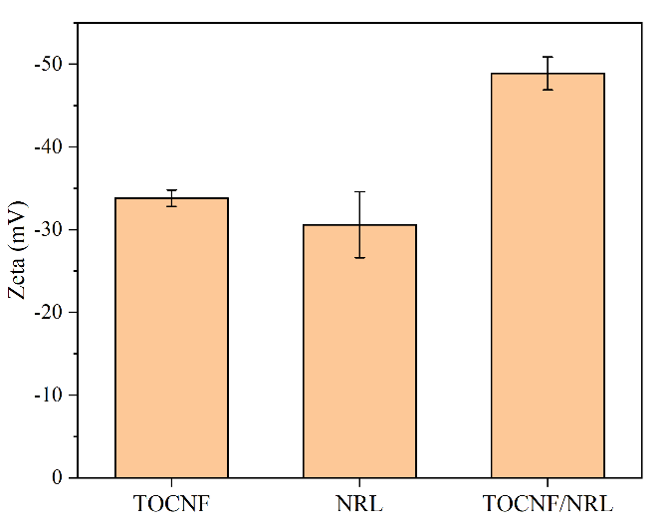
Fig. S1 Zeta potential values of TOCNF, NRL, TOCNF/NRL

- Morphological characterization of TOCNF and NRL particle size distribution
Figure S2a shows the TEM image of TOCNF, which has a high aspect ratio of 20-30 nm, and Figure S2b shows the TEM image of TOCN/NRL after mixing, which shows good dispersion. Figure S2c shows the particle size distribution of NRL, and it can be observed that the particle size of NRL is widely distributed in the range of 100 nm-1 μm, with an average particle size of 362.5 nm. Figure S2d shows the thickness of the films with different composite ratios.
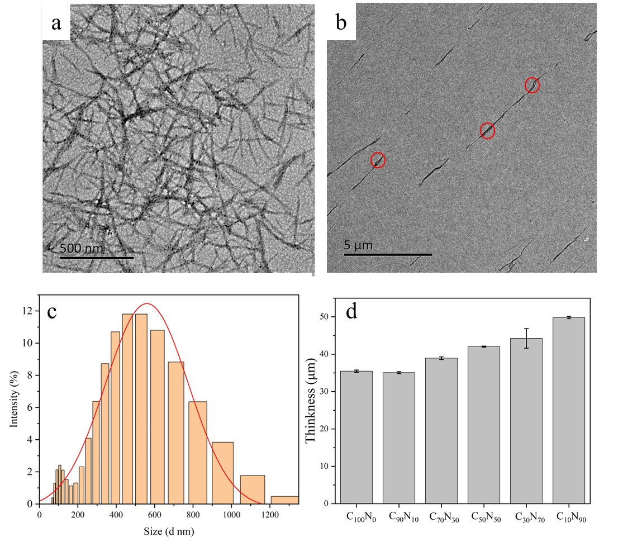
Fig.S2 (a) TEM map of TOCNF; (b) TEM map of TOCNF-NRL; (c) NRL particle size distribution; (d) thickness map of different TOCNF and NRL ratio films
- Membrane morphology and structure
The surface density and surface roughness of the film play a critical role in the gas barrier properties and surface wetting performance of the film. The SEM images in Figure S3 a show that the films at all scales have relatively flat and uniform surfaces, with no macroscopic bubbles, cracks or pores seen on the surface, which provides the basis for the excellent barrier properties of the films. From C₁₀₀N₀ to C₅₀N₅₀, the roughness of the film surface decreases and tends to be flat, which is due to the addition of NRL, which fills the gap of the TOCNF interwoven network, while the free NRL particles are adsorbed on the film surface to form a uniform and continuous cover, making the surface flat. The roughness of the films from C₅₀N₅₀ to C₁₀N₉₀ gradually increased again due to the high NRL content and the surface of the agglomerated films with similar particle shape of NRL particles (Sharma et al. 2020), such as the fine small particles on the surface of C₃₀N₇₀ film, which are phospholipid protein aggregates among the latex after the agglomeration of some NRL particles, and C₁₀N₉₀ film due to the further increase of NRL content that reached 90%, making the surface present large undulations, and a large number of free NRL particles were adsorbed on the surface with the evaporation of water, and extruded and fused with each other to form large aggregates.
Figure S3 b shows the AFM plots of the TOCNF/NRL composite films at different scales. the 3D morphology of the AFM plots can help us to observe the trend of the surface morphology of the samples more intuitively and obtain the mean square roughness of each sample surface, which can be used to quantify the variation pattern of the roughness of each sample surface. the pattern shown in the AFM plots matches the pattern shown in the SEM, from C₁₀₀N₀ to C₅₀N₅₀, the height of the undulations gradually decreases and the surface tends to be flat, and the mean square roughness decreases from 119 nm to 77.78 nm, a decrease of 60.71%, while from C₅₀N₅₀ to C₁₀N₉₀, the height of the undulations gradually increases and the mean square roughness finally reaches 116.13 nm, which corresponds to the pattern shown in the SEM image of the film. one corresponds to the other.
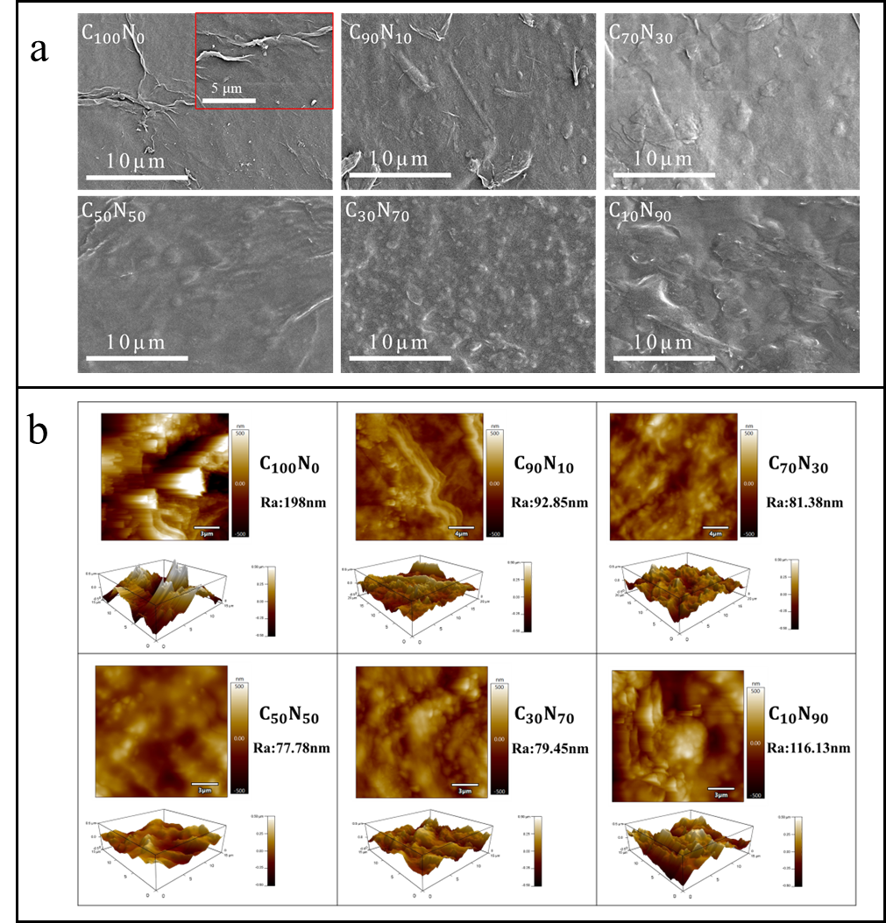
Fig. S3 (a) Scanning electron micrographs of different TOCNF and NRL ratios; (b) AFM graphs of different TOCNF and NRL ratios
- AFM - Analysis of Forces
The phospholipid-protein among the NRL particles after film formation has been shown by researchers to exist as a cross-linking point in the network structure of rubber molecular chains(Wu et al. 2017). The interaction forces between TOCNF-TOCNF and TOCNF -NRL measured by AFM are shown in Figure 4a and b. It can be seen that the interaction forces between TOCNF and NRL in the dry state are similar to those between TOCNF and TOCNF, and the interaction forces between TOCNF and TOCNF are hydrogen bonds formed between the abundant hydroxyl groups on the surface of TOCNF The interaction force existing between TOCNF and NRL may be between the hydroxyl and carboxyl groups on TOCNF and the phospholipid protein on the surface of NRL particles. This proves that the incorporation of NRL does not negatively affect the binding of TOCNF and provides data to support the adhesion of the protein-phospholipid layer of NRL to the surface of TOCNF by cohesive forces, and there are also previous studies on the AFM force profiles between nanocellulose and natural latex (Lorevice et al. 2020).
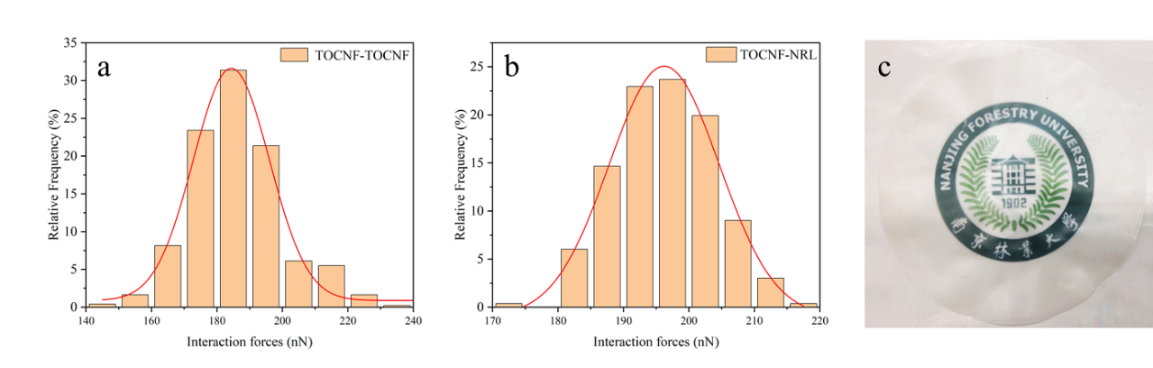
Fig. S4 (a) Interaction forces of TOCNF-TOCNF; (b) Interaction forces of TOCNF-NRL; (c) Physical picture

- Digital photographs of contact angle at different times
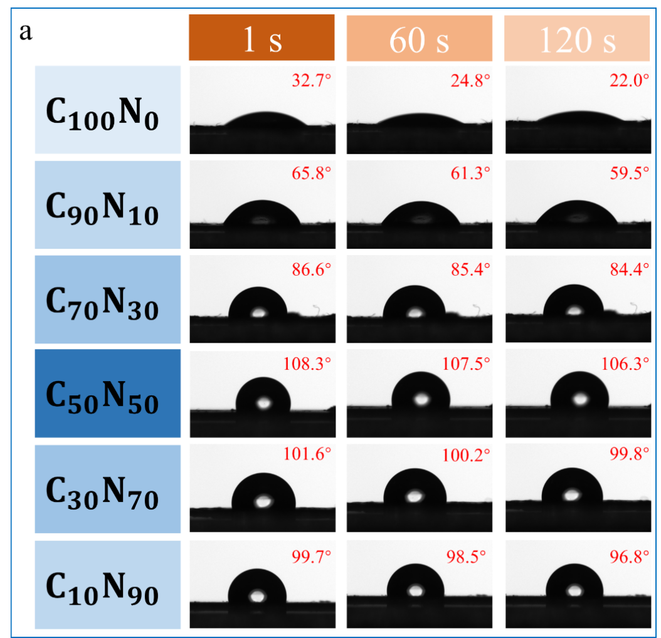
Fig. S5 Digital photographs of contact angle at different times
- FTIR
The chemical composition of the TOCNF/NRL composite film was studied by FTIR spectroscopy and the results of the analysis are shown in Figure S2. The spectrum of pure natural latex (C₀N₁₀₀) shows characteristic peaks of isoprene, proteins and phospholipids (Mekonnen et al. 2019). Peaks around 3288 cm⁻¹, 1658 cm⁻¹ and 1545 cm⁻¹ are associated with amine, amide-I (C=O associated with peptide bond) and amide-II (C-N associated with peptide bond) due to the presence of protein (Chhajed et al. 2023; Mekonnen et al. 2013). The spectrum of C₀N₁₀₀ shows stretching peaks of -CH₃ and -CH₂ at 2960 cm⁻¹ and 2915 cm⁻ ¹, respectively. The bending vibrations of -CH₃ and -CH₂ appear at 1450 cm⁻¹ and 1373 cm⁻¹, respectively. The characteristic peak of the cis-1,4-polyisoprene rubber component observed at 835 cm⁻¹ belongs to the out-of-plane wobble, corresponding to the -C=CH bond, and is associated with C=C stretching at 1450 cm⁻¹ (Chhajed et al. 2023; Mekonnen et al. 2013; Simchareon et al. 2012). The spectrum of pure TOCNF (C₁₀₀N₀) mainly includes the stretching vibrational bands of -OH and -CH₂ at 3330 and 2884 cm⁻¹, and the characteristic absorption peaks at 1604 cm⁻¹ and 897 cm⁻¹ belonging to the C=O and hemiacetal groups in the carboxyl group, respectively(Xia et al. 2018). The peak near 1735 cm⁻¹ in the figure is related to the phospholipid compound in NRL (Rolere et al. 2015). In addition, it can be observed from the figure that the peak at 1604 cm⁻¹ of C₁₀₀N₀ for adsorbed water molecules gradually shifts to 1658 cm⁻¹ (C₀N₁₀₀) with increasing NRL content, indicating that the addition of NRL improves the hydrophobic properties. All these changes in the characteristic peaks are successful interactions between NRL and TOCNF, as evidenced by the interaction forces between TOCNF and NRL shown in Figure 2c AFM.
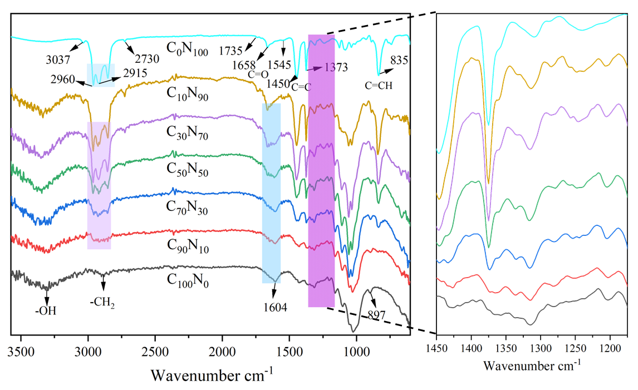
Fig. S6 FTIR of C₀N₁₀₀、C₁₀N₉₀、C₃₀N₇₀、C₅₀N₅₀、C₇₀N₃₀、C₉₀N₁₀、C₁₀₀N₀
- Thin film light transmission performance
The light transmittance of different composite films is shown in Figure S8. Pure TOCNF has a transmittance of only about 25%-30% in the visible region. The transmittance in the UV region decreases significantly as it depends on the wavelength and decreases as the wavelength of light approaches the diameter of the TOCNF due to higher light scattering(Kumar et al. 2014). The addition of NRL showed a significant increase in the transmittance of the composite film in the visible region, up to 68%. This indicates that the number of Air-CNF interfaces decreases and light scattering decreases when NRL fills the porous TOCNF network when the amount of NRL is increased. Interestingly, the spectrograms of all NRL-containing films changed the transmittance curves in a similar manner, which was particularly evident in the low-UV region, suggesting that the presence of NRL in the TOCNF network caused the nanocomposite films to decrease the transmittance more in the low-UV region, which indicates that the films may absorb UV light. The above findings are in agreement with some existing studies(Kumar et al. 2016).
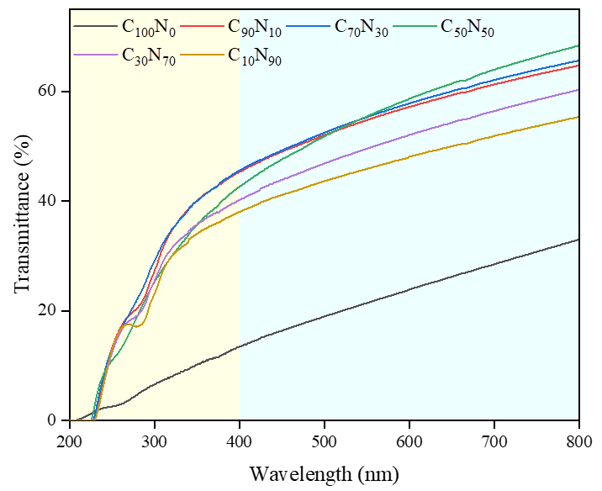
Fig. S7 Light transmission properties of the film
- Thermo-gravimetric analysis
The curves of TGA and DTG of the composite film are shown in Figure S9. From the available studies it is known that the weight loss is mainly due to the degradation of the polymer due to different reasons such as chain breakage, cross-link generation and cross-link fracture(Abraham et al. 2013). The analysis in the figure shows that the mass loss due to the evaporation of water from the sample has occurred at 100°C. The percentage mass loss of the films was significantly reduced by the addition of NRL, indicating that the addition of NRL to the TOCNF films improved the hydrophobic properties of TOCNF. The nanocellulose (C₅₀N₅₀) and its composite films showed a plunge hump at 223°C, C₅₀N₅₀ (352°C), and C₀N₁₀₀ (320°C), respectively. It indicates that the addition of NRL to the nanocellulose matrix can improve the thermal stability performance of the samples. The nanocellulose and natural latex composite film (C₅₀N₅₀) was more thermally stable than the pure natural latex (C₀N₁₀₀), which may be due to the larger interaction force between TOCNF and NRL (Figure S4b). All samples at higher temperatures were not completely degraded and showed residual masses of 1.5-23% of decomposition products, such as non-volatile carbon residues left after pyrolysis.
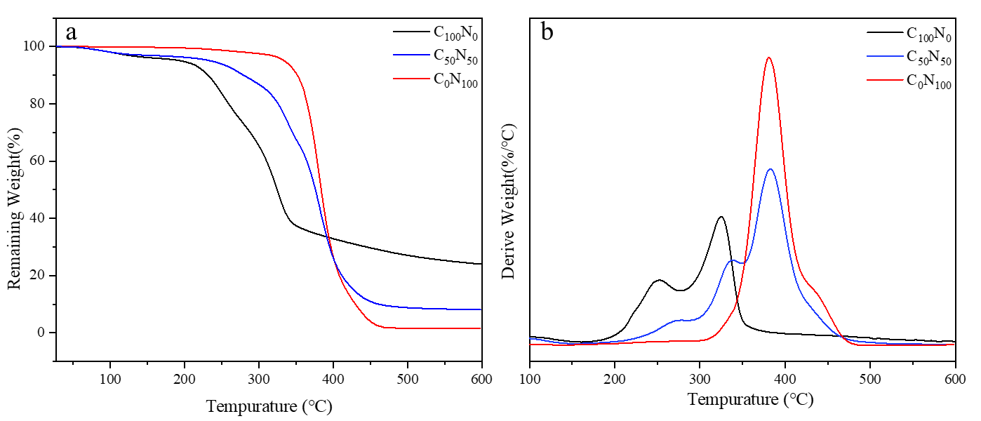
Fig. S8 TGA curve (a) and relative derivative curve (b) of the film

- Weight Loss, Decay Index, Relative Conductivity, Total Soluble Solids, Firmness, Color Change
Determination of weight loss rate. The weighing method was adopted, i.e. the fruits were weighed before treatment and recorded as W₁, and the fruits were weighed again at the time of treatment and recorded as W₂. Measurements were taken at the same time each day, with three strawberries in each group, and the weight loss rate was calculated using the following formula:
Weight loss=（W₁-W₂）/ W₁×100%
Determination of decay index. The degree of fruit decay was divided into 5 levels. level 0, no decay; level 1, fruit with 1~3 rotten spots; level 2, fruit with decay area between 1/4~1/2; level 3, fruit with decay area between 1/2~3/4; level 4, fruit with decay area >3/4. and the decay index was calculated according to the following formula:
Decay index = [∑ (number of grades × number of fruits corresponding to decay)]/total number of fruits in the group
Determination of cell permeability (relative conductivity). 2 g of pulp was submerged in 20 mL of distilled water and allowed to stand for 1 h. The initial conductivity was measured using a conductivity meter and recorded as a₁. Subsequently, it was placed in a boiling water bath for 30 min, cooled to room temperature, and the conductivity was measured again and recorded as a₂. Each group of treatments was measured three times and the average value was taken. The conductivity of distilled water was a. Calculations were performed according to the following equation:
Relative conductivity（%）=（a₁-a）/（a₂-a）×100%
Total soluble solids determination. The strawberries were homogenized with a handheld homogenizer, and the filtrate was collected through four layers of gauze filtration, and the filtrate obtained was determined using an Abbe refractometer, with reference to the agricultural industry standard NY/T 2637-2014.
Strawberry Firmness determination. The firmness of strawberries was measured using a texture analyzer (Texture Technologies Corp., Scarsdale, NY, USA) after wrapping with film and before treatment at room temperature with a probe type P/2E. Individual strawberries were placed on a platform and a flat stainless steel cylindrical probe with a diameter of 2 mm was pierced into the fruit at a speed of 1 mm/s. Six positions were taken for each strawberry and three strawberries were measured in each group.
Determination of strawberry colorimetry. A colorimeter (3nh, NR10QC) was used for measurement, and three points were taken for each strawberry, and three strawberries were measured in each group.

References
Abraham E, Thomas MS, John C, Pothen LA, Shoseyov O, Thomas S (2013) Green nanocomposites of natural rubber/nanocellulose: Membrane transport, rheological and thermal degradation characterisations Industrial Crops and Products 51:415-424 . https://doi.org/10.1016/j.indcrop.2013.09.022
Chhajed M, Verma C, Singh S, Maji PK (2023) Synergistic effect of natural rubber for imparting hydrophobicity in nanocellulose aerogel through one-pot synthesis and its application in oil/organic solvent sorption Journal of Water Process Engineering 51:103471 . https://doi.org/10.1016/j.jwpe.2022.103471
Dukhin AS, Goetz PJ (1998) Characterization of aggregation phenomena by means of acoustic and electroacoustic spectroscopy Colloids and Surfaces A: Physicochemical and Engineering Aspects 144:49-58. https://doi.org/10.1016/S0927-7757(98)00565-2
Isogai A, Zhou Y (2019) Diverse nanocelluloses prepared from TEMPO-oxidized wood cellulose fibers: Nanonetworks, nanofibers, and nanocrystals Current Opinion in Solid State and Materials Science 23:101-106 . https://doi.org/10.1016/j.cossms.2019.01.001
Kumar V et al. (2014) Comparison of nano- and microfibrillated cellulose films Cellulose 21:3443-3456. https://doi.org/10.1007/s10570-014-0357-5
Kumar V, Lazarus E, Salminen P, Bousfield D, Toivakka M (2016) Influence of nanolatex addition on cellulose nanofiber film properties Nordic Pulp & Paper Research Journal 31:333-340. https://doi.org/10.3183/npprj-2016-31-02-p333-340
Lorevice MV, Mendonça EO, Orra NM, Borges AC, Gouveia RF (2020) Porous Cellulose Nanofibril–Natural Rubber Latex Composite Foams for Oil and Organic Solvent Absorption ACS Applied Nano Materials 3:10954-10965. https://doi.org/10.1021/acsanm.0c02203
Mekonnen T, Mussone P, El-Thaher N, Choi PYK, Bressler DC (2013) Thermosetting Proteinaceous Plastics from Hydrolyzed Specified Risk Material Macromolecular Materials and Engineering 298:1294-1303. https://doi.org/10.1002/mame.201200429
Mekonnen TH, Ah-Leung T, Hojabr S, Berry R (2019) Investigation of the co-coagulation of natural rubber latex and cellulose nanocrystals aqueous dispersion Colloids and Surfaces A: Physicochemical and Engineering Aspects 583:123949. https://doi.org/10.1016/j.colsurfa.2019.123949
Rochette CN, Crassous JJ, Drechsler M, Gaboriaud F, Eloy M, de Gaudemaris B, Duval JFL (2013) Shell Structure of Natural Rubber Particles: Evidence of Chemical Stratification by Electrokinetics and Cryo-TEM Langmuir 29:14655-14665. https://doi.org/10.1021/la4036858
Rolere S, Liengprayoon S, Vaysse L, Sainte-Beuve J, Bonfils F (2015) Investigating natural rubber composition with Fourier Transform Infrared (FT-IR) spectroscopy: A rapid and non-destructive method to determine both protein and lipid contents simultaneously Polymer Testing 43:83-93 . https://doi.org/10.1016/j.polymertesting.2015.02.011
Sharma SK et al. (2020) Reinforcement of Natural Rubber Latex Using Jute Carboxycellulose Nanofibers Extracted Using Nitro-Oxidation Method Nanomaterials 10:706. https://doi.org/10.3390/nano10040706
Simchareon W, Amnuaikit T, Boonme P, Taweepreda W, Pichayakorn W (2012) Characterization of Natural Rubber Latex Film Containing Various Enhancers Procedia Chemistry 4:308-312. https://doi.org/10.1016/j.proche.2012.06.043
Wu J, Qu W, Huang G, Wang S, Liu H (2017) Super-Resolution Fluorescence Imaging of Spatial Organization of Proteins and Lipids in Natural Rubber Biomacromolecules 18. https://doi.org/10.1021/acs.biomac.6b01827
Xia J, Zhang Z, Liu W, Li VCF, Cao Y, Zhang W, Deng Y (2018) Highly transparent 100% cellulose nanofibril films with extremely high oxygen barriers in high relative humidity Cellulose 25:4057-4066. https://doi.org/10.1007/s10570-018-1843-y

