World Journal of Microbiology and Biotechnology

Enhanced erythritol production by Moniliella pollinis Mutant-58 using jaggery as a cost-effective substrate

Anil B. Khatape, ^{1,2,3,} Vidhya Rangaswamy, ^{3,} Syed G. Dastager ^{1,2,*}

¹ Academy of Scientific and Innovative Research (AcSIR), Ghaziabad- 201002, India

² NCIM-Resource Center, Biochemical Sciences Division, CSIR-National Chemical Laboratory,
Pune-411008, India

³ High Value Chemicals group, Reliance Industries Limited, Ghansoli, Navi Mumbai, India,
400701

*Corresponding Author:
Syed G Dastager
Telephone: +9120-25902505, E-mail: sg.dastager@ncl.res.in
ORCID: (https://orcid.org/0000-0002-8316-1242)

List of Contents
S.No. | Description | Page No.
1. | Table S1. Sugar composition of carbon substrates | 3
1. | Table S2. Coded values of independent variables | 3
2. | Table S3. Carbon balance of parent and mutant strain | 3
3. | Table S4. CCD designs run with their observed responses | 4 - 5
4. | Table S5. Result of erythritol spiked in fermented broth experiment | 5
5. | Figure S1. Protein standard curve | 6
6. | Figure S2. Standard curve for DCW and | 6
7. | Figure S3. UV, EMS, and NTG mutagenesis results | 7
8. | Figure S4. Change in biomass color with incubation time in parent and mutant strain | 8
9. | Figure S5. Main effect of a variable on erythritol production | 9
10. | Figure S6. Media optimization curve for maximum erythritol yield | 9
11. | Figure S7. Erythritol production in the fermentor by Mutant-58 strain using jaggery as carbon substrate | 10
12. | Figure S8. Moniliella pollinis parent and Mutant-58 cells (Photographs obtained by: optical Bright field microscopy 100X) | 10
13. | Figure S9. Mix standard curve for metabolites using HPLC | 12
14. | Figure S10. Metabolites analysis of glucose and jaggery-based fermentation | 13
15. | Figure S11. Spike-in experiment for identification of erythritol in the fermentation broth | 14

Carbon | Sucrose (%) | Glucose (%) | Fructose (%) | Total sugar (%)
Glucose | Nil | 99.8±0.8 | Nil | 99.8±0.8
Jaggery | 78.5±3.8 | 11.2±3.1 | 5.8±2.1 | 95.5±9
Molasses | 42.3±4.2 | 2.9±1.2 | 1.6±1 | 46.9± 6.4
Sugarcane Juice | 10.2 ±1.2 | 2.27±0.8 | 0.55±0.5 | 13.02±2.5

Table S1. Sugar composition of carbon substrates
Results are means ± S.D. for triplicate experiments

Table S2 Coded values of independent variables
Coded values | Jaggery (g L⁻¹) | YE (g L⁻¹) | KH₂PO₄ (g L⁻¹) | MgSO₄ (g L⁻¹) | pH
-1 | 100 | 2 | 2.5 | 0.2 | 5.5
0 | 200 | 4 | 5 | 0.25 | 6
1 | 300 | 6 | 7.2 | 0.5 | 6.5

Table S3 Carbon balance of parent and mutant strain
Organism | Carbon Input (100 %) | %  Carbon Erythritol | % Carbon Glycerol | % Carbon Ethanol | Total carbon output (moles) | Total % carbon output
Parent strain | 6.7 moles | 33.8 | 1.0 | 28.5 | 4.2 | 63.3
Mutant-58 | 6.7 moles | 45.4 | 2.7 | 20.6 | 4.6 | 68.6

Calculation of carbon balance (for Table S3)
IN MOLES | Sucrose (moles) | Glucose (moles) | Fructose (moles) | Total Sugar (moles) | Erythritol (moles) | Glycerol (moles) | Ethanol (moles)
Wild type MP | 0.0 | 6.7 | 0.0 | 6.67 | 2.25 | 0.066 | 1.901
Mut-58, GS-4 | 0.0 | 6.7 | 0.0 | 6.67 | 3.02 | 0.18 | 1.37
CARBON BALANCE | TOTAL CARBON INPUT (Carbon moles) | TOTAL CARBON OUTPUT (SUM of Erythritol, Glycerol and Ethanol Carbon moles) |  | % CARBON YIELD |  |  | Total % carbon output
Glucose in LFM |  |  |  | Erythritol | Glycerol | Ethanol
Wild type MP | 6.7 | 4.2 |  | 33.83 | 0.98 | 28.52 | 63.34
Mut-58, GS-4 | 6.7 | 4.6 |  | 45.35 | 2.66 | 20.62 | 68.64

Table S4 CCD designs run with their observed responses
Run Order | Jaggery  (g L⁻¹) | YE  (g L⁻¹) | pH | KH₂PO₄  (g L⁻¹) | MgSO₄.7H₂O (g L⁻¹) | Observed Erythritol yield (%)
1 | 100 | 2 | 5.5 | 2.5 | 0.5 | 16.9
2 | 300 | 2 | 5.5 | 2.5 | 0.2 | 20.2
3 | 100 | 6 | 5.5 | 2.5 | 0.2 | 24.5
4 | 300 | 6 | 5.5 | 2.5 | 0.5 | 24.5
5 | 100 | 2 | 6.5 | 2.5 | 0.2 | 18.2
6 | 300 | 2 | 6.5 | 2.5 | 0.5 | 9
7 | 100 | 6 | 6.5 | 2.5 | 0.5 | 17
8 | 300 | 6 | 6.5 | 2.5 | 0.2 | 23.4
9 | 100 | 2 | 5.5 | 7.5 | 0.2 | 17.8
10 | 300 | 2 | 5.5 | 7.5 | 0.5 | 22.4
11 | 100 | 6 | 5.5 | 7.5 | 0.5 | 16.5
12 | 300 | 6 | 5.5 | 7.5 | 0.2 | 21.8
13 | 100 | 2 | 6.5 | 7.5 | 0.5 | 18.5
14 | 300 | 2 | 6.5 | 7.5 | 0.2 | 12.5
15 | 100 | 6 | 6.5 | 7.5 | 0.2 | 19.9
16 | 300 | 6 | 6.5 | 7.5 | 0.5 | 20.8
17 | 0 | 4 | 6 | 5 | 0.35 | 3.2
18 | 400 | 4 | 6 | 5 | 0.35 | 20.2
19 | 200 | 0 | 6 | 5 | 0.35 | 12.97
20 | 200 | 8 | 6 | 5 | 0.35 | 22.5
21 | 200 | 4 | 5 | 5 | 0.35 | 40
22 | 200 | 4 | 7 | 5 | 0.35 | 26.4
23 | 200 | 4 | 6 | 0 | 0.35 | 24.5
24 | 200 | 4 | 6 | 10 | 0.35 | 22.1
25 | 200 | 4 | 6 | 5 | 0.05 | 32.8
26 | 200 | 4 | 6 | 5 | 0.65 | 30
27 | 200 | 4 | 6 | 5 | 0.35 | 35
28 | 200 | 4 | 6 | 5 | 0.35 | 35.9
29 | 200 | 4 | 6 | 5 | 0.35 | 36
30 | 200 | 4 | 6 | 5 | 0.35 | 37.2
31 | 200 | 4 | 6 | 5 | 0.35 | 37
32 | 200 | 4 | 6 | 5 | 0.35 | 37.8
*Experiments were performed in triplicate. All observed Erythritol yield (%)values are average of three replicates.

Table S5 Area under the curve (AUC) of erythritol standard and fermented broth
Sr. No. | Samples ID | Erythritol | Glycerol | Ethanol
1 | 72hr fermentation broth | 46892270±134 | 1773278±148 | 4314742±275
2 | Erythritol-500ppm | 14093433±418 | 0 | 0
3 | 72hr fermentation broth + Erythritol 500ppm | 60765318±248 | 1847725±310 | 4411826±218
AUC of 1+2 |  | 60985703 | 1773278 | 4314742

Fig. S1 Protein std curve

Fig. S2 Standard graph for DCW calculation using optical density values

Fig. S3 a) EMS, b) NTG and c) UV mutagenesis results

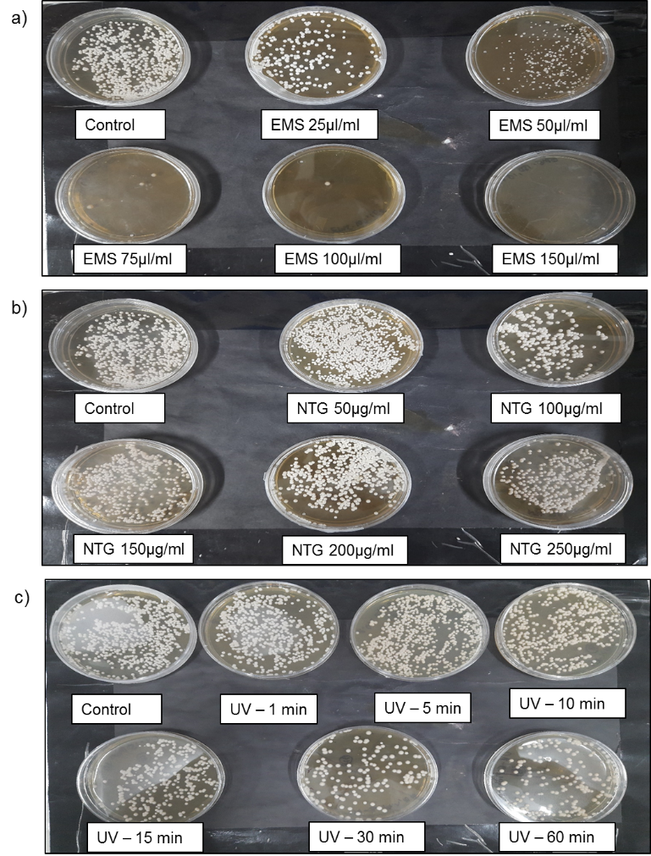

Fig. S4 Change in biomass color with incubation time in parent and mutant strain
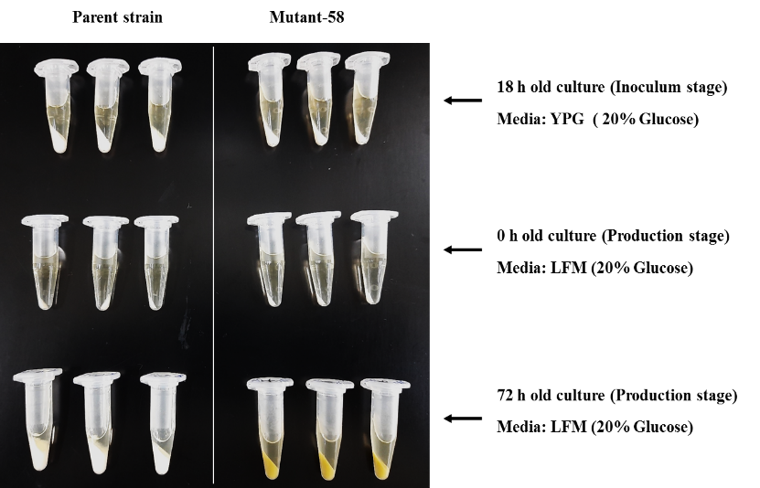

Fig. S5 Main effect of a variable on EPS production

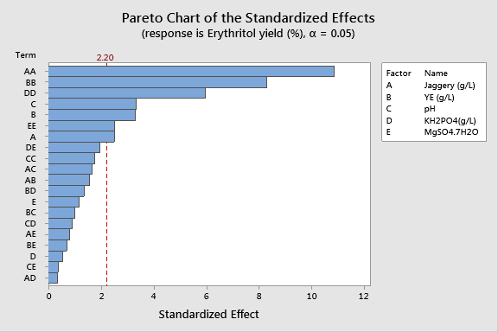

Fig. S6 Media optimization curve for maximum erythritol yield

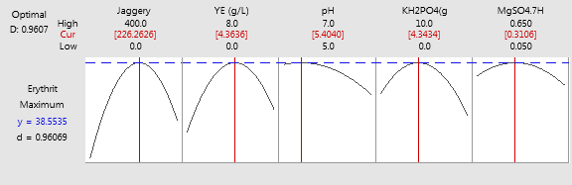

Fig. S7 Erythritol fermentation using Mutant-58 strain jaggery as carbon substarte

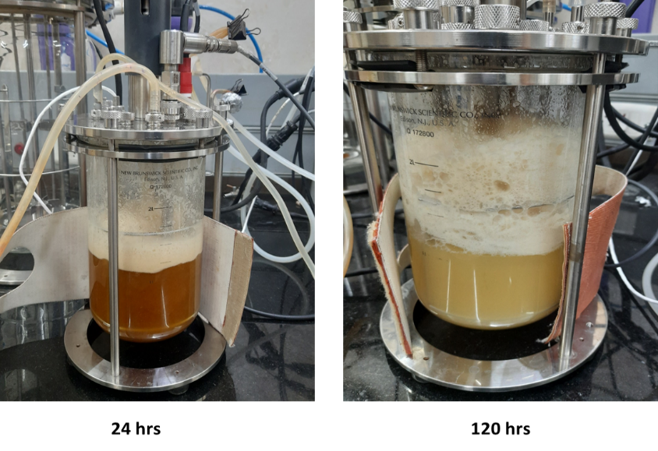

Fig. S8 Moniliella pollinis parent and Mutant-58 cells photographs obtained by: optical Bright field microscopy 100X)

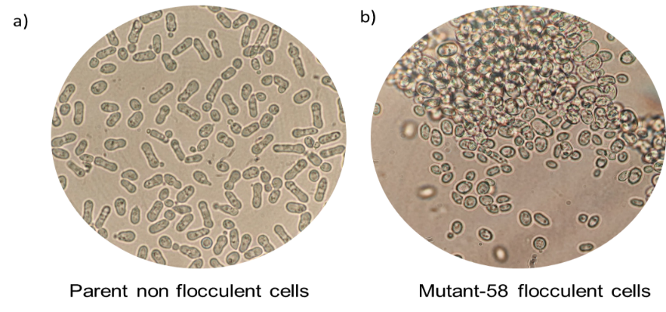

Identification of the metabolites in the fermented broth by HPLC
The concentrations of the initial and intermediate metabolites produced along with polyol were analyzed using HPLC. Sucrose, glucose, fructose, erythritol, glycerol, and ethanol were detected at a retention time of 8.25 min, 9.57 min, 10.38 min, 11.98 min, 13.57 min, and 20.7 min respectively, which matches the retention times of analytical grade products available under these conditions (Fig. S9). All metabolites' peaks resolution was good as all the peaks were separated quite clearly from each other in glucose as well as jaggery-based medium (Fig. S10).
Erythritol standard of 500ppm was prepared in distilled water. Another standard of 500 ppm erythritol was prepared using 72h old LFM medium supplemented initially with 20% glucose and inoculated with M. pollinis strain. The broth contains all the metabolites including erythritol, sugars, glycerol, and ethanol.. All three samples were analyzed separately, and chromatogram and AUC were observed for all the samples (Fig. S11). As shown in Table S5, almost 100% recovery of spiked erythritol was obtained from fermented broth with the same RT. Based on the HPLC chromatography results, it is confirmed that polyol produced at 11.98 RT by M. pollinis Mutant-58 strain in the fermentation broth is erythritol.

Fig. S9 Mix standard curve for metabolites

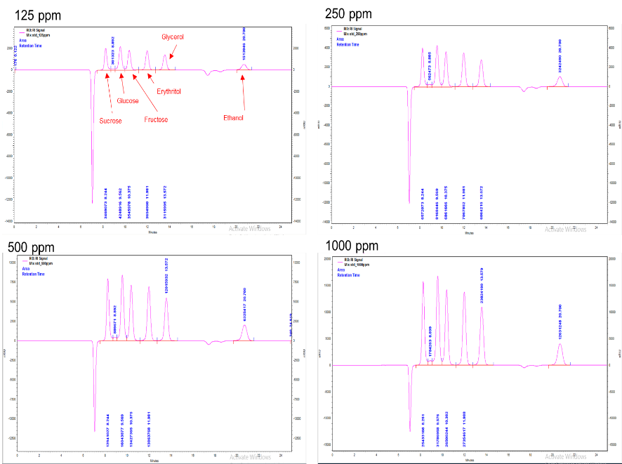

Fig. S10 Glucose and jaggery based fementation metabolites analysis

Parent strain in glucose glucose 0hr Parent strain in glucose 72hr 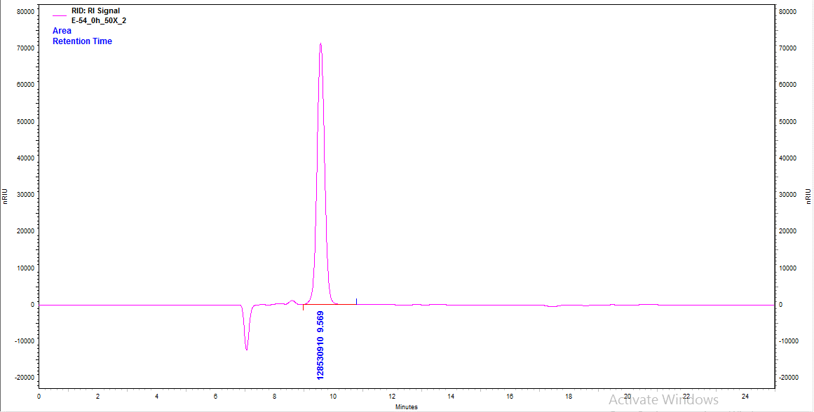 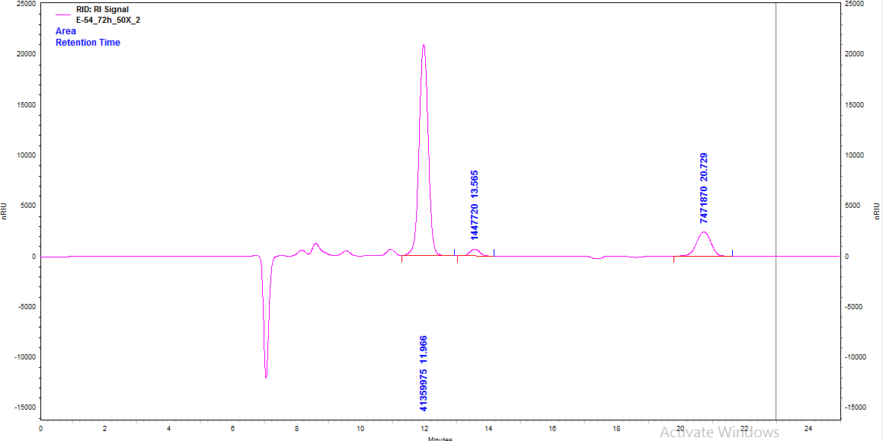
Parent strain in jaggery 0 hr Parent strain in jaggery 72 hr
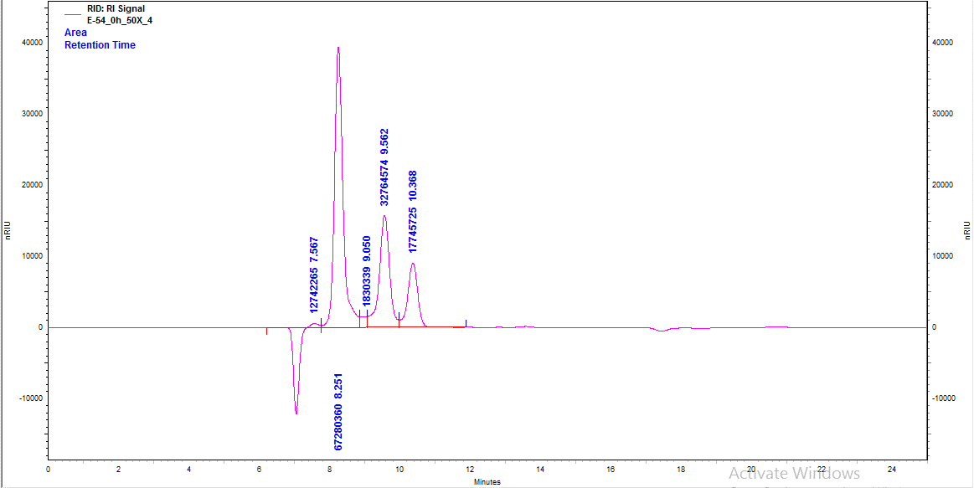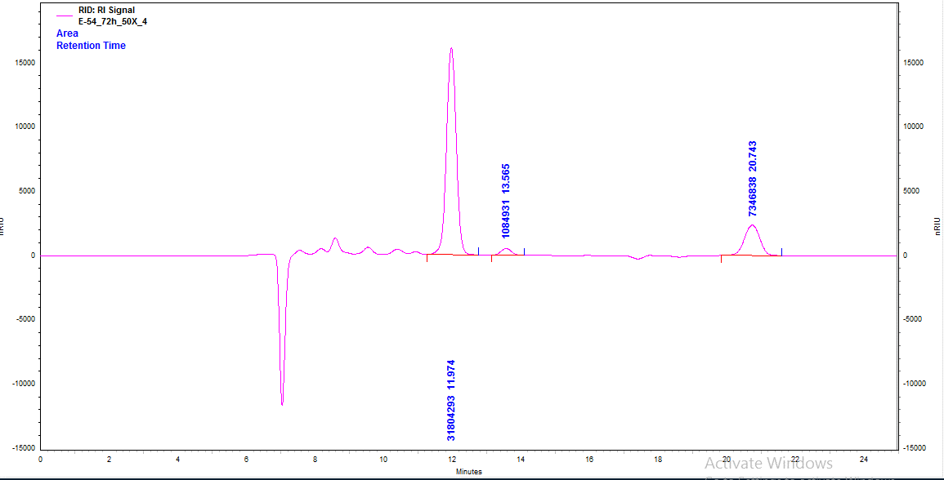
Mutant-58 in glucose 0hr Mutant-58 in glucose 72 hr
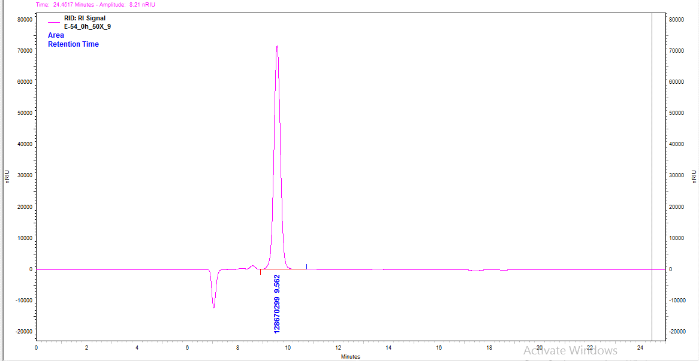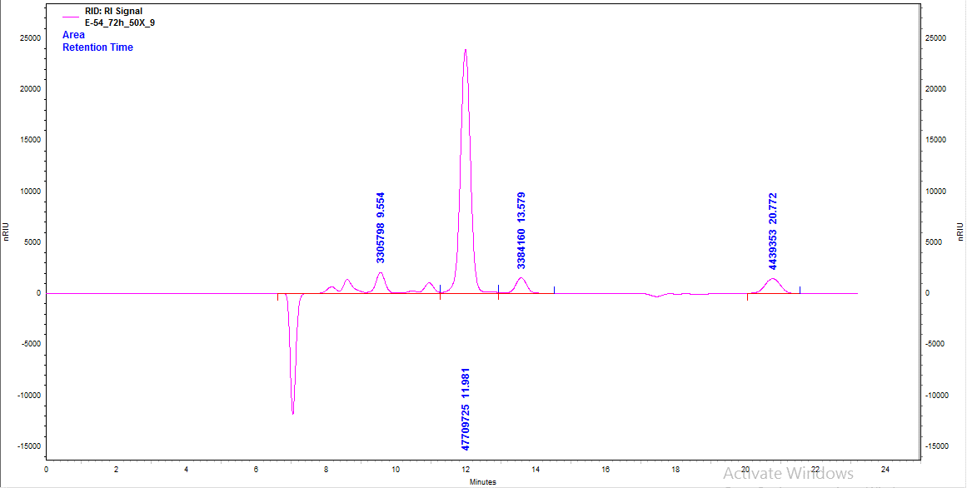

Mutant-58 in jaggery 0 hr Mutant-58 in jaggery 72 hr
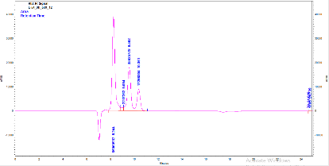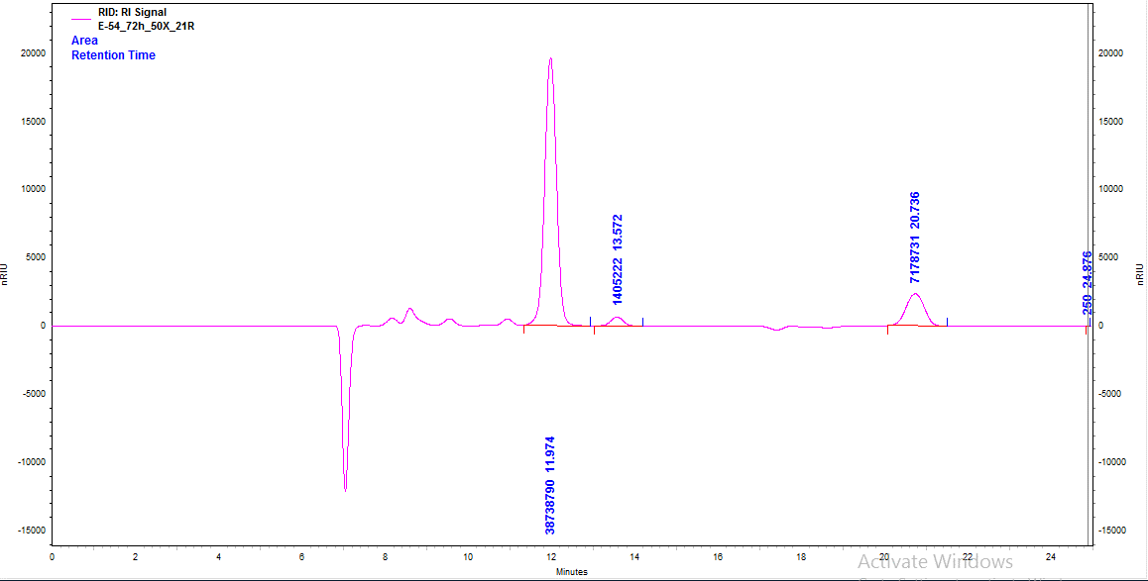

Fig. S11. Spike-in experiment for identification of erythritol in the fermentation broth, a) Erythritol 500ppm standard in DW, b) 72 h fermentation broth, c) Erythritol 500ppm standard spiked in the centrifuged fermentation broth

