Induction of the CtsR regulon improves Xylanase production in Bacillus subtilis

Biwen Wang, Frans van der Kloet, Leendert Hamoen

Table of content
Table S3 Strains and plasmids used in this study
Table S4 Primer sequences used in this study
Fig. S1 XynA production profile in an scr overexpressing strain
Fig. S2 Regulon fold-change spread plot of the 3 h and 6 h samples
Fig. S3 Comparison of our data with a previous XynA transcriptome study

Table S3. Strains and plasmids used in this study
Strain | Genome type | Source
BSB1 | B. subtilis wildtype 168 trp+; | Lab storage
BWB06 | BSB1 trp+; ∆xynA | [2]
BWB09 | BSB1 trp+; ∆xynA, ∆amyE | [2]
BKE00830 | 1A1 ∆ctsR::ery | [3]
SGB01 | BSB1 trp+; ∆xynA; amyE::P_{xyl}-scr | This study
SGB03 | BSB1 trp+; ∆xynA, ∆amyE, ∆ctsR::ery | This study
Plasmid
pCS58 | P_{amyQ}-xynA, bleo(Km) | DSM
pBW17 | P_{amyQ}-empty, bleo(Km) | This study
pHJS103 | amyE_Down-P_{xyl}-sfGFP-spec-amyE_Up, Sp, Ap | [4]
pBW18 | amyE_Down-P_{xyl}-scr-spec-amyE_Up, Sp, Ap | This study

Table S4. Primers used in this study
Name | Sequence (5’-3’) | Target
BW05 | CTAATTGAGAGAAGTTTCTATAGAATTTT | SpR-mazF-Fw
BW06 | CTACCCAATCAGTACGTTAATTT | SpR-mazF-Rv
BW34 | AAAGGAGCGATTTACATATGTAACAGATCATCCTTAATCA | pEmpty1-Fw
BW35 | TGATTAAGGATGATCTGTTACATATGTAAATCGCTCCTTT | pEmpty1-Rv
BW41 | CAGATCATCCTTAATCAGGGGTAGCTAACG | XnyAUp-Fw
BW42 | GAAACTTCTCTCAATTAGATTTCATGTAAACCGAGAACCA | XnyAUp-Rv
BW45 | GCAAAAGCCCTTATGAGGGCTTTTTTAATTGTTGTTTGCAGTAAC | XnyADn-Fw
BW46 | ACCCCTGATTAAGGATGATCTGATGTTACCTCCTATAATATTTTTTCCG | XnyADn-Rv
BW47 | AATTAACGTACTGATTGGGTAGTTCTTAGTTGGATTATCGGCAGC | XnyA-Fw
BW48 | GGATGATCTGTTACCACACTGTTACGTTAGAACTTCCACTAC | XnyA-Rv
BW49 | ATGATCAATTGGGGGCCGTTTTAACGATTGCTGCC | AmyEUp-Fw
BW50 | TCCCGTCTAGCCTTGCCCTCTTGACACTCCTTATTTGA | AmyEUp-Rv
BW51 | GGGCAAGGCTAGACGGGACTTACCGAAAGAAA | AmyEDn-Fw
BW52 | TATAGAAACTTCTCTCAATTAGCCCGCTCTTTTGGCAGGCCGC | AmyEDn-Rv
BW53 | AACGTACTGATTGGGTAGGCCATTCAGACATCTCCGA | AmyE-Fw
BW54 | CAGACCTGGCATTGATCGTGCCTGTCAGTTTAC | AmyE-Rv
BW60 | CCTAGGAATCTCCTTTCTAGATG | pHJS103-Fw
BW61 | AAAATGTCCAGACTTCGGA | pHJS103-Rv
BW131 | CATCTAGAAAGGAGATTCCTAGGGCATCGTAATAGATGCAACATA | Scr-Fw
BW132 | TGGATCCGAAGTCTGGACATTTTCTAATATTAGGTGAGTCTGAAAAT | Scr-Rv
TerS385 | CCCGAGGTGCGGACGGGCGCCATGA | AmyE-Ex-Fw
TerS386 | GGCTCAGCGGGATCAGGCGCTGCGCAA | AmyE-Ex-Rv

Fig. S1.
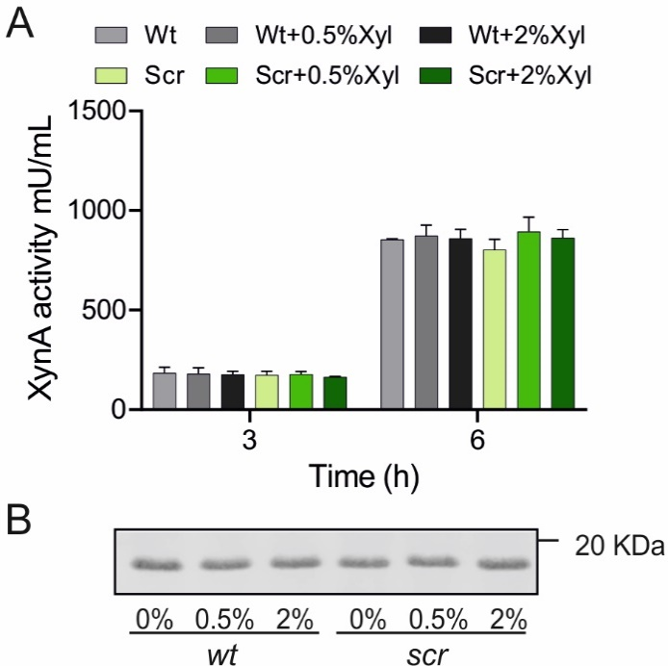

Fig. S1. XynA production profile in an scr overexpressing strain
(A) XynA enzyme activity in the supernatant of BWB09/pCS58 (wt) and scr overexpressing strain SGB01/pCS58 (Scr) at 3 h and 6 h growth in LB supplemented with 0 %, 0.5 % and 2 % xylose. (B) Coomassie-stained gel shows XynA band precipitated from 6 h supernatant samples. Samples were normalized by cell density. Three independent replicates were performed to confirm the reproducibility of results.

Fig. S2.
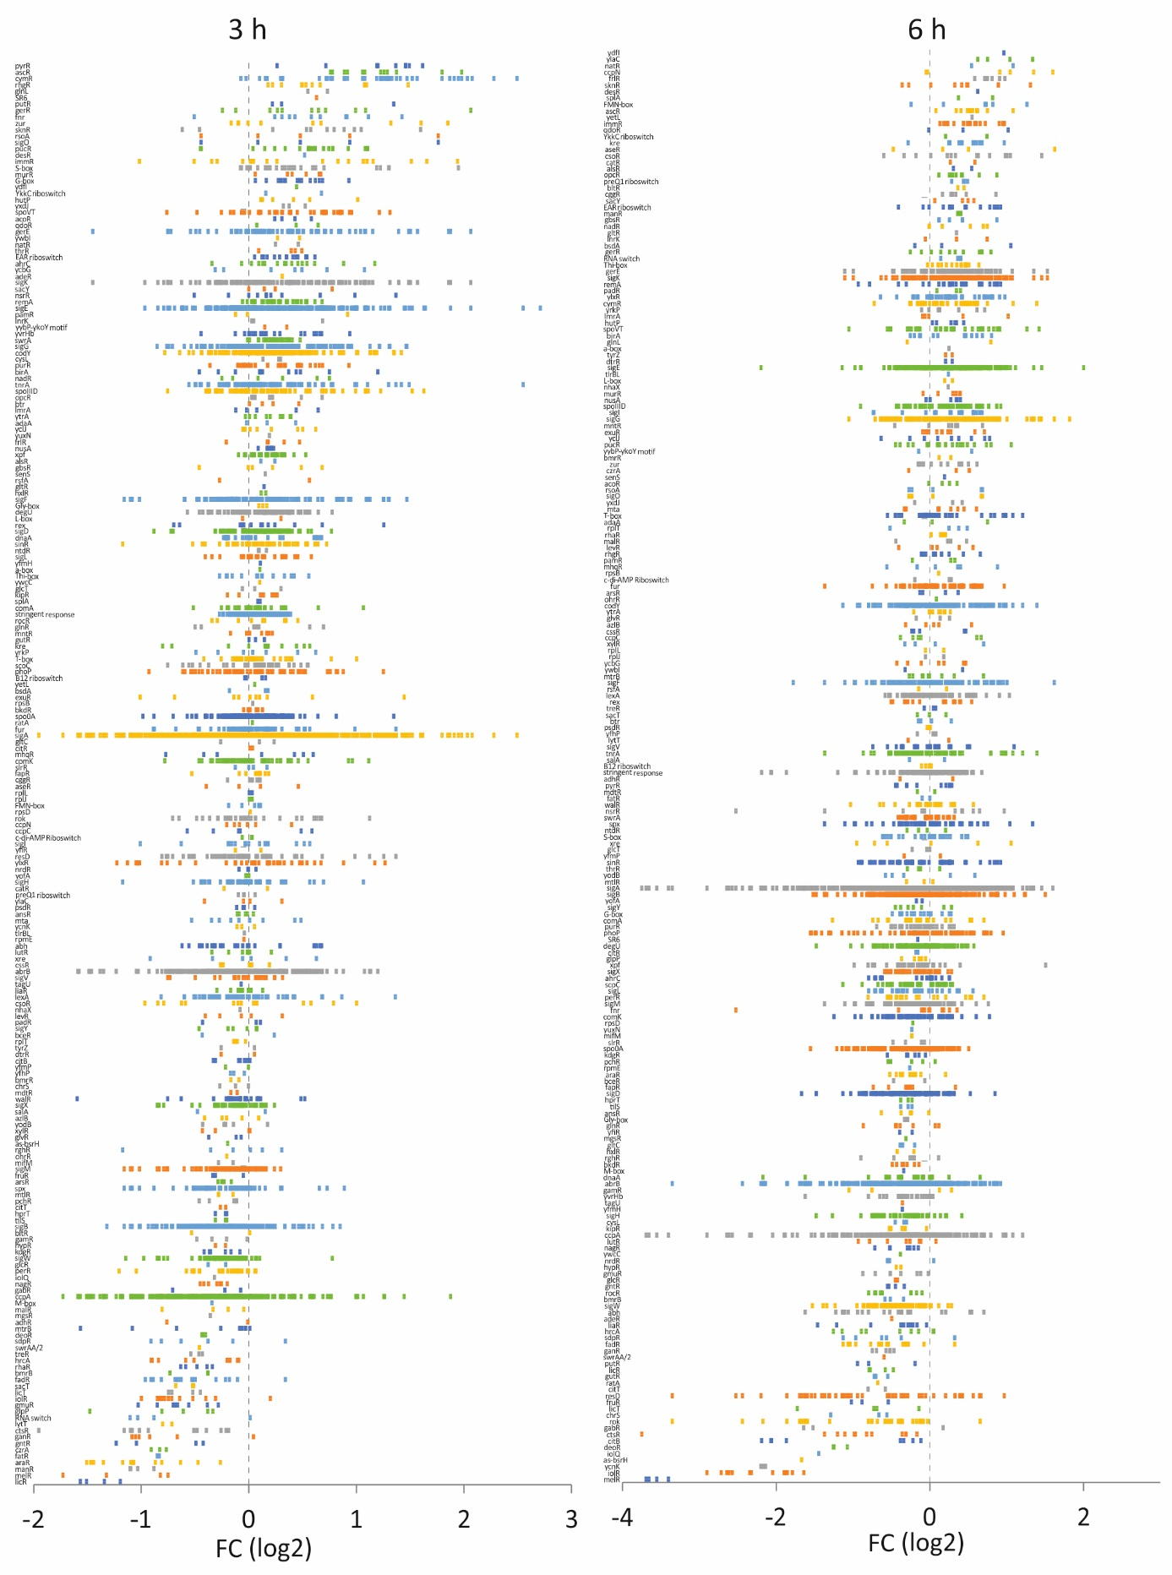
Fig. S2. Regulon fold-change spread plot of the 3 h and 6 h samples
Log₂ fold-change values (FC) of regulon genes were plotted along the X-axis. Regulons were sorted according to the average of the fold-change of all genes in a regulon.
Fig. S3.
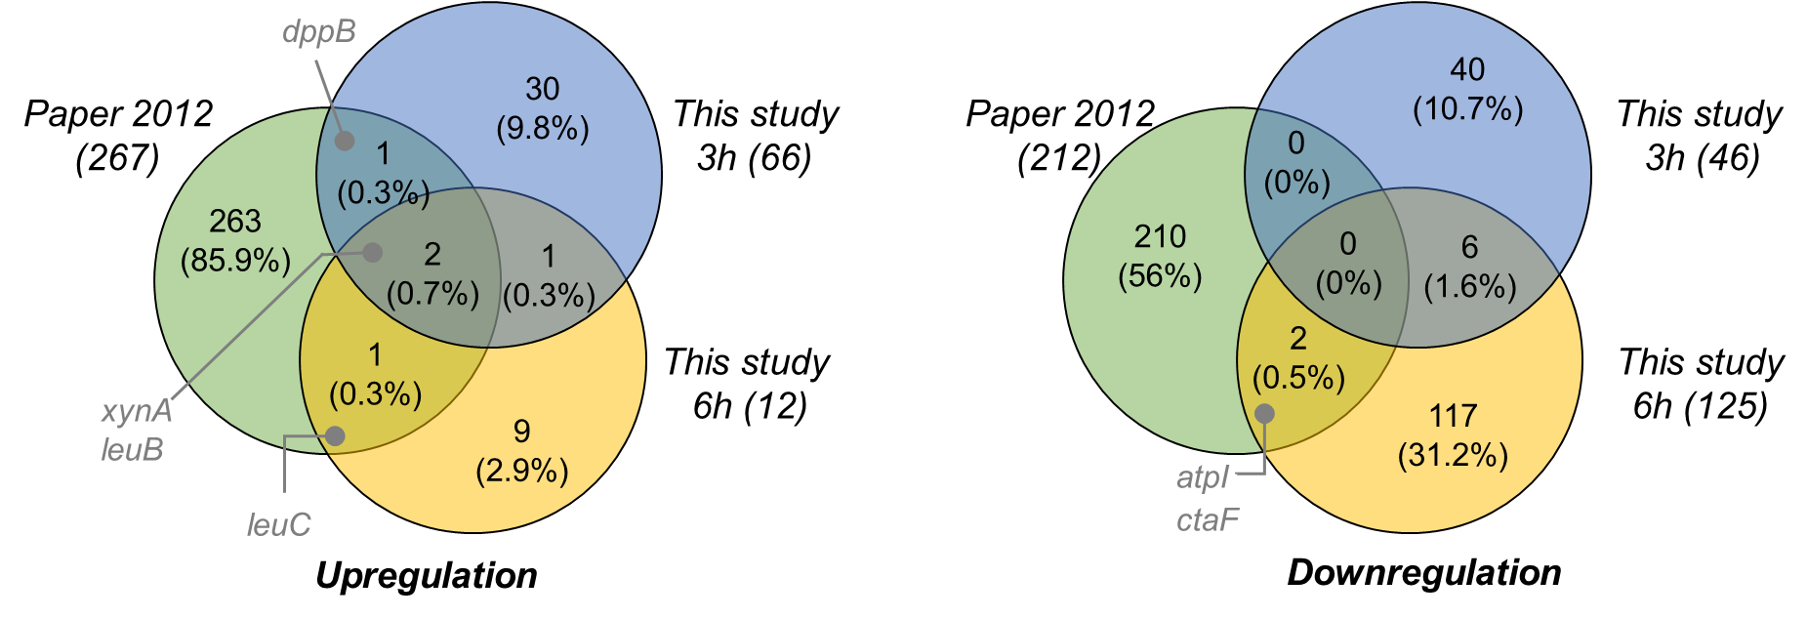
Fig. S3. Comparison of our data with a previous XynA transcriptome study
A significance threshold of ≥ 2 fold change with p-value < 0.05 was used to compare our data with a previous XynA transcriptome study [1].

References
1. Marciniak BC, Trip H, van-der Veek PJ, Kuipers OP. Comparative transcriptional analysis of Bacillus subtilis cells overproducing either secreted proteins, lipoproteins or membrane proteins. Microbial Cell Factories. 2012;11:66.
2. Schäfer A-B, Steenhuis M, Jim KK, Neef J, O’Keefe S, Whitehead RC, et al. Dual Action of Eeyarestatin 24 on Sec-Dependent Protein Secretion and Bacterial DNA. ACS Infect Dis. American Chemical Society; 2023;9:253–69.
3. Koo B-M, Kritikos G, Farelli JD, Todor H, Tong K, Kimsey H, et al. Construction and analysis of two genome-scale deletion libraries for Bacillus subtilis. Cell systems. Elsevier; 2017;4:291–305.
4. Müller A, Wenzel M, Strahl H, Grein F, Saaki TNV V, Kohl B, et al. Daptomycin inhibits cell envelope synthesis by interfering with fluid membrane microdomains. Proceedings of the National Academy of Sciences of the United States of America. National Acad Sciences; 2016;113:E7077–86.

