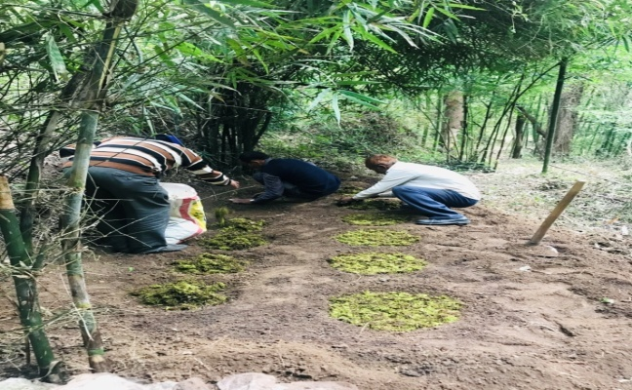
Plate 1 Stratification of P. wallichiana seeds

Plate 2 Pattern of seedling development of P. wallichiana along different aspects and altitudinal ranges (after stratification)

Plate 3 Pattern of seedling development of P. wallichiana along different aspects and altitudinal ranges (without stratification)

