Supplementary Materials

Clarifying the composition of the ATP consumption factors required for maintaining ion homeostasis in mouse rod photoreceptors

Muangkram Yuttamol¹*, Himeno Yukiko¹, and Amano Akira¹

¹Department of Bioinformatics, College of Life Sciences, Ritsumeikan University
*Corresponding Author

Contents
- S1 Summary of model modifications
- S2 Intensity-response relationship
- S3 Mathematical description of the mouse rod photoreceptor

S1 Summary of model modifications
Table 1S The modifications of the current model equations
Parameters | References;  original equations | Modification
Outer segment
Phototransduction | Hamer et al. 2005ª | -
Ca²⁺ dynamics | Hamer et al. 2005ª | Unidentified Ca²⁺ leak channel and Ca²⁺ diffusion from outer to inner segments
I_{CNG} | Hamer et al. 2005ª | Adding GHK equations
I_{NCKX} | Hamer et al. 2005ª | -
Inner segment
Ca²⁺ dynamics | Kamiyama et al. 2009 | Detailed Ca²⁺ influx and efflux mechanisms, and Ca²⁺ diffusion from outer to inner segments
I_{CaL} | Current study | Adding GHK equations and model fitting
I_{h} | Kamiyama et al. 2009 | Adding GHK equations and model fitting
I_{Kv} | Fortenbach et al. 2021 | -
I_{KCa} | Kamiyama et al. 2009 | Adding Nernst equation and model fitting
I_{ClCa} | Kamiyama et al. 2009 | Adding Nernst equation
I_{NaK} | Fortenbach et al 2021 | Model fitting
I_{PMCA} | Takeuchi et al. 2006 and  Kamiyama et al. 2009 | Model fitting
I_{NCX} | Luo and Rudy 1994 | Model fitting
I_{NKCC1} | Wei et al. 2014 | Model fitting
I_{KCC2} | Wei et al. 2014 | Model fitting
New parameters | Current study | Estimating the alterations of K⁺, Na⁺, and Cl⁻ concentrations  Estimating the amount of energy consumptions via ionic currents, and phototransduction in darkness and in light  Unidentified K⁺, Na⁺, and Cl⁻ leak currents
ªHamer et al. 2005, Dell'Orco et al. 2009, Invergo et al. 2014, Dell'Orco and Dal Cortivo 2019, Beelen et al. 2021
Noted that Model fitting is based on experimental mouse data and theoretical work (Table 1 in the main text), and GHK Eqs. are the classical Goldman–Hodgkin–Katz constant field equations.

S2 Intensity-response relationship
The relationship between the peak amplitude of I_{CNG} and the levels of light intensities is illustrated in Fig. S1 (see Dell'Orco et al. 2009, Invergo et al. 2014, Dell'Orco and Dal Cortivo 2019, Beelen et al.
2021).
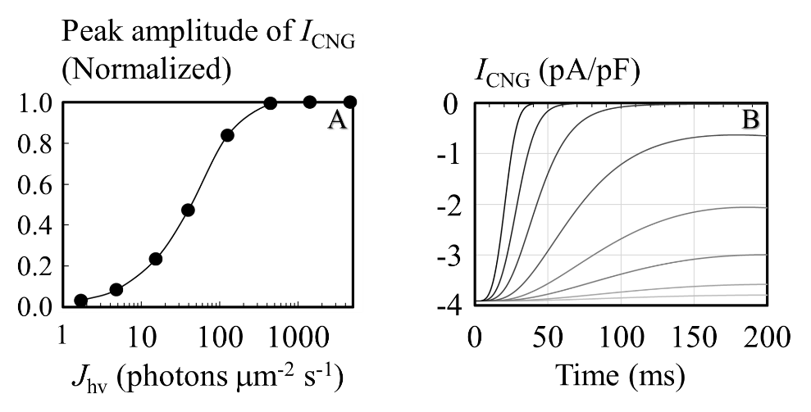

Fig. 1S A sigmoidal shape showing hyperpolarization of the membrane potential with the increased light-flash intensities (J_{hv}) and rising phase of I_{CNG}. Simulation results of light responses were performed in a variety of J_{hv}; 1.7, 4.8, 15.2, 39.4, 125, 444, 1406, and 4630 photons μm⁻² s⁻¹. A) exponential saturation relationship between the peak amplitude of I_{CNG} and a variety of light intensities (filled circle), B) rising phase of photocurrent response to light-flash simulations in grey to black (with color gradient). The responses started at time 0 s, and the stimuli consisted of 20 ms flashes.

S3 Mathematical description of the mouse rod photoreceptor
Membrane potential (V_{m} [mV])
$$I_{All}=I_{CNG}+I_{NCKX}+I_{Kv}+I_{KCa}+I_{h}+I_{ClCa}+I_{NaK}+I_{NCX}+{I_{CaL}+I}_{PMCA}+I_{L,Caos}+I_{L,Cais}+I_{L,K}+I_{L,Na}+I_{L,Cl}$$
$$C_{m}\frac{dV_{m}}{dt}=-I_{All} (V_{m}\left(0\right)=-36.186)$$
C_{m} = 3.6 pF (Ingram et al. 2019); Note that J_{NKCC1} and J_{KCC2} are electroneutral.
Reversal potential (E_{ion}) based on Nernst equation and the classical Goldman–Hodgkin–Katz constant field equation (C_{F})
$$E_{K}=\frac{R∙T}{1∙F∙{10}^{-3}}∙\ln\left(\frac{{\left[K^{+}\right]}_{o}}{{\left[K^{+}\right]}_{i}}\right)$$
$$E_{Na}=\frac{R∙T}{1∙F∙{10}^{-3}}∙\ln\left(\frac{{\left[{Na}^{+}\right]}_{o}}{{\left[{Na}^{+}\right]}_{i}}\right)$$
$$E_{Cl}=\frac{R∙T}{-1∙F∙{10}^{-3}}∙\ln\left(\frac{{\left[{Cl}^{-}\right]}_{o}}{{\left[{Cl}^{-}\right]}_{i}}\right)$$
$$E_{Cais}=\frac{R∙T}{2∙F∙{10}^{-3}}∙\ln\left(\frac{{\left[{Ca}^{2+}\right]}_{o}}{{\left[{Ca}^{2+}\right]}_{is}}\right)$$
$$E_{Caos}=\frac{R∙T}{2∙F∙{10}^{-3}}∙\ln\left(\frac{{\left[{Ca}^{2+}\right]}_{o}}{{\left[{Ca}^{2+}\right]}_{os}}\right)$$
$$C_{F,K}=\frac{1∙F∙V_{m}∙{10}^{-3}}{R∙T}∙\frac{\left({\left[K^{+}\right]}_{i}-{\left[K^{+}\right]}_{o}∙\exp\left(\frac{-1∙F∙V_{m}∙{10}^{-3}}{R∙T}\right)\right)}{\left(1-\exp\left(\frac{-1∙F∙V_{m}∙{10}^{-3}}{R∙T}\right)\right)}$$
$$C_{F,Na}=\frac{1∙F∙V_{m}∙{10}^{-3}}{R∙T}∙\frac{\left({\left[{Na}^{+}\right]}_{i}-{\left[{Na}^{+}\right]}_{o}∙\exp\left(\frac{-1∙F∙V_{m}∙{10}^{-3}}{R∙T}\right)\right)}{\left(1-\exp\left(\frac{-1∙F∙V_{m}∙{10}^{-3}}{R∙T}\right)\right)}$$
$$C_{F,Cais}=\frac{2∙F∙V_{m}∙{10}^{-3}}{R∙T}∙\frac{\left({\left[{Ca}^{2+}\right]}_{is}∙{10}^{-3}-{\left[{Ca}^{2+}\right]}_{o}∙{10}^{-3}∙\exp\left(\frac{-2∙F∙V_{m}∙{10}^{-3}}{R∙T}\right)\right)}{\left(1-\exp\left(\frac{-2∙F∙V_{m}∙{10}^{-3}}{R∙T}\right)\right)}$$
$$C_{F,Caos}=\frac{2∙F∙V_{m}∙{10}^{-3}}{R∙T}∙\frac{\left({\left[{Ca}^{2+}\right]}_{os}∙{10}^{-3}-{\left[{Ca}^{2+}\right]}_{o}∙{10}^{-3}∙\exp\left(\frac{-2∙F∙V_{m}∙{10}^{-3}}{R∙T}\right)\right)}{\left(1-\exp\left(\frac{-2∙F∙V_{m}∙{10}^{-3}}{R∙T}\right)\right)}$$
F = 96485.34 C mol⁻¹, R = 8.3145 J mol⁻¹ K⁻¹, T = 310 K, [K⁺]_{o} = 5 mM, [K⁺]_{i} = 140 mM, [Na⁺]_{o} = 145 mM, [Na⁺]_{i} = 5 mM, [Cl⁻]_{o} = 110 mM, [Cl⁻]_{i} = 30 mM, [Ca²⁺]_{o} = 1600 μM, [Ca²⁺]_{os} = 0.25 μM, [Ca²⁺]_{is} = 0.1 μM; Note that the concentrations are based on the typical mammalian neurons.
Calcium system [μM] at outer segment
Model equations; Dell'Orco et al. 2009, Invergo et al. 2014, Dell'Orco and Dal Cortivo 2019, Beelen et al. 2021
$$\frac{d{\left[{Ca}^{2+}\right]}_{os}}{dt}=\frac{-(I_{CNG,Ca}-2∙I_{NCKX}+I_{L,Caos})}{2∙F∙V_{os}}∙{10}^{-6}-\frac{d{\left[{Ca}^{2+}\right]}_{os,b}}{dt}-\frac{J_{dif}}{V_{os}}$$
${\left[{Ca}^{2+}\right]}_{os,b}$ is the concentration of buffered calcium.
$$\frac{d{\left[{Ca}^{2+}\right]}_{os,b}}{dt}=k_{1}∙\left(e_{T}-{\left[{Ca}^{2+}\right]}_{os,b}\right)∙{\left[{Ca}^{2+}\right]}_{os}-k_{2}∙{\left[{Ca}^{2+}\right]}_{os,b}$$
The $J_{dif}$ is the rate of Ca²⁺ diffusion between outer and inner segments.
$$J_{dif}=k_{3}∙\left({\left[{Ca}^{2+}\right]}_{os}-{\left[{Ca}^{2+}\right]}_{is}\right)$$
k₁ = 9.37059 s⁻¹ μM⁻¹, k₂ = 46.412 s⁻¹, k₃ = 1$×$10⁻²⁰ s⁻¹ μM⁻¹, e_{T} = 400 μM, V_{os} = 3.916$×$10⁻¹⁴ L

Calcium system [μM] at inner segment
Model equations; Kamiyama et al. 2009
$$\frac{d{\left[{Ca}^{2+}\right]}_{is}}{dt}=\frac{-(I_{CaL,Ca}+I_{PMCA}-2∙I_{NCX}+I_{L,Cais})}{2∙F∙V_{is}}∙{10}^{-6}-\frac{D_{Ca}∙S_{1}}{δ∙V_{is}}∙\left({\left[{Ca}^{2+}\right]}_{is}-{\left[{Ca}^{2+}\right]}_{if}\right)-\frac{d{\left[{Ca}^{2+}\right]}_{ls}}{dt}-\frac{d{\left[{Ca}^{2+}\right]}_{hs}}{dt}+\frac{J_{dif}}{V_{is}}$$
$$\frac{d{\left[{Ca}^{2+}\right]}_{if}}{dt}=\frac{D_{Ca}∙S_{1}}{δ∙V_{if}}∙\left({\left[{Ca}^{2+}\right]}_{is}-{\left[{Ca}^{2+}\right]}_{if}\right)-\frac{d{\left[{Ca}^{2+}\right]}_{lf}}{dt}-\frac{d{\left[{Ca}^{2+}\right]}_{hf}}{dt} ({\left[{Ca}^{2+}\right]}_{if}(0)=0.1)$$
$$\frac{d{\left[{Ca}^{2+}\right]}_{ls}}{dt}=L_{b1}∙{\left[{Ca}^{2+}\right]}_{is}∙\left(B_{L}-{\left[{Ca}^{2+}\right]}_{ls}\right)-L_{b2}∙{\left[{Ca}^{2+}\right]}_{ls} ({\left[{Ca}^{2+}\right]}_{ls}\left(0\right)=80)$$
$$\frac{d{\left[{Ca}^{2+}\right]}_{hs}}{dt}=H_{b1}∙{\left[{Ca}^{2+}\right]}_{is}∙\left(B_{H}-{\left[{Ca}^{2+}\right]}_{hs}\right)-H_{b2}∙{\left[{Ca}^{2+}\right]}_{hs} ({\left[{Ca}^{2+}\right]}_{hs}\left(0\right)=30)$$
$$\frac{d{\left[{Ca}^{2+}\right]}_{lf}}{dt}=L_{b1}∙{\left[{Ca}^{2+}\right]}_{if}∙\left(B_{L}-{\left[{Ca}^{2+}\right]}_{lf}\right)-L_{b2}∙{\left[{Ca}^{2+}\right]}_{lf} ({\left[{Ca}^{2+}\right]}_{lf}\left(0\right)=80)$$
$$\frac{d{\left[{Ca}^{2+}\right]}_{hf}}{dt}=H_{b1}∙{\left[{Ca}^{2+}\right]}_{if}∙\left(B_{H}-{\left[{Ca}^{2+}\right]}_{hf}\right)-H_{b2}∙{\left[{Ca}^{2+}\right]}_{hf} ({\left[{Ca}^{2+}\right]}_{hf}\left(0\right)=30)$$
V_{is} = 1.5664$×$10⁻¹⁴ L, V_{if} = 2.3496$×$10⁻¹⁴ L, D_{Ca} = 6$×$10⁻⁸ dm² s⁻¹, δ = 3$×$10⁻⁵ dm, S₁ = 3.142$×$10⁻⁸ dm², L_{b1} = 0.4 s⁻¹ μM⁻¹, L_{b2} = 0.21 s⁻¹, H_{b1} = 100 s⁻¹ μM⁻¹, H_{b2} = 90 s⁻¹, B_{L} = 500 μM, B_{H} = 300 μM

Cyclic nucleotide-gated ion channel (I_{CNG} [pA])
We adopted a comprehensive model of the phototransduction cascade complexes, which has been widely described (see Hamer et al. 2005, Dell'Orco et al. 2009, Invergo et al. 2014, Dell'Orco & Dal Cortivo 2019, Beelen et al. 2021). The relative ion permeability P_{Ca}/P_{M} of I_{CNG} is about 6 (Kaupp & Seifert 2002), with P_{M} being the permeability of monovalent cations, including; K⁺ and Na⁺.
$$\frac{d\left[cGMP\right]}{dt}=\frac{A_{max}}{1+{\left(\frac{{\left[{Ca}^{2+}\right]}_{os}}{0.171}\right)}^{3}}+\frac{A_{max}}{1+{\left(\frac{{\left[{Ca}^{2+}\right]}_{os}}{0.059}\right)}^{1.5}}-\left[cGMP\right]∙\left(β_{dark}+β_{sub}∙{\left[PDE\right]}^{*}\right)$$
Hamer et al. (2005) showed the equation (Eq. A12 in Hamer et al. 2005) of I_{CNG} as the following equation.
$$I_{CNG}=-\frac{2}{2+f_{Ca}}∙J_{dark}∙{\left(\frac{\left[cGMP\right]}{{\left[cGMP\right]}_{dark}}\right)}^{n_{CG}}$$
I_{CNG} is the total of ionic current derived from Ca²⁺, Na⁺, and K⁺ and given by
$$I_{CNG}=I_{CNG,Ca}+I_{CNG,Na}+I_{CNG,K}$$
$$I_{CNG,Ca}=P_{Ca,CNG}∙C_{F,Caos}∙p_{Open,CNG}∙C_{m}$$
$$I_{CNG,Na}=P_{Na,CNG}∙C_{F,Na}∙p_{Open,CNG}∙C_{m}$$
$$I_{CNG,K}=P_{K,CNG}∙C_{F,K}∙p_{Open,CNG}∙C_{m}$$
$$I_{CNG}=p_{Open,CNG}∙C_{m}∙(P_{Ca,CNG}∙C_{F,Caos}+P_{Na,CNG}∙C_{F,Na}+P_{K,CNG}∙C_{F,K})$$
Eq. A12 (for I_{CNG}) in Hamer et al. (2005) equals the above I_{CNG} equation based on the GHK constant field equation.
$$-\frac{2}{2+f_{Ca}}∙J_{dark}∙{\left(\frac{\left[cGMP\right]}{{\left[cGMP\right]}_{dark}}\right)}^{n_{CG}}=p_{Open,CNG}∙C_{m}∙(P_{Ca,CNG}∙C_{F,Caos}+P_{Na,CNG}∙C_{F,Na}+P_{K,CNG}∙C_{F,K})$$
Finally, we obtained the open probability of I_{CNG} in the new model.
$$p_{Open,CNG}=-\frac{2}{2+f_{Ca}}∙J_{dark}∙{\left(\frac{\left[cGMP\right]}{{\left[cGMP\right]}_{dark}}\right)}^{n_{CG}}∙\frac{1}{C_{m}∙(P_{Ca,CNG}∙C_{F,Caos}+P_{Na,CNG}∙C_{F,Na}+P_{K,CNG}∙C_{F,K})}$$
A_{max} = 60 μM s⁻¹, $β_{dark}$= 3.1873 s⁻¹, $β_{sub}$ = 0.0022 s⁻¹ μM⁻¹, f_{Ca} = 0.12, [cGMP]_{dark} = 6.4944 μM, J_{dark} = 14.87 pA
Potassium dependent sodium/calcium exchanger (I_{NCKX} [pA])
I_{NCKX} from Hamer et al. (2005)
$$I_{NCKX}=-\frac{f_{Ca}}{2+f_{Ca}}∙J_{dark}∙\frac{{\left[{Ca}^{2+}\right]}_{os}-{\left[{Ca}^{2+}\right]}_{0}}{{\left[{Ca}^{2+}\right]}_{os,dark}-{\left[{Ca}^{2+}\right]}_{0}}$$
${\left[{Ca}^{2+}\right]}_{os,dark}$ = 0.25 μM, ${\left[{Ca}^{2+}\right]}_{0}$ = 0.023 μM
Model fitting for ion permeability of I_{CNG} based GHK equation in the current model
In the darkness, Ca²⁺ influx is equal to Ca²⁺ efflux at rod outer segments.
$$-P_{Ca,CNG}∙C_{F,Caos}∙p_{Open,CNG}∙C_{m}∙\frac{1}{2∙F∙V_{os}}=-\frac{f_{Ca}}{2+f_{Ca}}∙J_{dark}∙\frac{{\left[{Ca}^{2+}\right]}_{os}-{\left[{Ca}^{2+}\right]}_{0}}{{\left[{Ca}^{2+}\right]}_{os,dark}-{\left[C{Ca}^{2+}a\right]}_{0}}∙\frac{-2}{2∙F∙V_{os}}$$
$$-P_{Ca,CNG}∙C_{F,Caos}∙p_{Open,CNG}∙C_{m}=-\frac{f_{Ca}}{2+f_{Ca}}∙J_{dark}∙\frac{{\left[{Ca}^{2+}\right]}_{os}-{\left[{Ca}^{2+}\right]}_{0}}{{\left[{Ca}^{2+}\right]}_{os,dark}-{\left[{Ca}^{2+}\right]}_{0}}∙(-2)$$
Replace p_{Open,CNG};
$$-P_{Ca,CNG}∙C_{F,Caos}∙\left(-\frac{2}{2+f_{Ca}}∙J_{dark}∙{\left(\frac{\left[cGMP\right]}{{\left[cGMP\right]}_{dark}}\right)}^{n_{CG}}∙\frac{1}{C_{m}∙\left(P_{Ca,CNG}∙C_{F,Caos}+P_{Na,CNG}∙C_{F,Na}+P_{K,CNG}∙C_{F,K}\right)}\right)∙C_{m} =-\frac{f_{Ca}}{2+f_{Ca}}∙J_{dark}∙\frac{{\left[{Ca}^{2+}\right]}_{os}-{\left[{Ca}^{2+}\right]}_{0}}{{\left[{Ca}^{2+}\right]}_{os,dark}-{\left[{Ca}^{2+}\right]}_{0}}∙(-2)$$
$$P_{Ca,CNG}∙C_{F,Caos}∙{\left(\frac{\left[cGMP\right]}{{\left[cGMP\right]}_{dark}}\right)}^{n_{CG}}∙\frac{1}{P_{Ca,CNG}∙C_{F,Caos}+P_{Na,CNG}∙C_{F,Na}+P_{K,CNG}∙C_{F,K}}=f_{Ca}∙\frac{{\left[{Ca}^{2+}\right]}_{os}-{\left[{Ca}^{2+}\right]}_{0}}{{\left[{Ca}^{2+}\right]}_{os,dark}-{\left[{Ca}^{2+}\right]}_{0}}$$
In the darkness; [cGMP] = [cGMP]_{dark}, ${\left[{Ca}^{2+}\right]}_{os}$ = ${\left[{Ca}^{2+}\right]}_{os,dark}$
$$\frac{P_{Ca,CNG}∙C_{F,Caos}}{P_{Ca,CNG}∙C_{F,Caos}+P_{Na,CNG}∙C_{F,Na}+P_{K,CNG}∙C_{F,K}}=f_{Ca}$$
In the darkness; ${\left[{Ca}^{2+}\right]}_{os}$= 0.25 μM, ${\left[{Ca}^{2+}\right]}_{o}$= 1600 μM, ${\left[{Na}^{+}\right]}_{i}$ = 5 mM, ${\left[{Na}^{+}\right]}_{o}$= 145 mM, ${\left[K^{+}\right]}_{i}$= 140 mM, ${\left[K^{+}\right]}_{o}$= 5 mM, $C_{F,Caos}$= -4.64, $C_{F,Na}$= -262.37, $C_{F,K}$ = 56.83,
$P_{Na}$/$P_{K}$ = ~1, $P_{Ca}$/$P_{Na}$= 1.9-6.5 (Picones & Korenbrot 1995, Wells & Tanaka 1997, Hackos & Korenbrot 1999, Kaupp & Seifert 2002)
$P_{Na}:P_{K}:P_{Ca}$ = 1x : 1x : R_{Ca} x ; x = scaling factor
R_{Ca}: 1.9 to 6.5
Fitting with f_{Ca} = 0.12
$$\frac{(R_{Ca}x)∙(-4.64)}{ (R_{Ca}x)∙(-4.64)+(1x) ∙(-262.37)+(1x)∙56.83}=0.12$$
$$\frac{-4.64∙R_{Ca}}{-4.64∙R_{Ca}-262.37+56.83}=0.12$$
$R_{Ca}=6.026$, $P_{Ca}≅6x$, x = 1/3.6

L-type voltage-gated calcium channel (I_{CaL} [pA])
Electrophysiological profiles; Morgans et al. 2005, Babai and Thoreson 2009, Grove et al. 2019, Ingram et al. 2020
Ion permeability; Takeuchi et al. 2006
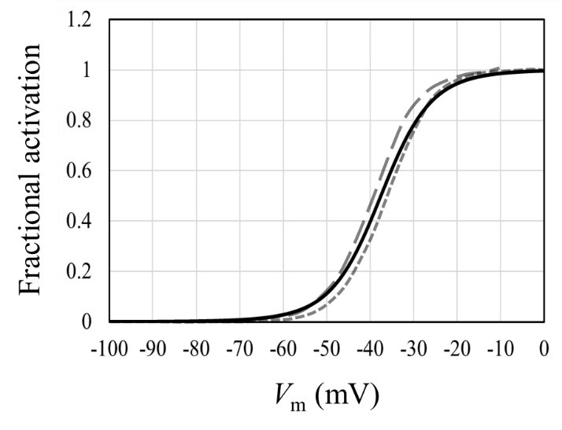
Fig. 2S Fractional activation of I_{CaL} in the current study (black line) and experimental observations. Dotted line; mouse rods (Morgans et al. 2005), Dashed line; mouse rods and cones (Babai and Thoreson 2009, Grove et al. 2019, Ingram et al. 2020)).
$$I_{CaL}=I_{CaL,Ca}+I_{CaL,K}+I_{CaL,Na}$$
$$I_{CaL,Ca}=P_{Ca,CaL}∙C_{F,Cais}∙p_{Open,CaL}∙C_{m}$$
$$I_{CaL,K}=P_{K,CaL}∙C_{F,K}∙p_{Open,CaL}∙C_{m}$$
$$I_{CaL,Na}=P_{Na,CaL}∙C_{F,Na}∙p_{Open,CaL}∙C_{m}$$
$$α_{CaL}=\frac{1000}{1+\exp\left(-\frac{V_{m}+20}{10}\right)}$$
$$β_{CaL}=\frac{1000}{1+\exp\left(\frac{V_{m}+55}{10}\right)}$$
$$\frac{dp_{Open,CaL}}{dt}=α_{CaL}∙\left(1-p_{Open,CaL}\right)-β_{CaL}∙p_{Open,CaL} (p_{Open,CaL}\left(0\right)=0.556)$$
k_{CaL} = 0.65 (scale factor), P_{Ca,CaL} = 1$×$ k_{CaL}, P_{K,CaL} = 0.000365$×$ k_{CaL}, P_{Na,CaL} = 0.0000185$×$ k_{CaL}

Plasma membrane Ca²⁺ pump (I_{PMCA} [pA])
Model equations; Takeuchi et al. 2006 & Kamiyama et al. 2009
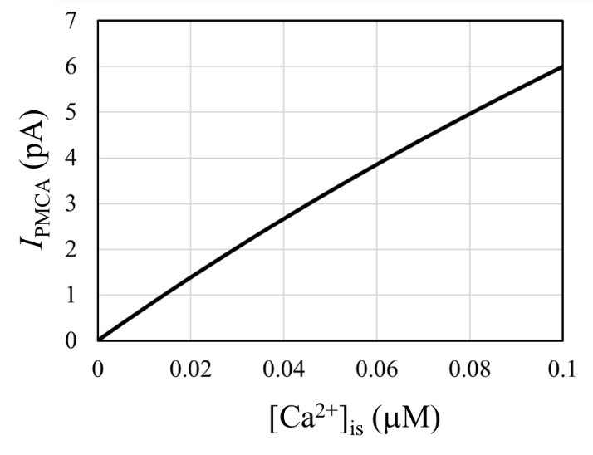
Fig. 3S Electrophysiological characteristics of I_{PMCA} in the current study.
$$I_{PMCA}=\frac{k_{PMCA}}{1+\frac{0.0005}{{\left[Ca\right]}_{is}∙{10}^{-3}}}∙C_{m}$$
k_{PMCA} = 10

Hyperpolarization-activated cyclic nucleotide-gated ion channel (I_{h} [pA])
Model equations; Kamiyama et al. 2009
Model fitting for shaping membrane potential response to light, i.e., characteristics of peak-plateau sag.
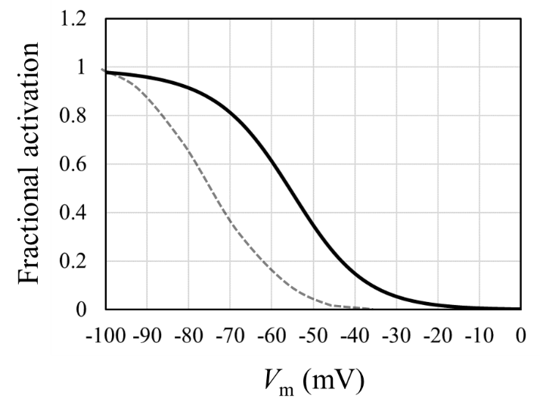
Fig. 4S Fractional activation of I_{h} in the current study (black line) and rabbit rod (Dotted line) from Demontis et al. (2002).
$$I_{h}=I_{h,K}+I_{h,Na}$$
$$I_{h,K}=P_{K,h}∙C_{F,K}∙p_{Open,h}∙C_{m}$$
$$I_{h,Na}=P_{Na,h}∙C_{F,Na}∙p_{Open,h}∙C_{m}$$
$$α_{h}=\frac{80}{1+\exp\left(\frac{V_{m}+78}{14}\right)}$$
$$β_{h}=\frac{180}{1+\exp\left(-\frac{V_{m}+8}{19}\right)}$$
$$\frac{dp_{Open,h}}{dt}=α_{h}∙\left(1-p_{Open,h}\right)-β_{h}∙p_{Open,h} (p_{Open,h}\left(0\right)=0.103)$$
P_{K,h} = 0.15, P_{Na,h} = 0.05

Voltage-gated potassium channel (I_{Kv} [pA])
Model equations; Fortenbach et al. 2021
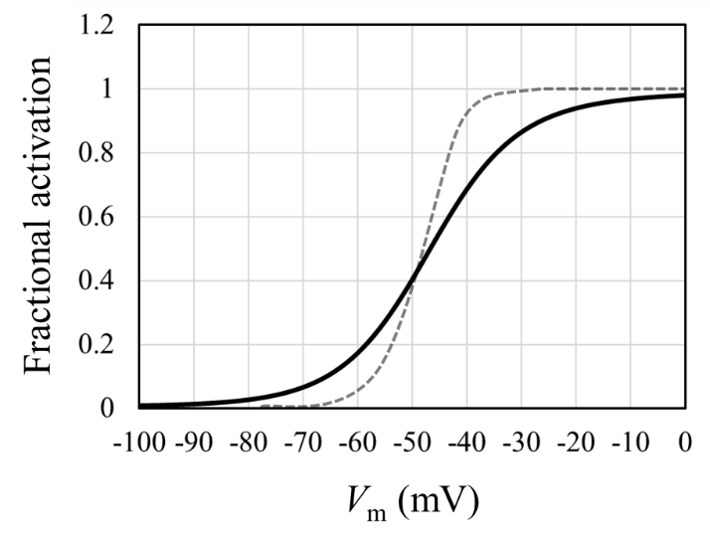
Fig. 5S Fractional activation of I_{Kv} in the current study (black line) and monkey rod (Dotted line) from Gayet-Primo et al. (2018).
$$I_{Kv}=g_{Kv}∙p_{Open,Kv}∙(V_{m}-E_{K})$$
$$α_{Kv}=0.5+\frac{30-0.5}{1+\exp\left(-\frac{V_{m}-5}{17}\right)}$$
$$β_{Kv}=0.25+\frac{100-0.25}{1+\exp\left(\frac{V_{m}+92}{11}\right)}$$
$$\frac{dp_{Open,Kv}}{dt}=α_{Kv}∙\left(1-p_{Open,Kv}\right)-β_{Kv}∙p_{Open,Kv} (p_{Open,Kv}\left(0\right)=0.769)$$
g_{Kv} = 0.2 nS

Calcium-activated potassium channel (I_{KCa} [pA])
Model equations; Kamiyama et al. 2009
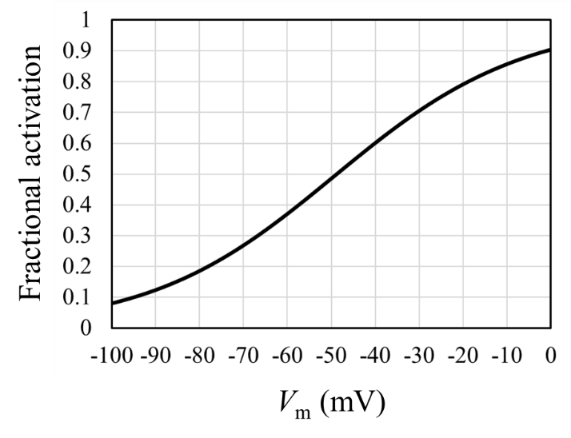
Fig. 6S Fractional activation of I_{KCa} in the current study.
$$I_{KCa}=g_{KCa}∙m_{KCa}^{2}∙m_{KCas}∙(V_{m}-E_{K})$$
$$α_{mKCa}=\frac{15∙(80-V_{m})}{\exp\left(\frac{{80-V}_{m}}{40}\right)-1}$$
$$β_{mKCa}=20∙\exp\left(-\frac{V_{m}}{35}\right)$$
$$\frac{dm_{KCa}}{dt}=α_{mKCa}∙\left(1-m_{KCa}\right)-β_{mKCa}∙m_{KCa} (m_{KCa}\left(0\right)=0.642)$$
$$m_{KCas}=\frac{{\left[Ca\right]}_{is}}{{\left[Ca\right]}_{is}+0.3}$$
g_{KCa} = 0.113 nS

Calcium-activated chloride channel (I_{ClCa} [pA])
Model equations; Kamiyama et al. 2009
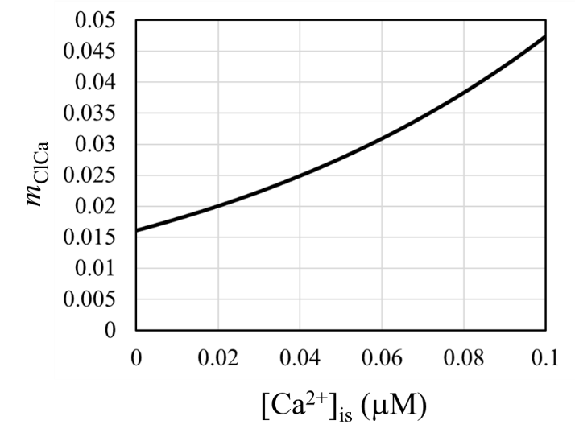
Fig. 7S The relationship between m_{ClCa} and calcium level.
$$I_{ClCa}=g_{ClCa}∙m_{ClCa}∙(V_{m}-E_{Cl})$$
$$m_{ClCa}=\frac{1}{1+\exp\left(\frac{0.37-{\left[Ca\right]}_{is}}{0.09}\right)}$$
g_{ClCa} = 2 nS

Sodium/potassium pump (I_{NaK} [pA])
Model equations; Fortenbach et al. 2021 (Original source; see Figure S4 in Fortenbach et al. 2021)
$$I_{NaK}=10.34∙\left(0.33+\frac{1-0.33}{1+\exp\left(-\frac{V_{m}+57.1}{27.6}\right)}\right)$$

Sodium/calcium exchanger (I_{NCX} [pA])
Model equations; Luo & Rudy 1994
$$I_{NCX}=k_{NCX}∙\frac{1}{K_{m,Na}^{3}+{\left[Na\right]}_{o}^{3}}∙\frac{1}{K_{m,Ca}+{\left[Ca\right]}_{o}∙{10}^{-3}}∙\frac{1}{1+k_{sat}∙\exp\left(\left(η-1\right)∙V_{m}∙\frac{F}{R∙T}\right)}∙{10}^{-3}∙\left(\exp\left(η∙V_{m}∙\frac{F}{R∙T}\right)∙{\left[Na\right]}_{i}^{3}∙{\left[Ca\right]}_{o}-\exp\left(\left(η-1\right)∙V_{m}∙\frac{F}{R∙T}\right)∙{\left[Na\right]}_{o}^{3}∙{\left[Ca\right]}_{i}\right)$$
k_{NCX} = 3.6$×$250 μA/μF, K_{m,Na} = 87.5 mM, K_{m,Ca} = 1.38 mM, k_{sat} = 0.1, $η$ = 0.35

Cotransporters [mM]
Model equations; Wei et al. 2014
$$J_{NKCC1}=-k_{NKCC1}∙\left(0.1∙\frac{1}{1+\exp{(16-{\left[K^{+}\right]}_{o})}}∙\ln\left(\frac{{\left[K^{+}\right]}_{i}∙{\left[Cl^{-}\right]}_{i}}{{\left[K^{+}\right]}_{o}∙{\left[Cl^{-}\right]}_{o}}\right)+\ln\left(\frac{{\left[Na^{+}\right]}_{i}∙{\left[Cl^{-}\right]}_{i}}{{\left[Na^{+}\right]}_{o}∙{\left[Cl^{-}\right]}_{o}}\right)\right)$$
$$J_{KCC2}=-k_{KCC2}∙0.3∙\ln\left(\frac{{\left[K^{+}\right]}_{i}∙{\left[Cl^{-}\right]}_{i}}{{\left[K^{+}\right]}_{o}∙{\left[Cl^{-}\right]}_{o}}\right)$$
k_{NKCC1} = 0.005, k_{KCC2} = 0.046

Unidentified leak channels (I_{L} [pA])
Leak channels of four essential ion species
$$I_{L,K}=g_{L,K}∙(V_{m}-E_{K})$$
$$I_{L,Na}=g_{L,Na}∙\left(V_{m}-E_{Na}\right)$$
$$I_{L,Cl}=g_{L,Cl}∙\left(V_{m}-E_{Cl}\right)$$
$$I_{L,Cais}=g_{L,Cais}∙\left(V_{m}-E_{Cais}\right)$$
$$I_{L,Caos}=g_{L,Caos}∙(V_{m}-E_{Caos})$$
g_{L,K} = 0.00011488937611594242
g_{L,Na} = 0.000071150566012260358
g_{L,Cl} = 0.00035986965484864007
g_{L,Cais} = 0.0002481452439628276
g_{L,Caos} = 0.000021232320024139139

Ion concentration
$$\frac{d\left[K^{+}\right]}{dt}=\frac{-(I_{CNG,K}-1∙I_{NCKX}+I_{h,K}+I_{Kv}+I_{CaL,K}+I_{KCa}-2∙I_{NaK}+I_{L,K})}{1∙F∙V_{cell}}∙{10}^{-9}+J_{NKCC1}+J_{KCC2}$$
$$\frac{d\left[{Na}^{+}\right]}{dt}=\frac{-(I_{CNG,Na}+4∙I_{NCKX}+I_{h,Na}+I_{CaL,Na}+3∙I_{NaK}+3∙I_{NCX}+I_{L,Na})}{1∙F∙V_{cell}}∙{10}^{-9}+J_{NKCC1}$$
$$\frac{d\left[{Cl}^{-}\right]}{dt}=\frac{-(I_{ClCa}+I_{L,Cl})}{-1∙F∙V_{cell}}∙{10}^{-9}+2∙J_{NKCC1}+J_{KCC2}$$
F = 96485.34 C mol⁻¹, V_{cell} = 7.832$×$10⁻¹⁴ L

Required ATP for ion pumping
$$\frac{d{\left[{Na}^{+}\right]}_{influx}}{dt}=\frac{-(I_{CNG,Na}+4∙I_{NCKX}+I_{h,Na}+I_{CaL,Na}+3∙I_{NCX}+I_{L,Na})}{1∙F∙V_{cell}}∙{10}^{-9}+J_{NKCC1}$$
$$ATP for pumping out excess Na^{+} =\frac{d{\left[{Na}^{+}\right]}_{influx}}{dt}∙\frac{N_{A}∙V_{cell}}{3}∙{10}^{-3}$$
Note that one ATP molecule is hydrolyzed for transporting three Na⁺ out of the cell.

$$\frac{d{\left[{Ca}^{+}\right]}_{influx}}{dt}=\frac{-(I_{CaL,Ca}+I_{L,Cais}-{2∙I}_{NCX})}{2∙F∙V_{is}}∙{10}^{-6}$$
$$ATP for pumping out excess Ca^{2+}=\frac{d{\left[Ca^{2+}\right]}_{influx}}{dt}∙N_{A}∙V_{is}∙{10}^{-6}$$
Note that I_{PMCA} consumes one ATP for pumping one Ca²⁺ out of the cell, whereas extruding one Ca²⁺ from the cell in exchange for three Na⁺ entering the cell via I_{NCX} has no ATP utilization. However, if I_{NCX} has a low expression in mouse rods, I_{PMCA} is mainly responsible for Ca²⁺ release mechanisms.
N_{A} = 6.022$×$10²³ molecules/mole
References; Supplementary Materials
- Hamer, R. D., Nicholas, S. C., Tranchina, D., Lamb, T. D. & Jarvinen, J. L. P. Toward a unified model of vertebrate rod phototransduction. Vis. Neurosci. 22, 417-436 (2005).
- Dell'Orco, D., Schmidt, H., Mariani, S. & Fanelli, F. Network-level analysis of light adaptation in rod cells under normal and altered conditions. Mol. Biosyst. 5, 1232-1246 (2009).
- Invergo, B. M., Dell'Orco, D., Montanucci, L., Koch, K. W. & Bertranpetit, J. A comprehensive model of the phototransduction cascade in mouse rod cells. Mol. BioSyst. 10, 1481-1489 (2014).
- Dell'Orco, D. & Dal Cortivo, G. Normal GCAPs partly compensate for altered cGMP signaling in retinal dystrophies associated with mutations in GUCA1A. Sci. Rep. 9, 20105 (2019).
- Beelen, C. J., Asteriti, S., Cangiano, L., Koch, K. W. & Dell'Orco, D. A hybrid stochastic/deterministic model of single photon response and light adaptation in mouse rods. Comput. Struct. Biotechnol. J. 19, 3720-3734 (2021).
- Kamiyama, Y., Wu, S. M. & Usui, S. Simulation analysis of bandpass filtering properties of a rod photoreceptor network. Vis. Res. 49, 970-978 (2009).Kamiyama et al. 2009.
- Fortenbach, C. et al. Loss of the K⁺ channel K_{v}2. 1 greatly reduces outward dark current and causes ionic dysregulation and degeneration in rod photoreceptors. J. Gen. Physiol. 153, e202012687 (2021).
- Takeuchi, A. et al. Ionic mechanisms of cardiac cell swelling induced by blocking Na⁺/K⁺ pump as revealed by experiments and simulation. J. Gen. Physiol. 128, 495-507 (2006).
- Luo, C. H. & Rudy, Y. A dynamic model of the cardiac ventricular action potential. I. Simulations of ionic currents and concentration changes. Circ. Res. 74, 1071-1096 (1994).
- Wei, Y., Ullah, G. & Schiff, S. J. Unification of neuronal spikes, seizures, and spreading depression. J. Neurosci. 34, 11733-11743 (2014).
- Ingram, N. T., Sampath, A. P. & Fain, G. L. Voltage-clamp recordings of light responses from wild-type and mutant mouse cone photoreceptors. J. Gen. Physiol. 151, 1287-1299 (2019).
- Kaupp, U. B. & Seifert, R. Cyclic nucleotide-gated ion channels. Physiol. Rev. 82, 769-824 (2002).
- Picones, A. & Korenbrot, J. I. Permeability and interaction of Ca²⁺ with cGMP-gated ion channels differ in retinal rod and cone photoreceptors. Biophys. J. 69, 120-127 (1995).
- Wells, G. B. & Tanaka, J. C. Ion selectivity predictions from a two-site permeation model for the cyclic nucleotide-gated channel of retinal rod cells. Biophys. J. 72, 127-140 (1997).
- Hackos, D. H. & Korenbrot, J. I. Divalent cation selectivity is a function of gating in native and recombinant cyclic nucleotide–gated ion channels from retinal photoreceptors. J. Gen. Physiol. 113, 799-818 (1999).
- Morgans, C. W. et al. Photoreceptor calcium channels: insight from night blindness. Vis. Neurosci. 22, 561-568 (2005).
- Babai, N. & Thoreson, W. B. Horizontal cell feedback regulates calcium currents and intracellular calcium levels in rod photoreceptors of salamander and mouse retina. J. Physiol. 587, 2353-2364 (2009).
- Grove, J. C. et al. Novel hybrid action of GABA mediates inhibitory feedback in the mammalian retina. PLoS Biol. 17, e3000200 (2019).
- Ingram, N. T., Sampath, A. P. & Fain, G. L. Membrane conductances of mouse cone photoreceptors. J. Gen. Physiol. 152, e201912520 (2020).
- Demontis, G. C. et al. Functional characterisation and subcellular localisation of HCN1 channels in rabbit retinal rod photoreceptors. J. Physiol. 542, 89-97 (2002).
- Gayet-Primo, J., Yaeger, D. B., Khanjian, R. A. & Puthussery, T. Heteromeric K_{V}2/K_{V}8. 2 channels mediate delayed rectifier potassium currents in primate photoreceptors. J. Neurosci. 38, 3414-3427 (2018).

