5. Appendix
Table S1: Descriptive data for numeric variables
Variable | Maximum | Minimum | Mean | SD
AverageStockPrice | 472.44 | 6.13 | 85.16 | 67.40
LogNetIncome | 23.75 | 14.29 | 20.83 | 1.01
LogCO2 | 18.64 | 8.84 | 14.73 | 2.05

Table S2: Descriptive data for binary variables
Variable | Frequency (percentage)
Variable | 1 (Yes) | 0 (No)
EnvironmentalExpendituresInvestments | 54.39 | 45.61
RenewableEnergyUse | 67.75 | 0.3225
EnvironmentalProducts | 71.64 | 28.36

Table S3: Model comparison using PSIS-LOO approach.
Model | Comparison inference | Estimate | SE
Model 1 | elpd_waic | -3382.1 | 35.9
 | p_waic | 9.9 | 2.2
 | waic | 6764.1 | 71.9
Model 2 | elpd_waic | -3382.3 | 35.6
 | p_waic | 8.8 | 2.0
 | waic | 6764.6 | 71.2
Model 3 | elpd_waic | -3412.3 | 34.3
 | p_waic | 7.7 | 1.7
 | waic | 6824.5 | 68.7
Model 4 | elpd_waic | -3426.5 | 34.7
 | p_waic | 5.4 | 1.4
 | waic | 6853.0 | 69.4

Table S4: Posteriors of Model 3
Parameters | Uninformative prior |  |  |  | Informative prior
Parameters | Mean | SD | n_eff | Rhat | Mean | SD | n_eff | Rhat
Constant | 188.56 | 19.45 | 5830 | 1 | 198.63 | 18.71 | 5887 | 1
EnvironmentalProducts | 12.13 | 5.30 | 10464 | 1 | 0.61 | 0.50 | 10001 | 1
EnvironmentalExpendituresInvestment | 11.27 | 4.87 | 8577 | 1 | 0.63 | 0.50 | 10509 | 1
RenewableEnergyUse | 13.30 | 5.21 | 9455 | 1 | 0.63 | 0.51 | 11096 | 1
LogCO2 | -8.59 | 1.31 | 5782 | 1 | -7.59 | 1.26 | 5906 | 1

Table S5: Posteriors of Model 4
Parameters | Mean | SD | n_eff | Rhat
Constant | -146.82 | 47.55 | 2801 | 1
LogNetIncome | 11.26 | 2.27 | 2812 | 1
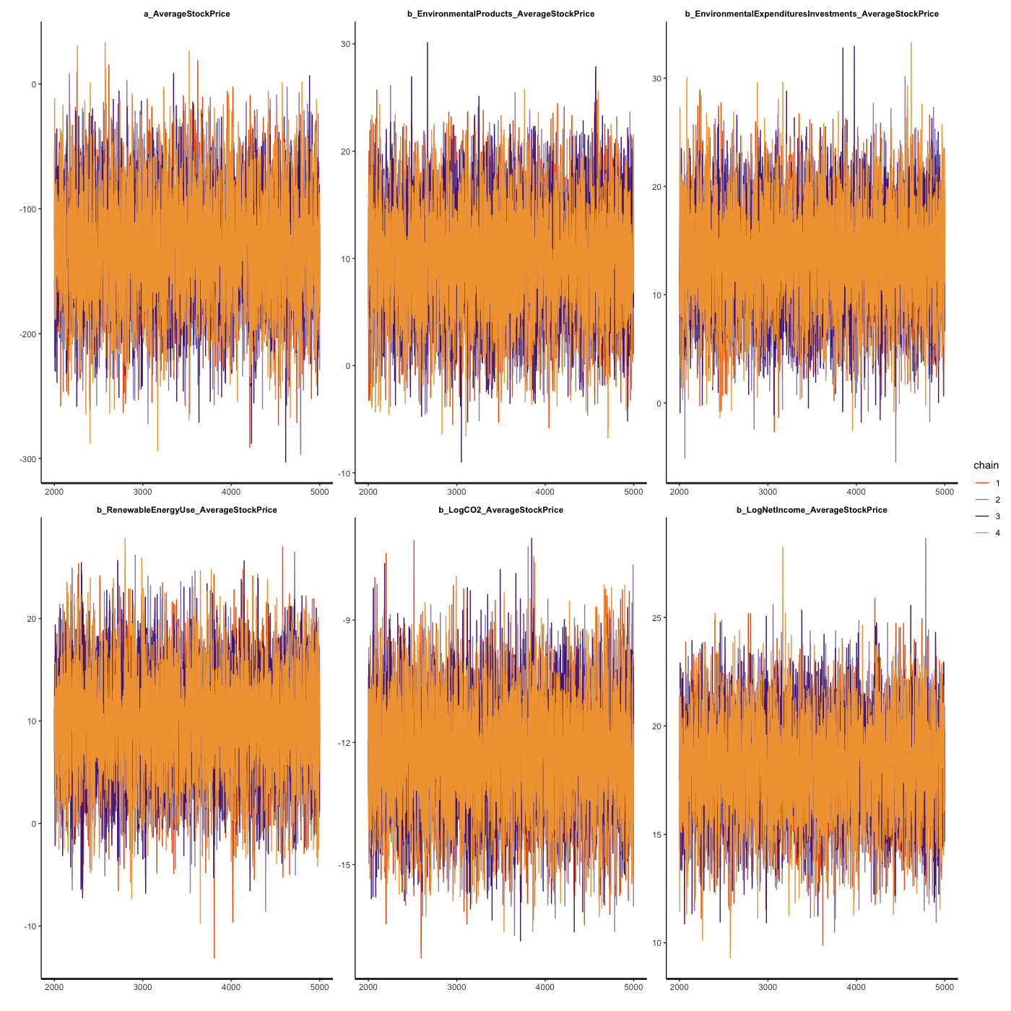
Figure S1: Model 2’s trace plots with uninformative priors.
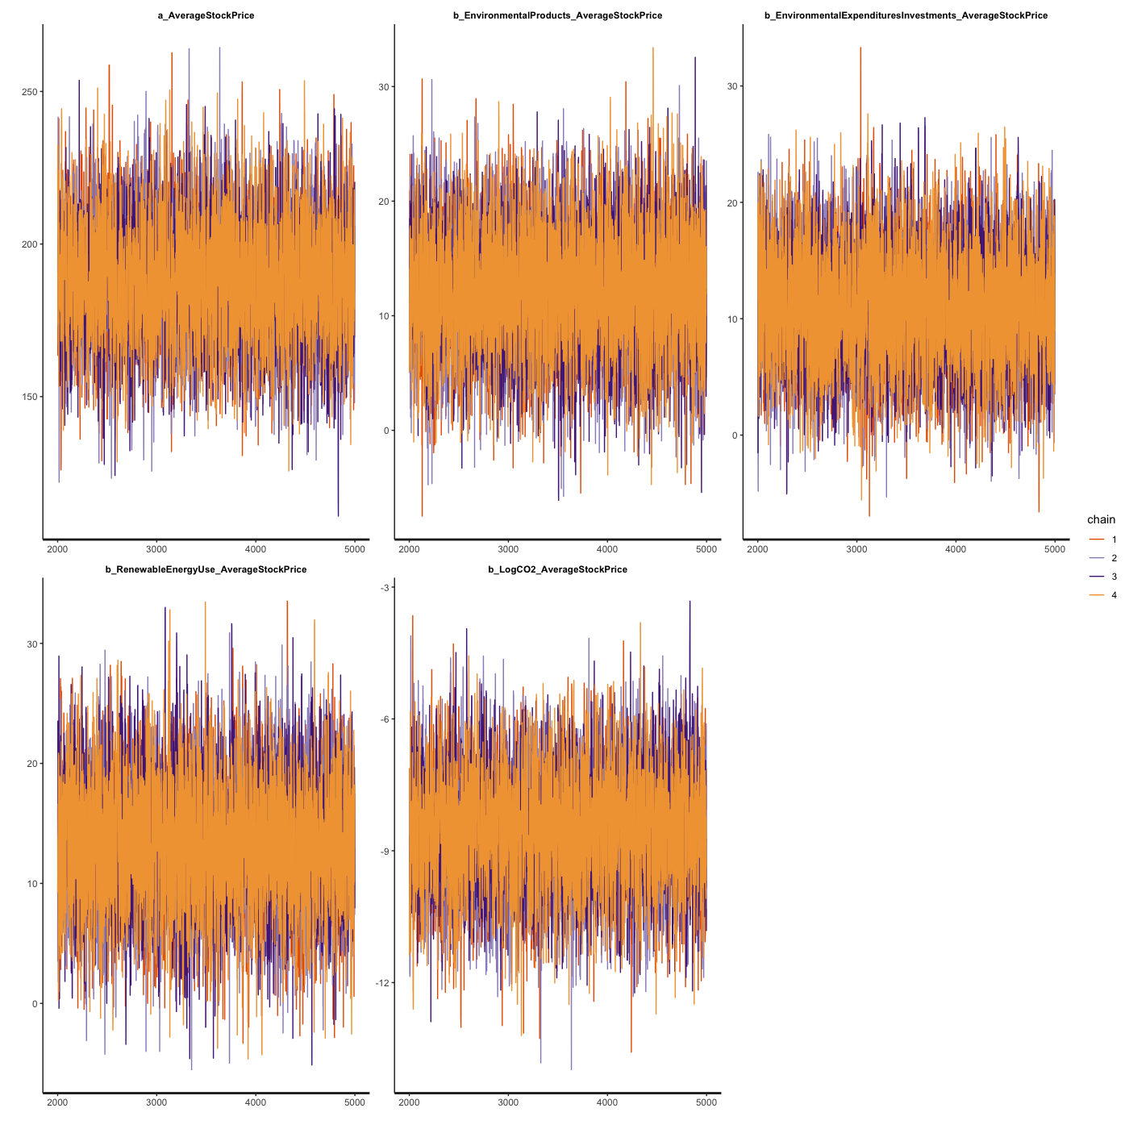
Figure S2: Model 3’s trace plots with uninformative priors.
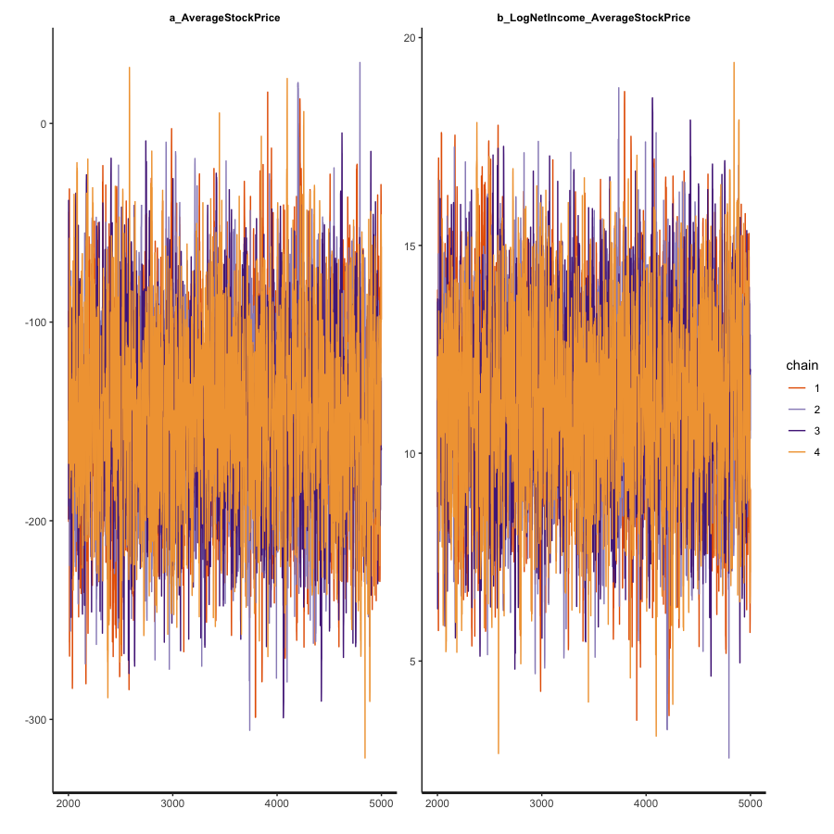
Figure S3: Model 4’s trace plots with uninformative priors.
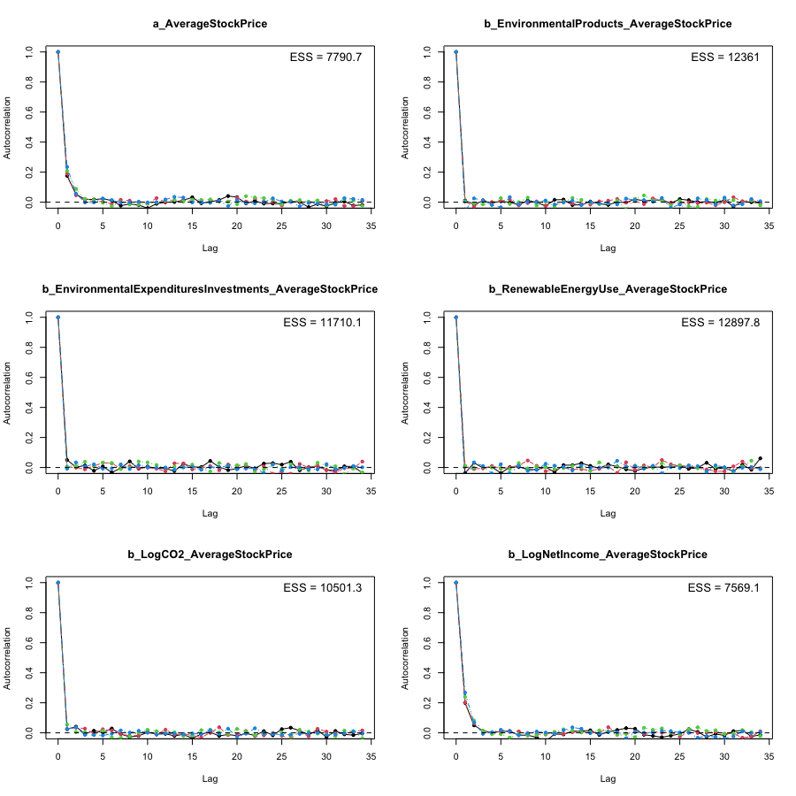
Figure S4: Model 2’s autocorrelation plots with uninformative priors.
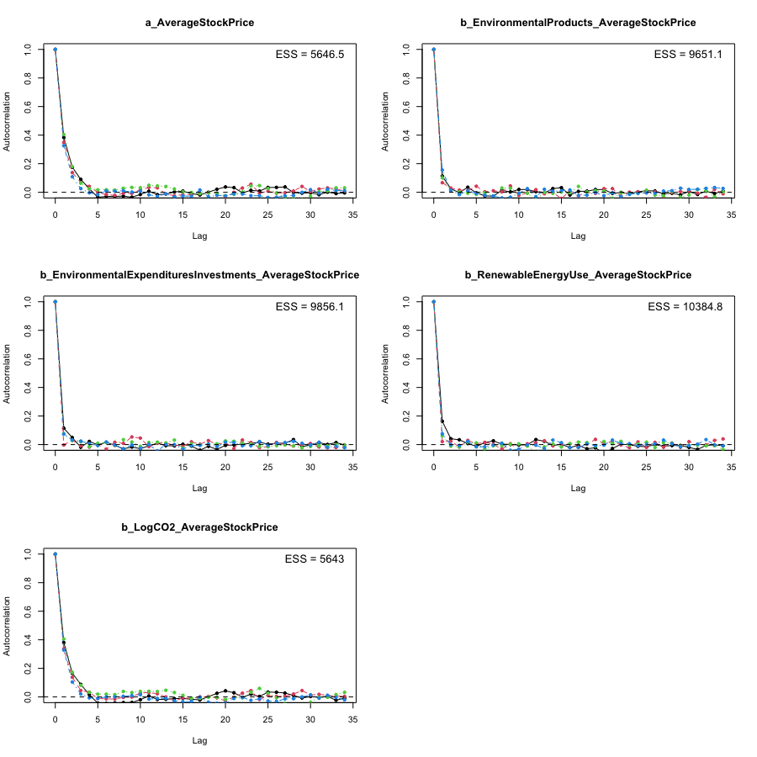
Figure S5: Model 3’s autocorrelation plots with uninformative priors.
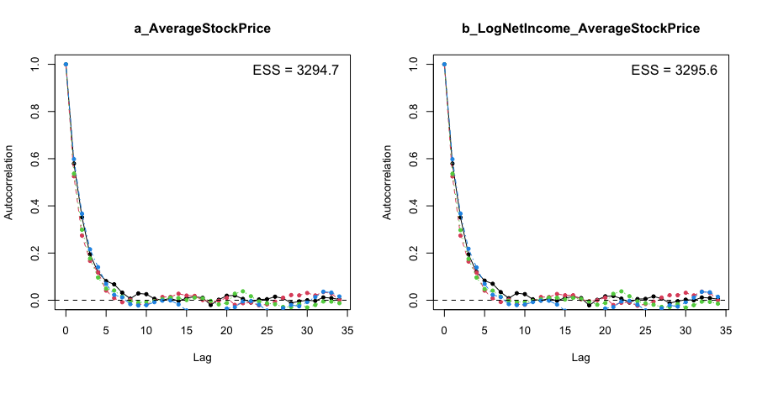
Figure S6: Model 4’s autocorrelation plots with uninformative priors.
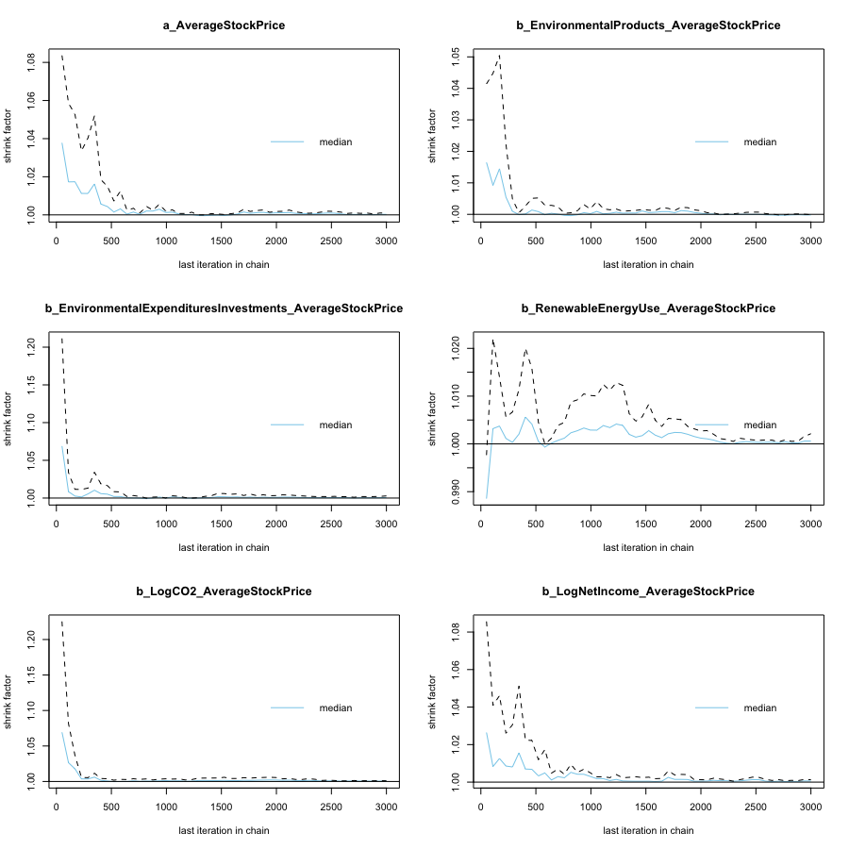
Figure S7: Model 2’s Gelman–Rubin–Brooks plots with uninformative priors.
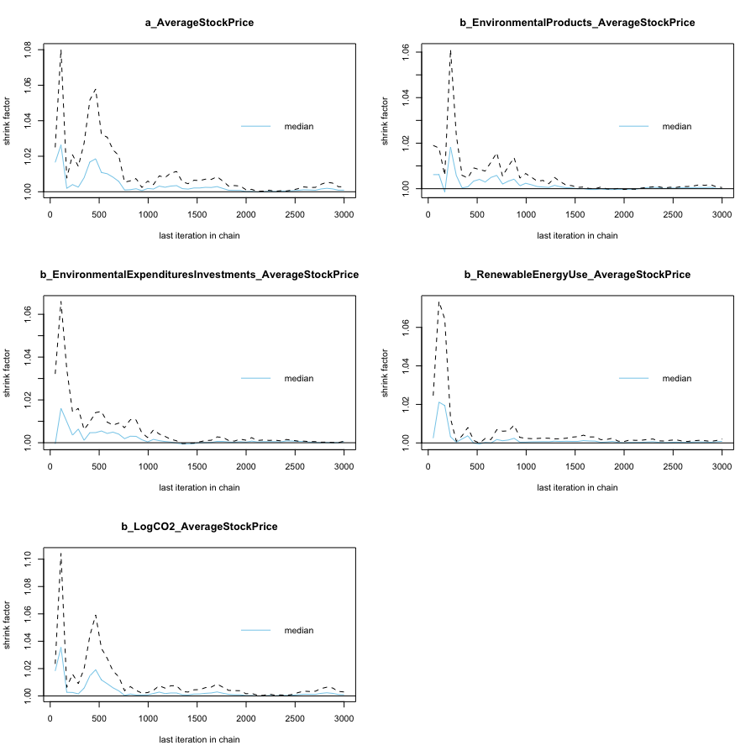
Figure S8: Model 3’s Gelman–Rubin–Brooks plots with uninformative priors.
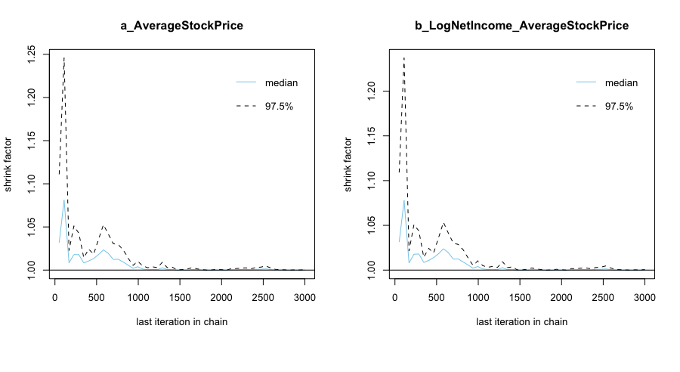
Figure S9: Model 4’s Gelman–Rubin–Brooks plots with uninformative priors.
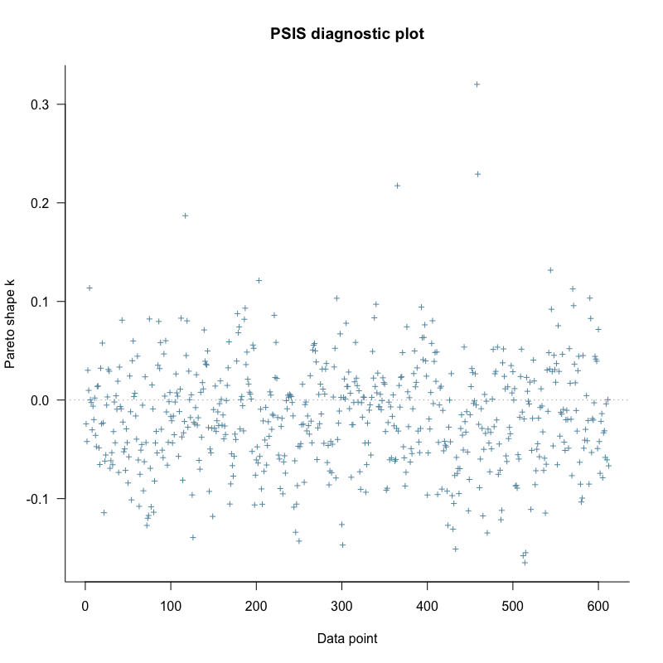
Figure S10: Model 2’s PSIS-LOO diagnosis with uninformative priors.
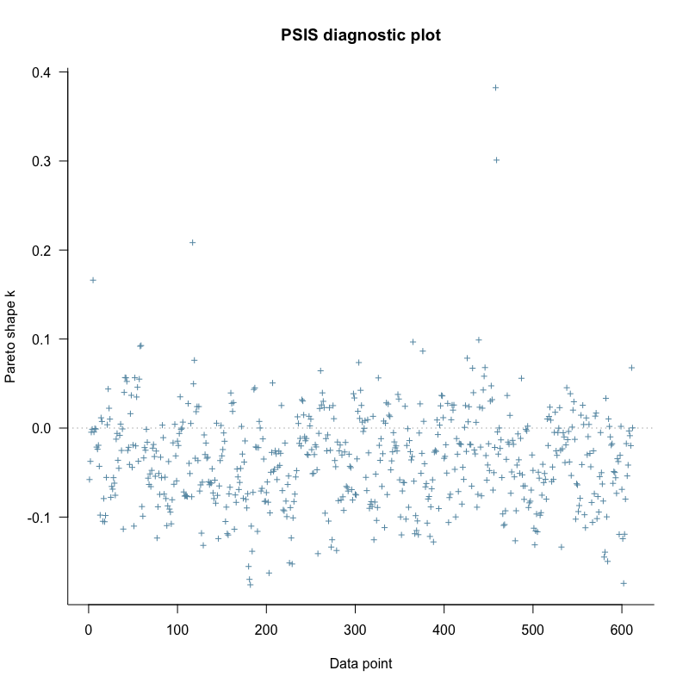
Figure S11: Model 3’s PSIS-LOO diagnosis with uninformative priors.
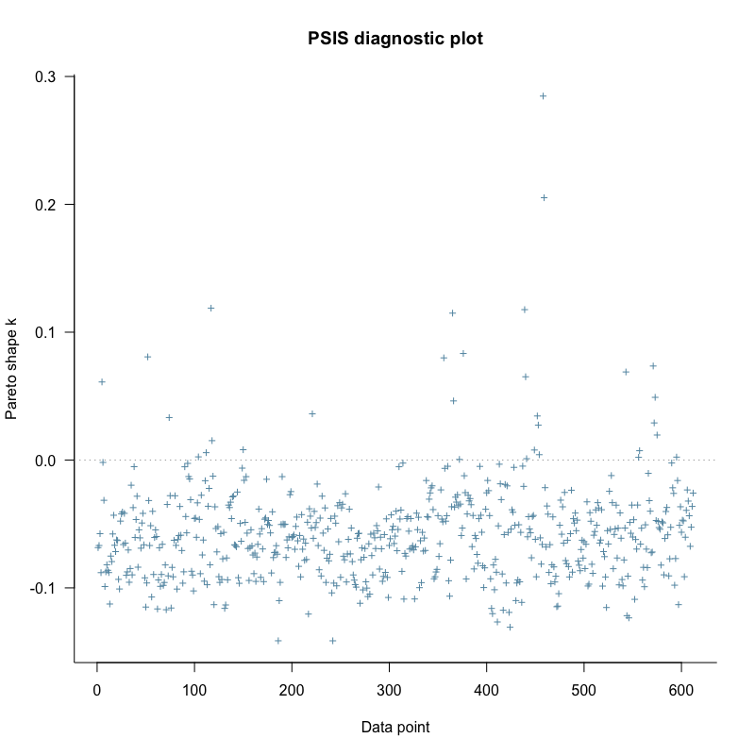
Figure S12: Model 4’s PSIS-LOO diagnosis with uninformative priors.
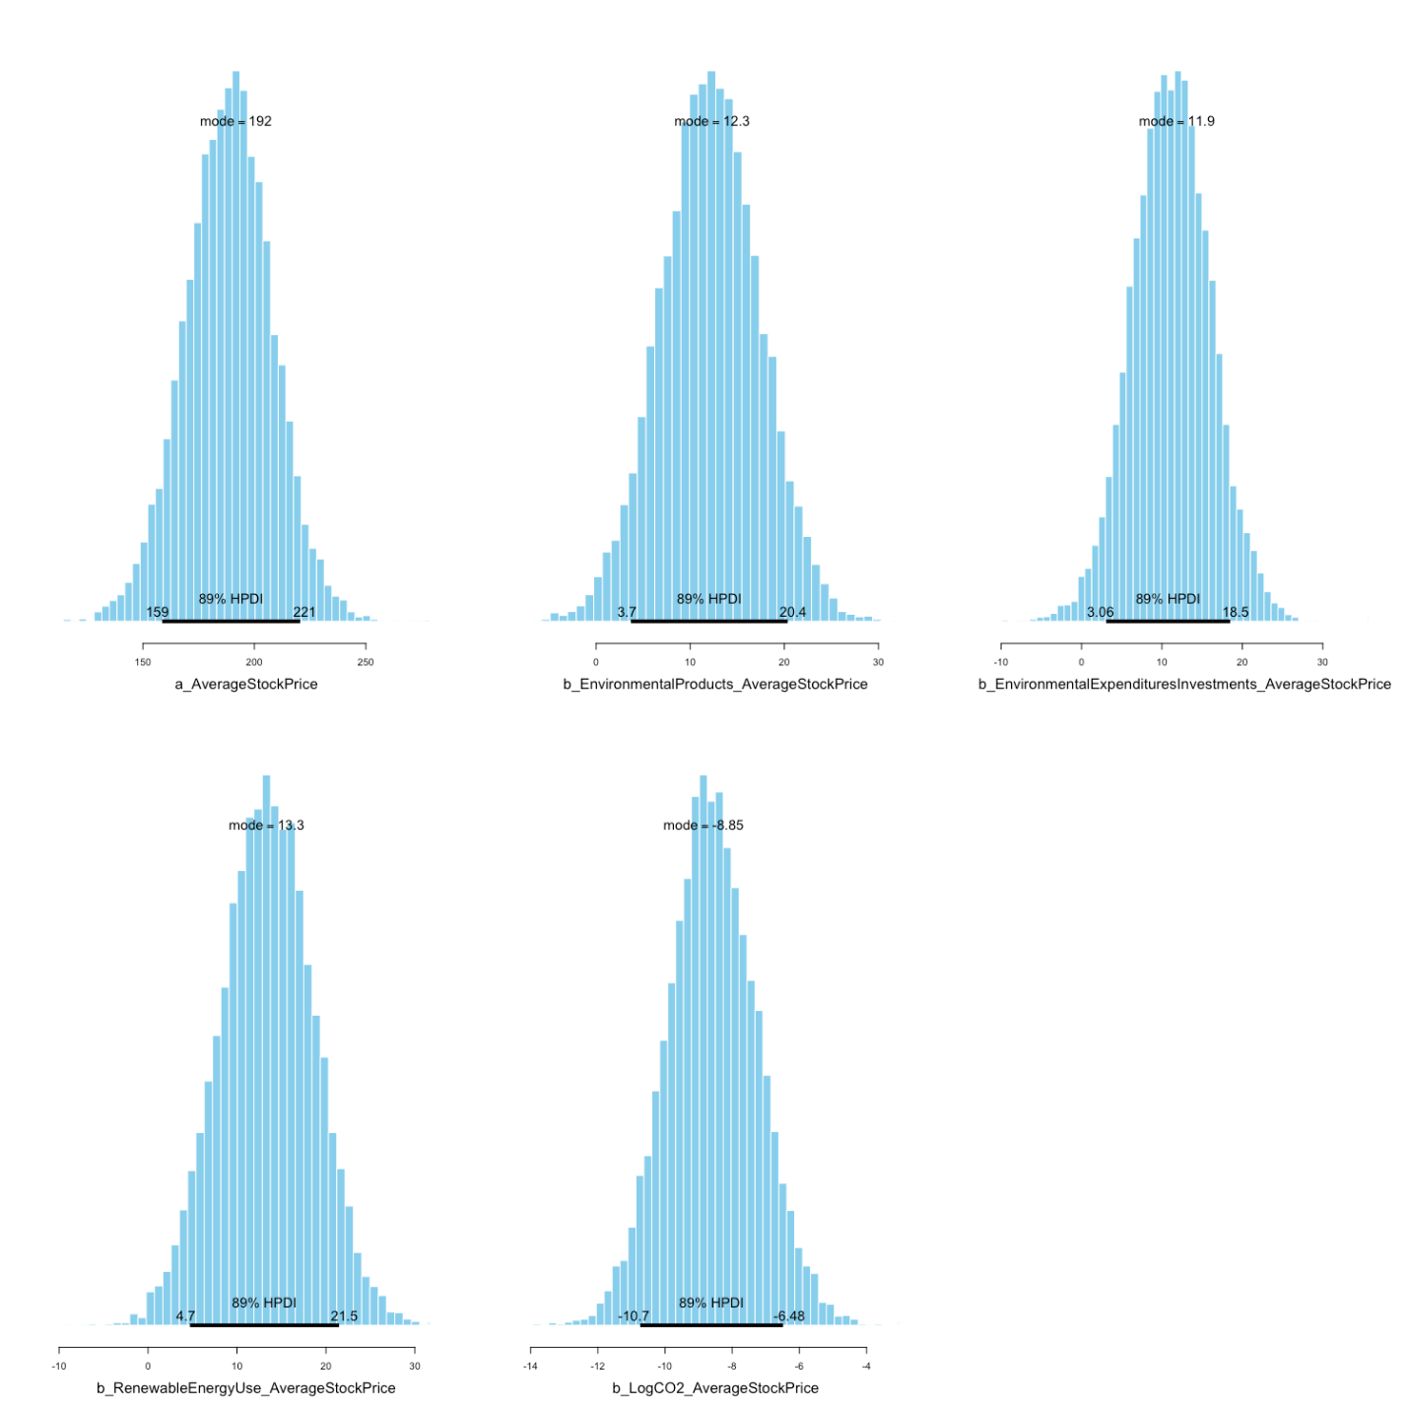
Figure S13: Model 3’s posterior distributions with uninformative priors.
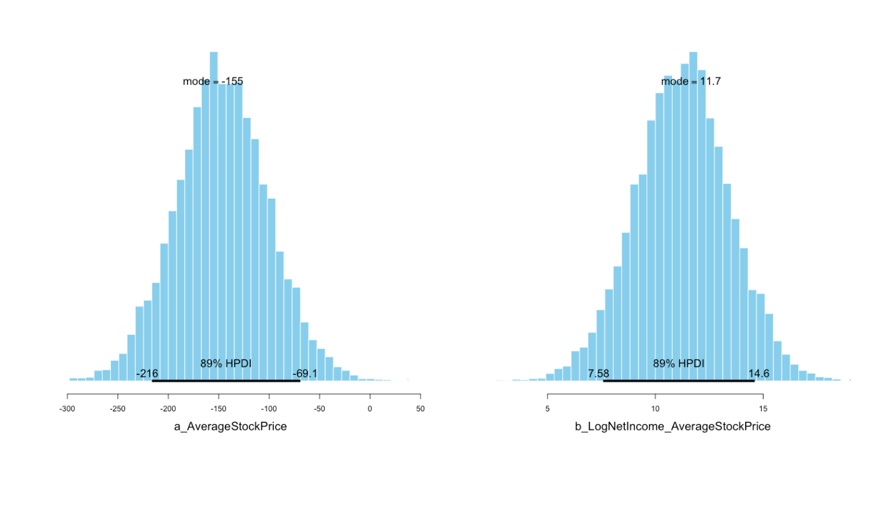
Figure S14: Model 4’s posterior distributions with uninformative priors.

