Supplementary Material
Portable droplet-based real-time monitoring of pancreatic
$α$-amylase in postoperative patients

Xinne Zhao^{1,†}, Fiona R. Kolbinger^{2,3,†,*}, Marius Distler², Jürgen Weitz^{2,3}, Denys Makarov⁴, Michael Bachmann¹, Larysa Baraban^{1,3,*}
¹ Institute of Radiopharmaceutical Cancer Research, Helmholtz-Zentrum Dresden-Rossendorf e. V. (HZDR), 01328 Dresden, Germany
² Department of Visceral, Thoracic and Vascular Surgery, University Hospital and Faculty of Medicine Carl Gustav Carus, TUD Dresden University of Technology, Germany
³ Else Kröner Fresenius Center for Digital Health (EKFZ), TUD Dresden University of Technology, Germany
⁴ Institute of Ion Beam Physics and Materials Research, Helmholtz-Zentrum Dresden-Rossendorf e. V., 01328 Dresden, Germany

† Contributed equally as co-first authors

* Corresponding authors:
Dr. Larysa Baraban, +49 (0) 351 2603091
e-mail: l.baraban@hzdr.de

Dr. Fiona Kolbinger, +49 (0) 351 458 19624
e-mail: fiona.kolbinger@uniklinikum-dresden.de

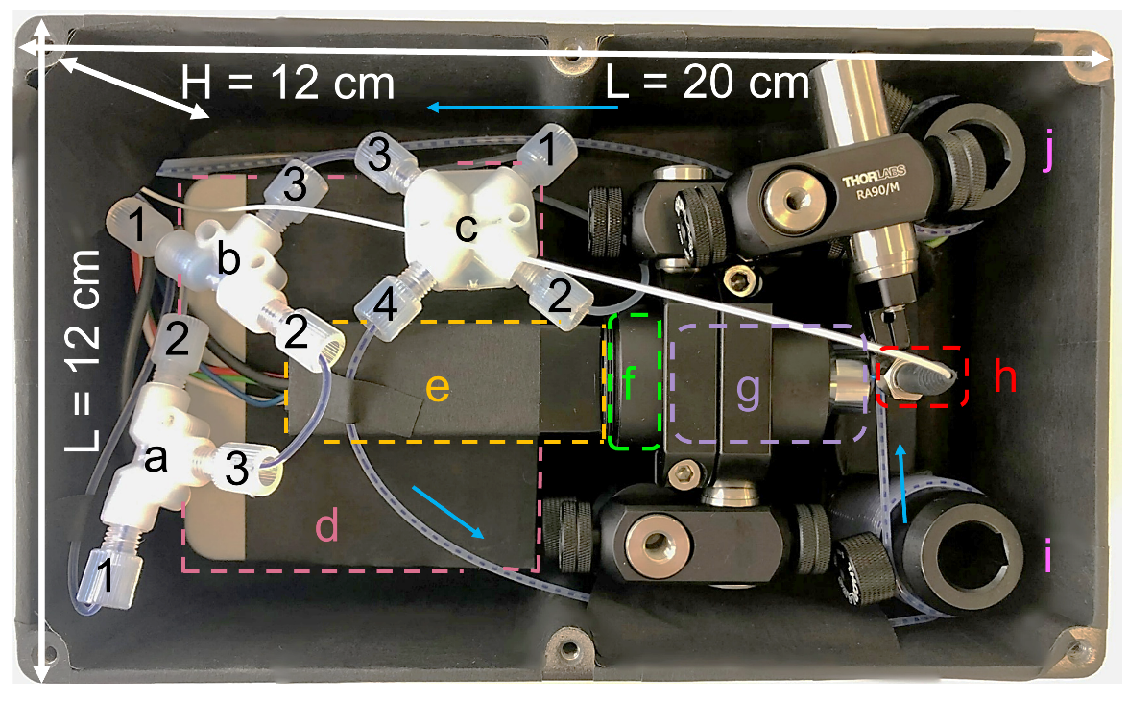
Supplementary Figure 1: Droplet-based millifluidic system assembled in a box with the size of 20 cm × 12 cm × 6.5 cm (L×W×H). a. T-junction: a1 input of reaction buffer; a2 input of amylase sample; a3 output of mixture of amylase sample and reaction buffer. b. T-junction: b1 input of reagent; b2 input of mixture of amylase sample and reaction buffer (from a3); b3 output of mixture of amylase sample, reaction buffer, and reagent. c. Cross-junction: c1 input of HFE oil; c2 input of mineral oil; c3 output of mixture of amylase sample, reaction buffer, and reagent (from b3); c4 output of droplet sequence. d. NI data acquisition (DAQ) device. e. Photomultiplier tube (HAMAMATSU). f. Optical filter (Thorlabs). g. Optical focus lens (Thorlabs). h. Optical fiber connected with the illumination source. i. and j. Coils for tubing storage. Blue arrows indicate fluid flow direction.

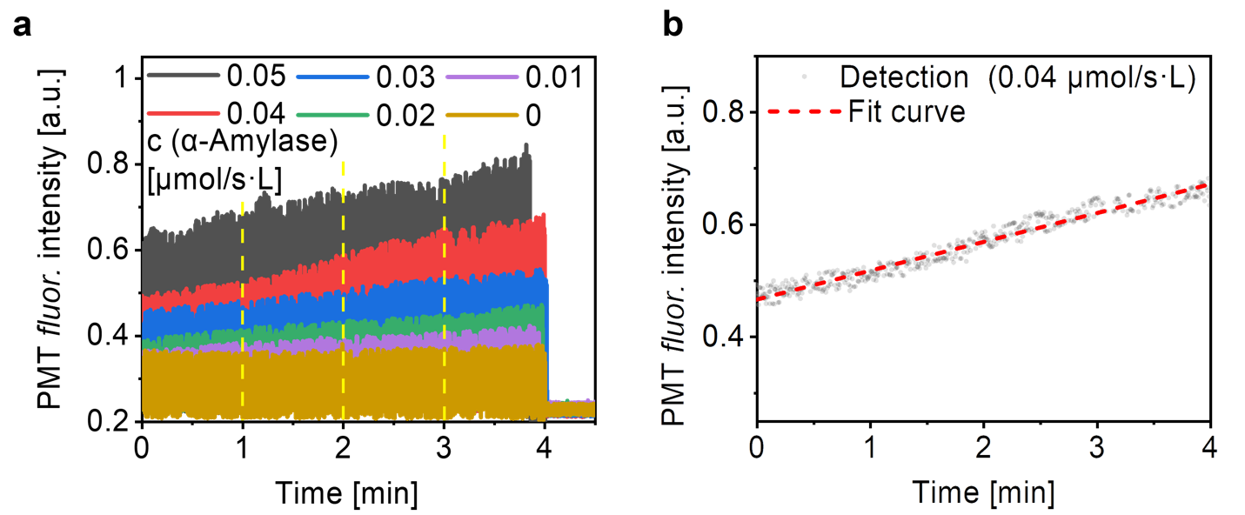
Supplementary Figure 2: Determination of readout time points for the millifluidic system. a. Change of the fluorescence intensity during the reaction between the substrate and standard α-amylase solution (with various concentrations) in millifluidic droplet-based reactors. Abbreviation: fluor.: Fluorescence. Yellow dash lines are the time points at which the calibration curves shown in Figure 2c are obtained. b. The fluorescence change (dash line, linear fit based on the experimental data) while passing through the detection area of the droplet sequence, due to the kinetic of the enzyme reaction with amylase concentration of 0.04 μmol/s·L (gray dots: fluorescence signal from the droplet (the same data as the red line in panel (a)).

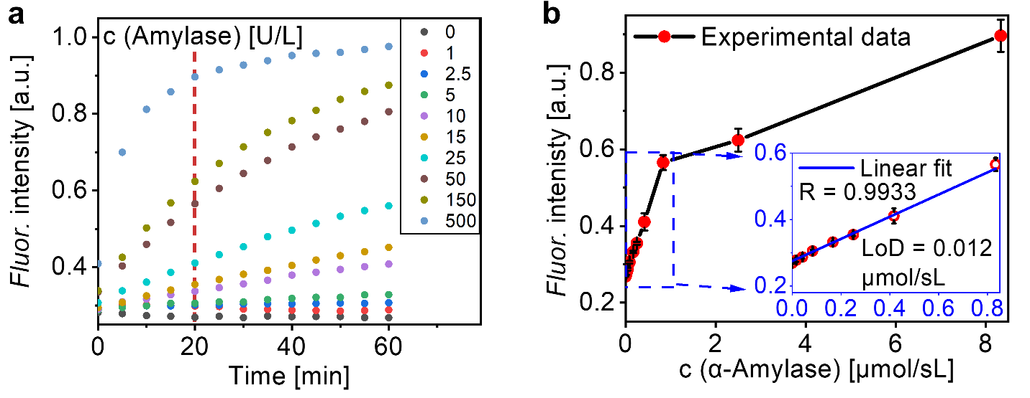
Supplementary Figure 3: Calibration curve of α-amylase concentration to the fluorescence intensity and determination of readout time points in the microplate method. a. Change of the fluorescence intensity during the reaction between the substrate and standard α-amylase solution (with various concentrations) in microplate wells. b. The plot of the fluorescence intensity and related α-amylase concentrations at the time point of 20 min (indicated in panel (a) with a red dashed line). From 0 to 0.83 µmol/s·L (0 to 50 U/L), the plot shows a good linear relationship (insert graph). Abbreviation: fluor.: Fluorescence, LoD: limit of detection.

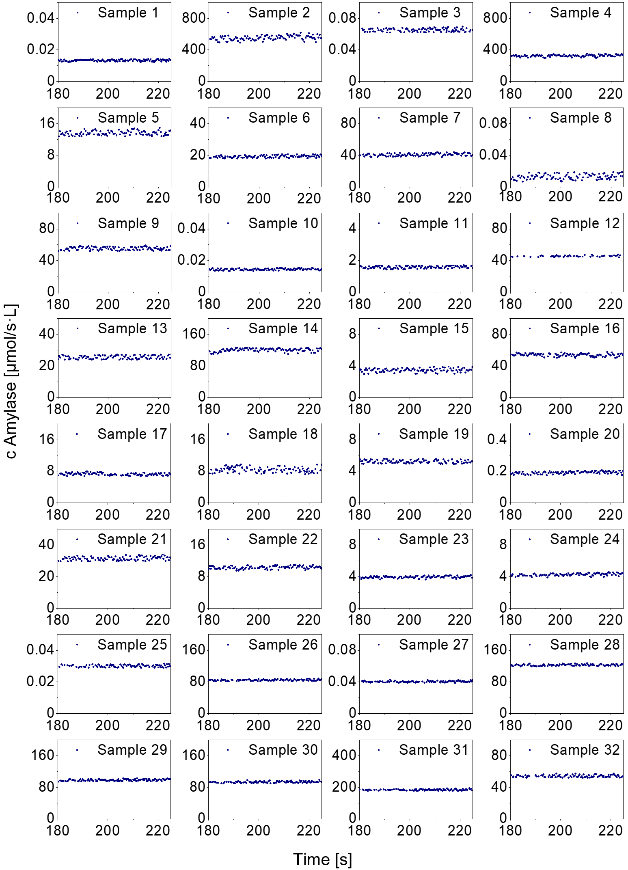
Supplementary Figure 4: Detection of α-amylase concentrations in 32 patient samples using the droplet-based millifluidic system.
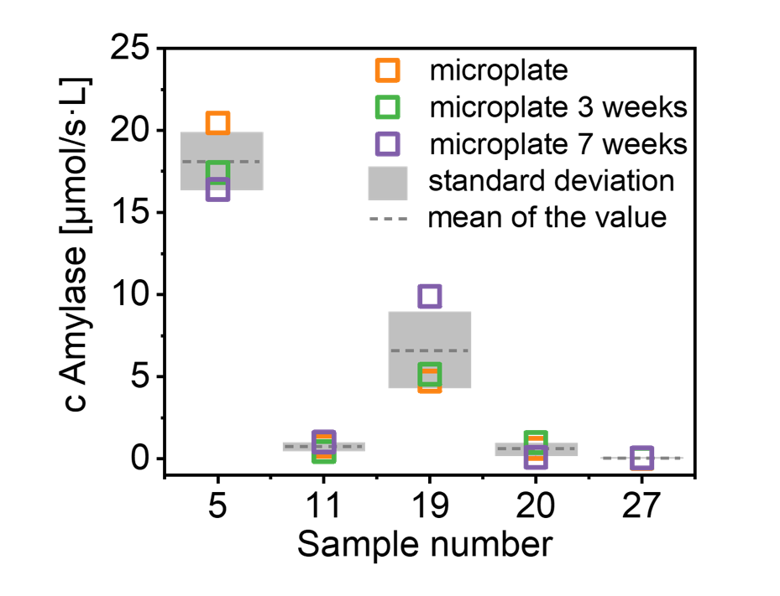
Supplementary Figure 5: Stability of the amylase concentration measured by microplate method. The patient samples were collected and stored in a freezer for up to 7 weeks. Here we show that this storage does not affect the amylase activity. α-Amylase concentration was measured in 5 arbitrarily selected patient samples using the microplate method. The measurements are shown of the samples right after being taken from the patient and after being kept in a freezer at -20 °C for 3 and 7 weeks.

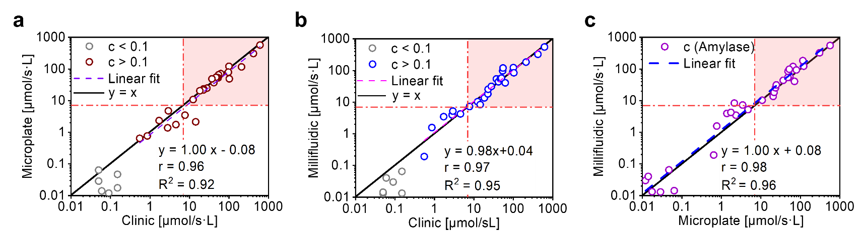
Supplementary Figure 6: Linear fit of the paired data of α-amylase concentration taken with a. clinic and microplate methods, b. clinic and millifluidic methods, and c. microplate and millifluidic methods. Gray colored paired data points in panels a and b are the mismatched data due to the LoD of the clinic method. Compared to the clinic method, the correlation between microplate and millifuidic methods is much better because the clinic method is not precise in the range of low concentrations (c of about 100 nmol/s·L and below).

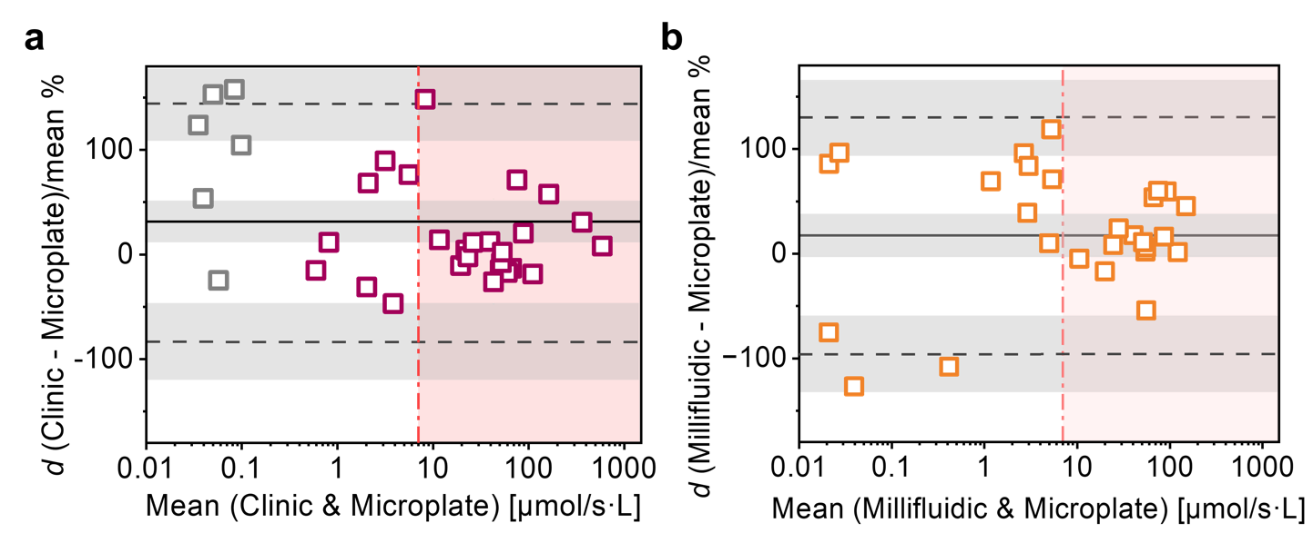
Supplementary Figure 7: Bland-Altman agreement of the results between methods. a.Bland-Altman agreement plot of results from the clinic and microplate methods expressed as percentage values. b. Bland-Altman agreement plot of results from the millifluidic and microplate methods expressed as percentage values. The x-axis displays the mean value measured by two methods (in log₁₀ scale). The y-axis represents the ratio of the difference, d, between the measured values of the two methods to the mean value. The black line represents the mean of the difference (d̅, black dash lines). The limits of agreement in 95% confidence are from -1.96σ to +1.96σ (σ, standard deviation) with confidence intervals (gray areas). The pink dashed lines in (a) and (b) represent the upper limit of the normal range of drain amylase, defined as an amylase level >3 times the upper limit of institutional normal serum amylase activity, i.e., 7 µmol/s·L.
Supplementary Table 1: Different application scenarios of droplet-based micro- and millifluidic techniques.

Applications | Examples | Technology readiness level (TRL) | Fields
cell biology | single-cell dynamics^{1–3} | laboratory prototype | fundamental research
PCR testing | raindance droplet digital PCR for viral nucleic acids detection⁴ | commercial products | clinical analytical diagnosis
enzymes enrichment | high-throughput screening for industrial enzyme production⁵ | laboratory and commercial products | chemical industry
polymerization | polymer microfluidics^{6,7} | laboratory and commercial products | chemical industry
food screening | food safety and quality analysis^{8,9} | laboratory and commercial products | food industry
glucose and lactate detection | Monitoring biomolecule concentrations in tissues¹⁰ | laboratory prototype | personalized diagnostics
amylase detection | α-amylase production yeast screen¹¹ | laboratory prototype | food industry
amylase detection | microfluidic-based rapid amylase assay system¹² | laboratory prototype | food industry
amylase detection (this work) | drain fluid analytics for postoperative patients | prototype for translation into clinic | clinical diagnostics, personalized health monitoring

Supplementary Table 2: Normal amylase concentration range reported in different research.

Sample type | Age | Normal range | Ref.
Serum | - | 0.5-1.83 μmol/s·L | ¹³
Serum | - | 0.32-1.43 μmol/s·L | ¹⁴
Serum | Newborn | 0.1-1.08 μmol/s·L | ¹⁵
Serum | Adult | 0.5-3.67 μmol/s·L | ¹⁵
Serum | Newborn | 0.83-1.08 μmol/s·L | ¹⁵
Serum | Adult | 0.45-2.18 μmol/s·L | ¹⁵
Serum | Adult 60 to 90 years | 0.4-2.52 μmol/s·L | ¹⁵
Serum | - | 0.42-2.17 μmol/s·L | ¹⁵
Urine | - | 0.017-0.25 μmol/s·L | ¹⁵
Serum | - | Up to 1.33 μmol/s·L | ¹⁶
Serum | - | 0.54-1.44 μmol/s·L | ¹⁷

Supplementary Table 3: Comparison of amylase detection using different methods.
Ref. |  | ¹¹ | ¹² | ¹⁸ | ¹⁹ | ²⁰ | Clinical standard (this work) | Microplate (this work) | Millifluidic (this work)
Real-time monitoring |  | Yes | No‡ | No | No | No# | No | No | Yes
LoDs |  | Not given | 1.0 × 10⁻³ CU/mL** | 0.01 v/v | 167 nmol/s·L | 9 nmol/s·L | 100 nmol/s·L | 12 nmol/s·L | 7 nmol/s·L
Volume requires | Reagent | 50 µL | 0.5 mL | Not given | 60 µL | Not given | 1-5 mL | 300 µL | 10 µL (100 droplets)
Volume requires | Sample | 50 µL | 0.5 mL | 150 µL | 5 µL (one drop) | 50 µL (one drop) | 1-5 mL | 300 µL | 10 µL (100 droplets)
Time of detection |  | 3 h | 4 min | 10-15 min | 15 min | 8 min | 2-6 h* | 20 min | 3 min
Methods |  | Fluorometric | Absorbance spectrometry | Colorimetric (channel) | Colorimetric (channel) | Plasmonic shift (optical fiber) | Colorimetric (plates) | Fluorometric (plates) | Fluorometric (droplets)
Research |  | α-amylase production yeast sorting | Rapid amylase assay | Forensic serological analysis | Amylase levels in human blood serum | Patient pancreatic drain fluidic amylase detection
Application |  | Food industry |  | Forensic analysis | Towards clinical application
* Footnote: time from samples uptake up to the results receiving by the patient, including assay preparation, handling, measuring and communication.
** Lowest response concentration.
‡ Footnote: device lifetime is 3 assay runs.
# Footnote: antibody-based test, regeneration is needed for each assay.
Supplementary Table 4: Summary of the 32 sample results: PMT fluorescence intensity, correlated amylase concentrations upon calibration curve, dilution factors, and calculated final amylase concentration of patient samples.
Sample | PMT fluo. intensity | millifluidic (μmol/s·L) | dilution | Amylase (μmol/s·L)
1 | 0.4190 | 0.0133 | 1 | 0.013
2 | 0.5993 | 0.0369 | 15000 | 553.30
3 | 0.4173 | 0.0130 | 5 | 0.065
4 | 0.6852 | 0.0433 | 7500 | 325.08
5 | 0.4437 | 0.0181 | 750 | 13.59
6 | 0.4827 | 0.0243 | 750 | 18.24
7 | 0.4340 | 0.0407 | 1000 | 40.67
8 | 0.4181 | 0.0131 | 1 | 0.013
9 | 0.4663 | 0.0221 | 2500 | 55.13
10 | 0.4243 | 0.0144 | 1 | 0.014
11 | 0.4311 | 0.0158 | 100 | 1.58
12 | 0.4672 | 0.0220 | 2000 | 44.00
13 | 0.4167 | 0.0128 | 2000 | 25.52
14 | 0.7614 | 0.0480 | 2500 | 120.00
15 | 0.5740 | 0.0347 | 100 | 3.47
16 | 0.7279 | 0.0460 | 1250 | 57.45
17 | 0.5196 | 0.0291 | 250 | 7.27
18 | 0.3781 | 0.0034 | 2500 | 8.38
19 | 0.4601 | 0.0209 | 250 | 5.23
20 | 0.6163 | 0.0383 | 5 | 0.192
21 | 0.4307 | 0.0157 | 2000 | 31.43
22 | 0.6552 | 0.0412 | 250 | 10.31
23 | 0.6297 | 0.0393 | 100 | 3.93
24 | 0.6739 | 0.0425 | 100 | 4.25
25 | 0.5289 | 0.0301 | 1 | 0.030
26 | 0.6710 | 0.0423 | 2000 | 84.69
27 | 0.6433 | 0.0404 | 1 | 0.040
28 | 0.7817 | 0.0491 | 2500 | 122.76
29 | 0.7802 | 0.0487 | 2000 | 97.40
30 | 0.7376 | 0.0466 | 2000 | 93.23
31 | 0.5971 | 0.0367 | 5000 | 183.52
32 | 0.4646 | 0.0216 | 2500 | 54.10

Supplementary Table 5: Bland-Altman plot statistics from measurement data (expressed as percentages of the data values) obtained from the clinic and millifluidic methods.
Parameter | Unit | Standard error formula | Standard error (se) | t value for 31 degrees of freedom | Confidence (se*t) | Confidence intervals
 |  |  |  |  |  | from | to
Sample number (n) | 32
Degree of freedom | 31
Difference mean (d̅) | 15.4% | $$\sqrt{{σ^{2}}/n}$$ | 10.3% | 2.04 | 21.0% | -5.5% | 36.4%
Standard deviation (σ) | -58.2%
d̅ -1.96σ | -98.6% | $$\sqrt{{{3σ}^{2}}/n}$$ | 17.8% | 2.04 | 36.3% | -135.0% | -62.3%
d̅ +1.96σ | 129.5% | $$\sqrt{{{3σ}^{2}}/n}$$ | 17.8% | 2.04 | 36.3% | 93.1% | 165.8%

Supplementary Table 6: Bland-Altman plot statistics from measurement data (expressed as percentages of the data values) obtained from clinic and microplate methods.
Parameter | Unit | Standard error formula | Standard error (se) | t value for 31 degrees of freedom | Confidence (se*t) | Confidence intervals
 |  |  |  |  |  | from | to
Sample number (n) | 32
Degree of freedom | 31
Difference mean (d̅) | 31.0% | $$\sqrt{{σ^{2}}/n}$$ | 10.0% | 2.04 | 20.9% | -10.1% | 51.9%
Standard deviation (σ) | 57.8%
d̅ -1.96σ | -82.3% | $$\sqrt{{{3σ}^{2}}/n}$$ | 18.0% | 2.04 | 36.1% | -118.4% | -46.2%
d̅ +1.96σ | -144.4% | $$\sqrt{{{3σ}^{2}}/n}$$ | 18.0% | 2.04 | 36.1% | 108.3% | 180.5%

Supplementary Table 7: Bland-Altman plot statistics from measurement data (expressed as percentages of the data values) obtained from millifluidic and microplate methods.
Parameter | Unit | Standard error formula | Standard error (se) | t value for 31 degrees of freedom | Confidence (se*t) | Confidence intervals
 |  |  |  |  |  | from | to
Sample number (n) | 32
Degree of freedom | 31
Difference mean (d̅) | 17.5% | $$\sqrt{{σ^{2}}/n}$$ | 10.2% | 2.04 | 20.7% | -3.24% | 38.22%
Standard deviation (σ) | 57.5%
d̅ -1.96σ | -95.2% | $$\sqrt{{{3σ}^{2}}/n}$$ | 17.6% | 2.04 | 35.9% | -131.1% | -59.3%
d̅ +1.96σ | -130.2% | $$\sqrt{{{3σ}^{2}}/n}$$ | 17.6% | 2.04 | 35.9% | 94.3% | 166.1%

References
1. Bounab, Y. et al. Dynamic single-cell phenotyping of immune cells using the microfluidic platform DropMap. Nat. Protoc. 15, 2920–2955 (2020).
2. Velve-Casquillas, G., Le Berre, M., Piel, M. & Tran, P. T. Microfluidic tools for cell biological research. Nano Today 5, 28–47 (2010).
3. Duncombe, T. A., Tentori, A. M. & Herr, A. E. Microfluidics: reframing biological enquiry. Nat. Rev. Mol. Cell Biol. 16, 554–567 (2015).
4. Long, S. & Berkemeier, B. Ultrasensitive detection and quantification of viral nucleic acids with Raindance droplet digital PCR (ddPCR). Methods San Diego Calif 201, 49–64 (2022).
5. Sjostrom, S. L. et al. High-throughput screening for industrial enzyme production hosts by droplet microfluidics. Lab. Chip 14, 806–813 (2014).
6. Tsao, C.-W. Polymer Microfluidics: Simple, Low-Cost Fabrication Process Bridging Academic Lab Research to Commercialized Production. Micromachines 7, 225 (2016).
7. Rizkin, B. A., Shkolnik, A. S., Ferraro, N. J. & Hartman, R. L. Combining automated microfluidic experimentation with machine learning for efficient polymerization design. Nat. Mach. Intell. 2, 200–209 (2020).
8. Liu, J. et al. A microfluidic based biosensor for rapid detection of Salmonella in food products. PLOS ONE 14, e0216873 (2019).
9. He, S., Joseph, N., Feng, S., Jellicoe, M. & L. Raston, C. Application of microfluidic technology in food processing. Food Funct. 11, 5726–5737 (2020).
10. Nightingale, A. M. et al. Monitoring biomolecule concentrations in tissue using a wearable droplet microfluidic-based sensor. Nat. Commun. 10, 2741 (2019).
11. Huang, M. et al. Microfluidic screening and whole-genome sequencing identifies mutations associated with improved protein secretion by yeast. Proc. Natl. Acad. Sci. 112, E4689–E4696 (2015).
12. Holmes, R. J. et al. Toward a Microfluidic-Based Rapid Amylase Assay System. J. Food Sci. 74, N37–N43 (2009).
13. Chase, C. W., Barker, D. E., Russell, W. L. & Burns, R. P. Serum amylase and lipase in the evaluation of acute abdominal pain. Am. Surg. 62, 1028–1033 (1996).
14. Oh, H.-C. et al. Low Serum Pancreatic Amylase and Lipase Values Are Simple and Useful Predictors to Diagnose Chronic Pancreatitis. Gut Liver 11, 878–883 (2017).
15. Amylase Serum and Acute Pancreatitis Diagnosis - Labpedia.net. https://labpedia.net/amylase-serum-and-acute-pancreatitis-diagnosis/ (2020).
16. Batra, H., Kumar, A., Saha, T., Misra, P. & Ambade, V. Comparative Study of Serum Amylase and Lipase in Acute Pancreatitis Patients. Indian J. Clin. Biochem. 30, 230–233 (2015).
17. Vissers, R. J., Abu-Laban, R. B. & McHugh, D. F. Amylase and lipase in the emergency department evaluation of acute pancreatitis11Clinical Laboratory in Emergency Medicine is coordinated by Jonathan S. Olshaker, MD, of the University of Maryland Medical Center, Baltimore, Maryland. J. Emerg. Med. 17, 1027–1037 (1999).
18. L. Cromartie, R., Wardlow, A., Duncan, G. & R. McCord, B. Development of a microfluidic device (μPADs) for forensic serological analysis. Anal. Methods 11, 587–595 (2019).
19. Dutta, S., Mandal, N. & Bandyopadhyay, D. Paper-based α-amylase detector for point-of-care diagnostics. Biosens. Bioelectron. 78, 447–453 (2016).
20. Pasquardini, L. et al. A Surface Plasmon Resonance Plastic Optical Fiber Biosensor for the Detection of Pancreatic Amylase in Surgically-Placed Drain Effluent. Sensors 21, 3443 (2021).

