SUPPLEMENTARY INFORMATION
Table of content
Combinatorial slot-die coating for high-throughput compositional screening of perovskite solar cells 1
Abstract 2
Introduction 3
Results and discussion 4
1.1 Morphology 5
1.2 Optical properties 6
1.3 Crystallographic properties 8
1.4 Performance of devices 9
Conclusion 10
Acknowledgement 11
Declaration of interests 11
Author Contributions 11
Reference 11
SUPPLEMENTARY INFORMATION 14
Experiments and characterizations 14
Materials 14
Perovskite precursor inks preparation 15
Fabrication of CSDC perovskite films and devices 15
Evaporate electron transport layers and contact layers 16
J-V measurements 16
Photoluminescence (PL) measurements 16
GIWAXS measurements 17

Experiments and characterizations

Materials
Lead (II) Bromide, Lead (II) Iodide (99.99%, trace metals basis), Self-assembled monolayer ([2-(9H-carbazol-9-yl)ethyl] phosphonic acid) (2PACz) was purchased from Tokyo Chemical Industry (TCI). Methylammonium Bromide (MABr), Formamidinium iodide (FAI) and methylammonium hydrochloride (MACl), was purchased from Dynamo. Bathocuproine (BCP) was purchased from Ossila. Ethanol (anhydrous) was purchased from VWR Chemicals and Copper Shots was purchased from Alfa Aesar. Other chemicals were purchased from Sigma-Aldrich. All the chemicals were used as received without purification.

Perovskite precursor inks preparation
1 mmol FAI with PbI₂ and 0.1 mmol MACl powders were scaled and mixed in a vial and dissolved with 0.46 ml 2-methoxyethanol (2-ME), 0.46 ml Acetonitrile and 0.08 ml (~ 0.83 mmol) N-Methyl-2-pyrrolidone (NMP) solvents, the vial was stirring to dissolve at room temperature. Similarly, 1 mmol MABr and PbBr₂ powders were scaled and mixed in another vial and dissolved with 1 ml anhydrous N,N-dimethylformamide (DMF), this vial was stirring until dissolve at 60 °C.

Fabrication of cSDC perovskite films and devices
The cSDC films was deposited by a slot-die coater (FOM technologies) in a nitrogen glovebox with content of water and oxygen less than 1 ppm. The air knife was mounted on the top of chuck (approximately 10 cm height) with ~ 28 PSI inner pressure. The perovskite precursor ink was fed into the slot-die head with T-joints tubbing from two syringe pumps, which can precisely control the pump rate of inks. We set the coating speed at 20 cm/min, pump rate as 60 µl/min, and ~ 0.2 mm gap. The temperature is controlled at room temperature. After coating, the wet perovskite thin-films were immediately treated with dried nitrogen gas through an air knife, which has pressure around 28 PSI over its entire length. As treated films were rapidly transferred to a pre-heated hot plate at 150 ºC and annealed for 15 to 20 minutes.
Pump setting: The ink1 and ink2 are FAPbI₃ amd MAPbBr₃, respectively. For a composition of (FAPbI₃)_{0.5}(MAPbBr₃)_{0.5} (ink3), the pump rate of ink1 and ink2 is set as 30 µl/min. The ink1 and ink2 was pre-mixed in a T connection and become ink3. The ink3 was pre-pump until it fills the reservoir inside the die head. The coating starts after those pre-settings.

Evaporate electron transport layers and contact layers
After annealing, all the substrates were loaded into an evaporation system (MBRAUN ProVap 3G). C₆₀ (23 nm), BCP (8 nm) and copper (100 nm) were subsequently deposition by thermal evaporate method. At base pressure of 1 × 10⁻⁶ mbar, the evaporate rate of BCP, C₆₀ and Copper was controlled at 0.1 Å/s, 0.05 Å/s to 0.1 Å/s, and 0.1 Å/s to 1 Å/s, respectively. The active area of all the PSCs is 0.16 cm² (determined by overlap area of ITO and Copper).

J-V measurements
The measurement geometries and methodologies were conducted analogously as previously report.^{[3]} In brief, the solar cells were measured under an AM 1.5G 100 mW/cm² illumination (Oriel LCS-100 class ABB solar simulator) with a silicon reference cell (Fraunhofer ISE) as spectrum and intensity calibration. The J-V scans was conducted from 1.2 V to −0.02 V (reverse scan) or −0.02 V to 1.2 V (forward scan), with a 30 ms delay time, 40 ms integration time and 20 mV voltage step at room temperature in a N₂-filled glovebox without any precondition.

Photoluminescence (PL) measurements
The measurement geometries and methodologies were conducted analogously as previously report.^{[33]} In brief, the perovskite films were excited by a blue LED (470 nm). The emitted PL signal was record by an Ocean Insight fiber-optic spectrometer.

GIWAXS measurements
The ex-situ GIWAXS and mapping were measured at the mySpot beamline^{[34]} at an incidence angle of 2 degree, using a radiation energy of 9 keV (lambda = 1.378 Å). The size of beam is 100 µm. The data was analysed and integrated by Dpdark software.^{[35]}
The Le Bail refinement was carried out with FULLPROF suite software.^{[36]} The peak shape was fitted by Thompson–Cox–Hastings pseudo-Voigt function.

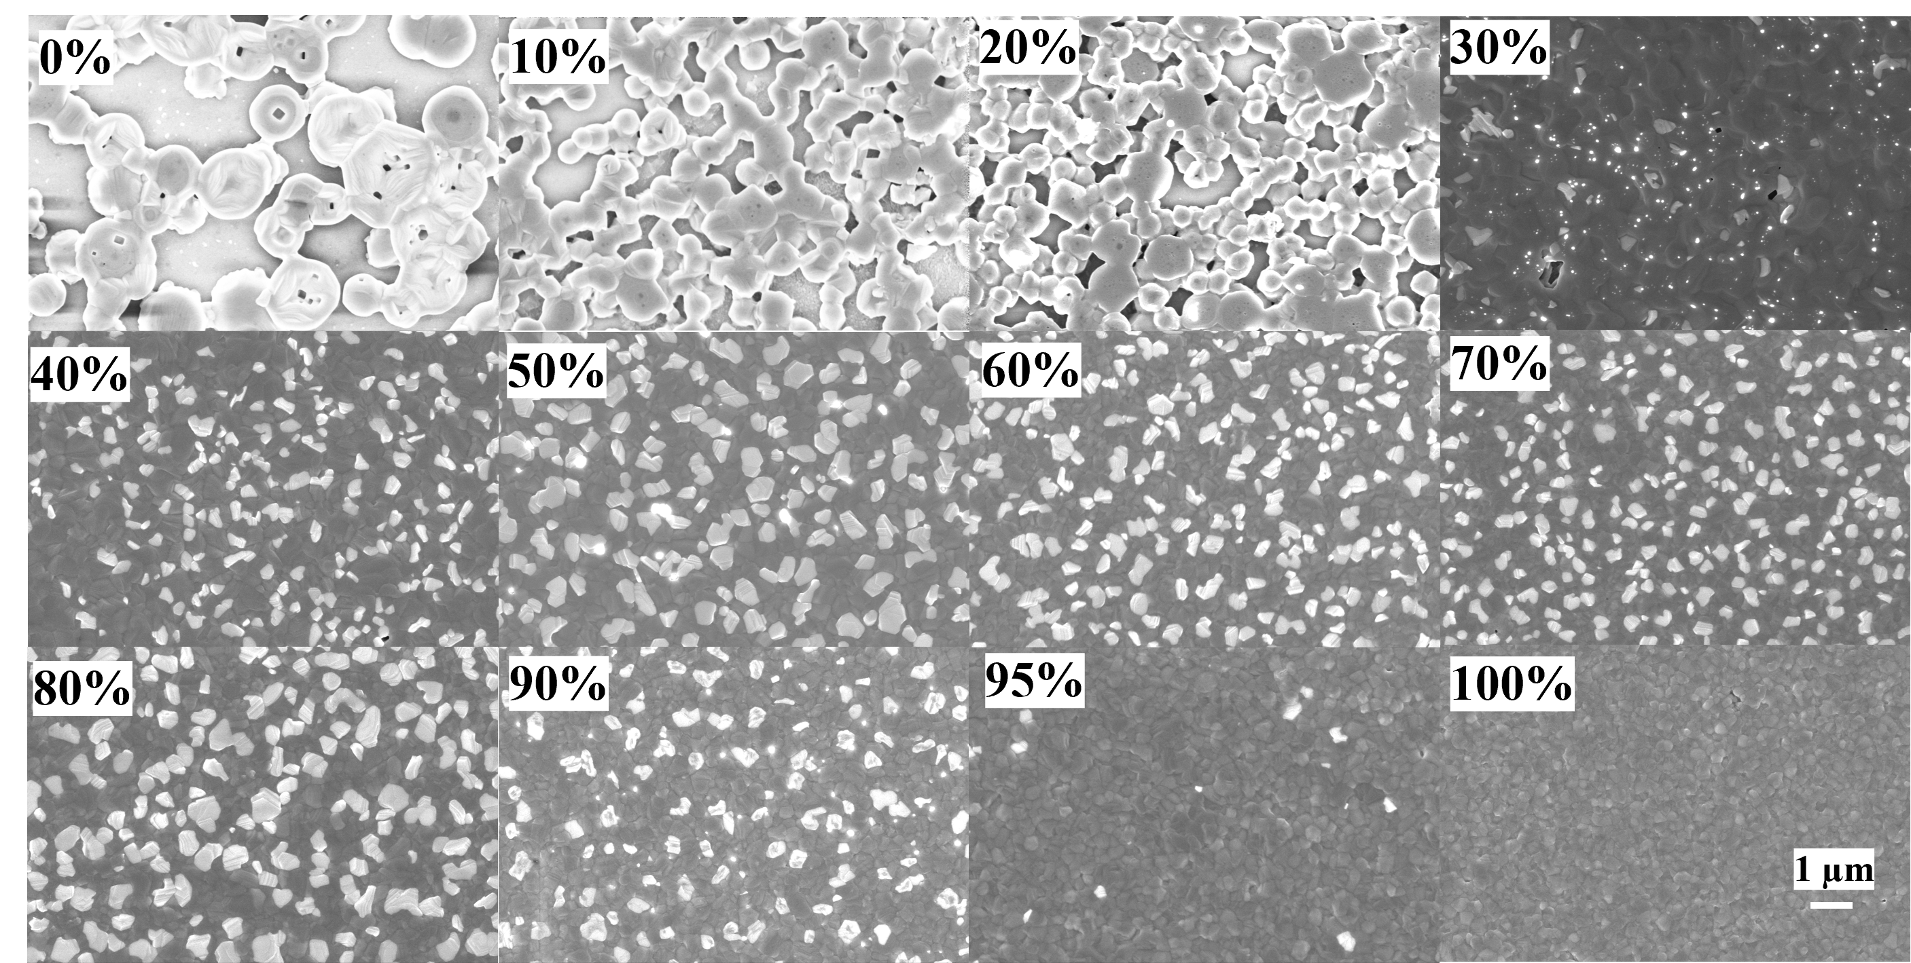
Supplementary Figure 1. the SEM top view images of combinatorial SDC perovskite from 0% to 100% FAPbI₃ samples.

Supplementary Figure 2. The Uv-Vis plots of cSDC films.

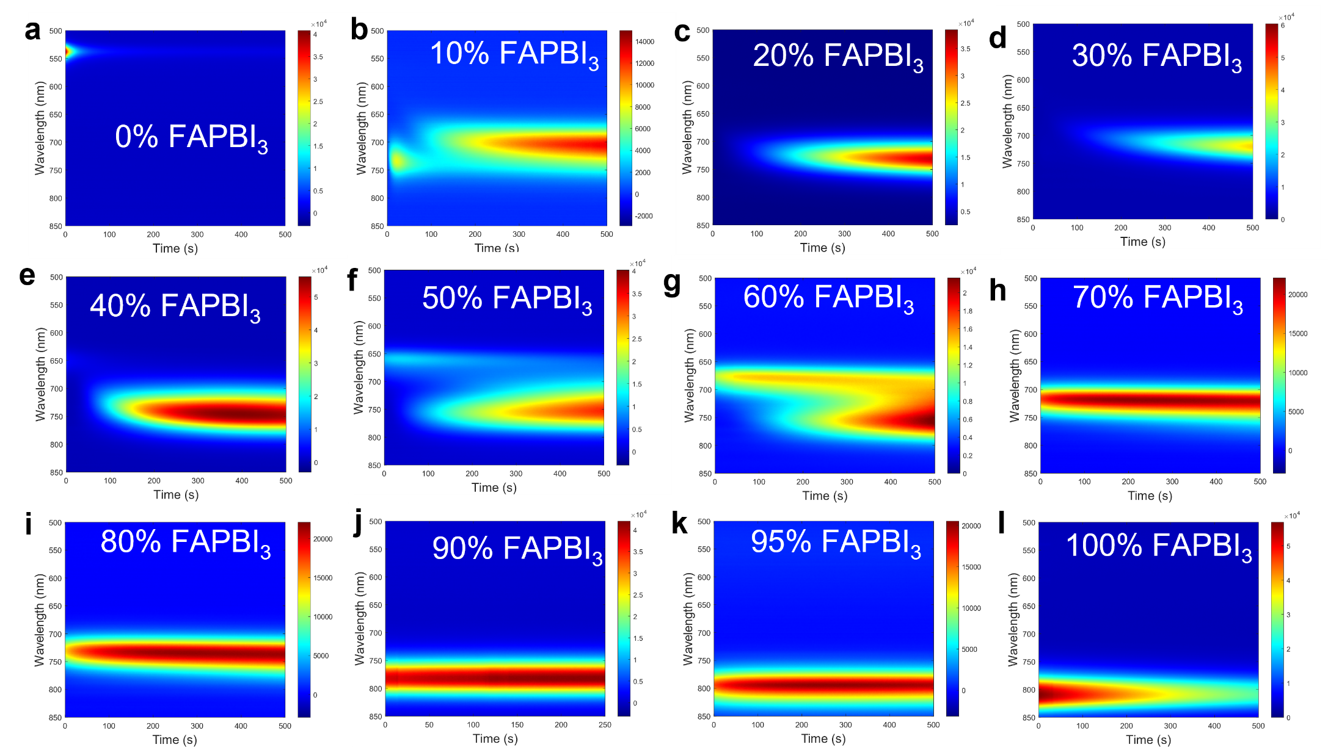

Supplementary Figure 3. The 2D plots of PL peak of cSDC films versus time.
Supplementary Figure 4. The fit results of the evolution of PL peak positions (For these two peaks, the fit was performed by selecting the peak with the highest intensity).

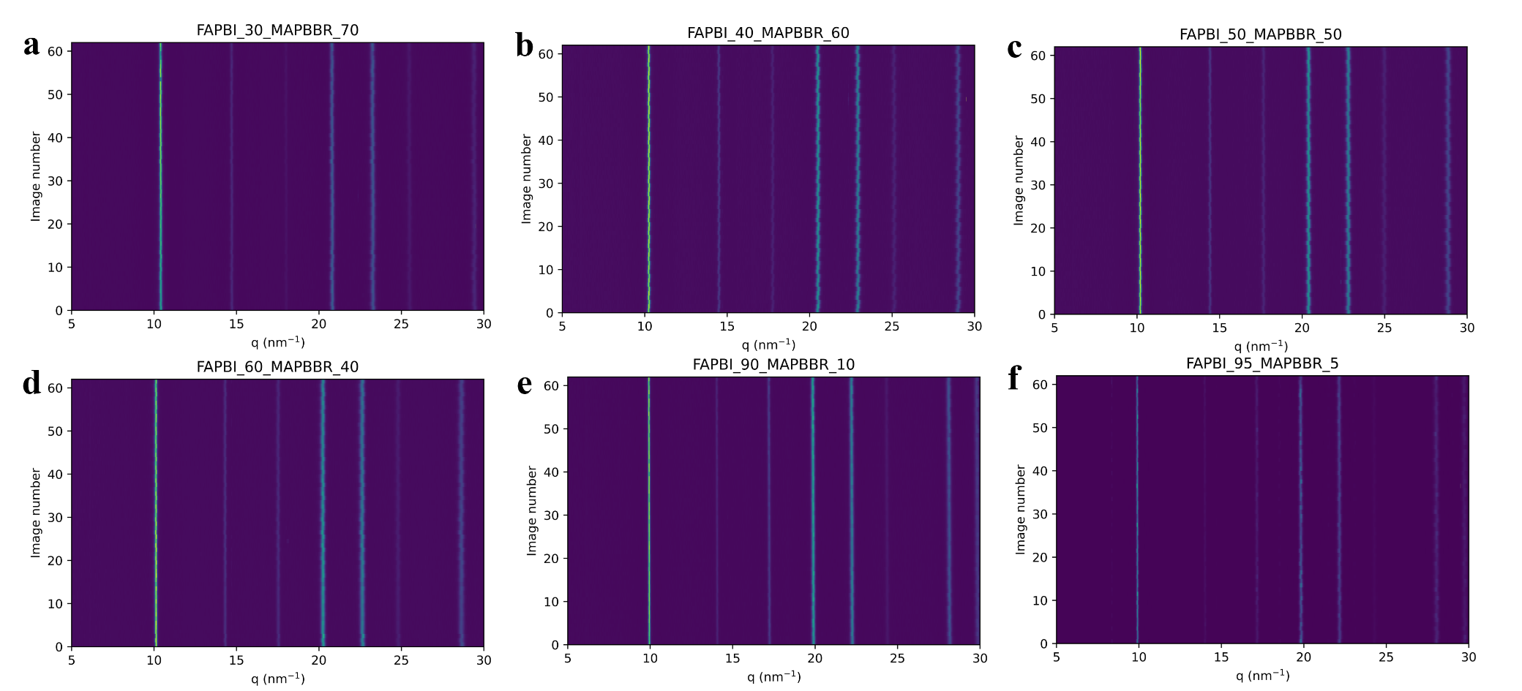
Supplementary Figure 5. Summarized plots of ex-situ GIWAXS mapping of cSDC perovskite films.

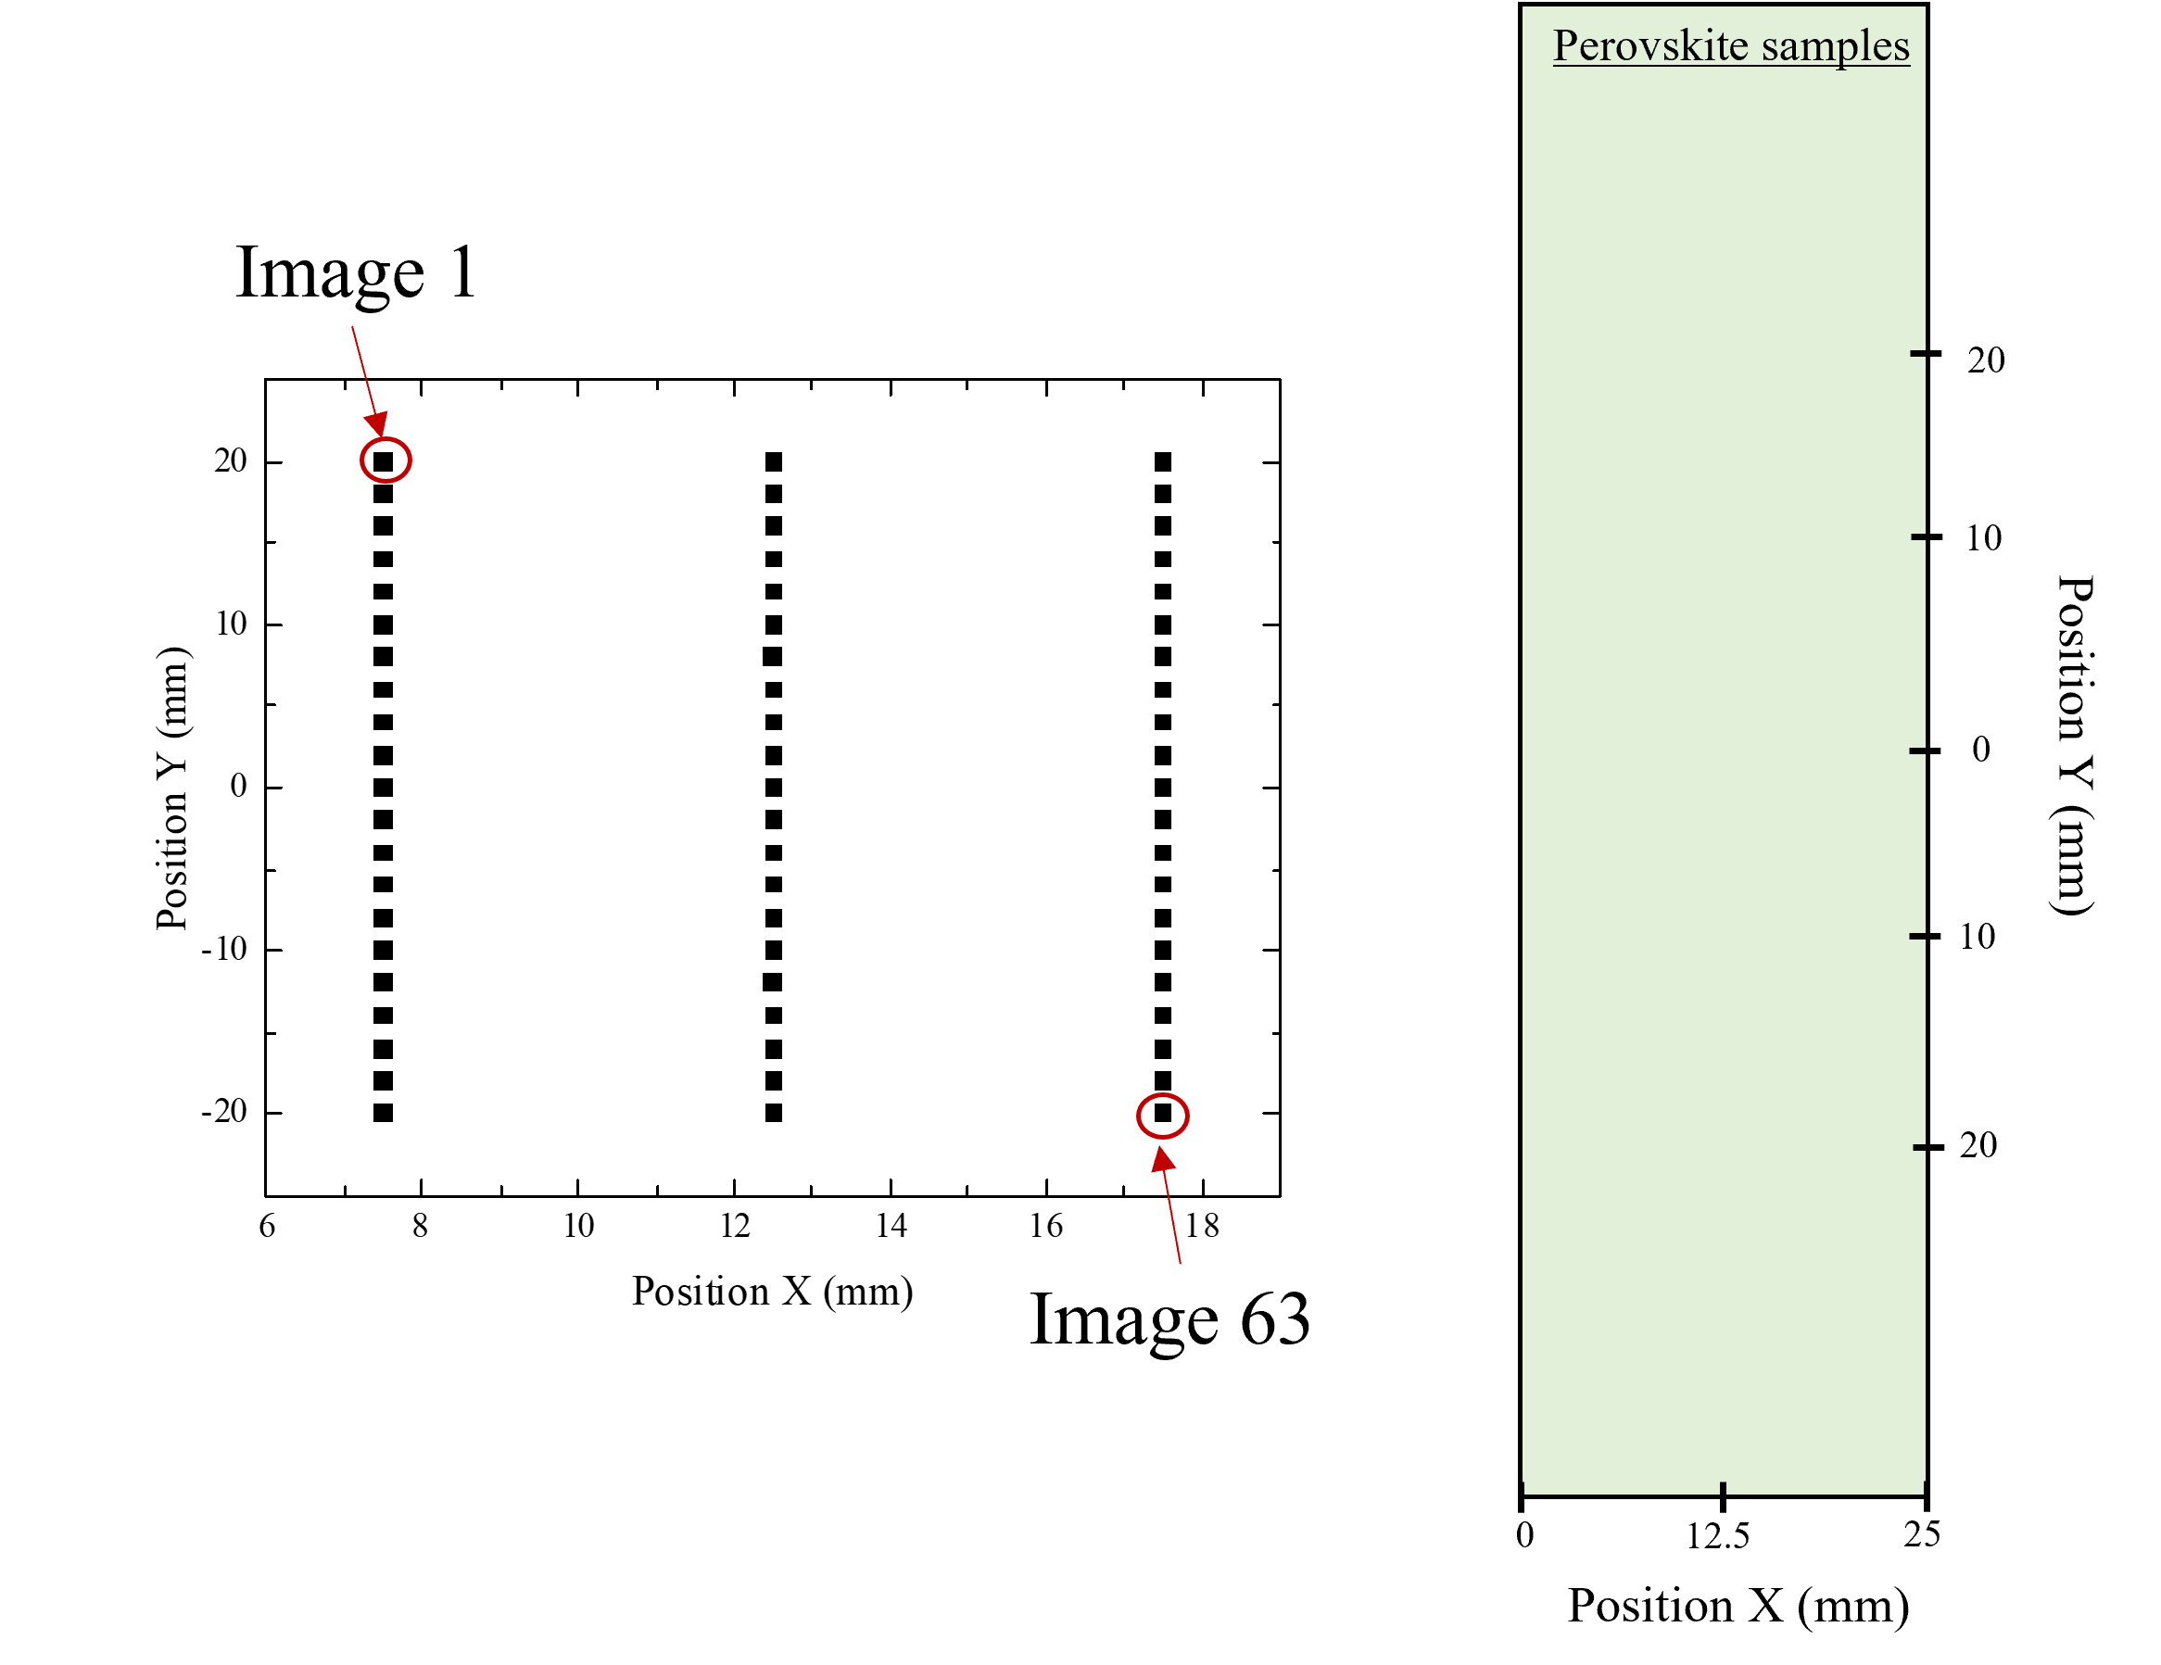
Supplementary Figure 6. The schematic of the measurement positions of cSDC perovskite films

Supplementary Figure 7. the integrated 1D patterns of cSDC perovskite films (note that the samples were annealed at 100 °C for 20 minutes). The 10% FAPbI₃ pattern shows a peak splitting at the 100 reflection, which might be related to the phase segregation effect.

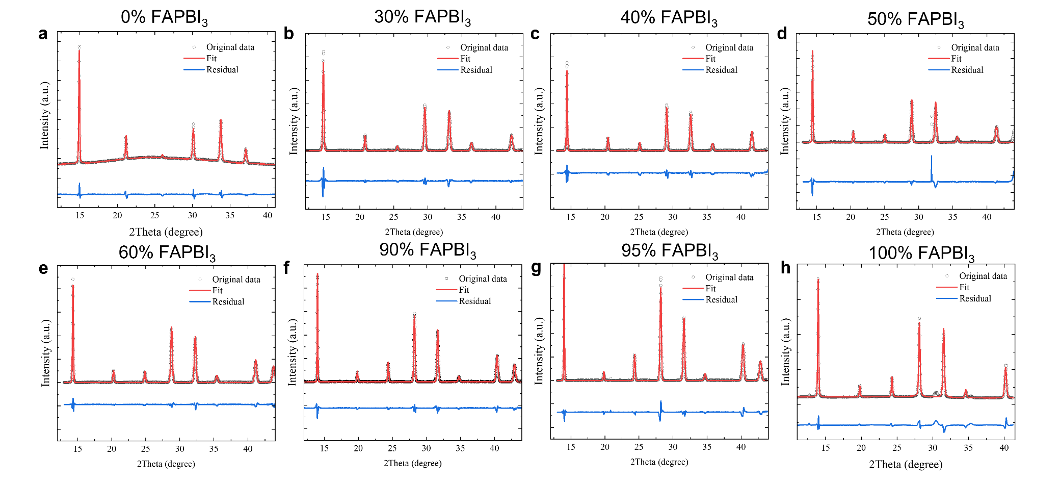
Supplementary Figure 8. The Le Bail refinement results of cSDC patterns.
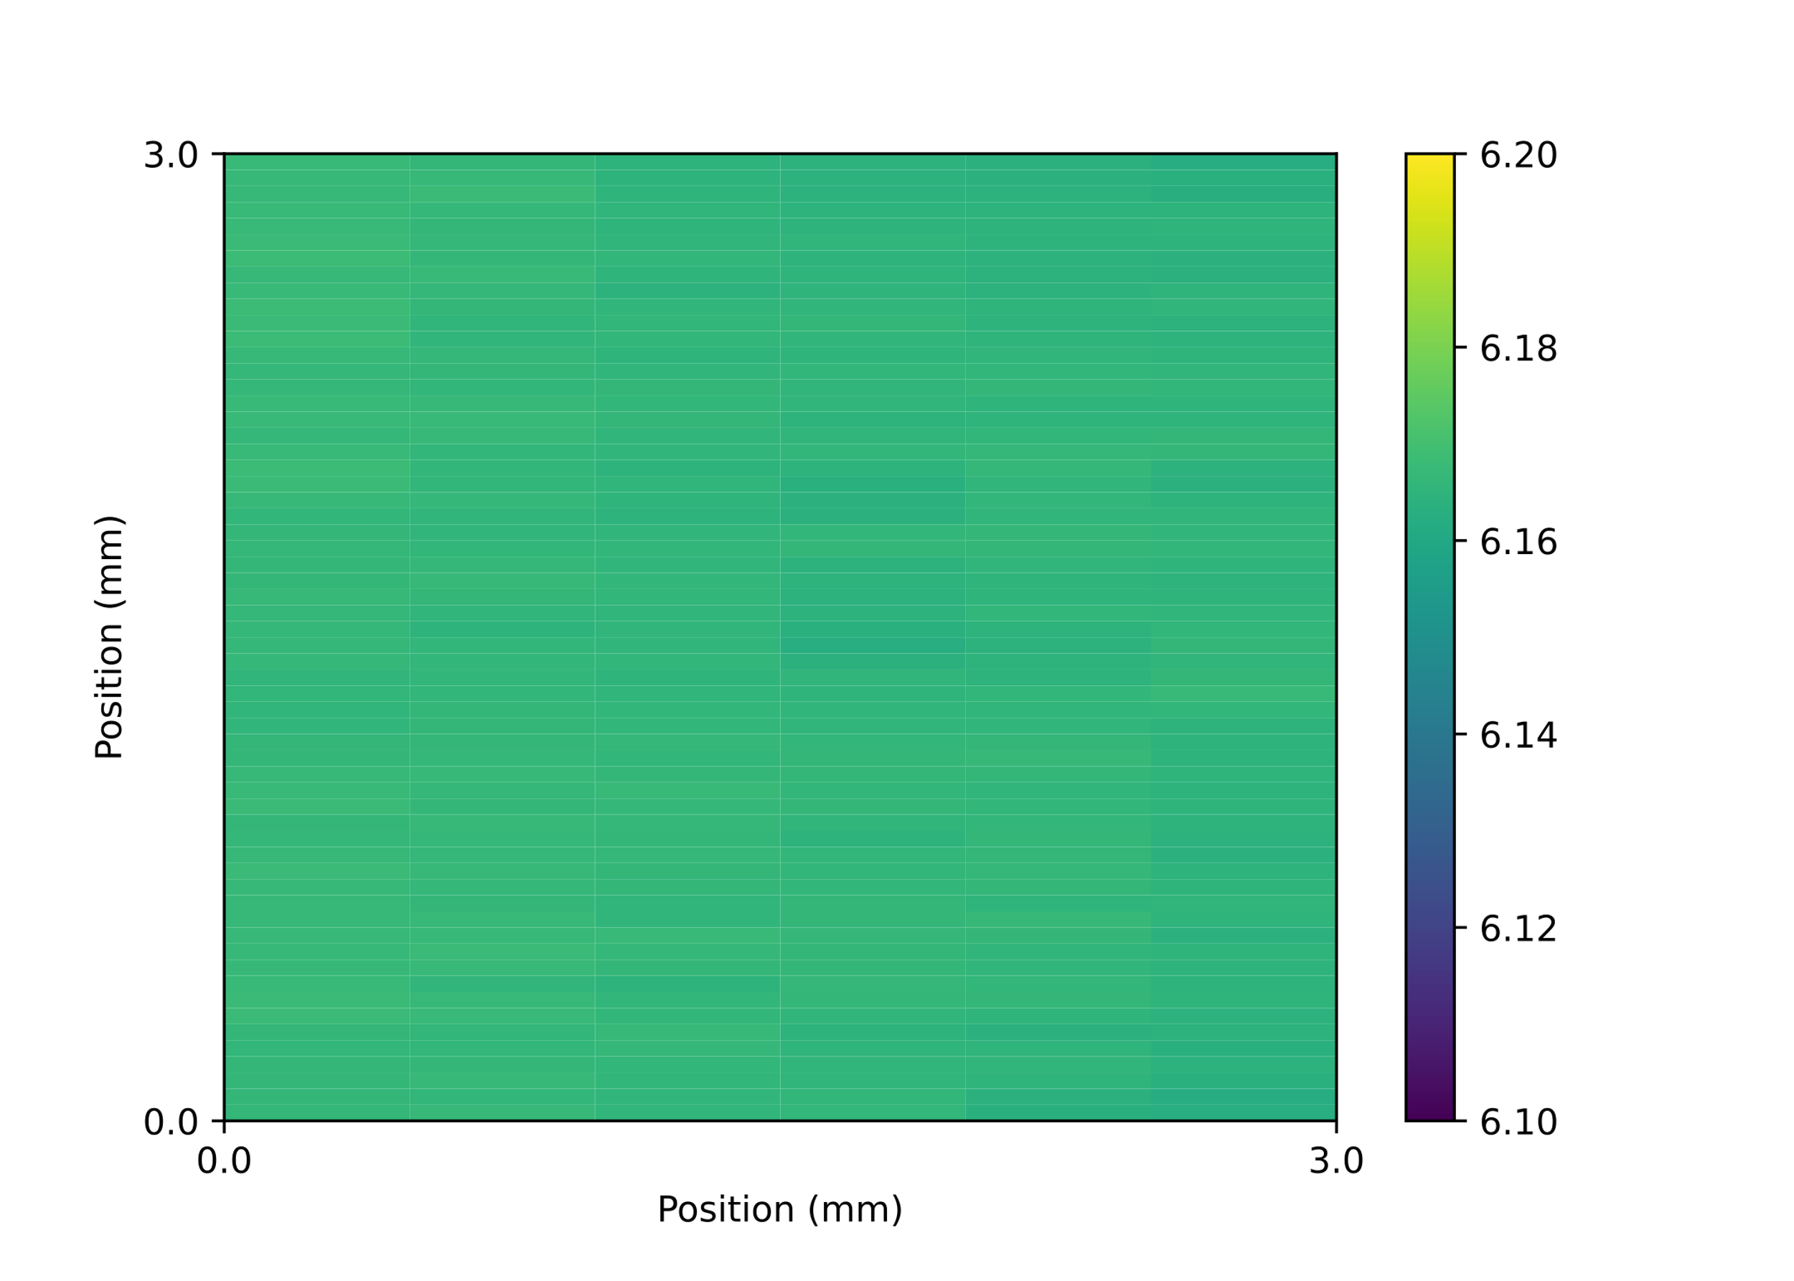
Supplementary Figure 9. The lattice spacing map of the 50% FAPbI₃ films with 10×50 µm² beam, which gives a beam projection around 50×300 µm².

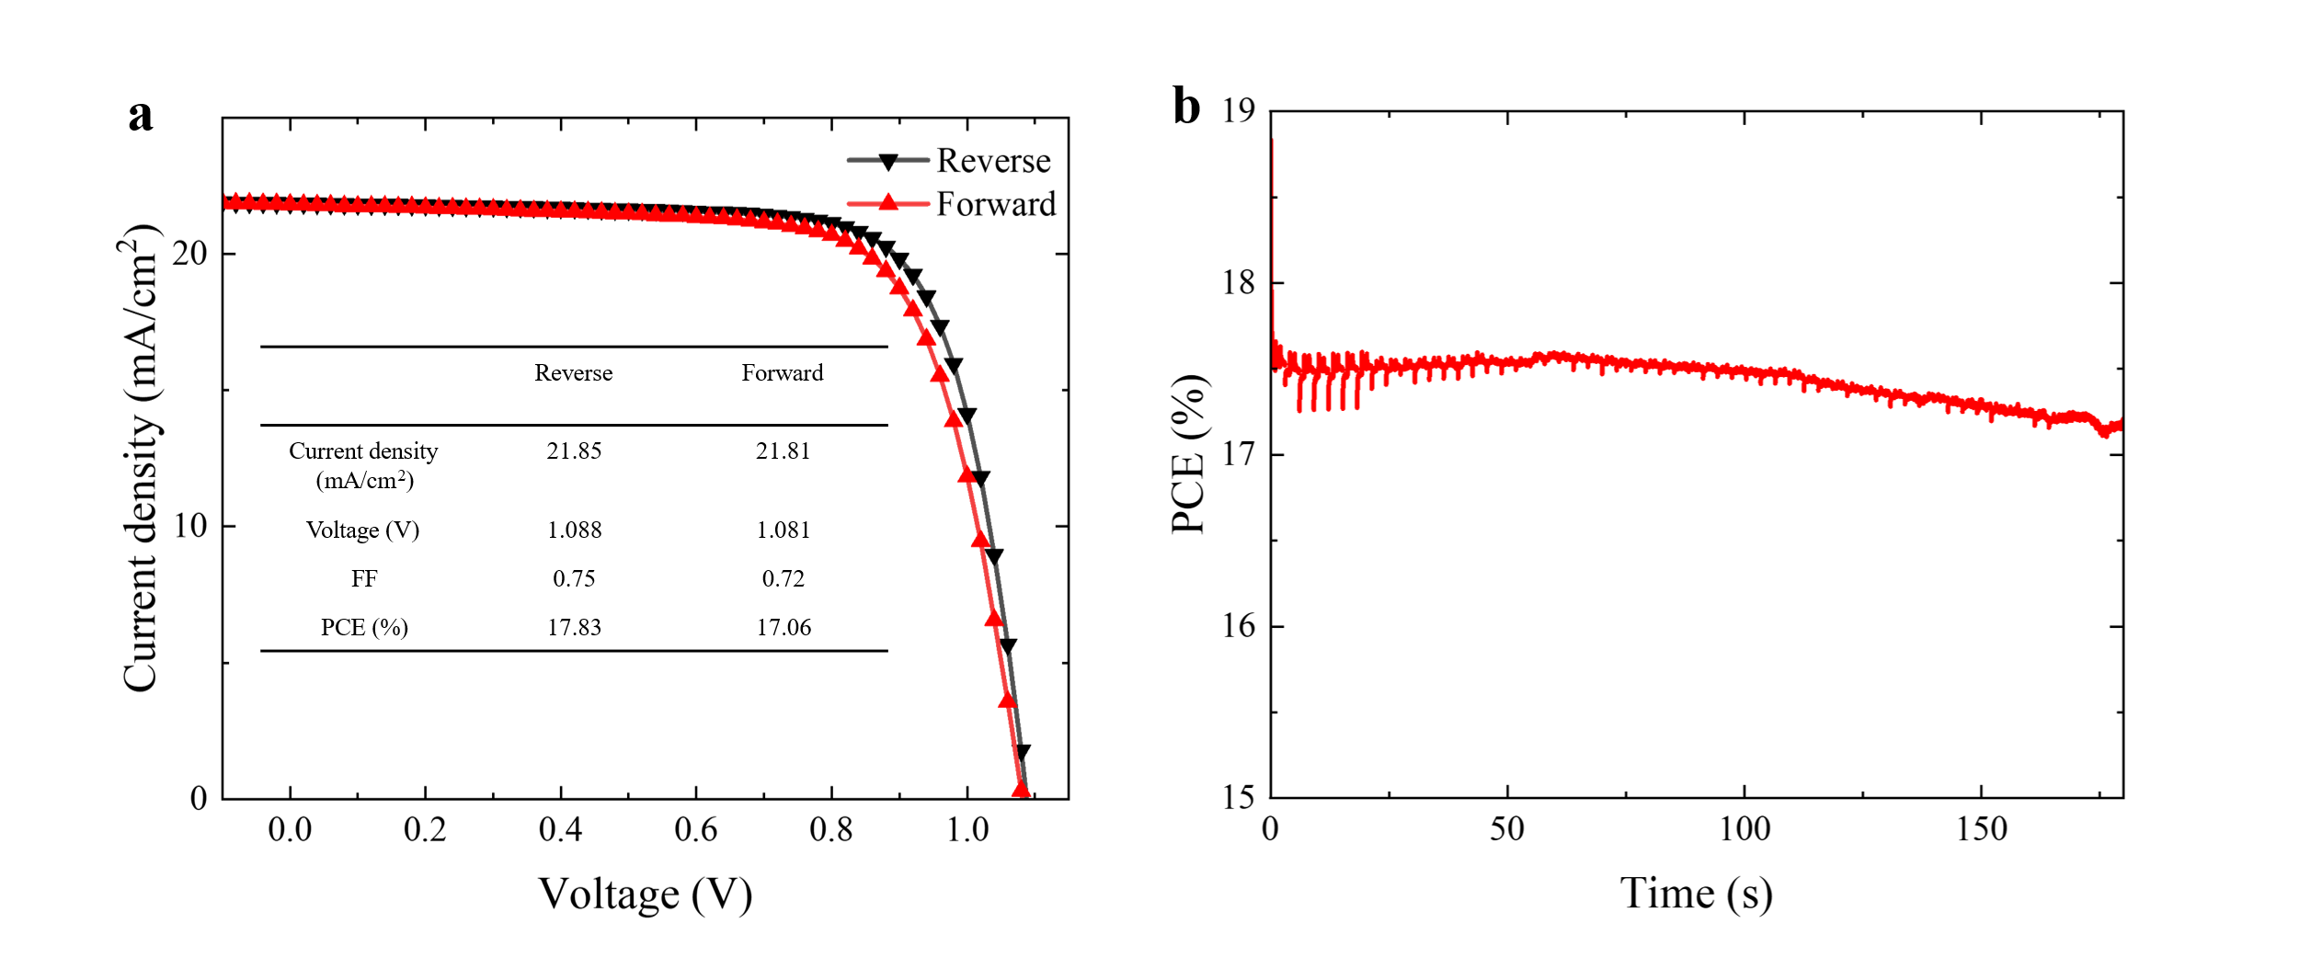
Supplementary Figure 10. a, the J–V curves of champion of 80% FAPbI₃ device. b, the corresponding MPP tracking curve.

Table S 1, the summarized bandgap of different FAPbI₃ content derived from the maximum of the first derivative of Tauc plot spectra of absorbance and $Q_{e}^{EQE}$
FAPbI₃  (%) | Absorbance  (eV) | $$Q_{e}^{EQE}$$  (eV) | PL  (eV)
100 | 1.583 | 1.547 | 1.517
95 | 1.596 | 1.568 | 1.550
90 | 1.613 | 1.593 | 1.576
80 | 1.675 | 1.646 | 1.671
70 | 1.718 | 1.713 | 1.703
60 | 1.761 | 1.793 | 1.801
50 | 1.887 | 1.859 | 1.847
40 | 1.935 |  | 1.867
30 | 2.05 |  | 1.960
20 | 2.141 |  | 1.787
10 | 2.214 |  | 1.811
0 | 2.315 |  | 2.286

Table S2. The mean value of lattice spacing of cSDC perovskite film with different FAPbI₃ contents.
FAPbI₃  (%) | Lattice spacing  (Å) | Standard deviation
100 | 6.342
95 | 6.338 | 0.004
90 | 6.318 | 0.003
60 | 6.205 | 0.004
50 | 6.160 | 0.005
40 | 6.125 | 0.006
30 | 6.044 | 0.004
20 | 6.105 | 0.009
10 | 5.956 | 0.006
0 | 5.936

Table S 3. The mean value of PV parameters of devices with different FAPbI₃ contents.
FAPbI₃  (%) | Voltage  (V) | FF | Current density  (mA/cm²) | PCE  (%)
100 | 0.68 | 0.64 | 22.47 | 10.06
95 | 0.74 | 0.63 | 21.18 | 10.91
90 | 0.87 | 0.68 | 20.60 | 12.24
80 | 1.12 | 0.71 | 19.85 | 15.98
70 | 1.09 | 0.64 | 17.87 | 12.91
60 | 1.23 | 0.66 | 15.39 | 12.64
50 | 1.23 | 0.62 | 13.11 | 10.07
40 | 0.01 | 0.02 | 1.336 | 0.034
30 | 0 | 0 | 0.094 | 0
0 | 0 | 0 | 0 | 0

