Supplementary Material

The pelagic food web of the Western Adriatic Sea: a focus on the role of small pelagics
Fanelli E.^{1,2 *}, Da Ros Z.¹, Menicucci S.³, Malavolti S.³, Biagiotti I.³, Canduci G. ³, De Felice A.³, Leonori I.³
¹ Department of Life and Environmental Sciences, Polytechnic University of Marche, Via Brecce Bianche 60131, Ancona (Italy)
² Stazione Zoologica Anton Dohrn, Villa Comunale, Naples (Italy)
³ CNR-National Research Council, IRBIM-Institute for Marine Biological Resources and Biotechnologies, Largo Fiera della Pesca 6010060125, Ancona (Italy)
*correspondence: Corresponding Author: E. Fanelli, e.fanelli@univpm.it
Table S1. Results of the analyses conducted to determine the diet of Sprattus sprattus. a) overall food items ingested by Sprattus sprattus throughout the sampling period in the Northern and Southern Adriatic Sea (NA and SA, respectively) in terms of percentage by weight; b) results of the SIMPER analysis for similarity of samples within each size class and dissimilarity of samples among the two size classes for Sprattus sprattus. Cut-off for low contribution at 80%. Av. Abund = average abundance; Av. Sim = average similarity; Contrib %= percentage of variance explained by the explanatory variables; Cum. %= cumulative percentage of variance explained by the explanatory variables.
a)
Taxon | NA | SA
CNIDARIA SIPHONOPHORA
Unidentified siphonophores | 2.45 | -
ANELLIDA POLYCHAETHA
Unidentified polychaetes | 0.32 | 0.03
MOLLUSCA
Unidentified bivalves | 1.95 | 4.21
Unidentified gastropods | 0.06 | -
ARTHROPODA CRUSTACEA
Copepoda
Calanus sp.e | 13.84 | 10.37
Microcalanus sp. | 29.10 | 23.76
Paracalanus sp. | 0.64 | 18.20
Acartia clausi | 9.94 | 5.33
Oncaea sp. | 0.96 | 0.56
Euchaeta sp. | 4.46 | 1.07
Centropages sp. | 2.06 | 0.72
Aetideus sp. | 0.35 | 0.50
Candacia sp. | 1.15 | 0.81
Mecynocera sp. | - | 0.09
Eurytemora sp. | 0.20 | -
Metridia sp. | 0.08 | -
Microsetella sp. | - | 0.35
Copepods remains | 13.97 | 13.54
Cladocera
Unidentified cladocerans | 9.51 | 6.70
Amphipoda
Unidentified hyperiids | 0.15 | -
Isopoda
Unidentified isopods | 0.95 | 0.04
Ostracoda
Unidentified ostracods | 1.70 | 5.01
Decapoda
Unidentified decapods | 0.90 | 1.00
OTHERS
Eggs | 5.06 | 7.62
Foraminifera | 0.20 | 0.09

b)
Medium | Average similarity: 41,13
Taxon | Av.Ab. | Av.Sim | Contrib% | Cum.%
Microcalanus sp. | 0.22 | 12.39 | 30.12 | 30.12
Calanus sp. | 0.18 | 10.59 | 25.75 | 55.87
Cladocerans | 0.12 | 4.43 | 10.77 | 66.64
Acartia sp. | 0.10 | 3.90 | 9.49 | 76.14
Large | Average similarity: 41,04
Microcalanus sp. | 0.24 | 10.57 | 25.74 | 25.74
Acartia sp. | 0.20 | 8.95 | 21.80 | 47.55
Calanus sp. | 0.20 | 8.36 | 20.38 | 67.92
Cladocerans | 0.16 | 4.96 | 12.08 | 80.00
Medium vs. Large | Average dissimilarity = 60,65
Taxon | Av.Ab. M | Av.Ab. L | Av.Diss | Contrib% | Cum.%
Microcalanus sp. | 0.22 | 0.24 | 6.50 | 10.72 | 10.72
Acartia sp. | 0.10 | 0.20 | 6.38 | 10.52 | 21.24
Cladocerans | 0.12 | 0.16 | 5.89 | 9.71 | 30.95
Calanus sp. | 0.18 | 0.20 | 5.79 | 9.55 | 40.50
Copepodes remains | 0.09 | 0.09 | 5.49 | 9.04 | 49.55
Eggs | 0.07 | 0.09 | 4.64 | 7.65 | 57.19
Euchaeta sp. | 0.03 | 0.08 | 3.43 | 5.66 | 62.85
Decapods | 0.06 | 0.10 | 3.41 | 5.63 | 68.48
Ostracods | 0.08 | 0.03 | 3.40 | 5.60 | 74.08

Table S2. Correlation between total length (TL) of the three small pelagic species (Sprspr=Sprattus sprattus, Engenc= Engraulis encrasicolus and Sarpil= Sardina pilchardus) and stable isotope ratios of nitrogen and carbon per each sub-area under study (NA=North Adriatic, CA=Central Adriatic, SA=South Adriatic). R=Pearson correlation coefficient.
 | Sprspr |  |  | Engenc |  |  | Sarpil
 | δ¹⁵N | δ¹³C |  | δ¹⁵N | δ¹³C |  | δ¹⁵N | δ¹³C
sub-area | NA |  |  | NA |  |  | NA
R | -0.07 | -0.12 |  | -0.39 | 0.61 |  | 0.20 | 0.43
p | 0.56 | 0.33 |  | 0.0006 | < 0.0001 |  | 0.07 | 0.00006
 | CA |  |  | CA |  |  | CA
R |  |  |  | -0.69 | 0.31 |  | -0.77 | 0.26
p |  |  |  | < 0.0001 | 0.006 |  | < 0.0001 | 0.14
 | SA |  |  | SA |  |  | SA
R | -0.02 | 0.15 |  | -0.65 | 0.34 |  | -0.48 | 0.27
p | 0.96 | 0.67 |  | < 0.0001 | 0.03 |  | 0.03 | 0.24

Table S3. Results of multivariate (on δ¹³C-δ¹⁵N) and univariate (on δ¹³C and δ¹⁵N, separately) PERMANOVA main test (Design 1) (a). pairwise comparisons (b) for the interaction term ‘species × size’ for pairs of levels of factors ‘species’ of factor ‘size’ and (c) for the interaction term ‘species × size’ for pairs of levels of factors ‘size class’ of factor ‘species’. Sprspr = Sprattus sprattus; Sarpil= Sardina pilchardus; Engenc = Engraulis encrasicolus. df=degrees of freedom; MS= mean square; Pseudo-F= statistic F; t=statistic t for pairwise comparisons; Unique perms= number of permutations; P= probability level; n.s. = not significant.
a) | δ¹³C-δ¹⁵N |  |  |  |  | δ¹⁵N |  |  |  | δ¹³C
Source | df | MS | Pseudo-F | P(perm) |  | MS | Pseudo-F | P(perm) |  | MS | Pseudo-F | P(perm)
Species | 2 | 42.23 | 29.96 | 0.0001 |  | 14.52 | 13.32 | 0.0001 |  | 27.71 | 86.63 | 0.0001
Size | 1 | 7.74 | 5.49 | 0.0099 |  | 4.74 | 4.35 | 0.04 |  | 3.00 | 9.38 | 0.0024
SpeciesxSize | 2 | 19.14 | 13.58 | 0.0001 |  | 11.35 | 10.42 | 0.0001 |  | 7.79 | 24.35 | 0.0001
Residuals | 400 | 1.41 |  |  |  | 1.09 |  |  |  | 0.32
Total | 405
b) Term 'Speciesxsize' for pairs of levels of factor 'Species'
Within level 'M' of factor 'size class'
Groups |  |  | t | P(perm) |  |  | t | P(perm) |  |  | t | P(perm)
Sprspr, Sarpil |  |  | 5.48 | 0.0001 |  |  | 5.93 | 0.0001 |  |  | 4.90 | 0.0001
Sprspr, Engenc |  |  | 2.13 | 0.0141 |  |  | 1.04 | n.s. |  |  | 2.78 | 0.0061
Sarpil, Engenc |  |  | 6.35 | 0.0001 |  |  | 5.86 | 0.0001 |  |  | 7.01 | 0.0001
Within level 'L' of factor 'size class'
Sprspr, Sarpil |  |  | 3.35 | 0.0005 |  |  | 3.34 | 0.0015 |  |  | 3.36 | 0.0011
Sprspr, Engenc |  |  | 4.87 | 0.0001 |  |  | 2.60 | 0.0097 |  |  | 13.59 | 0.0001
Sarpil, Engenc |  |  | 4.70 | 0.0001 |  |  | 0.52 | n.s. |  |  | 11.47 | 0.0001
c) Term 'Spxsi' for pairs of levels of factor 'size class'
Within level 'Sprspr' of factor 'Species'
M vs L |  |  | 2.57 | 0.0039 |  |  | 1.31 | n.s. |  |  | 3.40 | 0.0012
Within level 'Sarpil' of factor 'Species'
M vs L |  |  | 3.31 | 0.0004 |  |  | 1.62 | n.s. |  |  | 5.33 | 0.0001
Within level 'Engenc' of factor 'Species'
M vs L |  |  | 4.51 | 0.0001 |  |  | 4.64 | 0.0001 |  |  | 3.54 | 0.0009

Table S4. Results of multivariate (on δ¹³C-δ¹⁵N) and univariate (on δ¹³C and δ¹⁵N, separately) PERMANOVA main test (Design 2) (a). pairwise comparisons and (b) for the interaction term ‘species × sub-basin’ for pairs of levels of factors ‘species’ of factor ‘species’. Sprspr = Sprattus sprattus; Sarpil= Sardina pilchardus; Engenc = Engraulis encrasicolus; NA= North Adriatic Sea; CA= Central Adriatic Sea; SA= South Adriatic Sea. df=degrees of freedom; MS= mean square; Pseudo-F= statistic F; t=statistic t for pairwise comparisons; Unique perms= number of permutations; P= probability level; n.s. = not significant.
a) | δ¹³C-δ¹⁵N |  |  |  |  | δ¹⁵N |  |  |  | δ¹³C
Source | df | MS | Pseudo-F | P(perm) |  | MS | Pseudo-F | P(perm) |  | MS | Pseudo-F | P(perm)
Species | 2 | 31.85 | 24.21 | 0.0001 |  | 15.59 | 15.76 | 0.0001 |  | 16.25 | 49.87 | 0.0001
Sub-area | 2 | 16.50 | 12.54 | 0.0001 |  | 8.07 | 8.15 | 0.0003 |  | 8.43 | 25.85 | 0.0001
SpeciesxSub-area | 3 | 11.33 | 8.62 | 0.0001 |  | 9.63 | 9.73 | 0.0001 |  | 1.70 | 5.23 | 0.0019
Residuals | 398 | 1.32 |  |  |  | 0.99 |  |  |  | 0.33
Total | 405
b) Term 'Spxsu' for pairs of levels of factor 'Species'
Within level 'NA' of factor 'sub-area'
Groups |  |  | t | P(perm) |  |  | t | P(perm) |  |  | t | P(perm)
Sprspr, Sarpil |  |  | 3.55 | 0.0001 |  |  | 4.59 | 0.0001 |  |  | 0.12 | n.s.
Sprspr, Engenc |  |  | 4.32 | 0.0001 |  |  | 0.67 | n.s. |  |  | 7.96 | 0.0001
Sarpil, Engenc |  |  | 5.24 | 0.0001 |  |  | 4.00 | 0.0002 |  |  | 7.38 | 0.0001
Within level 'CA' of factor 'sub-area'
Sarpil, Engenc |  |  | 2.67 | 0.0051 |  |  | 0.92843 | n.s. |  |  | 7.1279 | 0.0001
Within level 'SA' of factor 'sub-area'
Sprspr, Sarpil |  |  | 4.69 | 0.0001 |  |  | 5.57 | 0.0001 |  |  | 2.96 | 0.0047
Sprspr, Engenc |  |  | 5.43 | 0.0001 |  |  | 5.93 | 0.0001 |  |  | 0.49 | n.s.
Sarpil, Engenc |  |  | 2.54 | 0.0056 |  |  | 0.93 | n.s. |  |  | 4.89 | 0.0001
c) Term 'SpeciesxSub-area' for pairs of levels of factor 'sub-area'
Within level 'Sprspr' of factor 'Species'
Groups |  |  | t | P(perm) |  |  | t | P(perm) |  |  | t | P(perm)
NA, SA |  |  | 4.44 | 0.0001 |  |  | 2.09 | 0.0377 |  |  | 6.2955 | 0.0001
Within level 'Sarpil' of factor 'Species'
NA, SA |  |  | 2.83 | 0.0009 |  |  | 3.13 | 0.0024 |  |  | 2.28 | 0.0252
NA, CA |  |  | 1.84 | 0.0378 |  |  | 1.56 | n.s. |  |  | 2.26 | 0.0242
SA, CA |  |  | 1.22 | n.s. |  |  | 1.48 | n.s. |  |  | 0.41 | n.s.
Within level 'Engenc' of factor 'Species'
NA, SA |  |  | 6.69 | 0.0001 |  |  | 7.43 | 0.0001 |  |  | 2.31 | 0.0234
NA, CA |  |  | 3.45 | 0.0005 |  |  | 3.63 | 0.0005 |  |  | 2.13 | 0.0341
SA, CA |  |  | 3.65 | 0.0002 |  |  | 3.80 | 0.0001 |  |  | 1.08 | n.s.

Table S5. Results of multivariate (on δ¹³C-δ¹⁵N) and univariate (on δ¹³C and δ¹⁵N, separately) PERMANOVA main test (Design 3) (a) and the pairwise comparisons for the interaction term ‘species × inshore vs. offshore’ for pairs of levels of factors ‘species’ (b) and for pairs of levels of factors ‘inshore vs. offshore’(c). Sarpil= Sardina pilchardus; Engenc = Engraulis encrasicolus. df=degrees of freedom; MS= mean square; Pseudo-F= statistic F; t=statistic t for pairwise comparisons; Unique perms= number of permutations; P= probability level; n.s. = not significant.
a) | δ¹³C-δ¹⁵N |  |  |  |  | δ¹⁵N |  |  |  | δ¹³C
Source | df | MS | Pseudo-F | P(perm) |  | MS | Pseudo-F | P(perm) |  | MS | Pseudo-F | P(perm)
Species | 1 | 30.66 | 22.81 | 0.00 |  | 2.25 | 2.22 | 0.13 |  | 28.40 | 86.05 | 0.0001
In vs. off | 1 | 83.69 | 62.26 | 0.00 |  | 76.66 | 75.59 | 0.00 |  | 7.04 | 21.32 | 0.0001
SpeciesxIn vs. off | 1 | 6.87 | 5.11 | 0.01 |  | 6.86 | 6.76 | 0.01 |  | 0.01 | 0.04 | n.s.
Residuals | 321 | 1.34 |  |  |  | 1.01 |  |  |  | 0.33
Total | 324
b) Term 'SpeciesxIn vs. off' for pairs of levels of factor 'Species'
Within level 'in' of factor 'in vs. off'
Groups |  |  | t | P(perm) |  |  | t | P(perm) |  |  | t | P(perm)
Sarpil, Engenc |  |  | 6.11 | 0.0001 |  |  | 4.33 | 0.0001 |  |  | 9.26 | 0.0001
Within level 'off' of factor 'in vs. off'
Sarpil, Engenc |  |  | 2.87 | 0.0016 |  |  | 0.65 | n.s. |  |  | 7.78 | 0.0001
c) Term 'SpeciesxIn vs. off' for pairs of levels of factor 'in vs. off'
Within level 'Sarpil' of factor 'Species'
in, off |  |  | 3.62 | 0.0001 |  |  | 4.20 | 0.0002 |  |  | 2.42 | 0.0187
Within level 'Engenc' of factor 'Species'
in, off |  |  | 8.77 | 0.0001 |  |  | 9.32 | 0.0001 |  |  | 4.79 | 0.0001

Table S6. Values of Total Area of the convex hull (TA) and of the corrected Standard Ellipse Area (SEAC) obtained considering the four different “ancillary” species and the areas in which they were caught. Values of TA and SEAC are expressed as ‰2. Other values are shown in the table: δ¹⁵N range (NR), δ¹³C range (CR), and the mean distance to centroid (CD).
Species | S. sprattus |  | S. pilchardus |  |  | E. encrasicolus
TA | 6.64 |  | 10.17 |  |  | 10.29
SEAc | 1.22 |  | 2.14 |  |  | 2.01
NR | 0.43 |  | 0.66 |  |  | 1.48
CR | 1.21 |  | 0.47 |  |  | 0.25
CD | 0.60 |  | 0.30 |  |  | 0.54
Area | NA | SA | NA | CA | SA | NA | CA | SA
TA | 7.50 | 2.49 | 9.51 | 6.58 | 4.62 | 9.26 | 5.86 | 2.93
SEAc | 1.86 | 1.60 | 2.14 | 2.01 | 1.85 | 2.46 | 1.47 | 0.84

Table S7. Isotopic signatures of the sources used to construct the mixing polygon for each one of the three studied species in the different sub areas and to select the sources to be used to run SIMMR models. The complete stable isotope dataset on zooplankton cited in Fanelli et al., 2022 is available at https://doi.org/10.1594/PANGAEA.945541. s.d. = standard deviation.

Sub-area | Source | mean δ¹³C | s.d. | mean δ¹⁵N | s.d. | Isotopic signatures taken from
North Adriatic | Acartia sp. | -21.58 | 0.61 | 7.86 | 0.86 | Fanelli et al., 2022
North Adriatic | Centropages typicus | -21.52 |  | 6.93 |  | Fanelli et al., 2022
North Adriatic | Oithona sp. | -20.41 |  | 4.10 |  | Fanelli et al., 2022
North Adriatic | Decapoda larvae | -19.81 | 0.19 | 7.58 | 1.45 | Fanelli et al., 2022
North Adriatic | Large Copepoda | -16.39 | 0.41 | 7.19 | 0.12 | Fanelli et al., 2022
North Adriatic | POM_NA | -23.05 | 0.20 | 10.00 | 0.20 | Berto et al., 2013
North Adriatic | Phyto1 | -19.05 | 1.34 | 3.75 | 0.07 | Faganeli et al., 2009
North Adriatic | Macroaggregates | -19.70 | 0.20 | 8.30 | 0.20 | Faganeli et al., 2009
North Adriatic | Phyto2 | -23.90 | 0.71 | 3.60 | 0.85 | Faganeli et al., 2009
Central Adriatic | Clauso-Paracalanidae | -20.86 | 0.36 | 4.03 | 0.33 | Fanelli et al., 2022
Central Adriatic | Calanus spp. | -20.89 | 0.44 | 5.61 | 0.26 | Fanelli et al., 2022
Central Adriatic | Centropages typicus | -21.20 | 0.40 | 4.92 | 1.25 | Fanelli et al., 2022
Central Adriatic | Fish larvae | -20.57 | 0.26 | 5.09 | 0.53 | Fanelli et al., 2022
Central Adriatic | Decapoda larvae | -20.74 | 0.04 | 5.77 | 0.07 | Fanelli et al., 2022
Central Adriatic | Temora sp. | -20.56 |  | 4.71 |  | Fanelli et al., 2022
Central Adriatic | Brachyuran larvae | -19.17 | 0.07 | 3.89 | 0.06 | Fanelli et al., 2022
Central Adriatic | Euchaeta sp. | -21.03 | 0.26 | 5.42 | 0.50 | Fanelli et al., 2022
Central Adriatic | POM_NA | -23.05 | 0.20 | 10.00 | 0.20 | Berto et al., 2013
Central Adriatic | Phyto1 | -19.05 | 1.34 | 3.75 | 0.07 | Faganeli et al., 2009
Central Adriatic | Macroaggregates | -19.70 | 0.20 | 8.30 | 0.20 | Faganeli et al., 2009
Central Adriatic | Phyto2 | -23.90 | 0.71 | 3.60 | 0.85 | Faganeli et al., 2009
South Adriatic | Clauso-Paracalanidae | -20.64 | 0.03 | 3.98 | 0.42 | Fanelli et al., 2022
South Adriatic | Calanus spp. | -21.04 | 0.92 | 6.54 | 0.66 | Fanelli et al., 2022
South Adriatic | Euchaeta sp. | -20.93 | 0.29 | 5.08 | 0.20 | Fanelli et al., 2022
South Adriatic | Decapoda larvae | -19.64 | 0.08 | 6.81 | 0.17 | Fanelli et al., 2022
South Adriatic | Temora stylifera | -19.77 |  | 6.24 |  | Fanelli et al., 2022
South Adriatic | Pleuromamma abdominalis | -21.14 |  | 3.59 |  | Fanelli et al., 2022
South Adriatic | Thaliacea | -19.59 | 0.29 | 3.35 | 0.07 | Fanelli et al., 2022
South Adriatic | Large Copepoda | -18.09 | 0.19 | 7.12 | 0.10 | Fanelli et al., 2022
South Adriatic | POM_GT | -21.00 | 1.92 | 5.80 | 1.41 | Faganeli et al., 2009
South Adriatic | POM_NA | -23.05 | 0.20 | 10.00 | 0.20 | Berto et al., 2013
South Adriatic | Phyto1 | -19.05 | 1.34 | 3.75 | 0.07 | Faganeli et al., 2009
South Adriatic | Macroaggregates | -19.70 | 0.20 | 8.30 | 0.20 | Faganeli et al., 2009
South Adriatic | Phyto2 | -23.90 | 0.71 | 3.60 | 0.85 | Faganeli et al., 2009

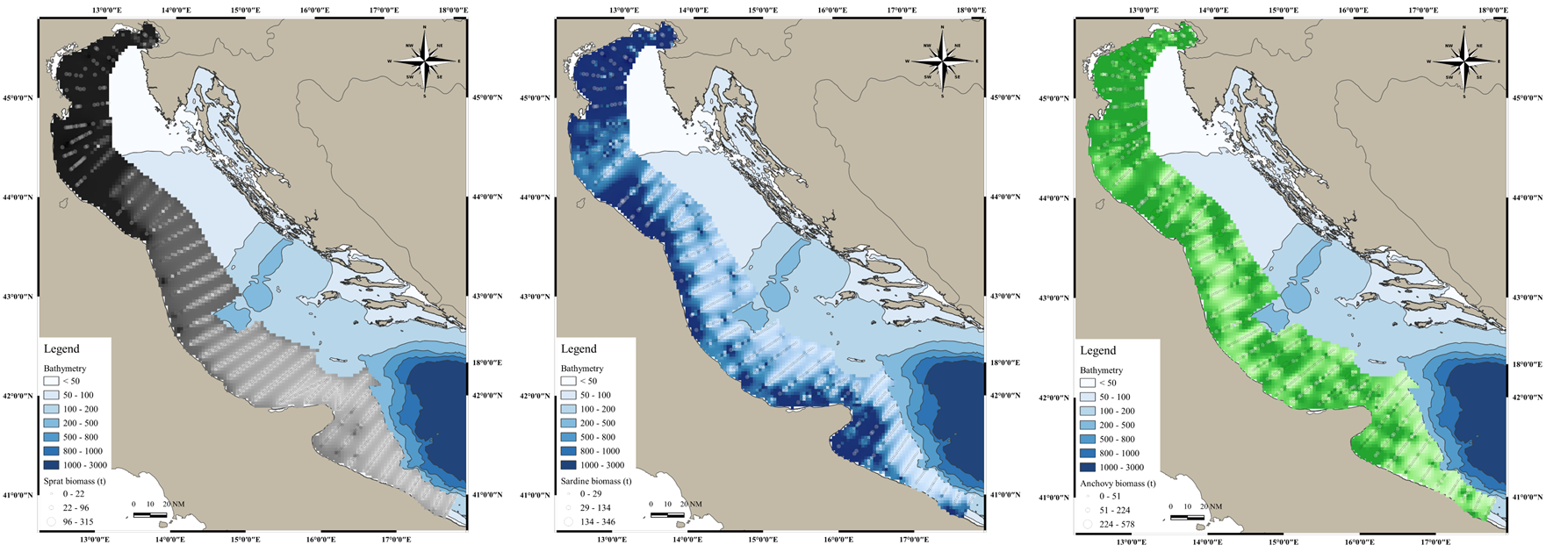
Figure S1. Distribution map of fish biomass (in tons, t) as derived by acoustic data from MEDIAS 2019 survey for Sprattus sprattus (on the left, black symbols), Sardina pilchardus (in the center, blue symbols), and Engraulis encrasicolus (on the right, green symbols).

Figure S2. Cumulative prey curve for Sprattus sprattus, obtained on the number of taxa observed in the stomach contents and by bootstrapping.

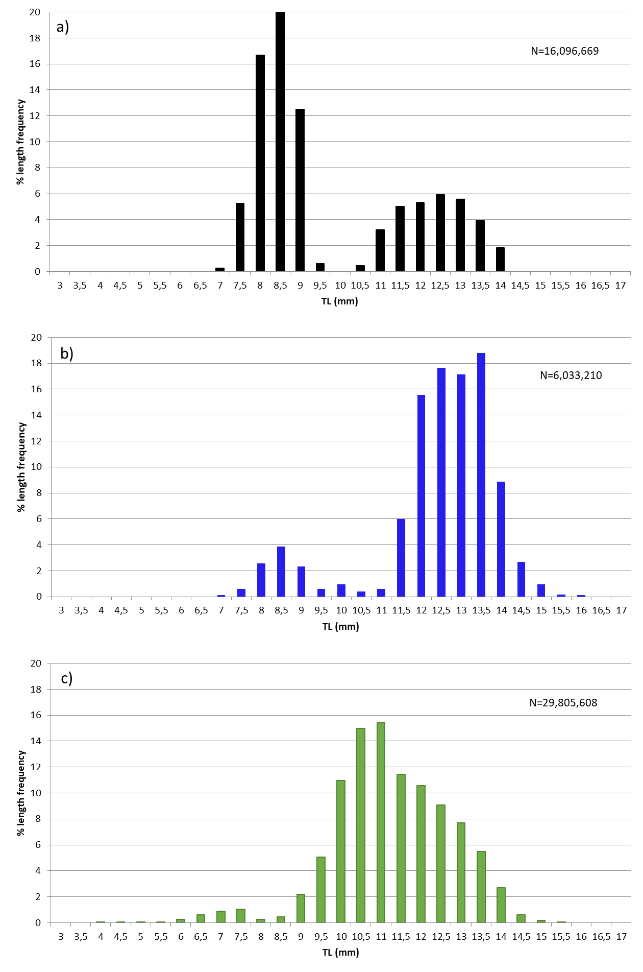
Figure S3. Length Frequency Distribution of a) Sprattus sprattus, b) Sardina pilchardus and c) Engraulis encrasicolus collected during MEDIAS 2019 survey in June-July 2019 in the Adriatic basin

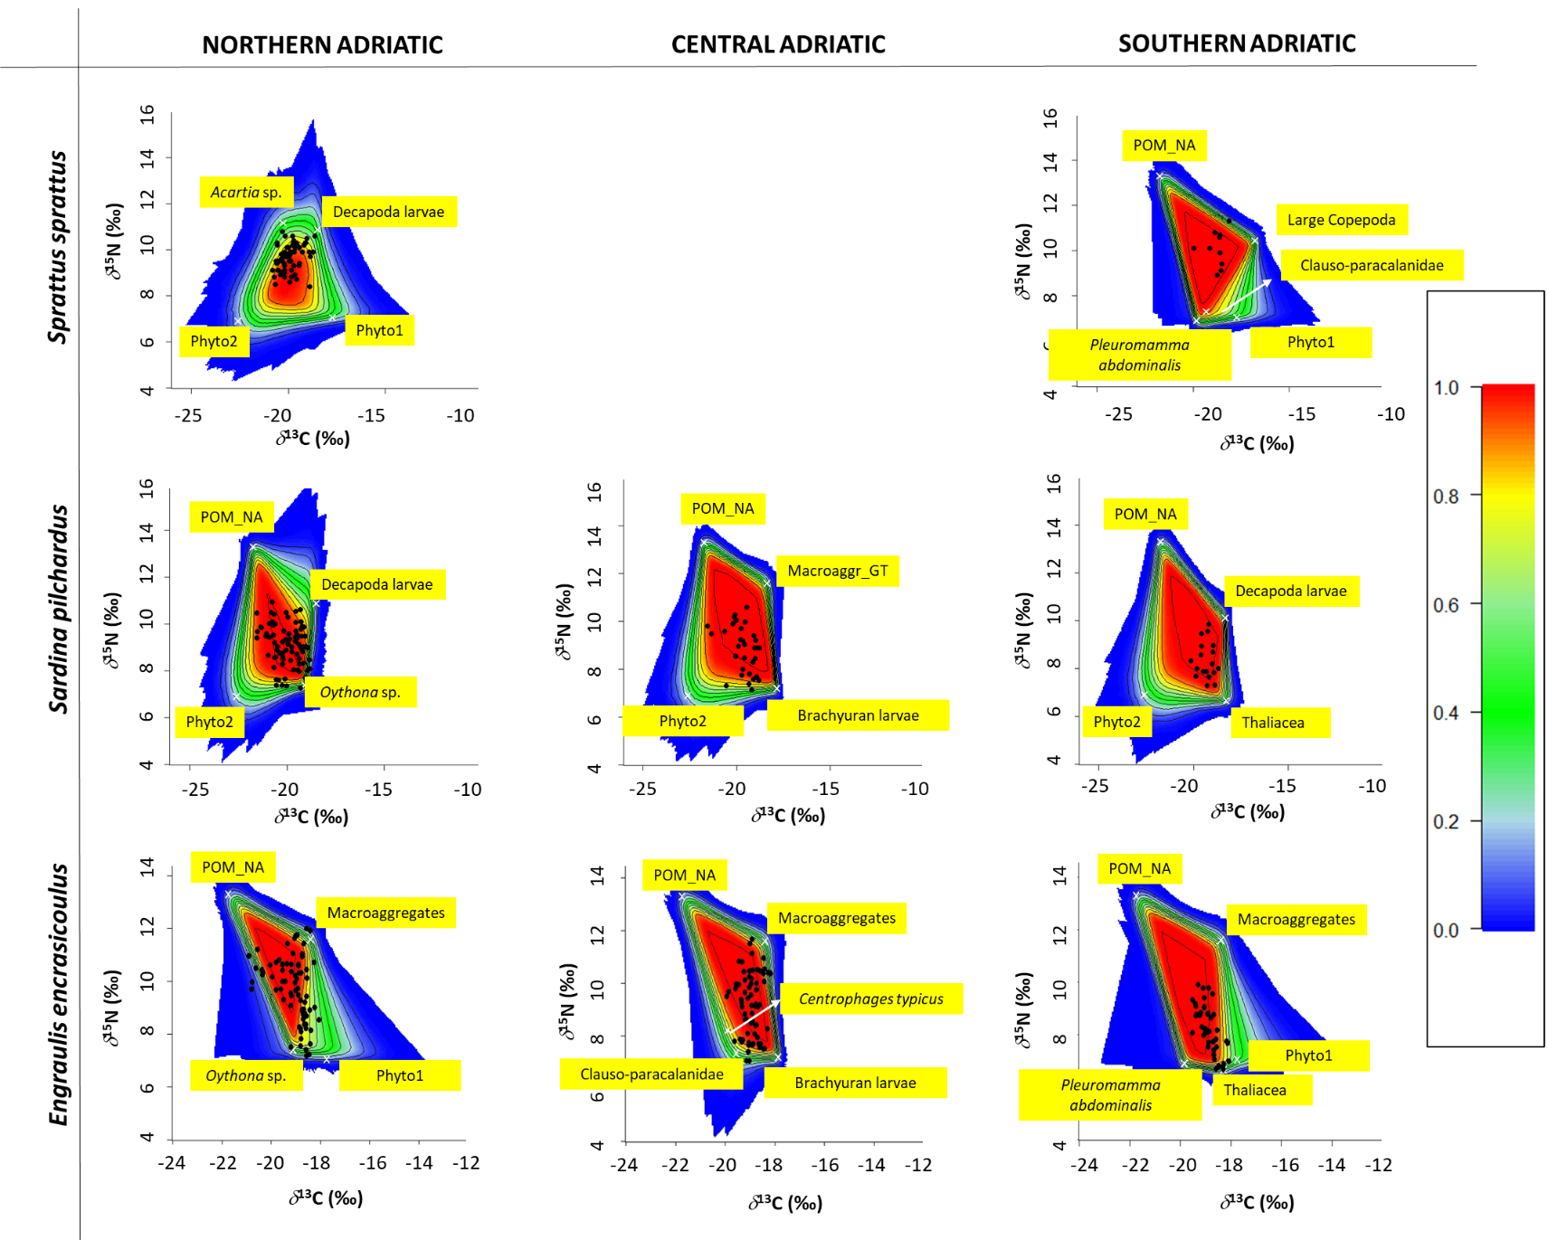
Figure S4. The biplots show the simulated mixing with the positions of the Sprattus sprattus, Sardina pilchardus and Engraulis encrasicolus samples (black dots) in the different sub-areas and the average signatures of the sources selected for the mixing model (white crosses). Probability contours are at the 5% level (outermost contour) and at every 10% level, following the colors shown in the legend in the right part of the graph. Macroaggregates = macroaggregates from the Northern Adriatic (source: Faganeli et al., 2009), POM_NA = POM (Particulate Organic Matter) from the Northern Adriatic (source Berto et al., 2013), Phyto1 and Phyto2= phytoplankton from the Northern Adriatic (source: Faganeli et al., 2009).

