Figure | Origin photo
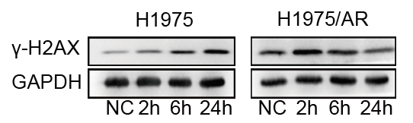
Figure 1D H1975 γ-H2AX

Figure 1D H1975/AR γ-H2AX

Figure 1D H1975 GAPDH

Figure 1D H1975/AR GAPDH
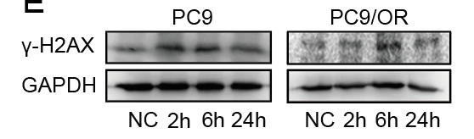  Figure 1E PC9 γ-H2AX | 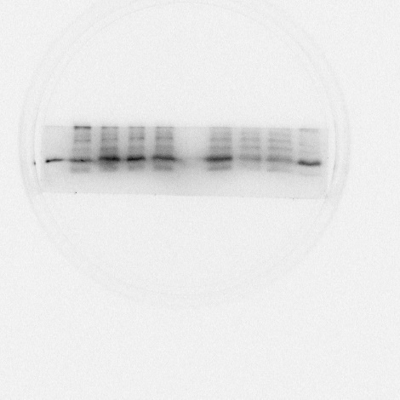
Figure 1E PC9/OR γ-H2AX
Figure 1E PC9 GAPDH | 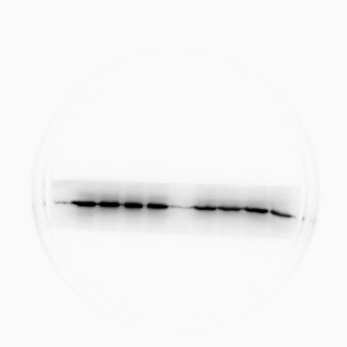
Figure 1E PC9/OR GAPDH | 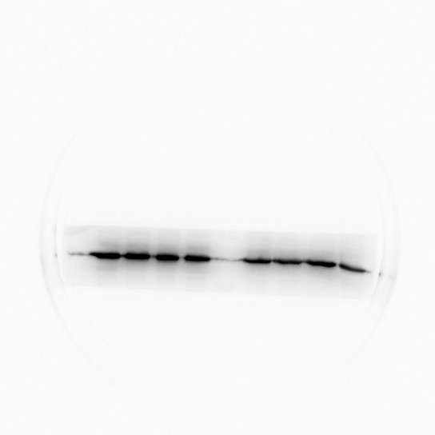
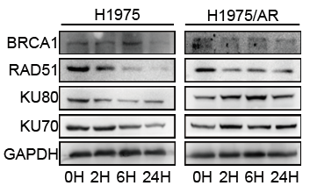
Figure 2A H1975 BRCA1
Figure 2A H1975/AR BRCA1 | 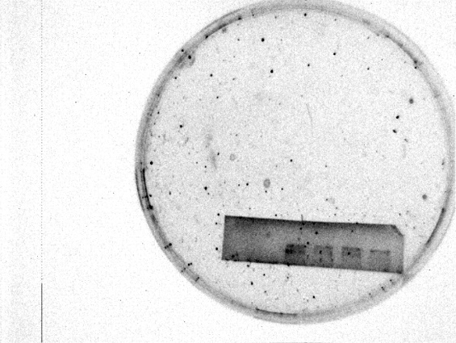
Figure 2A H1975 RAD51 | 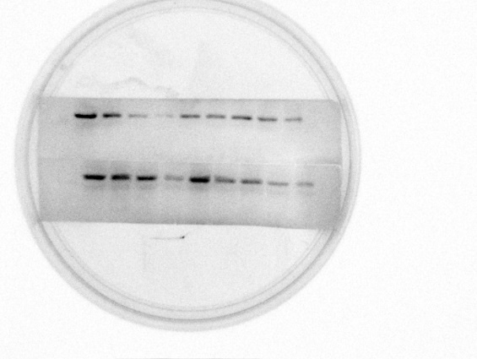
Figure 2A H1975/AR RAD51

Figure 2A H1975 KU80

Figure 2A H1975/AR KU80

Figure 2A H1975 KU70

Figure 2A H1975/AR KU70

Figure 2A H1975 GAPDH | 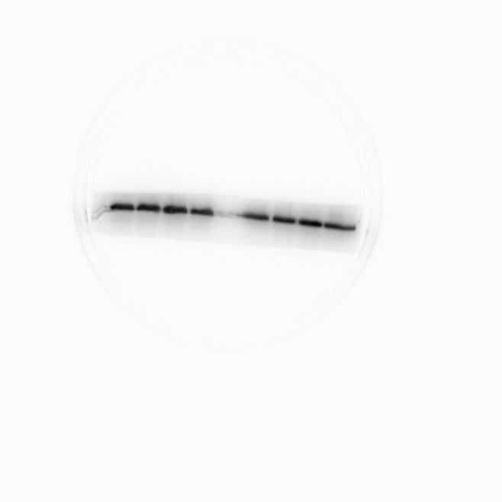
Figure 2A H1975/AR GAPDH | 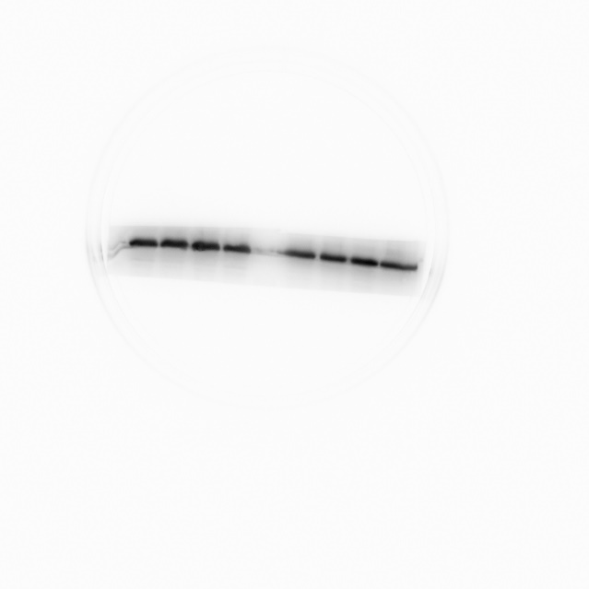
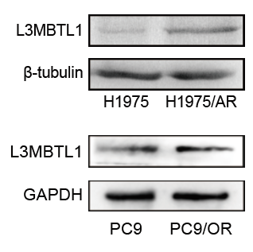  Figure 3B H1975&AR L3MBTL1 | 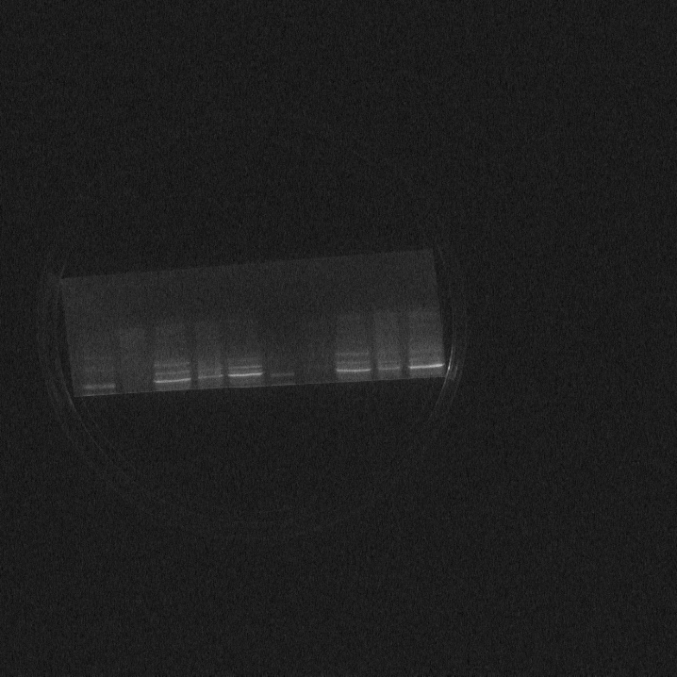  4 groups repeated  1  2  3  4
Figure 3B H1975&AR tubulin | 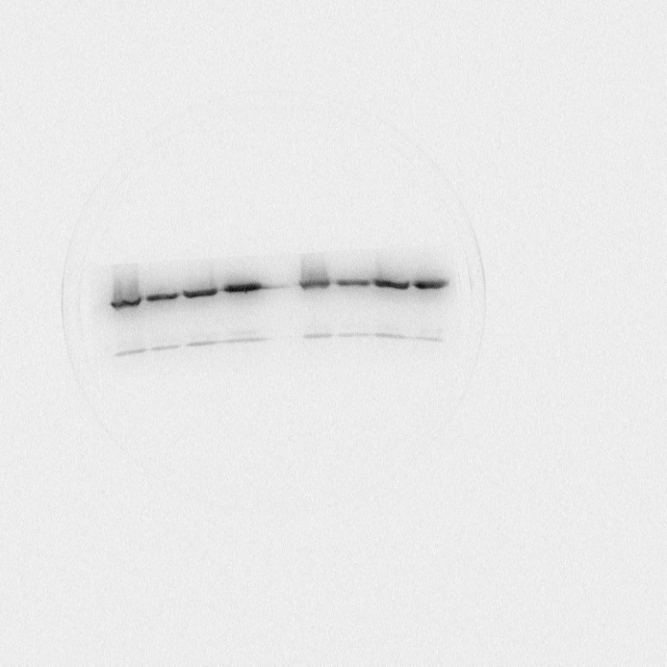  4 groups repeated  4  3  2  1
.
Figure 3B PC9&OR L3MBTL1

Figure 3B PC9&OR GAPDH

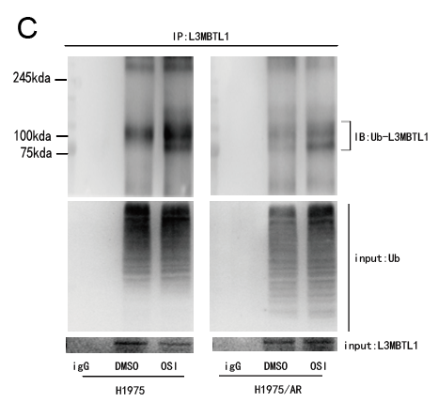
Figure 3C IP H1975 IB-Ub H1975&AR

Figure 3C IP H1975 INPUT Ub H1975&AR | 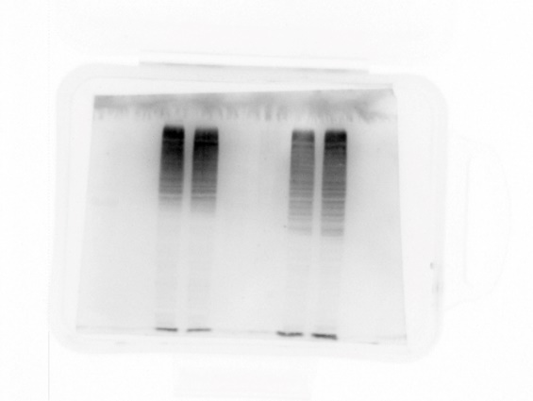
Figure 3C IP H1975 INPUT L3MBTL1 H1975&AR
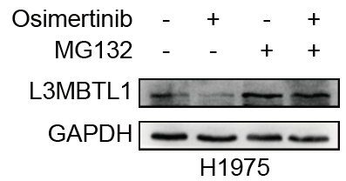
Figure 3E H1975 L3MBTL1
Figure 3E H1975 GAPDH
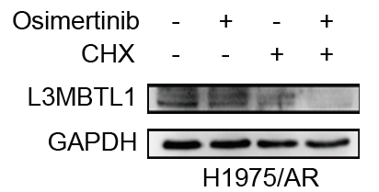
Figure 3E H1975/AR L3MBTL1
Figure 3E H1975/AR GAPDH

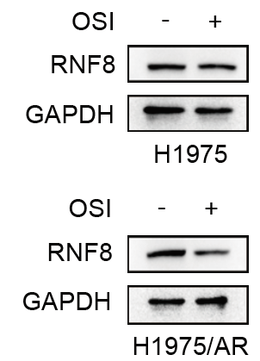
Figure 3I H1975 RNF8
Figure 3I H1975 GAPDH
Figure 3I H1975/AR RNF8
Figure 3I H1975/AR GAPDH
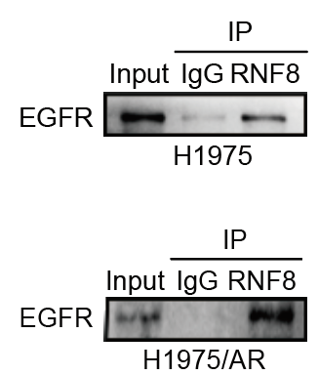
Figure 3I H1975
Figure 3I H1975/AR

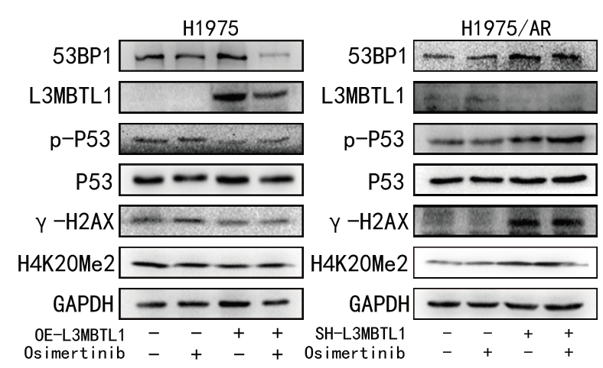
Figure 4E H1975 53BP1
Figure 4E H1975 L3MBTL1
Figure 4E H1975 P-P53
Figure 4E H1975 P53
Figure 4E H1975 γ-H2AX
Figure 4E H1975 H4K20Me2
Figure 4E H1975 GAPDH
Figure 4E H1975/AR 53BP1 | 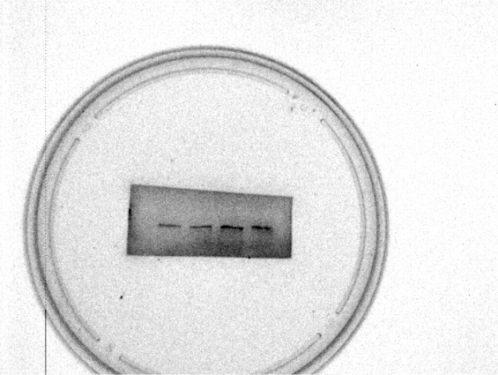
Figure 4E H1975/AR L3MBTL1
Figure 4E H1975/AR P-P53
Figure 4E H1975/AR P53
Figure 4E H1975/AR γ-H2AX
Figure 4E H1975/AR H4K20Me2
Figure 4E H1975/AR GAPDH
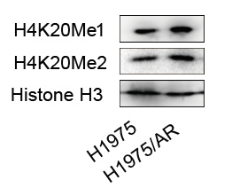
Figure 7A H4K20Me1
Figure 7A H4K20Me2
Figure 7A H3
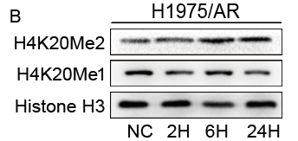
Figure 7B H4K20Me1
Figure 7B H4K20Me2
Figure 7B H3
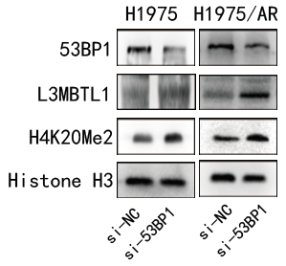
Figure 7E H1975 53BP1
Figure 7E H1975 L3MBTL1
Figure 7E H1975 H4K20Me2
Figure 7E H1975 H3
Figure 7E H1975/AR 53BP1
Figure 7E H1975/AR L3MBTL1
Figure 7E H1975/AR H4K20Me2
Figure 7E H1975/AR H3
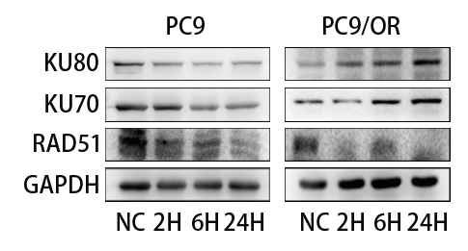  Figure S1D PC9 KU80 | 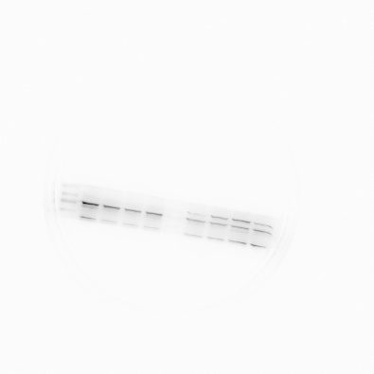
Figure S1D PC9/OR KU80
Figure S1D PC9 KU70 | 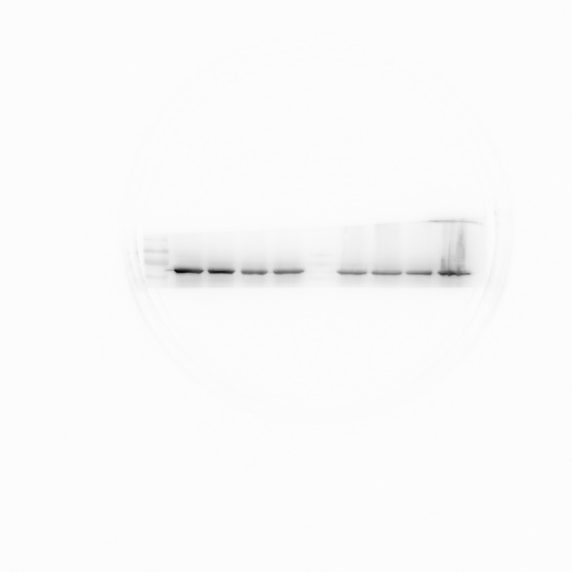
Figure S1D PC9/OR KU70
Figure S1D PC9 RAD51
Figure S1D PC9/OR RAD51
Figure S1D PC9 GAPDH | 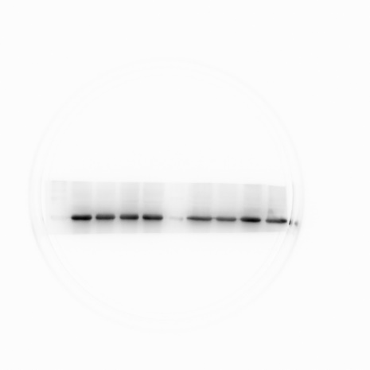
Figure S1D PC9/OR GAPDH
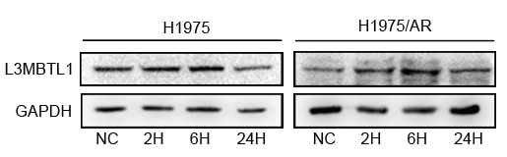
Figure S2A H1975 L3MBTL1
Figure S2A H1975/AR L3MBTL1
Figure S2A H1975 GAPDH
Figure S2A H1975/AR GAPDH
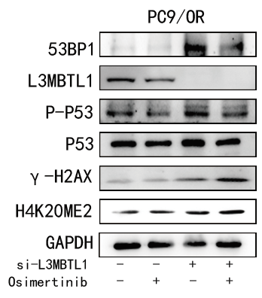
Figure S2C PC9/OR 53BP1
Figure S2C PC9/OR L3MBTL1
Figure S2C PC9/OR P-P53
Figure S2C PC9/OR P53
Figure S2C PC9/OR γ-H2AX
Figure S2C PC9/OR H4K20ME2
Figure S2C PC9/OR GAPDH

