Table 1. Characteristics of the Study Population by FGCRS group (n=6123)
 | N=6123 | FGCRS |  |  | P value
 | N=6123 | Lowest  2,327(38.00) | Middle  2,105(34.38) | Highest  1,691(27.62) | P value
-Sociodemographic characteristics
Age (y), mean±SD | 58.13±8.68 | 53.06±6.49 | 58.54±7.54 | 64.59±8.20 | 0.000
Gender (female), n (%) | 3,300(53.90) | 1,825(78.43) | 924(43.90) | 551(32.58) | 0.000
Living region, n (%) |  |  |  |  | 0.166
urban | 1,952(31.88) | 725(31.16) | 657(31.21) | 570(33.71)
rural | 4,1712(68.12) | 1,602 (68.84) | 1,448(68.79) | 1,121(66.29)
Marital status, n (%) |  |  |  |  | 0.000
Without spouse | 845(13.80) | 296(12.72) | 263(12.49) | 286(16.91)
Married and partnered | 5,278(86.20) | 2,031(87.28) | 1,842(87.51) | 1,405(83.09)
Educational status, n (%) |  |  |  |  | 0.000
Elementary school and below | 4,315(70.47) | 1,557(66.91) | 1,445(68.65) | 1,313(77.65)
Middle school | 1,230(20.09) | 523(22.48) | 454(21.57) | 253(14.96)
High school and above | 578(9.44) | 247(10.61) | 206(9.79) | 125(7.39)
Per household income, n (%) |  |  |  |  | 0.000
Lowest | 2,090(34.13) | 665(28.58) | 757(35.96) | 668(39.50)
Middle | 2,388(39.00) | 1,068(45.90) | 787(37.39) | 533(31.52)
Highest | 1,645(26.87) | 594(25.53) | 561(26.65) | 490(28.98)
Working status, n (%) |  |  |  |  | 0.000
No job | 113(1.85) | 39(1.68) | 34(1.62) | 40(2.37)
Have job | 4,393(71.75) | 1,825(78.43) | 1,536(72.97) | 1,032(61.03)
Retirement | 1,617(26.41) | 463(19.90) | 535(25.42) | 619(36.61)
Medical insurance (yes), n (%) | 5.804(94.79) | 2,201(94.59) | 1,996(94.82) | 1,607(95.03) | 0.817
-Anthropometric measurement
BMI (kg/m²) , mean±SD | 23.55±6.99 | 23.47±10.08 | 23.35±3.88 | 23.91±4.25 | 0.000
-Health-related lifestyle factors
Drinking (yes), n (%) | 2,557(41.76) | 655(28.15) | 996(47.32) | 906(53.58) | 0.000
-Assessment of CVD risk
FGCRS, mean±SD | 12.16±5.17 | 6.81±2.55 | 12.99±1.39 | 18.50±2.27 | 0.000
New CVD incidence(yes), n (%) | 870(14.21) | 242(10.40) | 306(14.54) | 322(19.04) | 0.000
-Assessment of ADLs disability
BADL (have difficulty), n (%) | 1,655(23.54) | 479(18.67) | 552(23.04) | 624(30.13) | 0.000
IADL (have difficulty), n (%) | 1,717(28.04) | 539(23.16) | 569(27.03) | 609(36.01) | 0.000
Note: Data were shown as means±standard deviation, or numbers (percentages). Risk categories of FGCRS: lowest risk, 0 to 10; middle risk, 11 to 15; highest risk, 16 to 29.

Table 2. Association of FGCRS and ADLs disability and its domains using the logistic regression analysis [OR (95% CI)]
 |  |  | IADL disability
  BADL disability
FGCRS | 1.023*(1.014-1.031) |  | 1.028*(1.020-1.037)
Gender (reference: Male)
Female | 1.481*(1.360-1.614) |  | 1.878*(1.732-2.036)
Age (reference:45 to 54 years old) |  |  |  | 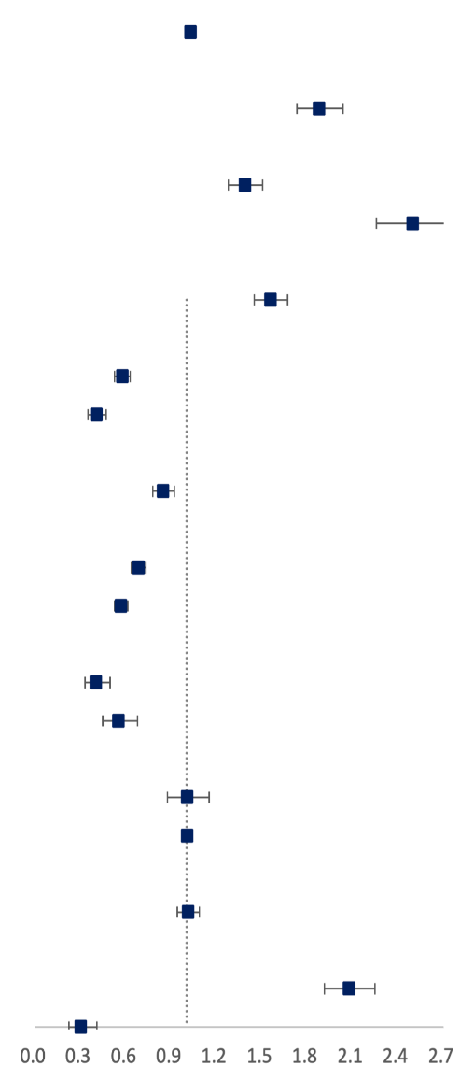
55 to 64 years old | 1.299*(1.189-1.418) |  | 1.386*(1.278-1.503)
65 years old and above | 2.204*(1.977-2.457) |  | 2.497*(2.256-2.765)
Living region (reference: Urban)
Rural | 1.92*(1.383-1.610) |  | 1.555*(1.449-1.670)
Educational status (reference: Elementary school and below)
Middle school | 0.659*(0.598-0.726) |  | 0.575*(0.526-0.630)
High school and above | 0.503*(0.433-0.586) |  | 0.406*(0.351-0.469)
Marital status (reference: Without spouse) |  | 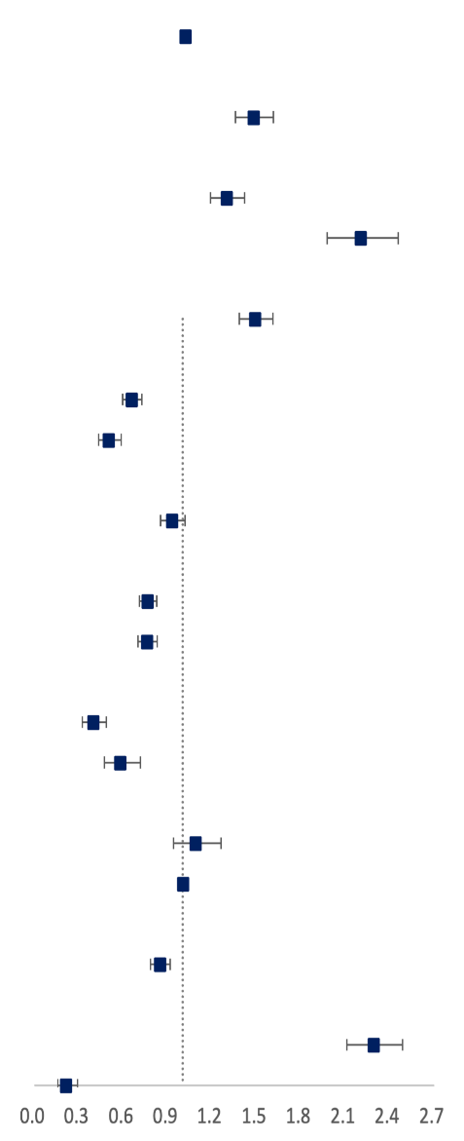
Married and partnered | 0.931(0.851-1.018) |  | 0.846*(0.778-0.920)
Per household income (reference: Lowest)
Middle | 0.766*(0.710-0.827) |  | 0.683*(0.636-0.733)
Highest | 0.763*(0.701-0.829) |  | 0.566*(0.523-0.613)
Working status (reference: No job)
Have job | 0.397*(0.324-0.487) |  | 0.403*(0.329-0.494)
Retirement | 0.581*(0.473-0.715) |  | 0.551*(0.448-0.678)
Medical insurance (reference: No)
Yes | 1.089(0.940-1.261) |  | 1.004(0.876-1.151)
BMI | 1.005*(1.001-1.009) |  | 1.005*(1.001-1.009)
Drinking (reference: No)
Yes | 0.849*(0.785-0.917) |  | 1.011(0.940-1.087)
New CVD incidence (reference: No)
Yes | 2.291*(2.112-2.486) |  | 2.074*(1.914-2.247)
Constant | 0.214*(0.157-0.292) |  | 0.302*(0.224-0.408)

Table 3. Stratified analysis by the subgroup for the association between FGCRS and disability [OR (95% CI)]
Variable | OR (95%CI)
Variable | BADL disability | IADL disability
Gender
Male | 1.030*(1.014-1.046) | 1.052*(1.037-1.068)
Female | 1.020*(1.010-1.030) | 1.023*(1.011-1.030)
Age group
45 to 54 years old | 1.013(0.996-1.030) | 1.027*(1.011-1.043)
55 to 64 years old | 1.0217*(1.009-1.035) | 1.025*(1.013-1.038)
65 years old and above | 1.0219*(1.006-1.038) | 1.038*(1.023-1.054)
Living region
Urban | 1.023*(1.008-1.040) | 1.014(0.999-1.029)
Rural | 1.016*(1.006-1.026) | 1.016*(1.006-1.026)
Per household income
Lowest | 1.017*(1.003-1.031) | 1.033*(1.020-1.046)
Middle | 1.012(0.998-1.027) | 1.032*(1.018-1.046)
Highest | 1.021*(1.003-1.038) | 1.023*(1.007-1.040)
Famine cohort
Never experienced famine | 0.968*(0.942-0.994) | 1.023(0.998-1.047)
Experienced in infancy and child | 1.013(0.993-1.033) | 1.033*(1.014-1.052)
Experienced in adolescence | 1.021*(1.009-1.034) | 1.029*(1.017-1.041)
Experienced after adults | 1.014(0.995-1.034) | 1.006(0.987-1.026)
Note: * means p<0.05.
Table 4. Association of FGCRS and disability using Distributed-Lag Model [OR (95% CI)]
Lag time | BADL disability | IADL disability
0- year | 0.996(0.987-1.005) | -
2- year | 1.015*(1.002-1.028) | 1.018*(1.006-1.031)
4- year | 1.019*(1.002-1.036) | 1.022*(1.005-1.039)
7- year | 1.023*(1.006-1.040) | 1.028*(1.012-1.045)
Note: “-” indicates that there are no baseline data for IADL disability. Specific results can be seen in Table A1 and Table A2.

