

The ARRIVE Guidelines Checklist
Animal Research: Reporting In Vivo Experiments
Carol Kilkenny¹, William J Browne², Innes C Cuthill³, Michael Emerson⁴ and Douglas G Altman⁵
¹The National Centre for the Replacement, Refinement and Reduction of Animals in Research, London, UK, ²School of Veterinary Science, University of Bristol, Bristol, UK, ³School of Biological Sciences, University of Bristol, Bristol, UK, ⁴National Heart and Lung Institute, Imperial College London, UK, ⁵Centre for Statistics in Medicine, University of Oxford, Oxford, UK.

 |  | ITEM | RECOMMENDATION | Section/  Paragraph
Title,
paragraph 1
Abstract,
paragraph1,2
 | INTRODUCTION
 | 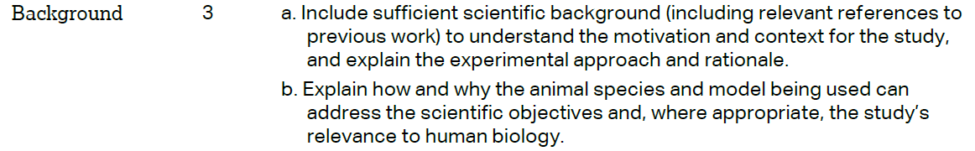 |  |  | Backgroud,  paragraph1,2  Backgroud,  paragraph2，3
Backgroud,
paragraph3
 | METHODS
Declarations ；
Ethics approval and consent to participate
 | 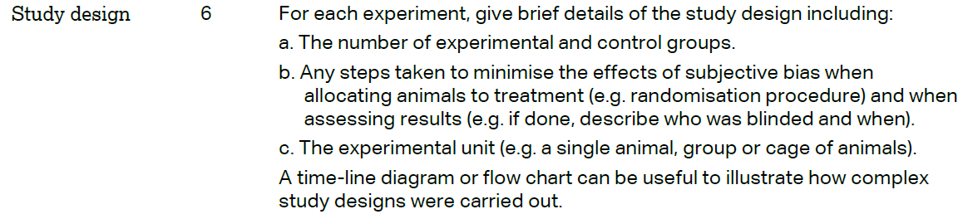 |  |  | Methods,  paragraph2
 | 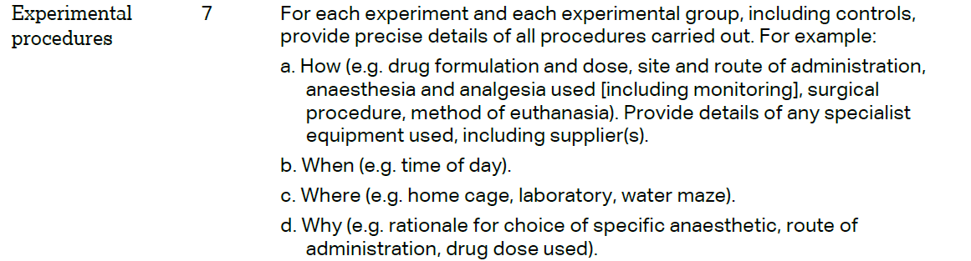 |  |  | Methods,  paragraph2,3
 | 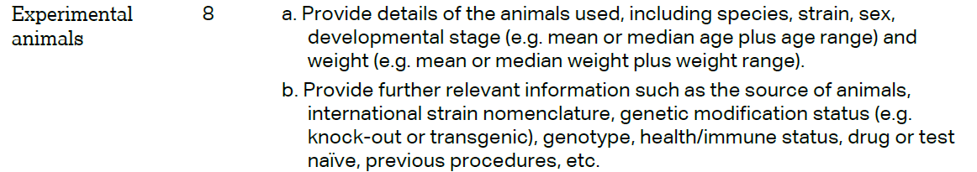 |  |  | Methods,  paragraph1,2
The ARRIVE guidelines. Originally published in PLoS Biology, June 2010¹
 | 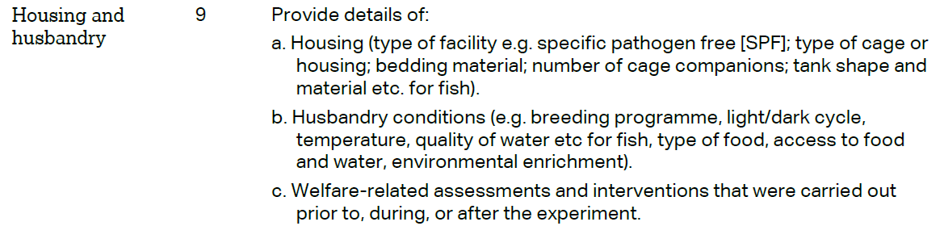 | Methods,  Paragraph1
 | 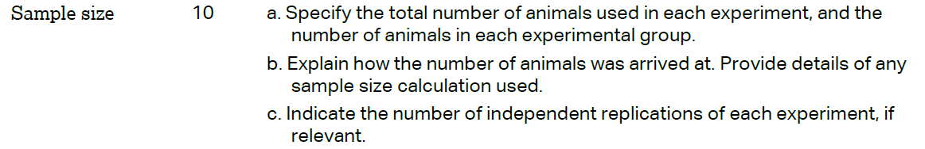 | Methods,  Paragraph1
 | 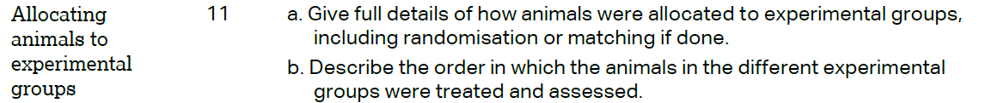 | Methods,  Paragraph1，2
Methods,
paragraph2
 | 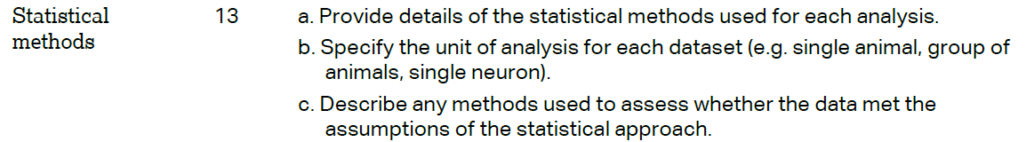 | Methods,  paragraph 3  (Bioinformatics analysis
 | RESULTS
Results,
Microbial
diversity in
chickens
Methods
, Virus enrichment, purification, and nucleic acid extraction
Results,
paragraph
1,2,3
 |  | N/A
 | DISCUSSION
 | 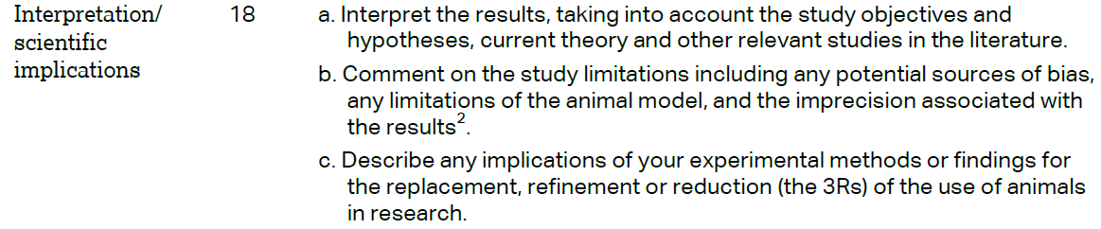 | Discussion,  paragraph 1,2
 |  | N/A
Funding,
paragraph 1

