Extended Data Fig. 1 | Monitoring sites of bird diversity in the YRB. Red dots indicate monitoring sites located in the Natural Forest Conservation Programme, yellow dots indicate monitoring sites in the Sloping Land Conversion Programme and blue dots indicate monitoring sites both in the two programmes. Orange dots indicate monitoring sites without an existing conservation policy.

Extended Data Fig. 2 | Land use change in the Yangtze River Basin and its upper, middle and lower reaches. The analysis of land use change in the Yangtze River Basin and its upper, middle and lower reaches from 2010 to 2020 showed that the land use change in the Yangtze River Basin as a whole showed significant spatial differences. In the upstream area, more land area was converted to woodland and grassland, but less was used by human beings. Land in the middle reaches is mostly converted to arable land, woodland and grassland, but some land is converted to construction land. In the lower reaches, more land is converted to cultivated land and construction land, while less is converted to woodland and grassland than in the upper and middle reaches.

Yangtze River Basin | 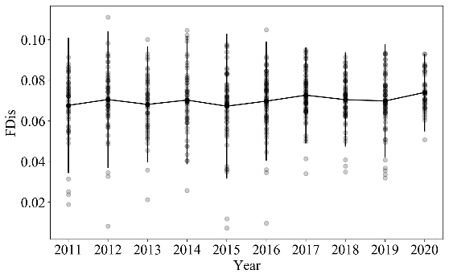 | 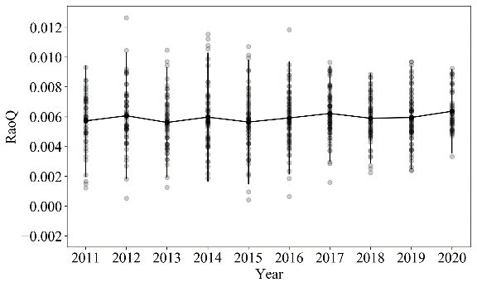
Forest | 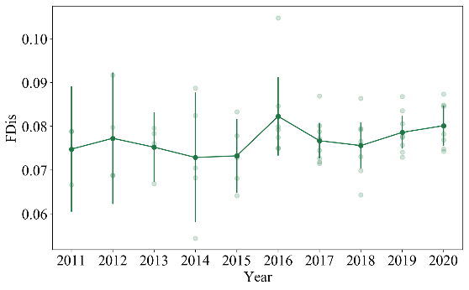 | 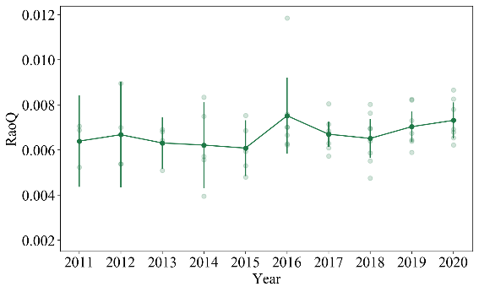
Farmland | 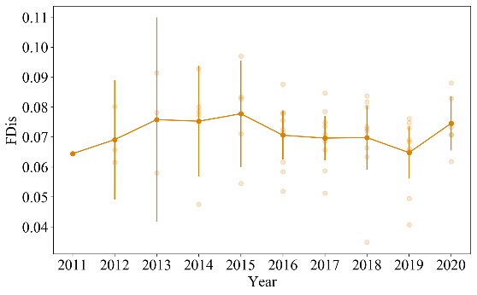 | 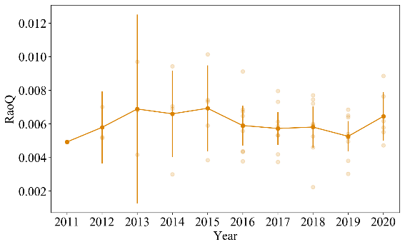
Wetland | 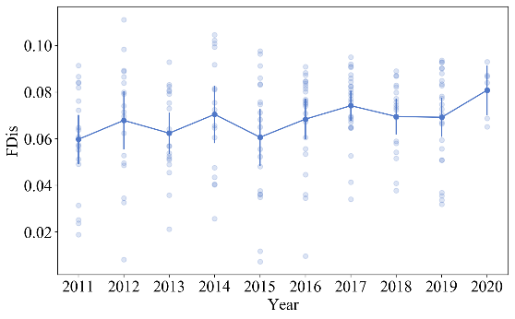 | 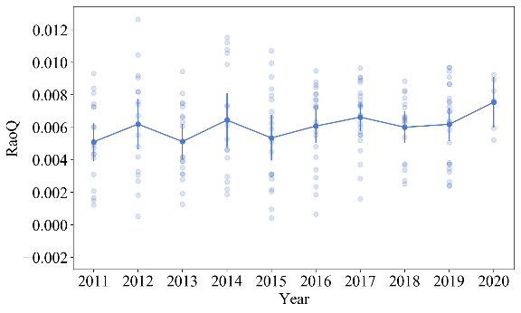

Extended Data Fig. 3 | The dynamic change of bird functional diversity in the Yangtze River Basin and different drainages.

Extended Data Fig. 4 | The trends of LPI of terrestrial birds and waterbirds in the Yangtze River Basin and its upper, middle, and lower reaches.

Extended Data Fig. 5 | The proportion of wildlife under special state protection under the NFCP and SLCP.

Extended Data Fig. 6 | Relationship between the proportion of artificial/natural forest and changes of bird diversity in forest habitats.
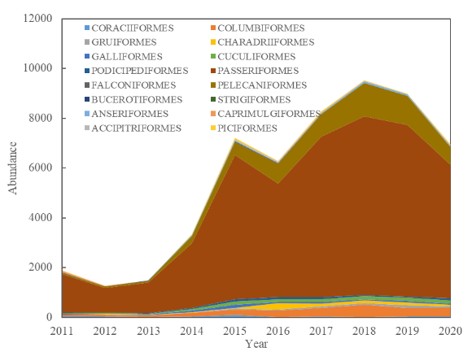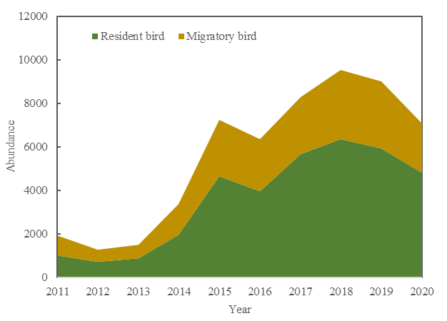
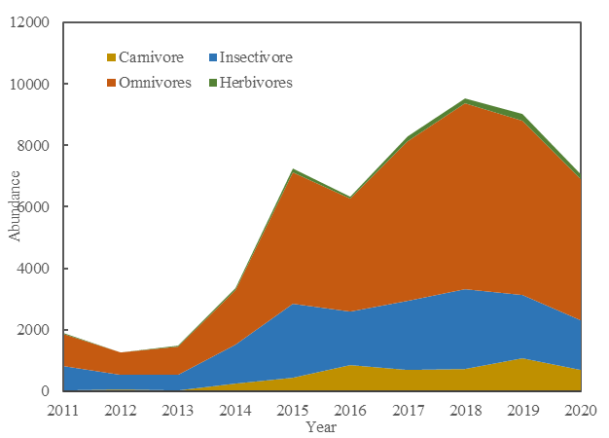
Extended Data Fig. 7 | Temporal variation of bird composition with different characteristics in farmland habitats.

Extended Data Fig. 8 | Relationship between the number of tractors and changes of bird diversity in farmland habitats

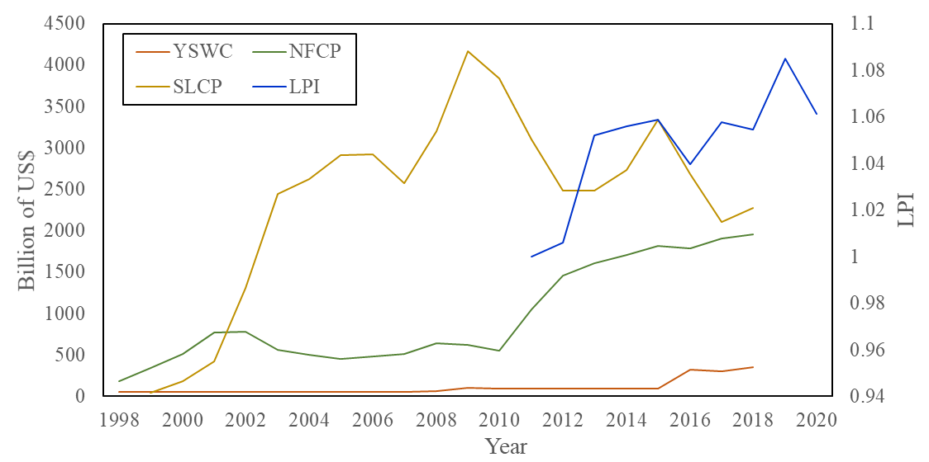
Extended Data Fig. 9 | The investment of conservation and restoration programmes and the Living Planet Index (LPI) in Yangtze River Basin. YSWC: Programme of Soil and Water Conservation; NFCP: Natural Forest Conservation Programme; SLCP: Sloping Land Conversion Programme.

