Discovery of inorganic glass electrolytes with polymer-like viscoelasticity

Tao Dai¹, Siyuan Wu¹, Yaxiang Lu^{1,3,4}*, Yang Yang¹, Yuan Liu¹, Chao Chang¹, Xiaohui Rong^{1,4}, Ruijuan Xiao¹, Junmei Zhao⁵*, Yanhui Liu¹, Weihua Wang¹, Liquan Chen¹, Yong-Sheng Hu^{1,2,3,4}*

¹Key Laboratory for Renewable Energy, Beijing Key Laboratory for New Energy Materials and Devices, Beijing National Laboratory for Condensed Matter Physics, Institute of Physics, Chinese Academy of Sciences, Beijing 100190, China
²College of Materials Science and Optoelectronic Technology, University of Chinese Academy of Sciences, Beijing 100049, China
³Huairou Division, Institute of Physics, Chinese Academy of Sciences, Beijing 101400, China
⁴Yangtze River Delta Physics Research Center Co. Ltd, Liyang 213300, China
⁵Institute of Process Engineering, Chinese Academy of Sciences; Beijing 100190, China.
*Corresponding authors. Email: yxlu@iphy.ac.cn, jmzhao@ipe.ac.cn, yshu@iphy.ac.cn

Discussion 1: Comparison of LACO75 and Li_{0.5}AlCl₂O_{0.75}
First of all, it is further confirmed that the existence of small amount of LiCl in LACO75 through the neutron powder diffraction (NPD) analysis of LACO75 with Rietveld refinement (Supplementary Fig. 2a). Then, as shown in Supplementary Fig. 2c, the ionic conductivity of Li_{0.5}AlCl₂O_{0.75} at 30℃ is 1.3 mS cm⁻¹ and the activation energy is 0.37 eV, slightly inferior to LACO75. However, apart from these subtle differences, the ionic conductivity of Li_{0.5}AlCl₂O_{0.75} is almost identical to that of LiAlCl_{2.5}O_{0.75}. Besides, the loss modulus of Li_{0.5}AlCl₂O_{0.75} peaks at -20.8℃ (Supplementary Fig. 2b), which means there is also no significant difference of T_{g} between Li_{0.5}AlCl₂O_{0.75} and LiAlCl_{2.5}O_{0.75}. The cathodic LSV curves of LiAlCl_{2.5}O_{0.75} and Li_{0.5}AlCl₂O_{0.75} are exactly the same (Supplementary Fig. 2d), indicating the same oxidation resistance.
Discussion 2: MACO preparation
Then MACO are synthesized by two direct heating processes:
- AlCl₃ + MCl → MAlCl₄ at 180℃
- 4MAlCl₄ + Sb₂O₃ → 4MAlCl_{2.5}O_{0.75} + 2SbCl₃↑ at 250℃
M= Li, Na.
Since the boiling points of SbCl₃ are 223.5℃, the SbCl₃ vapor can be removed at 250℃. Thus, the reaction is forced to continuously go to the right direction, which makes it possible to introduce high oxygen contents.
The SbCl₃ are recyclable because it can react with water to produce Sb₂O₃. Therefore, Sb₂O₃ can be excluded from the cost calculation in Supplementary Table 2.
Discussion 3: Li_{2x}AlCl₃S_{x} (x > 0, LACS).
It is found that not only BO, sulfur can also promote the ionic conductivity of LiAlCl₄. As shown in Supplementary Fig. 18, with the increase of sulfur content from 25% to 200%, the ionic conductivity showed a trend of increasing first and then decreasing. The LiAlCl₃S_{0.5} has an ionic conductivity of 1.0×10⁻⁴ S cm⁻¹ and the activation energy of 0.41 eV. The LASC is synthesized by direct mixing AlCl₃ and Li₂S and heating, which means one S²⁻ is introduced with two Li⁺. Thus, with the increase of sulfur content, a large amount of excessive Li⁺ will be introduced. The ionic conductivity of LiAlCl₃S_{0.5} should not be the highest value and the ratio of S/Al =0.5 is also not the optimal content. The higher ionic conductivity may be achieved by better synthesis methods to introduce S²⁻ in LiAlCl₄ in the future.

Discussion 4: The hardening process.
It is worth noting that the hardness of the melts at room temperature gradually increases within two days after synthesis but the viscoelasticity is still retained, which can be proved in all the above DMA tests. As shown in Supplementary Video 5, a continuous film can be easily scraped on the surface of a hardened LACO75 rod at room temperature, which is still notably different from the brittle LiAlCl₄ in Supplementary Video 1. However, when the hardened MACO are reheated, their hardness will decrease again and recover the flexibility perfectly, which means the hardening processes are completely reversible. All the MACO samples (except Supplementary Video 3 and 4) mentioned had undergone the hardening process.

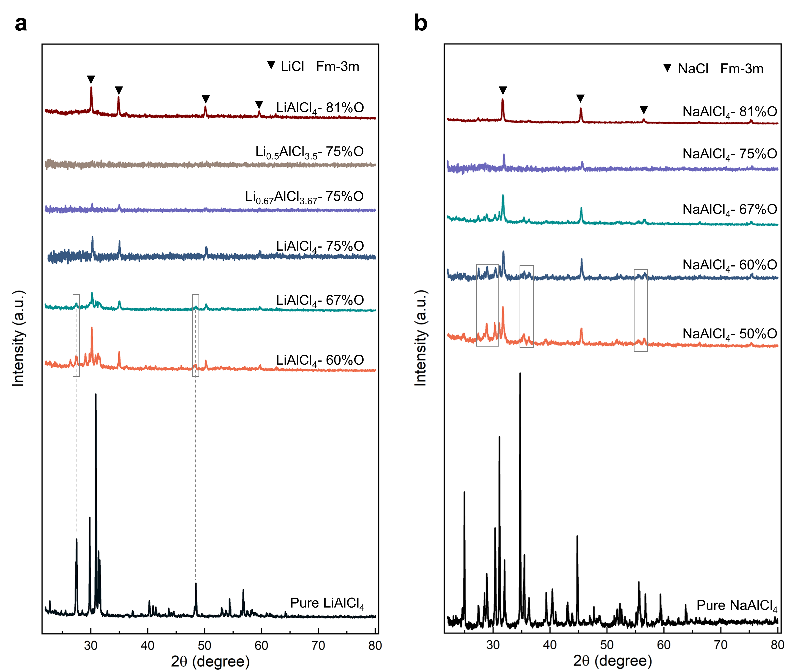
Fig. 1 | XRD diffraction patterns of MACO. a, XRD patterns of LACO with varying oxygen contents. b, XRD patterns of NACO with varying oxygen contents. The XRD signal intensities of MACO are the real intensities under the same test condition without any proportional reduction or increase.

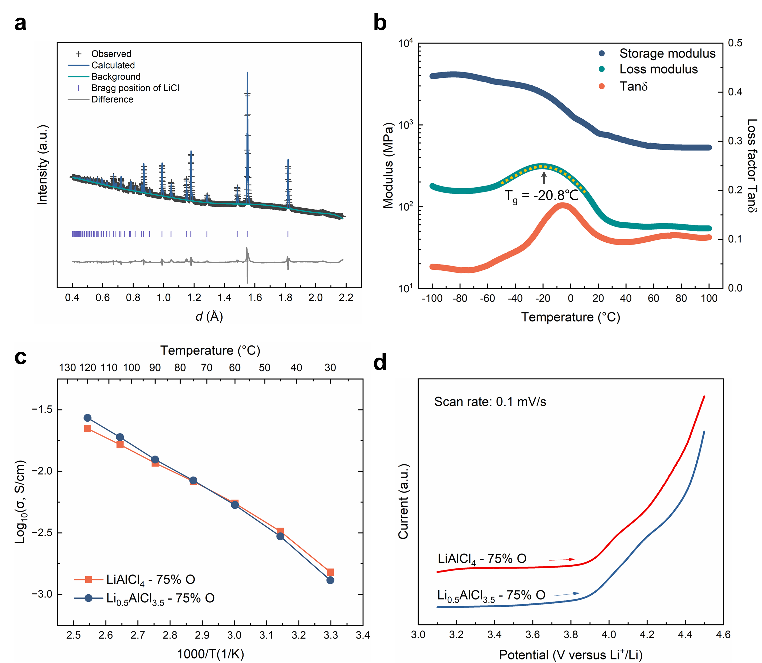
Fig. 2 | Comparison of LACO75 and Li_{0.5}AlCl₂O_{0.75}. a, Neutron powder diffraction (NPD) patterns of LACO75 along with Rietveld refinement of the pure phase LiCl. b, Dynamic moduli and loss tangent of Li_{0.5}AlCl₂O_{0.75} in DMA tests at various temperatures. c, Temperature-dependent conductivities of LACO75 and Li_{0.5}AlCl₂O_{0.75}. d, Cathodic LSV curves of LACO75 and Li_{0.5}AlCl₂O_{0.75} at a scan rate of 0.1 mV/s.

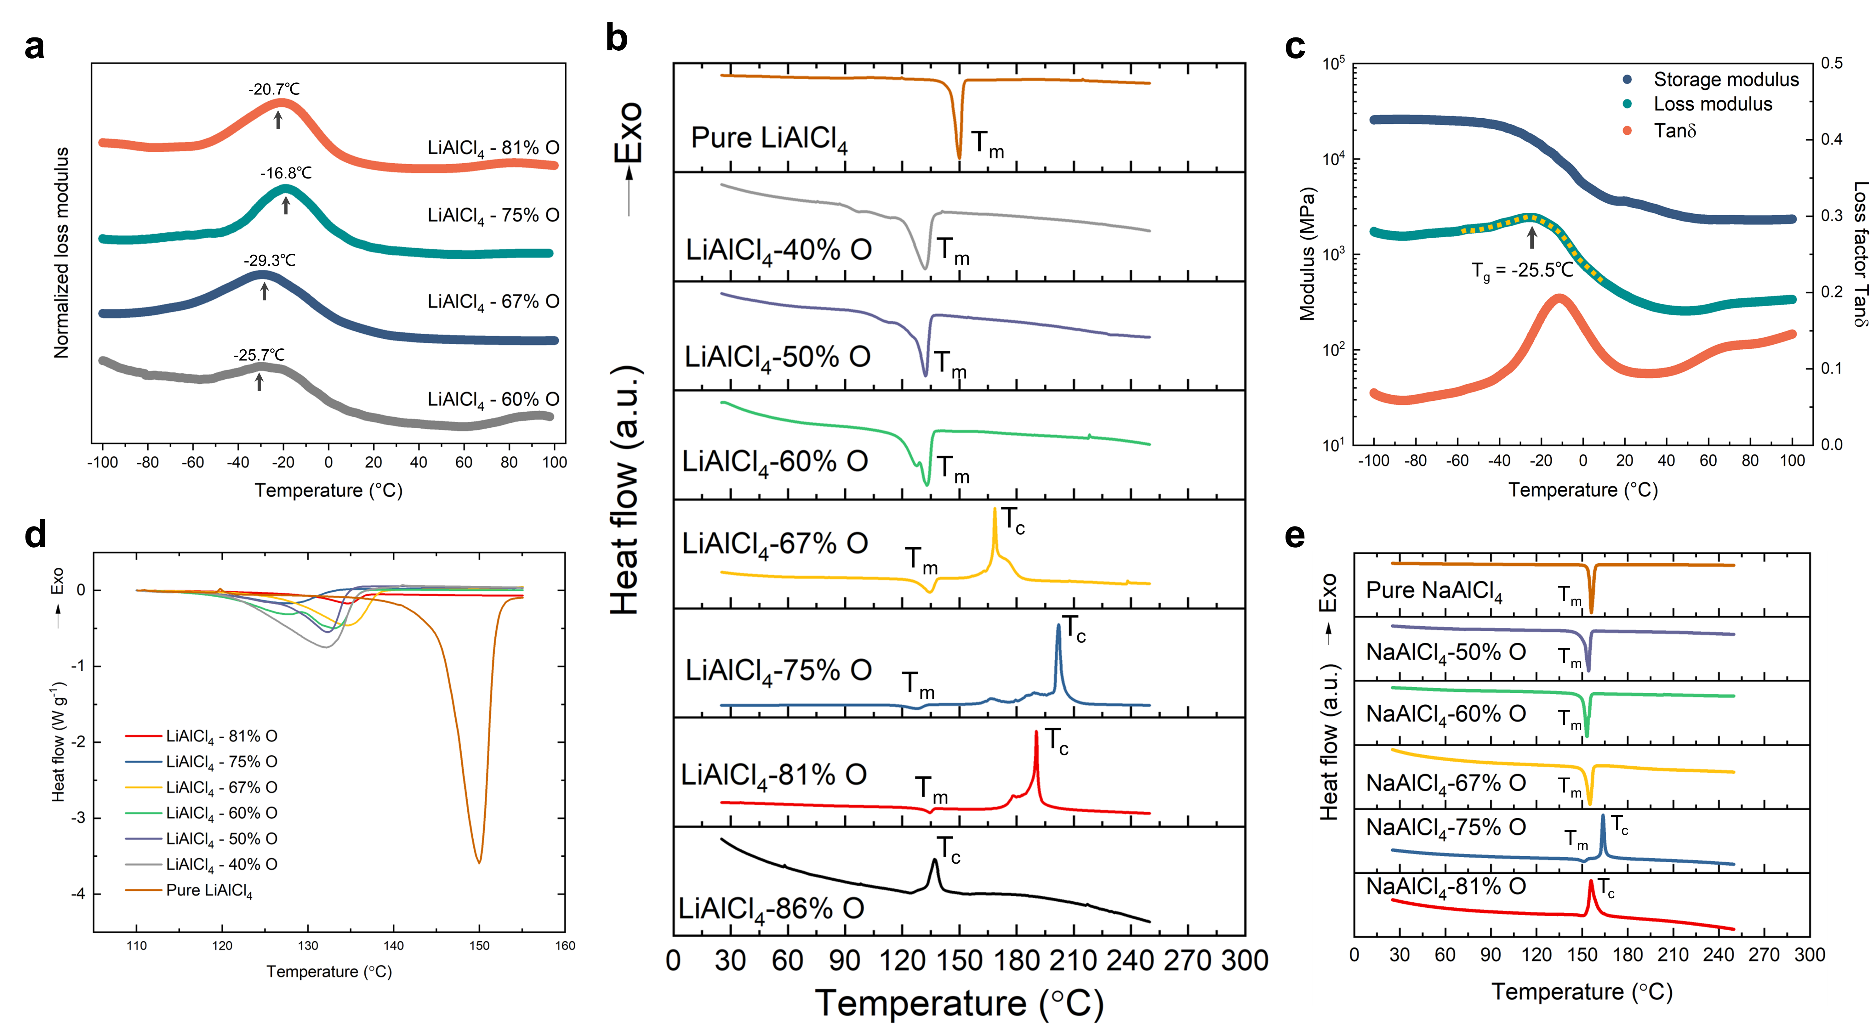
Fig. 3 | Thermal analysis of MACO. a, Normalized dynamic loss moduli of LACO in DMA tests at various temperatures. Their peaks signify the glass transition temperature (T_{g}). b, DSC heating profiles of LACO with different oxygen contents. c, Dynamic moduli and loss tangent of NACO75 in the DMA tests at different temperatures. d, Enlarged endothermic peaks of LACO in the DSC profiles for comparison. e, DSC heating profiles of NACO with different oxygen contents. The exothermic direction is upward.

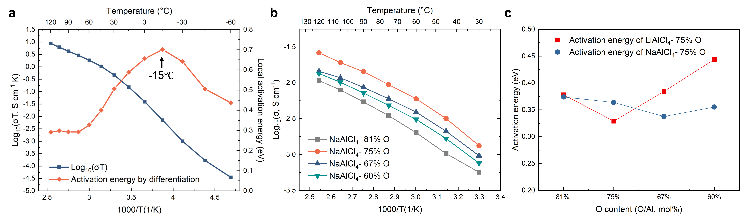
Fig. 4 | Ionic conduction properties. a, “Local activation energies” of LACO75. The activation energy is obtained by taking the derivative of Log10 (σT). b, Ionic conductivities of NACO with different oxygen contents as a function of temperature. c, Activation energies of LACO and NACO with different oxygen contents, calculated based on the data within 30-120°C.

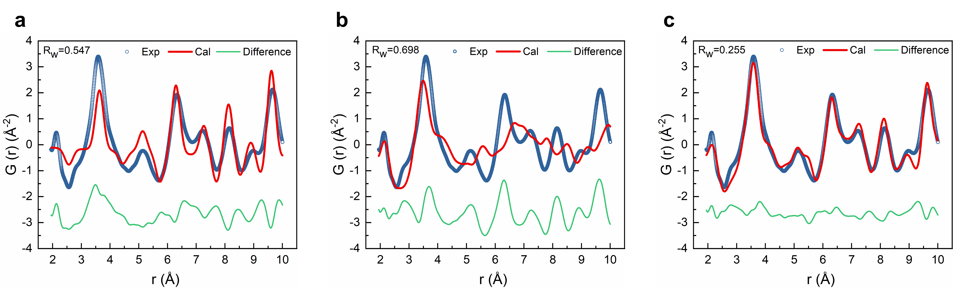
Fig. 5 | Pair distribution function (PDF) analysis of LACO75 from total neutron scattering data. a-c, Comparison of experimental PDF spectra with the calculated spectra of LiCl (Fm-3m) (a), the amorphous LACO75 structure (b) obtained by Ab initio molecular dynamics (AIMD) simulation and the complex consists of 89 wt% amorphous LACO75 and 11 wt% LiCl (c). It is demonstrated that the complex made up of 89 wt% amorphous LACO75 and 11 wt% LiCl matches well with the experimental PDF curve, validating the rationality of AIMD simulation.

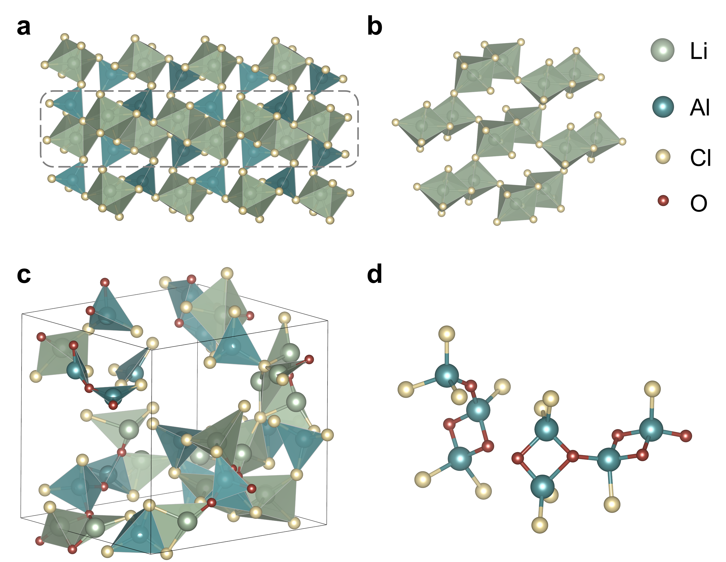
Fig. 6 | Structure of LiAlCl₄ and LACO75 by AIMD simulation. a, b, Layered structure (a) and “pseudolayers” (b) constituted by Li₂Cl₁₀ dimers of LiAlCl₄. c, d, Structure (c) and fragments (d) containing only Al, O and Cl of LACO75 obtained by the AIMD simulation.

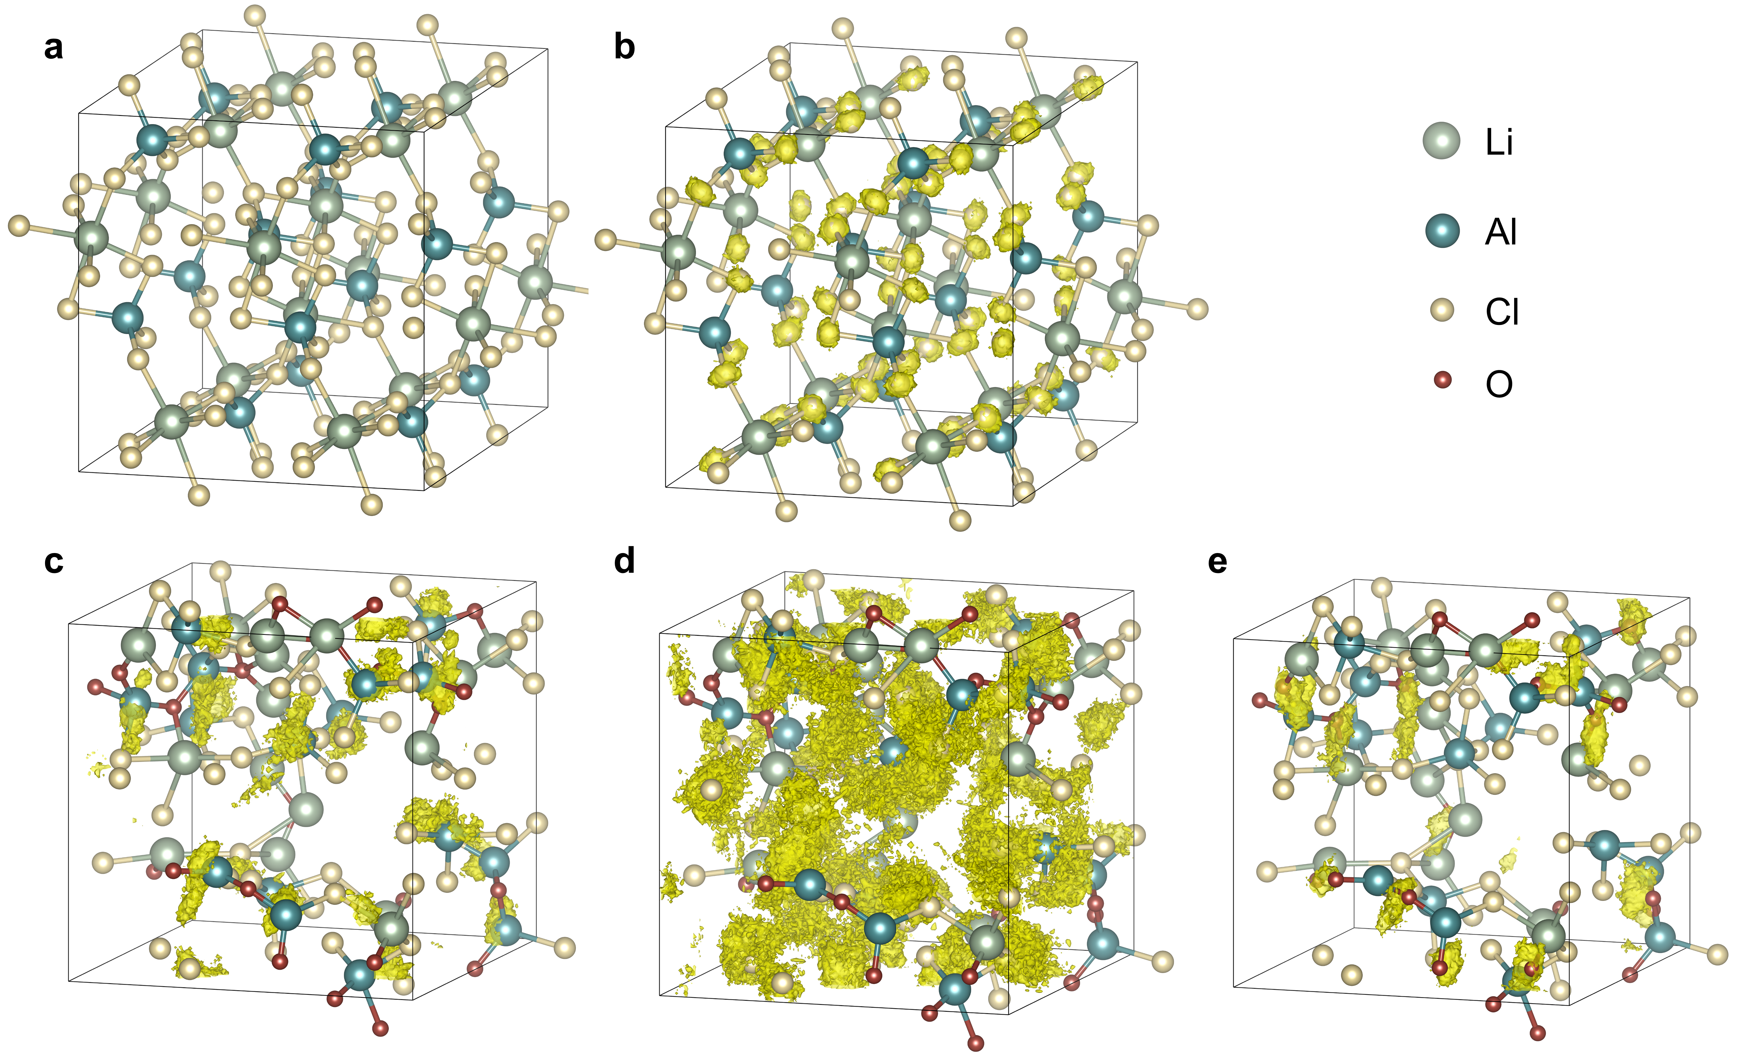
Fig. 7 | Atom position distribution during 0-100 ps at 300 K. a, b, Al (a) and Cl (b) in LiAlCl₄. c-e, Al (c), Cl (d) and O (e) in LACO75.

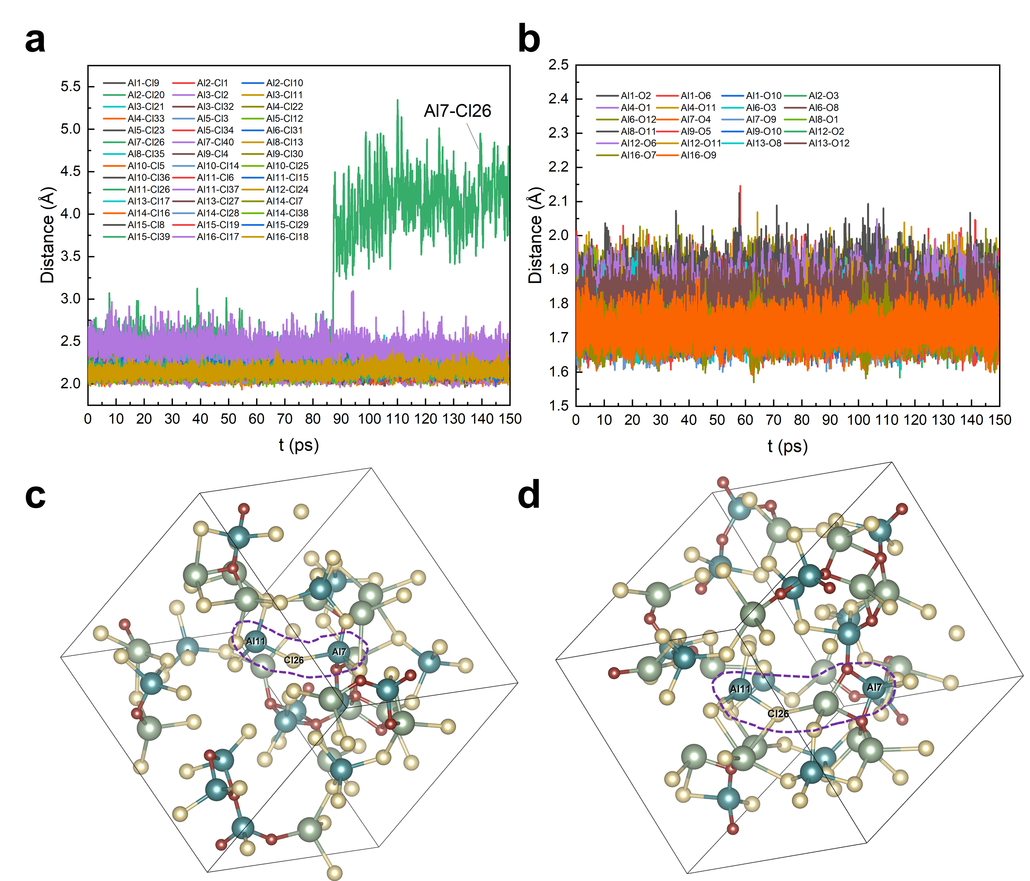
Fig. 8 | Distances between aluminum and surrounding anions. a, b, Lengths of all Al-O (a) and Al-Cl (b) bonds of LACO75 during 0-150 ps at 300K. c, d, Positions of Al7-Cl26 and Al11-Cl26 bonds at 0 ps (c) and 150 ps (d).

As shown in Supplementary Fig. 8a, b, The length of Al-Cl and Al-O bonds all remains constant except that of Al7-Cl26. However, the breaking of Al7-Cl26 bond does not imply the migration of Cl26, because Cl26 actually bonds with both Al7 and Al11 at 0 ps and then bonds only with Al11 after 87 ps, as demonstrated in Supplementary Fig. 8c, d. The bond of Al11-Cl26 is never broken during the entire simulation. Therefore, there is no separate migration of O²⁻ and Cl⁻.

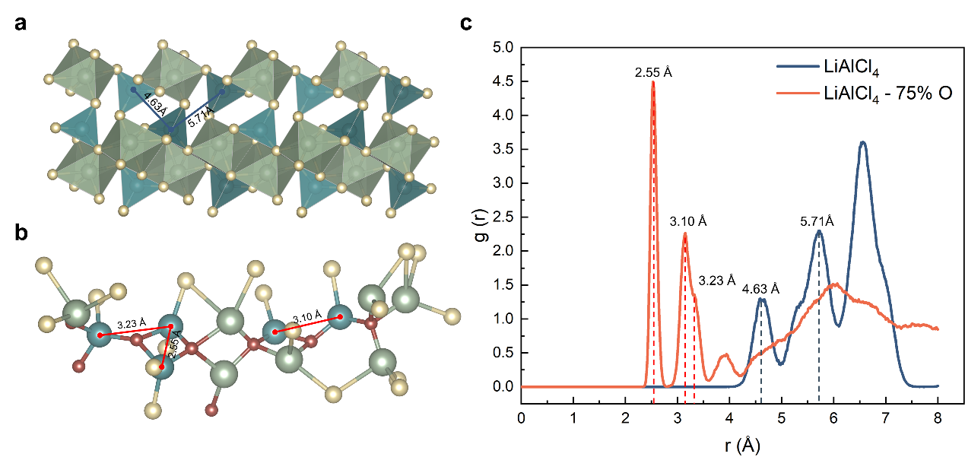
Fig. 9 | Structure and Al-Al RDF of LiAlCl₄ and LACO75. a, b, Microstructural fragments of LiAlCl₄ (a) and LACO75 (b). c, RDF of Al-Al in LiAlCl₄ and LACO75.

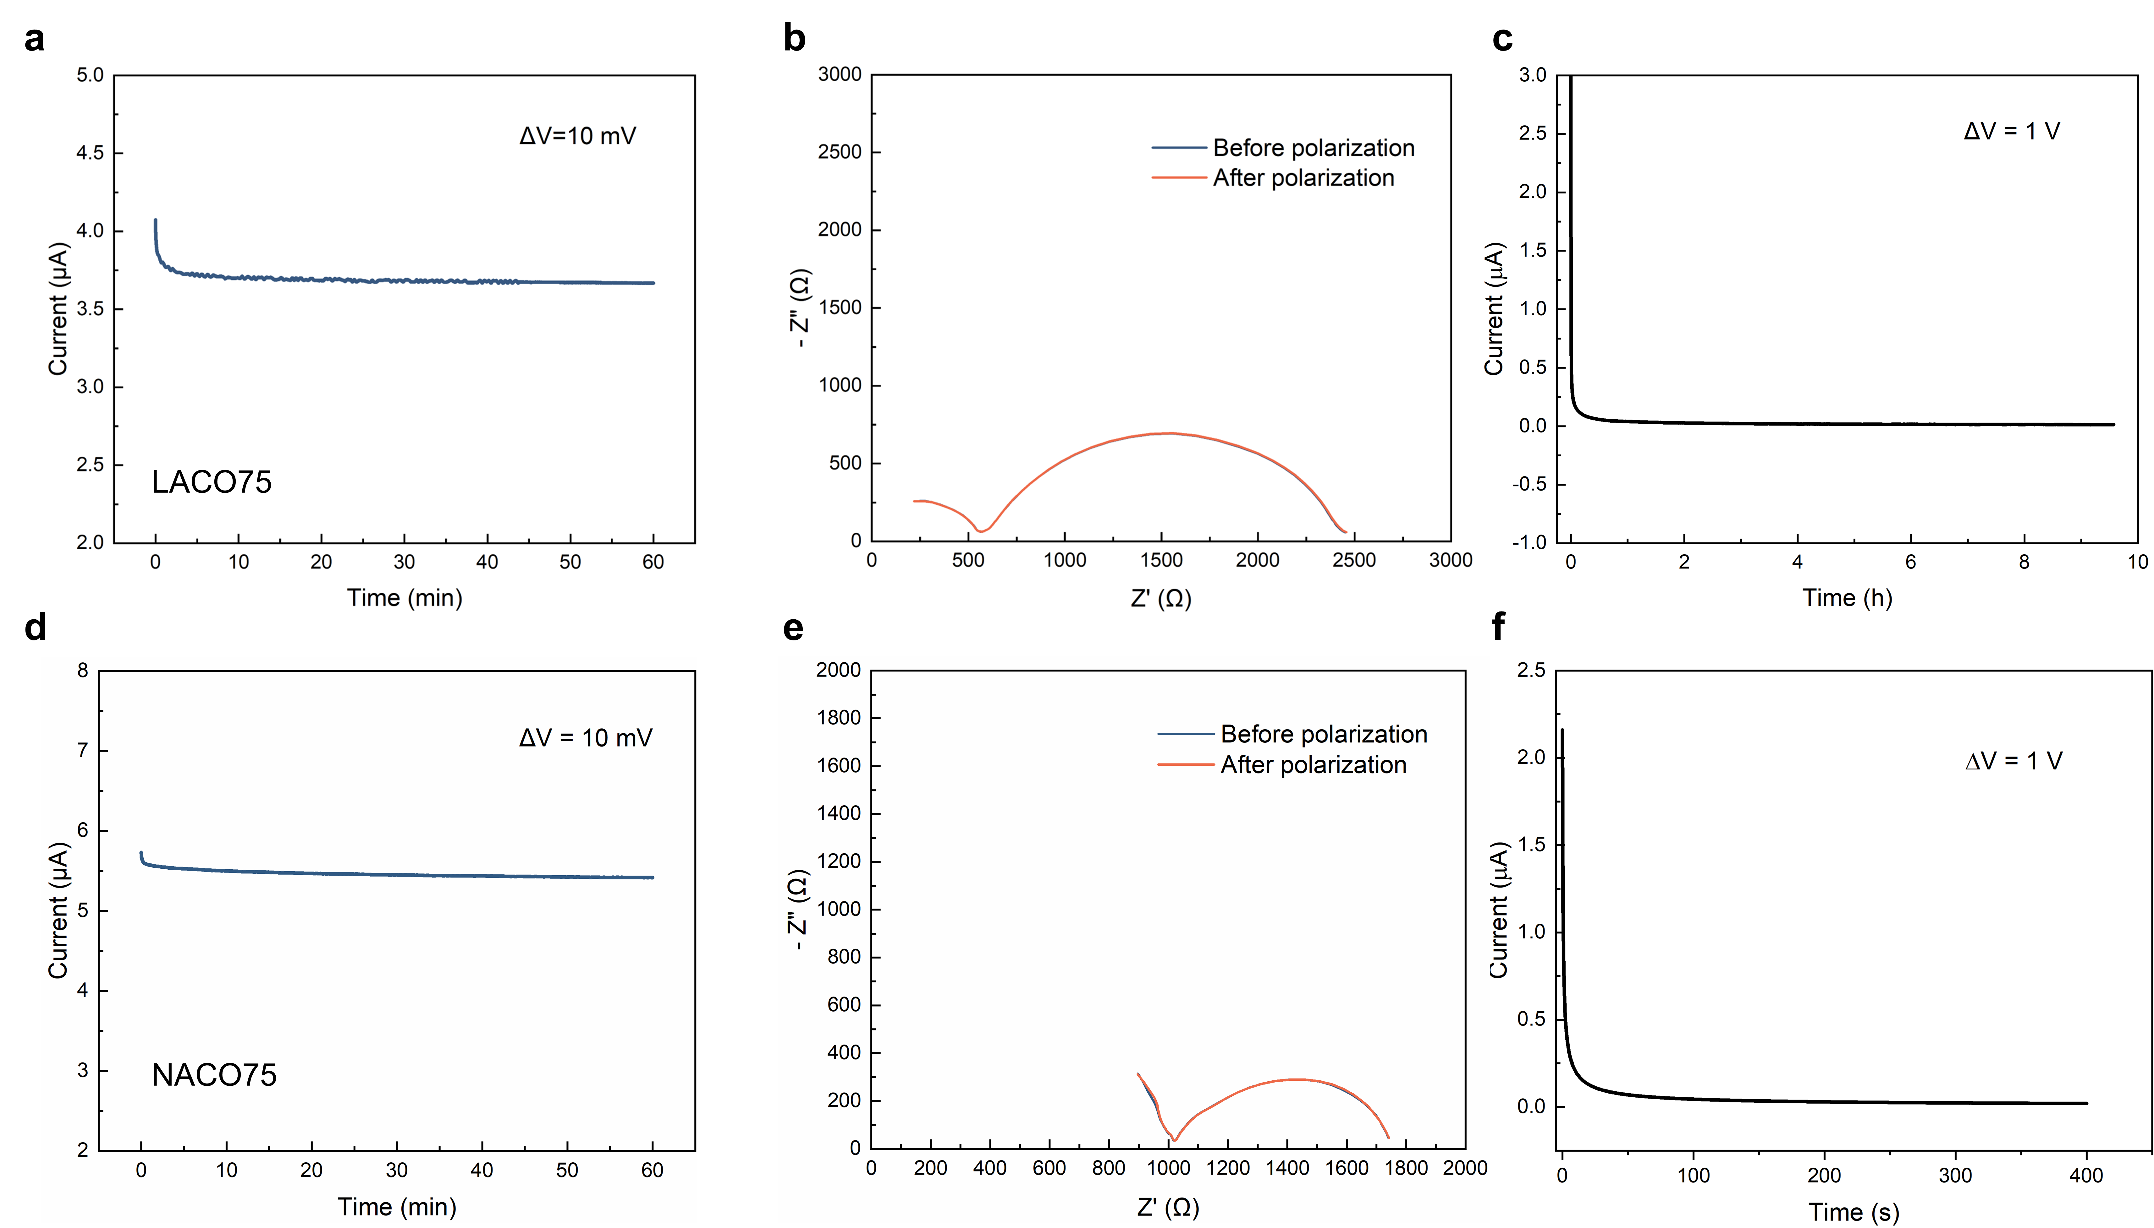
Fig. 10 | Transference number and electronic conductivity. a, b, DC polarization curve (a) and Nyquist plots before and after polarization (b) of LACO75. d, e, DC polarization curve (d) and Nyquist plots before and after polarization (e) of NACO75. c, f, DC polarization curve of the Ni/LACO75/Ni cell (c) and Ni/NACO75/Ni cell (f) for electronic conductivity testing. The transference number of LACO75 and NACO75 are 0.69 and 0.91 at 30°C, respectively. The electronic conductivity of LACO75 and NACO75 are 4.7×10⁻⁸ S cm⁻¹ and 4.3×10⁻⁸ S cm⁻¹ at 30°C, respectively.

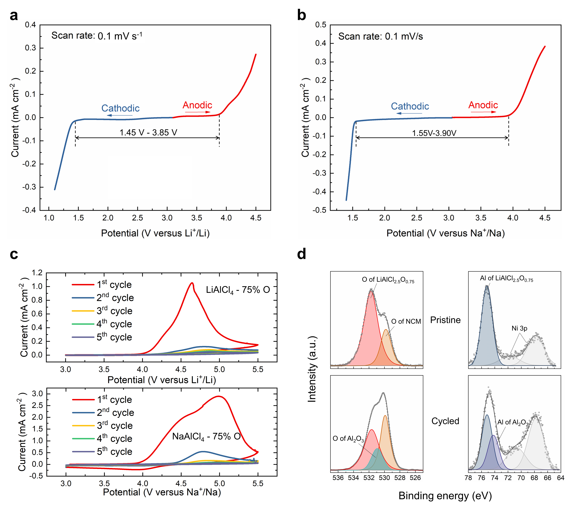
Fig. 11 | Potential windows and oxidation resistance of MACO. a, b, Linear sweep voltammetry (LSV) curves of the LACO75-CNT (a) and NACO75-CNT (b) composite electrodes at a scan rate of 0.1 mV/s. c, 3.0- 5.5 V cyclic voltammetry (CV) curves of the LACO75-CNT and NACO75-CNT composite electrodes at initial 5 cycles with a scan rate of 0.1 mV/s. d, O 1s and Al 2p X-ray photoelectron spectroscopy (XPS) spectra of pristine and charged LACO75-NCM622 composite cathodes.

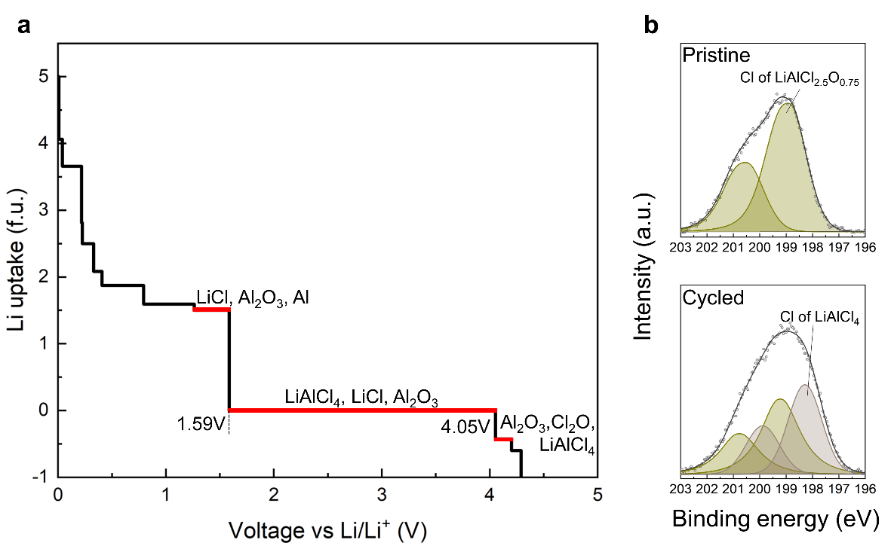
Fig. 12 | Calculated electrochemical window of LACO75 at 0 K and the Cl 2p XPS spectra before and after cycling. a, Plot of Li uptake per formula unit (f.u.) of LACO75 solid electrolyte dependent on the voltage vs Li/Li⁺. At low voltage (high Li chemical potential), LACO75 is reduced and uptakes Li while at high voltage (low Li chemical potential), LACO75 undergoes oxidation and loses Li. The predicted phase equilibria at corresponding regions of the profile are shown in the Supplementary Text 1. Note that Cl₂O is not actually exist due to the instable nature at RT. b, Cl 2p XPS spectra of pristine and charged LACO75- NCM622 composite cathodes.

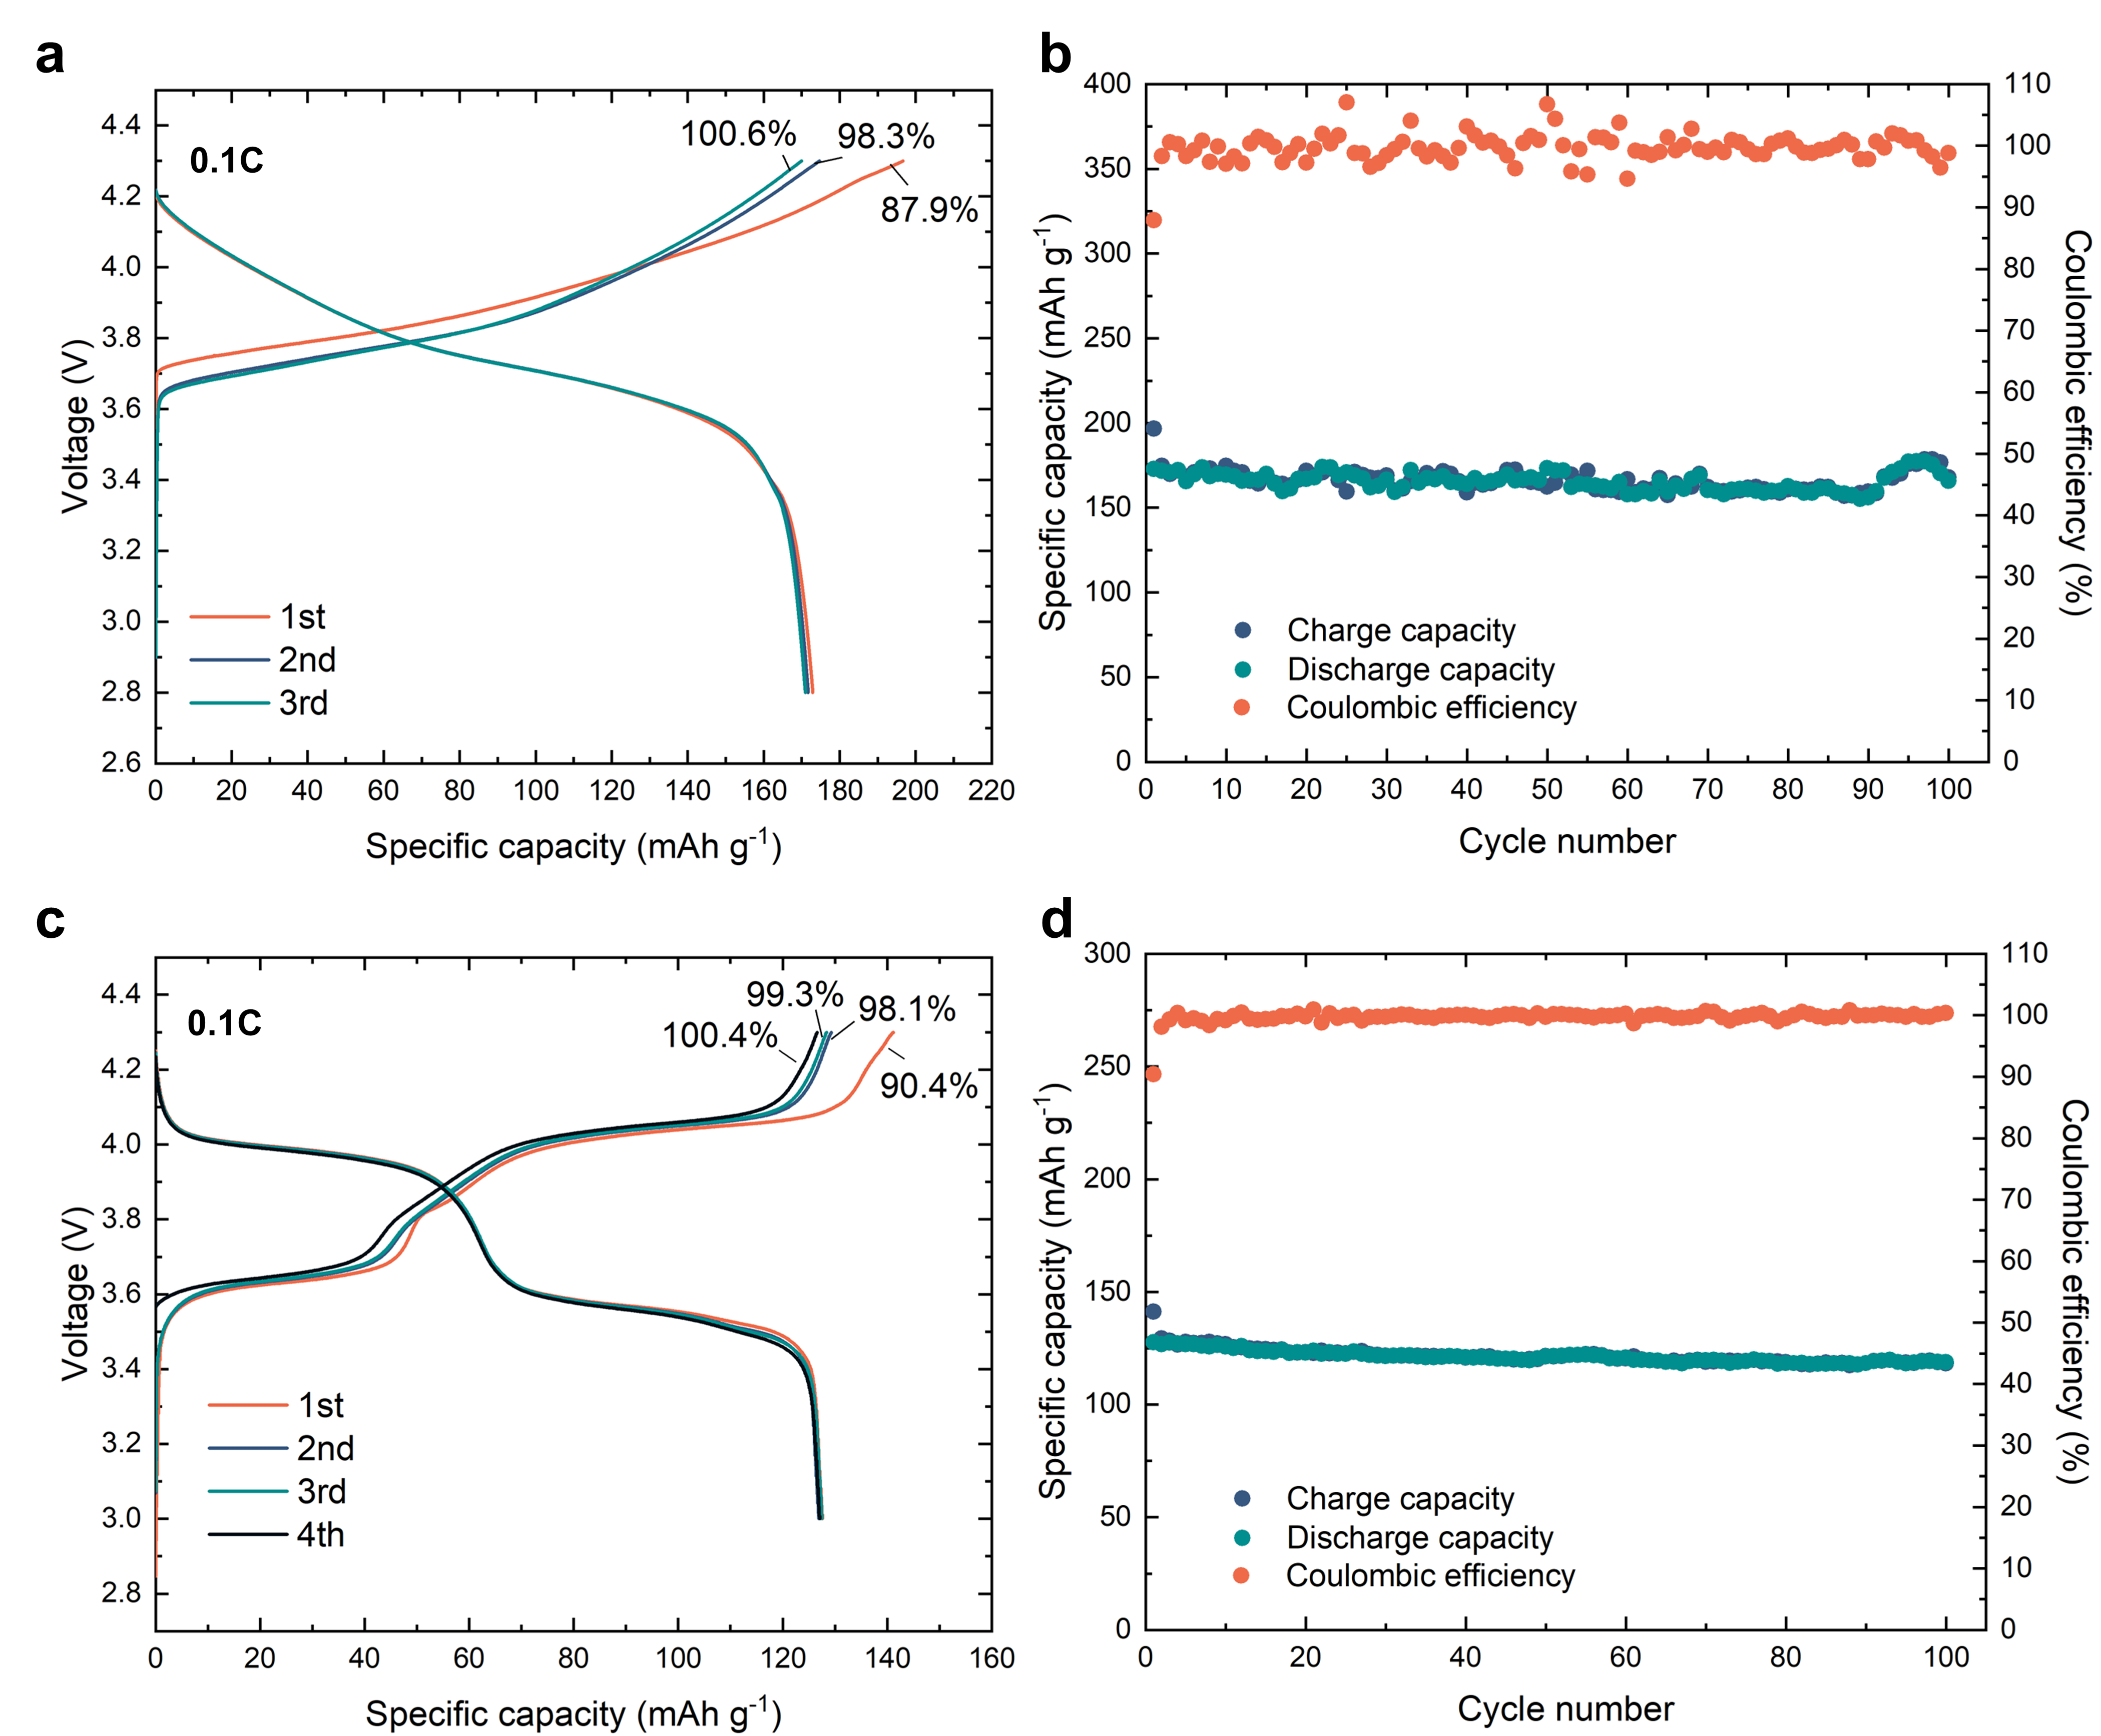

Fig. 13 | Electrochemical performance of MACO in solid-state batteries at 30°C. a, b, Initial charge and discharge profiles (a) and capacity retention (b) of the Li/LLZTO/LACO75/NCM622 cell cycled between 2.8-4.3V at 0.1C and at 30℃. c, d, Initial voltage curves (c) and capacity retention (d) of the Na/NASICON/NACO75/NVOPF cell cycled at 0.1C with cutoff voltages set at 3.0 V and 4.3 V at 30 °C.

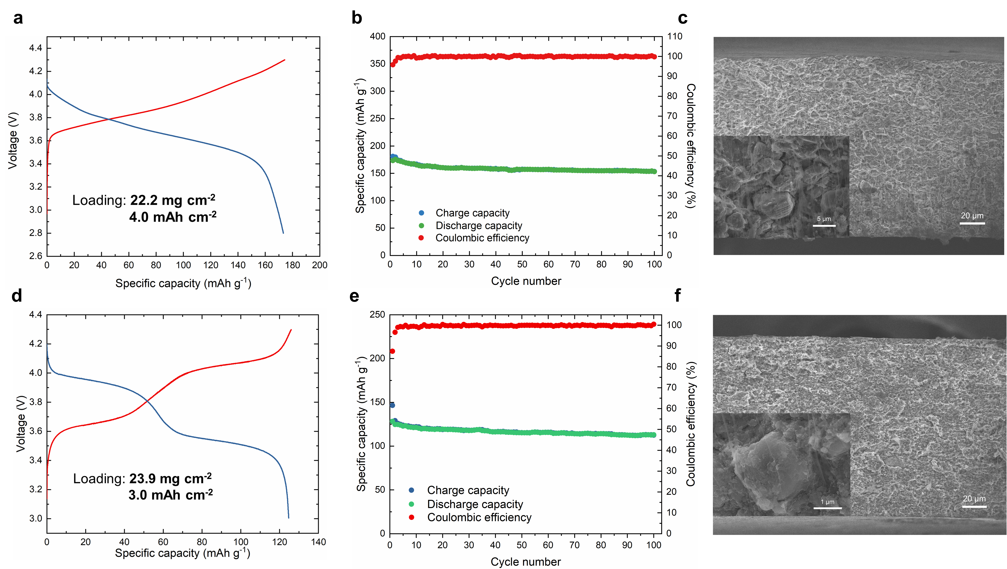

Fig. 14 | Cycling performance of MACO solid-state batteries with thick cathodes. a, b, Voltage profiles (a) at 3rd cycle and the capacity retention performance (b) of the Li/LLZTO/LACO75/NCM622 cell. d, e, Voltage curves (d) at 3rd cycle and the cycling performance (e) of the Na/NASICON/ NACO75-NVOPF cell. Both Li and Na cells were charged to 4.3 V at 0.1C and operated at 60℃. c, f, Cross-section morphology of the thick NCM622 (c) and thick NVOPF (f) cathodes. The inset of enlarged view shows that cathode particles are tightly embedded in the matrixes.

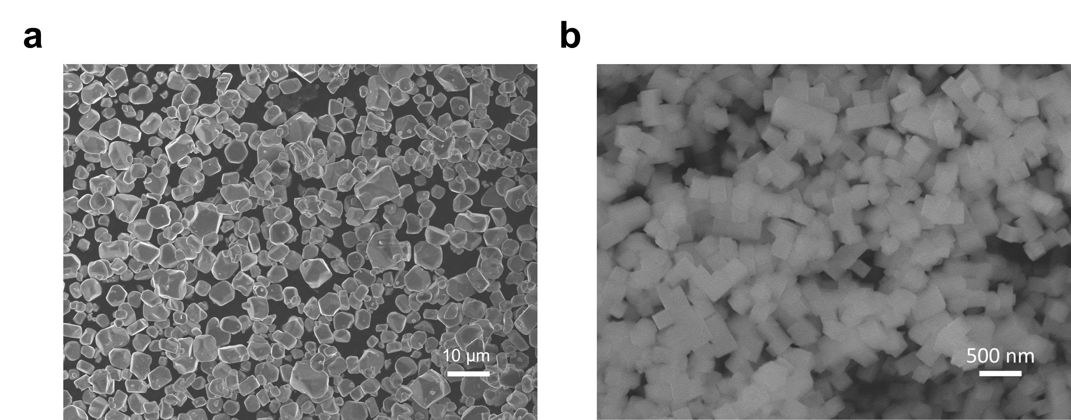
Fig. 15 | SEM images of cathode materials without any coatings. a, NCM622 particles. b, NVOPF particles.

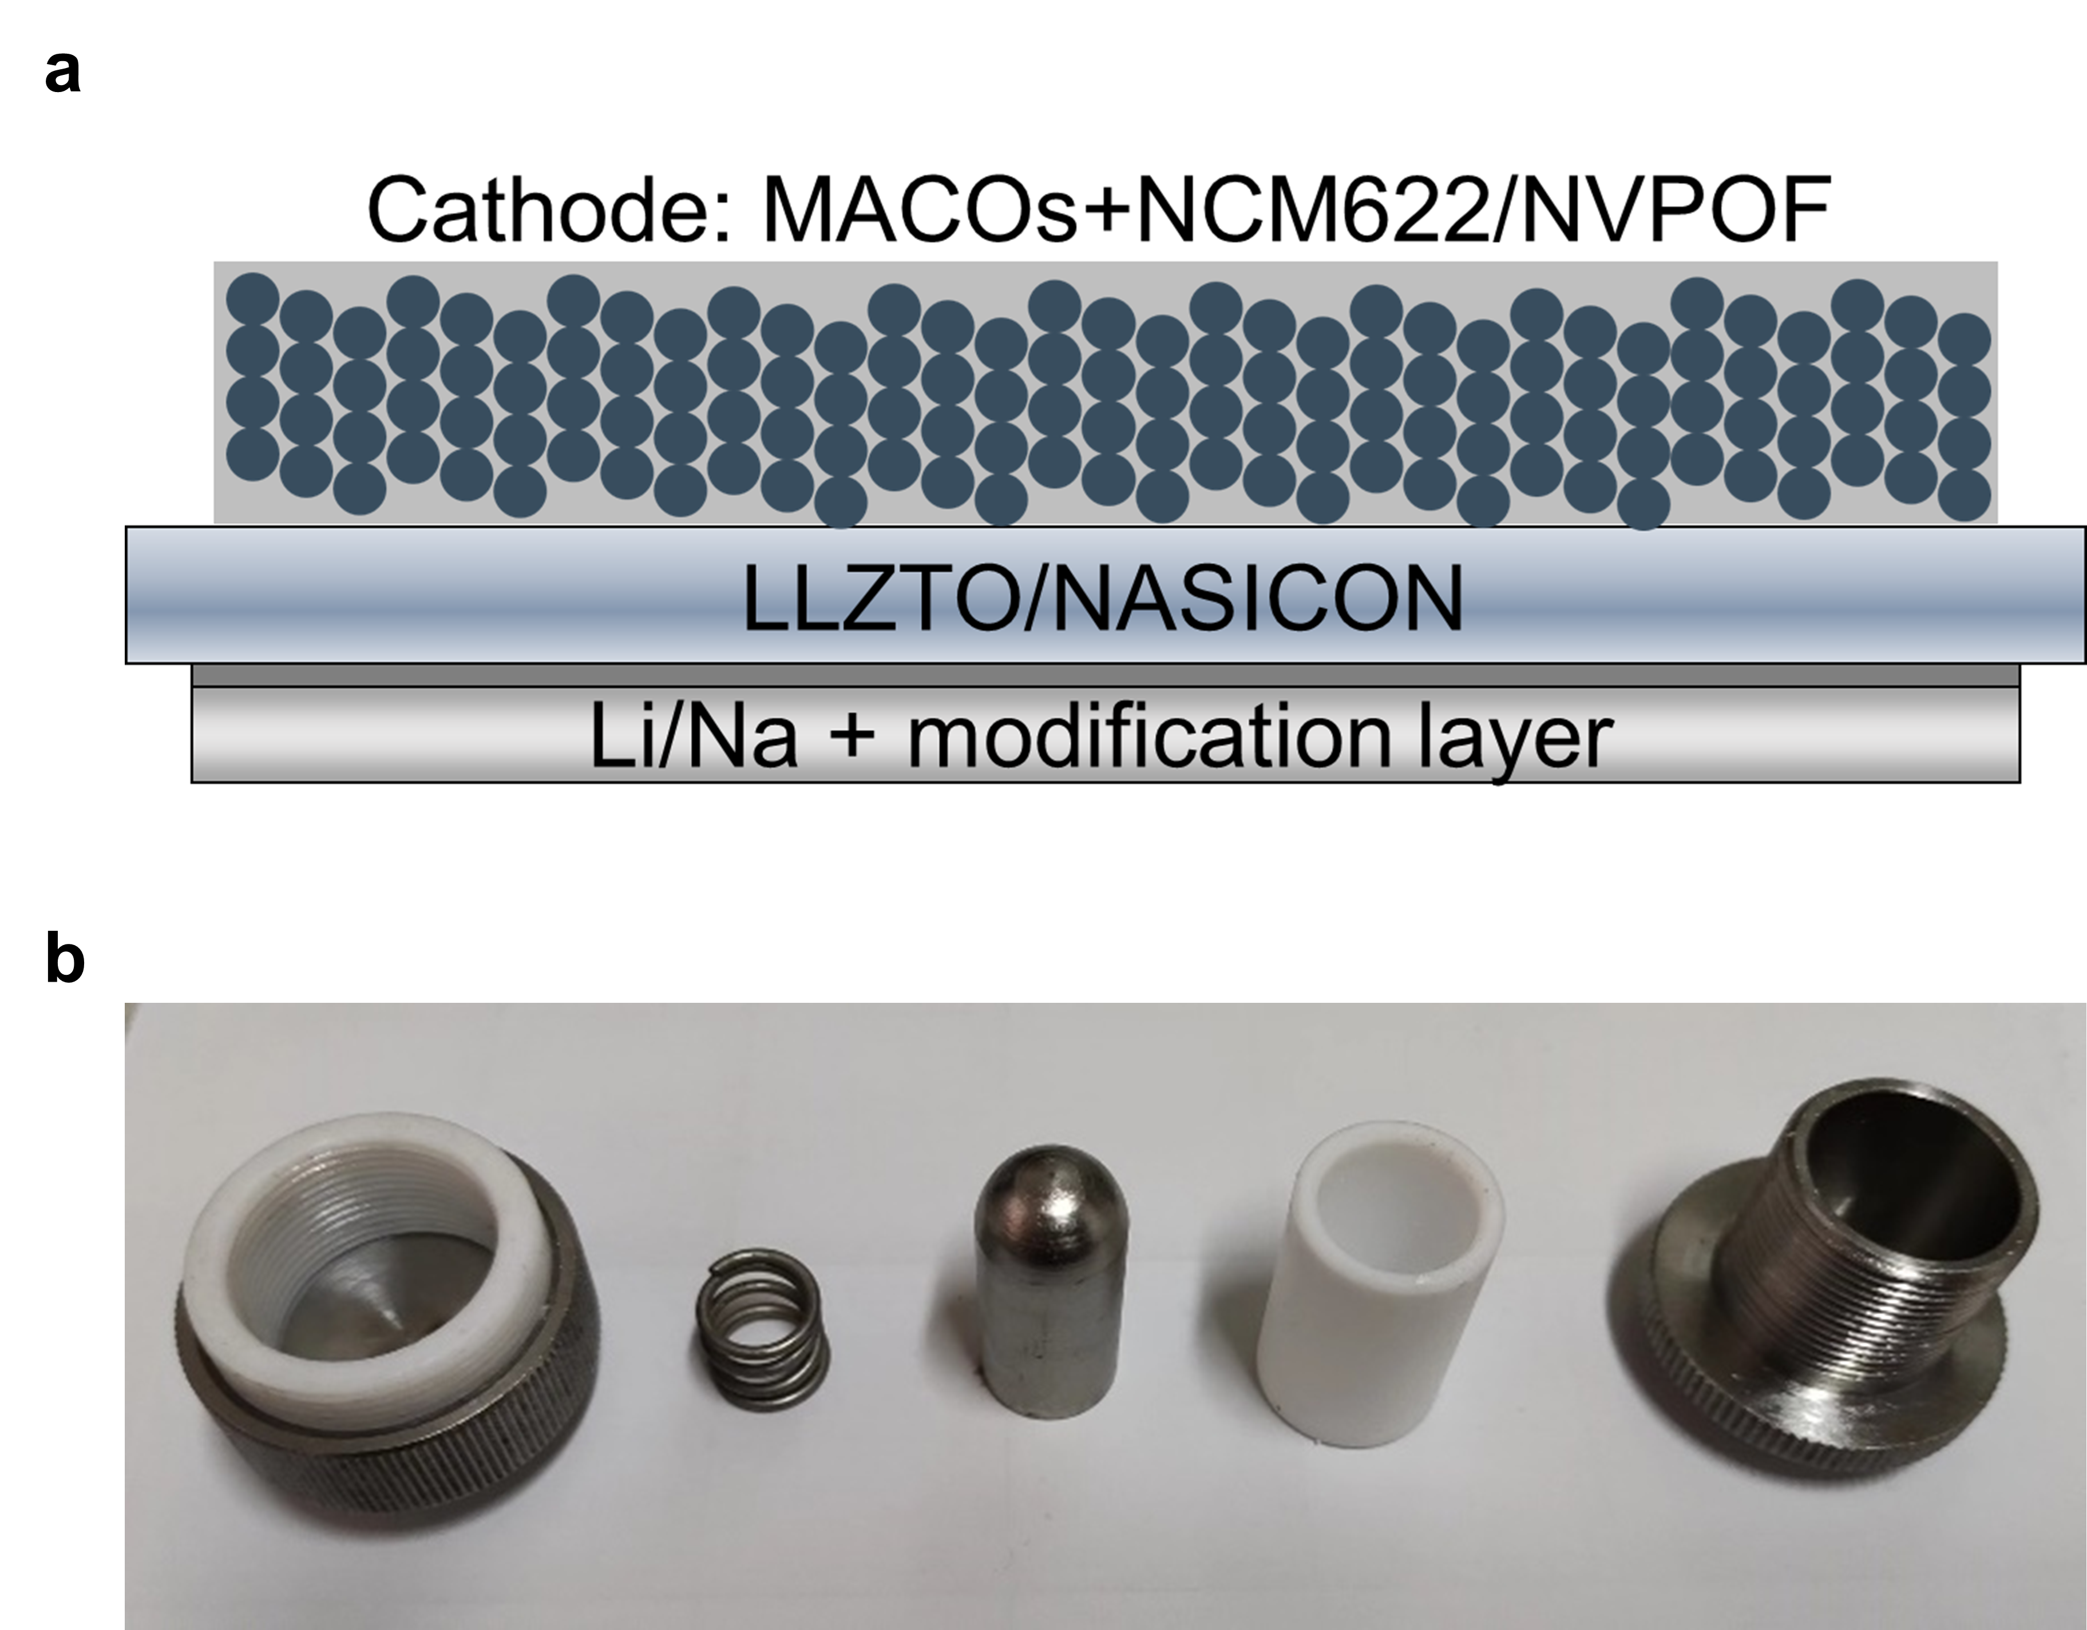
Fig. 16 | Schematic diagram of cell configuration and home-made battery case for testing.

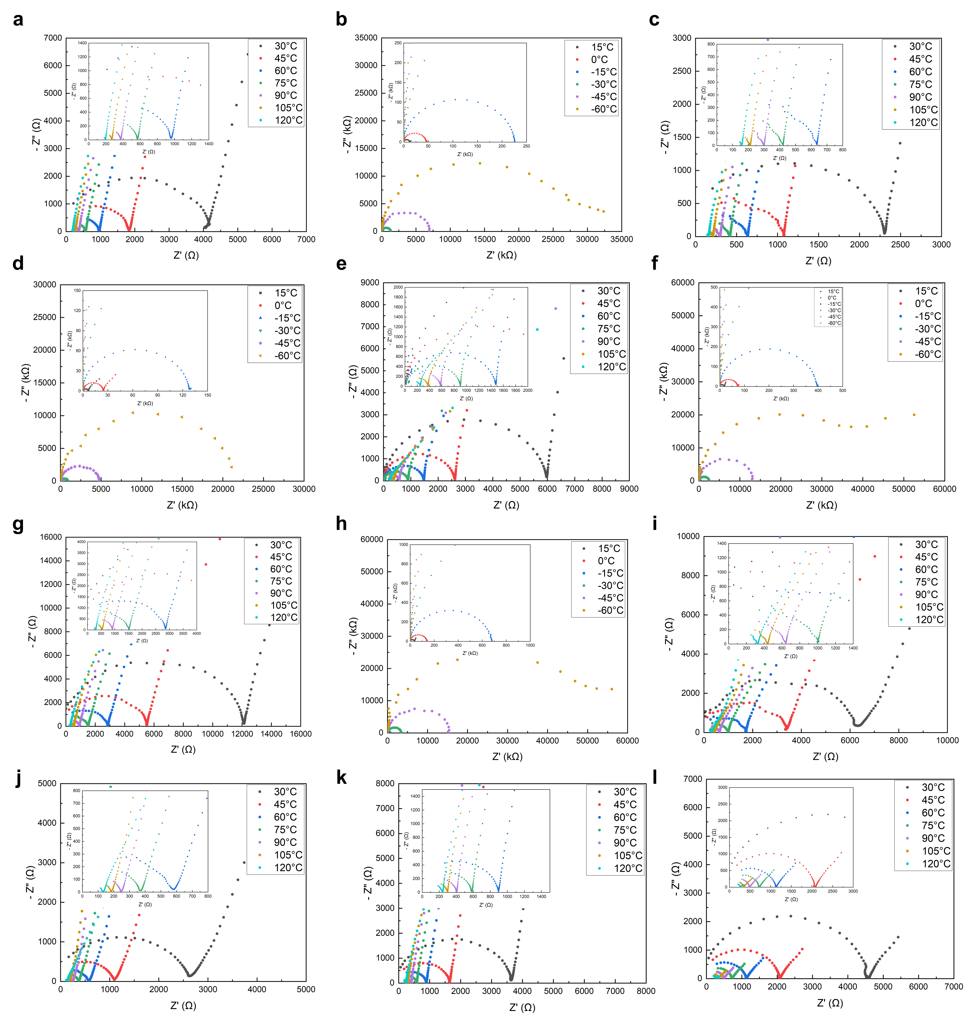
Fig. 17 | Electrochemical impedance spectroscopy. a-h, Temperature-dependent Nyquist plots of LiAlCl₄-81%O (a, b), LACO75 (c, d), LiAlCl₄-67%O (e, f), LiAlCl₄- 60%O (g, h). i-l, Temperature-dependent Nyquist plots of NaAlCl₄-81%O (i), NACO75 (j), NaAlCl₄-67%O (k), NaAlCl₄-60%O (l).

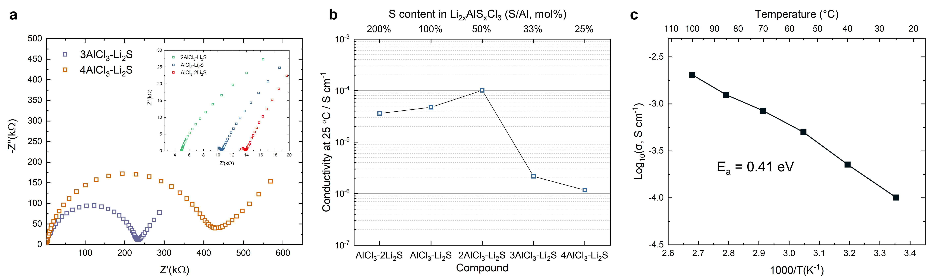
Fig. 18 | Ionic conductivity of Li_{2x}AlCl₃S_{x}. a, Nyquist plots. b, Ionic conductivities at 25℃ of Li_{2x}AlCl₃S_{x} with different sulfur contents. c, Temperature-dependent conductivities of LiAlCl₃S_{0.5}.

Precursor | Commodity code | Price (USD kg⁻¹)
LiCl | 28273910 | 17.7
NaCl | 25010020 | 2.07
AlCl₃ | 28273200 | 1.29
Sb₂O₃ | 28258000 | 24.07

Table 1. Material Cost Estimation according to the prices from the customs statistics in September 2022, provided by the General Administration of Customs of the People’s Republic of China.

 | LiAlCl_{2.5}O_{0.75} | NaAlCl_{2.5}O_{0.75}
Precursor | AlCl₃ + LiCl + (0.25 Sb₂O₃) | AlCl₃ + NaCl + (0.25 Sb₂O₃)
Precursor cost | 0.92 USD mol⁻¹ (2.68 USD mol⁻¹)  6.85 USD kg ⁻¹ (19.89 USD kg⁻¹) | 0.29 USD mol⁻¹ (2.05 USD mol⁻¹)  1.95 USD kg ⁻¹ (13.59 USD kg⁻¹)

Table 2. Precursor costs of LiAlCl_{2.5}O_{0.75} and NaAlCl_{2.5}O_{0.75}. The cost in brackets includes the cost of Sb₂O₃, that is, the case where Sb is not recycled and reused.

Supplementary Videos
Supplementary Video 1. A video showing the physical characteristics of liquid and solid MAlCl₄.
Supplementary Video 2. A video showing the physical characteristics of liquid MACO75.
Supplementary Video 3. A video showing that MACO75 can be rolled into thin films.
Supplementary Video 4. A video demonstrating the flexibility of LACO75 film at room temperature by repetitive bending.
Supplementary Video 5. A video demonstrating the viscoelasticity of hardened LACO75. Continuous films were produced by scraping a hardened LACO75 rod.

