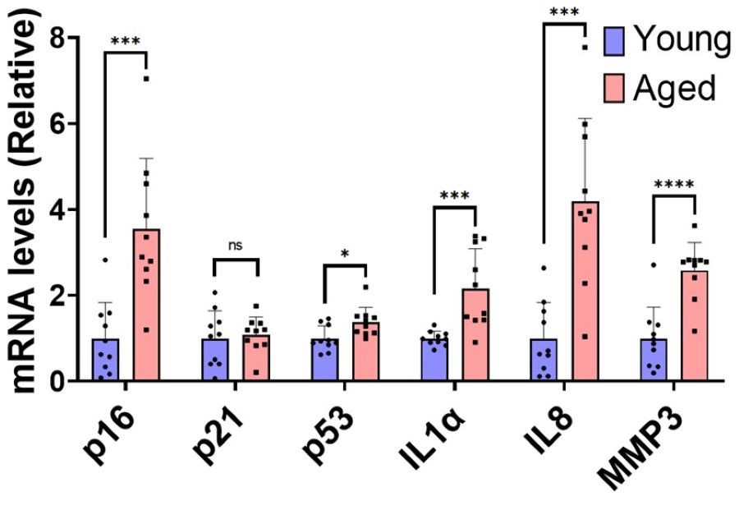Fig. S1.
Relative mRNA levels of p16, p21, p53, IL1α, IL8 and MMP3 from spine bone to two-month-old mice. Two-month-old (Young), n=10, twenty-four-year-old (Aged) mice, n=10.

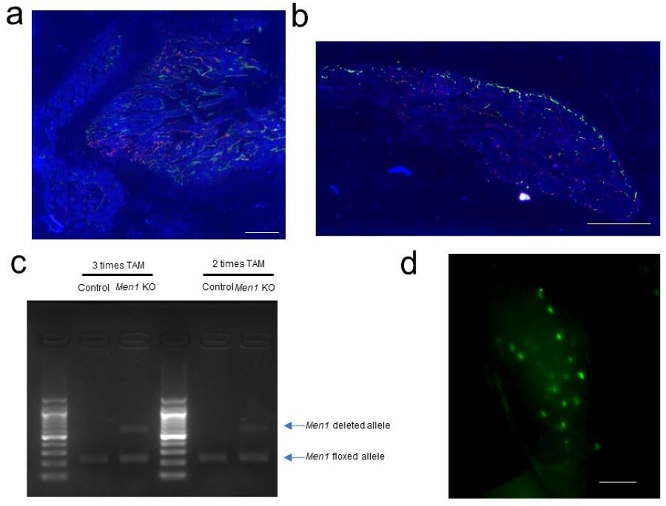
Fig. S2. Confirmation of Cre/loxP recombination and existing osteoblasts.
a The representative fluorescent image of distal femur from nine-week-old Col1a1-cre/ERT2; Col1a1-GFP; Ai9 mice receiving tamoxifen treatment at 10 mg/kg/day for four days at age of four, six and eight-week-old. GFP positive cells indicate osteoblasts and Tdtomato positive cells indicate Cre/loxP recombination cells. Scale bar, 500 μm. b The representative fluorescent image of bone morphogenetic protein (BMP)-induced ectopic bone from Col1a1-cre/ERT2; Col1a1-GFP; Ai9 mice receiving tamoxifen treatment at 10 mg/kg/day at 8 to 11 and 15 to 18 days after BMP transplantation surgery at 4 weeks of mice age. GFP positive cells indicate osteoblasts and Tdtomato positive cells indicate Cre/loxP recombination cells. Scale bar, 500 μm. c Cre/loxP recombination of tamoxifen treatment. The Results of electrophoresis of mouse calvaria. The calvaria of nine-week-old Men1 ^{flox/flox} (Control) and Men1 ^{flox/flox}; Col1a1-cre/ERT2 (Men1 KO) mice, treated by tamoxifen (TAM) (four days/week starting at age of four-, six- and eight-week (left: 3times TAM). The calvaria of seven-week-old Control and Men1 KO mice treated by tamoxifen (four days/week starting at age of five-, six-weFek (right: 2 times TAM). d The representative fluorescent image of bone chip from Col1a1-GFP mice. GFP positive cells indicate osteoblasts. Scale bar, 50 μm.

Table. S1. The primer sequences used in RT-qPCR.
Gene | Forward | Reverse
Men1 | TCATCCCCAACCTGCTGAAG | GCATTCTGGGTCCTGGAGAG
p16 | TGGAACTTCGCGGCCAATC | CGCTAGCATCGCTAGAAGTG
p21 | GGAGGAGCATGAATGGAGACAGA | TCGGACATCACCAGGATTGGA
p53 | GGACCCTGGCACCTACAATG | GGAAGGAAAGTAGGCCCTGG
IL1a | TGCAAGCTATGGCTCACTTC | GATACTGTCACCCGGCTCTC
IL6 | AGCCAGAGTCCTTCAGAG | CCACTCCTTCTGTGACTC
IL8 | TTGGAGCCAAGGCAAGAACAC | GGAGAGGCATCCGGTTCACA
MMP3 | AGTGGATCTTCGCAGTTGGA | CACAGGATGCCTTCCTTGGAT
Gapdh | GGGTGTGAACCACGAGAAAT | ACTGTGGTCATGAGCCCTTC
Hprt | AGATGAGCGCAAGTTGAATCTG | GATGGCCACAGGACTAGAACA

