Supplementary Materials

The unique turret region of Kv3 channels determines the mechanism of action of highly specific positive allosteric modulators.

Qiansheng Liang et al.
.

*Corresponding author. Email: Manuel.Covarrubias@jefferson.edu

This document includes:

Figs. S1 to S12
Tables S1 to S3

Figure S1. Statistical analysis of AUT5-induced changes in the gating parameters of Shaker-related Kv channels. The V_{0.5}, G_{max} and z were obtained from the best fits of the Boltzmann equation (Materials and Methods). Each pair of connected symbols (before, black and after, red AUT5) represents the result from individual oocytes expressing the indicated Kv channel. The paired Student t-test was used to evaluate the significance of the changes. P values are indicated above each plot.

Figure S2. The modulation of Kv3.2 by AUT5 is reversible. (A) Families of whole-oocyte currents evoked by step depolarizations (protocol in main text Fig. 1) before and after application to 2 mM AUT5 and following washout. Scale bars represent 1 μA and 100 ms. (B). Aggregate G_{p} – V_{c} curves from the conditions stated in (A). The solid lines are the best fits of the 1st-order Boltzmann equation (Materials and Methods). The best-fit parameters are shown below.

Kv3.2 | V_{0.5} (mV) | G_{max} (mS) | z (e₀)
Control | -3.7±0.9 | 0.0249±0.0022 | 4.2±0.1
2 µM AUT5 | -27.2±1.6 | 0.0217±0.0019 | 3.2±0.1
Washout | -9.5±1.2 | 0.0243±0.0025 | 3.3±0.1

Figure S3. Kv3.1 and Kv3.4 co-expressed in Xenopus oocytes can form heteromultimers with reduced sensitivity to AUT5. (A) Representative families of whole-oocyte currents recorded before (black) and after (red) application to 2 μM AUT5 from oocytes expressing Kv3.1 (left), Kv3.1/Kv3.4 heteromultimers (center) and Kv3.4 (right). 1.66 ng mRNA was injected into each oocytes and Kv3.1/Kv3.4 heteromultimers were 1:1 mixture of mRNA. All current families were evoked by the voltage protocol shown in main text Fig. 1. Scale bars represent 1 μA and 100 ms. (B) Normalized aggregate G_{p} – V_{c} curves from the groups indicated in (A). Note that the curve from oocytes co-expressing Kv3.1 and Kv3.4 exhibits a voltage dependence that is intermediate between that of Kv3.1 and Kv3.4, as it expected for the expression of heteromultimeric complexes. (C) Voltage dependence of the time constants of macroscopic inactivation. The uniformly slower time constants of the Kv3.1/Kv3.4 group is also consistent with the formation of heteromultimers composed of Kv3.1 and Kv3.4 subunits. (D) Aggregate G_{p} – V_{c} curves derived from families of currents like those shown in (A) before and after application to 2 μM AUT5. Whereas Kv3.1 exhibits the expected AUT5-induced hyperpolarizing shift and Kv3.4 exhibits no significant shift (main text Fig. 1 and Fig. S1), the Kv3.1/Kv3.4 heteromultimers exhibit a significantly reduced hyperpolarizing shift. ΔV_{0.5} = -12.0±0.7 mV (Kv3.1, n = 9), -6.1±0.8 mV (Kv3.1/Kv3.4, n = 12), and 1.2±0.8 mV (Kv3.4, n = 7). (E) Normalized aggregate G_{s} – V_{c} curves derived from sustained currents measured at the end of the trace before and after application to 2 μM AUT5. Because there is a greater contribution of Kv3.1 homomultimers to the sustained current, the AUT5-induced hyperpolarizing shifts of the Kv3.1 and Kv3.1/Kv3.4 groups are similar. ΔV_{0.5} = -12.7±0.7 mV (Kv3.1, n = 9) and -10.4±0.4 mV (Kv3.1/Kv3.4, n = 12). Solid lines in (B), (D) and (E) are the best fits of the 1st-order Boltzmann equation (Materials and Methods).

A

hKv3.2 ----------------------------MGKIENNERVILNVGGTRHETYRSTLKTLPGT 32
hKv3.1 ----------------------------MGQGDESERIVINVGGTRHQTYRSTLRTLPGT 32
hKv3.4 MISSVCVSSYRGRKSGNKPPSKTCLKEEMAKGEASEKIIINVGGTRHETYRSTLRTLPGT 60
*.: : .*::::*******:******:*****
T1-----------------------
hKv3.2 RLALLASSEPPGDCLTTAGDKLQPSPPPLSPPPRAPPLSPGPGGCFEGGAGNCSSRGGRA 92
hKv3.1 RLAWLAEPDAHSHFDYD------------------------------------------- 49
hKv3.4 RLAWLADPDGGGRPETD-----------------------------GGGVG-------SS 84
*** **. : .
------------------------------------------------------------
hKv3.2 SDHPGGGREFFFDRHPGVFAYVLNYYRTGKLHCPADVCGPLFEEELAFWGIDETDVEPCC 152
hKv3.1 ----PRADEFFFDRHPGVFAHILNYYRTGKLHCPADVCGPLYEEELAFWGIDETDVEPCC 105
hKv3.4 GSSGGGGCEFFFDRHPGVFAYVLNYYRTGKLHCPADVCGPLFEEELTFWGIDETDVEPCC 144
. ************::*******************:****:*************
----------T1
hKv3.2 WMTYRQHRDAEEALDIFETPDLIGGD-------P----GDDEDLA--AKRLGIEDAAGLG 199
hKv3.1 WMTYRQHRDAEEALDSFGGAPLDNSADDADADGPGD-SGDGEDELEMTKRLALS----DS 160
hKv3.4 WMTYRQHRDAEEALDIFESPDGGGS-----GAGPSDEAGDDERELALQ-RLGPH--EGGA 196
*************** * . * ** * **. .
S1-----------------S1
hKv3.2 GPDGKSGRWRRLQPRMWALFEDPYSSRAARFIAFASLFFILVSITTFCLETHEAFNIVKN 259
hKv3.1 PDGRPGGFWRRWQPRIWALFEDPYSSRYARYVAFASLFFILVSITTFCLETHERFNPIVN 220
hKv3.4 GHGAGSGGCRGWQPRMWALFEDPYSSRAARVVAFASLFFILVSITTFCLETHEAFNIDRN 256
.* * ***:*********** ** :********************* ** *
S2----------------S2 S3--
hKv3.2 KTEP--VINGTSVVLQYEIETDPALTYVEGVCVVWFTFEFLVRIVFSPNKLEFIKNLLNI 317
hKv3.1 KTEIENVRNGTQVRYYREAETEAFLTYIEGVCVVWFTFEFLMRVIFCPNKVEFIKNSLNI 280
hKv3.4 VTEILRVGNITSVHFRREVETEPILTYIEGVCVLWFTLEFLVRIVCCPDTLDFVKNLLNI 316
** * * *.* * **: ***:*****:***:***:*:: .*:.::*:** ***
---------------S3 S4-------------------S4
hKv3.2 IDFVAILPFYLEVGLSGLSSKAAKDVLGFLRVVRFVRILRIFKLTRHFVGLRVLGHTLRA 377
hKv3.1 IDFVAILPFYLEVGLSGLSSKAAKDVLGFLRVVRFVRILRIFKLTRHFVGLRVLGHTLRA 340
hKv3.4 IDFVAILPFYLEVGLSGLSSKAARDVLGFLRVVRFVRILRIFKLTRHFVGLRVLGHTLRA 376
***********************:************************************
S5-----------------S5
hKv3.2 STNEFLLLIIFLALGVLIFATMIYYAERVGAQPNDPSASEHTQFKNIPIGFWWAVVTMTT 437
hKv3.1 STNEFLLLIIFLALGVLIFATMIYYAERIGAQPNDPSASEHTHFKNIPIGFWWAVVTMTT 400
hKv3.4 STNEFLLLIIFLALGVLIFATMIYYAERIGARPSDPRGNDHTDFKNIPIGFWWAVVTMTT 436
****************************:**:*.** ..:**.*****************
S6-----------------S6
hKv3.2 LGYGDMYPQTWSGMLVGALCALAGVLTIAMPVPVIVNNFGMYYSLAMAKQKLPRKRKKHI 497
hKv3.1 LGYGDMYPQTWSGMLVGALCALAGVLTIAMPVPVIVNNFGMYYSLAMAKQKLPKKKKKHI 460
hKv3.4 LGYGDMYPKTWSGMLVGALCALAGVLTIAMPVPVIVNNFGMYYSLAMAKQKLPKKRKKHV 496
********:********************************************:*:***:

hKv3.2 PPAPQASSPTFCKTELNMACNSTQSDTCLGKDN-RLLEHNRS-----------VLSGDDS 545
hKv3.1 PRPPQLGSPNYCKSVVNSPHHSTQSDTCPLAQE-EILEINRADSKLNGEVAKAALANEDC 519
hKv3.4 PRPAQLESPMYCKSEETSPRDSTCSDTSPPAREEGMIERKRADSKQNGDANAV-LSDEEG 555
* * ** :**: . .** ***. : ::* :*: *: ::

hKv3.2 TGSEP----PLSPPERLPIRRSSTRDKNRRGETCFLLTTGDYTCASDGGIRKDNCKEVVI 601
hKv3.1 PHIDQ----ALTPDEGLPFTRSGTR---ERYGPCFLLSTGEYACPPGGGMRKDLCKESPV 572
hKv3.4 AGLTQPLASSPTPEERRALRRSTTRDRNKKAAACFLLSTGDYACADGSVRKGTFVLRDLP 615
:* * : ** ** .: ****:**:*:* . : .

hKv3.2 T-GYTQAEARSLT-------- 613
hKv3.1 IAKYMPTEAVRVT-------- 585
hKv3.4 L-QHSPEAACPPTAGTLFLPH 635
: * *

B
rKv1.1 YFAEAEEAES-------------------------------HFSSIP 360
rKv1.2 YFAEADERDS-------------------------------QFPSIP 362
rKv2.1 FFAEKDEDD-------------------------------TKFKSIP 361
rKv3.1 YYAERIGAQPNDPSASEH----------------------THFKNIP 388
rKv3.2 YYAERVGAQPNDPSASEH----------------------TQFKNIP 425
dShaw YYAERIQPNP-------H----------------------NDFNSIP 365
rKv4.1 FYAEKGTSKT-------------------------------NFTSIP 360
rKv5.1 YTMEQSHPE-------------------------------TLFKSIP 370
rKv6.1 YVIENEMADS------------------------------PEFTSIP 412
rKv7.1 YLAEKDAVNES---------------------------GRIEFGSYA 300
rkV8.1 YFAEQSIPD-------------------------------TTFTSVP 383
rKv9.1 YTAEEKNVG---------------------------------FDTIP 380
rKv10.1 IFDEDTKTIRNNSWLYQLALDIGTPYQFNGSGSGKWEGGPSKNSVYI 424
rKv11.1 QPHMDSHIG----WLHNLGDQIGKPYNSSGLG------GPSIKDKYV 614
rKv12.1 R-EDNSLLKWEVGWLHELGKRLESPYYGNNTLG-----GPSIRSAYI 422
KvAP IYIVEYPDPN------------------------------SSIKSVF 197

Figure S4. Sequence alignments of Kv channel amino acid sequences. (A) Full-length sequence comparisons between the human variants of Kv3.1a, Kv3.2a and Kv3.4a. Red characters highlight the T1 domain, and the transmembrane segments S1-S6, and bold characters highlight the extracellular pre-pore helix linker (‘turret’). (B) Sequence comparison of the turrets from representative members of the Kv channel family. Red characters highlight the unique turret regions of Kv3.1a and Kv3.2a. Conserved putative contact sites in the AUT5 binding pocket are highlighted in cyan.

Figure S5. The effects of deleting the T1 domain and swapping the extracellular S1S2 linker on the basal gating properties and AUT5 sensitivity of Kv3.2. (A) Families of whole-oocyte currents expressed by the indicated Kv3.2 mutants. 3.4x3.2 S1S2 is the Kv3.2 chimera in which the S1S2 linker from Kv3.4 is swapped for that from Kv3.2. Currents evoked by step depolarizations as shown in main text Fig. 1. Scale bars represent 1 μA and 100 ms. (B) Overlay of G_{p} – V_{c} curves obtained under basal conditions. (C) and (D) Overlay of G_{p} – V_{c} curves obtained from current recordings in the absence and presence of 2 μM AUT5. Solid lines in (B), (C) and (D) are the best fits of the 1st-order Boltzmann equation (Materials and Methods). The table below summarizes the V_{0.5} changes induced by the mutations and application to AUT5.

Kv3.2 | n | V_{0.5} (Control, mV) | V_{0.5} (2 μM AUT5, mV) | ΔV_{0.5} (mV) | P (vs. WT)
WT | 74 | -2.7±0.5 | -29.2±1.1 | -26.5±0.9
ΔT1 | 5 | 4.9±1.2 | -21.5±2.9 | -26.4±2.2 | 0.88792
3.4x3.2 S1S2 | 8 | 1.5±1.3 | -16.5±1.5 | -17.9±1.3 | 7x10⁻⁴

Figure S6. The effect of various Kv3.2 turret mutations on voltage-dependent gating under basal conditions. (A) Overlay of G_{p} – V_{c} curves for Kv3.2 WT and the turret mutations indicated on the graph. The positions of the mutations are as indicated on Fig. 5 and Table S1. Solid lines are the best fits of the 1st order Boltzmann equation. (B) Scatter plots comparing the V_{0.5} of the G_{p} – V_{c} curves. Each symbol is a measurement from an individual oocyte, and the bars indicate the mean values. The red dashed line is shown as the WT reference value of the V_{0.5}.

Figure S7. The effect of various Kv3.4 turret mutations on voltage-dependent gating under basal conditions. (A) Overlay of G_{p} – V_{c} curves for Kv3.4 WT and the turret mutations indicated on the graph. Solid lines are the best fits of the 1st order Boltzmann equation (Materials and Methods). (B) Scatter plots comparing the V_{0.5} of the G_{p} – V_{c} curves. Each symbol is a measurement from an individual oocyte, and the bars indicate the mean values. The red dashed line is shown as the WT reference value of the V_{0.5}. (C) Overlay of G_{p} – V_{c} curves for Kv3.4 WT and the turret mutations indicated on the graph. Solid lines are the best fits of the 1st order Boltzmann equation. (D) Scatter plots comparing the V_{0.5} of the G_{p} – V_{c} curves. Other details as indicated above for (B). A and B are experiments without PMA. C and D are experiments with PMA. The positions of the mutations are as indicated on Fig. 5 and Table S1.

Figure S8. The effects of AUT5 following elimination of fast Kv3.4 inactivation by activation of protein kinase C (PKC). (A) Families of WT Kv3.4 whole-oocyte currents evoked by the pulse protocol shown in main text Fig. 1, before and after bath application to 50 nM PMA to activate PKC (Materials and Methods) and following application to 2 μM AUT5. PMA remained present during the application of AUT5. Scale bars represent 1 μA and 100 ms. (B) Time course of the elimination of fast Kv3.4 inactivation upon bath application to 50 nM PMA. The currents evoked by 20 mV pulse for 400 ms and the holding potential is -100 mV. The interval between trace 0 and 1 is 20 seconds. From trace 1 to trace 8, the interval between two adjacent traces is 1 minute. (C) and (D) Overlay of G_{p} – V_{c} curves under the conditions indicated on the graph. Solid lines are the best fits of the 1st order Boltzmann equation. (E) Scatter plots of the changes in the best fit parameters. Each pair of connected symbols (before and after 2 μM AUT5) represents a measurement from an individual oocyte, and the bar represents the mean. The paired Student t-test was used to evaluate the significance of the changes. P values are indicated above each plot.

Figure S9. Gating properties of Kv3.2 mutants before and after bath application of 2 μM AUT5. (A) – (I) (top, left and center) Families of mutant Kv3.2 whole-oocyte currents evoked by the pulse protocol shown in main text Fig. 1, before (left, black) and after (center, red) bath application of 2 μM AUT5. Scale bars represent 1 μA and 100 ms. (A) – (I) (top, right) Overlay of G_{p} – V_{c} curves under the conditions indicated on the graph. Solid lines are the best fits of the 1st order Boltzmann equation. (A) – (I) (bottom) Scatter plots of the changes in the best fit parameters V_{0.5}, G_{max} and z. Each pair of connected symbols (before and after 2 μM AUT5) represents a measurement from an individual oocyte, and the bar represents the mean. The paired Student t-test was used to evaluate the significance of the changes. P values are indicated above each plot.

Figure S10. Gating properties of Kv3.4 mutants before and after bath application of 2 μM AUT5 and in continuous presence of PMA. (A) – (E) (top, left and center) Families of mutant Kv3.4 whole-oocyte currents evoked by the pulse protocol shown in main text Fig. 1, before (left, blue) and after (center, red) bath application of 2 μM AUT5. Scale bars represent 1 μA and 100 ms. (A) – (E) (top, right) Overlay of G_{p} – V_{c} curves under the conditions indicated on the graph. Solid lines are the best fits of the 1st order Boltzmann equation. (A) – (E) (bottom) Scatter plots of the changes in the best fit parameters V_{0.5}, G_{max} and z. Each pair of connected symbols (before and after 2 μM AUT5) represents a measurement from an individual oocyte, and the bar represents the mean. The paired Student t-test was used to evaluate the significance of the changes. P values are indicated above each plot. All experiments are with 50 nM PMA.

A

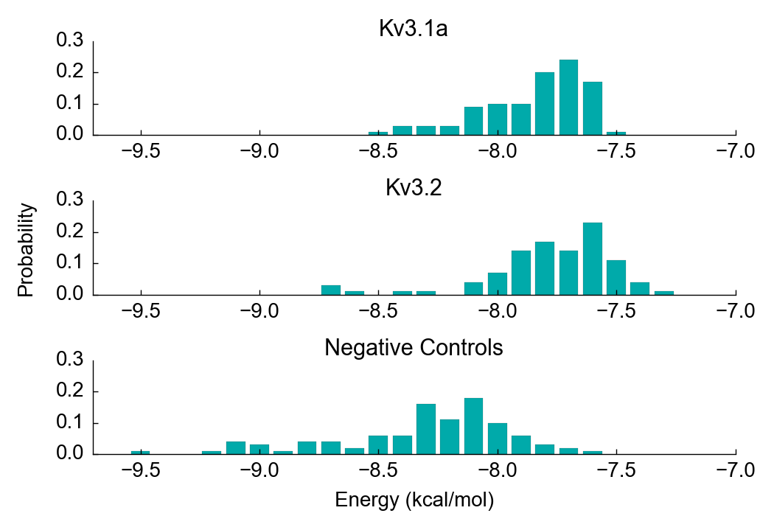

B

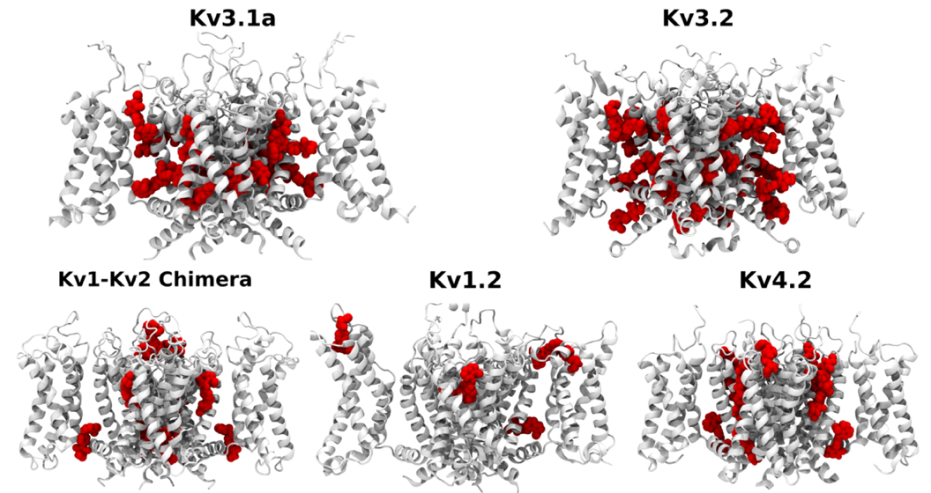

Figure S11. Distribution of binding energy values (kcal/mol) for all suggested sites in docking. (A) Probabilities were based on the total number of suggested solutions in docking calculations of AUT5 with Kv3.1a, Kv3.2 or Negative Controls (Kv1-Kv2 Chimera, Kv1.2 and Kv4.2). Each distribution contains at least 80 independent docking solutions. (B) Best AUT5 configurations (red) within the sites determined for Kv3.1a, Kv3.2a and negative controls (Kv1-Kv2 Chimera, Kv1.2 and Kv4.2). Sites were defined by a proximity criterion and their positioning in protein.

Figure S12. AUT5 modulation of Kv3.4 channels stably expressed in HEK293 cells. (A) Families of whole-cell currents before (left, black) and after bath application of 2 μM AUT5 (right, red). Currents were evoked by the pulse protocol shown in Fig. 1. (B) Overlay of G_{p} – V_{c} curves under the conditions indicated on the graph. Solid lines are the best fits of the 1st order Boltzmann equation. (C) Scatter plots of the changes in the best fit parameters V_{0.5}, G_{max} and z. Each pair of connected symbols (before and after 2 μM AUT5) represents a measurement from an individual cell, and the bar represents the mean. The paired Student t-test was used to evaluate the significance of the changes. P values are indicated above each plot. (D) – (F) Conditions like those described for panels (A) - (C), except that the recordings were conducted before and after bath application of 10 μM AUT5.

Table S1. Definitions of mutations

 | Definition
Kv3.2
N3S | N411S
S4R | S414R
A5G | A415G
S6N | S416N
N3S/S4R | N411S/S414R
N3S/A5G | N411S/A415G
N3S/S6N | N411S/S416N
S4R/A5G | S414R/A415G
S4R/A5G/S6N | N411S/A415G/S416N
3.4x3.2Turret | V406I/Q409R/N411S/S414R/A415G/S416N/E417D/Q420D
ΔTurret | deletion of N411 - E417 (NDPSASE)
ΔT1 | deletion aa 2 - 215
3.4x3.2 S1S2 | Kv3.2 S1S2 linker (aa 257-281) replaced with Kv3.4’s (aa 254-280)
Kv3.4
S3N | S410N
R4S | R413S
G5A | G414A
N6S | N415S
S3N/N6S | S410N/N415S
3.2x3.4Turret | S5S6 linker (aa 405 - 419) replaced with hKv3.2 (aa 406 - 420)
ΔTurret | deletion of N410 - E416 (SDPRGND)

Table S2. Primers used for mutagenesis of Kv3.2 and Kv3.4

Name | Sequence
Kv3.2
N3S Fwd | 5'-GAGTGGGAGCTCAACCTAGCGACCCTTCAG-3'
Rev | 5'-CTGAAGGGTCGCTAGGTTGAGCTCCCACTC -3'
S4R Fwd | 5’-CAACCTAACGACCCTCGAGCTAGTGAGCACACAC-3’
Rev | 5’-CAACCTAACGACCCTCGAGCTAGTGAGCACACAC-3’
A5G Fwd | 5'-CCTAACGACCCTTCAGGTAGTGAGCACACACAG -3'
Rev | 5'-CTGTGTGTGCTCACTACCTGAAGGGTCGTTAGG -3'
S6N Fwd | 5'- CAACCTAACGACCCTTCAGCTAATGAGCACACACA-3'
Rev | 5'- TGTGTGTGCTCATTAGCTGAAGGGTCGTTAGGTTG-3'
N3S/S4R Fwd | 5’-5'- GAGCTCAACCTAGCGACCCTCGAGCTAGTGAGCA-3'-3’
Rev | 5’-5'- TGCTCACTAGCTCGAGGGTCGCTAGGTTGAGCTC-3'-3’
N3S/A5G | template = A5G
Fwd | 5'-GAGTGGGAGCTCAACCTAGCGACCCTTCAG-3'
Rev | 5'-CTGAAGGGTCGCTAGGTTGAGCTCCCACTC -3'
N3S/S6N | template = S6N
Fwd | 5'-GAGTGGGAGCTCAACCTAGCGACCCTTCAG-3'
Rev | 5'-CTGAAGGGTCGCTAGGTTGAGCTCCCACTC -3'
S4R/A5G | template = S4R
Fwd | 5’-CCTAACGACCCTCGAGGTAGTGAGCACACACAG-3’
Rev | 5’-CTGTGTGTGCTCACTACCTCGAGGGTCGTTAGG-3’
S4R/A5G/S6N | template = S4R/A5G
Fwd | 5’-CTAACGACCCTCGAGGTAATGAGCACACACAGTTC-3’
Rev | 5’-GAACTGTGTGTGCTCATTACCTCGAGGGTCGTTAG-3’
3.4x3.2Turret | template = S4R, 7 more steps
 | S414R + A415G + S416N + E417D + Q409R + N411S + V406I + Q420D
A415G Fwd | 5’-CCTAACGACCCTCGAGGTAGTGAGCACACACAG-3’
Rev | 5’-CTGTGTGTGCTCACTACCTCGAGGGTCGTTAGG-3’
S416N Fwd | 5’-CTAACGACCCTCGAGGTAATGAGCACACACAGTTC-3’
Rev | 5’-GAACTGTGTGTGCTCATTACCTCGAGGGTCGTTAG-3’
E417D Fwd | 5’-CGACCCTCGAGGTAATGACCACACACAGTTCAAAAAC-3’
Rev | 5’-GTTTTTGAACTGTGTGTGGTCATTACCTCGAGGGTCG-3’
Q409R Fwd | 5'- GAG AGT GGG AGC TCG ACC TAA CGA CCC TCG -3'
Rev | 5'- CGA GGG TCG TTA GGT CGA GCT CCC ACT CTC -3'
N411S Fwd | 5'- GTG GGA GCT CGA CCT AGC GAC CCT CGA GGT AAT G -3'
Rev | 5'- CAT TAC CTC GAG GGT CGC TAG GTC GAG CTC CCA C -3'
V406I Fwd | 5’-C TAC TAT GCC GAG AGA ATC GGA GCT CGA CCT AGC G-3’
Rev | 5'- CGC TAG GTC GAG CTC CGA TTC TCT CGG CAT AGT AG -3'
Q420D Fwd | 5'- CGA GGT AAT GAC CAC ACA GAC TTC AAA AAC ATT CCC -3'
Rev | 5'- GGG AAT GTT TTT GAA GTC TGT GTG GTC ATT ACC TCG -3'
ΔTurret Fwd | 5'-GAGAGTGGGAGCTCAACCT CACACACAGTTCAAAAAC-3'
Rev | 5'-GTTTTTGAACTGTGTGTG AGGTTGAGCTCCCACTCTC-3'
ΔT1 | 2 steps
M1A Fwd | 5'- CGA ATT CCT GCA GCC CGG CAG GCA AGA TCG AGA AC -3'
Rev | 5'- GTT CTC GAT CTT GCC TGC CGG GCT GCA GGA ATT CG -3'
M154A Fwd | 5'- GAG CCC TGC TGC TGG GCG ACC TAC CGG CAG -3'
Rev | 5'- CTG CCG GTA GGT CGC CCA GCA GCA GGG CTC -3'
3.4x3.2 S1S2 | vector = Kv3.2, insert = Kv3.4
vector Fwd | 5’GCGGGAGGTAGAGACAGAGCCCATCTTGACGTATGTAGAAGGAGTGTGTG-3’
Rev | 5’-GGAGGATCTCTGTCACGTTGCGGTCAATATTGAAAGCTTCATGTGTTTCC-3’
insert Fwd | 5’-GGAAACACATGAAGCTTTCAATATTGACCGCAACGTGACAGAGATCCTCC-3’
Rev | 5’-CACACACTCCTTCTACATACGTCAAGATGGGCTCTGTCTCTACCTCCCGC-3’
Kv3.4
S3N Fwd | 5'-GGGGCCAGGCCCAACGACCCTCGGGG-3'
Rev | 5'-CCCCGAGGGTCGTTGGGCCTGGCCCC-3'
R4S Fwd | 5'-GCCAGGCCCTCCGACCCTTCAGGTAATGACCACA-3'
Rev | 5'-TGTGGTCATTACCTGAAGGGTCGGAGGGCCTGGC-3'
G5A Fwd | 5'-TCCGACCCTCGGGCTAATGACCACACC-3'
Rev | 5'-GGTGTGGTCATTAGCCCGAGGGTCGGA-3'
N6S Fwd | 5'-CGACCCTCGGGGTAGTGACCACACCGA-3'
Rev | 5'-TCGGTGTGGTCACTACCCCGAGGGTCG-3'
S3N/N6S | template = N6S
Fwd | 5'-GGGGCCAGGCCCAACGACCCTCGGGG-3'
Rev | 5'-CCCCGAGGGTCGTTGGGCCTGGCCCC-3'
3.2x3.4Turret | vector = Kv3.4, insert = Kv3.2
vector Fwd | 5'- CAC AGT TCA AAA ACA TTC CCA TTG GCT TCT GGT GGG CT -3'
Rev | 5'- AGC CCA CCA GAA GCC AAT GGG AAT GTT TTT GAA CTG TG -3'
insert Fwd | 5'- TAC TAC GCT GAG CGC GTG GGA GCT CAA CCT AAC GA -3'
Rev | 5'- TCG TTA GGT TGA GCT CCC ACG CGC TCA GCG TAG TA -3'
ΔTurret Fwd | 5'-ggggccaggccc cacaccgacttc-3'
Rev | 5'-gaagtcggtgtg gggcctggcccc-3'

Table S3. Reagents used

Name | Cat Number | Vendor
AUT5 |  | Autifony Therapeutics, Ltd. (Stevenage, UK)
DMSO | D128-500 | Fisher
Collagenase A | 10103586001 | Millipore-Sigma
DMEM | D5671 | Millipore-Sigma
L-Glutamine | G7513 | Millipore-Sigma
Tetracycline | T7660 | Millipore-Sigma
FBS | 631107 | Clontech
Blasticidin | ant-bl-05 | Invivogen
Geneticin | 10131-027 | Gibco
Penicillin/Streptomycin | 15070-063 | Gibco

