Extended Data

Extended Data Table 1| Cutting limits applied to the dataset for the raw trajectory data. The procedure is performed by two successive filtering steps.
Step | Component | Cutoff ($nσ_{E_{j}}$)
1 | $$E^{Local}$$ | ($-∞$, 2)
1 | $$E^{repulsive}$$ | ($-∞$, 1)
1 | $$E^{stacking}$$ | ($-∞$, 1)
1 | $$E^{pairing}$$ | ($-∞$, 3)
1 | $$B^{stage}$$ | ($-∞$, 3)
2 | $$CC^{AFM}$$ | (- 2, +$∞$)
2 | $$E^{total}$$ | ($-∞$, 3)

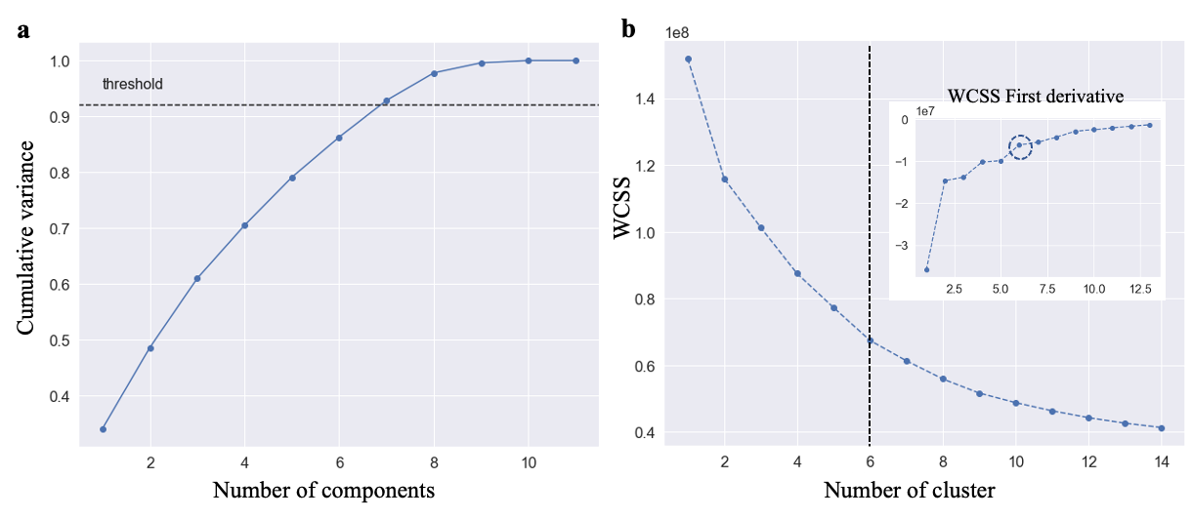
Extended Data Fig. 1| Unsupersised machine learning analysis procedure. a, comulative variance used to define the number of components during the SVD fitting of PCA. b, the inter-cluster variance - the within cluster sum of squares (WCSS) as fucntion of the mumber of cluster. The first derivative of WCSS is shown in the in set plot where we selected the intersection between considerable variations and a flatter pattern (circle) as the optimal position for define the number of cluster, using the k-means algorithm analysis.

Extended Data Table 2| Cohort Filtering Selection. Selection limits applied to the dataset from the particle populated in the selected cluster.
Component | Cut ($nσ_{E_{j}}$)
$$E^{Go}$$ | ($-∞$, 0)
$$E^{Local}$$ | ($-∞$, 3)
$${CC}^{AFM}$$ | (0,+$∞$)
$$E^{Total}$$ | ($-∞$, -1)

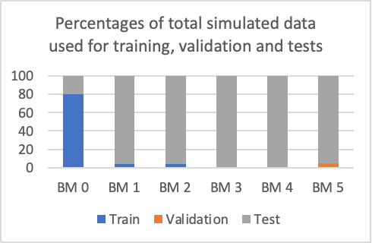
Extended Data Fig. 2| DNN pseudo-database. Percentages of total simulated data used for training, validation and tests.

Extended Data Table 3| DNN dataset variation, filtering, hyperparameter options and intervals.

Dataset Composition | Possible options
Data | BM 0
Data | BM 0 + 5% BM 1
Data | BM 0 + 5% BM 2
Data | BM 0 + 5% BM 1 + 5% BM 2
Max kappa | 15, 25, 50* or not cut
BM 0 noises | 5, 10, 5-15*, 5-25 or 5-50%
Hyperparameter | Possible values
Number of layers | 1 – 10
Number of neurons | 8 – 256
Neuron activations | relu, leakly-relu, elu*, gelu or selu
Regularization | L2, Dropout*, Dropout + L2 or Alpha Dropout (for selu activation)
L2 factor | 0.1, 0.03, 0.01, 0.003 or 0.001
Dropout rate | 10, 20* or 50%
Optimizer | Adam* or SGD
Learning Rate | 0.01, 0.003, 0.001*, 0.0003 or 0.0001
Weight initialization | Glorot Uniform, He Normal* or Lecun Normal
Mini-batch size | 16, 32, 64, 128* or 256
Number of epochs | 300
Note: * indicates the best option found.

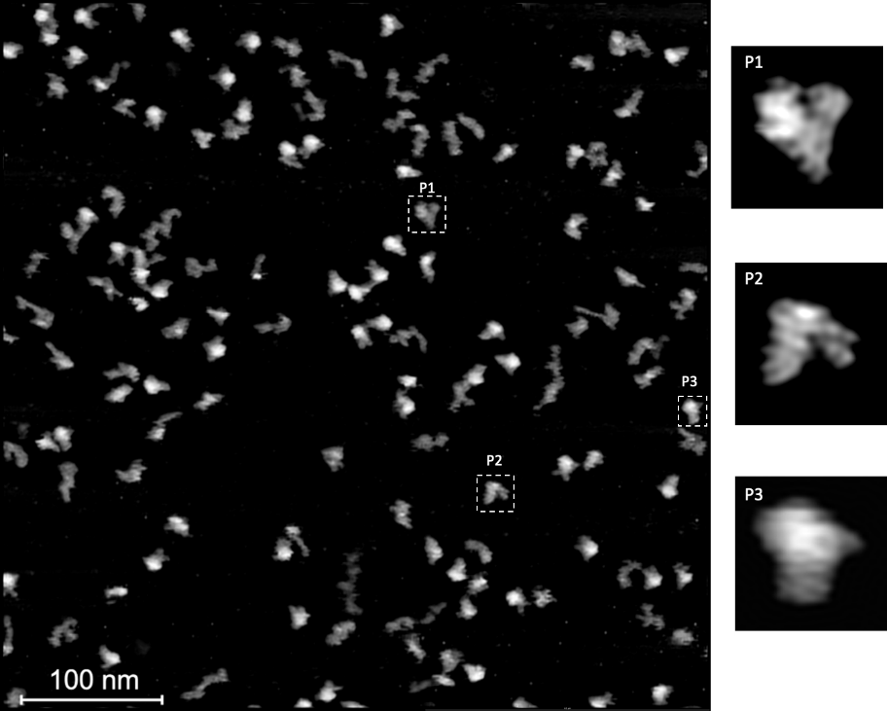

Extended Data Fig. 3| Experimental AFM image recorded for the full-length RNase P RNA. In this work, we selected three particles to perform the single molecule structure determination: P1, P2 and P3. Panels on the right are enlarged views of the boxed particles in the AFM image.

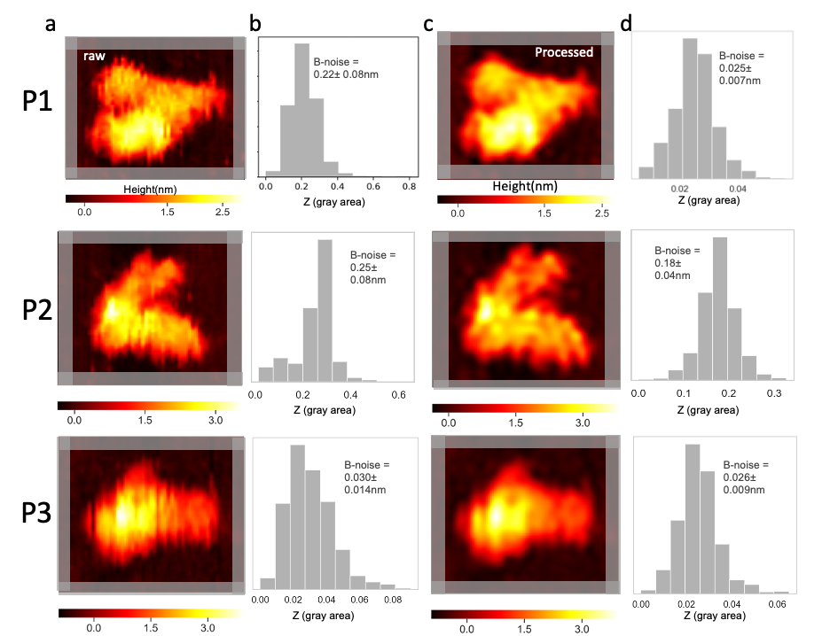

Extended Data Fig. 4| Noise estimation. a, cropped raw AFM images of the selected particles: P1, P2 and P3, the gray highlighted area indicates the empty region used to calculate the background noise. b, z-value distribution of the gray area shown in panel A. c, AFM image after processing procedure. d, noise assessment of the processed image for P1, P2 and P3, respectively.
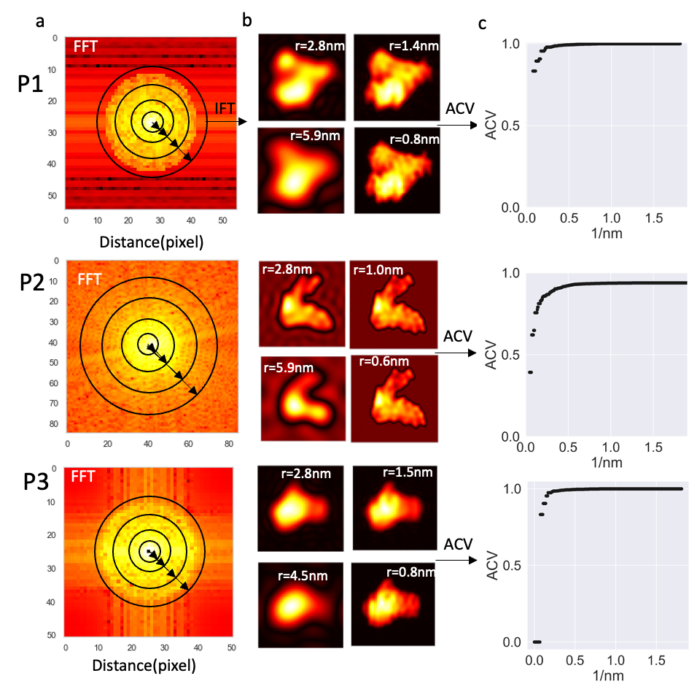

Extended Data Fig. 5| Resolution estimation. a, FFT images of the reference particles (P1, P2 and P3) after image processing, the black ring in the figure indicates how the low pass filtered Fourier ring was designed. b, inverse FFT (IFFT) images respective to the low pass filtered Fourier rings of panel A, in real space. c, ACV profiles after the applied low-pass cut-off filter, in Fourier space.

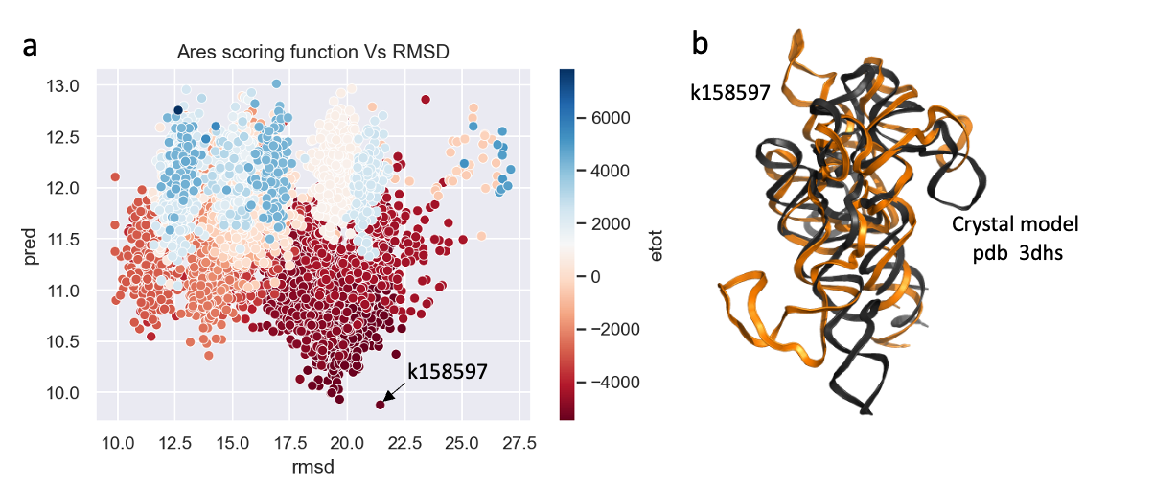
Extended Data Fig. 6| Initial model benchmark 0. a, ARES score vs RMSD values in comparison to the crystal model of trRNaseP RNA (pdb id: 3dhs); the lowest score of ARES is shown to be the model k158597. The models are colored as a function of their total energy, dark red for lower energies and dark blue for higher energies. b, cartoon visualization of the model k158597 (orange) with RMSD of 21.43 relative to 3dhs (black).

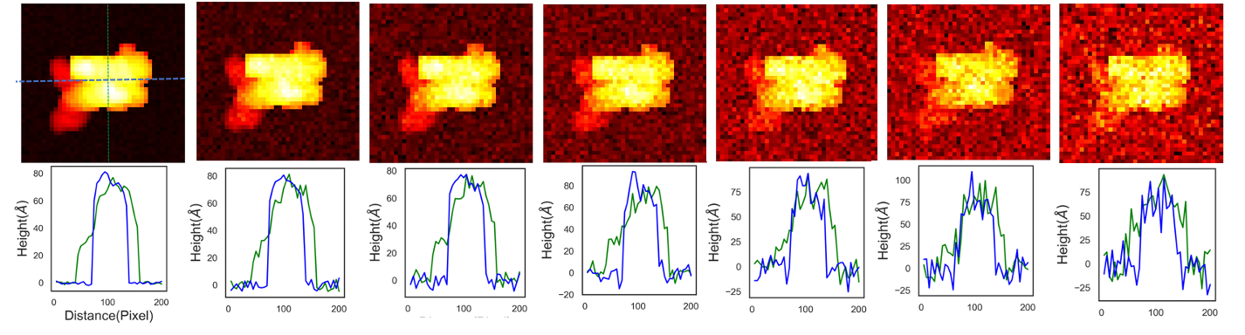
Extended Data Fig. 7| AFM topography images of trRNaseP RNA. Top panels: with superimposed Gaussian noise levels. Bottom panels: the corresponding Z-height signal profile of vertical and horizontal direction. From left to right, the noise levels are 5, 10, 15, 20, 30, 40, and 50%.

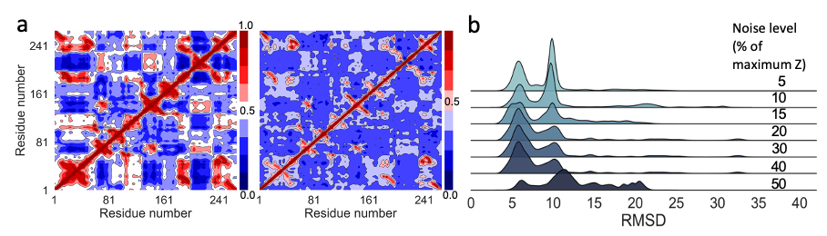

Extended Data Fig. 8| a, dynamic cross-correlation maps (DCCMs) of free (left) and AFM-restrained (right) molecular dynamics trajectories of RNase P RNA catalytic domain. b, stacked RMSD distribution plots of the simulated data at each noise level (5-50%) imposed on the fitting of the crystal structure (PDB ID: 3DHS) to the AFM molecular surfaces.

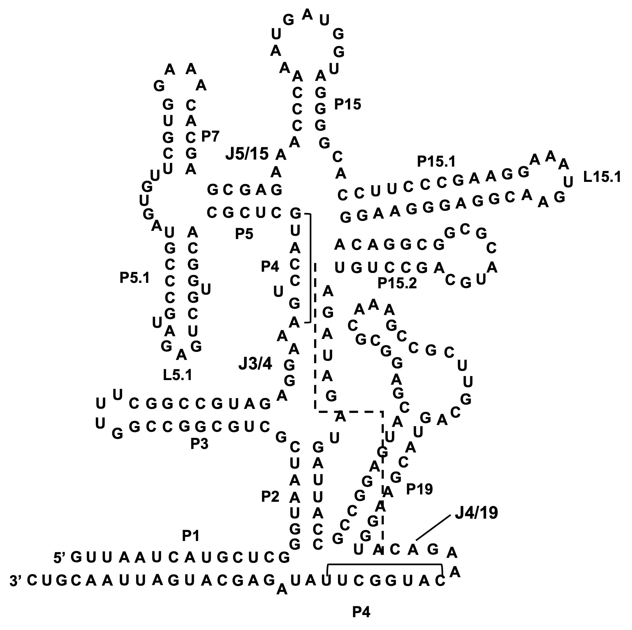
Extended Data Fig. 9| The secondary structure of truncated RNaseP RNA (21, 25).
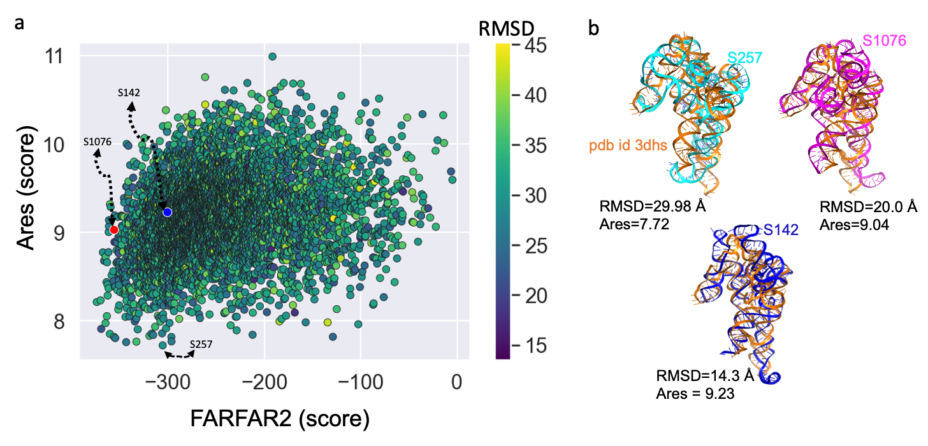
Extended Data Fig. 10| Ranking FARFAR2 ensemble models using ARES and FARFAR2 scoring functions. a, FARFAR2-score vs ARES-score, where the three selected models, S257, S1076 and S142, are used as the initial structures for dynamic fitting using the pdb id 3DHS - AFM image. b, superposition of the crystal structure (orange) (3DHS) with all the selected structures from FARFAR2 ensemble. The ARES scores and the RMSD to the crystal structure are also labeled below the structural models.

Extended Data Table 4| FARFAR2 inputs used to generate the structure models for trRNaseP RNA.
RNA | Sequence | Secondary structure | Nucleotide-nucleotide proximity
trRNase P  PDB id 3dhs | guuaaucaugcucggguaaucgcugcggccg  guuucggccguagaggaaaguccaugcucgc  acggugcugagaugccgcgagaaacccaaaugaugaugguaggggcaccuucccgaaggaaaugaacggagggaaggacaggcggcgcaugcagccuguagauagaugauuaccgccggaguacgaggcgcaaagccgcuugcaguacgaagguacagaacauggcuuauagagcaugauuaacguc | (((((((((((((.(((((((.(((((((((....)  )))))))).{.[.[[.[[[[[(((((((((.(((.  ..).)))))).....(((((....))))))))))...(  ((...........)))...(((((((...(........)...  )))))))((((((..........))))))........)))  ))))(((...((((..(((.....))).......))))..  .))).}....]]]]]]]]...)))))))))))))... | 72-143  73-142  182-241  180-129

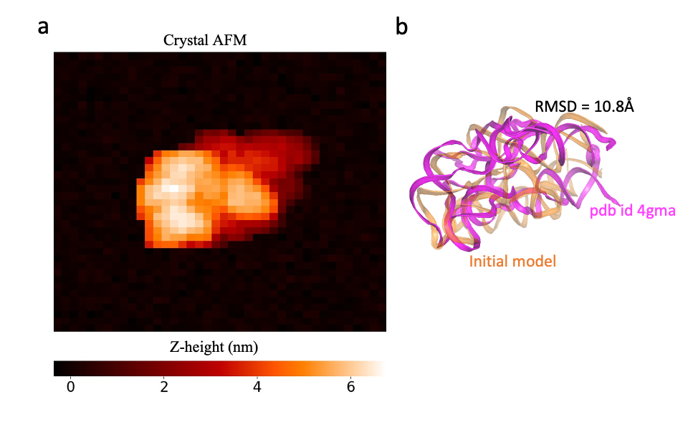
Extended Data Fig. 11| Benchmark 3 structure models. a, simulated AFM image of the target structure of adenosylcobalamin riboswitch (Cbl) used to drive the conformation during the dynamic fitting. b, crystal model of the Cbl RNA with 210 nts (pdb id 4gma-orange) and the initial configuration (magenta) used for driving the fitting and that has an RMSD of 10.8Å to the reference structure.
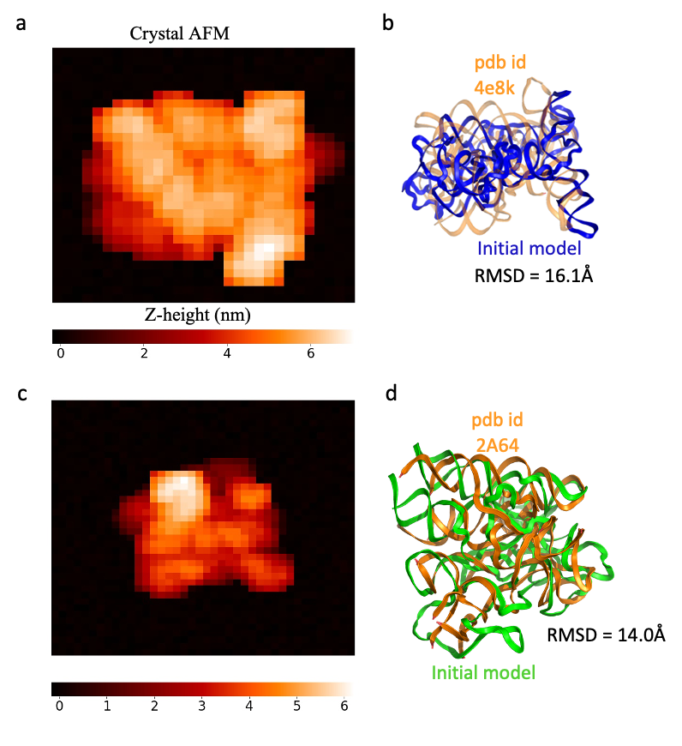
Extended Data Fig. 12| Benchmarks 4 and 5: Group II Intron and RNase P RNA. a, AFM image generated using the crystal model of Group II Intron (Accession code: 4e8k). b, cartoon representation of crystal structure (orange) and SAXS model (blue) for group II intron. c, AFM image of RNaseP RNA crystal model (Accession code: 2A64) and d, cartoon representation of crystal structure (orange) and SAXS model of the RNaseP RNA (green).

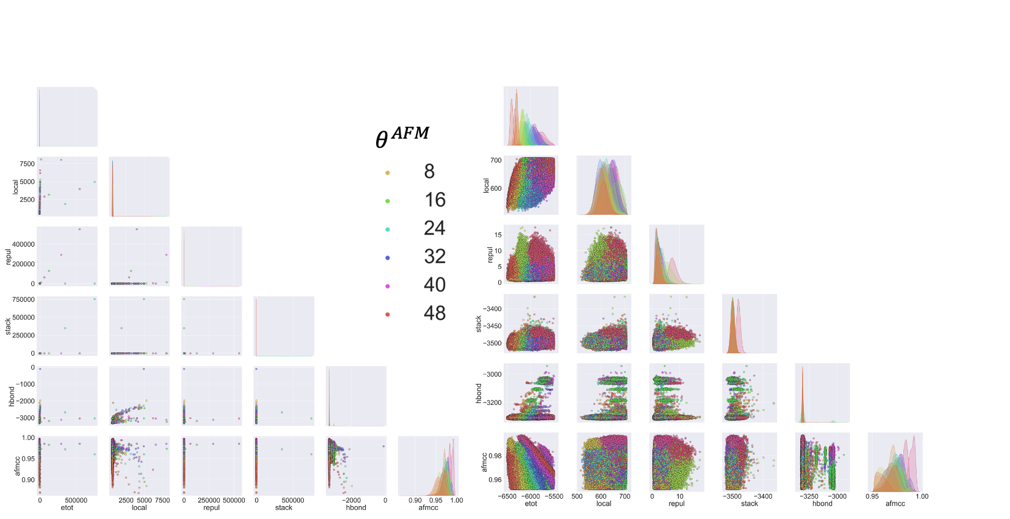
Extended Data Fig. 13| Energy and topography pair-correlation plot of Benchmark 1. Left: raw trajectory. Right: After HORNET-UML energy-filtering step.
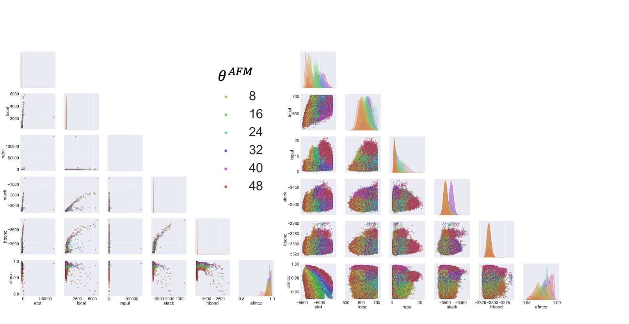 Extended Data Fig. 14| Energy and topography pair-correlation plot of Benchmark 2. Left: raw trajectory. Right: After HORNET-UML energy-filtering step.
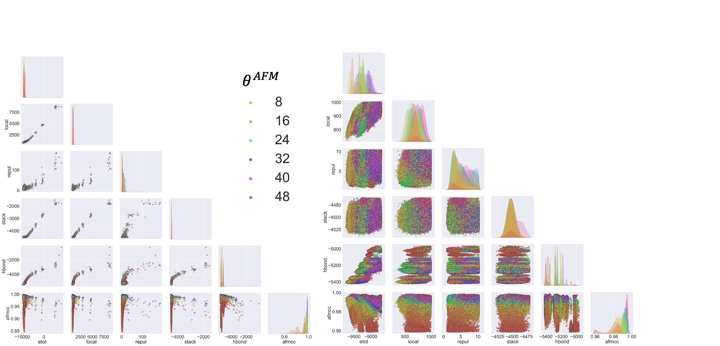
Extended Data Fig. 15| Energy and topography pair-correlation plot of Benchmark 3. Left: raw trajectory. Right: After HORNET -UML energy-filtering step.
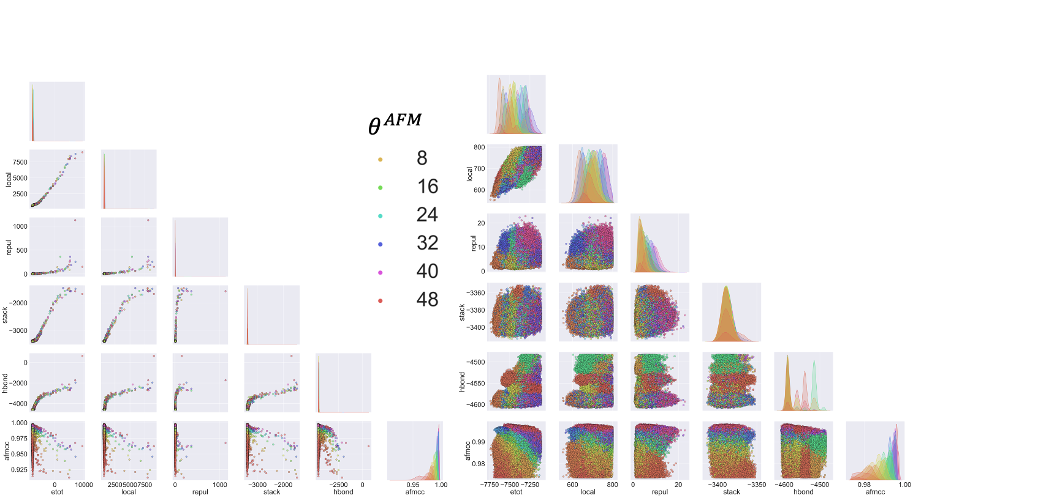
Extended Data Fig. 16| Energy and topography pair-correlation plot of Benchmark 4. Left: raw trajectory. Right: After HORNET -UML energy-filtering step.
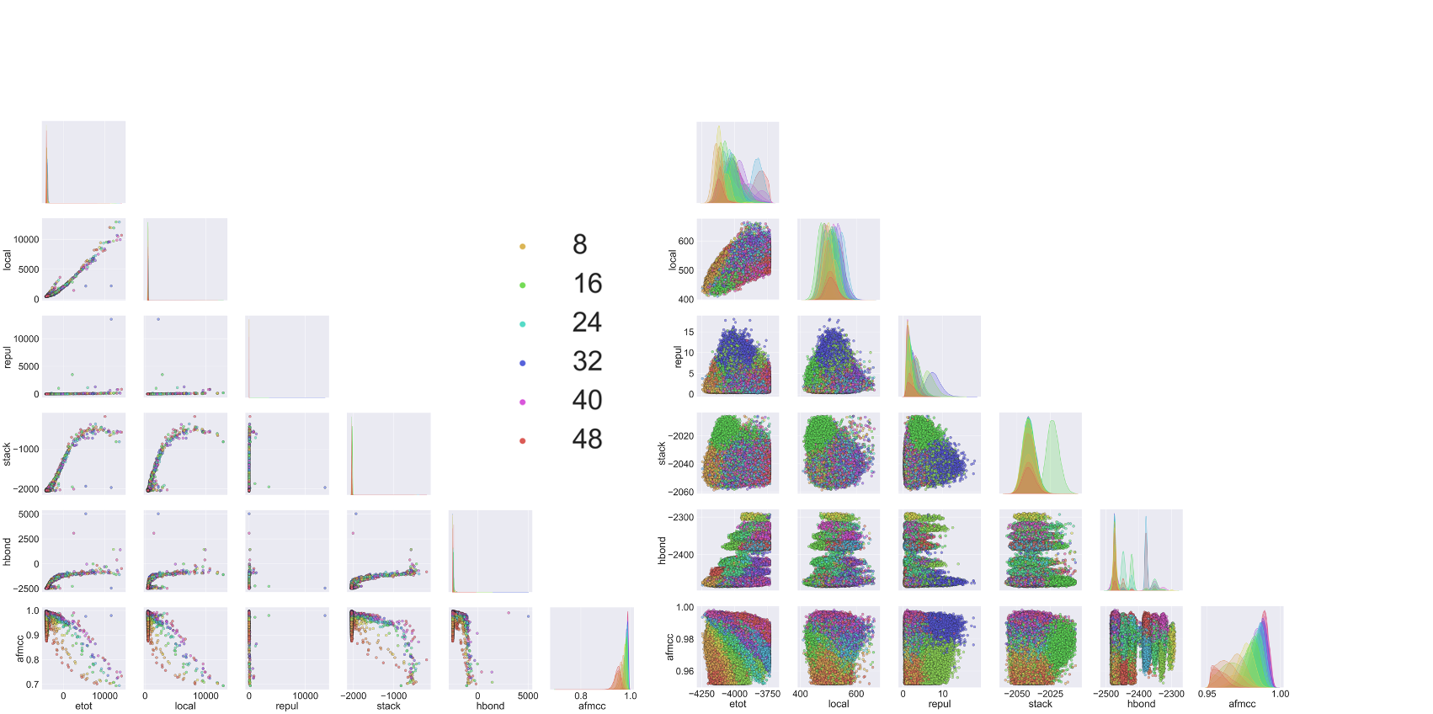
Extended Data Fig. 17| Energy and topography pair-correlation plot of Benchmark 5. Left: raw trajectory. Right: After HORNET -UML energy-filtering step.

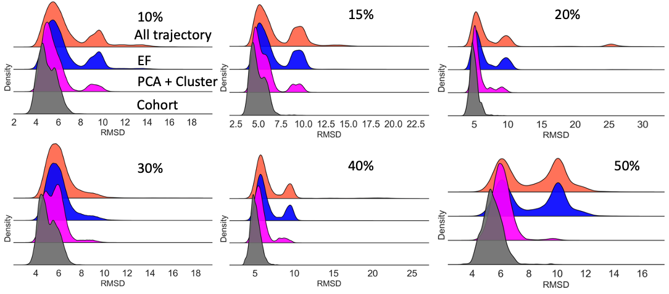

Extended Data Fig. 18| HORNET-UML analysis of Benchmark 0. RMSD distribution over all the steps of the analysis starting from all the models generated during the MD-AFM fitting (orange). The blue curve is the RMSD of the remaining models after the energy filtering process, while the magenta curve is the RMSD distribution of the selected cluster after PCA and clustering analysis, and finally, the cohort of models (gray) is selected from the magenta population based on energetics and topographic information.

Extended Data Table 5| Top Models Benchmark 0. Top 10 models selected from the Cohort population after UML analysis of Benchmark 0 (Extended Data Fig. 18) and input information described at Benchmark 0 using the 10 lowest total energy as the cutoff.

Noise level (%) | RMSD ( Å ) | E^{Total} (kcal/mol) | θ^{AFM} | CC^{AFM}
10 | 6.845 | -6590.95 | 12 | 0.994
10 | 4.175 | -6584.259 | 14 | 0.993
10 | 3.851 | -6582.08 | 10 | 0.989
10 | 4.946 | -6581.46 | 10 | 0.989
10 | 4.208 | -6579.19 | 14 | 0.990
10 | 4.22 | -6578.44 | 12 | 0.991
10 | 5.172 | -6577.44 | 12 | 0.989
10 | 4.558 | -6576.849 | 12 | 0.989
10 | 5.946 | -6575.95 | 12 | 0.990
10 | 4.179 | -6575.89 | 10 | 0.993
15 | 4.815 | -6584.679 | 15 | 0.988
15 | 4.772 | -6579.11 | 15 | 0.987
15 | 4.944 | -6577.17 | 9 | 0.987
15 | 3.603 | -6576.71 | 13 | 0.991
15 | 3.583 | -6575.46 | 15 | 0.989
15 | 4.225 | -6574.59 | 14 | 0.988
15 | 4.426 | -6573.31 | 15 | 0.988
15 | 4.075 | -6573.0 | 13 | 0.990
15 | 4.72 | -6570.820 | 14 | 0.988
15 | 4.48 | -6570.71 | 14 | 0.990
20 | 5.462 | -6578.83 | 6 | 0.982
20 | 3.847 | -6578.59 | 12 | 0.986
20 | 4.863 | -6578.43 | 7 | 0.982
20 | 5.199 | -6577.97 | 12 | 0.982
20 | 3.772 | -6577.42 | 12 | 0.982
20 | 4.441 | -6574.980 | 12 | 0.982
20 | 4.203 | -6573.91 | 12 | 0.984
20 | 4.164 | -6573.75 | 12 | 0.983
20 | 4.707 | -6573.019 | 6 | 0.983
20 | 5.404 | -6572.22 | 12 | 0.981
30 | 4.565 | -6592.24 | 15 | 0.966
30 | 4.362 | -6578.84 | 15 | 0.969
30 | 3.278 | -6577.93 | 15 | 0.969
30 | 4.277 | -6577.06 | 13 | 0.969
30 | 5.052 | -6574.1 | 15 | 0.967
30 | 4.929 | -6573.61 | 13 | 0.966
30 | 4.384 | -6572.62 | 15 | 0.970
30 | 4.657 | -6571.423 | 15 | 0.967
30 | 4.239 | -6570.70 | 13 | 0.968
30 | 4.641 | -6570.20 | 15 | 0.966
40 | 6.644 | -6596.84 | 12 | 0.946
40 | 4.241 | -6581.09 | 9 | 0.945
40 | 4.04 | -6580.07 | 9 | 0.948
40 | 4.366 | -6579.37 | 12 | 0.948
40 | 5.097 | -6577.94 | 12 | 0.948
40 | 4.825 | -6576.86 | 8 | 0.945
40 | 4.383 | -6576.62 | 9 | 0.944
40 | 4.346 | -6575.33 | 8 | 0.944
40 | 4.417 | -6573.34 | 12 | 0.950
40 | 4.482 | -6570.54 | 9 | 0.947
50 | 5.615 | -6575.15 | 8 | 0.922
50 | 4.305 | -6574.33 | 8 | 0.924
50 | 4.117 | -6570.94 | 10 | 0.920
50 | 5.602 | -6570.5 | 11 | 0.924
50 | 6.375 | -6570.07 | 10 | 0.919
50 | 5.666 | -6567.21 | 11 | 0.926
50 | 6.206 | -6566.74 | 10 | 0.923
50 | 6.325 | -6566.47 | 10 | 0.923
50 | 4.446 | -6564.43 | 7 | 0.922
50 | 5.15 | -6563.86 | 10 | 0.921

Extended Data Table 6| Top 10 models selected from the DNN for BM0 UML – Cohort models.

AFM Noise  Level | True RMSD | Predicted | AFM Noise  Level | True RMSD | Predicted | AFM Noise  Level | True RMSD | Predicted
5% | 3.51 | 4.93 | 10% | 4.45 | 4.89 | 15% | 3.99 | 5.01
5% | 5.29 | 4.94 | 10% | 5.44 | 4.94 | 15% | 5.22 | 5.02
5% | 6.07 | 4.94 | 10% | 5.67 | 4.98 | 15% | 4.297 | 5.02
5% | 3.80 | 4.94 | 10% | 5.65 | 4.98 | 15% | 3.84 | 5.02
5% | 4.07 | 4.94 | 10% | 5.47 | 5.00 | 15% | 3.81 | 5.02
5% | 5.98 | 4.95 | 10% | 4.62 | 5.00 | 15% | 3.82 | 5.03
5% | 5.40 | 4.98 | 10% | 4.35 | 5.01 | 15% | 4.079 | 5.03
5% | 4.12 | 4.97 | 10% | 3.57 | 5.01 | 15% | 3.99 | 5.04
5% | 5.6 | 4.98 | 10% | 3.65 | 5.01 | 15% | 4.10 | 5.04
5% | 5.8 | 4.99 | 10% | 5.58 | 5.02 | 15% | 4.61 | 5.05

AFM Noise  Level | True RMSD | Predicted | AFM Noise  Level | True RMSD | Predicted
20% | 5.12 | 5.05 | 30% | 4.24 | 5.31
20% | 3.67 | 5.05 | 30% | 6.43 | 5.31
20% | 3.47 | 5.07 | 30% | 4.30 | 5.32
20% | 4.02 | 5.08 | 30% | 5.08 | 5.32
20% | 3.84 | 5.09 | 30% | 5.32 | 5.38
20% | 4.43 | 5.10 | 30% | 4.05 | 5.33
20% | 5.54 | 5.11 | 30% | 4.97 | 5.33
20% | 3.94 | 5.12 | 30% | 4.99 | 5.33
20% | 4.43 | 5.12 | 30% | 4.30 | 5.34
20% | 5.39 | 5.14 | 30% | 5.70 | 5.34
(Extended Data Table 6 continued)

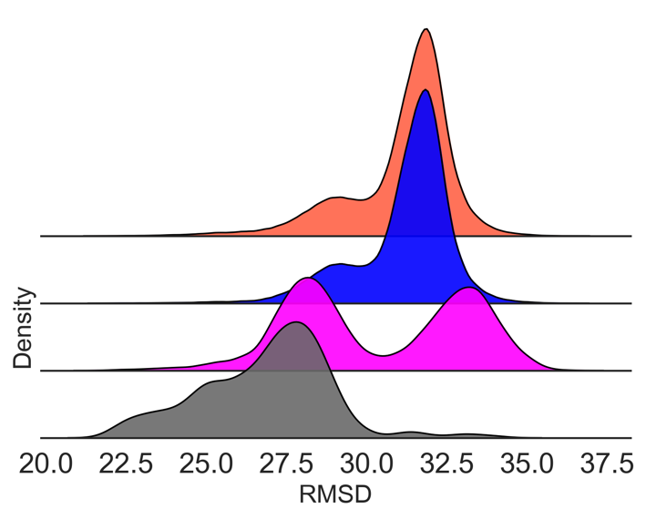
Extended Data Fig. 19| HORNET-UML analysis of Benchmark 1 initial conformation using particle S257 from FARFAR2 prediction of trRNase P RNA. Even though the particle S257 has a good FARFAR2 score and the lowest ARES score, the model shows a fold completely different from the GT structure. We performed the DM fitting using the AFM topography of the crystal structure as the driving force for particle fitting. For the trajectory time of ~ 11μs (estimation using CafeMol unit time of 49fs), the particle could not convert to a conformation close to the target structure, showing a minimum RMSD of 21.4 Å with major smaller population centered at 27.5 Å.

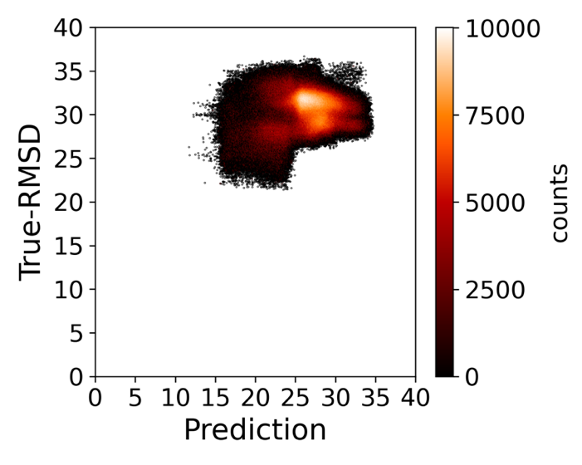
Extended Data Fig. 20| DNN structure prediction for S257 dynamic fitting trajectory. True RMSSD vs Predicted. The minimum predicted RMSD using the DDN trained model for the entire trajectory with ~ 16 million models is 12.4Å. The minimum values are clear outliers in the prediction distribution, where the centered distribution is located ~ 27Å. The DNN prediction was able to identify that the structure calculation did not converge to the GT-structure. Note. This data was never seen by the DNN trained model.

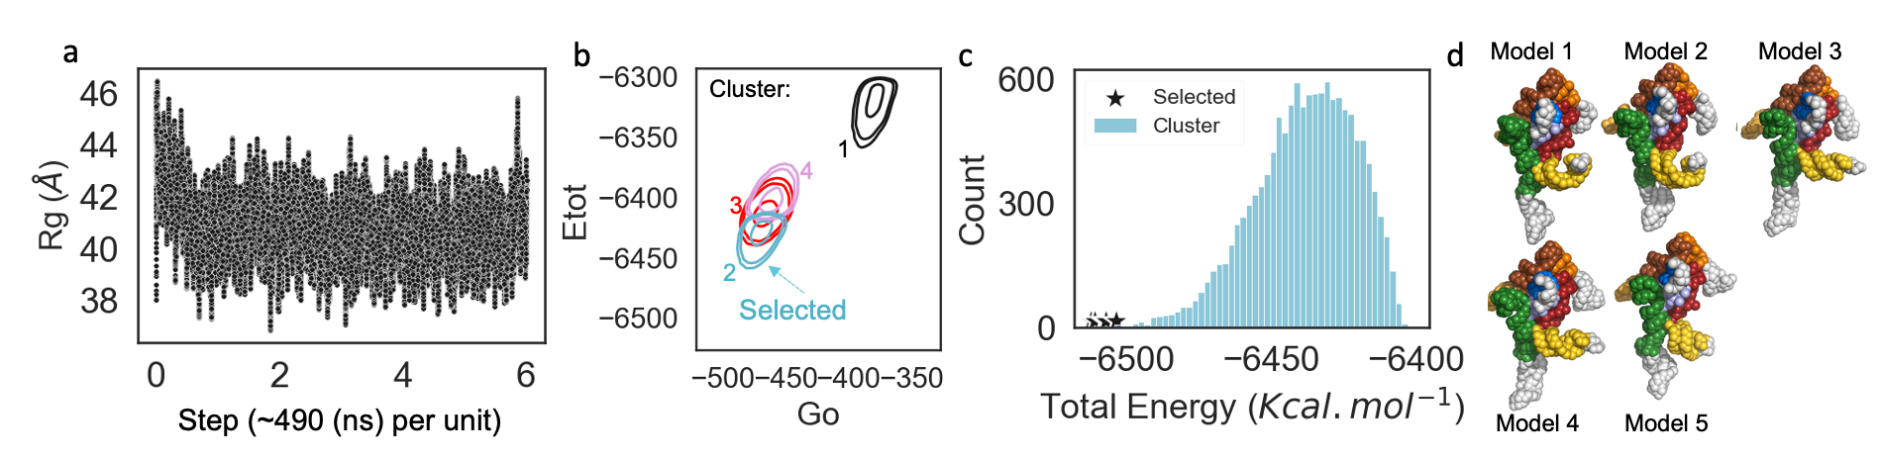
Extended Data Fig. 21| Coarse-grained S257 MD-simulation and analysis. a, in order to optimize the energy minimization of S257, we performed a molecular dynamic simulation of ~ 2.9$μs$ using CafeMol(8). b, to select the minimized structure from the MD trajectory, we applied the HORNET-UML approach without the AFM restraint, and the cluster with structures of the lowest total and Go energies was selected. c, next, we selected 5 models with the lowest total energy (star symbol) and these models were used individually as initial structures to perform dynamic fitting using the AFM-topography of the crystal model (pdb id 3dhs) superposed with 5% of added noise (Extended Data Fig. 7). d, the five selected models from previous step shown as beads, with the RMSDs relative to the crystal model of 19.3, 17.8, 19.0, 19.2 and 14.4 for models 1, 2, 3, 4, and 5, respectively.

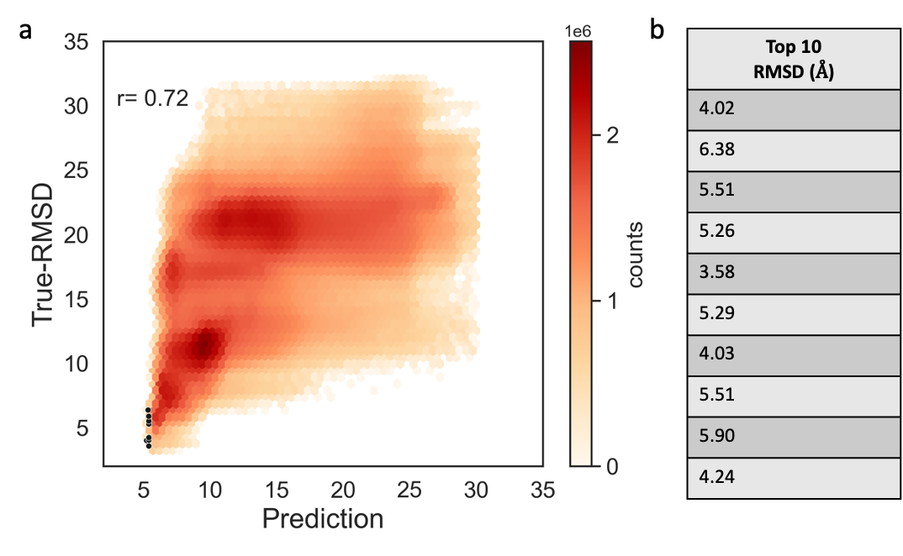

Extended Data Fig. 22. Structure RMSD prediction using DNN. a, correlation between the true RMSD and the predicted. The black dots indicate the position of the best 10 models selected from all five individual AFM fitting calculations for the models shown in Extended Data Fig. 21. b, true RMSD of the top 10 models selected by the HORNET trained model.

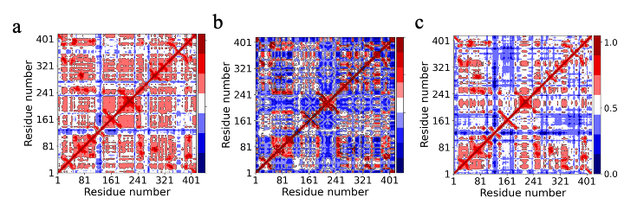
Extended Data Fig. 23| Dynamic cross-correlation maps (DCCM) respectively for each trajectory. a, P1. b, P2. c, P3.

Extended Data Table 7| Top 10 models selected from the DNN for P1, P2 and P3. Respectively values for the radius of gyration (Rg), the energy terms: total (E^{Total}), local (E^{Lotal}), Go (E^{Go}), repulsive (E^{repul}), stacking( E^{stacking}), paring (E^{paring}), and electrostatic (E^{elect}), the AFM cross-correlation value between experimental AFM topography and calculated model (CC^{AFM}), AFM potential(V^{AFM}), AFM force factor ( θ^{AFM}) and finally model prediction of the model accuracy in terms of RMSD (pred) in Å. The energy unit is kcal/mol.

Particle | Rg | E^{Total} | E^{Local} | E^{Go} | E^{repul} | E^{stacking} | E^{pairing} | E^{elect} | CC^{AFM} | V^{AFM} | stage | θ^{AFM} | pred
P1 | 40.8 | -6604.83 | 917.37 | -802.74 | 2.65 | -4116.24 | -3201.37 | 423.25 | 0.98 | 187.73 | -16.46 | 14 | 5.6
P1 | 40.8 | -6599.19 | 936.15 | -789.05 | 2.71 | -4128.88 | -3211.06 | 416.36 | 0.98 | 190.64 | -17.06 | 14 | 5.7
P1 | 41.6 | -6585.88 | 946.85 | -806.8 | 1.87 | -4128.72 | -3204.72 | 414.83 | 0.98 | 205.6 | -15.78 | 14 | 5.7
P1 | 40.8 | -6582.69 | 961.16 | -794.42 | 2.23 | -4135.77 | -3213.57 | 416.38 | 0.98 | 198.06 | -17.75 | 14 | 5.7
P1 | 41.1 | -6577.27 | 948.44 | -788.09 | 1.97 | -4129.77 | -3219.5 | 421.94 | 0.98 | 199.77 | -13.01 | 14 | 5.7
P1 | 40.1 | -6569.6 | 940.3 | -780.57 | 3.05 | -4128.29 | -3213.31 | 416.69 | 0.98 | 205.31 | -13.76 | 14 | 5.7
P1 | 41.1 | -6625.17 | 919.29 | -808.64 | 2.1 | -4137.25 | -3203.67 | 412.22 | 0.98 | 203.59 | -13.79 | 14 | 5.7
P1 | 40.8 | -6628.65 | 881.59 | -769.65 | 2.99 | -4124.15 | -3207.14 | 415.82 | 0.98 | 184.55 | -13.64 | 14 | 5.7
P1 | 41.6 | -6572.29 | 974.5 | -815.71 | 1.3 | -4132.15 | -3212.46 | 412.56 | 0.98 | 214.86 | -16.18 | 14 | 5.7
P1 | 40.9 | -6580.52 | 928.91 | -776.25 | 2.86 | -4128.89 | -3216.96 | 417.23 | 0.98 | 206.44 | -14.84 | 14 | 5.8
P2 | 49.1 | -9660.63 | 818.99 | -839.05 | 2.81 | -4869.61 | -5463.29 | 455.27 | 0.99 | 243.07 | -9.81 | 24 | 4.4
P2 | 48.3 | -9595.19 | 838.6 | -866.67 | 2.65 | -4863.44 | -5460.94 | 457.43 | 0.98 | 303.59 | -7.4 | 23 | 4.4
P2 | 48.3 | -9580.44 | 852.79 | -866.63 | 2.36 | -4858.09 | -5461.75 | 457.68 | 0.98 | 299.15 | -6.92 | 23 | 4.4
P2 | 48.4 | -9599.43 | 834.6 | -865.72 | 4.05 | -4858.0 | -5466.5 | 457.31 | 0.98 | 299.96 | -6.11 | 23 | 4.5
P2 | 48.8 | -9613.26 | 832.48 | -834.27 | 2.78 | -4848.85 | -5467.74 | 453.01 | 0.99 | 253.92 | -5.58 | 24 | 4.5
P2 | 48.8 | -9565.62 | 852.32 | -842.8 | 5.27 | -4857.46 | -5447.19 | 464.11 | 0.99 | 264.71 | -5.57 | 24 | 4.5
P2 | 48.4 | -9581.44 | 830.72 | -843.33 | 3.61 | -4857.8 | -5468.03 | 456.81 | 0.98 | 301.48 | -5.88 | 23 | 4.5
P2 | 48.8 | -9568.25 | 847.85 | -838.45 | 4.94 | -4876.16 | -5457.87 | 463.42 | 0.98 | 289.74 | -2.71 | 24 | 4.5
P2 | 49.1 | -9614.55 | 855.41 | -853.13 | 3.59 | -4856.91 | -5465.01 | 455.33 | 0.99 | 254.86 | -9.68 | 24 | 4.5
P2 | 49.1 | -9583.19 | 851.66 | -831.68 | 3.25 | -4864.33 | -5468.04 | 461.8 | 0.98 | 269.61 | -6.45 | 24 | 4.5
P3 | 45.7 | -9646.01 | 840.73 | -885.97 | 3.02 | -4870.25 | -5462.91 | 451.66 | 0.98 | 276.73 | 0.0 | 15 | 4.7
P3 | 45.7 | -9631.0 | 835.74 | -892.34 | 1.58 | -4859.65 | -5469.42 | 452.57 | 0.93 | 299.55 | 0.0 | 15 | 4.7
P3 | 45.7 | -9644.31 | 829.6 | -882.71 | 3.29 | -4872.97 | -5459.24 | 450.93 | 0.97 | 285.82 | 0.0 | 15 | 4.7
P3 | 45.7 | -9157.99 | 869.07 | -858.81 | 2.81 | -4864.22 | -5453.21 | 450.76 | 0.98 | 694.64 | 0.0 | 49 | 4.8
P3 | 45.8 | -9137.16 | 869.85 | -840.52 | 2.83 | -4866.05 | -5456.34 | 450.32 | 0.98 | 701.77 | 0.0 | 49 | 4.8
P3 | 46.7 | -9132.9 | 879.88 | -852.03 | 2.13 | -4854.5 | -5460.52 | 447.25 | 0.98 | 703.93 | 0.0 | 49 | 4.8
P3 | 45.9 | -9110.73 | 862.98 | -839.6 | 2.49 | -4874.27 | -5458.91 | 450.52 | 0.98 | 745.08 | 0.0 | 49 | 4.8
P3 | 45.8 | -9146.07 | 883.73 | -840.65 | 2.4 | -4871.48 | -5472.66 | 452.17 | 0.98 | 699.45 | 0.0 | 49 | 4.8
P3 | 45.8 | -9083.82 | 872.33 | -853.09 | 3.58 | -4874.93 | -5453.82 | 451.42 | 0.98 | 769.72 | 0.0 | 49 | 4.8
P3 | 45.8 | -9593.03 | 840.31 | -874.08 | 1.89 | -4859.49 | -5461.77 | 452.17 | 0.97 | 306.96 | 0.0 | 15 | 4.8

Extended Data Table 8| Top 10 models selected from the cohort of UML and evaluated by DNN for P1, P2 and P3. Respectively values the energy terms: total (E^{Total}), local (E^{Lotal}), Go (E^{Go}), repulsive (E^{repul}), stacking( E^{stacking}), paring (E^{paring}), and electrostatic (E^{elect}), the AFM cross-correlation value between experimental AFM topography and calculated model (CC^{AFM}), AFM potential (V^{AFM}), AFM force factor ( θ^{AFM}), and, finally, model prediction of the model accuracy in terms of RMSD (pred) in Å.The energy units is kcal/mol and prediction.

Particle | E^{Total} | E^{Local} | E^{Go} | E^{repul} | E^{stacking} | E^{pairing} | E^{elect} | CC^{AFM} | V^{AFM} | stage | θ^{AFM} | pred
P1 | -6659.61 | 887.29 | -787.74 | 3.54 | -4140.5 | -3207.66 | 410.04 | 0.98 | 199.73 | -25.29 | 14 | 5.8
P1 | -6651.64 | 902.54 | -793.21 | 3.51 | -4142.06 | -3208.7 | 416.63 | 0.98 | 183.98 | -15.32 | 14 | 5.8
P1 | -6653.47 | 908.18 | -795.04 | 3.38 | -4132.93 | -3216.59 | 412.33 | 0.98 | 180.53 | -14.31 | 14 | 5.8
P1 | -6649.23 | 901.84 | -794.22 | 3.81 | -4141.64 | -3208.87 | 407.68 | 0.98 | 204.87 | -23.69 | 14 | 5.8
P1 | -6645.38 | 921.97 | -796.12 | 3.41 | -4141.51 | -3217.44 | 407.74 | 0.98 | 207.62 | -32.04 | 14 | 5.8
P1 | -6661.07 | 924.99 | -809.65 | 1.66 | -4150.1 | -3214.15 | 412.13 | 0.98 | 184.23 | -11.16 | 14 | 5.9
P1 | -6642.3 | 891.19 | -787.19 | 2.45 | -4136.72 | -3205.11 | 417.22 | 0.98 | 186.4 | -11.51 | 14 | 5.9
P1 | -6672.08 | 908.6 | -806.37 | 2.86 | -4139.21 | -3210.55 | 417.97 | 0.98 | 165.22 | -11.58 | 11 | 5.9
P1 | -6643.87 | 911.24 | -791.59 | 2.64 | -4135.96 | -3215.72 | 418.27 | 0.98 | 178.15 | -11.88 | 14 | 5.9
P1 | -6640.0 | 901.39 | -789.34 | 5.92 | -4133.27 | -3210.17 | 410.79 | 0.98 | 188.3 | -14.61 | 14 | 6.0
P2 | -9744.31 | 819.73 | -844.03 | 3.59 | -4852.8 | -5468.51 | 451.5 | 0.98 | 157.21 | -11.98 | 12 | 4.6
P2 | -9741.05 | 825.74 | -844.93 | 2.92 | -4861.54 | -5460.19 | 447.12 | 0.98 | 158.1 | -9.25 | 12 | 4.7
P2 | -9798.4 | 800.0 | -860.37 | 2.93 | -4875.19 | -5472.76 | 446.06 | 0.98 | 169.56 | -9.61 | 10 | 4.7
P2 | -9741.4 | 830.51 | -873.88 | 2.01 | -4880.01 | -5462.33 | 445.35 | 0.98 | 206.97 | -11.01 | 15 | 4.7
P2 | -9757.01 | 825.43 | -851.19 | 2.78 | -4872.95 | -5470.81 | 447.65 | 0.98 | 173.08 | -11.98 | 10 | 4.7
P2 | -9738.28 | 818.26 | -855.04 | 1.75 | -4855.52 | -5458.95 | 445.8 | 0.98 | 174.18 | -9.73 | 12 | 4.7
P2 | -9738.12 | 824.34 | -854.36 | 2.88 | -4869.83 | -5465.06 | 446.45 | 0.98 | 188.22 | -11.74 | 12 | 4.7
P2 | -9743.96 | 839.65 | -854.56 | 2.33 | -4881.07 | -5466.98 | 445.21 | 0.98 | 178.35 | -7.86 | 12 | 4.7
P2 | -9773.79 | 820.63 | -862.18 | 3.1 | -4882.2 | -5469.61 | 447.26 | 0.98 | 176.81 | -8.58 | 10 | 4.7
P2 | -9740.64 | 835.96 | -847.86 | 2.76 | -4865.34 | -5472.79 | 447.41 | 0.98 | 168.6 | -10.36 | 10 | 4.7
P3 | -9710.9 | 814.06 | -870.58 | 2.31 | -4875.42 | -5466.14 | 447.13 | 0.98 | 236.76 | 0.0 | 14 | 4.8
P3 | -9715.56 | 823.28 | -880.53 | 2.57 | -4880.06 | -5472.17 | 445.04 | 0.98 | 245.34 | 0.0 | 14 | 4.9
P3 | -9717.65 | 794.77 | -875.14 | 2.79 | -4875.21 | -5463.25 | 444.77 | 0.97 | 252.64 | 0.0 | 14 | 5.0
P3 | -9782.39 | 850.0 | -881.4 | 2.69 | -4875.07 | -5468.0 | 442.5 | 0.97 | 145.91 | 0.0 | 8 | 5.0
P3 | -9702.2 | 825.03 | -871.32 | 3.08 | -4879.89 | -5463.83 | 439.91 | 0.97 | 243.84 | 0.0 | 12 | 5.0
P3 | -9789.33 | 820.5 | -890.02 | 2.36 | -4861.36 | -5458.24 | 443.22 | 0.98 | 153.24 | 0.0 | 8 | 5.0
P3 | -9777.07 | 868.14 | -896.49 | 2.76 | -4867.45 | -5464.51 | 441.46 | 0.98 | 138.04 | 0.0 | 8 | 5.0
P3 | -9703.17 | 826.41 | -881.08 | 2.66 | -4862.83 | -5469.57 | 444.79 | 0.98 | 235.46 | 0.0 | 14 | 5.0
P3 | -9706.74 | 820.8 | -883.63 | 2.81 | -4868.88 | -5450.65 | 442.88 | 0.98 | 228.96 | 0.0 | 14 | 5.0
P3 | -9756.69 | 861.67 | -874.73 | 2.12 | -4873.94 | -5459.67 | 440.92 | 0.98 | 145.96 | 0.0 | 8 | 5.0

