Supplementary Information
Protocol for recapitulation of 3D atomistic structures from AFM images
Outline
Dynamic fitting to low-resolution AFM images of proteins using CafeMol as the platform to obtain relative orientation/position has been demonstrated ¹. Implementing the dynamic fitting to high-resolution AFM images for the topological structure determination of RNA, however, involves several practical challenges. First, as discussed above, the CG force field for RNA is far less developed compared to that for proteins, and the relative weights, ${}^{AFM}$, ${}^{c}$, and ${}^{nc}$ of the various energy terms must be empirically determined by following the RNA hierarchical folding principle ². Thus, the AFM weighting factor ${}^{AFM}$ is systematically evaluated to obtain an optimal CC, where the primary covalent geometry and secondary structural interactions of the RNA are strictly maintained, and any tertiary interactions present in the initial model are weighted minimally. The direct outcome of this approach is the optimal fit to the experimental AFM topographic surfaces while maintaining the RNA’s primary and secondary structures and avoiding bias toward the initial structure. We developed an algorithm using unsupervised learning (UML) and deep neural networks (DNN) that address this issue and it is able to select and predict the accuracy of the calculated RNA structure by determining a suitable θ^{AFM} value that would result in an RNA structure closest to the AFM image, without violating covalent and secondary structural restraints.

Setting up the calculations
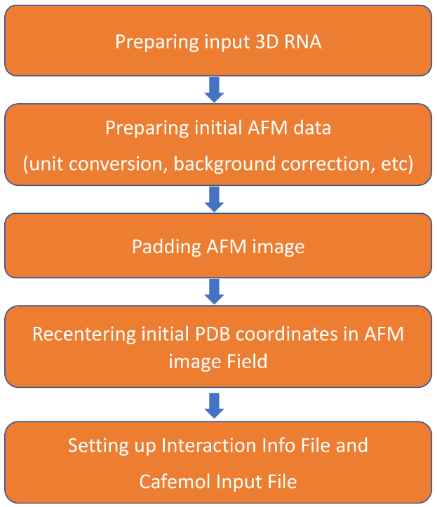
We developed a software pipeline that seamlessly performs all meticulous workflow steps (Supplementary Information Fig. 1) for preparing the input PDB coordinates and the input files. We used Go potential for local interactions and native-contact pairs, Debye-Hückel-type for electrostatic interactions, 15 mM KCl, and a constant temperature of 298.0 K for all structure calculations. For de novo structure determination without a known initial structure, we have adapted the program, RNA2D3D ^{3,4}, in the form of a singularity container to generate an open input 3D structure from the given secondary structure information. If the coordinates of a conformationally homologous structure, such as a crystal structure, are known, they are used as the initial
structure. The dimensions of the processed AFM data are first conv.erted to angstroms. The AFM image is then padded with an area of zero noise around the image to allow enough molecular freedom for translation/rotation during dynamic fitting. Another crucial step in the dynamic fitting is to recenter the initial PDB coordinates in the field of the AFM image in order to produce a meaningful image correlation between the calculated and reference images. The final steps involve setting up header information, including specifying proper pixel sizes, energy parameters, and dynamic fitting parameters. All of these steps are seamlessly carried out by execution of the script available at https://github.com/PNAI-CSB-NCI-NIH/HORNET providing as input the AFM data, model coordinates, and the “ninfo” file (discussed below). The optimal weighting factors, θ ^{c} and θ ^{nc}, which include individual values for bond lengths, bond angles, dihedral angles, hydrogen bonds, base stacking, and long-range interactions, are empirically determined (5, 5, 1, 1, 1, 9, 9), respectively. θ ^{AFM} varies depending on image quality and deviations from the initial conformation to the optimized conversion toward the AFM topography. We perform dynamic fitting at various θ^{AFM} values ranging from 2 to 50. The results are analyzed using UML and/or DNN, once the top cohort is ranked by DNN, which is designed to evaluate the energetic and topography information for each model generated during the dynamic fitting.
Supplementary Information Figure 1.| The workflow for preparing input files for recapitulating 3D structures from AFM using dynamic fitting
It is important to properly set up the “ninfo” file, which mainly consists of the interaction parameters for bond lengths, bond angles, dihedral angles, hydrogen bonding across base pairs, base stacking, and long-range tertiary contacts. The scaling factors in this file are empirically customized for RNA folding based on the hierarchical folding principles of RNA, which essentially states that secondary structural elements fold first, leading to the initiation of tertiary contacts. Therefore, the force constants for secondary structure interactions are kept relatively higher to keep the secondary structural elements intact during dynamic fitting. On this front, our pipeline scripts offer the flexibility to change the weights of the scaling factors: θ ^{c} and θ^{nc}, which are associated with bond lengths, bond angles, dihedral angles, hydrogen bonding, and base stacking, and θ ^{contact} for long-range interactions that are scaled weakly compared to primary and secondary scaling factors to minimize bias toward the initial structures. In addition, one can define the tertiary contacts in a user-friendly text file, which will then be processed for assimilating into the standard “ninfo” file generated by a python script available at https://github.com/PNAI-CSB-NCI-NIH/HORNET. Those user-defined tertiary interactions may be obtained from other biochemical and biophysical measurements.

Bead to all-atom conversion
The final coordinates generated from the CG MD calculations are in the form of three-beads per residue model, which can then be rendered into explicit all-atom models. We developed a rendering pipeline that writes out the beads to all atoms and carries out structure refinement using the Xplor-NIH package (Supplementary Information Fig. 2). The specific steps for reconstructing the atomistic RNA structures are outlined as follows.
- Reduction to 1 bead per residue:
[center of mass of 3 beads (xyz)] => [1 bead(hkl)] => apply [all residues]
- As the majority of RNAs are comprised of A-form duplexes, each duplex region in the RNA is replaced by a matching all-atom duplex built from the standard G2G duplex library. The matching duplex is aligned to the specific location in the RNA based on iterative translation and rotation targeted for best fit. The non-duplex regions are explicitly written out into all-atom coordinates based on references to the bead positions. The steps for writing out the 1-bead-per-residue to the all-atom model can be summarized as:
[duplex regions] => [library based all-atom duplex reconstruction]
[non-duplex regions] => [individual all-atom residue reconstruction]
- Regularization protocol from Xplor-NIH used to fix covalent geometry.
- Simulated annealing refinement using Xplor-NIH version 3.1. In addition to the covalent bond, bond angle and improper dihedral terms and the quartic RepelPot term, the following energy terms were employed: base-pair distance and planarity restraints, the TorsionDB statistical torsion angle potential.
- Torsional angle term, the ORIE base-base positional potential of mean force, and the explicit HBON hydrogen-bonding term. Two non-crystallographic symmetry terms were also employed, one restraining heavy atoms from deviating more than 2 Å RMSD from the input structure, and a second restraining the coordinates to the corresponding 3-bead-per-residue model using the “GlobDiffPot” term with the corresponding energy written as,
$E_{glob}=\frac{1}{2}k_{bead}\sum_{i}{\left[{\left|q_{Pi}-r_{Pi}\right|}^{2}+{\left|q_{Ri}-r_{ri}\right|}^{2}+{\left|q_{Bi}-r_{Bi}\right|}^{2}\right]}$ ,
where $k_{bead}$ is an energy scale factor, $q_{i}$ are three positions derived from the current atomic coordinates, $r_{i}$ are the corresponding input bead coordinates, and $i$ is each residue for which bead coordinates are available, summed over all residues. The substitutions P, R, and B represent phosphorous, ring, and base position, respectively, where $q_{Pi}$ is the phosphorous position, $q_{Ri}$ is the average position of the five ribose-ring heavy atoms, and $q_{Bi}$is the position of the N₁ atom for purine nucleotides and that of the N₃ atom for pyrimidine nucleotides. For our case studies, we used a value of $k_{bead}$ = 3 kcal/mol throughout the calculations.

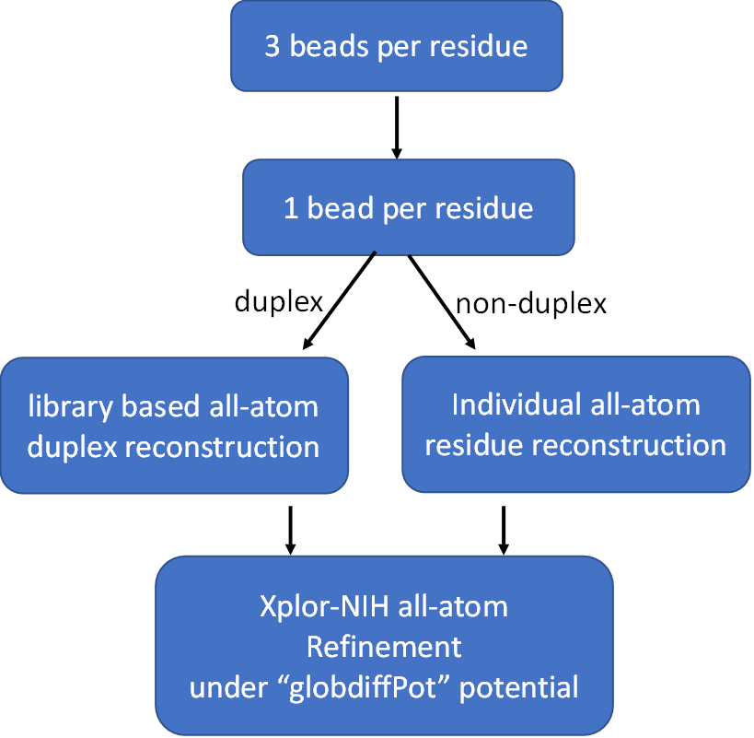
Supplementary Information Figure 2| The flowchart for all-atom conversion.

The used script is available at https://github.com/PNAI-CSB-NCI-NIH/HORNET, which takes as input the base-pair information file (if not available an empty file with the sequence can be provided) and a list of coarse-grained PDBs for all-atom conversion.

References

1 Niina, T., Fuchigami, S. & Takada, S. Flexible Fitting of Biomolecular Structures to Atomic Force Microscopy Images via Biased Molecular Simulations. J Chem Theory Comput 16, 1349-1358 (2020). https://doi.org:10.1021/acs.jctc.9b00991
2 Cruz, J. A. & Westhof, E. The dynamic landscapes of RNA architecture. Cell 136, 604-609 (2009). https://doi.org:10.1016/j.cell.2009.02.003
3 Bhandari, Y. R. et al. Topological Structure Determination of RNA Using Small-Angle X-Ray Scattering. J Mol Biol 429, 3635-3649 (2017). https://doi.org:10.1016/j.jmb.2017.09.006
4 Martinez, H. M., Maizel, J. V., Jr. & Shapiro, B. A. RNA2D3D: a program for generating, viewing, and comparing 3-dimensional models of RNA. J Biomol Struct Dyn 25, 669-683 (2008). https://doi.org:10.1080/07391102.2008.10531240

