Supplementary Information for

Sr/Ca in foraminiferal calcite as a proxy for calcifying fluid composition

Qicui Jiaª, Shuo Zhang^{a,*}, James M. Watkins^{b}, Laurent S. Devriendt^{c}, Yuefei Huang^{a,d}, Guangqian Wangª

ªState Key Laboratory of Hydroscience and Engineering, Department of Hydraulic Engineering, Tsinghua University, Beijing, China
^{b}Department of Earth Sciences, University of Oregon, Eugene, OR, USA, 97403
^{c}Chemical Sciences Division, Lawrence Berkeley National Laboratory, Berkeley, CA 94720, USA
^{d}State Key Laboratory of Plateau Ecology and Agriculture, Qinghai University, Xining, Qinghai 810016, China

*Shuo Zhang
Email: zhangs2019@tsinghua.edu.cn

Analysis of the D_{Sr} data from Yu et al.¹
Variations in core-top D_{Sr} data from Yu et al.¹ for the benthic species C.wuellerstorfi and C.mundulus are poorly explained by variations in environmental DIC or a single DIC species (Fig. S1a-d). Each DIC species becomes significantly more correlated with D_{Sr} when the effect of pressure on the solubility product (K_{sp}) is included (Fig. S1e-h); with the strongest correlations and best inter-ocean agreement observed for D_{Sr} vs DIC/K_{sp} and D_{Sr} vs HCO₃⁻/K_{sp} (R² = 0.58 and 0.56 respectively). This suggests Ω in the foraminiferal calcifying fluid is (partly) controlled by pressure and environmental DIC and/or HCO₃⁻.

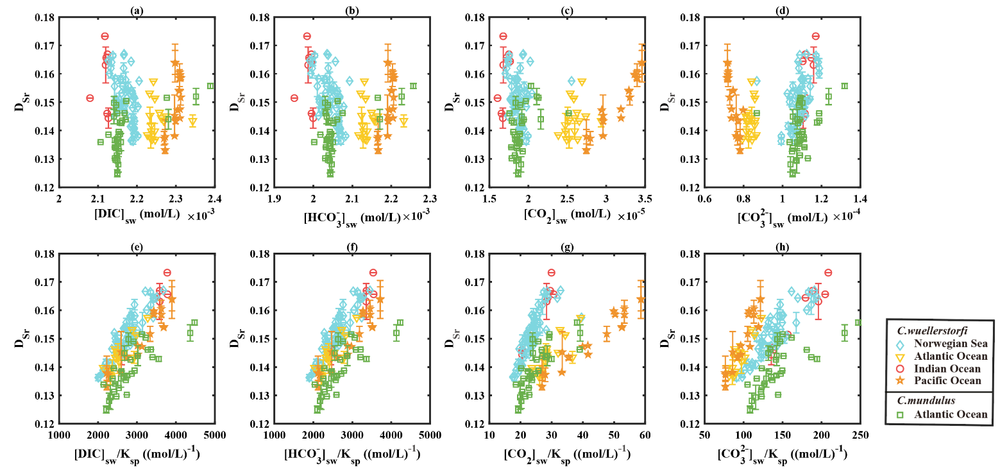
Figure S1. The dependence of foraminiferal D_{Sr} on environmental carbonate chemistry.

Possible combinations of P_{cell} and F_{ALK} that match D_{Sr}
The key parameters in our model are P_{cell} and F_{ALK}, which characterize the transport rate of CO₃²⁻, HCO₃⁻, Sr²⁺, Ca²⁺, OH⁻ and H⁺, and the rate of alkalinity pump. The effects of these parameters can be understood within a simple framework. At steady state, the mass balance of DIC (ignoring the small amount of CO₂(aq)) and alkalinity in the calcifying fluid dictates that
$$\begin{aligned}ΔDIC={\left[DIC\right]}_{sw}-{\left[DIC\right]}_{cf}≈R_{p}/P_{cell}\#\left(s1a\right)\end{aligned}$$
and
$$\begin{aligned}ΔALK={\left[ALK\right]}_{sw}-{\left[ALK\right]}_{cf}=(2R_{p}-F_{ALK})/P_{cell}\#\left(s1b\right)\end{aligned}$$

Where P_{cell} (m/s) is the membrane permeability to CO₃²⁻, HCO₃⁻, Sr²⁺, Ca²⁺, OH⁻ and H⁺, R_{p} (mol/m²/s) is the calcite precipitation flux, F_{ALK} (mol/m²/s) is the proton pump rate, and the subscript sw and cf denote the concentration of a chemical component in seawater and in the calcifying fluid respectively. In our default model, P_{cell} = 4x10⁻⁶ m/s, F_{ALK} = 4.7x10⁻⁶ mol/m²/s. With these parameters the resulting$ΔDIC$ is about 300 μM and $ΔALK$ is about -500 μM (negative because the calcifying fluid has a larger alkalinity than seawater). The value of $F_{ALK}$ is about 10 times greater than R_{p} (~1×10⁻⁶ mol/m²/s) and the term $2R_{p}-F_{ALK}≈-F_{ALK}$. If P_{cell} is reduced/increased by a factor of 10, a 10-fold decrease/increase in F_{ALK} will result in roughly the same $ΔDIC$ and $ΔALK$ and therefore the same D_{Sr} (Fig. S4). With smaller values of P_{cell} (smaller than 1×10⁻⁶ m/s), F_{ALK} becomes comparable with R_{p} and the F_{ALK} value that fits the D_{Sr} data can only be found numerically. However, the resulting pH of the calcifying fluid when P_{cell} < 1×10⁻⁶ m/s is over 10, which is considerably higher than previous estimates². The shaded zone in Fig. S2 shows possible combinations of F_{ALK} and P_{cell} values that can fit the D_{Sr} data. The R² value of fitted D_{Sr} is used to locate the optimal F_{ALK} and P_{cell} values which are used in our model in the main text.

It is worth noting that the D_{Sr} data can also be fit if seawater uptake is considered instead of ion transport. Our formulations include the term of seawater uptake fluxes, and with appropriate $τ_{sw}$ and F_{ALK} values the model can produce the same D_{Sr} as the base model with P_{cell} and F_{ALK}. Our model therefore does not rule out the possibility that foraminifera receive their calcifying ions from seawater uptake. The consistency between Sr in foraminiferal calcite and inorganic calcite still holds in either case.

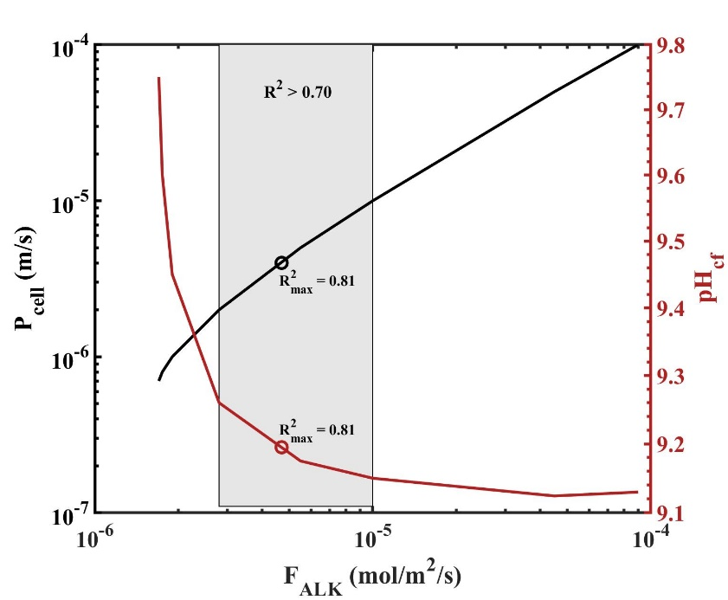
Fig. S2. Possible combinations of F_{ALK} and P_{cell} values (black line, left vertical axis) that fit the D_{Sr} data for C. wuellerstorfi and associated pH_{cf} in the foraminifera at a water depth of 3000 m (red line, right vertical axis). The grey shaded area shows possible combinations of F_{ALK} and P_{cell} values with R² of fitted D_{Sr} values larger than 0.7. The black and red circles represent the optimal fitting parameters (P_{cell} = 4 x 10⁻⁶ m/s, F_{ALK} = 4.7x10⁻⁶ mol/m²/s for C. wuellerstorfi, R²=0.81).
Additional outputs of carbonate chemistry of the calcifying fluid
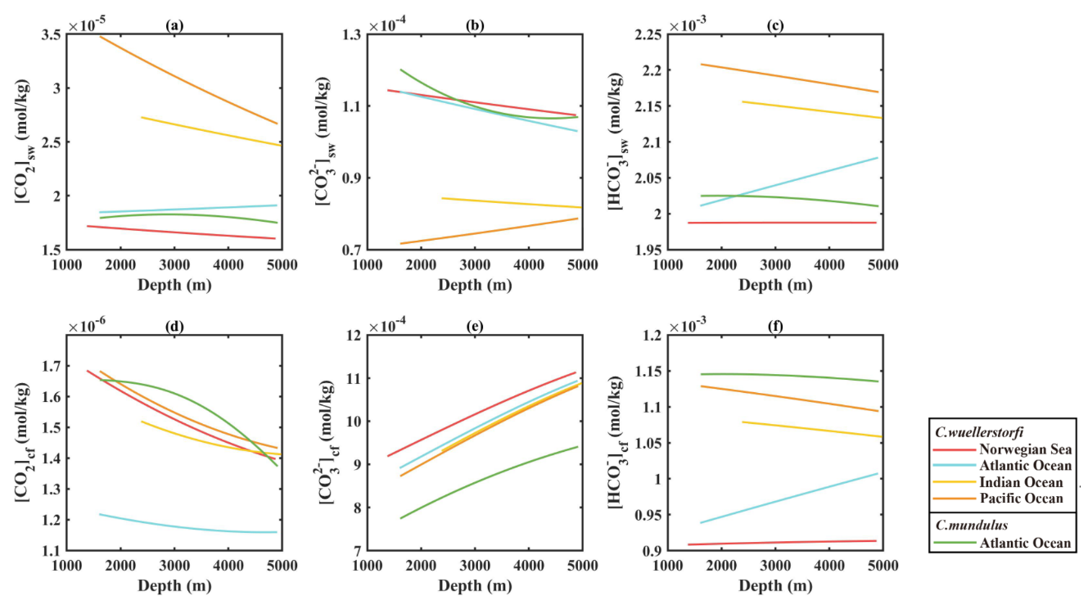

Fig. S3. Additional carbonate chemistry of seawater and the foraminifera (C. wuellerstorfi and C.mundulus) calcifying fluid calculated by the model. Because of the elevation of pH_{cf}, [CO₂]_{cf} decreases by about 1 order of magnitude compared to that in seawater, [CO₃²⁻]_{cf} increases by about 1 order of magnitude, and [HCO₃⁻]_{cf} decreases slightly.

The ion-by-ion model for Sr partitioning
The ion-by-ion model for Sr partitioning during calcite precipitation has been presented in a previous paper³. Due to the high calcite saturation state in the calcifying fluid, we consider that the precipitation of foraminiferal calcite is driven by 2D nucleation⁴. The original model was developed for calcite precipitation at three temperatures (5, 25, and 40 ºC) and atmospheric pressure. We extend its temperature and pressure range in this paper so that it can be applied to the low temperature, high pressure foraminifera data in Yu et al.¹. The foraminifera samples collected in Yu et al.¹ are from water depths between 1000 and 5000 m, and at temperatures around 2 ºC.

The model in Jia et al.³ considers the speciation of HCO₃⁻ and CO₃²⁻ in an aqueous solution and their contributions to calcite precipitation. Four ions (Ca²⁺, Sr²⁺, CO₃²⁻ and HCO₃⁻) attach to, and detach from, kink sites. Following the notation of Jia et al.³, we denote Ca²⁺, CO₃²⁻, HCO₃⁻ and Sr²⁺ ions in the solution as A, B₁, B₂ and M, respectively. A full list of formulas and parameters in this model is provided in SI Appendix, Table S2. The parameters include thermodynamic parameters such as the solubility of calcite $K_{CaCO_{3}}$, and kinetic parameters such as the attachment frequency of Ca²⁺ to the carbonate ion type kink sites $k_{A1}$. The values of these parameters at three temperatures and atmospheric pressure have been optimized to fit three sets of experimental inorganic D_{Sr} data³. To extend this model to low temperature and high pressures, as required by the Yu et al.¹ data, we need to evaluate how the thermodynamic and kinetic parameters change with temperature and pressure.

The dependence of the thermodynamic parameters on temperature has been presented in Jia et al.³. The kinetic parameters at 5, 25, and 40 ºC are extrapolated to the seawater temperature in Yu et al.¹ of approximately 2 ºC (Table S1) as functions of temperature. The empirical formulas follow the form of:
$$\begin{aligned}k_{A1}\left(T\right)≈8.84×{10}^{11}exp⁡(\frac{-1280}{T})\#\left(s2a\right)\end{aligned}$$
$$\begin{aligned}ν_{M1}\left(T\right)≈1.60×{10}^{13}exp⁡(\frac{-5396}{T})\#\left(s2b\right)\end{aligned}$$
$$\begin{aligned}ν_{A1}\left(T\right)≈1.60×{10}^{6}exp⁡(\frac{-930.7}{T})\#\left(s2c\right)\end{aligned}$$
The effect of pressure on $K_{CaCO_{3}}$ can be estimated from the following formula⁵:
$$\begin{aligned}\ln\left(\frac{K_{CaCO_{3}}^{p}}{K_{CaCO_{3}}^{P_{0}}}\right)=\frac{1}{RT}\left(-∆VP+0.5∆KP^{2}\right)\#\left(s3\right)\end{aligned}$$
where $K_{CaCO_{3}}^{p}$ is the solubility of calcite at pressure P (bar), $K_{CaCO_{3}}^{P_{0}}$ is the solubility at atmospheric pressure, and $∆V$ and $∆K$ are the changes in volume and compressibility, which can be calculated as follows:
$$\begin{aligned}∆V=\sum_{i}{\overline{V}{}_{i,products}}-\sum_{i}{\overline{V}{}_{i,reactants}}\#\left(s4\right)\end{aligned}$$
$$\begin{aligned}∆K=\sum_{i}{\overline{K}{}_{i,products}}-\sum_{i}{\overline{K}{}_{i,reactants}}\#\left(s5\right)\end{aligned}$$
where $\overline{V}$ and $\overline{K}$ of reactants and products are:
$$\begin{aligned}\overline{V}\left(T\right)=\overline{V}\left(0℃\right)+A_{v}T+B_{v}T^{2}\#\left(s6\right)\end{aligned}$$
$$\begin{aligned}\overline{K}\left(T\right)=\overline{K}\left(0℃\right)+A_{K}T\#\left(s7\right)\end{aligned}$$
where $A_{v}$, $A_{K}$, $B_{v}$ are coefficients⁵. The effect of pressure on $K_{HCO_{3}^{-}}$ in seawater can be estimated similarly.
The solubility of the calcite-type SrCO₃ $K_{SrCO_{3}}$at temperature T and pressure P is related to $K_{CaC{O_{3}}_{T,P}}$ and ${K_{Sr}^{a}}_{T,P}$ through ${K_{SrCO_{3}}}_{T,P}={K_{CaCO_{3}}}_{T,P}/{K_{Sr}^{a}}_{T,P}$, where $K_{Sr}^{a}$ is the equilibrium constant for the ion exchange reaction $CaCO_{3}+Sr^{2+}=SrCO_{3}+Ca^{2+}$. The effects of temperature and pressure on ${K_{Sr}^{a}}_{T,P}$ can be estimated by evaluating the Gibbs free energy change of ion exchange reaction:
$$\begin{aligned}ln{K_{Sr}^{a}}_{T,P}=-∆G_{r,T,P}^{0}/RT\#\left(s8\right)\end{aligned}$$
The Gibbs free energy change at temperature T and pressure P was estimated in Sverjensky⁶:
$$∆G_{r,T,P}^{0}={\left[∆G_{f,SrCO_{3}}^{0}-∆G_{f,CaCO_{3}}^{0}\right]}_{Tr,Pr}-\left(T-Tr\right)\left(S_{SrCO_{3}}^{0}-S_{CaCO_{3}}^{0}\right)+\left(P-Pr\right)\left(V_{SrCO_{3}}^{0}-V_{CaCO_{3}}^{0}\right)-{\left[∆G_{f,{Sr}^{2+}}^{0}-∆G_{f,{Ca}^{2+}}^{0}\right]}_{T,P}≈∆G_{r,Tr,Pr}^{0}+\left(P-Pr\right)\left(V_{SrCO_{3}}^{0}-V_{CaCO_{3}}^{0}\right) (s9)$$
where $∆G_{f,SrCO_{3}}^{0}$, $∆G_{f,CaCO_{3}}^{0}$, $S_{SrCO_{3}}^{0}$, $S_{CaCO_{3}}^{0}$, $V_{SrCO_{3}}^{0}$ and $V_{CaCO_{3}}^{0}$ are values at 25°C and 1 bar. $∆G_{f,{Sr}^{2+}}^{0}$ and $∆G_{f,{Ca}^{2+}}^{0}$ values are estimated at temperature T and pressure P, and can be approximated by their values at 1 bar. Within the water depth studied in this work, the largest pressure increase is 500 bar. The pressure change term $\left(P-Pr\right)\left(V_{SrCO_{3}}^{0}-V_{CaCO_{3}}^{0}\right)$ and $∆G_{r,Tr,Pr}^{0}$ are 6.09 cal/mol and 1.2 Kcal/mol, respectively. $\frac{K_{Sr}^{a,p}}{K_{Sr}^{{a,P}_{0}}}$ = 1.005 and therefore the change of ${K_{Sr}^{a}}_{T,P}$ from 0 bar to 500 bar is about 0.5% and very small. The final temperature and pressure corrected values of the thermodynamic and kinetic parameters are compiled in Table S1.

Table S1. The extrapolated attachment/detachment frequencies and calculated thermodynamic parameters in the four oceans. T is the mean temperature of seawater at varying depth.
Oceans | The Norwegian Sea  pH 8.09 | The Atlantic Ocean  pH 7.96 | The Indian Ocean  pH 7.84 | The Pacific Ocean  pH 7.80
T (K) | 272.26 | 276.01 | 274.51 | 275.05
$k_{A1}$ (s⁻¹M⁻¹) | 8.01×10⁹ | 8.47×10⁹ | 8.24×10⁹ | 8.29×10⁹
$ν_{A1}$ (s⁻¹) | 5.23×10⁴ | 5.44×10⁴ | 5.34×10⁴ | 5.36×10⁴
$v_{M1}$ (s⁻¹) | 3.92×10⁴ | 4.95×10⁴ | 4.43×10⁴ | 4.53×10⁴
$K_{CaCO_{3}}$ (1bar) | 4.17×10⁻⁹ | 4.09×10⁻⁹ | 4.12×10⁻⁹ | 4.11×10⁻⁹
$K_{HCO_{3}^{-}}$ (1bar) | 2.28×10⁻¹¹ | 2.60×10⁻¹¹ | 2.47×10⁻¹¹ | 2.51×10⁻¹¹
$K_{SrCO_{3}}$ (1bar) | 3.82×10⁻⁸ | 3.63×10⁻⁸ | 3.70×10⁻⁸ | 3.66×10⁻⁸
Depth (m) | 1375~3299 | 1604~4779 | 2382~4156 | 1614~4441
$$K_{CaCO_{3}}$$ | (5.49-7.88) ×10⁻⁹ | (5.55-9.68) ×10⁻⁹ | (6.50-8.91) ×10⁻⁹ | (5.56-9.19) ×10⁻⁹
$K_{HCO_{3}^{-}}$ | (2.53-2.90) ×10⁻¹¹ | (2.92-3.60) ×10⁻¹¹ | (2.93-3.31) ×10⁻¹¹ | (2.83-3.43) ×10⁻¹¹
$$K_{SrCO_{3}}$$ | (5.04-9.63) ×10⁻⁸ | (4.93-8.85) ×10⁻⁸ | (5.81-9.22) ×10⁻⁸ | (4.98-8.99) ×10⁻⁸

An evaluation of D_{Sr} and D_{Mg} of foraminiferal calcite using the Nehrke et al.⁸ model

Our model is conceptually consistent with the framework proposed by Nehrke et al.⁸. The transmembrane transport (TMT) and passive transport (PT) mechanisms are proposed in Nehrke et al.⁸ for interpreting D_{Sr} and D_{Mg} values in foraminiferal calcite. If the fraction of Ca supplied by PT is f, the observed D_{Sr} and D_{Mg} values in foraminifera calcite are
$$\begin{aligned}D_{sr}^{obv}={f×D}_{sr}^{pcp}+\left(1-f\right)×D_{Sr}^{TMT}×D_{Sr}^{pcp}\#\left(s10\right)\end{aligned}$$
and
$$\begin{aligned}D_{Mg}^{obv}=f×D_{Mg}^{pcp}+\left(1-f\right)×D_{Mg}^{TMT}×D_{Mg}^{pcp}\#\left(s11\right)\end{aligned}$$
where pcp refers to precipitation of CaCO₃. For Mg $D_{Mg}^{obv}$ is about 2/5000=0.0004 for low Mg foraminifera calcite, and $D_{Mg}^{pcp}$ of inorganic calcite is 0.02⁹. Substituting these values in Eq. s11 we get:
$$\begin{aligned}f+\left(1-f\right)×D_{Mg}^{TMT}=0.02\#\left(s12a\right)\end{aligned}$$
Because the term $\left(1-f\right)×D_{Mg}^{TMT}$ is larger than 0, Eq. s11a requires that f is smaller than 0.02 (2%).

The value of $D_{Mg}^{obv}$ can be as high as 100/5000=0.02 in high Mg foraminifera calcite, so that Eq. s12a becomes
$$\begin{aligned}f+\left(1-f\right)×D_{Mg}^{TMT}=1\#\left(s12b\right)\end{aligned}$$
The value of $D_{Mg}^{TMT}$ is negligible⁸. Eq. s12b suggests that f is about 100% in foraminifera with high Mg.

For Sr, $D_{sr}^{obv}$ is about 0.15¹, and $D_{sr}^{pcp}$ of inorganic calcite is between 0.025 and 0.3¹⁰. Because f is smaller than 2% in low Mg foraminiferal calcite, the term ${f×D}_{sr}^{pcp}$ is smaller than 0.006, a negligible fraction in $D_{sr}^{obv}$. Eq. s10 can therefore be simplied to
$$\begin{aligned}D_{sr}^{obv}=\left(1-f\right)×D_{Sr}^{TMT}×D_{Sr}^{pcp}\#\left(s13\right)\end{aligned}$$
The term (1-f) is larger than 98%, close to 1. So for Sr, the observed D_{Sr} is essentially the product of the partition coefficients during transmembrane transport and during calcite precipitation.
$$\begin{aligned}D_{sr}^{obv}=D_{Sr}^{TMT}×D_{Sr}^{pcp}\#\left(s14\right)\end{aligned}$$

To summarize, based on Mg data, TMT is the main component of Ca transport in low Mg foraminifera with its contribution higher than 98%, and it changes the partitioning of Sr by an additional factor of $D_{Sr}^{TMT}$. The value of $D_{Sr}^{TMT}$ is not known exactly, but any given value of $D_{Sr}^{TMT}$ can be applied to Eq. s14 to correct the $D_{sr}^{obv}$ values. The correlation between $D_{sr}^{obv}$ and Ω is likely due to the effect of Ω on $D_{Sr}^{pcp}$, with $D_{Sr}^{TMT}$ being relatively constant.

SI References
1 Yu, J. M., Elderfield, H., Jin, Z. D., Tomascak, P. & Rohling, E. J. Controls on Sr/Ca in benthic foraminifera and implications for seawater Sr/Ca during the late Pleistocene. Quaternary Sci. Rev. 98, 1-6, doi:10.1016/j.quascirev.2014.05.018 (2014).
2 de Nooijer, L., Toyofuku, T. & Kitazato, H. Foraminifera promote calcification by elevating their intracellular pH. PNAS 106(36), 15374-15378 (2009).
3 Jia, Q., Zhang, S., Lammers, L., Huang, Y. & Wang, G. A model for pH dependent strontium partitioning during calcite precipitation from aqueous solutions. Chem. Geol 608, doi:10.1016/j.chemgeo.2022.121042 (2022).
4 Nielsen, L. C., DePaolo, D. J. & De Yoreo, J. J. Self-consistent ion-by-ion growth model for kinetic isotopic fractionation during calcite precipitation. Geochim. Cosmochim. Acta 86, 166-181, doi:10.1016/j.gca.2012.02.009 (2012).
5 Millero, F. J. The effect of pressure on the solubility of minerals in water and seawater. Geochim. Cosmochim. Acta 46, 11-22 (1981).
6 Sverjensky, D. A. Prediction of Gibbs free energies of calcite-type carbonates and the equilibrium distribution of trace elements between carbonates and aqueous solutions. Geochim. Cosmochim. Acta 48, 1127-1134 (1984).
7 Nielsen, L. C., De Yoreo, J. J. & DePaolo, D. J. General model for calcite growth kinetics in the presence of impurity ions. Geochim. Cosmochim. Acta 115, 100-114, doi:10.1016/j.gca.2013.04.001 (2013).
8 Nehrke, G. et al. A new model for biomineralization and trace-element signatures of Foraminifera tests. Biogeosciences 10, 6759-6767, doi:10.5194/bg-10-6759-2013 (2013).
9 Mavromatis, V., Gautier, Q., Bosc, O. & Schott, J. Kinetics of Mg partition and Mg stable isotope fractionation during its incorporation in calcite. Geochim. Cosmochim. Acta 114, 188-203 (2013).
10 Zhang, S. & DePaolo, D. J. Equilibrium calcite-fluid Sr/Ca partition coefficient from marine sediment and pore fluids. Geochim. Cosmochim. Acta 289, 33-46, doi:10.1016/j.gca.2020.08.017 (2020).

