Supporting Information

Magnetic Immobilization of Dispersin B with Activity in Degradation of Bacterial Biofilm

Zewen Liu¹, Zisong Zhao¹, Kai Zeng¹, Yue Xia¹, Weihua Xu², Ruoyu Wang², Junhui Guo¹, and Hao Xie¹

- School of Chemistry, Chemical Engineering, and Life Science, Wuhan University of Technology, Wuhan 430070, China
- Department of Orthopaetics, Union Hospital, Tongji Medical College, Huazhong University of Science and Technology, Wuhan 430030, China

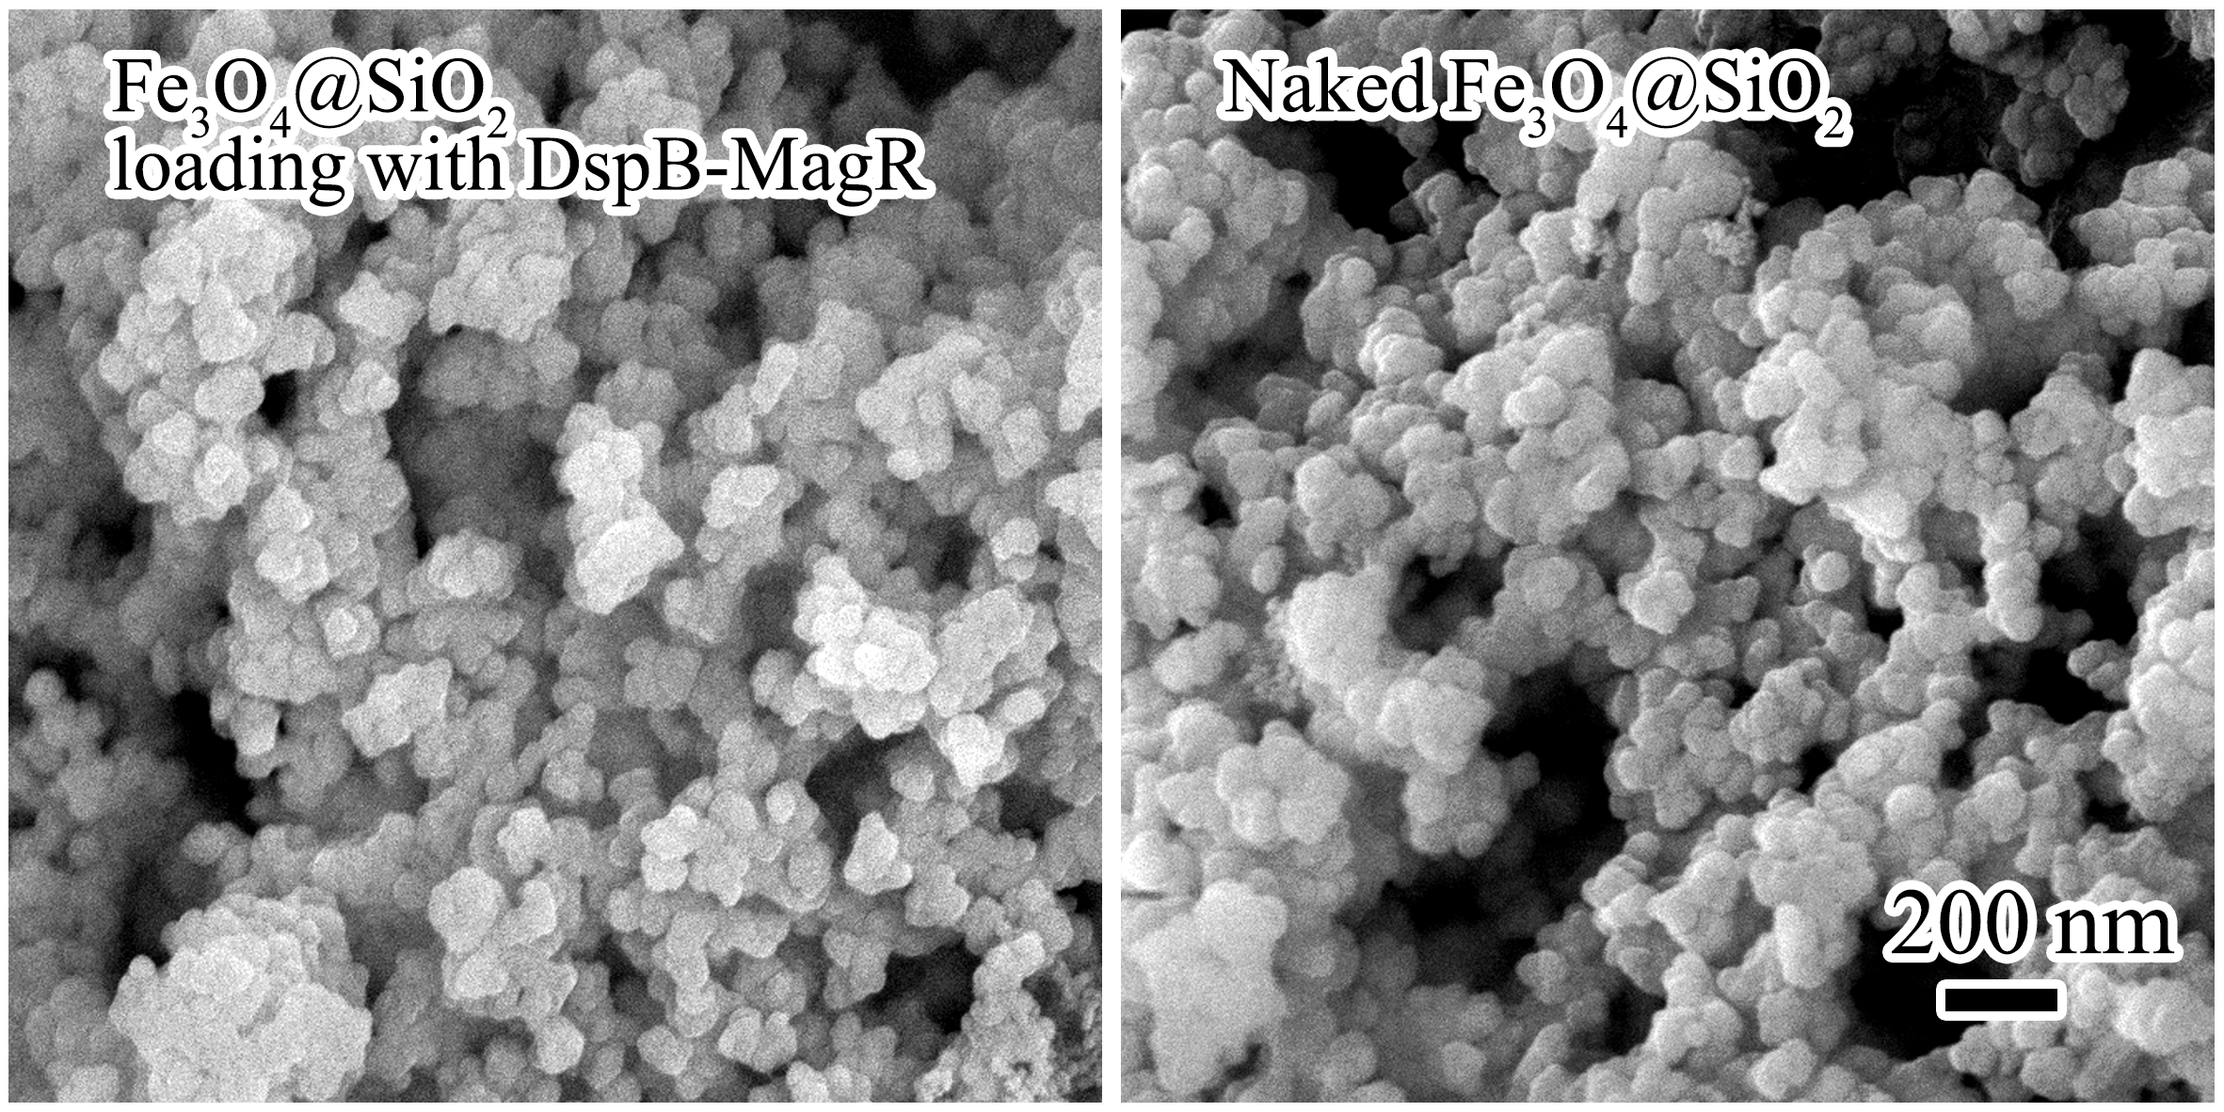
Figure S1. SEM image of Fe₃O₄@SiO₂ nanoparticles loading with DspB-MagR (left) and naked Fe₃O₄@SiO₂ (right).

