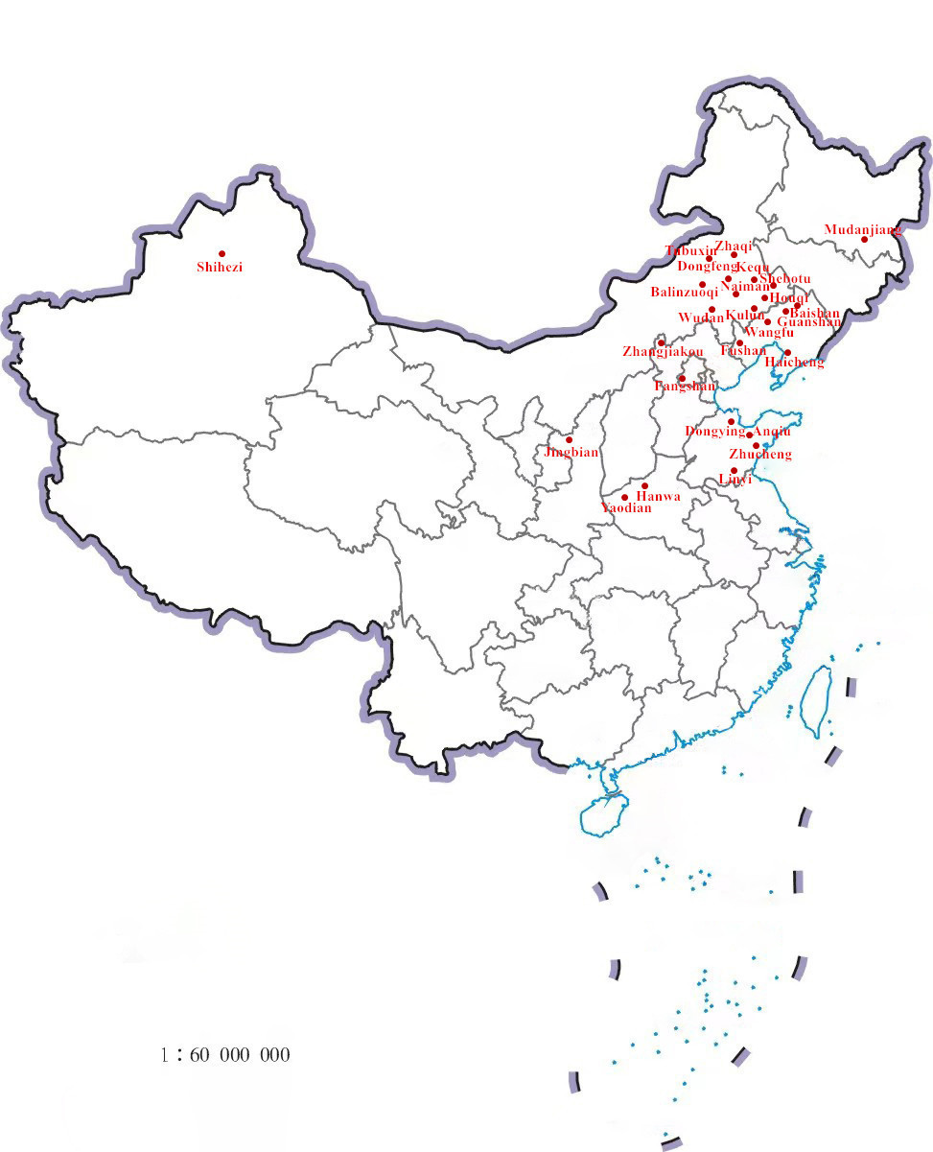
Fig. S1 The sampling sites of seed of Xanthoceras sorbifolium Bunge

