Procedure
1. Preparation of the Patient

NOTE: ICP sensor is placed in the patient by a surgical operation (Figure 1). The sensor is placed in the epidural space, subdural space, parenchyma, or ventricular system.

(1) Connect the ICP monitoring machine with the bedside monitor via a specific communication cable.
(2) Adjust the reference of patient's bedside monitor, so that the data from the bedside monitor are in accordance with the ICP monitoring machine.
(3) Perform an arterial line placement on patient's left or right radial artery.
(4) Connect the arterial line with the baroreceptor.
(5) Connect the pressure transducer with patient's bedside monitor via a communication cable.
(6) Zero adjust the bedside monitor so that the measured blood pressure coincides with the actual value.

2. Recording of Physiological Parameters

(1) Connect the patient's bedside monitor with the data collecting and storing device via a network cable.
(2) Press the power button to turn on the data collecting device.
(3) Wait for a few seconds until the multimodality monitoring software runs automatically.
(4) Enter the information of the patient, including the name, ID, and diagnosis
(5) Click the "Save and start monitoring" button to start data collecting and storing.
(6) Click the "Turn off" button on the screen at the end of the data acquisition (Figure 2).

3. Parameter Analysis

(1) Dump the stored data to a U-disk through universal serial bus (USB) interfaces on the host.
(2) Enter a user name and password to log in to the analysis server.
(3) Click the "Create new record" button and select the data file in the U-disk to start uploading.
(4) Wait for around 10 to 20 min before the data are analyzed (depending on the data size).
(5) Click the "Detail" button of each record to see the result.
(6) Click the "Chart viewing" to see the final diagram.
(7) Drag the timeline to see more detail.
(8) Click the "scattergram" button to see the distribution of the parameters (Figure 3).

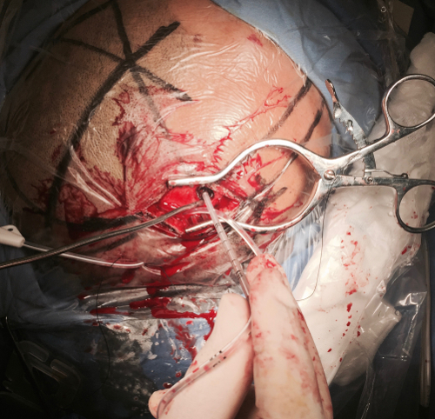
Figure 1: ICP sensor placement. The patient undergoes an operation for ICP sensor placement before monitoring. The sensor can be placed in the epidural space, subdural space, parenchyma, or ventricular system. This figure shows ventricular puncture and sensor placement. The ICP sensor is located at the tip of the catheter.

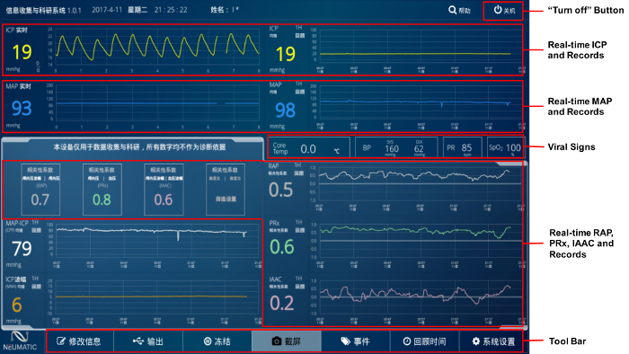
Figure 2: Screen of monitoring system. The upper left area shows current ICP waveform and blood pressure. The lower left area shows current RAP, PRx, IAAC, CPP, and AMP. The right part of the screen shows the history. Shown at the bottom are some of the functional buttons such as output, screen shot, and adding markers.

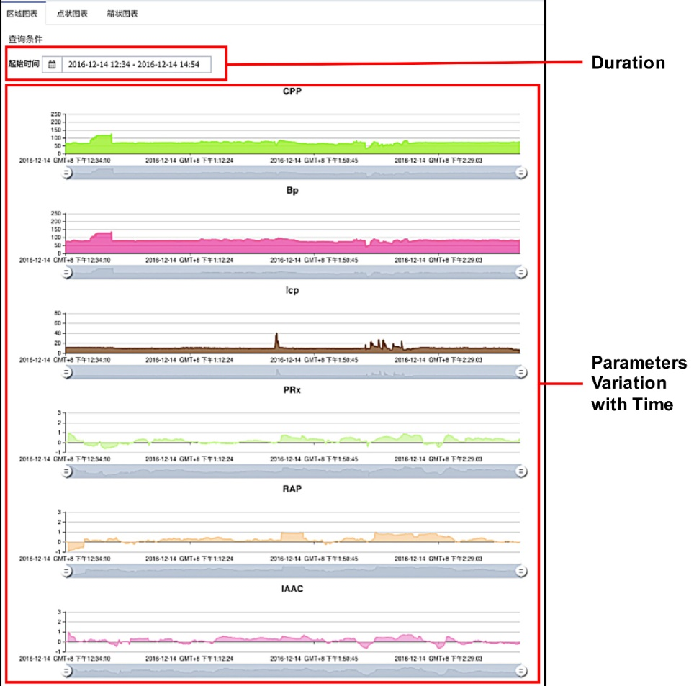

Figure 3: Representative data of a cerebral hemorrhage patient. The parameters such as ICP, BP, CPP, PRx, RAP, and IAAC are recorded and plotted. The X axis is the timeline and the Y axes are the separate parameters.

