Supplementary Figures
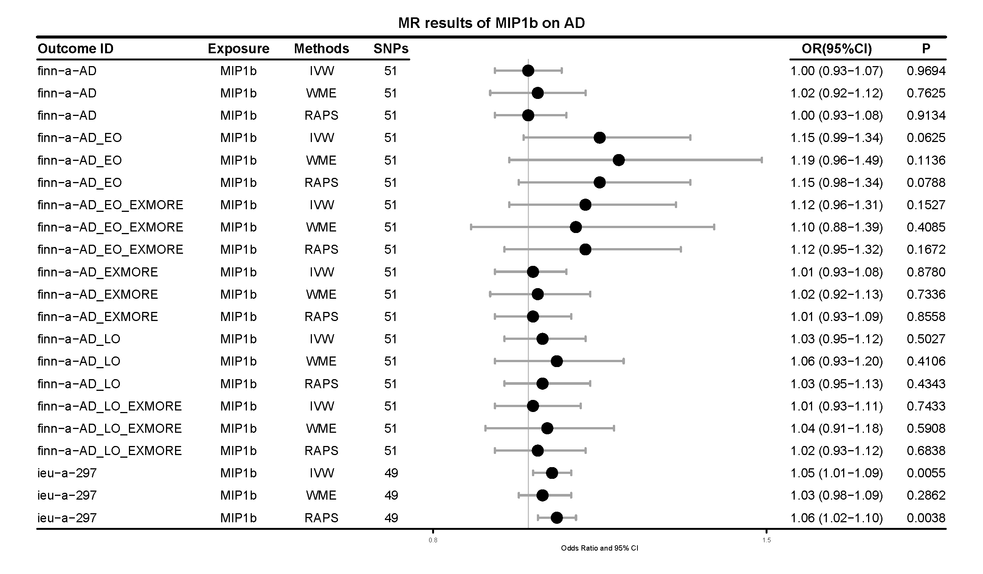
Figure S1. Causal effects of genetically determined cytokines on Alzheimer's disease (AD) in FinnGene population.
WRO, wald ratio; IVW, inverse-variance weighted; WME, weighted median estimator; RAPS, robust adjusted profile score. The ‘Outcome ID’ is MR-base ID (https://www.mrbase.org/).
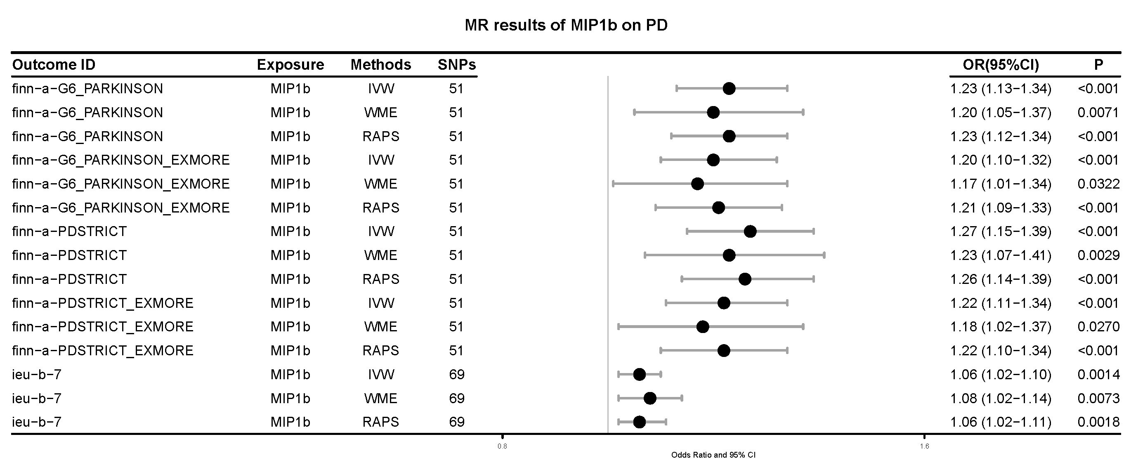
Figure S2. Causal effects of genetically determined cytokines on Parkinson's disease (PD) in FinnGene population.
WRO, wald ratio; IVW, inverse-variance weighted; WME, weighted median estimator; RAPS, robust adjusted profile score. The ‘Outcome ID’ is MR-base ID (https://www.mrbase.org/).
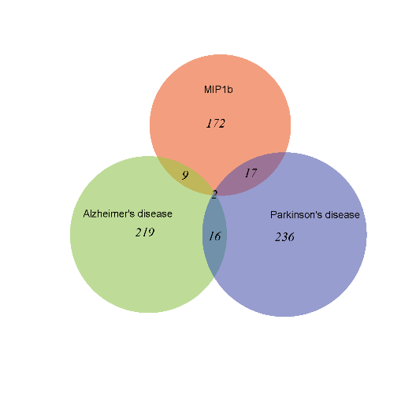
eQTL
MIP1b
eQTL
AD
eQTL
PD
200 Gene
246 Gene
271 Gene
SMR
SMR
SMR
P_{SMR}<0.05
P_{SMR}<0.05
P_{SMR}<0.05
Figure S3. The results of SMR (summary-data-based Mendelian randomization) analysis.

