Supplement 2. The scene of gamification using DMCs

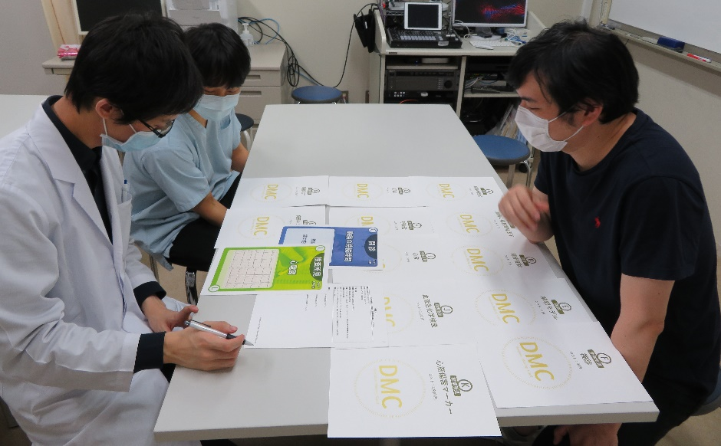
Student 2
Student 1
Supervisor

