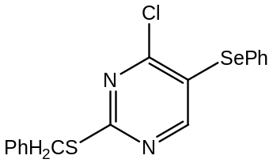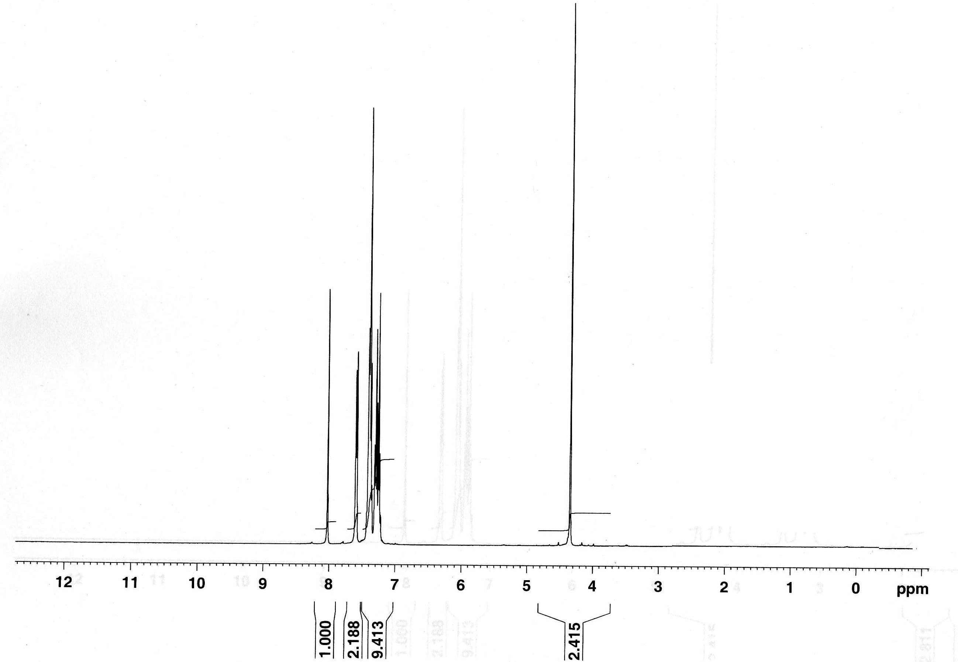

Figure S1: ¹H-NMR spectra of compound 1

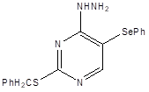
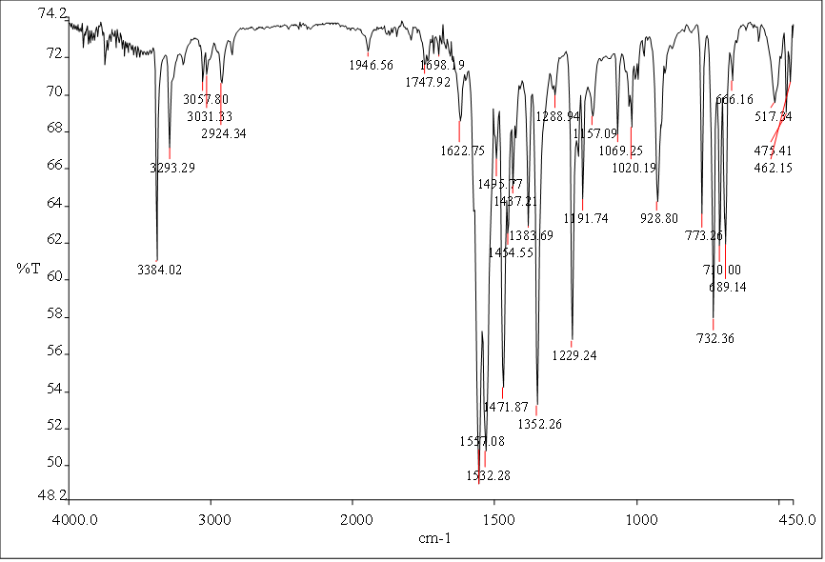
Figure S2: IR spectra of compound 2

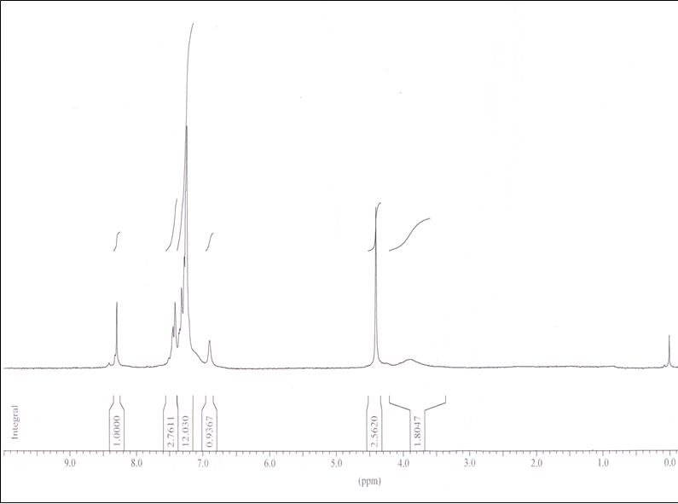
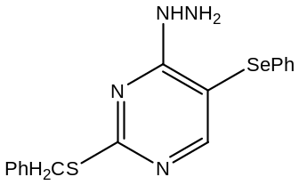

Figure S3: ¹H-NMR spectra of compound 2
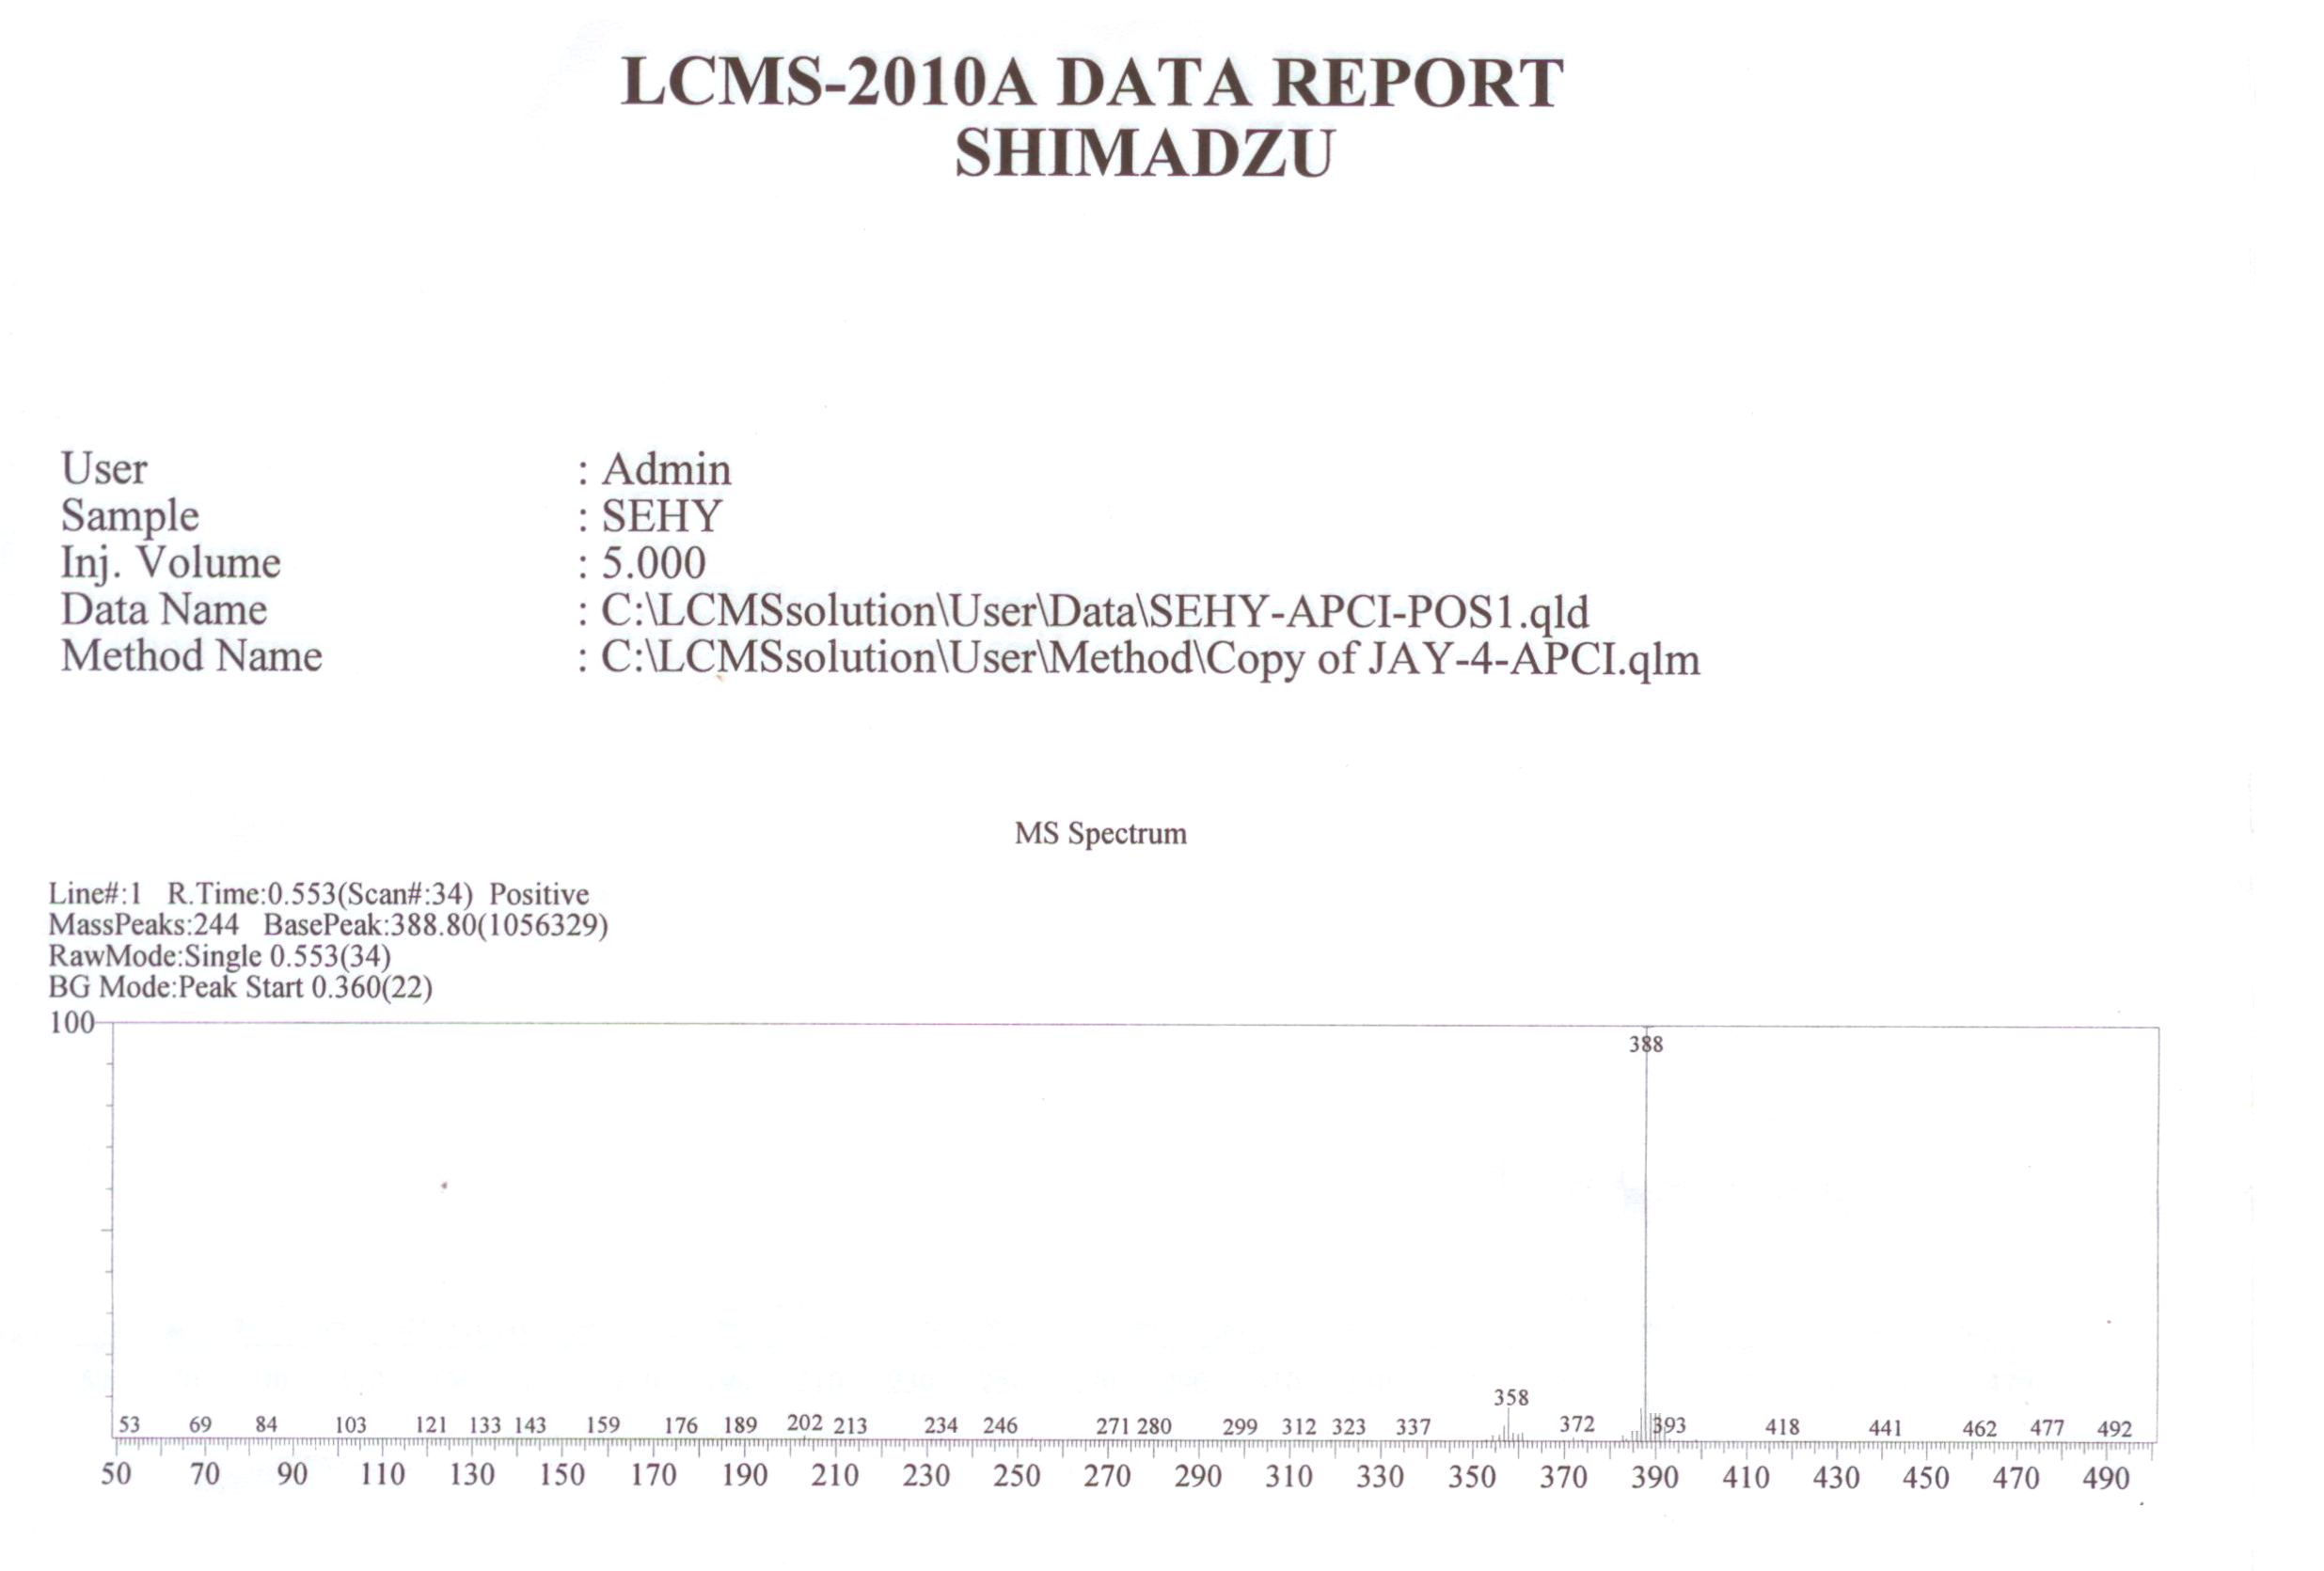

Figure S4: Mass spectra of compound 2

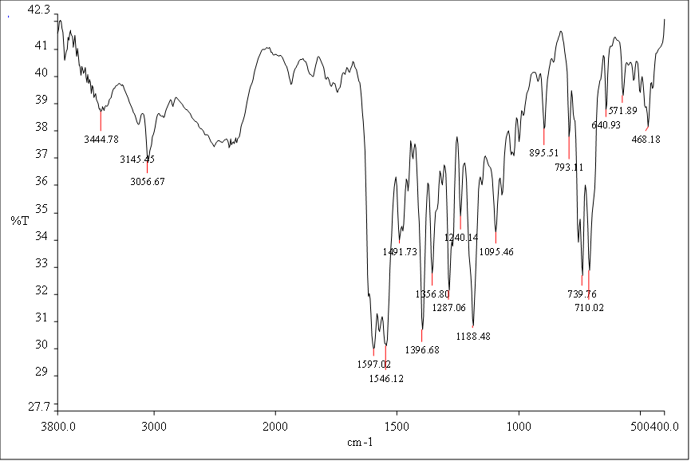
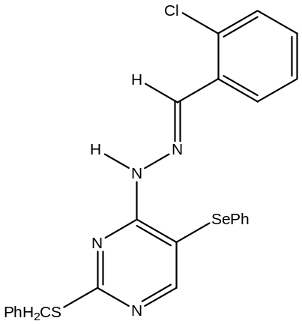Figure S4: IR spectra of compound 3b
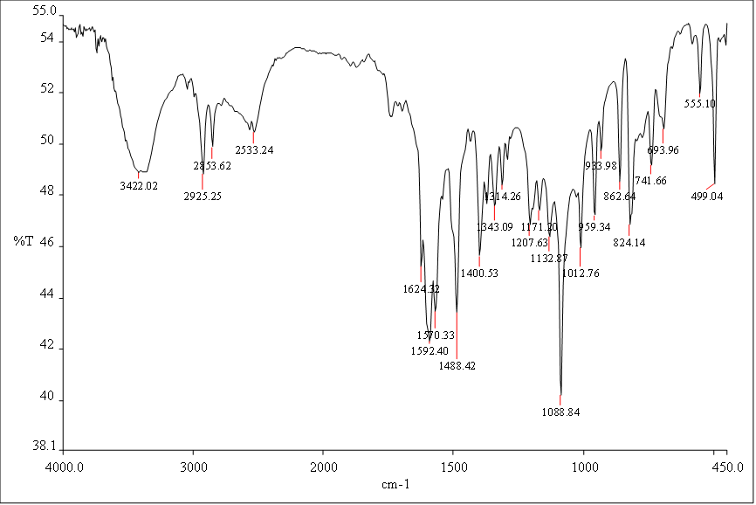
Figure S5: IR spectra of compound 3c
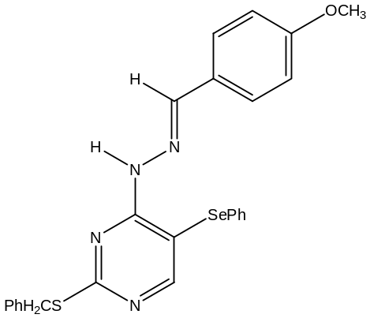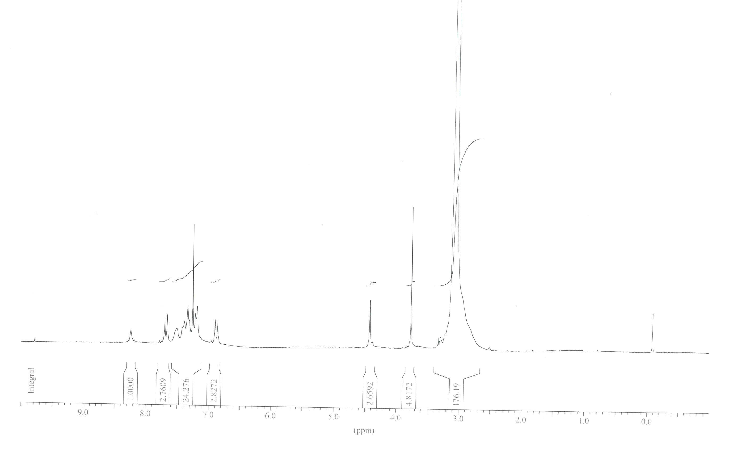

Figure S6: ¹H-NMR spectra of compound 3a
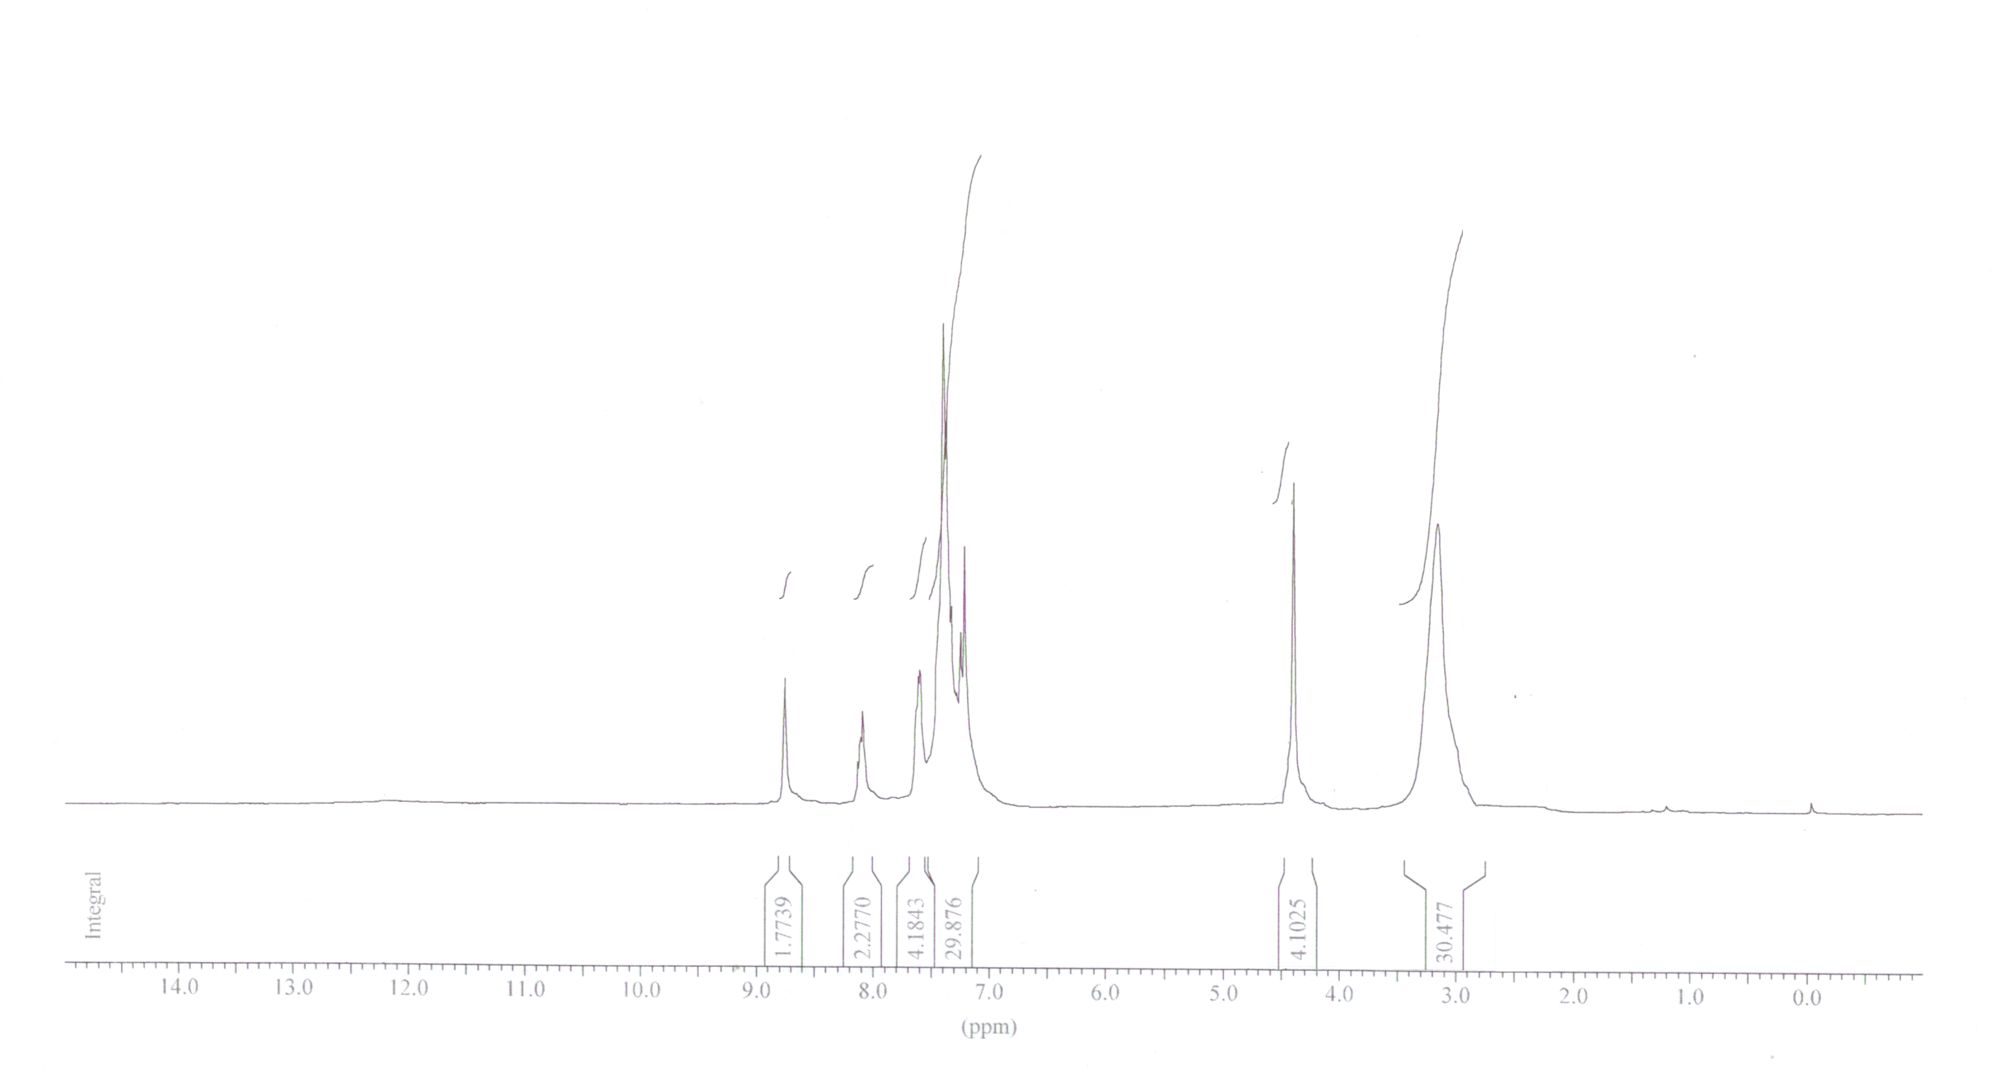

Figure S7: ¹H-NMR spectra of compound 3b

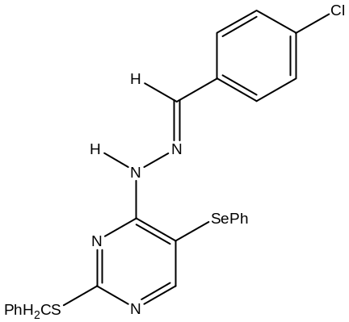Figure S8: ¹H-NMR spectra of compound 3c

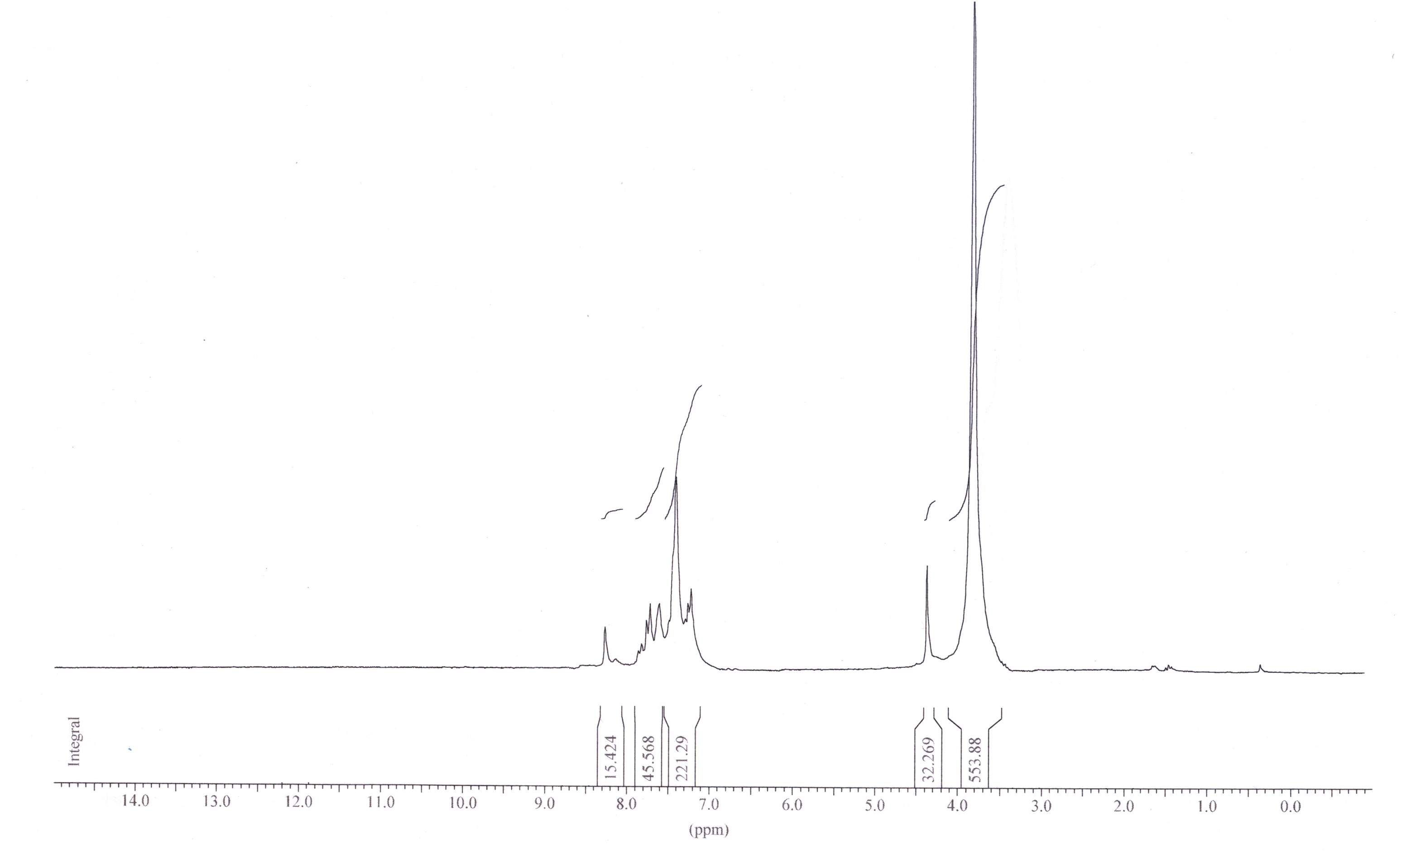
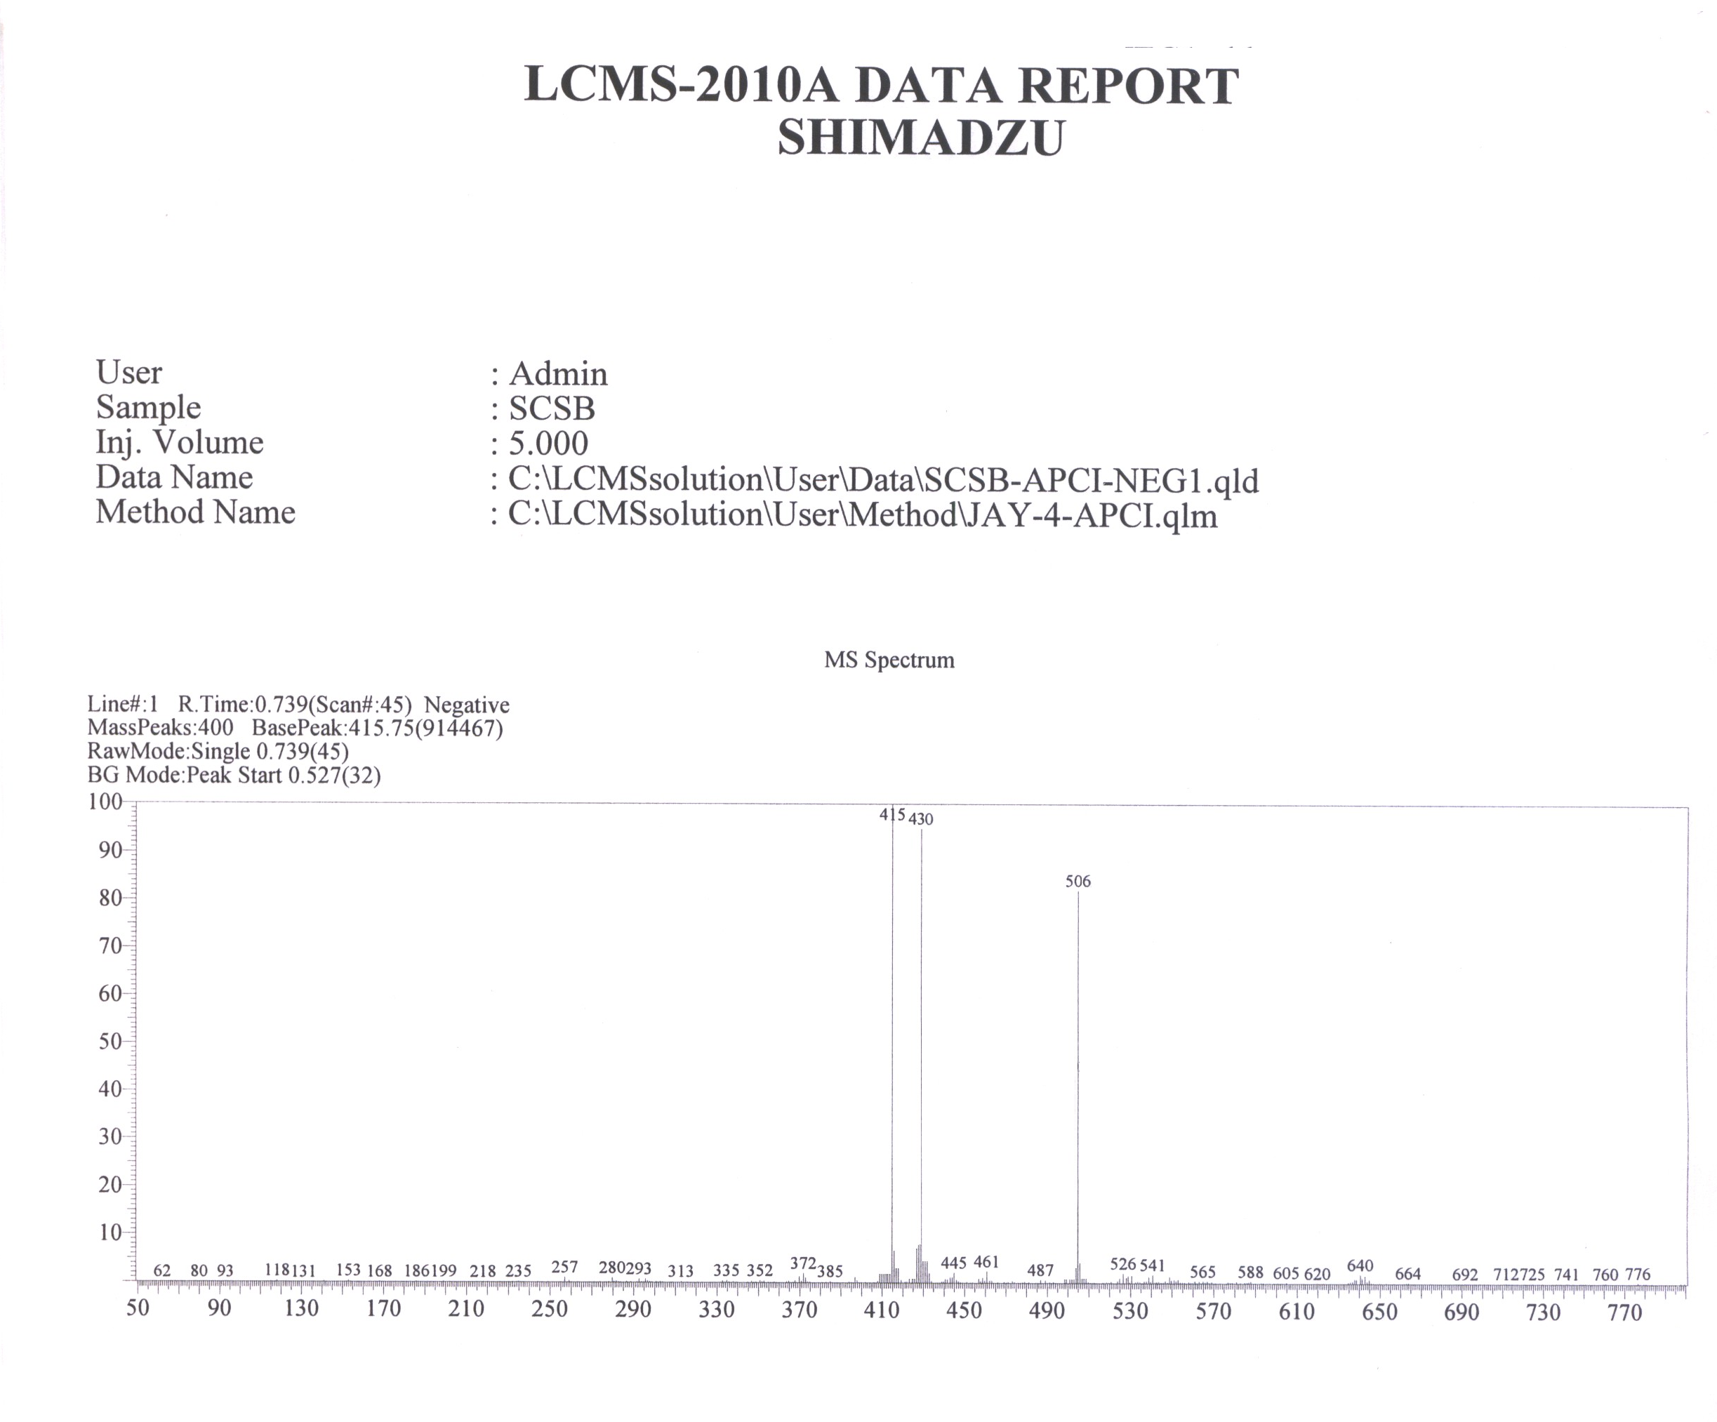

Figure S9: Mass spectra of compound 3a
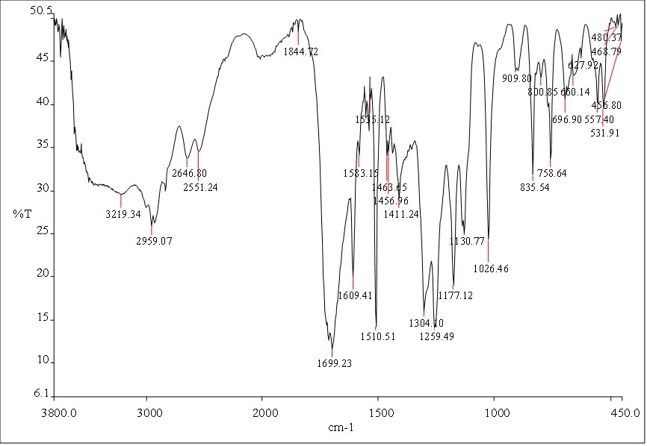

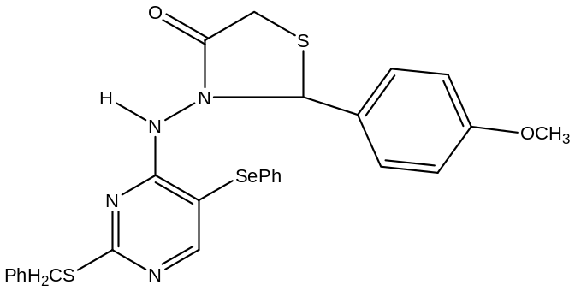

Figure S10: IR spectra of compound 4a
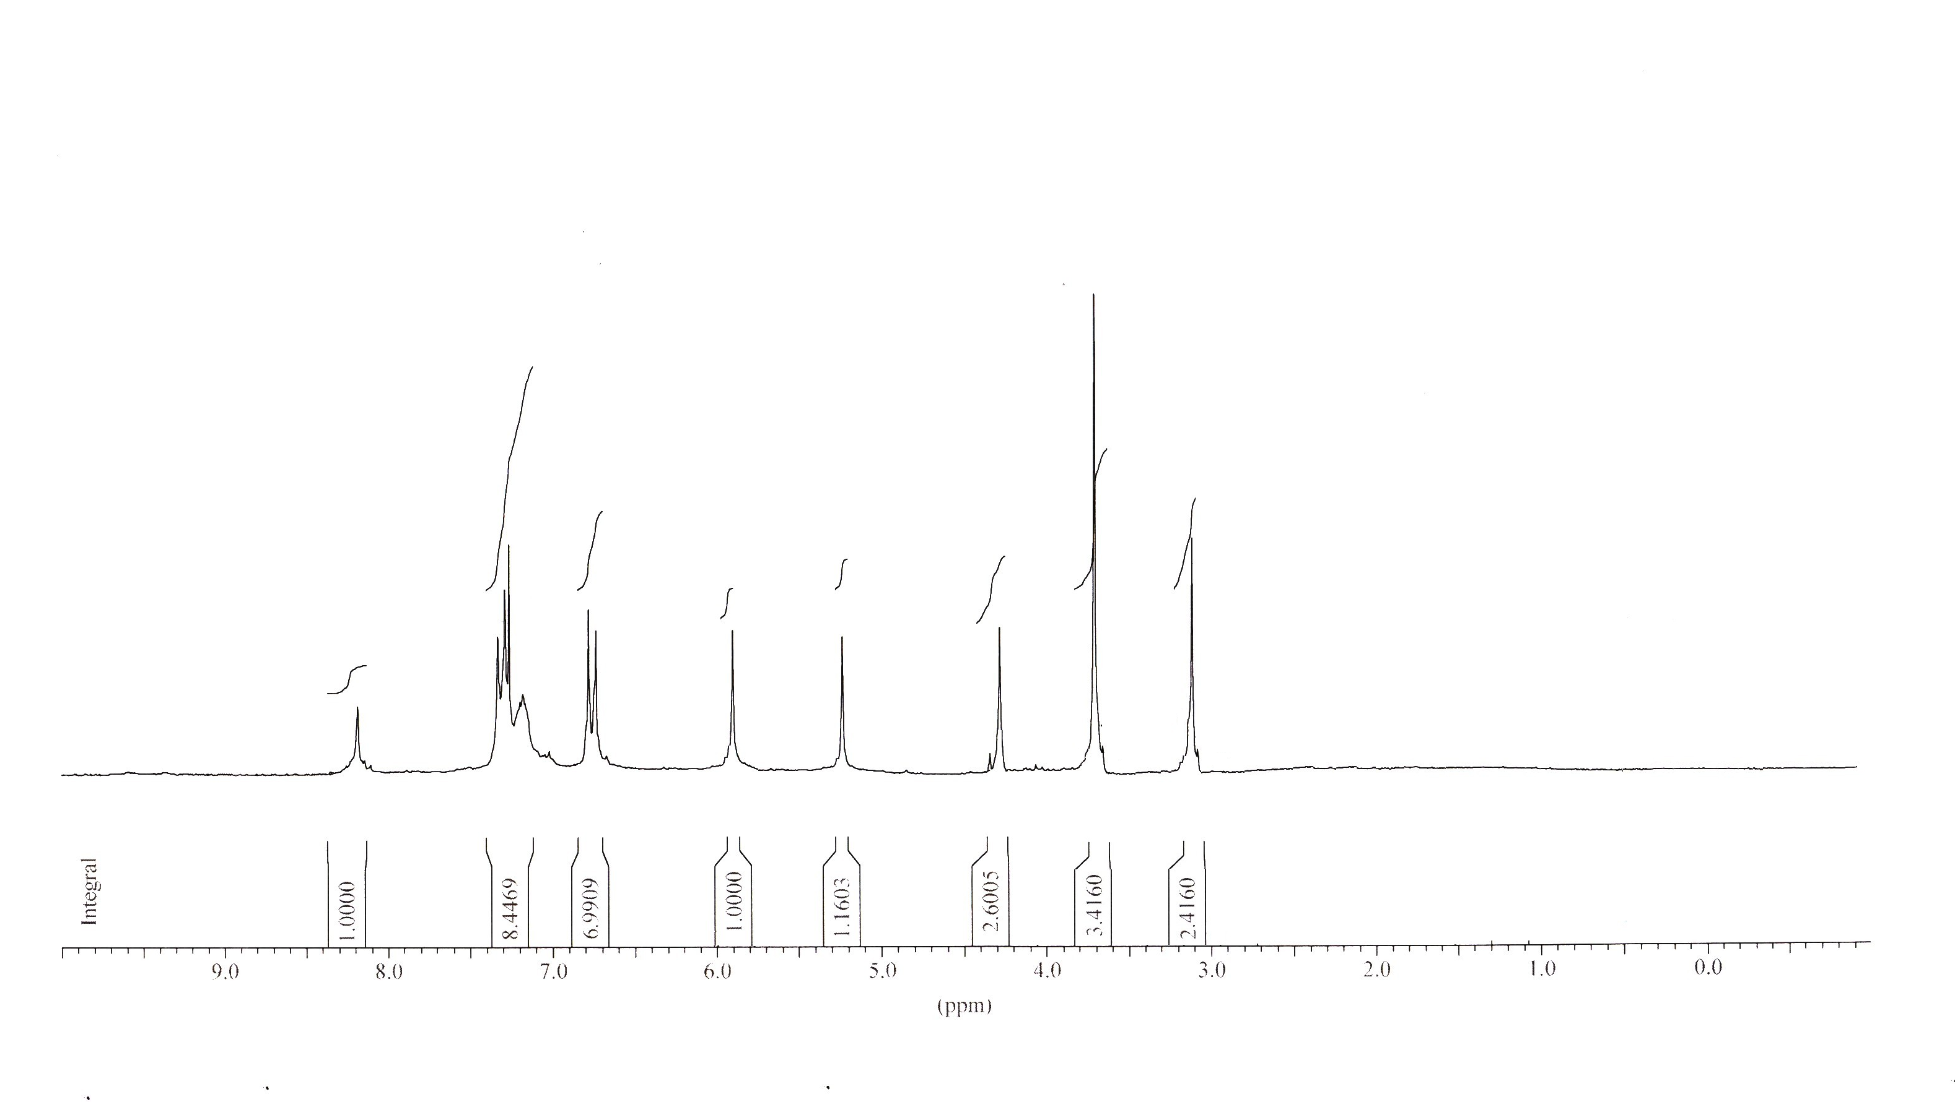

Figure S11: ¹H-NMR spectra of compound 4a
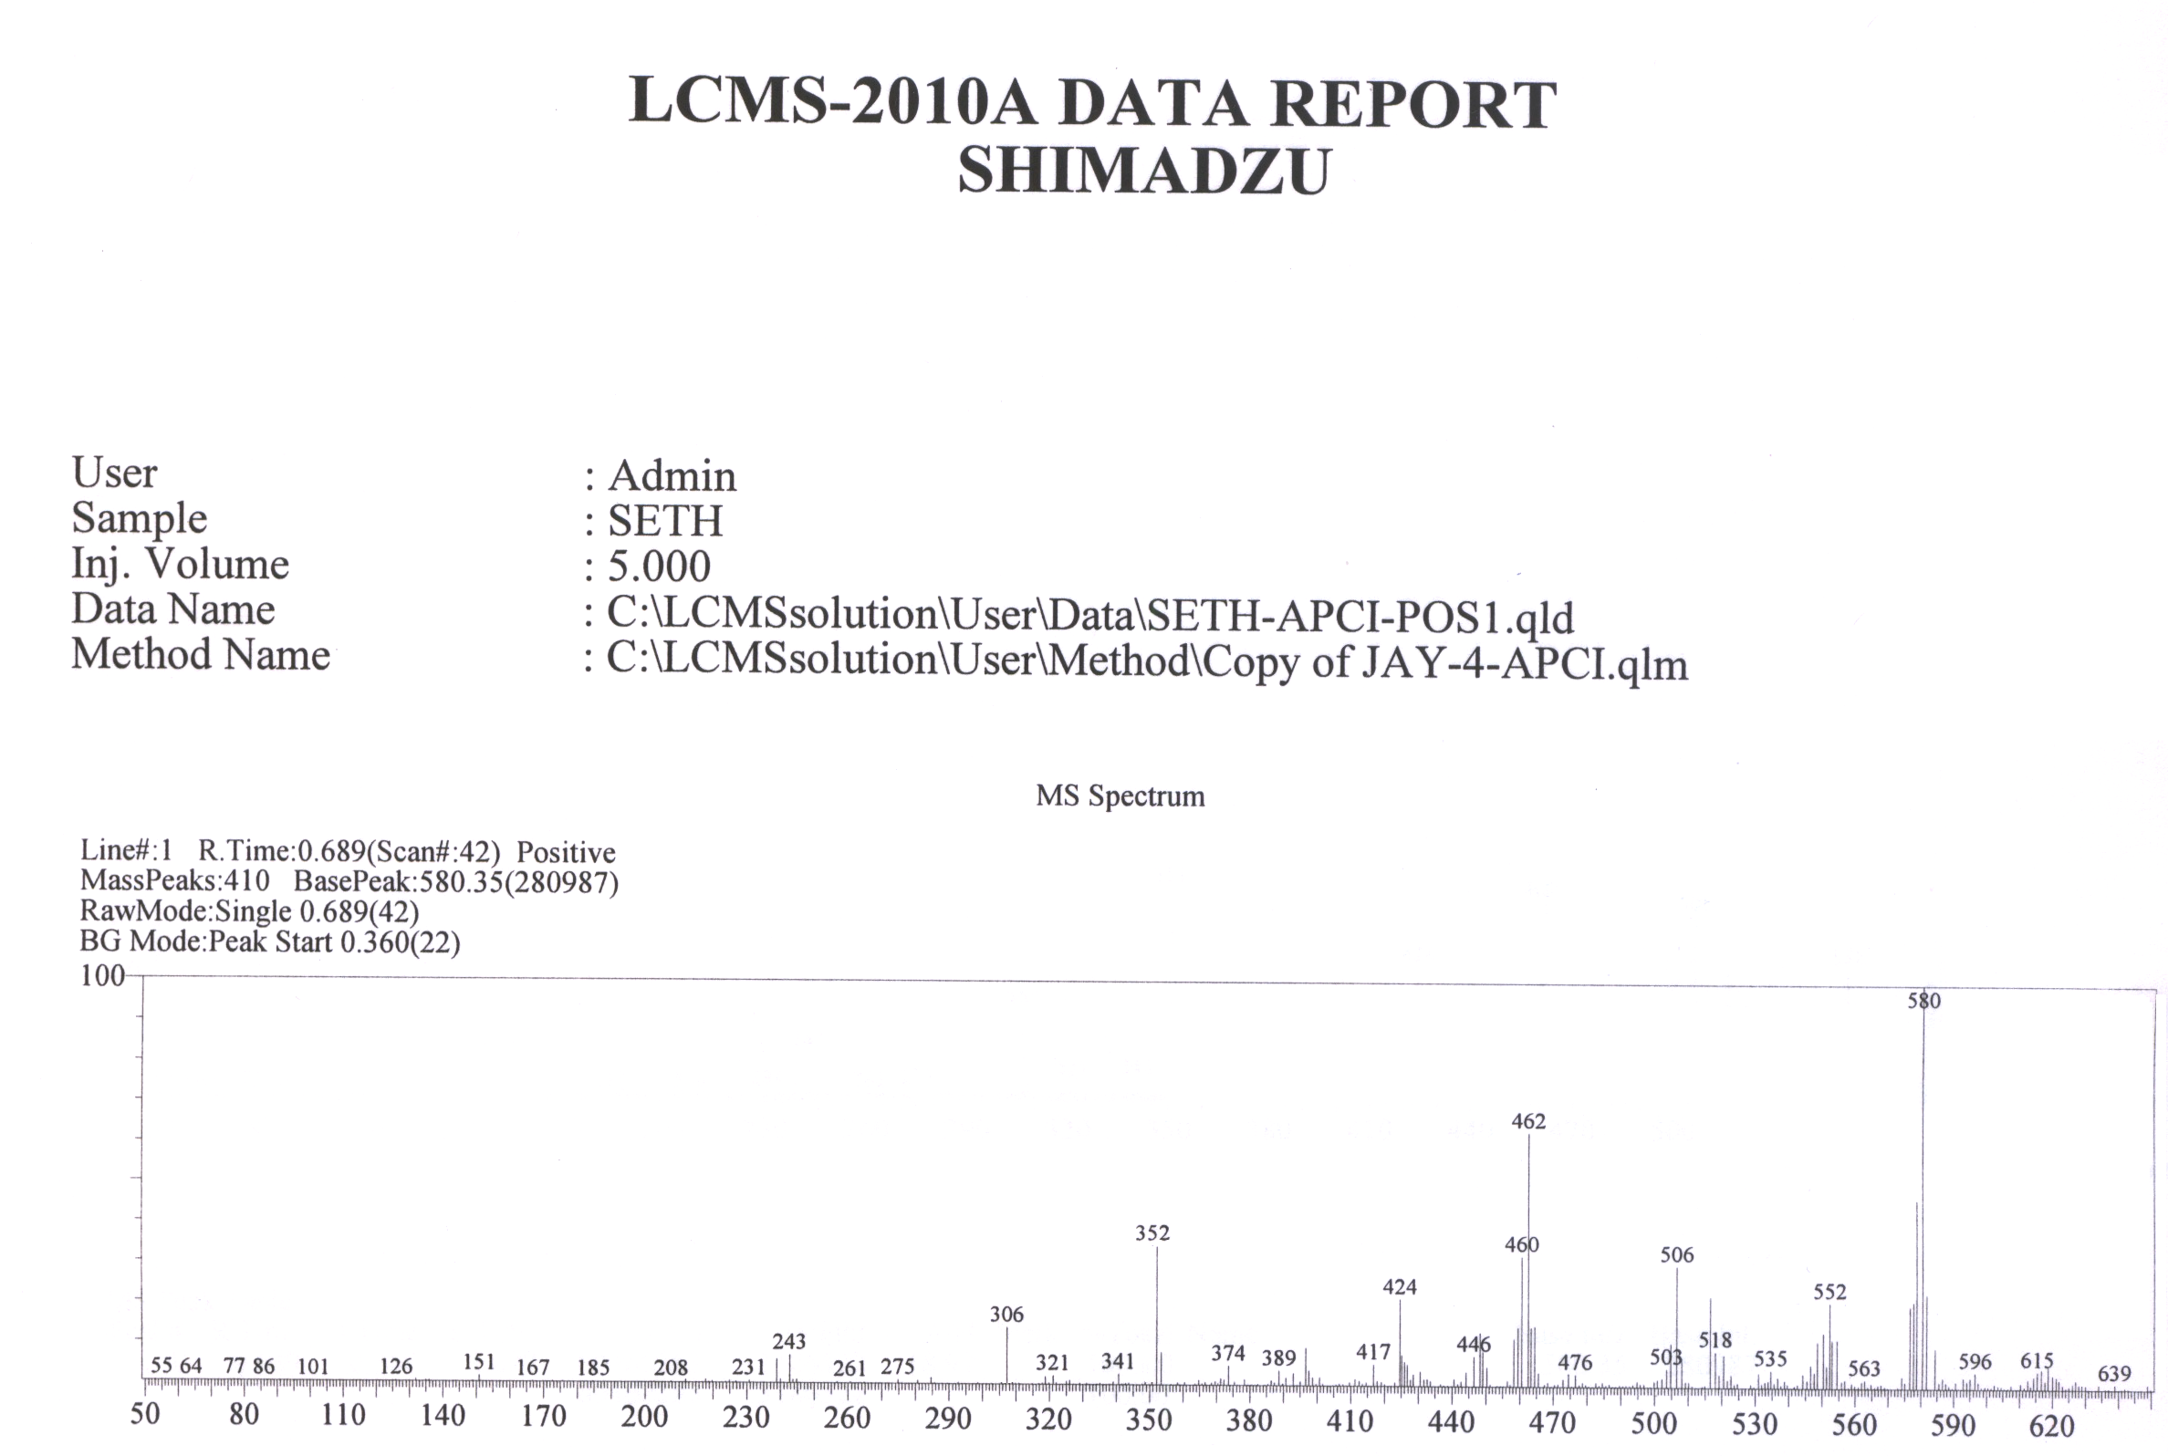

Figure S12: Mass spectra of compound 4a
Figure – 1.3.17

Mass spectra of compound 13a
Figure – 1.3.7

