Supplementary Materials
Table S1. Chinese version of the Hwalek–Sengstock Elder Abuse Screening Test in the CLASS
Domains | Questions
Physical abuse | In the last year, your family members have insulted/cursed/threatened/beaten you.
Psychological abuse
Physical neglect | In the last year, your family members did not provide care when you needed.
Physical neglect | In the last year, your family members did not provide you with a fixed shelter.
Physical neglect | In the last year, your family member did not give you enough or good food to eat.
Psychological neglect | In the last year, your family members have not visited/asked after/talked to you for a long time.
Material abuse | In the last year, your family members did not provide you with basic living expenses/embezzled your money.
Violation of personal rights | In the last year, your family members forbid you to leave the house.
Note: CLASS: China Longitudinal Aging Social Survey
Table S2. The Social Isolation Scale for Chinese older people
Items | Questions
1 | If there is an opportunity, I would like to participate in some work of the village committee.
2 | I often want to do something for the society.
3 | I like studying now.
4 | I think I am still a useful person for the society.
5 | The society is changing so quickly that it is difficult for me to adapt to this change.
6 | Now there are more and more opinions that I can’t accept.
7 | There are more and more social policies today that I find difficult to accept.
8 | Today’s social changes are increasingly unfavourable to the elderly.

Table S3. The six-item Lubben Social Network Scale
Items | Questions
1 | How many friends are you able to meet each month?
2 | How many friends are you comfortable talking about private affairs with?
3 | How many friends are able to provide you their help when you need it?
4 | How many relatives are you able to meet each month?
6 | How many relatives are you comfortable talking about private affairs with?
7 | How many relatives are able to provide you their help when you need it?

Table S4. Chinese version of the Mini-mental State Examination in the CLHLS
Domains | Questions | Scores
Orientation | What is the month and date (Western or Chinese calendar) right now? | 1
Orientation | What lunar year is this year? | 1
Orientation | What is the date (Chinese calendar day and month) of the National Day? | 1
Orientation | What is the name of this district or town? | 1
Orientation | Who is the current president of the country? | 1
Registration | Repeat table, apple, and coin. | 3
Attention and calculation | I will ask you to spend 7 dollars from 100 dollars; then, you must spend 7 dollars from the number you arrived at and continue to spend 7 dollars until you are asked to stop. | 5
Recall | Repeat the three words (in any order) that you heard a little while ago. | 3
Note: CLHLS: Chinese Longitudinal Healthy Longevity Survey.

Table S5. Summary of regression model testing for the mediating effects of social isolation on depressive symptoms
 | Social isolation |  |  | Depression
 | β | SE | p | β | SE | p
Elder abuse | 0.0841*** | 0.0208 | 0.0001 | 0.0744*** | 0.0129 | 0
Social isolation |  |  |  | 0.1669*** | 0.0071 | 0
Filial piety | -0.1077*** | 0.0096 | 0 | -0.1236*** | 0.006 | 0
Live state | 0.0193 | 0.0197 | 0.3264 | 0.0433*** | 0.0123 | 0
Gender | -0.0178 | 0.0113 | 0.1146 | 0.0111*** | 0.007 | 0.0004
Residence | -0.0439*** | 0.0135 | 0.0012 | -0.0031 | 0.0084 | 0.1134
Age | 0.0041*** | 0.0009 | 0 | 0.0019 | 0.0005 | 0.7151
Education level | -0.169*** | 0.0177 | 0 | -0.0745*** | 0.0111 | 0.0005
Marital status | -0.0137 | 0.0147 | 0.3509 | -0.0386*** | 0.0091 | 0
ADL | 0.0027 | 0.0058 | 0.6382 | 0.0079*** | 0.0036 | 0
IADL | 0.0081* | 0.0045 | 0.0731 | 0.0092** | 0.0028 | 0.0295
Chronic disease | 0.0124*** | 0.0036 | 0.0006 | 0.0259*** | 0.0023 | 0.001
Ln_income | -0.0238*** | 0.0045 | 0 | -0.0234*** | 0.0028 | 0
Working status | -0.0121 | 0.0142 | 0.3941 | 0.0219** | 0.0088 | 0.0133
Cognitive function | -0.0159*** | 0.0021 | 0 | -0.0081*** | 0.0013 | 0
Constant | 3.4108*** | 0.0999 | 0 | 1.7213*** | 0.0667 | 0
R² | 0.0766 |  |  | 0.2266
N | 7,700 |  |  | 7,700
Note: SE: standard error; ADL: activities of daily living; IADL: instrumental activities of daily living.
Table S6. Summary of regression model testing for the mediating effects of loneliness on depressive symptoms
 | Loneliness |  |  | Depression
 | β | SE | p | β | SE | p
Elder abuse | 0.1593*** | 0.0214 | 0 | 0.0471*** | 0.0122 | 0.0001
Loneliness |  |  |  | 0.2589*** | 0.0065 | 0
Filial piety | -0.227*** | 0.0099 | 0 | -0.0828*** | 0.0058 | 0
Live state | 0.0764*** | 0.0203 | 0.0002 | 0.0267** | 0.0116 | 0.0209
Gender | 0.0112 | 0.0116 | 0.3378 | 0.0053 | 0.0066 | 0.4267
Residence | -0.0243* | 0.0139 | 0.0811 | -0.0041 | 0.0079 | 0.6051
Age | 0.0054*** | 0.0009 | 0 | 0.0012** | 0.0005 | 0.0215
Education level | -0.0899*** | 0.0183 | 0 | -0.0794*** | 0.0104 | 0
Marital status | -0.0437*** | 0.0151 | 0.0039 | -0.0295*** | 0.0086 | 0.0006
ADL | 0.0093 | 0.006 | 0.1224 | 0.0059* | 0.0034 | 0.0819
IADL | 0.0019 | 0.0046 | 0.6774 | 0.0101*** | 0.0026 | 0.0001
Chronic disease | 0.0241*** | 0.0037 | 0 | 0.0217*** | 0.0021 | 0
Ln_income | -0.0058 | 0.0046 | 0.2128 | -0.0259*** | 0.0026 | 0
Working status | 0.0591*** | 0.0147 | 0.0001 | 0.0046 | 0.0083 | 0.5834
Cognitive function | 0.0115*** | 0.0021 | 0 | -0.0137*** | 0.0012 | 0
Constant | 1.773*** | 0.1031 | 0 | 1.8313*** | 0.0597 | 0
R² | 0.1072 |  |  | 0.3136
N | 7,700 |  |  | 7,700
Note: SE: standard error; ADL: activities of daily living; IADL: instrumental activities of daily living.
Table S7. Summary of regression model testing for the mediating effects of social network on depressive symptoms
 | Social network |  |  | Depression
 | β | SE | p | β | SE | p
Elder abuse | -0.0013 | 0.0383 | 0.9739 | 0.0883*** | 0.0133 | 0
Social network |  |  |  | -0.037*** | 0.004 | 0
Filial piety | 0.0858*** | 0.0176 | 0 | -0.1384*** | 0.0061 | 0
Live state | -0.1198*** | 0.0363 | 0.001 | 0.0421*** | 0.0126 | 0.0009
Gender | -0.0365* | 0.0208 | 0.0793 | 0.0068 | 0.0072 | 0.3472
Residence | 0.0698*** | 0.0249 | 0.0051 | -0.0078 | 0.0087 | 0.3669
Age | 0.0001 | 0.0016 | 0.9303 | 0.0026*** | 0.0006 | 0
Education level | 0.0092 | 0.0327 | 0.7773 | -0.1023*** | 0.0113 | 0
Marital status | 0.0398 | 0.0271 | 0.1413 | -0.0394*** | 0.0094 | 0
ADL | -0.0258** | 0.0107 | 0.016 | 0.0074** | 0.0037 | 0.0477
IADL | -0.0104 | 0.0083 | 0.2128 | 0.0102*** | 0.0029 | 0.0004
Chronic disease | 0.0058 | 0.0067 | 0.3891 | 0.0282*** | 0.0023 | 0
Ln_income | 0.0598*** | 0.0083 | 0 | -0.0252*** | 0.0029 | 0
Working status | 0.1255*** | 0.0262 | 0 | 0.0245*** | 0.0091 | 0.0072
Cognitive function | 0.0099*** | 0.0038 | 0.0095 | -0.0104*** | 0.0013 | 0
Constant | 1.6121*** | 0.1843 | 0 | 2.3499*** | 0.0643 | 0
R² | 0.0289 |  |  | 0.1803
N | 7,700 |  |  | 7,700
Note: SE: standard error; ADL: activities of daily living; IADL: instrumental activities of daily living.
Table S8. Summary of regression model testing the mediating effects of social participation on depression symptom
 | Social participation |  |  | Depression
 | β | SE | p | β | SE | p
Elder abuse | 0.1922*** | 0.0261 | 0 | 0.0893*** | 0.0134 | 0
Social participation |  |  |  | -0.0045 | 0.0058 | 0.4431
Filial piety | 0.0151 | 0.012 | 0.2086 | -0.1415*** | 0.0062 | 0
Live state | 0.1334*** | 0.0248 | 0 | 0.0471*** | 0.0127 | 0.0002
Gender | -0.0104 | 0.0142 | 0.4617 | 0.0081 | 0.0073 | 0.2652
Residence | -0.05*** | 0.017 | 0.0033 | -0.0106 | 0.0087 | 0.2229
Age | -0.0004 | 0.0011 | 0.7182 | 0.0026*** | 0.0006 | 0
Education level | 0.1023*** | 0.0223 | 0 | -0.1022*** | 0.0114 | 0
Marital status | 0.0407** | 0.0185 | 0.0273 | -0.0407*** | 0.0095 | 0
ADL | -0.0087 | 0.0073 | 0.2338 | 0.0083** | 0.0037 | 0.0269
IADL | 0.0155*** | 0.0057 | 0.0062 | 0.0107*** | 0.0029 | 0.0002
Chronic disease | -0.0584*** | 0.0046 | 0 | 0.0277*** | 0.0024 | 0
Ln_income | 0.0986*** | 0.0056 | 0 | -0.027*** | 0.0029 | 0
Working status | -0.0362** | 0.0179 | 0.0429 | 0.0197** | 0.0092 | 0.0314
Cognitive function | -0.0192*** | 0.0026 | 0 | -0.0108*** | 0.0013 | 0
Constant | -0.2208* | 0.1257 | 0.079 | 2.2894*** | 0.0644 | 0
R² | 0.0848 |  |  | 0.1711
N | 7,700 |  |  | 7,700
Note: SE: standard error; ADL: activities of daily living; IADL: instrumental activities of daily living.
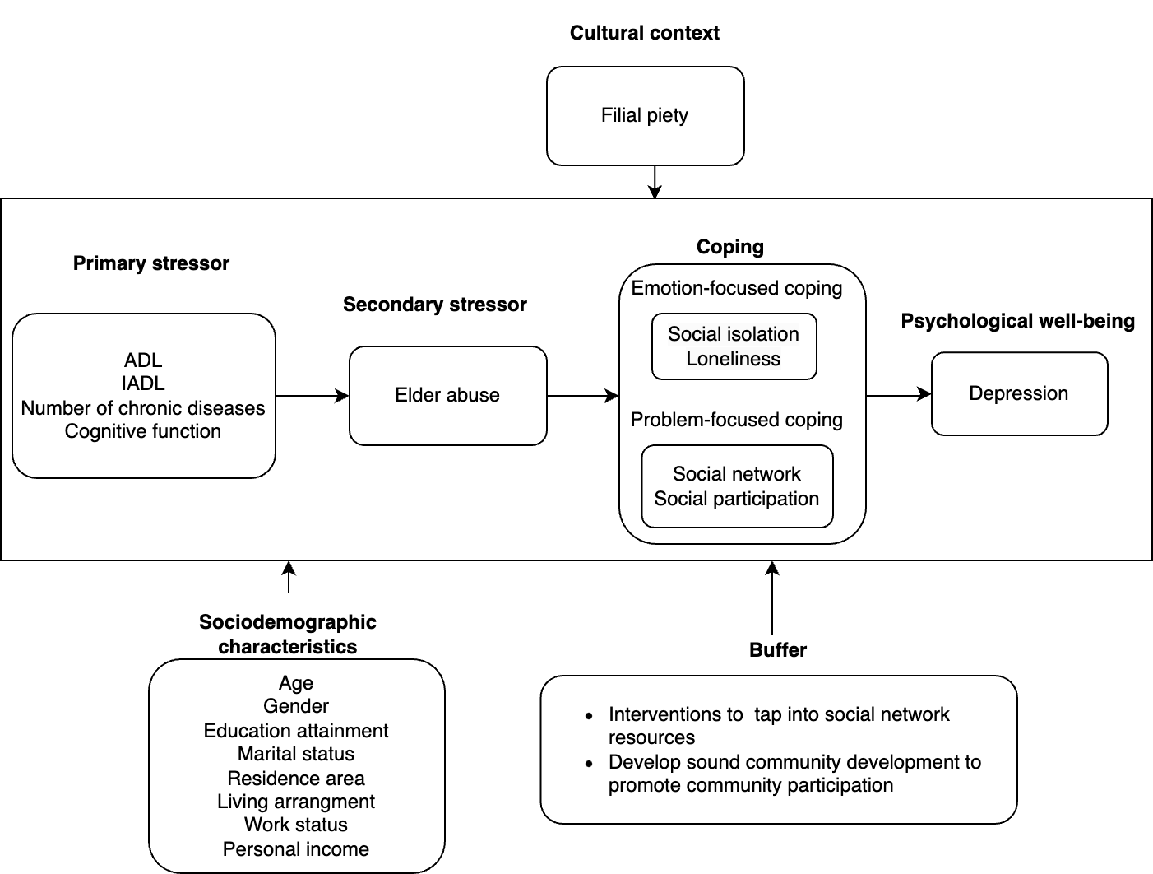

Figure S1. Verified conceptual model based on the stress-and-coping model

