Dominance and identity of the dominant bee drive bee diversity on flowers

Electronic Supplementary Material
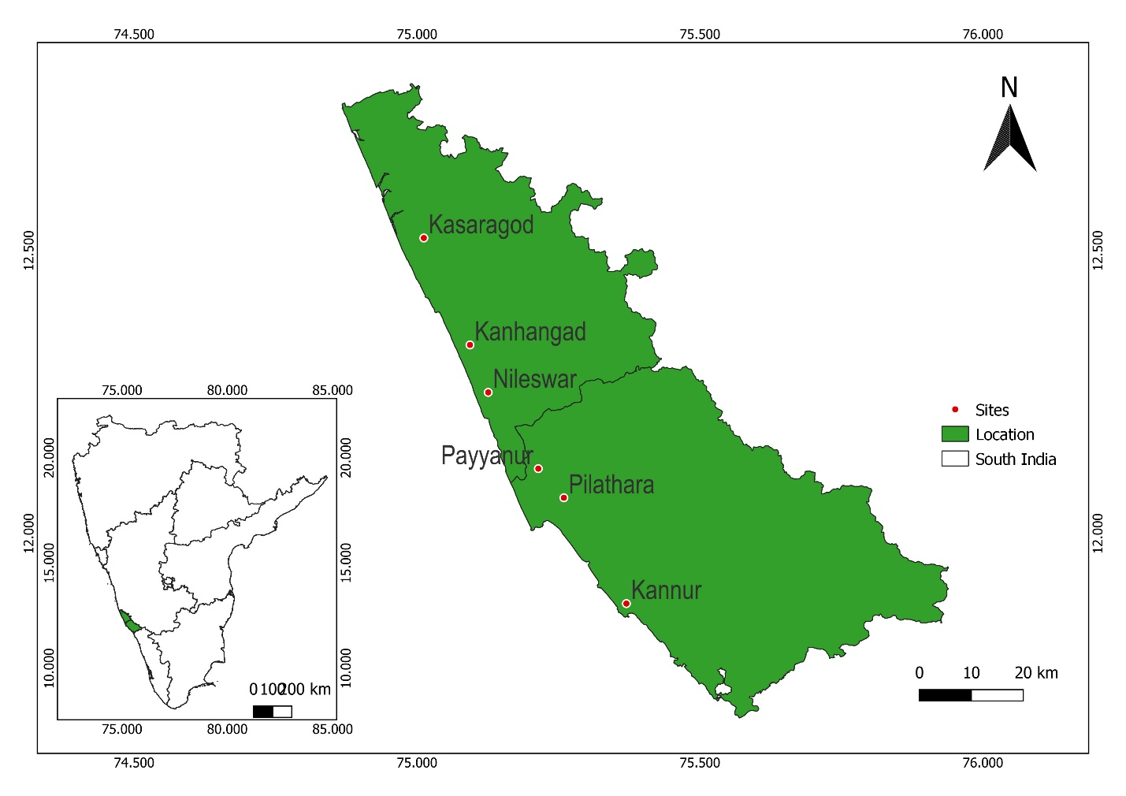
Fig S1. Map showing the study locations in the area of north Malabar region of Kerala, India.

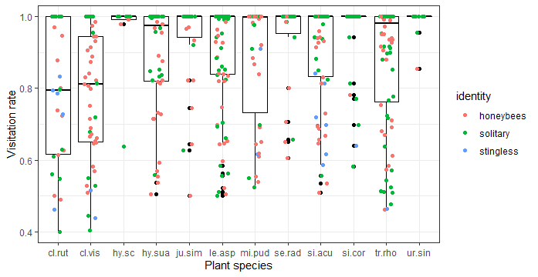
Fig S2. The dominance of different bee functional groups differed among plant species.

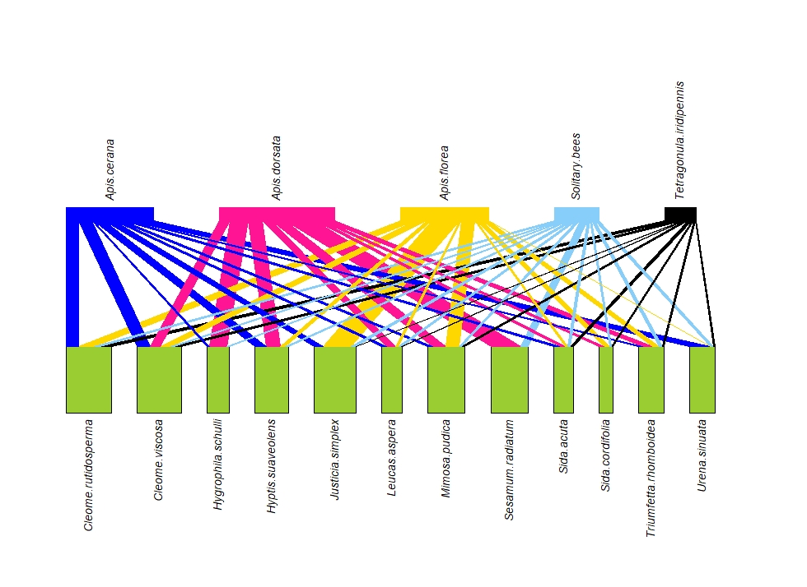

Fig S3. The interaction network between bee functional groups and plant species.

