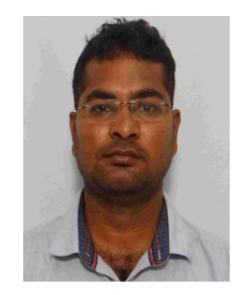
Yugender Mood is currently Research scholar in the department of Electronics and Communication engineering, National institute of Technology Tiruchirappalli, India. He received his BTech degree and MTech degree in 2013 and 2018 respectively from JNTU Hyderabad. His research interests include electromagnetic metamaterial related MIMO Antennas for 5 G Communications. He is student member of IEEE and Executive Committee member IEEE student Brach at NIT Trichy chapter.


R. Pandeeswari is an Associate professor in the department of Electronics and Communication Engineering, National Institute of Technology, Tiruchirappalli, India. She received her Ph.D. degree from the department of Electronics and Communication engineering, National Institute of Technology Tiruchirappalli, India. She has published more than 15 research articles in peer-reviewed journals. Her research interests include metamaterial-based microwave antenna, bio implantable antenna and reconfgurable antenna for cognitive radio applications. She is the Principal Investigator of the ISRO-Technology Development Program (TDP) funded project titled ‘‘Design and development of X-band & Ka-band passive devices’’ in coordination with the Space Technology Incubation Centre of NIT Trichy. She is the Indian PI of the SPARC (Ministry of Education, Government of India) project titled ‘‘Metamaterial Based Low Profle LTCC Balanced Antipodal Vivaldi Antenna for 5G eMBB’’ in collaboration with the University of Saskatchewan, Canada. She is a member of IEEE and faculty advisor of Antennas and Propagation Society of IEEE NIT Trichy Chapter

