Supplementary Information
Figure S1. Schematic diagram of the learning area within the 8-arm radial maze and the visual cues used for the easy and difficult learning tasks. Figure cited from Wang et al. 2007 Am J Clin Nutr.
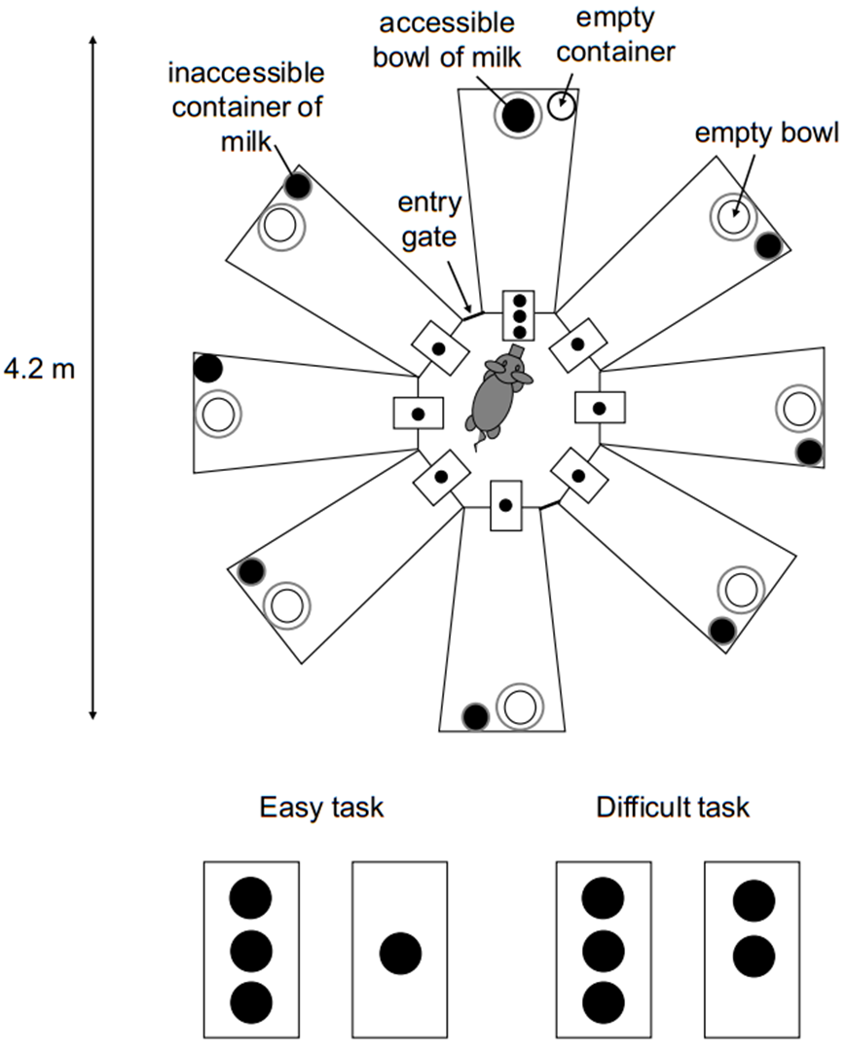

Figure S2. Melt curve and standard curve of LfR, HPRT1 and GAPDH.
(a)
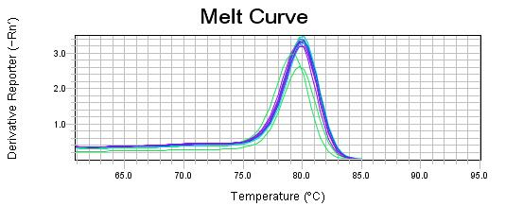

(b)
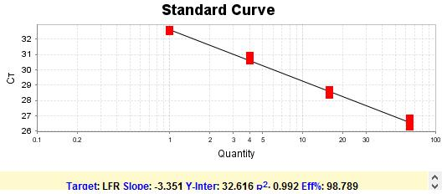
(c)
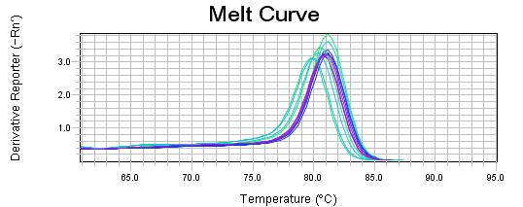
(d)
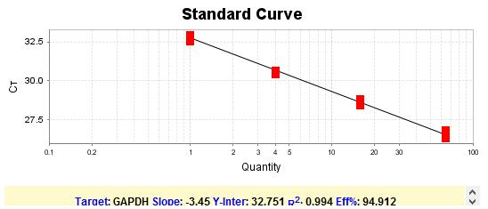
(e)
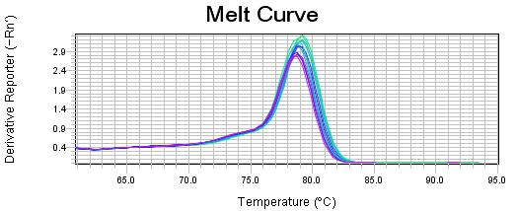
(f)
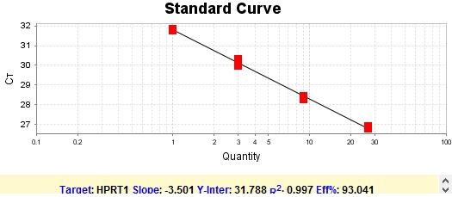

Supplementary Figure 3
A: Alignment of the amplified porcine brainstem LfR cDNA to the human LfR ITLN1 (NM_017625.3).
Identity= 79.61%

B: Alignment of the amplified porcine brainstem LfR cDNA to the human LfR ITLN2 (NM_080878.3)
Identity= 83.76%

C: Alignment of the amplified porcine brainstem LfR cDNA to the mouse LfR Itln1(NM_010584.3)
Identity= 76.02%

Supplementary Figure 4
A: The body weight gain of piglets throughout the course of the study.
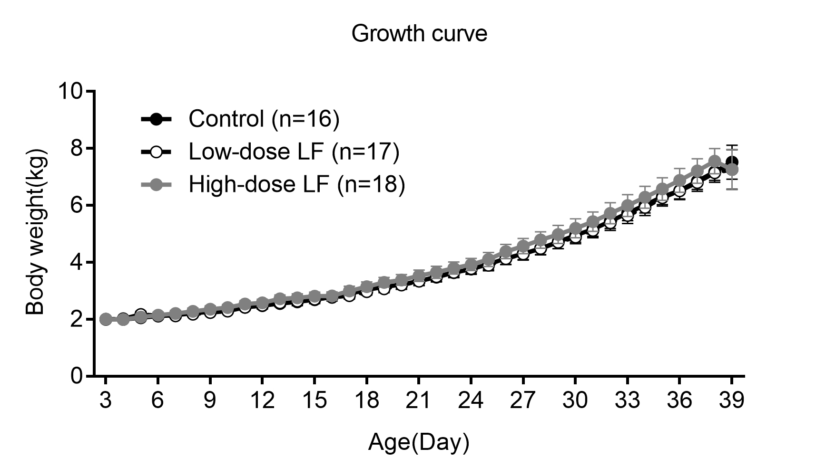
B: The whole brain and cerebellum weight of piglets at 39 days of age
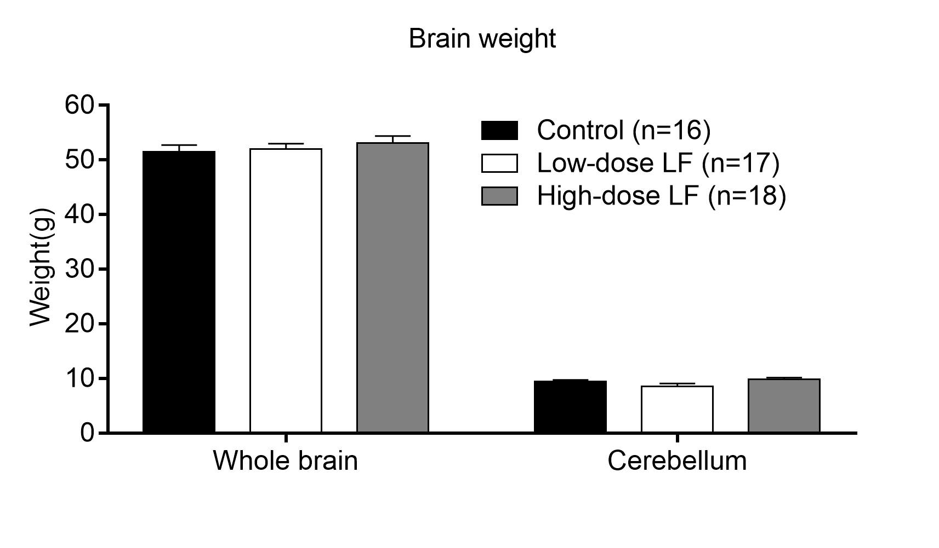
C: The ratio of brain weight to body weight of piglets at 39 days of age.
