Structural features of T-DNA that induce transcriptional gene silencing during agroinfiltration

Emi Iida, Kazunori Kuriyama, Midori Tabara, Atsushi Takeda, Nobuhiro Suzuki, Hiromitsu Moriyama and Toshiyuki Fukuhara*

Supplementary Table and Figures

Table S1 Nucleotide sequences of PCR primers.
Primer name | Nucleotide sequence (5′-3′)
For qPCR
NbACT_F | AAAGACCAGCTCATCCGTGG
NbACT_R | CATGAATGCCAGCAGCTTCC
16cGFP_F | GCGATGGCCCTGTCCTTTTA
16cGFP_R | TGCCATGTGTAATCCCAGCA
NbDCL2_F | TTGCTTCCATCTTTGGGTTC
NbDCL2_R | CGTTTGTGACCTTGCGTAGA
NbDCL3_F | ATCTCCCATCGTGACTCCTG
NbDCL3_R | TCAGCAACCAGCAACTCATC
NbDCL4_F | AGGAAACCCCAGAAGAGCAT
NbDCL4_R | CCGCAGTATGTCCCAACTTT
For Probes
35S promoter_F | ACAAAGGGTAATATCCGGAAACCT
35S promoter_R | AGAGGAAGGGTCTTGCGAAG
16cGFPprobe_F | ATGAGTAAAGGAGAAGAACTTTTCA
16cGFPprobe_R | TTATTTGTATAGTTCATCCATGCCA
eGFP_F | AGGGTACCATGGTGAGCAAG
eGFP_R | TTTGAACGATCGGGGAAAT

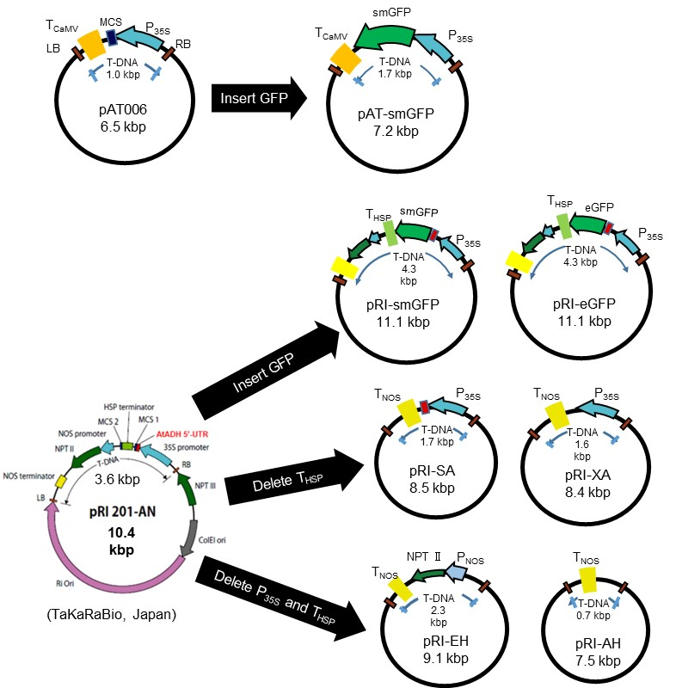

Fig. S1 Schematic drawings of T-DNA plasmids used in agroinfiltration. The binary plasmid pAT006 has a pMDC background (Tsuzuki et al., 2014), and pRI201-AN is commercially available from TakaraBio (Kusatsu, Japan). The construction procedure of their derivatives is described in the Materials and Methods. Abbreviations are as follows; P_{35S}, Cauliflower mosaic virus (CaMV) 35S promoter; P_{NOS}, Nopaline synthase (NOS) promoter; T_{CaMV}, CaMV terminator; T_{NOS}, NOS terminator; T_{HSP}, Heat shock protein (HSP) terminator derived from A. thaliana; eGFP, enhanced GFP; smGFP, soluble modified GFP; NPT, neomycin phosphotransferase; AtADH 5′-UTR, A. thaliana alcohol dehydrogenase 5’-untranslated region; RB, right border; LB, left border.

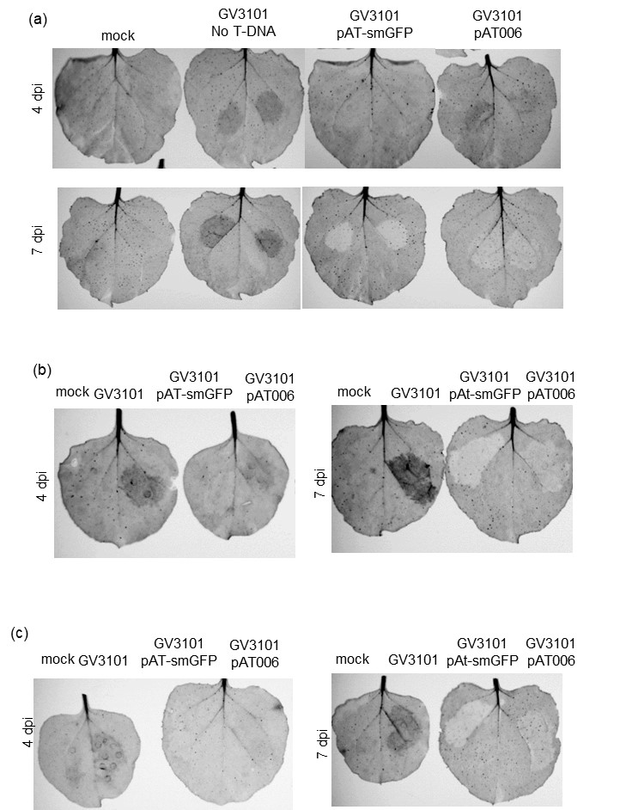

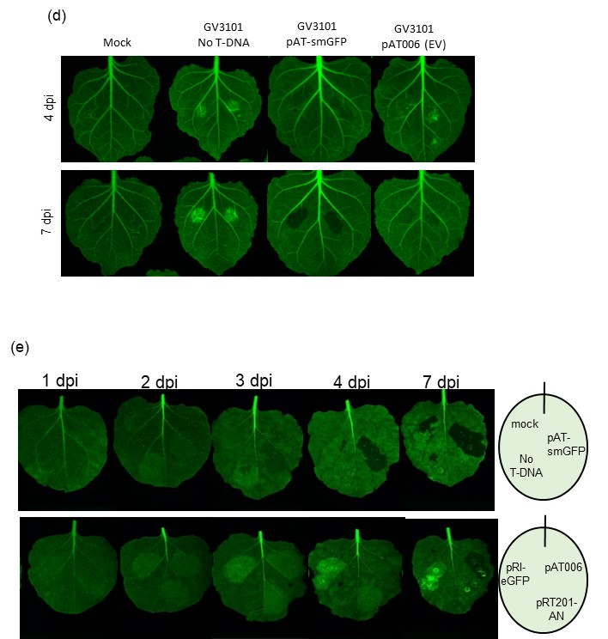

Fig. S2 Related to Fig. 1. Induction of GFP gene silencing by infiltrating A. tumefaciens cells harboring the empty T-DNA plasmid as well as the GFP-expressing plasmid. Photographs of N. benthamiana leaves over-expressing the GFP gene (16c line), into which agrobacteria were infiltrated. The results of five experiments are shown (a to e). Intensities of green fluorescence in black and white photographs and color photographs were measured by the imaging analyzer LAS-3000 (a - c; FUJIFILM, Japan) and the Fluorescence Imaging System, FOBI (d and e; NeoScience, Seoul, South Korea), respectively.

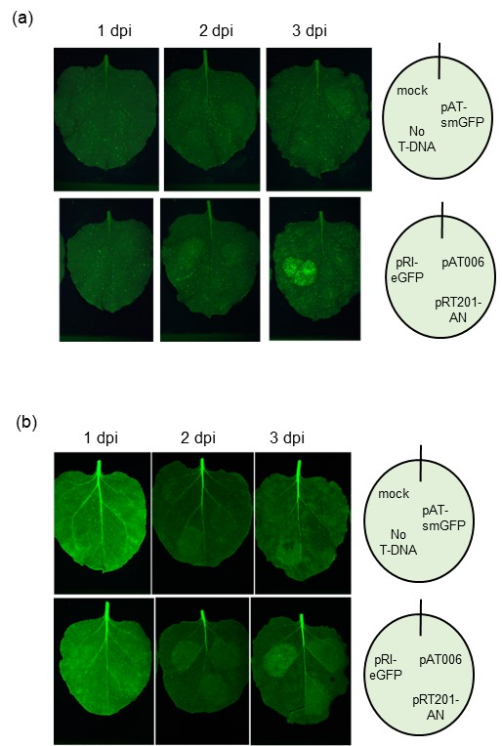

Fig. S3 Related to Fig. 2. Induction of TGS by T-DNA insertion. Photographs of N. benthamiana leaves of WT (a) and 16c line (b), into which A. tumefaciens cells were infiltrated. Total RNA was isolated from the infiltrated sites of the N. benthamiana leaves shown here and Northern hybridization was performed. The results of Northern hybridization are shown in Fig. 2.

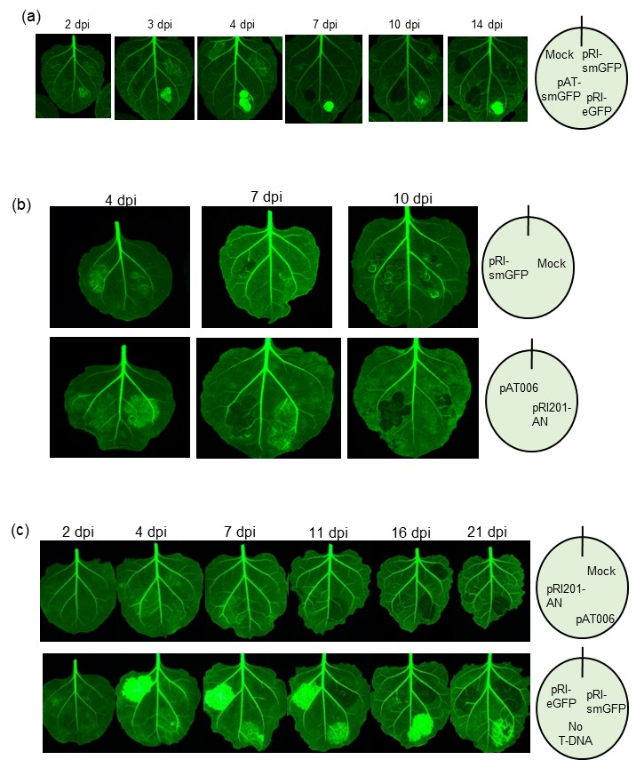
Fig. S4 Related to Figs. 3 and 4. The structural feature of T-DNA to suppress the induction of TGS. Photographs of N. benthamiana leaves over-expressing the GFP gene (16c line), into which A. tumefaciens cells were infiltrated. The results of three experiments are shown (a to c). Total RNA was isolated from the infiltrated regions of the N. benthamiana leaves shown in b and c, and Northern hybridization was performed. The results of Northern hybridization are shown in Fig. 4b and 4c.

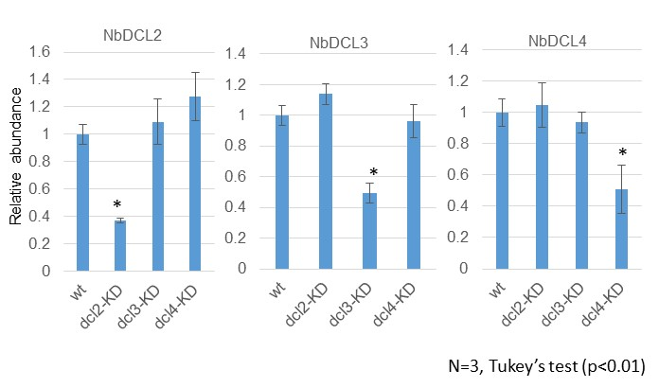

Fig. S5 Related to Fig. 5. Confirmation of knocked-down of NbDCL genes in RNAi N. benthamiana plants by qPCR. Relative transcript abundance of three N. benthamiana Dicer-like protein genes (NbDCL2 to NbDCL4) in leaves was measured by qPCR. Data were obtained from three biological replicates. The actin gene (NbACT) was used as the internal standard. The amount of WT plants was set to 1 as the standard. Bars indicate ±SE, and significant differences (Tukey’s test) are indicated by * (p<0.01).

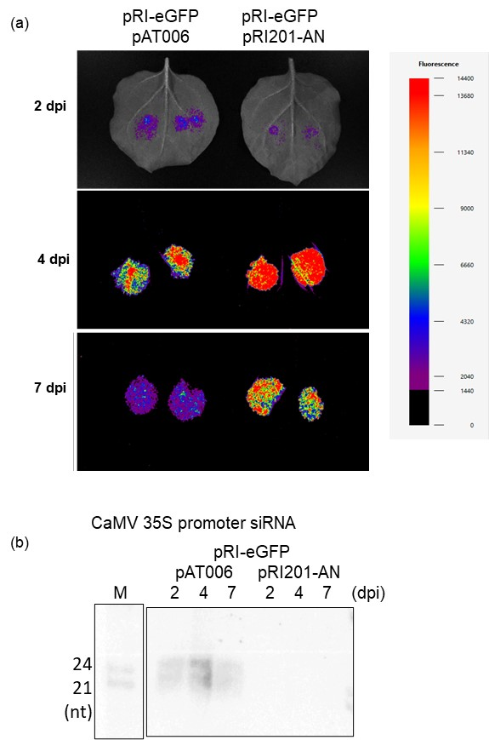

Fig. S6 Related to Fig. 5. The induction of TGS to the GFP gene in a WT N. benthamiana plant by co-agroinfiltration. a Photographs of leaves of WT N. benthamiana plants, into which A. tumefaciens cells harboring T-DNA plasmids were co-infiltrated. A. tumefaciens cells harboring pRI-eGFP was mixed with either agrobacteria harboring pAT006 or those harboring pRI201-AN and then co-infiltrated into leaves of WT N. benthamiana plants. Green fluorescence was observed at 2, 4 and 7 dpi by the FOBI system and presented as pseudo-color by using the NEO image program. b Detection of siRNAs derived from the CaMV 35S promoter from co-infiltrated sites of agrobacteria harboring pRI-eGFP and those harboring pAT006 by Northern hybridization. M indicates molecular weight markers of 21-nt and 24-nt ssRNAs, and rRNA indicates 5S rRNA as a loading control.

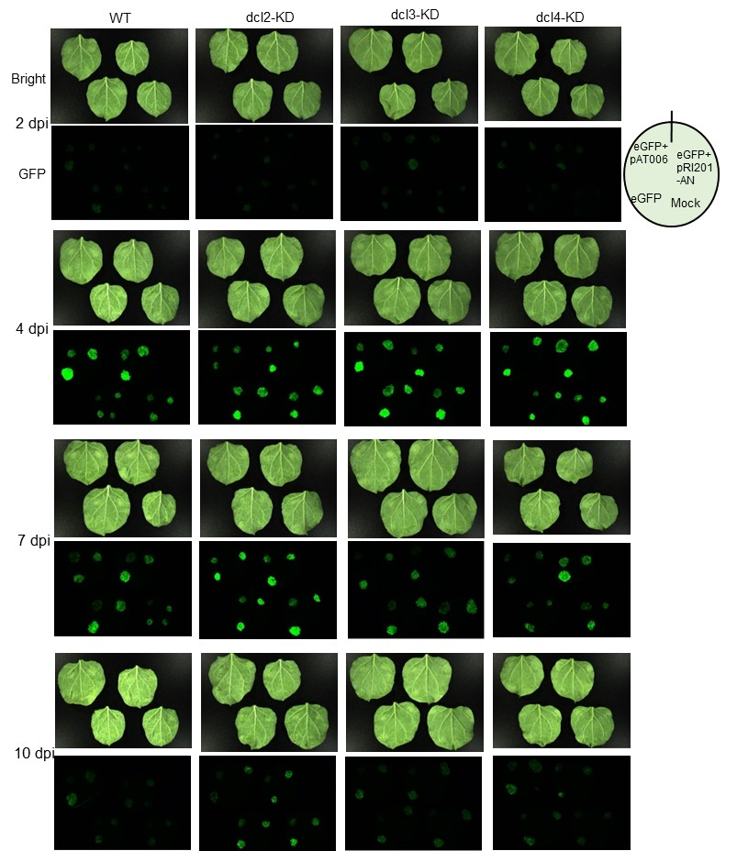
Fig. S7 Related to Fig. 5. Involvement of siRNA-producing Dicers during TGS induction. Photographs of leaves of WT and three dcl-KD mutant plants of N. benthamiana, into which A. tumefaciens cells harboring T-DNA plasmids were co-infiltrated. A. tumefaciens cells harboring pRI-eGFP was mixed with either A. tumefaciens cells harboring pAT006 (GFP+pAT) or those harboring pRI201-AN (GFP+pRI), and then co-infiltrated into leaves of WT and three dcl-KD mutant plants of N. benthamiana. Only A. tumefaciens cells harboring pRI-eGFP was also infiltrated as a control (GFP), and Mock indicates mock inoculation with agroinfiltration buffer. Green fluorescence was observed at 2, 4, 7 and 10 dpi by the FOBI system. Intensities of green fluorescence in agroinfiltrated sites were quantified and analyzed by the NEO image program and shown in Figs. 5b and S8.

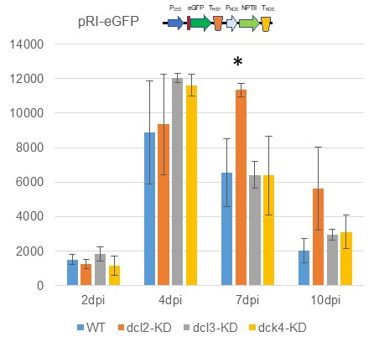

Fig. S8 Related to Fig. 5. Involvement of siRNA-producing Dicers during TGS induction. A. tumefaciens cells harboring T-DNA plasmids were co-infiltrated into leaves of WT and three dcl-KD mutant plants of N. benthamiana. Photographs of leaves infiltrated with agrobacteria harboring pRI-eGFP+pAT006, pRI-eGFP+RI201-AN, pRI-eGFP and Mock are shown in Figs. 5 and S7. Intensities of green fluorescence in infiltrated sites were quantified and analyzed by the NEO image program. Bars indicate ±standard errors (SE) of four biological replicates, and significant differences (Tukey’s test) are indicated by * (p<0.01). Results of pRI-eGFP+pAT006 and pRI-eGFP+pRI201-AN) are shown in Fig. 5b, and the results of pRI-eGFP are shown here.

