Supplementary Information

AiKPro: Deep Learning Model for Kinome-Wide Bioactivity Profiling Using Structure-based Sequence Alignments and Molecular 3D Conformer Ensemble Descriptors

Hyejin Park¹, Sujeong Hong¹, Myeonghun Lee¹, Sungil Kang¹, Rahul Brahma², Kwang-Hwi Cho²*, Jae-Min Shin¹*
¹AzothBio, Rm. DA724 Hyundai Knowledge Industry Center, Hanam-si, Gyeonggi-do, Republic of Korea
²School of Systems Biomedical Science, Soongsil University, Seoul, Republic of Korea

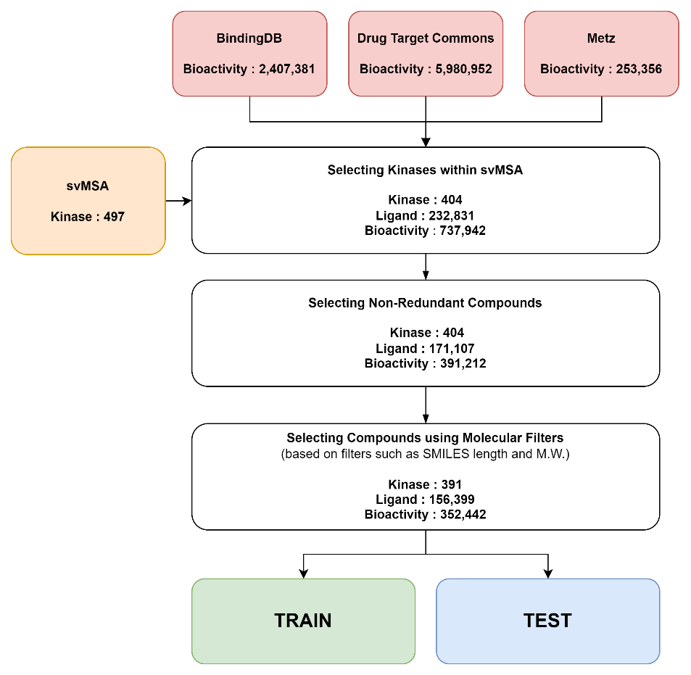
Supplementary Figure S1. Schematic flow of the data curation process, which involves data acquisition, data cleaning, and data splitting into training and test sets.

In this study, we used a previously performed structurally validated multiple sequence alignment (svMSA) study of 497 human kinases¹ to represent the kinases. This allowed us to take into account the 3D structural information of the kinase active site, which is critical for understanding the sequence-structure-function relationships of kinases.
To obtain the compound structures and bioactivity data, we used several public compound databases, including BindingDB², Drug Target Commons (DTC)³, and the Metz dataset⁴. The BindingDB dataset contained 2,407,381 bioactivities, while DTC contained a total of 380,559 bioactivities. The Metz dataset contained 253,356 bioactivities.
These datasets were merged to create a single dataset. The merged data yielded 404 kinases, 232,831 unique ligands, and 737,942 bioactivities, where the interactions of compounds with kinases in the svMSA's kinase list were expressed as IC50 and Ki values.
Next, we removed duplicate kinase-compound pairs to ensure data integrity, resulting in 391,212 bioactivities with 404 kinases and 171,107 unique ligands. When several kinase-compound pairs were present in duplicate, the average was used instead if the standard deviation was within a narrow enough range of 0.25 or less.
We then used molecular filters to select molecules that met specific criteria, including a molecular weight between 200 and 800 Da, a canonical SMILES length of 100 or less, and consisting of only organic atoms (H, B, C, N, O, F, P, Cl, Br, I and S). We also performed molecular sanitization to remove any molecules that did not meet the required criteria.
The final curated dataset consisted of 391 targets, 156,399 unique compounds, and 352,442 bioactivities covering various kinase target families relevant to drug discovery. This dataset was used for the subsequent data analysis and model development in this study.
Supplementary Figure S2. Comparison of AiKPro predictions and molecular docking scores.
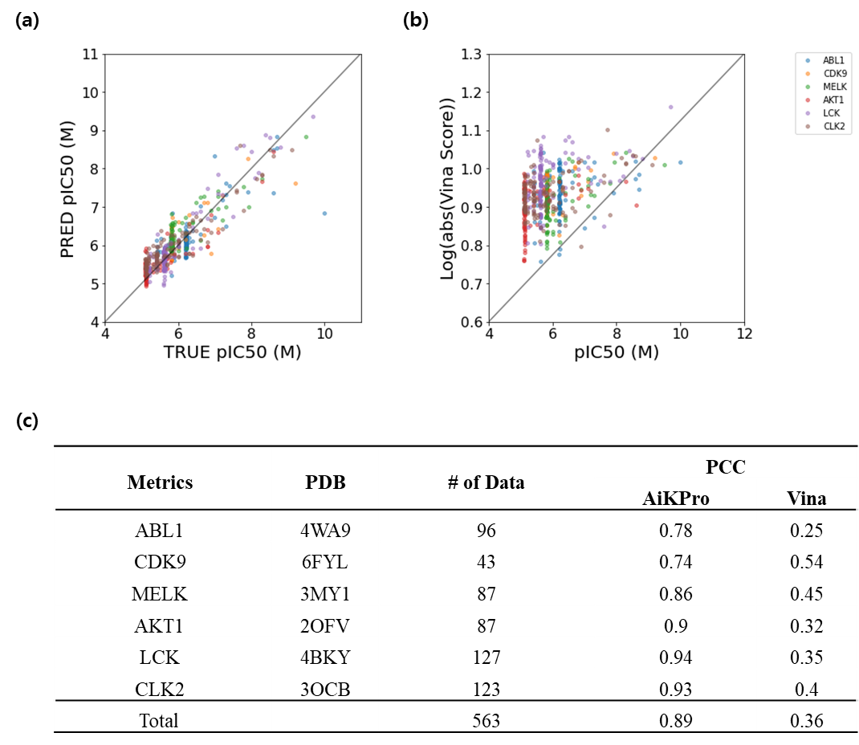

Scatter plots in (a) and (b) illustrate the correlation between the observed pIC50(M) and predicted values of AiKPro and molecular docking score, respectively. Table (c) summarizes the Pearson correlation coefficient (PCC) values for six kinases of AiKPro and molecular docking.

Supplementary Figure S3. Illustration of the 5-fold cross-validation used for training set evaluation and the ensemble prediction method used for the test set evaluation in this study.
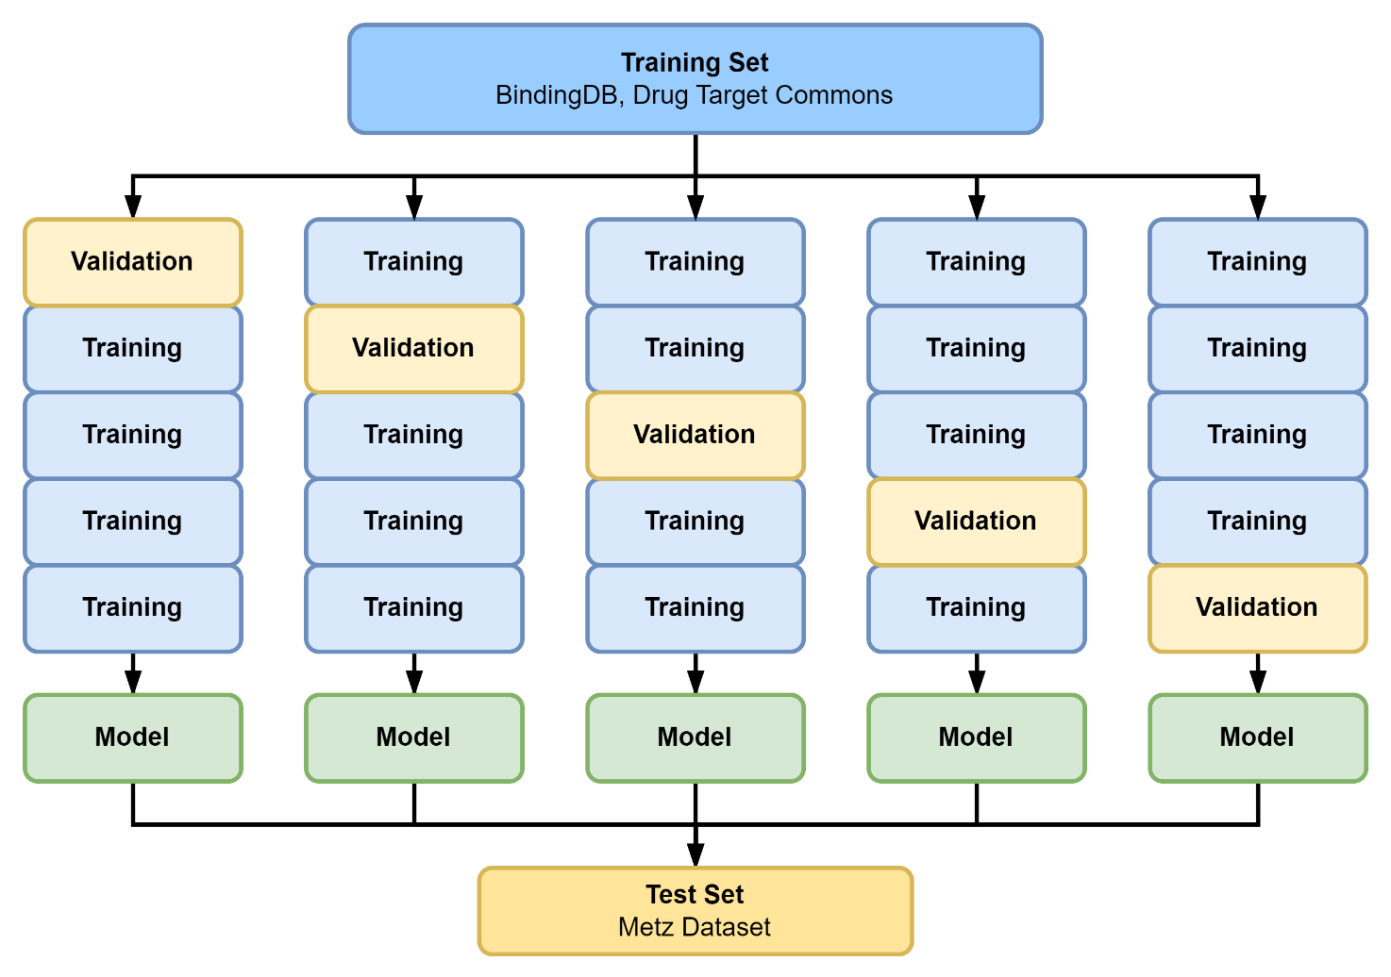

Supplementary Figure S4. Learning curves and scatter plots of actual-predicted bioactivity for each architecture.
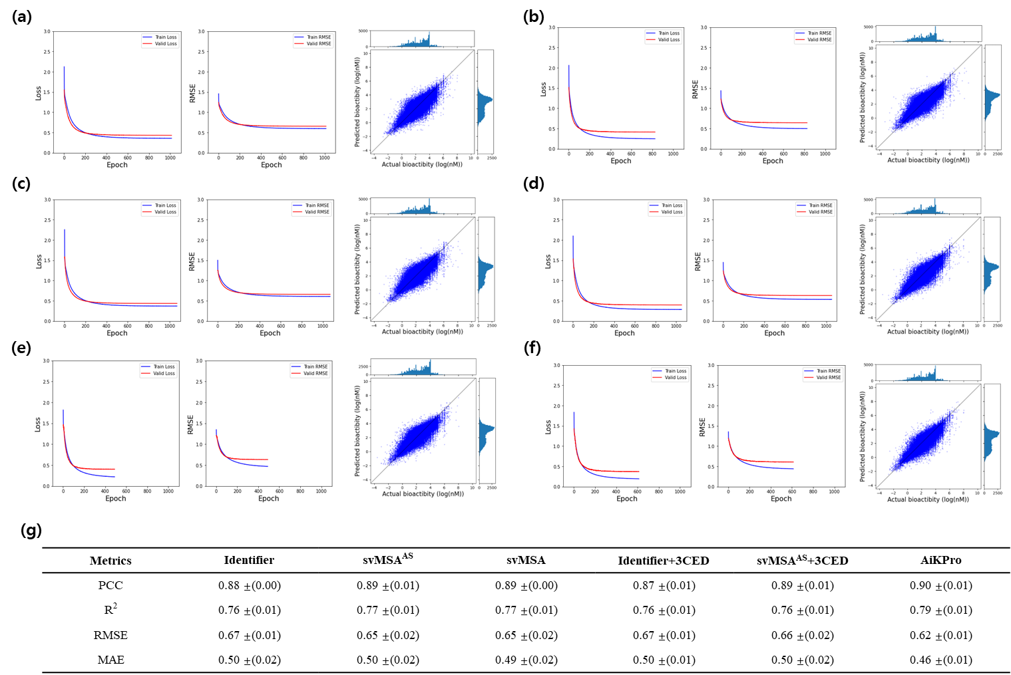

The models using Identifier, svMSA^{AS}, and svMSA are illustrated in panels (a), (c), and (e), respectively. Panels (b), (d), and (f) show models where 3CED was used with each Kinase representation, respectively. The 5-fold cross-validation performance is summarized in panel (g).

Table S1. Hyperparameters for AiKPro model training.

Hyperparameter | Value
Epoch | 3000
Batch size | 512
Learning rate | 0.00001
Patience | 100
Optimizer | Adam
Loss Function | MSE

Table S2. Performance metrics of different models. PCC, R2, RMSE, and MAE are used as evaluation metrics.

Metrics | PCC | R² | RMSE | MAE
Identifier | 0.70 | 0.44 | 0.55 | 0.38
Identifier+3CED | 0.81 | 0.58 | 0.49 | 0.38
svMSA^{AS} | 0.73 | 0.4 | 0.58 | 0.38
svMSA^{AS}+3CED | 0.84 | 0.66 | 0.44 | 0.33
svMSA | 0.8 | 0.55 | 0.5 | 0.34
svMSA+3CED (AiKPro) | 0.88 | 0.72 | 0.40 | 0.30

References
- Modi, V. & Dunbrack, R. L. A Structurally-Validated Multiple Sequence Alignment of 497 Human Protein Kinase Domains. Scientific Reports 2019 9:1 9, 1–16 (2019).
- Liu, T., Lin, Y., Wen, X., Jorissen, R. N. & Gilson, M. K. BindingDB: a web-accessible database of experimentally determined protein–ligand binding affinities. Nucleic Acids Res 35, D198–D201 (2007).
- Tanoli, Z. R. et al. Drug Target Commons 2.0: a community platform for systematic analysis of drug–target interaction profiles. Database 2018, (2018).
- Metz, J. T. et al. Navigating the kinome. Nature Chemical Biology 2011 7:4 7, 200–202 (2011).

