Size-dependent growth tactics of a partially migratory fish before migration

Ryo Futamura, Kentaro Morita, Yoichiro Kanno, Shoji Kumikawa, Yuichi Matsuoka, Atsushi Okuda, Hiroshi Sugiyama, Hiroyuki Takahashi, Jiro Uchida, Osamu Kishida*
* Corresponding author: kishida@fsc.hokudai.ac.jp

Statistical analyses on growth rate
Relationship between river-descending timing and body mass
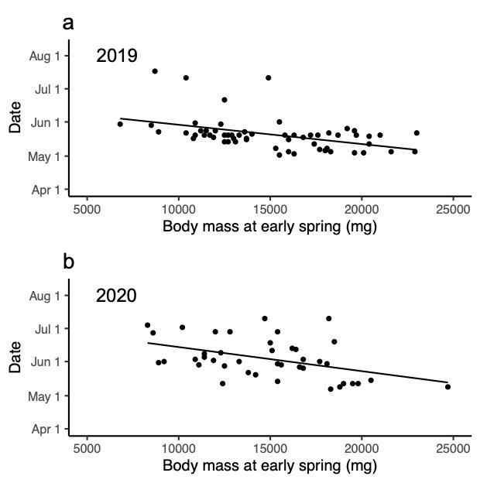
Figure S2. Relationship between the river-descending timing (date) and body mass at the early spring of the prospective migrants in 2019 (a) and 2020 (b). Regression lines; (a) Y = -1.8 × 10⁻³X + 75.93, p < 0.001, Adjusted R² = 0.18; (b) Y = -0.02X + 95.99, p < 0.003, Adjusted R² = 0.18.

