Supplementary files:

Supplementary Table 1. Cronbach alpha internal consistency estimates for social variables in three waves

Variables | T0 | T1 | T2
Social participation | 0.69 | 0.67 | 0.66
Social networks
Friends | 0.70 | 0.80 | 0.75
Children | 0.87 | 0.90 | 0.88
Siblings | 0.75 | 0.79 | 0.79
Grandchildren | 0.74 | 0.71 | 0.71
Social support
Friends | 0.72 | 0.67 | 0.65
Children | 0.72 | 0.71 | 0.72
Family | 0.70 | 0.73 | 0.72
Partner /spouse | 0.73 | 0.74 | 0.74

Supplementary Table 2. Characteristics of the participants in three waves
Variables | Baseline (n=1643) | Time-point 1 (n=1386) | Time-point 2 (n=1224)
Covariates
Age (years), mean ± SD | 78.7 ±7.9 | 78.1±7.8 | 77.6±7.6
Gender (%)
Male | 49.8 | 49.1 | 48.1
Female | 50.2 | 50.9 | 51.9
Income, mean ± SD | 4.1 ± 1.7 | 4.2±1.7 | 4.3±1.7
Education (years), mean ± SD | 10.6 ±4.7 | 10.7 ±4.7 | 10.8 ±4.6
Smoking status (%)
Current smoker | 7.4 | 6.9 | 6.5
Former smoker | 48.5 | 49.6 | 49.4
Non-smoker | 44.1 | 43.5 | 44.1
Alcohol consumption (%)
Yes | 71 | 71.1 | 71.8
No | 29 | 28.9 | 28.2
Sleeping disturbance (%)
Yes | 41 | 40.6 | 41.4
No | 58.8 | 59.4 | 58.6
Predictors
Social participation, mean ± SD | 42.8 ± 5.7 | 42.8±5.5 | 42.8±5.4
Friends
Social Network, mean ± SD | 18 ± 16.6 | 15.6±15 | 15.2±15.3
Social Support, mean ± SD | 16.1 ± 7.5 | 15.3±8.1 | 15.5±8.1
No friends (%) | 14.8 | 14.1 | 14.1
Nuclear family
Social Network-children, mean ± SD | 9.6 ± 7.4 | 9.3±7.1 | 9.2±6.8
Social Support-children, mean ± SD | 17.5 ± 8 | 17.3±8 | 17.5±7.9
Social Support-partner, mean ± SD | 11.9 ± 11.1 | 11.5±11 | 11.2±11
No children (%) | 14.7 | 14.6 | 14
No partner (%) | 45.5 | 46.2 | 46.7
Extended family
Social Network-Grandchildren, mean ± SD | 11.3 ± 11 | 12±12.1 | 11.7±11.5
Social Network- siblings, mean ± SD | 8.5 ±7.4 | 8.5±7.2 | 8.3±7.1
Social support -family, mean ± SD | 17.1 ± 4.7 | 16.9±4.7 | 17±4.6
No grandchildren (%) | 22.2 | 21.8 | 21.6
No siblings (%) | 13 | 13.2 | 13.4
Moderator
Frailty, mean ± SD | 20±8.6 | 21.4±9.1 | 21.2±9.3
Health outcomes
Disability, mean ± SD | 1.6±6.8 | 1.7±7.5 | 1.8±8.4
Depressive symptoms, mean ± SD | 2.8±2.6 | 2.8±2.7 | 2.6±2.6
Comorbidity, mean ± SD | 3.1±1.9 | 3.3±2.3 | 3.4±2.3
Cognitive function, mean ± SD | 23.4±4.6 | 23.9±4.8 | 24±5.1
Missing, % | 0 | 15.6 | 25.5

Notes: SD = Standard deviation, n=Total number.

Supplementary Table 3. Minimum and maximum values of variables in three waves

 | T0 |  | T1 |  | T2
Predictors | Min | Max | Min | Max | Min | Max
Social participation | 22 | 55 | 23 | 55 | 25 | 55
Friends
Social Networks | 0 | 70 | 0 | 60 | 0 | 70
Social Support | 0 | 25 | 0 | 25 | 0 | 25
Nuclear family
Social Networks-children | 0 | 38 | 0 | 36 | 0 | 30
Social Support-children | 0 | 25 | 0 | 25 | 0 | 25
Social Support-partner | 0 | 25 | 0 | 25 | 0 | 25
Extended family
Social Networks -Grandchildren | 0 | 50 | 0 | 62 | 0 | 56
Social Networks- siblings | 0 | 34 | 0 | 36 | 0 | 34
Social support-family | 0 | 25 | 0 | 25 | 0 | 25
Moderator
Frailty | 0 | 34 | 0 | 36 | 0 | 39
Outcomes
Disability | 0 | 9 | 0 | 9 | 0 | 9
Depression | 0 | 13 | 0 | 14 | 0 | 15
Comorbidity | 0 | 7 | 0 | 13 | 0 | 12
Cognitive function | 0 | 30 | 0 | 30 | 0 | 30

Notes: Due to the large variances, we rescaled the scores by dividing them by a constant of such size that their variances fall between one and ten after rescaling (Muthén & Muthén, 2017). We divided each score in Mplus as follows: Social support and cognitive decline/5; frailty/6; social network-siblings and children/5; social networks-grandchildren/10; social networks-friends/20; social participation/6; depression and chronic diseases/2.

Supplementary Figure 1. Relationship between baseline social participation and change in depressive symptoms as a function of change in frailty (mean slope ± 1 SD).

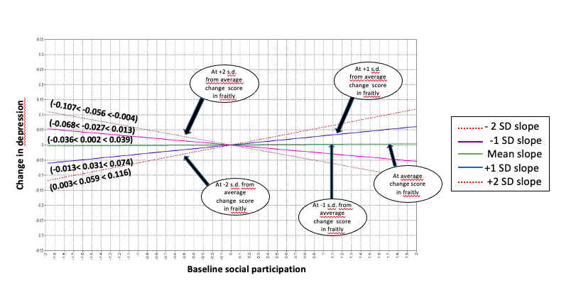

Reference:

Muthén, L. K., & Muthén, B. (2017). Mplus user's guide: Statistical analysis with latent variables, user's guide. Muthén & Muthén.

