Supplementary Information
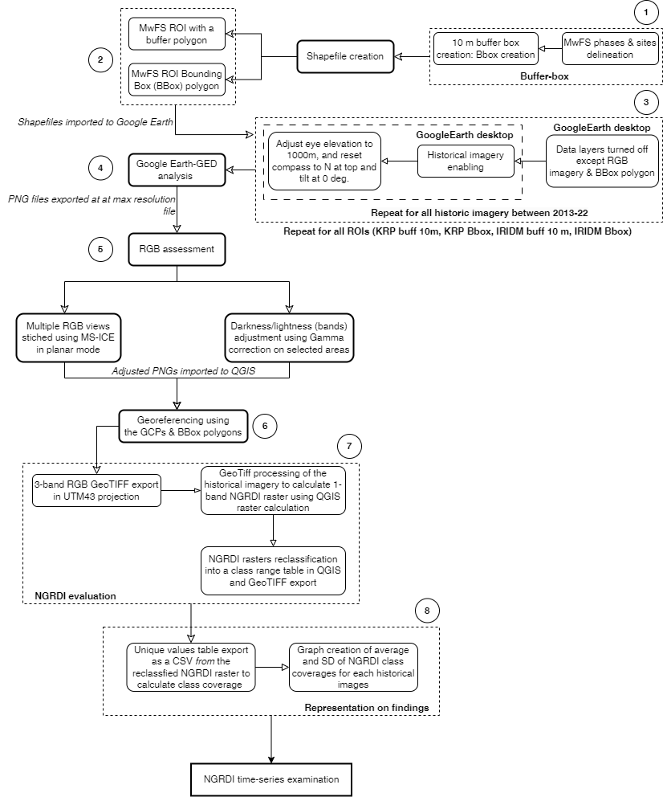

Figure S1
Schematic representation of the methodology for historical imagery and NGRDI time-series generation of both the MwFS in consideration
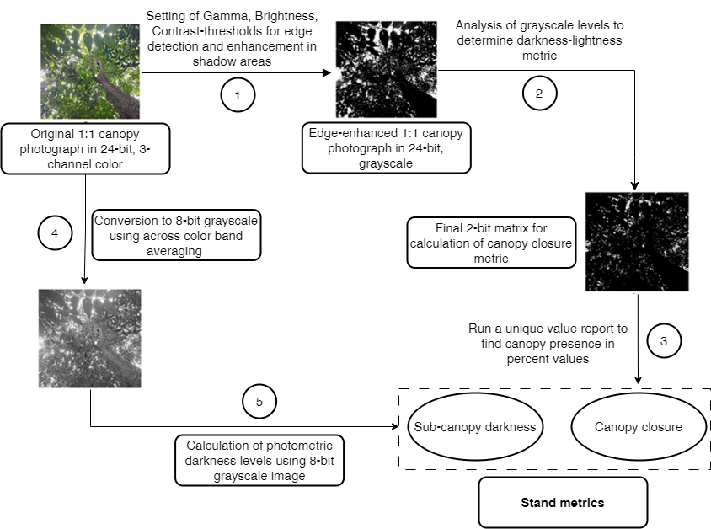

Figure S2
Diagrammatic representation of the protocol for estimating canopy distribution (canopy closure and sub-canopy shade levels at forest stand floor) in MwFS case studies

Table S1

 | KRPDLS Regional |  |  |  | KRPDLS MwFS
Julian month | Non  -vegetated | Herbaceous | Open  Canopy | Closed  Canopy | Non  -vegetated | Herbaceous | Open  Canopy | Closed  Canopy
1 | 89.851 | 8.720 | 1.428 | 0.000 | 97.287 | 2.688 | 0.025 | 0.000
3 | 90.208 | 3.145 | 5.519 | 1.128 | 97.957 | 1.934 | 0.109
4 | 84.666 | 9.849 | 5.415 | 0.070 | 91.358 | 7.172 | 1.443 | 0.028
11 | 58.618 | 40.103 | 1.227 | 0.052 | 61.749 | 37.141 | 1.079 | 0.031
13 | 88.171 | 8.819 | 2.780 | 0.230 | 90.476 | 8.142 | 1.241 | 0.141
14 | 70.578 | 17.109 | 10.658 | 1.655 | 71.301 | 15.385 | 11.590 | 1.724
15 | 92.485 | 6.159 | 1.213 | 0.143 | 93.131 | 4.927 | 1.692 | 0.251
16 | 92.485 | 6.161 | 1.212 | 0.143 | 93.131 | 4.927 | 1.692 | 0.251
17 | 43.552 | 30.880 | 15.516 | 10.052 | 26.943 | 46.629 | 23.125 | 3.304
26 | 99.922 | 0.077 | 0.001 |  | 99.910 | 0.088 | 0.001
28 | 94.465 | 5.346 | 0.189 | 0.001 | 91.900 | 7.862 | 0.236 | 0.001
33 | 51.862 | 46.379 | 1.719 | 0.040 | 49.051 | 48.498 | 2.414 | 0.037
38 | 85.372 | 14.273 | 0.340 | 0.015 | 84.307 | 15.245 | 0.426 | 0.022
39 | 99.235 | 0.765 | 0.000 |  | 98.907 | 1.093 | 0.000
40 | 99.464 | 0.527 | 0.008 | 0.000 | 99.346 | 0.651 | 0.004
41 | 65.953 | 15.449 | 16.056 | 2.542 | 73.271 | 12.724 | 12.215 | 1.790
47 | 66.845 | 18.715 | 13.389 | 1.051 | 79.482 | 15.407 | 4.833 | 0.278
48 | 98.693 | 1.248 | 0.057 | 0.002 | 99.946 | 0.054
49 | 88.602 | 10.754 | 0.587 | 0.057 | 90.371 | 9.167 | 0.454 | 0.008
50 | 75.747 | 17.479 | 6.565 | 0.208 | 79.222 | 15.790 | 4.816 | 0.172
51 | 90.674 | 7.471 | 1.852 | 0.003 | 88.946 | 8.827 | 2.226 | 0.001
53 | 49.219 | 31.252 | 17.465 | 2.064 | 37.451 | 41.527 | 18.389 | 2.633
58 | 13.182 | 21.607 | 56.283 | 8.928 | 18.686 | 24.953 | 48.470 | 7.892
60 | 15.248 | 24.113 | 56.364 | 4.275 | 20.009 | 22.806 | 52.310 | 4.875
63 | 48.692 | 21.499 | 23.161 | 6.648 | 44.685 | 23.364 | 28.189 | 3.762
64 | 57.501 | 13.982 | 24.034 | 4.483 | 55.484 | 16.082 | 26.203 | 2.231
70 | 24.442 | 23.747 | 48.953 | 2.858 | 14.757 | 32.215 | 49.577 | 3.452
71 | 33.016 | 27.162 | 38.129 | 1.693 | 25.117 | 31.941 | 40.779 | 2.163
72 | 36.543 | 35.532 | 27.558 | 0.367 | 20.834 | 48.488 | 30.213 | 0.465
73 | 52.949 | 24.247 | 21.438 | 1.366 | 47.810 | 31.681 | 19.241 | 1.268
74 | 63.644 | 16.756 | 16.605 | 2.995 | 62.056 | 20.248 | 16.586 | 1.110
75 | 54.139 | 13.739 | 18.194 | 13.927 | 45.445 | 16.444 | 23.414 | 14.698
81 | 16.520 | 11.258 | 53.507 | 18.715 | 15.475 | 13.593 | 57.127 | 13.806
83 | 15.587 | 16.908 | 53.378 | 14.128 | 24.001 | 17.409 | 46.890 | 11.700
85 | 50.027 | 33.481 | 16.301 | 0.190 | 30.240 | 46.267 | 23.219 | 0.274
86 | 52.271 | 15.836 | 28.976 | 2.917 | 30.572 | 18.940 | 45.279 | 5.208
108 | 1.146 | 18.672 | 74.972 | 5.210 | 1.642 | 14.786 | 77.184 | 6.389
109 | 6.670 | 7.736 | 45.267 | 40.328 | 5.952 | 3.957 | 42.486 | 47.605
110 | 58.174 | 34.686 | 6.949 | 0.191 | 55.206 | 37.560 | 7.233
118 | 10.644 | 3.309 | 72.947 | 13.100 | 9.294 | 1.461 | 75.565 | 13.680
 | IRIDM Regional |  |  |  | IRIDM MwFS
Julian month | Non  -vegetated | Herbaceous | Open  Canopy | Closed  Canopy | Non  -vegetated | Herbaceous | Open  Canopy | Closed  Canopy
11 | 71.361 | 25.857 | 2.691 | 0.092 | 64.440 | 32.210 | 3.231 | 0.119
13 | 91.757 | 7.967 | 0.247 | 0.028 | 97.123 | 2.871 | 0.007
14 | 94.378 | 5.336 | 0.257 | 0.029 | 98.753 | 1.181 | 0.060 | 0.006
22 | 52.077 | 40.042 | 7.867 | 0.014 | 98.999 | 1.001
25 | 93.986 | 5.752 | 0.243 | 0.020 | 99.451 | 0.549 | 0.000
26 | 95.761 | 4.043 | 0.194 | 0.001 | 99.905 | 0.094 | 0.001
39 | 98.223 | 1.771 | 0.005 | 0.001 | 99.999 | 0.001
40 | 97.473 | 2.487 | 0.035 | 0.006 | 99.954 | 0.046
47 | 96.912 | 3.055 | 0.031 | 0.002 | 99.956 | 0.044
49 | 95.773 | 3.018 | 1.207 | 0.002 | 99.948 | 0.052
50 | 97.260 | 2.693 | 0.042 | 0.005 | 99.992 | 0.008
58 | 58.689 | 38.389 | 2.914 | 0.009 | 43.776 | 52.569 | 3.655 | 0.000
61 | 89.199 | 7.996 | 2.335 | 0.471 | 88.525 | 10.506 | 0.966 | 0.003
71 | 43.266 | 33.885 | 20.719 | 2.129 | 33.411 | 27.522 | 35.991 | 3.075
72 | 87.993 | 8.369 | 3.346 | 0.292 | 81.860 | 12.803 | 5.228 | 0.108
74 | 91.814 | 5.900 | 1.639 | 0.646 | 97.633 | 1.992 | 0.366 | 0.009
75 | 97.123 | 1.769 | 0.616 | 0.492 | 99.960 | 0.040 | 0.000
87 | 93.208 | 4.290 | 2.255 | 0.246 | 78.147 | 12.538 | 8.096 | 1.220
100 | 81.417 | 8.401 | 8.462 | 1.720 | 43.214 | 12.529 | 35.813 | 8.445
108 | 32.371 | 36.587 | 26.526 | 4.516 | 9.916 | 15.177 | 55.726 | 19.181
109 | 51.727 | 28.551 | 16.497 | 3.224 | 13.516 | 15.569 | 56.210 | 14.704
110 | 82.464 | 7.360 | 7.992 | 2.185 | 33.170 | 20.721 | 36.891 | 9.217
112 | 80.108 | 8.982 | 10.289 | 0.621 | 25.837 | 25.890 | 45.248 | 3.025

