Supporting information

Simultaneous determination of paracetamol, propyphenazone, aspirin and caffeine in white wine samples by liquid chromatography-triple quadrupole tandem mass spectrometry

Dan Han^{a*}, Yongliang Dingª, Kun Pengª, Bobing Tang^{b}, Cunxian Xi^{b}, Anping Deng^{c*}

ª Medical College, Chongqing Engineering Research Center of Pharmaceutical Sciences, Chongqing Medical and Pharmaceutical College,
Mid College-City Road 82, Shapingba District, Chongqing 401331, China.
^{b} The Inspection Technical Center of Chongqing Customs, Honghuang Road 8, Jiangbei District, Chongqing 400020, China
^{c} College of Chemistry, Chemical Engineering & Materials Science, Soochow University, Renai Road 199, Suzhou 215123, China

* Corresponding author: Tel: +86 512 65884630; Fax: +86 512 65884630
e-mail: 284416221@qq.com; denganping@suda.edu.cn
Table S1. The gradient elution program of two mobile phases in LC-MS/MS
Time (min) | Mobile phase A (%) | Mobile phase B (%)
0 | 95% | 5%
1 | 95% | 5%
2 | 65% | 35%
3 | 65% | 35%
4 | 20% | 80%
6 | 20% | 80%
6.5 | 95% | 5%
8.0 | 95% | 5%

Table S2. Comparison of two sample pretreatment methods for four drugs in LC-MS/MS
Drug | Spiked level  (μg/L) | Recovery (%)  Method 1* Method 2** | RSD (%)  Method 1* Method 2**
paracetamol | 4.0 | 95.9 92.5 | 6.2 6.3
paracetamol | 20.0 | 94.0 93.7 | 5.5 5.8
paracetamol | 40.0 | 96.6 91.3 | 3.9 6.8
propyphenazone | 0.5 | 101.5 90.8 | 1.4 2.9
propyphenazone | 4.0 | 98.5 93.2 | 3.2 5.2
propyphenazone | 8.0 | 96.3 87.4 | 3.3 4.9
aspirin | 10.0 | 102.2 91.6 | 4.2 4.3
aspirin | 100.0 | 102.0 93.2 | 2.6 5.4
aspirin | 180.0 | 100.2 94.3 | 1.6 4.1
caffein | 5.0 | 93.0 85.7 | 2.2 4.7
caffein | 20.0 | 93.4 90.9 | 1.8 6.0
caffein | 40.0 | 98.4 93.2 | 2.1 5.7
Method 1*: low pressure distillation; Method 2**: boiling evaporation

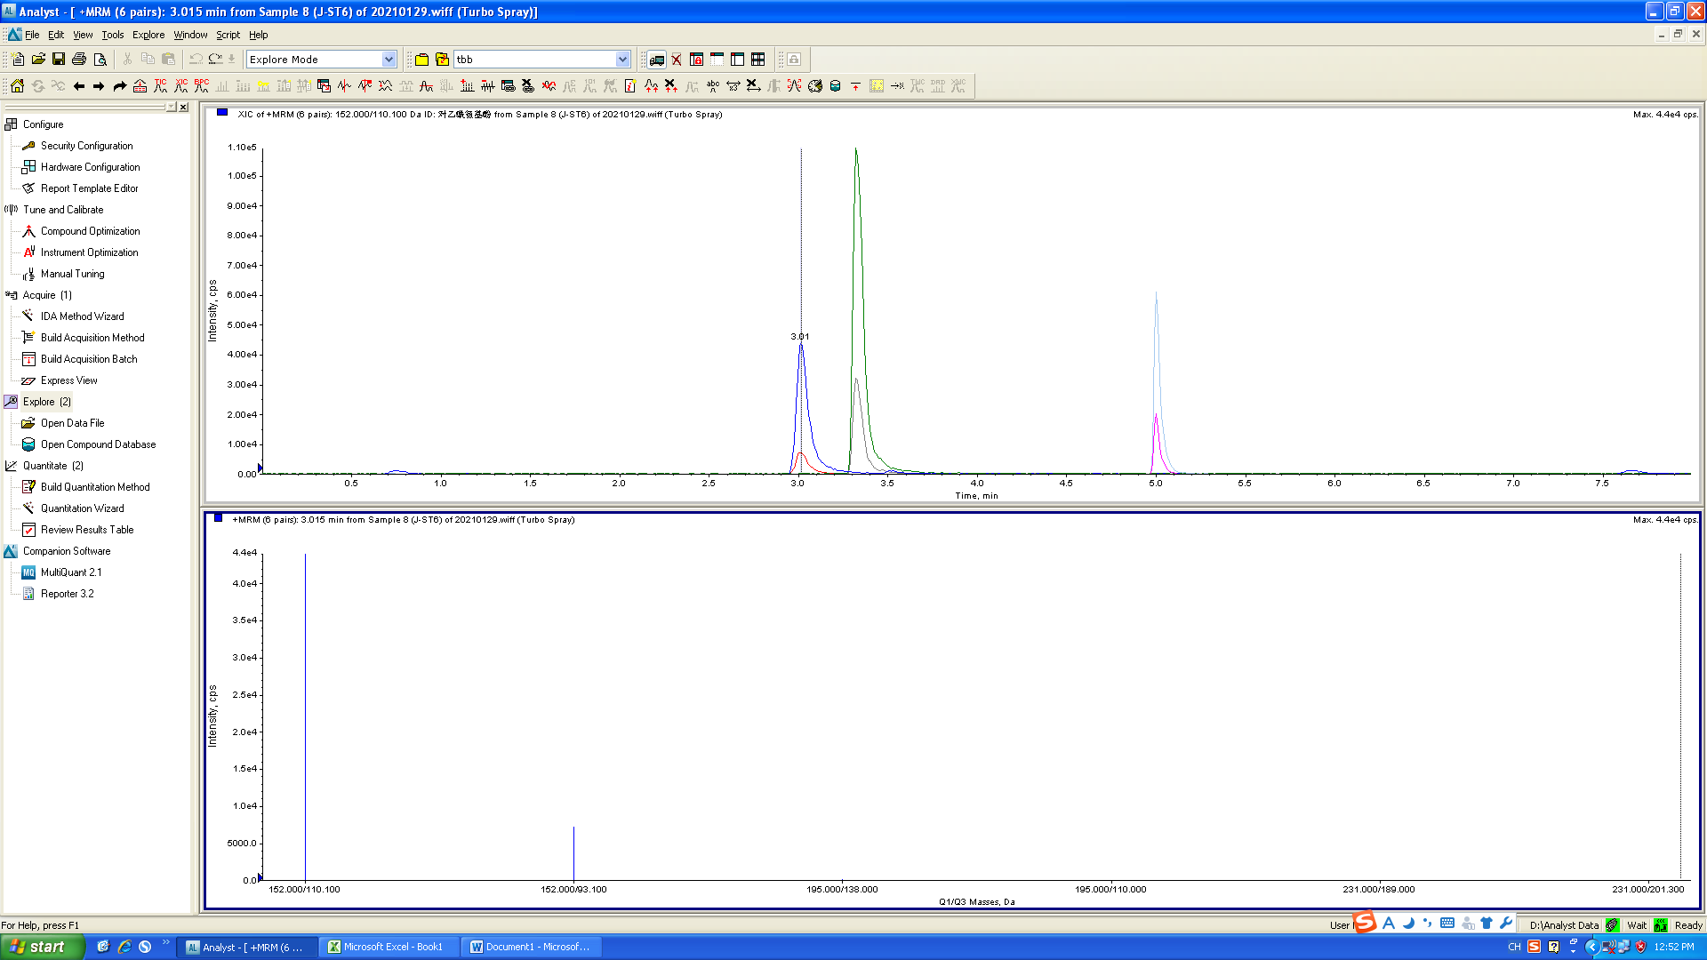
(a)

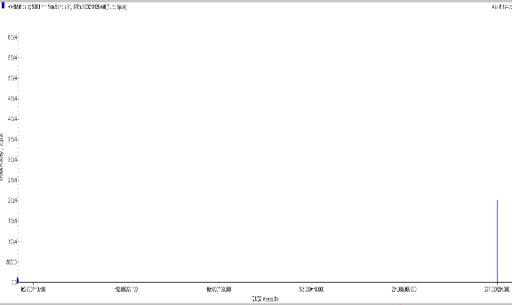
(b)

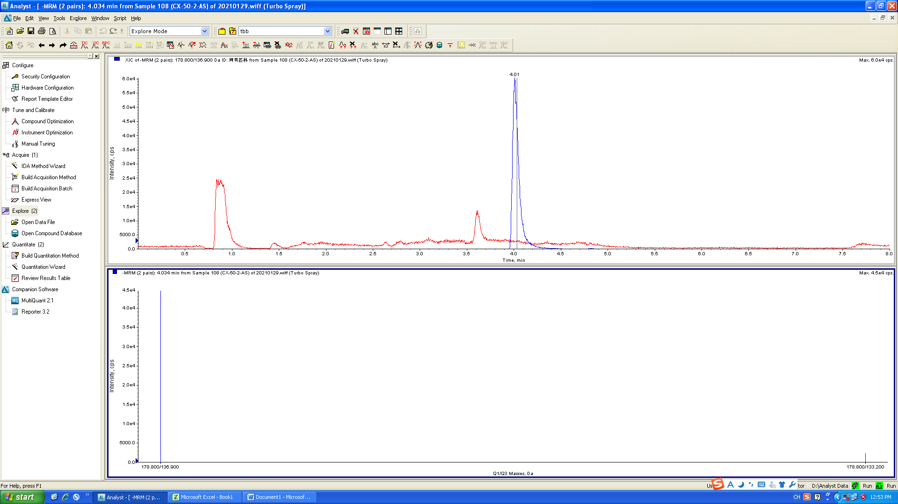

(c)

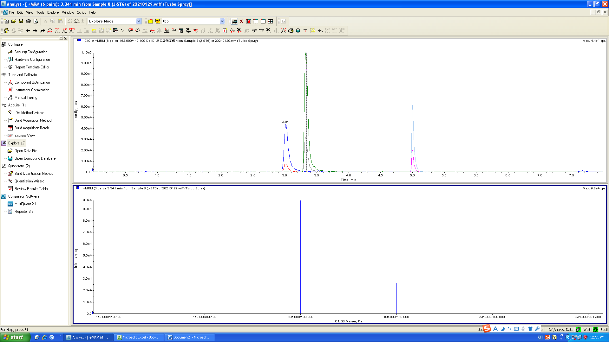
(d)
Fig. S1. Mass spectra. (a) paracetamol, (b) propyphenazone, (c) aspirin, (d) caffein

