Electronic Supplementary Information (ESI)

Dielectronic properties and photocatalytic activities of two novel cobalt(II) meso-tetraphenylporphyrin-based coordination complexes.
Nesrine Amiri ^{a ¥}, Mouhieddinne Guergueb ª, Marwa Bourguiba ^{b,c} and Habib Nasri ª
ª Laboratory of Physico-Chemistry of Materials, University of Monastir, Avenue of the Environment, 5019 Monastir, Tunisia.
^{b} Applied Mechanics and Systems Research Laboratory (LASMAP-EPT), polytechnic school, La Marsa, University of carthage, Tunisia.
^{c} Faculty of science of Tunis, University of Tunis el manar, Tunisia.

¥ Corresponding author: E-mail: nesamiri@gmail.com
Tel: (+216) 28256432

Table of contents
No. | Contents | Pg No.
1 | Scheme S1. Molecular structures of [Co^{II}(Porph))(DMAP)₂]. | 2
2 | Table S1. UV/Vis data of several free base meso-porphyrins, complex 1, complex 2 and a selection of cobalt meso-metalloporphyrins in dichloromethane. | 3
3 | Table S2. Emission data for complexes 1-2 and some related cobaltous metalloporphyrins. | 4
4 | Fig. S1. ¹H NMR spectra of 1 (CDCl₃, 500 MHz, 298 K). | 5
5 | Fig. S2. ¹H NMR spectra of 2 (CDCl₃, 500 MHz, 298 K). | 5
6 | Fig. S3. High resolution ESI mass spectrum of 1 in CH₂Cl₂. | 6
7 | Fig. S4. High resolution ESI mass spectrum of 2 in CH₂Cl₂. | 6
9 | references | 7

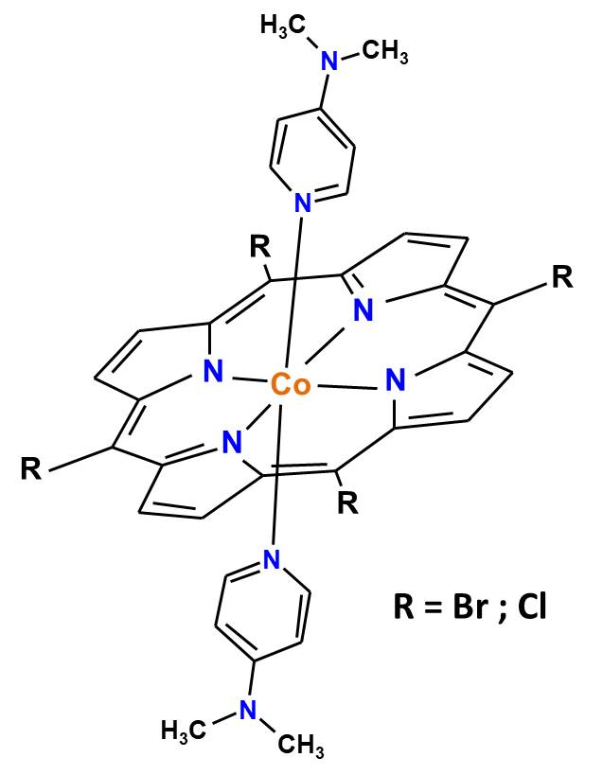
Scheme S1. Molecular structures of [Co^{II}(Porph))(DMAP)₂].

Table S1 UV/Vis data of several free base meso-porphyrins, complexe 1, complex 2 and a selection of cobalt meso-metalloporphyrins in dichloromethane.
Compound |  | Soret band  λ [nm] (log ε) |  |  |  | Q bands  λ [nm] (log ε) |  |  |  | [ref]
Free base meso-porphyrins
H₂TPPª | 416 (6.10) |  | 513 (5.70) | 550 (4.36) |  |  | 590 (4.24) |  | 646 (4.19) |  | [1]
H₂TTPª | 420 (5.95) |  | 515 (5.82) | 555 (4.28) |  |  | 595 (4.17) |  | 650 (4.10) |  | [1]
H₂TPBP^{b} | 419 (5.90) |  | 515 (4.46) | 551 (4.13) |  |  | 590 (3.94) |  | 646 (3.84) |  | [2]
H₂Pp^{c} | 421 |  | 517 | 553 |  |  | 592 |  | 648 |  | [3]
H₂TMAPP^{d} | 425 (5.92) |  | 522(5.67) | 550 (4.32) |  |  | 597 (4.15) |  | 653 (3.98) |  | [4]
H2TMPP^{e} | 423(5.53) |  | 521(4.38) | 558(4.30) |  |  | 597(4.20) |  | 650(4.17) |  | [5]
H₂TBrPP | 419 (6.58) |  | 515 (5.24) | 549 (4.93) |  |  | 590 (4.77) |  | 648 (4.68) |  | this work
H₂TClPP | 417(5.50) |  | 515(4.93) | 548(4.55) |  |  | 590(4.46) |  | 646(4.41) |  | this work
Tetracoordinated cobalt(II) meso-metalloporhyrins
[Co^{II}(TPP)]ª | 412 |  | 528 |  | — |  |  |  |  |  | [6]
[Co^{II}(TpivPP)]^{f} | 412 |  | 524 |  | — |  |  |  |  |  | [7]
[Co^{II}(Pp)]^{c} | 414 |  | 531 |  | — |  |  |  |  |  | [3]
[Co^{II}(TMAPP)]^{d} | 415 (5.85) |  | 539 (5.49) |  | — |  |  |  |  |  | [4]
[Co^{II}(TPBP)]^{b} | 412 (6.07) |  | 528 (5.58) |  | — |  |  |  |  |  | [2]
[Co(TMPP)]^{e} | 414(5.65) |  | 535(4.36) |  | — |  |  |  |  |  | [5]
[Co^{II}(TBrPP)] | 412(5.58) |  | 528(4.62) |  | — |  |  |  |  |  | this work
[Co^{II}(TClPP)] | 412(5.58) |  | 529(4.80) |  | — |  |  |  |  |  | this work
Pentacoordinated and hexacoordinated cobalt(II) meso-porphyrins
[Co^{II}(TPBP)(4,4’-bpy)₂]^{b,g}(1) | 435 (5.75) |  | 552 (4.49) |  |  |  |  |  |  |  | this work
[Co^{II}(TpîvPP)(4,4’-bpy)₂]^{f,g} | 439 (5.40) |  | 550 (4.25) |  | — |  |  |  |  |  | [7]
[Co^{II}(TPP)(4,4′-bpy)₂]^{a,g} | 438 (5.39) |  | 549 (4.21) |  | — |  |  |  |  |  | [3]
[Co(TPP)(Hon)₂]^{a,h} | 434 (4.46) |  | 521 (3.54) |  | 555 (3.41) |  |  |  |  |  | [8]
[Co^{II}(TMPP)(4-CNpy)]^{e,i} | 437(5.62) |  | 558(4.60) |  | 600(4.54) |  |  |  |  |  | [5]
[Co^{II}(TClPP)(4-CNpy)]^{i} | 436(5.65) |  | 556(4.69) |  | 598(4.64) |  |  |  |  |  | [5]
[Co^{II}(TMPP)(py)]^{e} | — |  | 535 |  | — |  |  |  |  |  | [8]
[Co^{II}(TMPP)(pip)]^{e,j} | — |  | 532 |  | — |  |  |  |  |  | [9]
[Co^{II}(TClPP)(pipz)]^{k} | 436(5.60) |  | 553(4.63) |  | 592(4.49) |  |  |  |  |  | [10]
[{Co^{II}(TMPP)₂(μ₂₋pipz]^{e,k} | 438(5.60) |  | 556(4.67) |  | 597(4.55) |  |  |  |  |  | [10]
[Co^{II}(TBrPP)(DMAP)₂] | 435(5.62) |  | 556(4.65) |  | — |  |  |  |  |  | this work
[Co^{II}(TClPP)(DMAP)₂] | 436(5.66) |  | 557(4.67) |  | — |  |  |  |  |  | this work
ª TPP = meso-[tetraphenyl]porphyrinato. ^{b} TPBP = meso-[tetrakis-[4-(benzoyloxy)phenyl]porphyrinato. ^{c} H₂Pp = meso-tetrakis(4-N-pyrazolyl)phenyl porphyrinato. ^{d} TMAPP = meso-tetrakis {4-[((4-methoxyphenyl)acetyl)oxy]phenyl}porphyrinato. ^{e} TMPP = meso-tetra[para-methoxyphenyl]porphyrinato. ^{f} TpîvPP = α,α,α,α-tetrakis(o-pivalamidophenyl)porphyrinato. ^{g} 4,4’-bpy = 4,4’-bipyridine. ^{h} Hon = 2-aminopheno. ^{i} 4-CNpy = 4-cyanopyridine. ^{j} pip = piperidine. ^{k} pipz = µ-piperazine.

Table S2 Emission data for complexes 1-2 and some related cobaltous metalloporphyrins.
Compound | λ_{exci}ª | λ_{max} (nm) |  |  | Φ_{f}^{b} | τ_{f}^{c} (ns) |  | Solvent |  | Ref.
Compound | λ_{exci}ª | Q(0,0)[nm] | Q(0,1)[nm]
Free base meso-porphyrins
H₂TPP^{d} | — | 653 | 722 |  | 0.12 | 9.6 | DMF |  | [11]
H₂TPP^{d} | — | 654 | 712 |  | 0.110 | - | CH₂Cl₂ |  | [12,13]
H₂TPP^{d} | — | 656 | 717 |  | 0.09 | - | CH₂Cl₂ |  | [14]
H₂TPBP^{e} | 420 | 651 | 719 |  | 0.054 | - | CH₂Cl₂ |  | [15]
H₂TMPP^{f} | 424 | 656 | 719 |  | 0.082 | 7.16 | CH₂Cl₂ |  | [5]
H2TMAPP^{g} | 522 | 655 | 719 |  | 0.050 | 5.93 | CH₂Cl₂ |  | [4]
H₂TBrPP | 549 | 654 | 720 |  | 0.054 | 7.23 | CH₂Cl₂ |  | this work
H₂TClPP | 548 | 651 | 714 |  | 0.081 | 7.16 | CH₂Cl₂ |  | this work
Tetracoordinated cobalt(II) meso-metalloporhyrins
[Co^{II}(TPBP)]^{e} | 552 | 653 |  | 719 | 0.032 | - | CH₂Cl₂ |  | [2]
[Co^{II}(TMPP)]^{f} | 414 | 655 |  | 719 | 0.035 | 6.02 | CH₂Cl₂ |  | [5]
[Co^{II}(TMAPP)]^{g} | 540 | 653 |  | 718 | 0.028 | 1.5 | CH₂Cl₂ |  | [4]
[Co^{II}(TBrPP)] | 528 | 654 |  | 719 | 0.036 | 6.17 | CH₂Cl₂ |  | this work
[Co^{II}(TClPP)] | 529 | 652 |  | 713 | 0.04 | 6.10 | CH₂Cl₂ |  | this work
Pentacoordinated and hexacoordinated cobalt(II) meso-porphyrins
[Co^{II}(TMPP)(4-CNpy)]^{f,h} | 437 | 652 |  | 717 | 0.054 | 1.97 | CH₂Cl₂ |  | [5]
[Co^{II}(TClPP)(4-CNpy)]^{h} | 439 | 653 |  | 714 | 0.06 | 1.997 | CH₂Cl₂ |  | [5]
[Co^{II}(TPBP)(4,4’-bipy)₂]^{e,i} | 550 | 652 |  | 718 | 0.036 | — | CH₂Cl₂ |  | [2]
[{Co^{II}(TMPP)}₂(μ₂-pipz)]^{g,j} | — | 653 |  | 719 | 0.026 | 1.57 | CH₂Cl₂ |  | [10]
[{Co^{II}(TMPP)}₂(μ₂-pipz)]^{g,j} | — | 648 |  | 710 | — | 6.10 | Ethanol
[Co^{II}(TClPP)(pipz)]^{g} | — | 651 |  | 717 | 0.042 | 1.51 | CH₂Cl₂ |  | [10]
[Co^{II}(TClPP)(pipz)]^{g} | — | 640 |  | 711 | — | 5.90 | Ethanol
[Co^{II}(TBrPP)(DMAP)₂] | 556 | 654 |  | 719 | 0.058 | 1.731 | CH₂Cl₂ |  | this work
[Co^{II}(TClPP)(DMAP)₂] | 557 | 652 |  | 713 | 0.063 | 1.981 | CH₂Cl₂ |  | this work
ª λ_{exci} = wavelength value of excitation. ^{b} Φ_{f} = fluorescence quantum yields. ^{c} τ_{f} = fluorescent lifetime. ^{d} TPP = meso-[tetraphenyl]porphyrinato. ^{e} TPBP = meso-[tetrakis-[4-(benzoyloxy)phenyl]porphyrinato. ^{f} TMPP = meso-tetra[para-methoxyphenyl]porphyrinato. ^{g} TMAPP = meso-tetrakis {4-[((4-methoxyphenyl)acetyl)oxy]phenyl}porphyrinato. ^{h} 4-CNpy = 4-cyanopyridine. ^{i} 4,4’-bipy = 4,4’-bipyridine. ^{j} pipz = µ-piperazine.

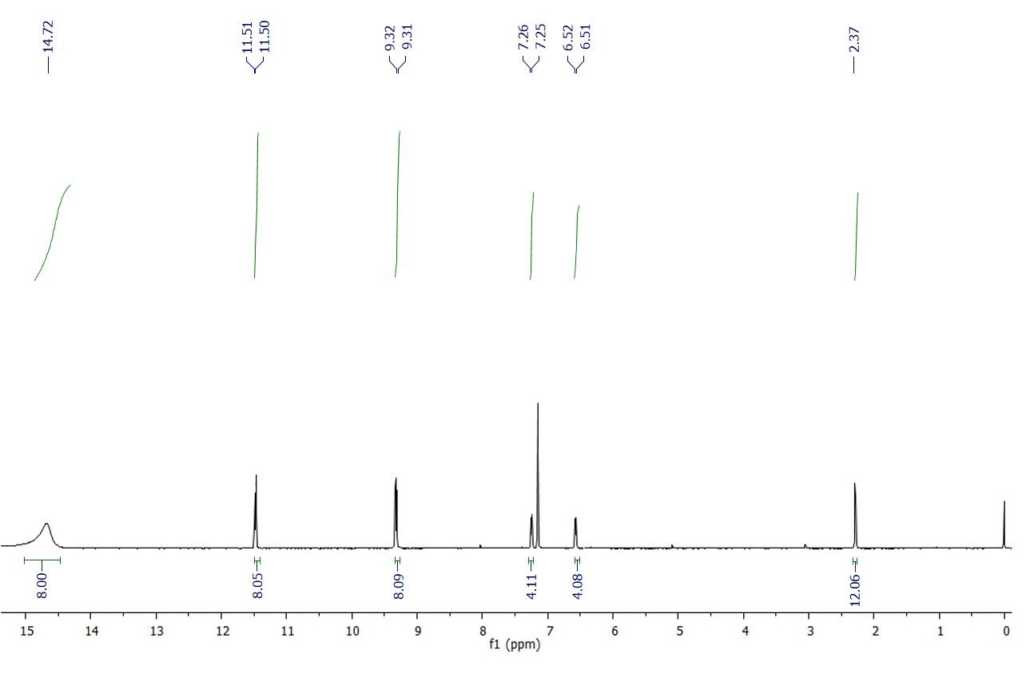
Fig. S1. ¹H NMR spectra of 1 (CDCl₃, 500 MHz, 298 K).
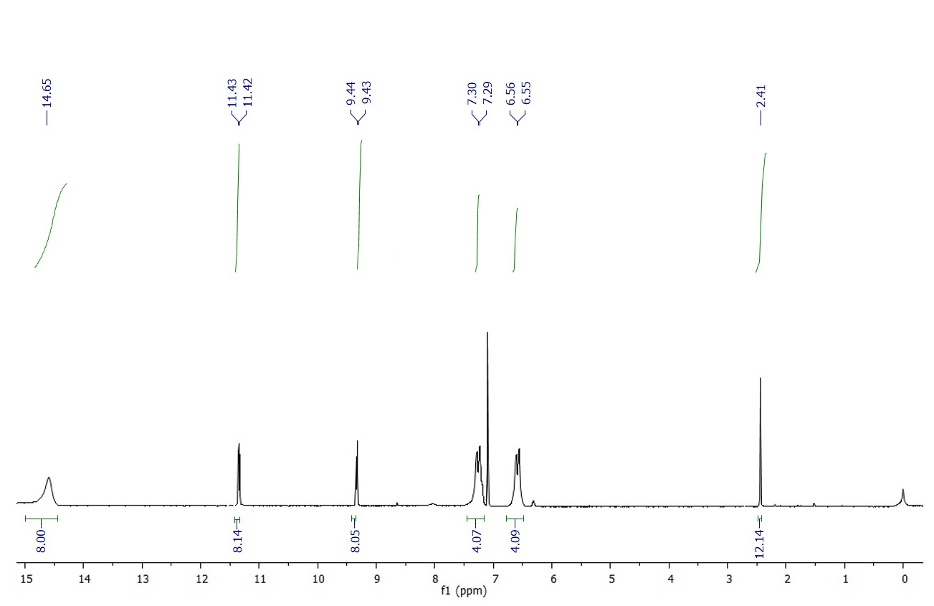
Fig. S2. ¹H NMR spectra of 2 (CDCl₃, 500 MHz, 298 K).

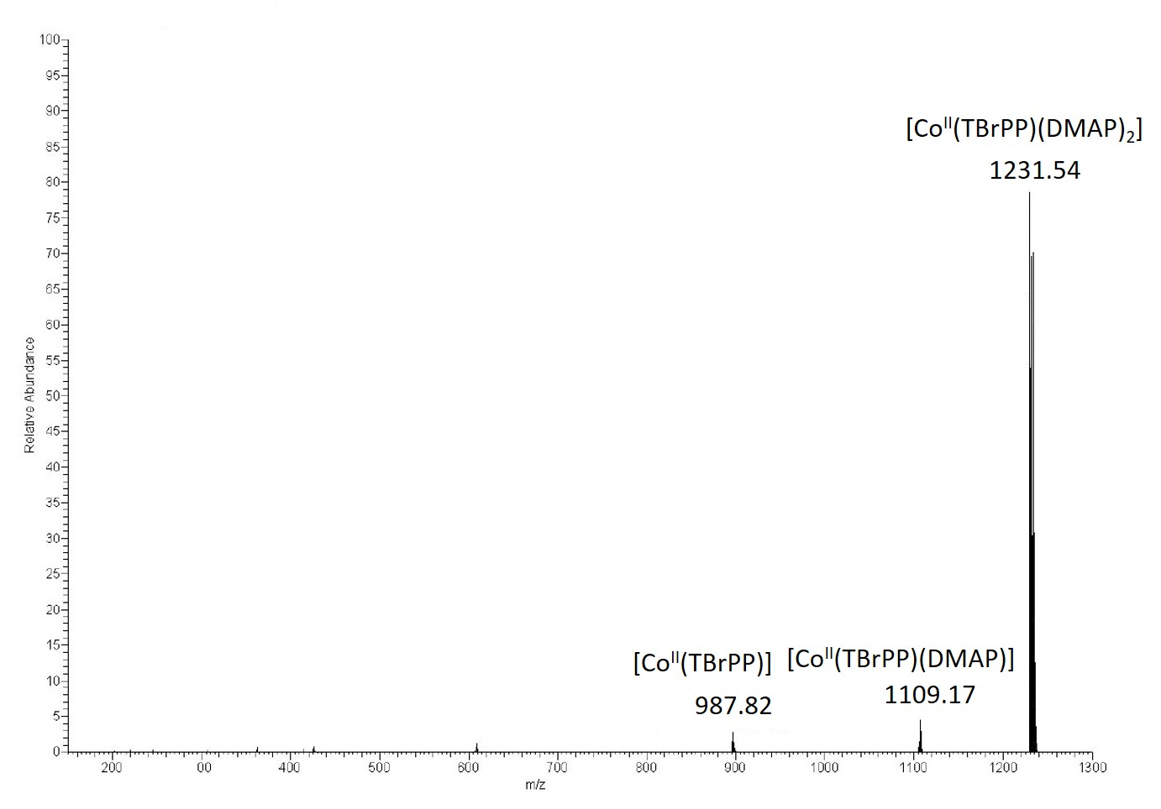
Fig. S3. High resolution ESI mass spectrum of 1 in CH₂Cl₂
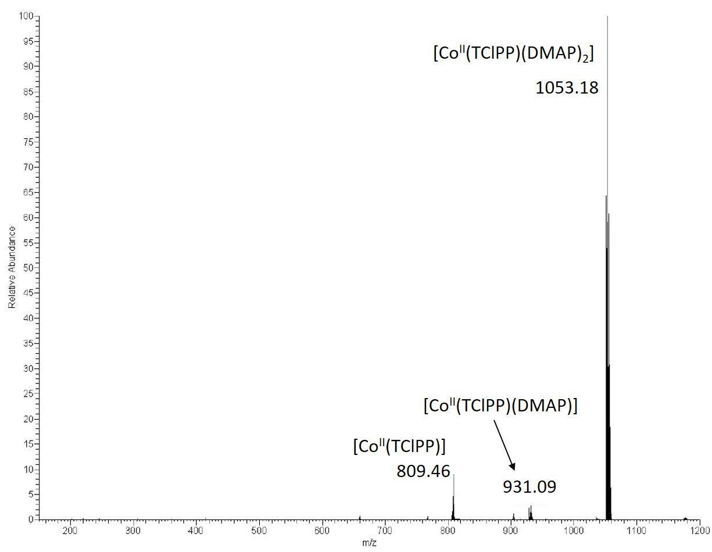Fig. S4. High resolution ESI mass spectrum of 2 in CH₂Cl₂

References

- Z. Denden, K. Ezzayani, E. Saint-Aman, F. Loiseau, S. Najmudin, C. Bonifácio, J.-C. Daran and H. Nasri, Insights on the UV/Vis, fluorescence, and cyclic Voltammetry properties and the molecular structures of ZnII tetraphenylporphyrin complexes with pseudohalide axial azido, cyanato‐N, thiocyanato‐N, and cyanido ligands, Eur. J. Inorg. Chem. 15 (2015) 2596-2610.
- N. Amiri, S. Nouir, M. Hajji, T. Roisnel, T. Guerfel, G. Simonneaux, H. Nasri, Synthesis, structure, photophysical properties and biological activity of a cobalt(II) coordination complex with 4,4’-bipyridine and porphyrin chelating ligands, J. Saudi Chem. Soc. 23 (2019), 781–794.
- Y. X. Du, Z. Q. Zhang, Y. H. Yao and J. Li, Inorg. Chem. Commun. 64 (2016) 19–22.
- N. Amiri, M. Guergueb, M. S. Al-Fakeh, M. Bourguiba, H. Nasri, A new cobalt(II) meso-porphyrin: synthesis,characterization, electric properties and application in the catalytic degradation of dyes, RSC Adv. 10 (2020) 44920.
- M. Guergueb, S. Nasri, J. Brahmi, F. Loiseau, F. Molton, T. Roisnel, V. Guerineau, I. Turowska-Tyrk, K. Aouadi, H. Nasri, Eﬀect of the coordination of p-acceptor 4cyanopyridine ligand on the structural and electronic properties of meso-tetra(para-methoxy) and meso-tetra(para-chlorophenyl) porphyrin cobalt(II) coordination compounds. Application in the catalytic degradation of methylene blue dye, RSC Adv. 10 (2020) 6900.
- Y. Belghith, A. Mansour, J.-C. Daran, H.Nasri. Spectroscopic and molecular structure characterization of the bis(2-aminophenol)(5,10,15,20-tetraphenylporphyrinato) cobalt(II) complex, Open J Inorg Chem. 2 (2012) 81-87.
- A. Mansour, Y. Belghith, M. S. Belkhiria, A. Bujaczb, V. Guérineau, H. Nasri, Synthesis, crystal structures and spectroscopic characterization of Co(II) bis(4,4′-bipyridine) with meso-porphyrins α,β,α,β-tetrakis(o-pivalamidophenyl) porphyrin (α,β,α,β-TpivPP) and tetraphenylporphyrin (TPP), J. Porphyrins Phthalocyanines 17 (2013) 1094-1103.
- F. A. Walker, J. Am. Chem. Soc., 95 (1973) 1154–9115.
- X. Q. Lin, B. Boisselier-Cocolios and K. M. Kadish, Inorg. Chem., 25 (1986) 3242–3248.
- M. Guergueb, S. Nasri, J. Brahmi, Y. O. Al-Ghamdi, F. Loiseau, F. Molton, T. Roisnel, V, Guerineau, H, Nasri, Spectroscopic characteri-zation, X-ray molecular structures and cyclic voltammetry study of two (piperazine) cobalt(II) meso-arylporphyin complexes. Application as a catalyst for the degradation of 4-nitrophenol, Polyhedron 209 (2021) 115468.
- J. W. Owens, R. Smith, R. Robinson and M. Robins, Inorg. Chim. Acta, 279 (1998) 226–231.
- H. J. Giraudeau, M. Callot and M. Gross, Inorg. Chem. 18 (1979) 201–206.
- S. Fortier, G. Wu and T. W. Hayton, Dalton Trans. 39 (2010) 352–354. 64 65
- A. Altomare, G. Casacarano, C. Giacovazzo, A. Guagliardi, M. C. Burla, G. Polidori and M. Camalli, J. Appl. Crystallogr. 27 (1994) 435–436.
- N. Amiri, M. Hajji, T. Roisnel, G. Simonneaux, H. Nasri, Synthesis, molecular structure, photophysical properties and spectroscopic characterization of new 1D-magnesium(II) porphyrin-based coordination polymer, Research on Chemical Intermediates 44 (2018) 5583–5595.

