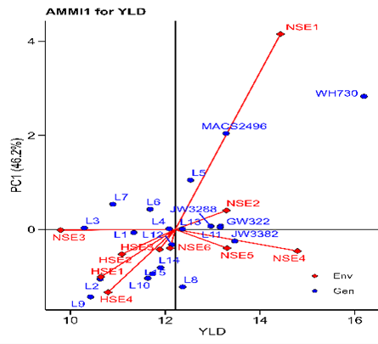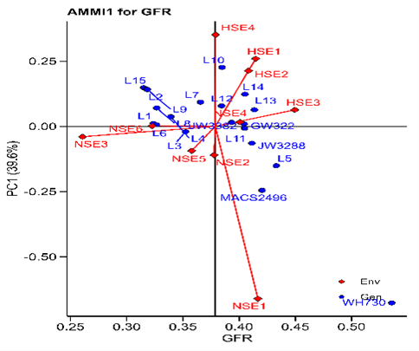
Supplemental Fig. S1. Across all the environments “AMMI1” graphs displays the main effect and IPC1 effect values describing relationship among examined wheat genotype and environment.
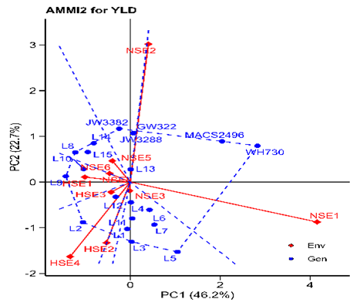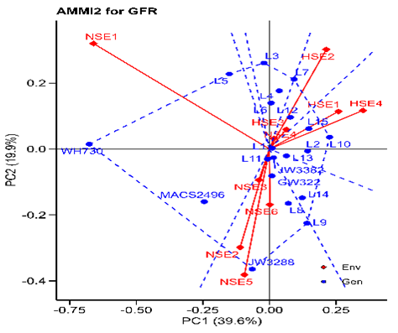
Supplemental Fig. S2. Across all the environments “AMMI2” graphs displays both the axes of interaction (IPCA1 and IPCA2) values for genotype effect and genotype by environment interaction effect.
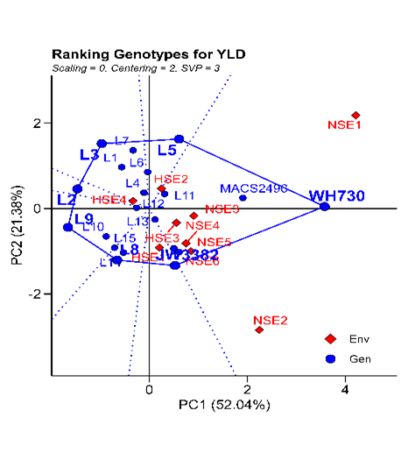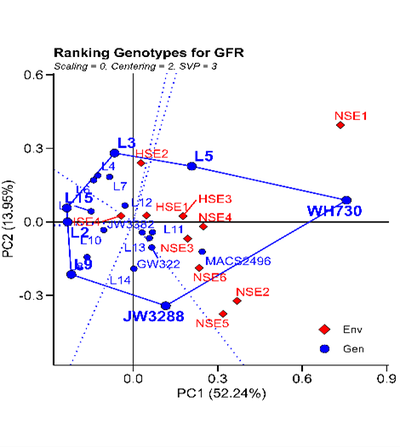
Supplemental Fig. S3. Across all the environments polygon view of “Which-won-where” model of GGE biplot representing the performance of wheat genotypes and their interactions with environment.
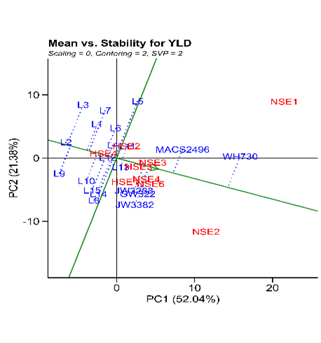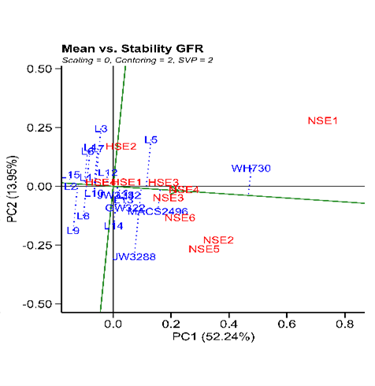Supplemental Fig. S4. Across all the environments “mean versus stability” model describing the interaction effect of wheat genotypes.
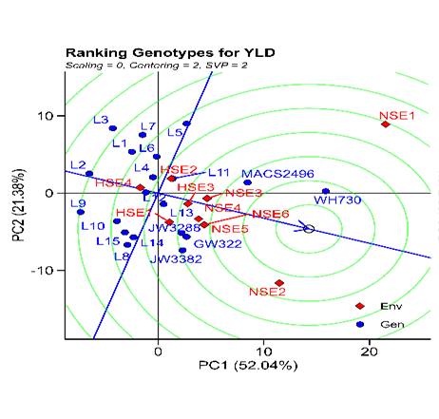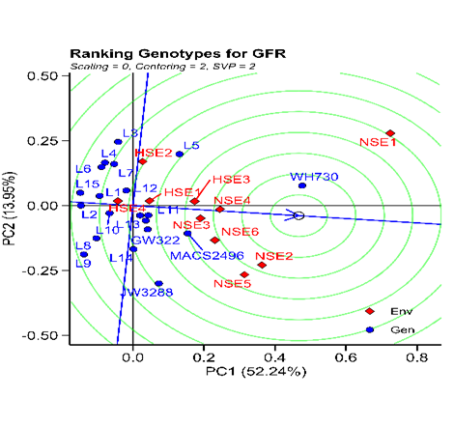Supplemental Fig. S5. Across all the environments “ranking genotypes” model of biplot assess other wheat genotypes against the ideal genotype conferring genotype interaction and genotype x environment interactions
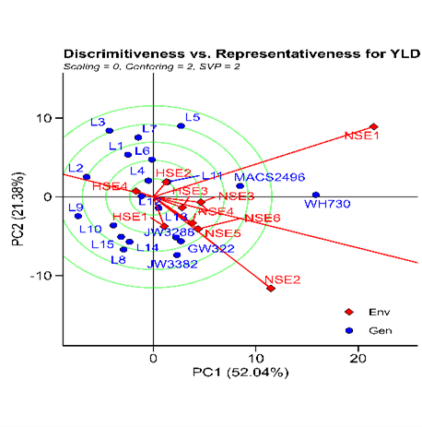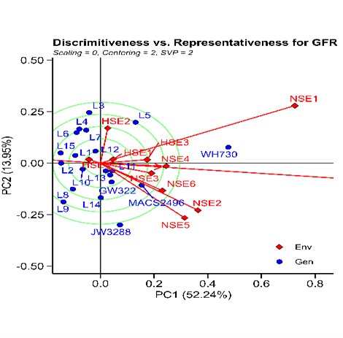Supplemental Fig. S6. Across all the environments “Discrimitiveness vs. Representativeness” model of biplot evaluate the wheat genotypes against the ideal genotypes, conferring genotype interaction and genotype x environment interactions.

Supplemental Table S1. Mean grain yield and grain filling rate for 20 genotypes evaluated in 6 normal sown environments.
ENV | GEN | YLD | GFR | ENV | GEN | YLD | GFR | ENV | GEN | YLD | GFR
NSE1 | L1 | 14.20 | 0.36 | NSE2 | L1 | 8.80 | 0.30 | NSE3 | L1 | 9.40 | 0.30
NSE1 | L2 | 9.10 | 0.26 | NSE2 | L2 | 8.05 | 0.23 | NSE3 | L2 | 10.50 | 0.28
NSE1 | L3 | 13.50 | 0.48 | NSE2 | L3 | 6.55 | 0.15 | NSE3 | L3 | 12.00 | 0.27
NSE1 | L4 | 14.20 | 0.41 | NSE2 | L4 | 13.65 | 0.27 | NSE3 | L4 | 11.00 | 0.21
NSE1 | L5 | 20.50 | 0.65 | NSE2 | L5 | 10.55 | 0.36 | NSE3 | L5 | 7.90 | 0.25
NSE1 | L6 | 15.90 | 0.39 | NSE2 | L6 | 11.85 | 0.34 | NSE3 | L6 | 10.80 | 0.29
NSE1 | L7 | 16.40 | 0.40 | NSE2 | L7 | 8.55 | 0.28 | NSE3 | L7 | 7.60 | 0.21
NSE1 | L8 | 8.80 | 0.26 | NSE2 | L8 | 14.80 | 0.37 | NSE3 | L8 | 10.10 | 0.24
NSE1 | L9 | 6.50 | 0.19 | NSE2 | L9 | 9.10 | 0.29 | NSE3 | L9 | 7.50 | 0.21
NSE1 | L10 | 9.40 | 0.29 | NSE2 | L10 | 12.90 | 0.37 | NSE3 | L10 | 9.10 | 0.22
NSE1 | L11 | 16.90 | 0.47 | NSE2 | L11 | 11.30 | 0.37 | NSE3 | L11 | 8.90 | 0.28
NSE1 | L12 | 13.70 | 0.43 | NSE2 | L12 | 13.10 | 0.41 | NSE3 | L12 | 7.30 | 0.22
NSE1 | L13 | 14.40 | 0.40 | NSE2 | L13 | 15.30 | 0.48 | NSE3 | L13 | 7.60 | 0.18
NSE1 | L14 | 10.10 | 0.31 | NSE2 | L14 | 15.80 | 0.49 | NSE3 | L14 | 8.00 | 0.23
NSE1 | L15 | 9.50 | 0.29 | NSE2 | L15 | 15.60 | 0.32 | NSE3 | L15 | 9.10 | 0.17
Parents
NSE1 | WH730 | 29.40 | 1.03 | NSE2 | WH730 | 20.10 | 0.61 | NSE3 | WH730 | 15.00 | 0.42
NSE1 | MACS2496 | 23.20 | 0.55 | NSE2 | MACS2496 | 17.30 | 0.55 | NSE3 | MACS2496 | 10.00 | 0.33
Commercial checks
NSE1 | GW322 | 15.00 | 0.43 | NSE2 | GW322 | 18.20 | 0.47 | NSE3 | GW322 | 10.40 | 0.25
NSE1 | JW3382 | 13.50 | 0.40 | NSE2 | JW3382 | 18.40 | 0.46 | NSE3 | JW3382 | 12.40 | 0.31
NSE1 | JW3288 | 14.50 | 0.38 | NSE2 | JW3288 | 16.00 | 0.45 | NSE3 | JW3288 | 11.30 | 0.40
Supplemental Table S1. Continued …
ENV | GEN | YLD | GFR | ENV | GEN | YLD | GFR | ENV | GEN | YLD | GFR
NSE4 | L1 | 11.75 | 0.26 | NSE5 | L1 | 12.65 | 0.29 | NSE6 | L1 | 11.45 | 0.28
NSE4 | L2 | 13.95 | 0.45 | NSE5 | L2 | 12.05 | 0.29 | NSE6 | L2 | 10.85 | 0.28
NSE4 | L3 | 13.25 | 0.38 | NSE5 | L3 | 9.90 | 0.27 | NSE6 | L3 | 8.70 | 0.29
NSE4 | L4 | 13.25 | 0.28 | NSE5 | L4 | 11.65 | 0.26 | NSE6 | L4 | 10.45 | 0.28
NSE4 | L5 | 13.90 | 0.45 | NSE5 | L5 | 13.10 | 0.39 | NSE6 | L5 | 11.90 | 0.37
NSE4 | L6 | 14.65 | 0.31 | NSE5 | L6 | 10.40 | 0.24 | NSE6 | L6 | 9.20 | 0.18
NSE4 | L7 | 14.65 | 0.47 | NSE5 | L7 | 10.55 | 0.27 | NSE6 | L7 | 9.35 | 0.22
NSE4 | L8 | 13.65 | 0.31 | NSE5 | L8 | 14.80 | 0.35 | NSE6 | L8 | 13.60 | 0.36
NSE4 | L9 | 13.55 | 0.33 | NSE5 | L9 | 15.00 | 0.40 | NSE6 | L9 | 13.80 | 0.38
NSE4 | L10 | 16.20 | 0.44 | NSE5 | L10 | 12.60 | 0.31 | NSE6 | L10 | 11.40 | 0.34
NSE4 | L11 | 15.95 | 0.45 | NSE5 | L11 | 15.30 | 0.43 | NSE6 | L11 | 14.10 | 0.35
NSE4 | L12 | 15.20 | 0.37 | NSE5 | L12 | 13.65 | 0.35 | NSE6 | L12 | 12.45 | 0.23
NSE4 | L13 | 15.00 | 0.48 | NSE5 | L13 | 13.20 | 0.38 | NSE6 | L13 | 12.00 | 0.41
NSE4 | L14 | 14.05 | 0.38 | NSE5 | L14 | 13.75 | 0.39 | NSE6 | L14 | 12.55 | 0.40
NSE4 | L15 | 14.55 | 0.32 | NSE5 | L15 | 12.10 | 0.24 | NSE6 | L15 | 10.90 | 0.29
Parents
NSE4 | WH730 | 18.00 | 0.56 | NSE5 | WH730 | 16.65 | 0.54 | NSE6 | WH730 | 15.45 | 0.55
NSE4 | MACS2496 | 13.80 | 0.46 | NSE5 | MACS2496 | 15.45 | 0.50 | NSE6 | MACS2496 | 14.25 | 0.27
Commercial checks
NSE4 | GW322 | 17.50 | 0.49 | NSE5 | GW322 | 13.45 | 0.43 | NSE6 | GW322 | 12.25 | 0.34
NSE4 | JW3382 | 19.65 | 0.49 | NSE5 | JW3382 | 13.10 | 0.28 | NSE6 | JW3382 | 11.90 | 0.34
NSE4 | JW3288 | 13.35 | 0.39 | NSE5 | JW3288 | 16.80 | 0.60 | NSE6 | JW3288 | 15.60 | 0.37
ENV = Environment, GEN = Genotypes, YLD = Grain yield, GFR = Grain filling rate, NSE1 = Jabalpur-Dece-2019-20, NSE2 = Sagar-Dece-2019-20, NSE3 = Narmadapuram-Dece-2019-20, NSE4 = Jabalpur-Dece-2020-21, NSE5 = Sagar-Dece-2020-21, NSE6 = Narmadapuram-Dece-2020-21.

Supplemental Table S2. Mean grain yield and grain filling rate for 20 genotypes evaluated across 4 heat stress environments.
ENV | GEN | YLD | GFR |  | ENV | GEN | YLD | GFR
HSE1 | L1 | 9.80 | 0.31 |  | HSE2 | L1 | 10.30 | 0.36
HSE1 | L2 | 9.75 | 0.31 |  | HSE2 | L2 | 10.15 | 0.35
HSE1 | L3 | 9.35 | 0.49 |  | HSE2 | L3 | 9.10 | 0.41
HSE1 | L4 | 8.70 | 0.39 |  | HSE2 | L4 | 14.35 | 0.46
HSE1 | L5 | 8.35 | 0.39 |  | HSE2 | L5 | 15.15 | 0.54
HSE1 | L6 | 10.50 | 0.36 |  | HSE2 | L6 | 13.25 | 0.48
HSE1 | L7 | 10.75 | 0.51 |  | HSE2 | L7 | 10.10 | 0.43
HSE1 | L8 | 12.65 | 0.36 |  | HSE2 | L8 | 12.30 | 0.38
HSE1 | L9 | 9.55 | 0.39 |  | HSE2 | L9 | 9.15 | 0.32
HSE1 | L10 | 13.35 | 0.65 |  | HSE2 | L10 | 12.05 | 0.44
HSE1 | L11 | 11.45 | 0.42 |  | HSE2 | L11 | 10.15 | 0.36
HSE1 | L12 | 9.50 | 0.40 |  | HSE2 | L12 | 11.00 | 0.45
HSE1 | L13 | 10.35 | 0.43 |  | HSE2 | L13 | 13.10 | 0.53
HSE1 | L14 | 10.40 | 0.42 |  | HSE2 | L14 | 9.90 | 0.41
HSE1 | L15 | 11.75 | 0.35 |  | HSE2 | L15 | 11.15 | 0.42
Parents
HSE1 | WH730 | 12.40 | 0.42 |  | HSE2 | WH730 | 11.80 | 0.41
HSE1 | MACS2496 | 9.40 | 0.41 |  | HSE2 | MACS2496 | 10.10 | 0.37
Commercial checks
HSE1 | GW322 | 12.65 | 0.43 |  | HSE2 | GW322 | 10.45 | 0.42
HSE1 | JW3382 | 11.70 | 0.46 |  | HSE2 | JW3382 | 10.00 | 0.35
HSE1 | JW3288 | 10.55 | 0.41 |  | HSE2 | JW3288 | 8.20 | 0.30
Supplemental Table S2. Continued …
ENV | GEN | YLD | GFR |  | ENV | GEN | YLD | GFR
HSE3 | L1 | 13.40 | 0.42 |  | HSE4 | L1 | 11.65 | 0.38
HSE3 | L2 | 9.85 | 0.32 |  | HSE4 | L2 | 12.05 | 0.43
HSE3 | L3 | 10.55 | 0.49 |  | HSE4 | L3 | 10.05 | 0.30
HSE3 | L4 | 12.05 | 0.50 |  | HSE4 | L4 | 11.55 | 0.35
HSE3 | L5 | 10.95 | 0.50 |  | HSE4 | L5 | 13.05 | 0.44
HSE3 | L6 | 10.85 | 0.38 |  | HSE4 | L6 | 9.45 | 0.31
HSE3 | L7 | 12.15 | 0.51 |  | HSE4 | L7 | 8.90 | 0.37
HSE3 | L8 | 12.60 | 0.35 |  | HSE4 | L8 | 10.40 | 0.30
HSE3 | L9 | 11.30 | 0.41 |  | HSE4 | L9 | 8.80 | 0.28
HSE3 | L10 | 9.65 | 0.45 |  | HSE4 | L10 | 9.70 | 0.37
HSE3 | L11 | 12.40 | 0.44 |  | HSE4 | L11 | 15.15 | 0.51
HSE3 | L12 | 11.10 | 0.44 |  | HSE4 | L12 | 14.40 | 0.56
HSE3 | L13 | 12.20 | 0.45 |  | HSE4 | L13 | 10.50 | 0.41
HSE3 | L14 | 13.35 | 0.61 |  | HSE4 | L14 | 11.15 | 0.43
HSE3 | L15 | 11.55 | 0.34 |  | HSE4 | L15 | 11.15 | 0.43
Parents
HSE3 | WH730 | 14.10 | 0.53 |  | HSE4 | WH730 | 9.05 | 0.30
HSE3 | MACS2496 | 12.20 | 0.53 |  | HSE4 | MACS2496 | 7.15 | 0.25
Commercial checks
HSE3 | GW322 | 10.90 | 0.35 |  | HSE4 | GW322 | 10.90 | 0.45
HSE3 | JW3382 | 13.00 | 0.47 |  | HSE4 | JW3382 | 11.05 | 0.38
HSE3 | JW3288 | 13.55 | 0.48 |  | HSE4 | JW3288 | 9.80 | 0.35
ENV = Environment, GEN = Genotypes, YLD = Grain yield, GFR = Grain filling rate, HSE1 = Jabalpur-Jan-2019-20, HSE2 = Narmadapuram-Jan-2019-20, HSE3 = Jabalpur-Jan-2020-21, HSE4 = Narmadapuram-Jan-2020-21.

Supplemental Table S3. Across all the environment stability parameters for grain yield and grain filling rate
Genotypes | YLD |  |  |  |  |  |  | GFR
Genotypes | G_{m} | R_{gm} | b_{i} | S²d_{i} | ASV | R_{ASV} | GSI | G_{m} | R_{gm} | b_{i} | S²d_{i} | ASV | R_{ASV} | GSI
L1 | 11.80 | 9 | 0.98 | 2.38 | 1.30 | 9 | 18 | 0.32 | 17 | 0.53 | 0.00 | 0.02 | 1 | 18
L2 | 10.84 | 16 | 0.44 | 2.31 | 0.87 | 5 | 21 | 0.32 | 19 | 0.35 | 0.00 | 0.29 | 12 | 31
L3 | 10.56 | 18 | 0.42 | 4.83 | 1.75 | 15 | 33 | 0.35 | 13 | 1.41 | 0.01 | 0.26 | 10 | 23
L4 | 12.29 | 8 | 0.71 | 1.04 | 0.46 | 2 | 10 | 0.34 | 14 | 1.45 | 0.00 | 0.19 | 8 | 22
L5 | 13.15 | 2 | 2.00 | 7.16 | 3.21 | 20 | 22 | 0.43 | 2 | 1.58 | 0.01 | 0.38 | 16 | 18
L6 | 12.58 | 5 | 1.19 | 4.49 | 1.97 | 16 | 21 | 0.33 | 16 | 0.97 | 0.00 | 0.14 | 6 | 22
L7 | 11.62 | 10 | 1.83 | 4.98 | 2.64 | 19 | 29 | 0.37 | 12 | 1.87 | 0.00 | 0.28 | 11 | 23
L8 | 12.97 | 3 | 0.58 | 9.70 | 2.09 | 18 | 21 | 0.33 | 15 | 0.35 | 0.00 | 0.22 | 9 | 24
L9 | 11.39 | 11 | 1.07 | 7.42 | 2.02 | 17 | 28 | 0.32 | 18 | 0.49 | 0.01 | 0.36 | 15 | 33
L10 | 11.36 | 12 | 1.22 | 2.51 | 1.48 | 12 | 24 | 0.39 | 10 | 1.41 | 0.01 | 0.45 | 18 | 28
L11 | 12.51 | 7 | 1.67 | 5.21 | 1.36 | 10 | 17 | 0.41 | 7 | 0.83 | 0.00 | 0.03 | 2 | 9
L12 | 12.54 | 6 | 1.85 | 0.90 | 0.76 | 4 | 10 | 0.38 | 11 | 1.41 | 0.00 | 0.18 | 7 | 18
L13 | 13.55 | 1 | 1.61 | 3.47 | 1.27 | 8 | 9 | 0.41 | 4 | 1.35 | 0.00 | 0.13 | 5 | 9
L14 | 12.78 | 4 | 1.38 | 4.47 | 1.71 | 14 | 18 | 0.41 | 6 | 1.23 | 0.01 | 0.29 | 13 | 19
L15 | 11.02 | 15 | 1.16 | 4.38 | 1.65 | 13 | 28 | 0.32 | 20 | 0.99 | 0.00 | 0.30 | 14 | 34
Parents
WH730 | 11.10 | 14 | 0.78 | 0.05 | 0.20 | 1 | 15 | 0.54 | 1 | 0.9 | 0.04 | 1.34 | 20 | 21
MACS2496 | 08.92 | 20 | 0.40 | 2.17 | 1.22 | 7 | 27 | 0.42 | 3 | 1.11 | 0.01 | 0.51 | 19 | 22
Commercial checks
GW322 | 11.14 | 13 | 0.58 | 3.46 | 1.44 | 11 | 24 | 0.40 | 8 | 0.84 | 0.00 | 0.08 | 4 | 12
JW3382 | 10.57 | 17 | 0.44 | 0.52 | 0.60 | 3 | 20 | 0.39 | 9 | 0.93 | 0.00 | 0.04 | 3 | 12
JW3288 | 10.22 | 19 | 0.20 | 0.89 | 1.21 | 6 | 25 | 0.41 | 5 | 0 | 0.01 | 0.39 | 17 | 22
YLD = Grain yield, GFR = Grain filling rate, G_{m=} grand mean, R_{gm =} Rank by grand mean, b_{i} = Regression coefficient of Eberhart and Russell, S²d_{i}= Deviation form regression of Eberhart and Russel, ASV = AMMI stability value, R_{ASV} = Rank by AMMI stability value.
Supplemental Table S4. Across all the environments AMMI-based ANOVA for grain yield and grain filling rate
Source | YLD |  |  |  |  | GFR
Source | DF | MSS | Percent Explained | p-value |  | MSS | Percent Explained | p-value
Environment | 9 | 54.20 | 12.3 | <0.001 |  | 0.118 | 14.5 | <0.001
Block | 10 | 0.50 | 0.001 | 0.65 |  | 0.001 | 0.002 | 0.143
Genotype | 19 | 26.60 | 12.8 | <0.001 |  | 0.059 | 15.4 | <0.001
G x E | 171 | 8.29 | 35.8 | <0.001 |  | 0.014 | 33.7 | <0.001
PC1 | 27 | 18.30 | 46.2 | <0.001 |  | 0.036 | 39.6 | <0.001
PC2 | 25 | 12.40 | 22.7 | <0.001 |  | 0.019 | 19.9 | <0.001
PC3 | 23 | 8.68 | 14.1 | <0.001 |  | 0.012 | 11.4 | <0.001
PC4 | 21 | 7.70 | 11.4 | <0.001 |  | 0.010 | 8.1 | <0.001
PC5 | 19 | 6.14 | 8.20 | <0.001 |  | 0.009 | 6.9 | <0.001
PC6 | 17 | 4.33 | 5.20 | <0.001 |  | 0.008 | 5.5 | <0.001
PC7 | 15 | 2.78 | 2.90 | <0.001 |  | 0.006 | 3.9 | <0.001
PC8 | 13 | 1.52 | 1.40 | <0.001 |  | 0.006 | 2.9 | <0.001
PC9 | 11 | 0.14 | 0.10 | <0.001 |  | 0.004 | 1.9 | <0.001
Residuals | 190 | 0.65 | 2.10 | - |  | 0.0009 | 0.02 | -
Total | 570 | 6.94 | - | - |  | 7.32 | - | -
YLD = Grain yield, GFR= Grain filling rate, DF= degree of freedom, MSS= mean sum of square, *p < 0.05, **p < 0.01, ***p < 0.001, G x E = Genotype by environment interactions.

